**Detect and Keep a Count of Cars using YoloV8 trained on custom dataset**

**Name** **-** Anmol Katakwar

**Phone -** Number - 830849068

**Email** **-** [anmolkatakwar99@gmail.com](mailto:anmolkatakwar99@gmail.com)

1. **Summary**

This project involves training a YOLOv8 (You Only Look Once) model on a custom dataset to detect and count cars on a highway. The model leverages the latest advancements in object detection technology to provide accurate and efficient car detection and counting. The supervision method is used to count cars and draw a line to separate the counting area.

1. **Objectives**

* Train a YOLOv8 model on a custom datasets for car detection.
* Implement a method to count cars crossing a predefined line on the highway.
* Provide real-time visualization of detected cars and their count.

1. **Approach**

* **Data Collection:** Gather images of different cars with annotation.

( 500+ Train images / 90 Test images )

* **Model Training:** Train the YOLOv8 model on the annotated datasets**.**
* **Counting Implementation:** Use supervision to count cars crossing a predefined line in the video.

1. **Tools and Technologies**

* **YOLOv8:** Object detection model
* **OpenCV**: For video processing and visualization
* **Python:** Programming language
* **Supervision** : To keep a count of cars

1. **Code and implementation**
2. **Import necessary libraries**

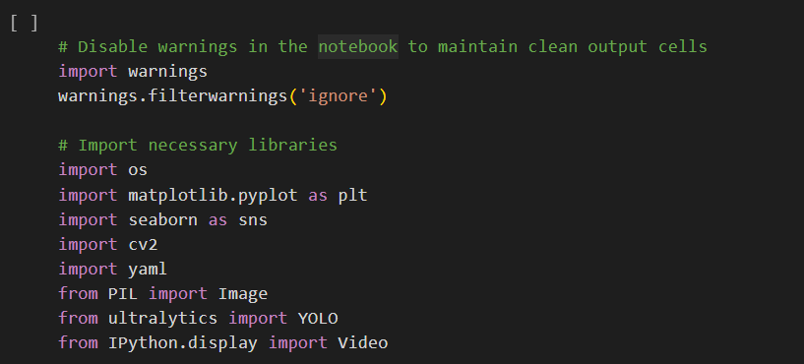

1. **Set the path for dataset and data.yaml file**

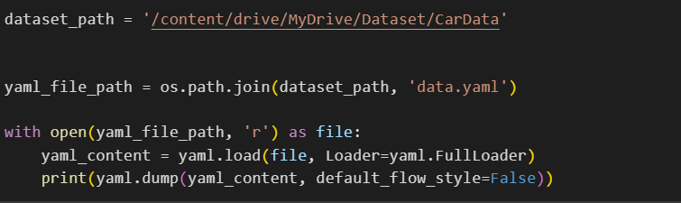

1. **Check if the cuda device is available or not**

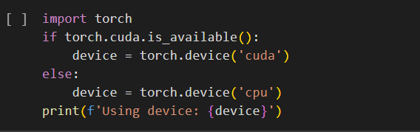

1. **Check Training the yolov8 model for 100 epochs with batch size 32**

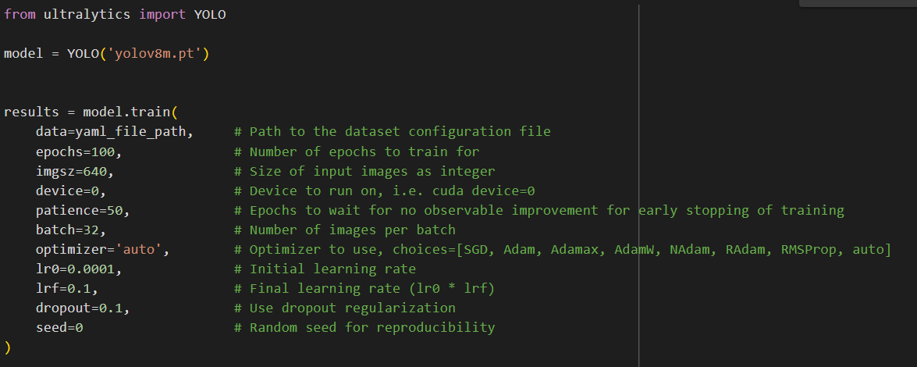

1. **Validating model on test dataset**

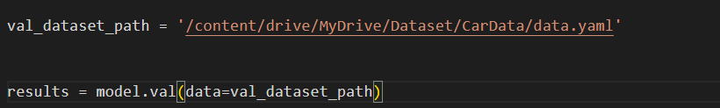



1. **Checking model in images**

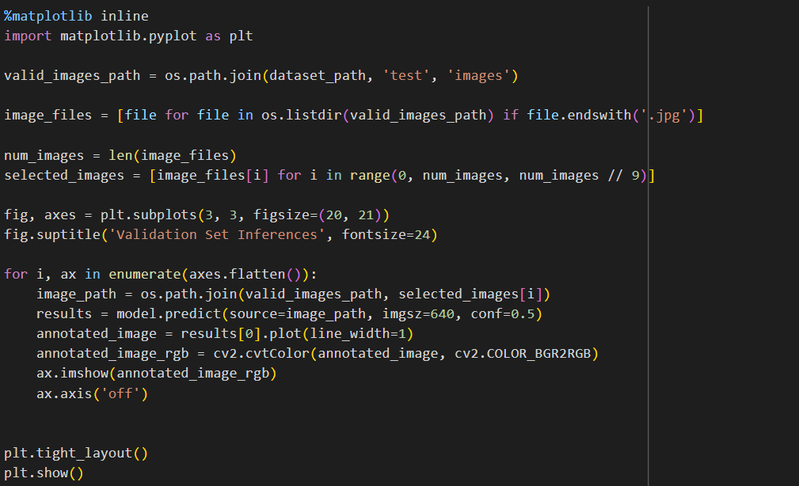

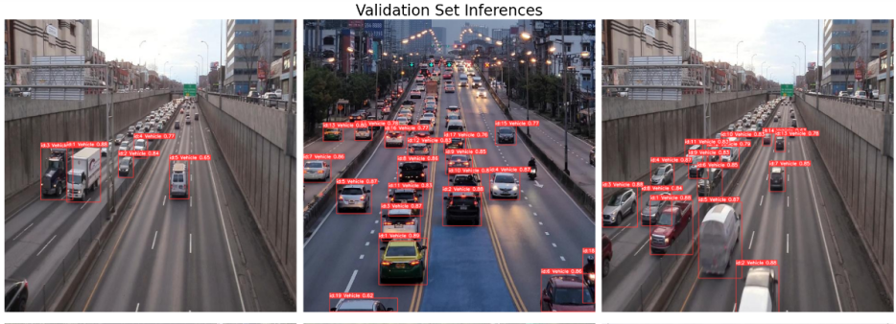

1. **Using Supervision library, Drawing a line on sample video and counting cars which are passing through the line**

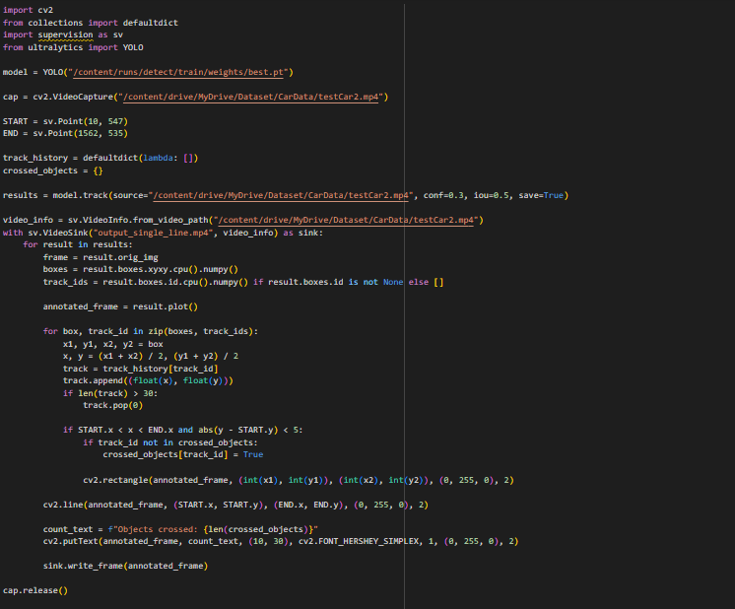

1. **Graphs**

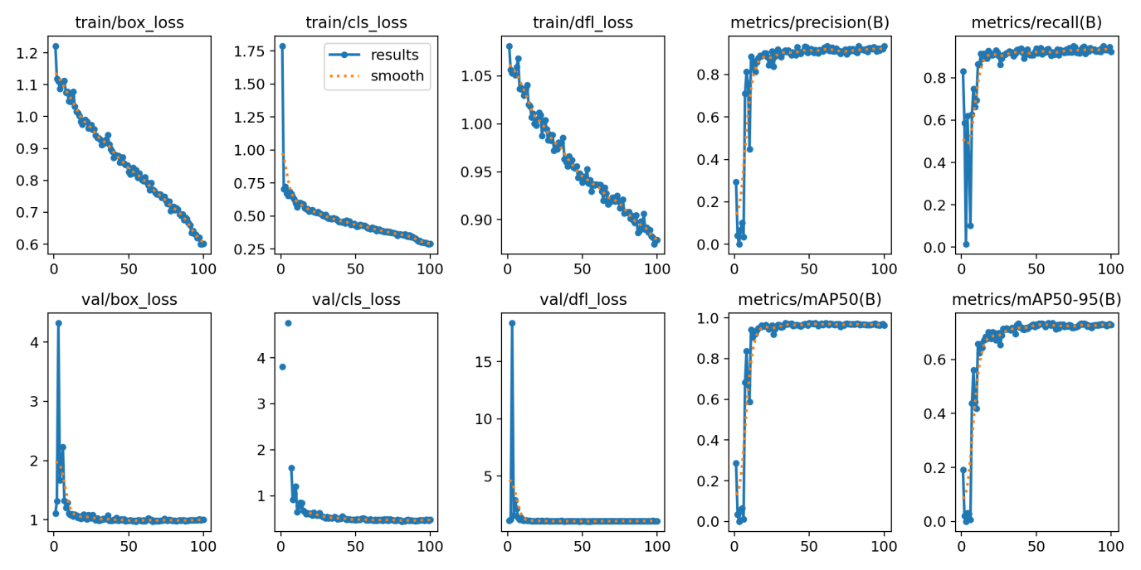

1. **Conclusion**

The YOLOv8 model trained on custom dataset achieves a box loss of less than 0.6, precision and recall both exceeding 80%, and a mean Average Precision (mAP) greater than 90%. These metrics indicate that the model performs with high accuracy and reliability in detecting and counting cars on the highway