

Software Requirements Specification

for

MEMEit

Version 1.0

Prepared by

Group Name: MEMEit

|  |  |  |
| --- | --- | --- |
| Ian Kieswether | 11594545 | ian.kieswether@wsu.edu |
| Logan Nelson | 11577923 | logan.nelson@wsu.edu |
| Yekaalo Habtemichael | 11585389 | y.habtemichael@wsu.edu |

|  |  |
| --- | --- |
|  |  |
| Date: | 25 Oct 2019 |
|  |  |
|  |  |
|  |  |

Contents

Revisions ii

1 Introduction 1

1.1 Document Purpose **Error! Bookmark not defined.**

1.2 Product Scope **Error! Bookmark not defined.**

1.3 Intended Audience and Document Overview **Error! Bookmark not defined.**

1.4 Definitions, Acronyms and Abbreviations 1

1.5 Document Conventions **Error! Bookmark not defined.**

1.6 References and Acknowledgments **Error! Bookmark not defined.**

2 Overall Description 2

2.1 Product Perspective **Error! Bookmark not defined.**

2.2 Product Functionality **Error! Bookmark not defined.**

2.3 Users and Characteristics **Error! Bookmark not defined.**

2.4 Operating Environment **Error! Bookmark not defined.**

2.5 Design and Implementation Constraints **Error! Bookmark not defined.**

2.6 User Documentation **Error! Bookmark not defined.**

2.7 Assumptions and Dependencies **Error! Bookmark not defined.**

3 Specific Requirements 4

3.1 External Interface Requirements 4

3.2 Functional Requirements **Error! Bookmark not defined.**

3.3 Behaviour Requirements **Error! Bookmark not defined.**

4 Other Non-functional Requirements 6

4.1 Performance Requirements **Error! Bookmark not defined.**

4.2 Safety and Security Requirements **Error! Bookmark not defined.**

4.3 Software Quality Attributes **Error! Bookmark not defined.**

5 Other Requirements Error! Bookmark not defined.

Appendix A – Data Dictionary 7

Appendix B - Group Log 7

Revisions

| Version | Primary Author(s) | Description of Version | Date Completed |
| --- | --- | --- | --- |
| V1.0 | Ian Kieswether  Logan Nelson  Yekaalo Habtemichael | Final version of the SRS ready to be submitted | 10/25/19 |

# 

# Introduction

## Document Purpose

The product in this SRS is a series of webpages, databases, and interfaces. The document discribes the whole system of software, which will cover all scopes of the project. The scopes being the product’s architecture, development and future additions. The product described will be the base line 1.0 version of this system as well as the future versions/revisions.

## Product Scope

The product will have a landing page, then a separate login page that will prompt users to login to their specific account after doing so they will be able to use the system to browse memes that they have made and added. The goal of this product is to have a place where a user can store their memes. A v2.0 feature is to add would allow users to interact with each other. A v3.0 feature is to allow users to upload text files.

## Intended Audience and Document Overview

This document is intended for the clients as well as the CS320 professor Dr. Xinghui Zhau. The efficent way to read this document is to start at section 1 and proceed through 1.4. After that section 2 describes the product and how it functions as well as some basic requirements to utilize it. Section 3 covers the various interfaces used throughout the system.

## Definitions, Acronyms and Abbreviations

**Database** - An organized collection of data, accessable through functions by the website

**Landing Page** - A webpage where the user first arrives when accessing our website.

**Meme** - For our purposes, a meme is a picture with text that conveys humor to the viewer if they have the appropriate knowledge and context for the humor trying to be conveyed.

## Document Conventions

Font Arial

Font size 11

Text is single spaced and has 1” margins

## References and Acknowledgments

The document did not require references from any outside sources

# Overall Description

## Product Perspective

The product is a new self-contained product that contains a database that contains a users collection of entertaining pictures with text. The product includes customer name, username, password. This information will be used for keeping the records of the customer for any resting account or for any other kind of information.

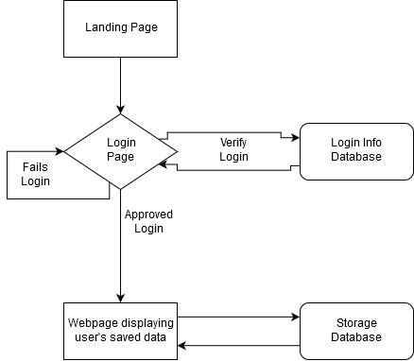*Diagram of System v1.0*

## Product Functionality

The product has the following functions:

* Provides a user authentication process.
* Allows users to upload Memes under their account.
* Allows users to view Memes uploaded by other users. (v2.0 feature)
* Allows users to either up or down vote Memes uploaded by other users. (v2.0 feature)
* Memes with more up votes will be filtered to the top of the web page. (v2.0 feature)
* Memes with the most down votes will be filtered to the bottom of the web page. (v2.0 feature)
* Allow users to make and upload their own text files and make them private or public (v3.0 feature)

## Users and Characteristics

The primary target audience for this product is users who have a good sense of humor, that will share Memes of their own as well as be interested in interacting with memes uploaded by other users. Currently all customers are equal as there is no different tiers for the product, however the admins do matter more because they have to maintain the product.

## Operating Environment

* Client/server system
* Operating system: Windows/MacOS.
* Databases: Text file database as well as a folder tree to store user’s uploaded content
* Platform: Javascript and HTML as well as some external Javascript libraries

## Design and Implementation Constraints

The information of all the users must be stored in a database that will be a text file accessable by the system. The library system is connected to the server and will be running 24/7 accessable for the user. The user can access the library for the Memes from any computer as long as browsing capabilities and an internet connection are available. The login system connected to the text file database and the database used by the login interface must be compatible with the interface of the text file library interface.

The user must have a correct username and password to access their personal account. We will not be able to implement a security protection for the software and this is because it’s beyond our scope of knowledge.

## User Documentation

**README file can be provided**

When a user logs in, their username, password, and backup name are required. Usernames can contain characters and numbers with no spaces in between only. Passwords should be unique that include a minimum of 8 characters which can be upper or lower case letters, numbers, or symbols. Backup names should be in all lower case and failure to follow proper setup will result in a warning and preventing the account set up.

When uploading Memes, should be only images files that include .png, .jpeg or .gif to upload.

## Assumptions and Dependencies

The user will need to know how to navigate webpages and be able to read English, as the system interface will be provided in English. The customer must also remember their name, username and password information, however there will be a recovery method.

# Specific Requirements

## External Interface Requirements

### User Interfaces

The design or layout of every form will be very clear and very interactive to the user. When the user opens the webpage the landing page will appear from there then users can log in. In the login window the user can easily entered the desired password and login name then it will give the successfully login message. From each and every window the user can easily go to any desired window that will be absolute and relative linking. There will be a proper collection of interfaces, which will provide better look and feel. In the screen layout the background color, and the graphics and font style will be in proper manner and well organized. If the user will input any error statement, then it will give the proper error message display. In the opening of the system there will be a landing page. User can easily save its data into the database and keep track of the uploaded files. This system will be easily understandable and operable by the user.

### Hardware Interfaces

The v1.0 of the product will run natively on a local device where user data is only stored while the application is running, while later versions will include support for persistent storage of uploaded files on a remote server.

### Software Interfaces

The product will require interaction with the server’s operating system in order the access either of the two databases used to store data from the user. There will be one database that stores user’s login credentials, and a second database that stores user’s uploaded content. The database that store user’s login credentials will only need to be accessed during the login process while the second will be interacted with constantly while users both upload data and when they are browsing memes on their home page as it will be used to populate user’s feed with meme’s that have been uploaded already.

### Communications Interfaces

The product will use encryption standards provided by a meteor plugin; a javascript framework used to build web applications. The encryption will likely be done using bcrypt which works in tandem with meteor and will be utilized when the user logs in and their username and password are sent to the server for authentication.

## Functional Requirements

v1.0

*User*

* Login or create a new login
* The user can upload Memes
* Accessing data that was stored at anytime
* Update stored Memes anywhere and anytime

v2.0

User (includes v1.0)

* Access Memes uploaded by other users
* Like or dislike memes
* Report inappropriate Meme

Admins

* Remove Memes reported by Users
* Remove report status from falsely reported Memes

v3.0

Users (includes v2.0)

* Add files other than Memes

## Behaviour Requirements

### Use Case View

Add meme

Upload a new image file (meme) to the corrisponding (sp) database.

Browse Data

Browse data the user has uploaded previously

Login

Verify user credientials via a login database to allow users to see their uploaded memes

Add new Login or Recover Login

Allow new login info to be added or recover a login using the user’s name

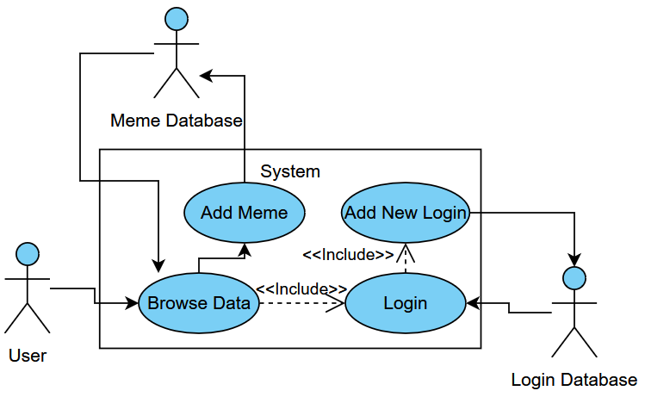Use Case Diagram for v1.0

# Other Non-functional Requirements

## Performance Requirements

Requirements involve

* This system is reliable.
* The performance of the functions and every module must be well.
* The risk factor must be taken at initial step for better performance of the software.
* For login to the page password and username must matched to the password

and name

* Stored in the database and thus only authenticated users are allowed to the login.
* There will be various ways of retrieving data and it takes less time.
* There will be ambiguity in the data and the record

## Safety and Security Requirements

* There will be proper security regarding to the accessing of data.
* The external security can be provided by given the login authentication.
* The data that are stored in the database must be private.
* There is also required a user authentication.

## Software Quality Attributes

**4.3.1** - Adaptability - The application will be built from the start to work on desktop or mobile from a web browser which includes macOS, Windows, or Linux machines as well as on android or iOS.

**4.3.2** - Reusablitity – The application will be designed in such a way as to accommodate different types of file uploads. Although it will be mainly for the storage and display of image files such as jpeg, png, or pdf, the system could be easily altered to store and other type of file if need be in subsequent versions of the software.

**4.3.3** - Usability – The application will be designed with the user in mind, with the goal of making it as simple and familiar as possible to use with little to no learning curve.

Appendix A – Data Dictionary

Table: Login Database

|  |  |  |  |
| --- | --- | --- | --- |
| Field | Data Type | Contraints | Description |
| Username | String | Must be all lowercase | Username used to check if password matches with records |
| Password | String | Minimum of 8 characters of lower and upper case letters, numbers, and/or special characters | Password checked against the databases records. If they match user gets an ID key that other software uses to index data |
| Name | String | Must be all lowercase | Used to allow users to reset their passwords by entering their name |

Table: Meme Database

|  |  |  |  |
| --- | --- | --- | --- |
| Field | Data Type | Contraints | Description |
| ID Key | string | None, only system can see this. | Used to index user’s data |
| File to Upload | File | Must be a file in a .png, .jpeg, or .gif format | File chosen to be stored by user |
| File to Upload (v2.0) | File | Files may now also include .txt files | Allows user to store Text files |

Appendix B - Group Log

Team Meetings

October 16, 2019 for 2 hrs and 0 minutes

October 21, 2019 for 1 hrs and 15 minutes

October 25, 2019 for 1 hrs and 0 minutes

Individual Work:

*October 24, 2019 for 2 hrs and 45 minutes by Yekaalo Habtemichael*

October 24, 2019 for 2 hrs and 15 minutes Logan Nelson

October 24, 2019 for 2 hrs and 0 minutes Ian Kieswether