

System Design Document

for

MEMEit

Version 2.0

Prepared by

Group Name: MEMEit

|  |  |  |
| --- | --- | --- |
| Ian Kieswether | 11594545 | ian.kieswether@wsu.edu |
| Logan Nelson | 11577923 | logan.nelson@wsu.edu |
| Yekaalo Habtemichael | 11585389 | y.habtemichael@wsu.edu |

|  |  |
| --- | --- |
|  |  |
| Date: | 11 Nov 2019 |
|  |  |

Revisions

| Version | Primary Author(s) | Description of Version | Date Completed |
| --- | --- | --- | --- |
| V2.0 | Ian Kieswether  Logan Nelson  Yekaalo Habtemichael | Initial Version of SDD | 11/8/19 |

# 

# Activity Diagrams

## Activity Diagram for Content Sub-System

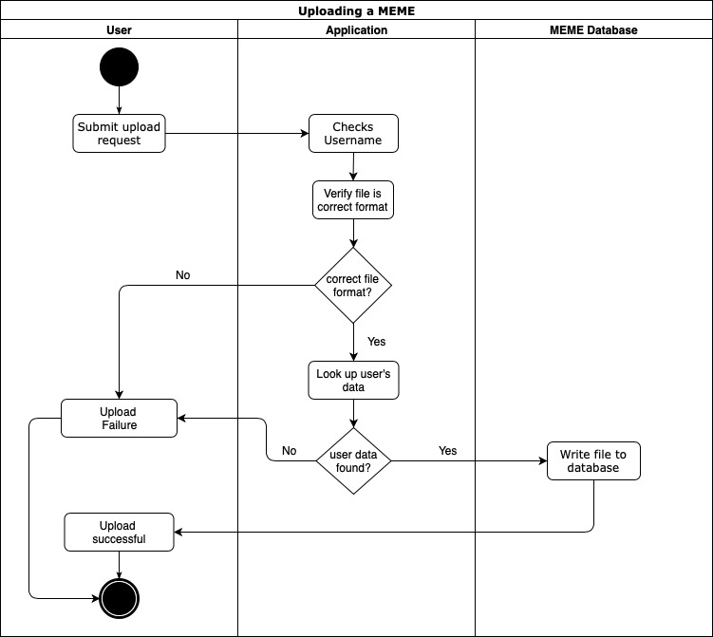The use case diagram below represents the work flow for a user uploading a MEME.

Diagram 1

*Activity Diagram for Content Sub-System*

# Class Diagram

## Product Perspective

Diagram 2 shows the flow of the system. The database will be the hierarchy for the login database and the Memes database. The username will be the key where both the login and Memes database will share. The login database will have a sign in, signup and update functions. If the user is new user will signup but if it is a return user who wants to sign in or update information will check the data from the user Account database. The userAccount database will store the username and password will full name data to fetch information to login for comparison of what’s been given. Store Memes will only store the memes picture files.

Diagram 2

*Class Diagram*

# Behavior Diagrams

## State Machine Diagram for Log In System

The diagram 3.1 is for the log in sub-system of the MEMEit system. It explains how the log in process goes from the programmers perspective.

Diagram 3.1

*Log In Sub System*

## State Machine Diagram for Content and Browsing system

The diagram 3.2 is for the content and browing sub-system of the MEMEit system. It explains how the process for browsing and adding data goes from the programmers perspective.

Diagram 3.2

*Content and Browsing Sub System*