Platform Development
For Enterprise Power BI and Microsoft Fabric
CHAPTER 03
Quality Gates
Brandon Campbell
Draft manuscript • September 2026

Chapter 3 — Quality Gates
Most Power BI teams already have standards—in a center-of-excellence deck, a reviewer&#39;s head, or a checklist pinned to a Teams channel: no floating-point columns, hide the foreign keys, format every measure, keep pages readable. What most teams lack is a way to know, before a merge, which of those standards a change was actually held to. A standard enforced by whoever reviews the pull request is a preference. It becomes a gate only when a machine applies it the same way every time and a person can predict the result.
This chapter is about building that machine from two community rule engines, a source-controlled baseline, and one short PowerShell script that decides how strict to be.

A gate is a rule set you can predict
Here is the claim. A quality check becomes a quality gate when four things are true: the rules are a versioned baseline in the repository; the effective rule set for a given branch is generated by a script you can run locally and inspect; blocking is decided by the tools&#39; exit codes for severities and log types you understand; and every waiver is an owned, expiring exception rather than an edit to the baseline. Take away any one of those and the pipeline still runs rules, but nobody can say in advance what will stop a merge.
Try the test on your own pipeline. Pick an open pull request and, without running anything, write down which rules could fail it and which could only warn. If you can&#39;t, you have quality checks, not a gate. In this repository the answer depends on three interacting layers—the baseline files, Prepare-QualityRules.ps1, and the tools&#39; own severity handling—and it is not what most people guess from reading any one of them.
For report and model authors, the sections on the two rule vocabularies, the branch policy, and exceptions explain why a change that passed on your branch can fail on its pull request and what to do about it. For platform engineers, the sections on wiring, tool downloads, and adapter differences are where the gate&#39;s reliability is won or lost.

Green on the branch, red on the pull request
The characteristic failure of a branch-aware quality gate is not a rule that fires. It is a rule that fires somewhere the author didn&#39;t expect. The repository documents both halves in docs/Troubleshooting.md: &quot;a dataset rule triggers on main or develop but not on a feature branch,&quot; and &quot;a report rule is only blocking on main or develop.&quot; The troubleshooting guide explains the mechanism accurately. What it cannot do is prevent the reaction that usually follows.
COMPOSITE FIELD NOTE — The Rule That Waited for the Pull Request
This Field Note is a composite assembled from troubleshooting patterns the repository documents; it does not describe a single incident. The facts are single-sourced in docs/Troubleshooting.md (&quot;Dataset Rules Behave Differently on Branches,&quot; &quot;Report Rules Behave Differently on Branches,&quot; &quot;A Rule Is Too Noisy,&quot; and &quot;Tool Download Failures in CI&quot;) and docs/faq.md (&quot;The Dataset Quality Rules job fails. How do I read the failure output?&quot;).
A model author builds out a finance report and model in a feature workspace. Every push runs the pipeline, and every run is green. She opens a pull request into main, and the report-rules job fails on a rule she has never seen fail: SHOW_AXES_TITLES, which her team&#39;s Rules-Report.json defines as a warning. Several charts hide their axis titles by design, because the titles repeat the visual header.
The first instinct in the pull request thread is the wrong one. A teammate suggests changing the rule&#39;s logType in Rules-Report.json as part of the same pull request, or setting disabled to true, and merging. It would work. It would also weaken the standard for every report in the repository, bury the decision inside an unrelated feature, and leave no record of who approved it or for how long.
The platform engineer explains what actually happened. On a feature-branch push, Prepare-QualityRules.ps1 keeps five named report rules at warning. On a pull request targeting main, it promotes those same five to error, and Fab Inspector returns a failing exit code for error-level findings. The rule didn&#39;t change between runs; the policy did, because the target branch did. The same week, a second author on the dataset side notices something odder: a severity-2 rule she expected to block on main only produced a warning. That one takes longer to explain.
What changed after this: the team stopped editing baseline files inside feature pull requests. Legitimate deviations went into policy-exceptions.json with an owner, a reason, an approver, and an expiry date, and the engineer wired New-EffectiveQualityRules.ps1 into the pipeline so that file actually took effect. Authors began running Prepare-QualityRules.ps1 locally with -SourceBranch refs/heads/main before opening a pull request, so the strict rule set was never a surprise. And the team wrote down, per rule severity, what blocks and what warns—which turned out to be the most useful page in their standard.

The pattern to take away is that branch-aware strictness is sound, but it moves the moment of truth from the push to the pull request. If authors can&#39;t preview the strict rule set, they meet it for the first time in front of a reviewer, and the pressure to weaken the rule arrives at the same moment.

Two engines, two vocabularies
The repository gates semantic models with Tabular Editor 2&#39;s Best Practice Analyzer and reports with Fab Inspector, formerly published as PBI Inspector V2, whose README describes it as a community project not supported by Microsoft. Neither engine is a Microsoft product, and they express strictness in different vocabularies.
Dataset rules live in shared/Rules-Dataset.json, a JSON array of BPA rules. Each has a stable ID, a Scope of Tabular Object Model types, a boolean Expression that returns true on a violation, an optional FixExpression, and an integer Severity.
Listing 3.1 — shared/Rules-Dataset.json, lines 2–12. One dataset rule from the repository&#39;s BPA baseline.
json example
{
"ID": "AVOID_FLOATING_POINT_DATA_TYPES",
"Name": "[Performance] Do not use floating point data types",
"Category": "Performance",
"Description": "The \"Double\" floating point data type should be avoided, as it can result in unpredictable roundoff errors and decreased performance in certain scenarios. Use \"Int64\" or \"Decimal\" where appropriate (but note that \"Decimal\" is limited to 4 digits after the decimal sign).",
"Severity": 2,
"Scope": "DataColumn, CalculatedColumn, CalculatedTableColumn",
"Expression": "DataType = \"Double\"",
"FixExpression": "DataType = DataType.Decimal",
"CompatibilityLevel": 1200
},

The repository&#39;s baseline contains 70 rules: 18 at severity 1, 40 at severity 2, and 12 at severity 3. It closely tracks the BPARules.json published in the microsoft/Analysis-Services GitHub repository, which the pipelines download as a fallback; on September 24, 2026 that upstream file contained 71 rules, the extra one being NUMERIC_COLUMN_SUMMARIZE_BY at severity 3. That single difference will matter shortly.
Report rules use a different shape: an object with a top-level rules array, where each rule has an id, an itemType and part that scope it to the report structure, a test written in JSON logic, a disabled flag, and a logType of warning or error.
Listing 3.2 — shared/examples/Rules-Report.json, lines 4–10. The identifying fields of one report rule.
json example
"id": "REDUCE_PAGES",
"name": "Reduce number of pages per report",
"description": "Keep reports concise enough for users to navigate quickly.",
"logType": "warning",
"itemType": "Report",
"part": "Pages",
"disabled": false,

That file lives under shared/examples/. As of this writing there is no shared/Rules-Report.json in the repository, although docs/faq.md, Lab 2, and shared/pbip-local/README.md all describe one. Every pipeline looks for Rules-Report.json in the project root and, finding none, falls back to Fab Inspector&#39;s upstream Base-rules.json downloaded at run time. Until you commit your own report baseline, your report gate is whatever that upstream file contains on the day the pipeline runs—so the first practical step is to generate and commit one with the Enterprise Standards Builder.
The two vocabularies map to blocking behavior differently, and I verified both on September 24, 2026 with the tool versions the pipelines&#39; releases/latest URLs returned that day: Tabular Editor 2.29.0 and Fab Inspector 3.4.0.
For Tabular Editor, the pipeline runs TabularEditor.exe &quot;&lt;model definition&gt;&quot; -A &quot;&lt;rules&gt;&quot; -V. The -V switch makes Tabular Editor emit Azure DevOps logging commands, and its documentation states that severity 1 findings are informational, severity 2 findings are warnings, and severity 3 or higher are errors, with exit code 1 only when an error-level output occurs. My runs matched: a severity-1 violation exited 0; a severity-2 violation emitted ##vso[task.logissue type=warning;] and task.complete result=SucceededWithIssues and exited 0; a severity-3 violation emitted an error, result=Failed, and exited 1.
For Fab Inspector, the pipeline runs PBIRInspectorCLI.exe -fabricitem &quot;&lt;report folder&gt;&quot; -rules &quot;&lt;rules&gt;&quot; -formats &quot;ADO&quot;. With the ADO or GitHub format, a failing rule whose logType is error exited 1 and a failing warning rule exited 0. With the default Console format, the same failing error-level rule exited 0. If anyone &quot;simplifies&quot; the pipeline&#39;s -formats argument, the report gate silently stops blocking.

How the branch becomes a policy
shared/scripts/Prepare-QualityRules.ps1 sits between the baseline and the tools. The pipelines never pass a baseline file to either engine directly; they pass the effective file this script writes. An identical copy lives in shared/universal-pipeline/scripts/ for the shared-template pattern.
Listing 3.3 — shared/scripts/Prepare-QualityRules.ps1, lines 20–49. Normalizing whatever branch value the CI platform supplies into one policy reference.
powershell example
function Test-UsableBranchRef {
param([string]$Value)

return ![string]::IsNullOrWhiteSpace($Value) -and $Value -notlike '$(*'
}

function ConvertTo-BranchRef {
param([string]$Value)

if (!(Test-UsableBranchRef -Value $Value)) {
return ''
}

if ($Value.StartsWith('refs/', [System.StringComparison]::OrdinalIgnoreCase)) {
return $Value
}

return "refs/heads/$Value"
}

$outputDirectory = Split-Path -Path $OutputPath -Parent
if ($outputDirectory) {
New-Item -ItemType Directory -Path $outputDirectory -Force | Out-Null
}

$sourceBranchRef = ConvertTo-BranchRef -Value $SourceBranch
$targetBranchRef = ConvertTo-BranchRef -Value $TargetBranch
$policyBranchRef = if (Test-UsableBranchRef -Value $targetBranchRef) { $targetBranchRef } else { $sourceBranchRef }
$strictBranchRefs = @('refs/heads/main', 'refs/heads/develop')
$isStrictBranch = $strictBranchRefs -contains $policyBranchRef

Lines 20 to 24 define what counts as a usable branch value: not blank, and not an unexpanded Azure Pipelines macro that still reads $(…). Lines 26 to 38 normalize a bare name such as main into refs/heads/main while leaving anything already beginning with refs/ alone. That normalization exists because the platforms don&#39;t agree on format: Microsoft&#39;s predefined-variables reference gives refs/heads/main for System.PullRequest.TargetBranch in Azure Repos and plain main for a GitHub repository. Line 47 prefers -TargetBranch when one is supplied, and lines 48 and 49 define strictness as membership in exactly two refs, main and develop.
Listing 3.4 — shared/scripts/Prepare-QualityRules.ps1, lines 51–58. Dataset mode filters by severity.
powershell example
if ($Mode -eq 'dataset') {
$rules = Get-Content -Path $SourcePath -Raw | ConvertFrom-Json
$minimumSeverity = if ($isStrictBranch) { 2 } else { 3 }
$effectiveRules = @($rules | Where-Object { [int]$_.Severity -ge $minimumSeverity })
$effectiveRules | ConvertTo-Json -Depth 100 | Set-Content -Path $OutputPath -Encoding UTF8
Write-Host "Prepared dataset rules for $policyBranchRef with minimum severity $minimumSeverity."
exit 0
}

In dataset mode, the only thing the branch changes is which rules reach Tabular Editor: severity 2 and above on a strict branch, severity 3 and above everywhere else. Put that together with Tabular Editor&#39;s own mapping and you get the table the Field Note&#39;s team eventually wrote down. On a feature branch, 12 rules are evaluated and all 12 can block. On main or develop, 52 are evaluated, the same 12 can block, and the other 40 surface as warnings. The 18 severity-1 rules never run in CI on any branch. That is why the second author&#39;s severity-2 rule warned instead of failing. &quot;Strict&quot; in dataset mode means more visible, not more blocking.
Listing 3.5 — shared/scripts/Prepare-QualityRules.ps1, lines 60–80. Report mode defaults missing log types and promotes five named rules on strict branches.
powershell example
$mainOnlyBlockingWarnings = @(
'REDUCE_VISUALS_ON_PAGE',
'REDUCE_OBJECTS_WITHIN_VISUALS',
'REDUCE_PAGES',
'SHOW_AXES_TITLES',
'GIVE_VISIBLE_PAGES_MEANINGFUL_NAMES'
)

$reportRules = Get-Content -Path $SourcePath -Raw | ConvertFrom-Json
foreach ($rule in $reportRules.rules) {
if ($rule.PSObject.Properties.Name -notcontains 'logType' -or [string]::IsNullOrWhiteSpace($rule.logType)) {
$rule | Add-Member -NotePropertyName logType -NotePropertyValue 'warning'
}

if ($mainOnlyBlockingWarnings -contains $rule.id) {
$rule.logType = if ($isStrictBranch) { 'error' } else { 'warning' }
}
}

$reportRules | ConvertTo-Json -Depth 100 | Set-Content -Path $OutputPath -Encoding UTF8
Write-Host "Prepared report rules for $policyBranchRef. Strict-branch blocking rules promoted: $isStrictBranch"

Report mode works differently. Lines 69 to 72 give any rule without a logType the value warning. Lines 74 to 76 then touch only the five rule IDs hard-coded on lines 60 to 66, setting each to error on a strict branch and to warning everywhere else—including when the baseline already says error. Every other rule keeps whatever logType the baseline gives it. In report mode, therefore, strictness really does mean more blocking, but only for those five IDs and only if your baseline uses them.
I ran the script against the repository&#39;s baseline and example files with several branch values to make the behavior concrete. Every row below is observed output, not inference.
-SourceBranch value | Policy reference logged | Dataset minimum severity | Dataset rules kept
refs/heads/feature/sales-ytd | refs/heads/feature/sales-ytd | 3 | 12
refs/heads/main | refs/heads/main | 2 | 52
main | refs/heads/main | 2 | 52
develop | refs/heads/develop | 2 | 52
refs/pull/42/merge | refs/pull/42/merge | 3 | 12
$(System.PullRequest.TargetBranch) | (blank) | 3 | 12

The last two rows are the ones to remember. If a pull-request build reaches the script without a resolved target branch, the script falls back to the source ref, which for a pull request is a refs/pull/… ref, and the lenient policy applies. The script does not fail; it logs Prepared dataset rules for with minimum severity 3., with a telltale double space where the branch should be. Search your logs for that line.
Against shared/examples/Rules-Report.json on main, four rules became errors—REDUCE_PAGES, REDUCE_VISUALS_ON_PAGE, SHOW_AXES_TITLES, and GIVE_VISIBLE_PAGES_MEANINGFUL_NAMES—because the fifth promoted ID, REDUCE_OBJECTS_WITHIN_VISUALS, is not in that file. Against the upstream Base-rules.json the pipelines fall back to, only three of the five IDs were present on the day I checked. And a rule with a custom ID, such as the report-page-visual-density rule Lab 4 has participants create in the Rule Designer, is never promoted no matter what severity the lab sets for protected branches, because promotion is keyed to the literal IDs in the script.
One defect is worth knowing before it bites. Line 70 treats a rule whose logType exists but is blank as missing, and line 71 then tries to add a property that already exists. With $ErrorActionPreference set to Stop, the script fails with &quot;Cannot add a member with the name &quot;logType&quot; because a member with that name already exists,&quot; exits 1, and writes no output file; I reproduced this with a one-rule file whose logType was an empty string. The job fails closed, which is the right direction, but the message points at the script rather than the rule. Remove empty logType values from generated files, or add -Force to the Add-Member call.

Previewing the gate locally
Authors can see the strict rule set before a reviewer does. From the repository root, with PowerShell 7:
powershell example
pwsh -File shared/scripts/Prepare-QualityRules.ps1 -Mode dataset `
-SourcePath shared/Rules-Dataset.json -OutputPath out/Rules-Dataset.effective.json `
-SourceBranch refs/heads/main
pwsh -File shared/scripts/Prepare-QualityRules.ps1 -Mode report `
-SourcePath shared/examples/Rules-Report.json -OutputPath out/Rules-Report.effective.json `
-SourceBranch refs/heads/main

The first prints Prepared dataset rules for refs/heads/main with minimum severity 2. and writes 52 rules; the second prints Prepared report rules for refs/heads/main. Strict-branch blocking rules promoted: True. Point the report command at your own Rules-Report.json once it exists, and add -ExecutionPolicy Bypass where your machine requires it, as docs/Local-Validation-Guide.md shows.

Figure 3.1 — One quality job, end to end
Architecture diagram (Mermaid source)
sequenceDiagram
autonumber
participant CI as CI job
participant Net as GitHub downloads
participant Prep as Prepare-QualityRules.ps1
participant TE as TabularEditor.exe -A -V
participant FI as PBIRInspectorCLI -formats ADO
CI->>Net: Download tool zip (releases/latest)
CI->>Net: Download fallback rules (always)
Note over CI,Net: Either download failing fails the job
CI->>CI: Use repo Rules-*.json if present, else fallback
CI->>CI: Resolve branch: PR target if set, else source ref
CI->>Prep: -Mode dataset or report, -SourceBranch ref
Prep-->>CI: Rules-*.effective.json
alt dataset job
CI->>TE: Analyze each model definition folder
TE-->>CI: Sev 1 info, Sev 2 warning, Sev 3 error
Note right of TE: Exit 1 only when an error-level finding occurs
else report job
CI->>FI: Inspect each report folder
FI-->>CI: logType error fails, warning passes
Note right of FI: Exit 1 on error-level findings with ADO or GitHub format
end
CI->>CI: Non-zero exit code throws, job fails, publish is blocked

Wiring the gate on three platforms
The three adapters run the same script and tools but differ in where they get the branch, which Windows runner they use, how they invoke the tools, and how a job is skipped. This section is for the platform engineer.

Where the branch comes from
Azure DevOps reads the pull-request target from SYSTEM_PULLREQUEST_TARGETBRANCH and otherwise uses BUILD_SOURCEBRANCH.
Listing 3.6 — azdo/azure-pipelines.yml, lines 107–112. Azure DevOps chooses the policy branch inside the inline script.
powershell example
$effectiveRulesPath = Join-Path $tempPath "Rules-Dataset.effective.json"
$qualityBranch = $env:BUILD_SOURCEBRANCH
$pullRequestTargetBranch = $env:SYSTEM_PULLREQUEST_TARGETBRANCH
if (![string]::IsNullOrWhiteSpace($pullRequestTargetBranch)) {
$qualityBranch = $pullRequestTargetBranch
}

Microsoft documents that System.PullRequest.TargetBranch is initialized only when the build ran because of a pull request affected by a branch policy. For Azure Repos that is the normal case, but any build where the variable is absent falls through to the lenient policy, as the table above shows.
GitHub Actions reads GITHUB_BASE_REF, which GitHub sets only for pull_request and pull_request_target events, and prefixes it with refs/heads/ itself. It also adds a guard the other adapters lack.
Listing 3.7 — .github/workflows/powerbi-ci.yml, lines 115–131. GitHub Actions resolves the branch and refuses to run if the fallback rules were used.
powershell example
$effectiveRulesPath = Join-Path $tempPath "Rules-Dataset.effective.json"
$qualityBranch = "$env:GITHUB_REF"
if (![string]::IsNullOrWhiteSpace($env:GITHUB_BASE_REF)) {
$qualityBranch = "refs/heads/$env:GITHUB_BASE_REF"
}

& (Join-Path $repoPath "scripts\Prepare-QualityRules.ps1") `
-Mode dataset `
-SourcePath $sourceRulesPath `
-OutputPath $effectiveRulesPath `
-SourceBranch $qualityBranch

$effectiveRules = Get-Content -Path $effectiveRulesPath -Raw | ConvertFrom-Json
Write-Host "Effective dataset rule count: $(@($effectiveRules).Count)"
if ($effectiveRules.ID -contains 'NUMERIC_COLUMN_SUMMARIZE_BY') {
throw "Effective dataset rules still include NUMERIC_COLUMN_SUMMARIZE_BY. Add or refresh shared/Rules-Dataset.json."
}

Lines 127 to 131 are a clever piece of defense. The repository&#39;s baseline deliberately omits NUMERIC_COLUMN_SUMMARIZE_BY, which the upstream fallback file contains at severity 3. If that ID appears in the effective rules, the job must have fallen back to the downloaded file, and it fails with an instruction to refresh shared/Rules-Dataset.json. That turns a silent fallback into a loud one. Azure DevOps and GitLab would benefit from the same guard.
GitLab reads CI_MERGE_REQUEST_TARGET_BRANCH_NAME, which is populated in merge-request pipelines, and otherwise CI_COMMIT_REF_NAME.
Listing 3.8 — gitlab/gitlab-ci.yml, lines 100–104. GitLab derives the policy branch from merge-request variables.
powershell example
$effectiveRulesPath = Join-Path $tempPath "Rules-Dataset.effective.json"
$qualityBranch = "refs/heads/$env:CI_COMMIT_REF_NAME"
if (![string]::IsNullOrWhiteSpace($env:CI_MERGE_REQUEST_TARGET_BRANCH_NAME)) {
$qualityBranch = "refs/heads/$env:CI_MERGE_REQUEST_TARGET_BRANCH_NAME"
}

Because GitLab&#39;s workflow rules in this file admit both branch pipelines and merge-request pipelines, a push to a branch with an open merge request can produce one lenient run and one strict run for the same commit. Only the merge-request run represents the gate.

Runners, invocation, and output
All three quality jobs need Windows. Azure DevOps uses the windows-2022 Microsoft-hosted image declared for the whole pipeline. GitHub runs these two jobs on windows-latest with shell: pwsh. GitLab requires a runner you register yourself with the windows tag, and its scripts write to $env:TEMP rather than a platform temp variable. That self-managed runner deserves a check the hosted images make easy to forget. The Fab Inspector CLI build the pipelines download is framework-dependent. When I ran it on a machine without a .NET 8 x64 runtime, it exited before evaluating anything, with &quot;Failed to resolve hostfxr.dll&quot; and a request for apphost_version=8.0.28. Install that runtime on the GitLab runner, and check the software list of any hosted image you rely on.
Tabular Editor is started the same way everywhere, following its documentation&#39;s advice for PowerShell tasks: Start-Process with -Wait -PassThru, then a check of the process exit code.
Listing 3.9 — azdo/azure-pipelines.yml, lines 153–159. Azure DevOps runs Tabular Editor and throws on a non-zero exit code.
powershell example
Write-Host "##[group]Running rules for: '$itemPath'"
$process = Start-Process -FilePath $toolPath -ArgumentList """$itemPath"" -A ""$rulesPath"" -V" -NoNewWindow -Wait -PassThru
Write-Host "##[endgroup]"

if ($process.ExitCode -ne 0) {
throw "Tabular Editor rules failed for $itemPath with exit code $($process.ExitCode)"
}

GitHub&#39;s version also redirects standard output and standard error to files and replays them, sending stderr lines through Write-Error. Because GitHub prepends $ErrorActionPreference = &#39;stop&#39; to pwsh scripts, the first replayed stderr line ends the step, so on GitHub any stderr output from Tabular Editor fails the job even when its exit code is 0. For Fab Inspector, Azure DevOps and GitLab use the same Start-Process pattern, while GitHub calls the executable directly and checks $LASTEXITCODE.
Listing 3.10 — .github/workflows/powerbi-ci.yml, lines 299–306. GitHub Actions invokes Fab Inspector with the call operator.
powershell example
foreach ($itemFolder in $itemsFolders) {
$itemPath = $itemFolder.Directory.FullName
Write-Host "Running rules for: $itemPath"
& $toolPath -fabricitem "$itemPath" -rules "$rulesPath" -formats "ADO"
if ($LASTEXITCODE -ne 0) {
throw "Fab Inspector rules failed for $itemPath with exit code $LASTEXITCODE"
}
}

All three adapters pass -formats &quot;ADO&quot;. On Azure DevOps that produces native logging commands. On GitHub and GitLab the same ##vso[…] lines appear as plain text, and nothing is annotated. Fab Inspector&#39;s CLI reference also lists a GitHub format that emits Actions-compatible annotations. In my test it produced the same exit codes as ADO, so switching the GitHub adapter to it is a low-risk improvement. Tabular Editor has a matching -G switch for GitHub workflow commands, according to its documentation.

Skipping, and what a skip means downstream
The adapters disagree most about skipping. The project-local Azure DevOps file offers no skip switch. The shared template under shared/universal-pipeline/ offers skipDatasetRules and skipReportRules parameters that remove the jobs at compile time. GitLab honors SKIP_DATASET_RULES and SKIP_REPORT_RULES variables through rules that set when: never. GitHub is the subtle one. The workflow defines workflow_dispatch inputs such as skip_dataset_rules and folds them into workflow-level environment variables, but each job&#39;s if: condition reads only the repository variables vars.PBIP_CI_SKIP_DATASET_RULES and vars.PBIP_CI_SKIP_REPORT_RULES. As written, the manual-run inputs do not skip anything; only the repository variables do.
Downstream, a skipped quality job is treated as acceptable. GitHub&#39;s publish job accepts success or skipped for each quality job. GitLab&#39;s publish job lists the quality jobs as optional needs. In Azure DevOps, a removed job simply isn&#39;t part of the stage. That means a skip anywhere is a policy decision, not a convenience, and it should be recorded as one.

When the downloads fail
Every quality job begins by downloading its tool and a fallback rule file from GitHub.
Listing 3.11 — azdo/azure-pipelines.yml, lines 74–93. Both downloads run unconditionally at the start of the dataset job.
powershell example
- task: PowerShell@2
displayName: 'Download Tabular Editor and fallback rules'
inputs:
targetType: 'inline'
script: |
$tempPath = Join-Path "$(Agent.TempDirectory)" "pbip-quality"
$toolPath = Join-Path $tempPath "TE"

New-Item -ItemType Directory -Path $tempPath -Force | Out-Null
New-Item -ItemType Directory -Path $toolPath -Force | Out-Null

Write-Host "##[debug]Downloading Tabular Editor binaries"
$downloadUrl = "https://github.com/TabularEditor/TabularEditor/releases/latest/download/TabularEditor.Portable.zip"
$zipFile = Join-Path $tempPath "TabularEditor.zip"
Invoke-WebRequest -Uri $downloadUrl -OutFile $zipFile
Expand-Archive -Path $zipFile -DestinationPath $toolPath -Force

Write-Host "##[debug]Downloading dataset fallback rules"
$rulesUrl = "https://raw.githubusercontent.com/microsoft/Analysis-Services/master/BestPracticeRules/BPARules.json"
Invoke-WebRequest -Uri $rulesUrl -OutFile (Join-Path $tempPath "Rules-Dataset.fallback.json")

Three properties of that step shape the gate&#39;s failure behavior. Both downloads are unconditional, so a runner that can reach the Tabular Editor release but not raw.githubusercontent.com fails a job that would never have used the fallback file. The tool URLs use releases/latest, so the version floats; the next run may get something newer than the versions I tested without any change to the repository. And a failed download fails the job, which blocks artifact publication on all three platforms. The gate fails closed—the right default—but a network restriction looks exactly like a quality failure until someone reads the log.
The troubleshooting guide&#39;s list of causes—transient release availability, network restrictions on the agent, and upstream asset-name changes—is accurate. The asset-name risk is not hypothetical. The Fab Inspector repository has been renamed from PBI-InspectorV2 to fab-inspector. On September 24, 2026 the pipelines&#39; old URLs still resolved, the release still contained win-x64/CLI/PBIRInspectorCLI.exe at the path the jobs expect, and the old raw URL for Base-rules.json still returned the file. None of those facts is guaranteed tomorrow.
For an enterprise gate, pin tool versions to specific release URLs and log them, cache or mirror the archives inside your network, and make the fallback download conditional on the baseline being absent—or remove it and fail when the baseline is missing, as GitHub&#39;s guard effectively does for datasets.

Exceptions without editing the baseline
The Field Note&#39;s team needed a way to say &quot;this report may hide axis titles until the end of the quarter, and here is who approved it&quot; without touching the baseline. The repository has the pieces, but as shipped none of the three pipelines uses them.
The Policy Exception Register at tools/policy-exception-register/index.html records each exception&#39;s ID, rule ID, owner, approver, affected artifact, reason, mitigation, status, and expiration, and exports policy-exceptions.json. The script that consumes it is shared/scripts/New-EffectiveQualityRules.ps1, which merges the baseline, the same branch policy as Prepare-QualityRules.ps1, optional declarative overrides, and active exceptions into effective files plus a JSON and Markdown summary. Its definition of &quot;active&quot; is strict.
Listing 3.12 — shared/scripts/New-EffectiveQualityRules.ps1, lines 34–41. Only approved exceptions with a future or current expiry date take effect.
powershell example
function Test-ActiveException {
param($Exception)
if (!$Exception) { return $false }
if ($Exception.status -ne 'approved') { return $false }
if ([string]::IsNullOrWhiteSpace($Exception.expiresOn)) { return $false }
$expires = [datetime]::Parse($Exception.expiresOn).Date
return $expires -ge (Get-Date).Date
}

An exception must be approved and must carry an expiresOn date that hasn&#39;t passed; anything else is recorded under exceptionsIgnored and the baseline applies. I tested three exceptions against the repository&#39;s files with -TargetBranch main. An approved, unexpired exception setting SHOW_AXES_TITLES to warning took effect after the branch promotion, so the rule warned on main. An approved exception for REDUCE_PAGES that had expired on 2026-08-01 was ignored, and the rule stayed at error. An approved dataset exception lowering HIDE_FOREIGN_KEYS to severity 1 removed it from the strict set, which dropped from 52 rules to 51. The generated effective-rules-summary.md listed the two applied exceptions by ID.
That matches the governance controls in docs/enterprise-quality-rules-pattern.md: every exception has an owner, a reason, and an expiry, and an expired one reverts to the baseline. None of the three pipeline files calls the script today, so the wiring is yours to add: replace each &quot;Prepare … rules for branch policy&quot; step with one call to New-EffectiveQualityRules.ps1, passing the resolved target branch as -TargetBranch and your committed policy-exceptions.json as -ExceptionsPath, and publish the summary files as build artifacts. Expiry is compared with the runner&#39;s local date, and the Markdown summary lists applied exceptions but not ignored ones, which appear only in the JSON summary.

Tools that produce and explain the rules
Four of the repository&#39;s browser tools serve this chapter directly. They run locally in a browser and are companion tools shipped with the repository, not Microsoft products.
The Enterprise Standards Builder at tools/enterprise-standards-builder/index.html turns policy choices into both rule files and an auditable policy profile. It offers named profiles—Advisory adoption, Enterprise standard, and Strict enterprise gate—and parameters such as maximum pages and visuals per page. According to docs/tool-walkthrough.md, it adjusts pre-built policies but does not create new ones or edit raw JSON. It is the right tool for producing the missing shared/Rules-Report.json.
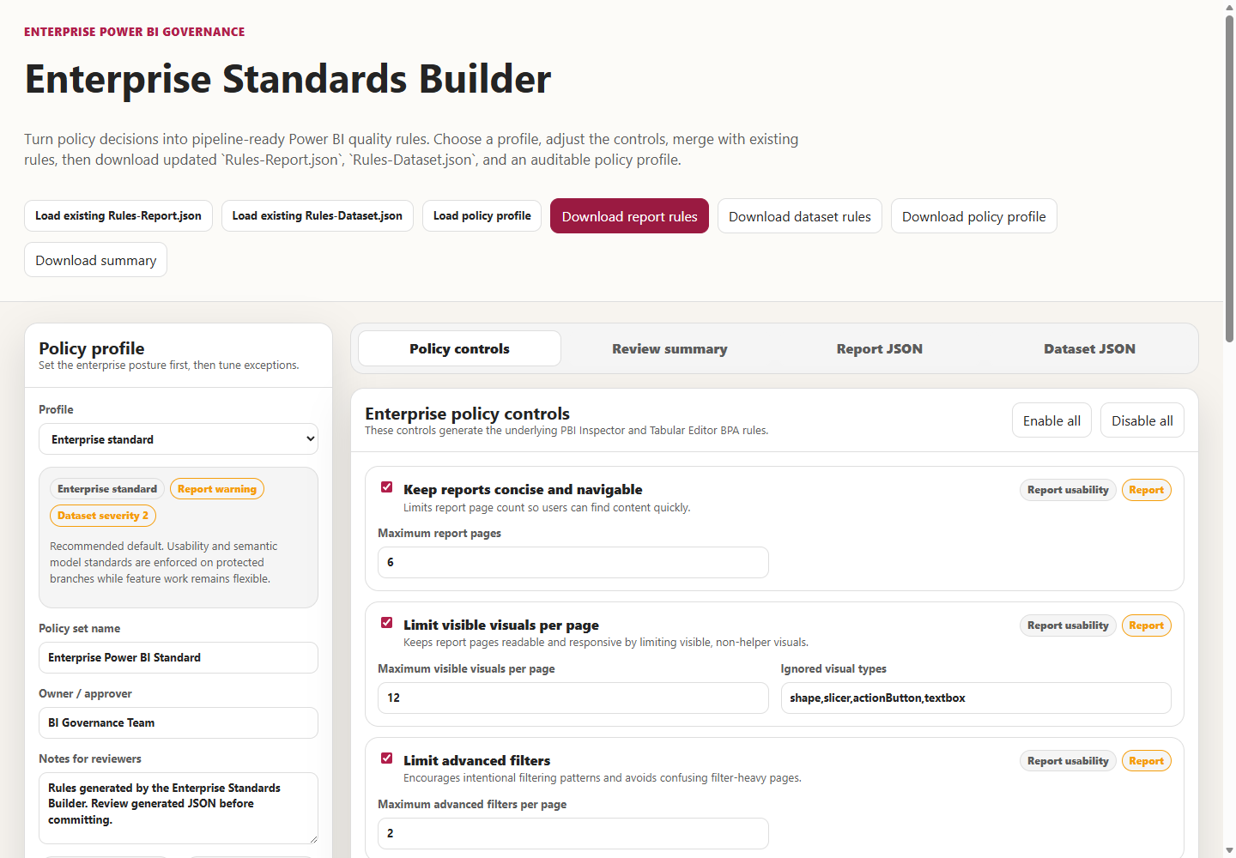
The Quality Rule Designer at tools/rule-designer/index.html is for individual rules. It creates, edits, and deletes rules from templates or custom JSON logic and previews the JSON diff. Keep the promotion list in mind when you use it. Changing a rule&#39;s ID removes it from Prepare-QualityRules.ps1&#39;s promotion list, and a new custom ID never joins that list.
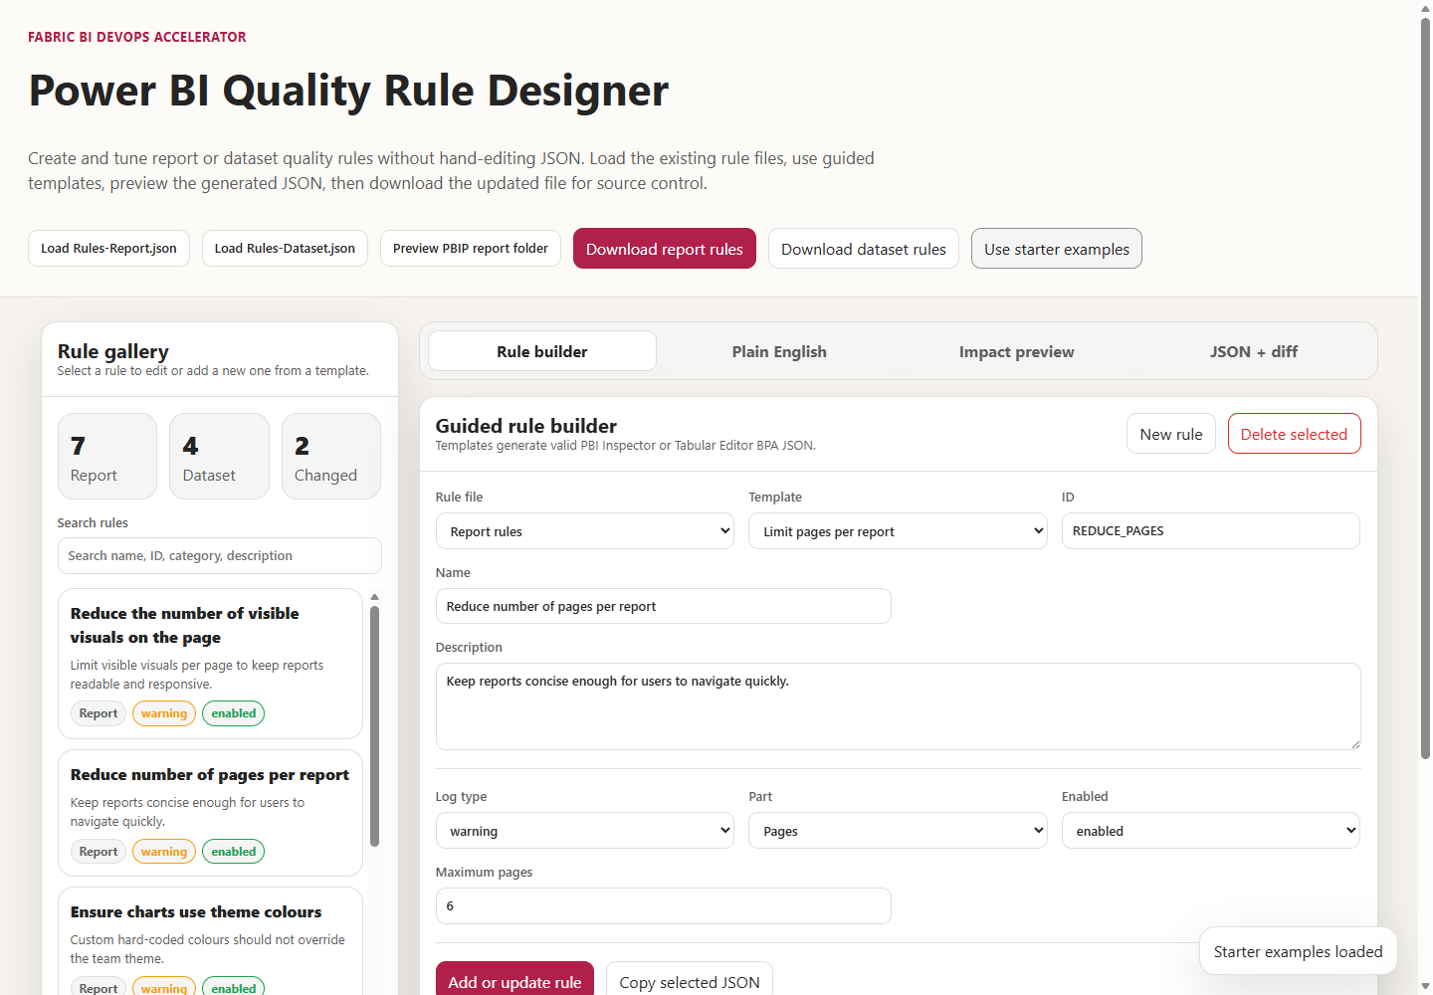
The Effective Rules Generator at tools/effective-rules-generator/index.html is the browser counterpart of New-EffectiveQualityRules.ps1. You load baselines, choose source and target branches, add overrides and exception JSON, and preview what CI would enforce before committing anything. It is the most direct way to answer the question this chapter opened with.
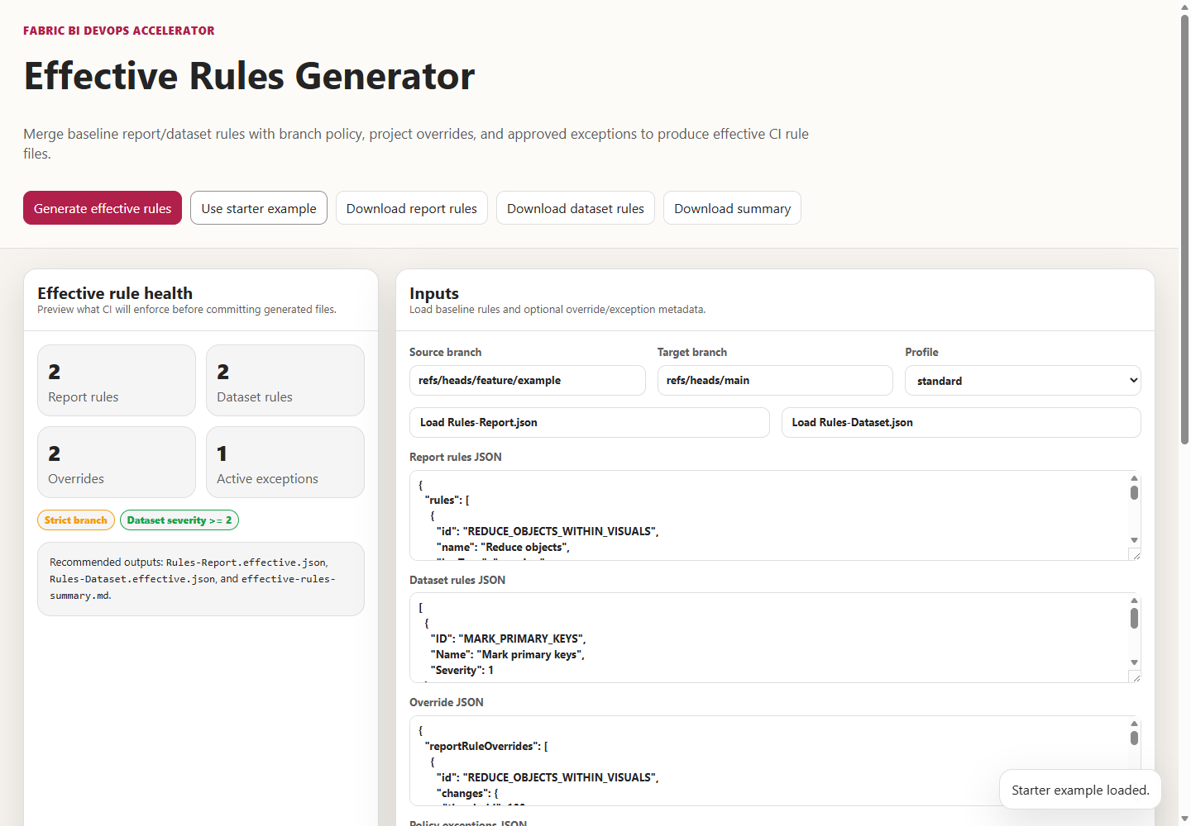
Finally, the Policy Exception Register creates the file the generator and script consume.
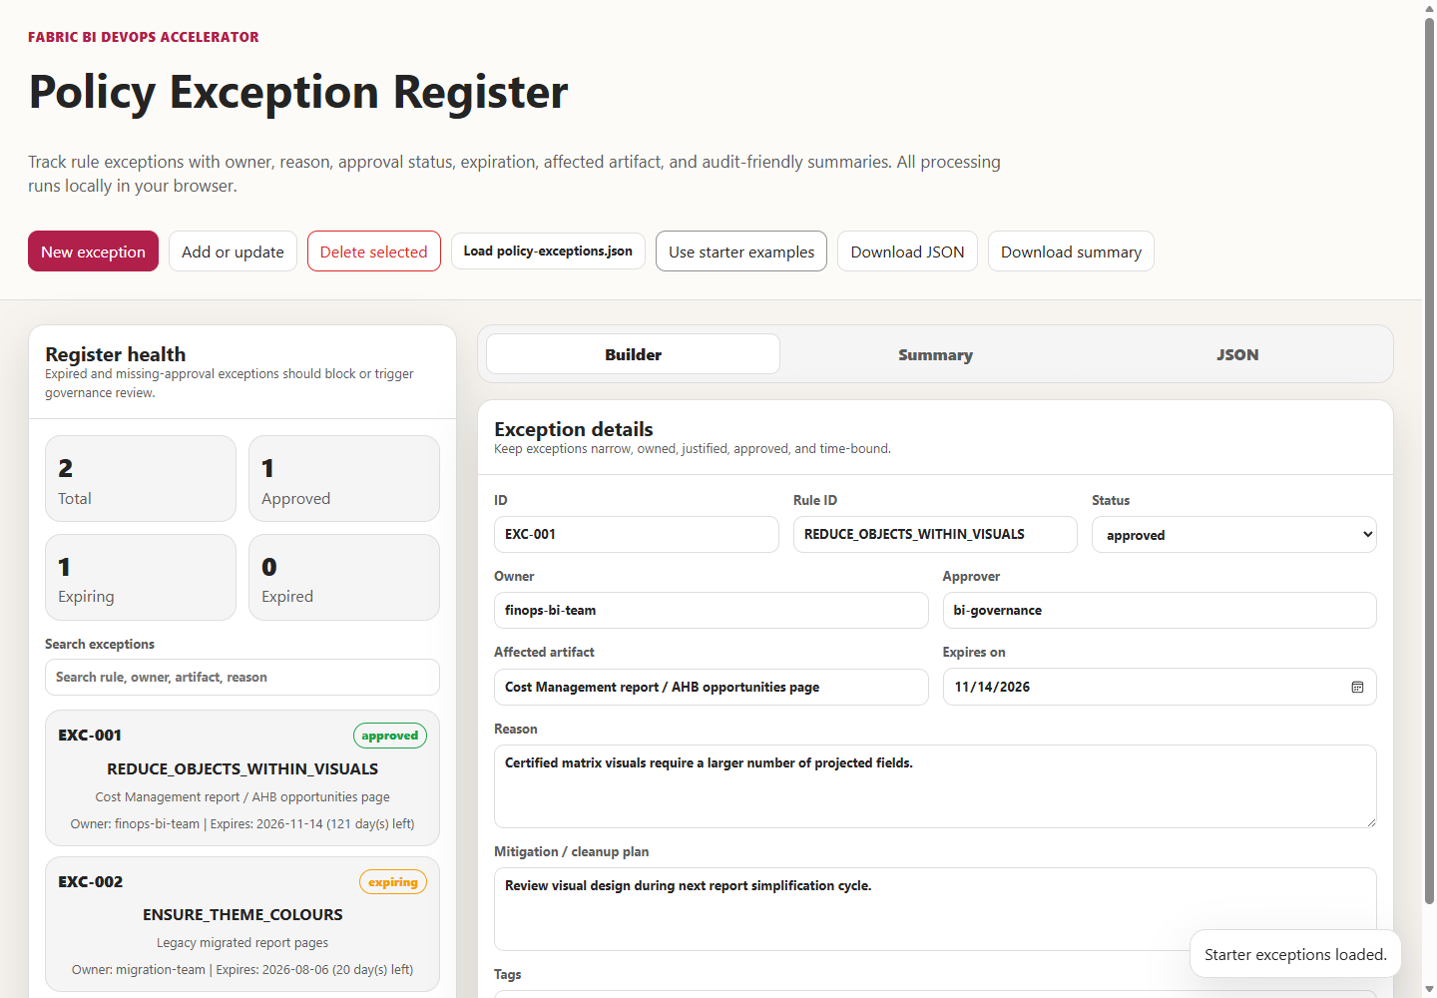
The Rule Coverage Matrix, used in Lab 4, maps each written policy to an automated rule or a manual check. Use it to record which standards the gate enforces and which still rely on a reviewer.

Diagnosing a failed or suspicious quality run
What you see | What it usually means | What to do
Tabular Editor rules failed for … with exit code 1 | A severity-3 rule fired, or the model failed to load. | Read the ##vso[task.logissue type=error;] lines above it; a TMDL load error names the document and line.
A severity-2 rule appears only as a warning on main | Expected: Tabular Editor maps severity 2 to warning. | Raise the rule to severity 3 if it should block everywhere.
Fab Inspector rules failed for … with exit code 1 | An error-level report rule failed, often one of the five promoted IDs on a strict branch. | Fix the report, or record an approved exception.
Report job passes with no findings at all | Missing .platform file, or a changed -formats value. | See Chapter 1 on .platform; keep ADO or GitHub format.
Prepared dataset rules for with minimum severity 3. | The branch did not resolve; the lenient policy applied. | Check the PR target variable for your platform.
Effective dataset rules still include NUMERIC_COLUMN_SUMMARIZE_BY (GitHub) | The repository baseline wasn&#39;t found; the fallback was used. | Restore or correct shared/Rules-Dataset.json and PROJECT_ROOT.
Download step fails | Network egress, GitHub availability, or an asset-name change. | Check both URLs separately; pin and mirror tools.

Trade-offs and lighter paths
The full gate is worth building when several authors share standards and no reviewer can hold them all in mind. A single author or a pilot team can start with advisory rules: run both jobs, keep report rules at warning and dataset rules at severity 2 or lower, and treat the output as a checklist that blocks nothing. The Standards Builder&#39;s advisory profile exists for this stage. Promote rules to severity 3 or error one at a time, as docs/Rules-Authoring-Guide.md recommends, once the backlog of violations is cleaned up.
Teams that want to avoid Windows runners can use the shared template&#39;s skip parameters, as the FAQ shows, and keep only the Linux jobs. That removes model and report rules from CI entirely, so pair it with local BPA and Fab Inspector runs before each pull request. It is a lighter path, not an equivalent one.
Teams with many repositories should move in the other direction, toward the end state described in docs/enterprise-quality-rules-pattern.md. That means a central, versioned baseline consumed by tag, declarative project overrides instead of copied rule files, and exceptions that fail or revert when they expire. The shared template&#39;s rulesDatasetPath and rulesReportPath parameters are the first step.
The one shortcut I would never take is editing the baseline inside a feature pull request to get a build green. It changes the standard for everyone, silently, with no expiry. The exception register exists so that nobody has to.

Evidence and further reading
Repository sources: shared/scripts/Prepare-QualityRules.ps1 and its universal copy, shared/scripts/New-EffectiveQualityRules.ps1, shared/Rules-Dataset.json, shared/examples/Rules-Report.json, shared/examples/policy-exceptions.json, the three pipeline files, shared/universal-pipeline/templates/fabric-ci.yml, docs/Troubleshooting.md, docs/faq.md section 3, docs/Rules-Authoring-Guide.md, docs/enterprise-quality-rules-pattern.md, docs/Local-Validation-Guide.md, docs/tool-walkthrough.md, tools/README.md, and docs/workshops/accelerator-toolkit/labs/lab4-standards-rules-policy.md.
First-hand evidence, all gathered on September 24, 2026: the branch-policy table produced by running Prepare-QualityRules.ps1; the empty-logType failure; the exception behavior produced by running New-EffectiveQualityRules.ps1; the severity and exit-code behavior of Tabular Editor 2.29.0 and Fab Inspector 3.4.0 against small fixtures; the .NET runtime requirement of the downloaded Fab Inspector build; and HTTP checks of the pipelines&#39; download URLs.
Upstream and official documentation:
- Tabular Editor 2 command-line options, BPA severity mapping, and exit codes: https://docs.tabulareditor.com/en/features/Command-line-Options.html
- Best Practice Analyzer rules published by Microsoft: https://github.com/microsoft/Analysis-Services/tree/master/BestPracticeRules
- Fab Inspector repository and CLI reference: https://github.com/NatVanG/fab-inspector and https://github.com/NatVanG/fab-inspector/blob/main/docs/cli-reference.md
- Azure Pipelines predefined variables, including System.PullRequest.TargetBranch: https://learn.microsoft.com/en-us/azure/devops/pipelines/build/variables
- Azure Repos branch policies and build validation: https://learn.microsoft.com/en-us/azure/devops/repos/git/branch-policies
- GitHub Actions variables, including GITHUB_BASE_REF: https://docs.github.com/en/actions/reference/workflows-and-actions/variables
- GitHub Actions contexts and job conditions: https://docs.github.com/en/actions/reference/workflows-and-actions/contexts
- GitLab predefined variables and merge-request pipelines: https://docs.gitlab.com/ci/variables/predefined_variables/ and https://docs.gitlab.com/ci/pipelines/merge_request_pipelines/
- Power BI project report folder and PBIR: https://learn.microsoft.com/en-us/power-bi/developer/projects/projects-report

Freshness note
Last verified September 24, 2026. The tool behaviors in this chapter were observed with Tabular Editor 2.29.0 and Fab Inspector 3.4.0, the versions the pipelines&#39; floating releases/latest URLs returned that day. Tabular Editor&#39;s documentation also describes a cross-platform successor CLI, te, as a limited public preview with a stated expiry of October 31, 2026, and recommends TabularEditor.exe for production pipelines for now; revisit that before you rely on either. Fab Inspector&#39;s README describes it as a community project not supported by Microsoft, and its repository has been renamed from PBI-InspectorV2. If you pin versions, as recommended above, rerun the severity and exit-code experiments whenever you move the pin.

Reader decision checklist
- Is there a committed Rules-Report.json and Rules-Dataset.json in the folder your pipeline treats as the project root, or is your report gate running on a file downloaded at build time?
- For a pull request into main today, which dataset rules can block (severity 3 and above) and which can only warn? Can every author on the team answer that?
- Which of the five report rule IDs that Prepare-QualityRules.ps1 promotes exist in your baseline, and should any custom rule IDs be added to that list?
- Does every adapter resolve the pull-request target branch reliably, and would you notice the log line that shows it didn&#39;t?
- Are your tool versions pinned, and can your runners reach the download URLs, or a mirror of them?
- Are exceptions recorded in policy-exceptions.json with an owner, approver, and expiry, and does your pipeline actually consume that file?
- Who is allowed to skip a quality job on each platform, and where is a skip recorded?
- Is your Fab Inspector output format still ADO or GitHub, so error-level findings produce a failing exit code?

