Platform Development
For Enterprise Power BI and Microsoft Fabric
CHAPTER 07
CI/CD Platform Parity
Brandon Campbell
Draft manuscript • September 2026

Chapter 7 — CI/CD Platform Parity
The repository behind this book makes an unusual promise: Azure DevOps, GitHub Actions, and GitLab CI/CD are supported as equals. Most accelerators pick one platform and leave the others as an exercise. This one ships three pipeline files, a parity matrix, and a generator that emits YAML for all three. That is genuinely useful, and it creates a specific risk. When three files are said to be equivalent, people stop reading two of them.
This chapter reads all three, side by side, and asks what &quot;equal&quot; should mean.

Parity is a contract about behavior, not a count of files
The position this chapter defends is that platform neutrality is a behavioral contract. The same change, pushed to the same branch or proposed against the same target, must meet the same gates, in the same order, with the same blocking semantics, and must leave comparable evidence behind, whichever platform runs it. Adapters are free to differ in syntax, runner model, and secret storage. They are not free to differ in which changes they let through. Where an adapter genuinely cannot meet a clause of the contract, the gap is written down as a gap, with its consequence, rather than rounded up to &quot;supported.&quot;
That claim is falsifiable with a small experiment. Pick five changes: a valid project, a broken byPath reference, a severity-3 model violation, an error-level report violation, and a malformed DAX catalog. Predict, for each platform, whether the pipeline blocks the merge and what evidence it retains. If your three predictions always match and are always right, your adapters are at parity, and the rest of this chapter is confirmation. For this repository, as shipped, they don&#39;t all match, and the places they diverge are instructive.
This is the platform engineer&#39;s chapter. Report and model authors can read the contract and the summary table and stop there. The point for authors is that the gate they meet shouldn&#39;t depend on which platform their team happened to choose.

&quot;Supported, supported, supported&quot;
The failure mode is a comparison that is true line by line and misleading as a whole. shared/examples/platform-parity-matrix.json, the starter data for the repository&#39;s parity tool, marks Azure DevOps, GitHub Actions, and GitLab as supported for PBIP validation, both rule engines, DAX metadata tests, artifact publication, Dev deployment, feature deployment, and branch policy.
Listing 7.1 — shared/examples/platform-parity-matrix.json, lines 64–72. The starter matrix marks feature deployment as supported on every platform.
json example
{
"id": "feature-deploy",
"capability": "Feature workspace deployment",
"category": "Deployment",
"azureDevOps": "supported",
"githubActions": "supported",
"gitLabCi": "supported",
"notes": "Uses configured feature workspace prefix."
},

Every one of those cells describes something a pipeline file contains. None describes whether the behavior matches. Earlier chapters found several places where it doesn&#39;t: GitLab&#39;s credential variables are marked Protected and so never reach unprotected feature branches; GitHub never renders its JUnit file; and GitLab&#39;s deploy jobs can&#39;t reach the GCC High path at all. The matrix has no row for GCC High.
COMPOSITE FIELD NOTE — The Matrix That Chose the Platform
This Field Note is a composite built from what the repository&#39;s files say and do. It does not describe a single engagement. The sources are shared/examples/platform-parity-matrix.json, the GCC High caveat in gitlab/README.md, the deploy jobs in gitlab/gitlab-ci.yml, docs/architecture/gcc-high-deployment.md, and the variable guidance in the GitLab file&#39;s header.
A program office standardizing on GitLab asks whether the accelerator will work for a GCC High team. The platform engineer opens the parity matrix, sees supported for Dev deployment and feature deployment, and reads the bold caveat in gitlab/README.md about &quot;the tested GCC High deployment path in this accelerator.&quot; The answer given is yes.
The first Dev deployment authenticates against the commercial authority. GitLab&#39;s deploy job never passes AuthorityHost, FabricApiBaseUri, FabricApiScope, or UsePowerBiImport to deploy-dynamic.ps1, so the script runs with its commercial defaults. Setting the GCC High endpoint variables in GitLab has no effect, because nothing reads them. The first feature-branch push fails differently: the credentials were created Masked and Protected, as the header instructs, and the branch isn&#39;t protected.
What changed after this: the team added a GCC High row to its parity matrix, marked gap for GitLab, with a note naming the missing parameters. It added a note to the feature-deployment row explaining the protected-variable interaction. And it replaced its single matrix review with the behavioral check described later in this chapter, run whenever any pipeline file changes.

The lesson is not that GitLab is a second-class platform. Each gap is a few lines of YAML. The lesson is that a parity matrix edited by hand records someone&#39;s belief, and nothing in the repository compares that belief with the files.

The invariant gate contract
The operating model starts by writing the contract down, independent of any platform. The contract below is what I&#39;d hold every adapter in this repository to. The right-hand column lists what adapters may legitimately vary.
Contract clause | Must be identical across adapters | May differ
Inputs | The PBIP path validated, searched by quality jobs, packaged, and deployed | Variable names and path syntax
Gate order | Structure validation before rules and tests; rules and tests before publication; publication before deployment | Stage versus job versus needs wiring
Branch policy | The policy branch is the pull-request target when one exists, otherwise the pushed branch | Which platform variable supplies it
Tools | The same tool versions and rule files | Download location, caching, runner image
Blocking semantics | A non-zero exit from any gate blocks publication and deployment; a skip is recorded as a skip | How a skip is expressed
Evidence | Structure, rule, and test results retained for an agreed period and visible to reviewers | Artifact service and retention mechanics
Deployment targets | main to Dev, feature/* to a feature workspace, pull requests deploy nothing | Environment and approval mechanism
Cloud mode | Commercial or GCC High chosen from configuration, with the same deploy path per cloud | Where endpoint variables are stored
Credentials | Available only to deploy steps | Secret store and scoping

The contract has a useful property: each clause can be checked either by reading the YAML or by running a fixture through it. The rest of this chapter does both.

Reading the three adapters side by side
This section compares the combined pipelines—azdo/azure-pipelines.yml, .github/workflows/powerbi-ci.yml, and gitlab/gitlab-ci.yml—clause by clause. Earlier chapters examined several of these differences in depth. Here the goal is the comparison itself.

Triggers and pull-request context
The three files trigger on the same branch families in different grammars. The Azure DevOps file uses trigger for pushes to main, develop, and feature/* and a pr block for main and develop; for Azure Repos, pull-request validation actually comes from a branch policy, as Chapter 2 explained. GitHub uses push on main, develop, and feature/**, pull_request on main and develop, and workflow_dispatch. GitLab uses workflow rules admitting merge-request pipelines and branch pipelines for the same three families. The repository also contains a second Azure DevOps file with a narrower contract.
Listing 7.2 — azdo/azure-pipelines_ci.yml, lines 4–16. The CI-only Azure DevOps file triggers on a smaller branch set and has no deploy stages.
yaml example
trigger:
branches:
include:
- main
- feature/*

pr:
branches:
include:
- main

pool:
vmImage: 'windows-2022'

azure-pipelines_ci.yml omits develop, publishes with the older PublishBuildArtifacts@1 task as pbip-artifacts, and deploys nothing. It is a legitimate CI-only adapter, but it is a fourth adapter, and the parity matrix doesn&#39;t mention it. docs/Troubleshooting.md compounds the confusion: its &quot;Two Pipeline YAML Files Exist&quot; entry names azure-pipelines.yml and a file called azure-pipeline.yml, which isn&#39;t in the repository. The two files that exist are azure-pipelines.yml and azure-pipelines_ci.yml. Pick which one is authoritative for each project and delete or rename the other.

Runners and operating systems
Azure DevOps declares one pool, windows-2022, for the whole pipeline, so even the Python jobs run on Windows. GitHub mixes runners: ubuntu-latest for validation, DAX tests, and publication, windows-latest for both rule jobs and both deploy jobs. GitLab runs validation and DAX tests in python:3.11-slim on any Docker-capable Linux runner, publication in alpine:latest, and the rule and deploy jobs on a Windows runner you register yourself with the windows tag. The rule engines force Windows everywhere. Tabular Editor 2&#39;s documentation describes TabularEditor.exe as Windows-only, and the Fab Inspector build the pipelines download is win-x64-CLI.zip. The self-registered GitLab runner is the one place where the runtime isn&#39;t curated for you. Chapter 3 showed that the Fab Inspector CLI needs a .NET 8 x64 runtime, and a bare Windows shell runner won&#39;t have one unless someone installs it.

Tool downloads and caching
All three adapters download the same four files from the same URLs at the start of each rule job: Tabular Editor&#39;s and Fab Inspector&#39;s releases/latest archives, and the two fallback rule files. My comparison script, shown later, confirmed that the three files contain an identical set of download URLs. That is parity of a kind: every platform floats to whatever is latest at run time, in the same way. None of the three uses its platform&#39;s caching mechanism, pins a version, or verifies a checksum. That is the first contract clause I would tighten, because version drift across runs is also drift across platforms whenever two teams&#39; pipelines run on different days.

Rule preparation and tool invocation
All three call Prepare-QualityRules.ps1 in dataset and report modes with the pull-request target when one exists. The branch values come from SYSTEM_PULLREQUEST_TARGETBRANCH, GITHUB_BASE_REF, and CI_MERGE_REQUEST_TARGET_BRANCH_NAME. Only GitHub adds the guard that fails when the fallback BPA rules were used instead of the repository baseline. GitHub also calls Fab Inspector directly and checks $LASTEXITCODE, and because it runs pwsh with $ErrorActionPreference = &#39;stop&#39; prepended, it treats Tabular Editor&#39;s replayed standard-error output as fatal. The other two use Start-Process and check the process exit code only. Those are small differences in failure semantics, but they are exactly the kind the contract exists to catch: a Tabular Editor run that writes to stderr and exits 0 passes on Azure DevOps and GitLab and fails on GitHub.

Test publication and artifacts
Chapter 4 compared the DAX results in detail. Azure DevOps publishes JUnit to its Tests tab only when the runner succeeds. GitHub retains the XML as an artifact even on failure but doesn&#39;t render it. GitLab retains and renders it for seven days. For the deployable artifact the differences are larger. Azure DevOps publishes the whole shared folder as pbip-drop, so the deploy script travels with the content. GitHub uploads only the PBIP folder and re-checks out the repository for the script. GitLab copies the PBIP folder into pbip-drop/ with a seven-day expiry. The artifact service differs by design. The content of the artifact differing is a contract question: only the Azure DevOps artifact is self-contained enough to redeploy exactly what was validated without reference to the repository.
The publication gate is where &quot;skip&quot; semantics diverge most visibly. GitHub&#39;s condition is explicit.
Listing 7.3 — .github/workflows/powerbi-ci.yml, lines 344–352. GitHub publishes when every gate succeeded or was skipped.
yaml example
if: >-
${{
always() &&
vars.PBIP_CI_SKIP_PUBLISH != 'true' &&
needs.validate_pbip.result == 'success' &&
(needs.dataset_rules.result == 'success' || needs.dataset_rules.result == 'skipped') &&
(needs.report_rules.result == 'success' || needs.report_rules.result == 'skipped') &&
(needs.dax_tests.result == 'success' || needs.dax_tests.result == 'skipped')
}}

GitLab expresses the same intent with needs marked optional, and adds a rule that never publishes from merge-request pipelines.
Listing 7.4 — gitlab/gitlab-ci.yml, lines 223–243. GitLab publishes after the gates, treats skipped gates as optional, and skips publication for merge requests.
yaml example
publish_artifact:
stage: publish
image: alpine:latest
needs:
- job: validate_pbip
artifacts: false
- job: dataset_rules
optional: true
artifacts: false
- job: report_rules
optional: true
artifacts: false
- job: dax_tests
optional: true
artifacts: false
rules:
- if: '$SKIP_PUBLISH == "true"'
when: never
- if: '$CI_PIPELINE_SOURCE == "merge_request_event"'
when: never
- when: on_success

Azure DevOps has no job-level skip in the project-local file at all. Its Publish stage depends on the Test stage, which depends on the whole Validate stage, and it runs on pull-request builds too, so a PR build in Azure DevOps produces a pbip-drop artifact that nothing deploys. All three treat a skipped gate as acceptable for publication. Only GitLab refuses to publish from a merge request. Only GitHub defines manual-run skip inputs, and as Chapter 3 showed, its job conditions ignore them.

Environments, approvals, and secrets
Chapter 6 covered credentials. For parity, the relevant facts are structural. Azure DevOps deploy stages are ordinary jobs with no environment, so there is nowhere to attach an approval without changing the YAML. GitHub&#39;s deploy jobs name environments, dev and feature, where protection rules can be added in settings. GitLab&#39;s name dev and a per-branch feature/$CI_COMMIT_REF_SLUG, which can be protected in settings. The contract clause &quot;credentials available only to deploy steps&quot; holds on Azure DevOps and GitHub as written and fails on GitLab until the variables are scoped to environments.

Dev deployment, feature deployment, and cloud mode
All three deploy main and develop to Dev and feature/* to a prefixed feature workspace, and none deploys from a pull request. The deployment parameters differ. Azure DevOps and GitHub pass the endpoint set and switch to PBIX import when the endpoints identify GCC High. GitLab passes neither, so GCC High is unreachable from it as written. That makes cloud mode the one contract clause the repository&#39;s adapters fail outright, rather than merely express differently.

When a gate fails
Failure semantics are where parity matters most, because they decide what reaches a workspace. Tracing the shipped files for five failures gives this picture.
Failure | Azure DevOps | GitHub Actions | GitLab CI/CD
Structure validation exits 1 | Rule jobs and later stages don&#39;t run | Rule, test, publish, and deploy jobs are skipped by their conditions | Jobs needing validate_pbip don&#39;t start
A rule job exits 1 | Validate stage fails; Test, Publish, and deploy don&#39;t run | Publication condition fails; deploy jobs don&#39;t run; DAX job still runs in parallel | Publication doesn&#39;t run; DAX job may already have run
DAX runner exits 1 | Test stage fails; results not published to the Tests tab | Publication blocked; XML still uploaded | Publication blocked; XML retained and rendered
A tool download fails | Treated as a rule-job failure | Treated as a rule-job failure | Treated as a rule-job failure
Deploy script throws | Deploy stage fails; artifact already published | Deploy job fails; artifact already uploaded | Deploy job fails; artifact already stored

Every adapter blocks deployment on every gate failure, which is the clause that matters most, and each expresses it through a different mechanism: stage dependencies, job conditions, or needs. The differences are in timing and evidence. On GitHub and GitLab the DAX job runs alongside the rule jobs, so a run can fail two gates at once; on Azure DevOps the DAX stage waits for the Validate stage, so a rule failure hides whether the catalog would have passed. Evidence differs too. Azure DevOps loses the DAX failure detail from its Tests tab, and GitHub keeps it only as a download. None of that lets a bad change through. All of it changes what a reviewer can see.

The honest summary
Putting those observations into the parity tool&#39;s own vocabulary gives a different matrix from the starter file. This is my assessment of the shipped files, not a table from the repository.
Capability | Azure DevOps | GitHub Actions | GitLab CI/CD | Why
Structure validation | supported | supported | supported | Same script and path
Rule engines | supported | supported | partial | GitLab requires a self-managed Windows runner with .NET 8
PR-target rule policy | supported | supported | supported | Different variables, same resolution
Fallback-rules guard | gap | supported | gap | Only GitHub fails when the fallback BPA file is used
DAX results visible to reviewers | partial | partial | supported | Azure DevOps skips publishing on failure; GitHub doesn&#39;t render
Self-contained deploy artifact | supported | partial | partial | Only Azure DevOps packages the script with the content
Dev deployment, commercial | supported | supported | supported | Same script
Feature deployment | supported | supported | partial | Protected credentials don&#39;t reach unprotected branches
GCC High deployment | supported | supported | gap | GitLab passes no endpoint or import parameters
Environment approvals | gap | supported | supported | Azure DevOps deploy stages have no environment
Credentials scoped to deploy steps | supported | supported | partial | GitLab variables reach every job unless scoped
Reusable template | supported | gap | gap | Only an Azure DevOps template exists

A table with &quot;gap&quot; and &quot;partial&quot; in it is more useful than one without, because each non-supported cell is a backlog item with a known fix.

Figure 7.1 — One contract, three adapters
Architecture diagram (Mermaid source)
classDiagram
class GateContract {
+validateStructure(pbipPath)
+prepareRules(targetOrSourceBranch)
+runDatasetRules()
+runReportRules()
+runDaxCatalog()
+publishArtifact()
+deploy(branch, cloud)
+retainEvidence(days)
}
class AzureDevOpsAdapter {
windows-2022 pool for all jobs
PR target from SYSTEM_PULLREQUEST_TARGETBRANCH
pbip-drop contains shared folder
GCC High via IsGccHigh output variable
no environments on deploy stages
}
class GitHubActionsAdapter {
ubuntu-latest and windows-latest jobs
PR target from GITHUB_BASE_REF
fallback-rules guard
JUnit uploaded, not rendered
environments dev and feature
}
class GitLabAdapter {
slim containers and a windows-tagged runner
PR target from CI_MERGE_REQUEST_TARGET_BRANCH_NAME
JUnit report, 7-day artifacts
no endpoint or PBIX parameters
variables visible to every job by default
}
GateContract <|.. AzureDevOpsAdapter
GateContract <|.. GitHubActionsAdapter
GateContract <|.. GitLabAdapter

Testing parity instead of asserting it
Parity is tested at two levels: a static check that the adapters contain the same contract elements, and a behavioral check that the same fixtures produce the same outcomes.
The static check is cheap enough to run on every pull request that touches a pipeline file. The script below is mine, not part of the repository. It searches each adapter for one regular expression per contract element and reports where they differ. It can&#39;t prove behavior, but it catches the most common kind of drift: a step added to one file and forgotten in the others.
python example
# parity_check.py - author's sketch; not part of the repository.
CONTRACT = {
"structure validator": r"validate_pbip_structure\.py",
"PR target branch used": r"SYSTEM_PULLREQUEST_TARGETBRANCH|GITHUB_BASE_REF|CI_MERGE_REQUEST_TARGET_BRANCH_NAME",
"Tabular Editor run": r"TabularEditor\.exe",
"Fab Inspector run": r"PBIRInspectorCLI\.exe",
"JUnit surfaced": r"PublishTestResults@2|junit:",
"cloud endpoint passthrough": r"AuthorityHost|AUTHORITY_HOST",
"GCC High PBIX switch": r"UsePowerBiImport",
"fallback-rules guard": r"NUMERIC_COLUMN_SUMMARIZE_BY",
# ...plus rule preparation, DAX runner, and deploy script entries
}
for item, pattern in CONTRACT.items():
hits = [bool(re.search(pattern, t)) for t in texts.values()]
drift += len(set(hits)) > 1

Run against the repository on September 24, 2026, the full version checked twelve elements. It reported every adapter containing the structure validator, both rule preparations, the PR-target resolution, both rule engines, the DAX runner, and the deploy script. It found four drifting elements: JUnit surfacing (absent from GitHub), endpoint passthrough and the PBIX switch (both absent from GitLab), and the fallback-rules guard (present only in GitHub). It also confirmed that the three files contain an identical set of tool and rule download URLs, and it exited 1 because drift was found. Those four lines are the same gaps the honest summary table records, found mechanically.
The behavioral check needs fixtures and runners, and it&#39;s the one that matters. Keep a small set of fixture branches or folders: the valid project from Chapter 1, the renamed-model and missing-.platform variants, a model with a rule that always fires at severity 3, a report with an always-failing error-level rule, and the DAX catalog variants from Chapter 4. Run each through each adapter, on the platforms&#39; own runners, whenever a pipeline file, Prepare-QualityRules.ps1, or a tool version changes. Record, per fixture per platform, whether publication happened and which evidence files were retained, and compare the three rows. Differences are either bugs in an adapter or clauses of the contract that need an explicit exception. The repository has no such suite today. Building it is the single most valuable parity investment, because it turns the matrix from an opinion into a test result.

Keeping adapters from drifting apart
Tests find drift after it happens. Ownership keeps it from happening. The repository&#39;s own change checklist, docs/repo-change-checklist.md, addresses pipelines directly.
Listing 7.5 — docs/repo-change-checklist.md, lines 52–61. The repository&#39;s checklist for pipeline and script changes.
markdown example
## CI/CD and script changes

When changing pipelines or scripts:

- [ ] Validate PowerShell parsing for changed `.ps1` files.
- [ ] Run available local smoke tests for scripts.
- [ ] Confirm Azure DevOps, GitHub Actions, and GitLab implications are documented.
- [ ] Update platform-specific README files when setup, variables, runners, triggers, or behavior changes.
- [ ] Update `docs/sparse-clone-guide.md` if sparse clone behavior changes.
- [ ] Confirm branch-aware behavior still works for feature branches and protected branches.

Line 58 asks that the three platforms&#39; &quot;implications are documented.&quot; That is necessary and not sufficient. Documentation says what a change should do on each platform, while the static and behavioral checks show what it does. Three habits close the gap. Make any pull request that edits one adapter touch the other two or record why not, which a path-based CODEOWNERS rule or required reviewer group can enforce on GitHub and GitLab, and an equivalent branch policy on Azure DevOps. Run the static check in that pull request. And schedule the behavioral fixtures, weekly or on each tool-version change, so a floating releases/latest download that changes behavior is noticed on all three platforms at once rather than by whichever team deploys next.

The Platform Parity Matrix and the Pipeline Config Generator
The repository ships two browser tools for this chapter. Like the rest of tools/, they are companions shipped with the repository, not Microsoft products.
The CI/CD Platform Parity Matrix at tools/platform-parity-matrix/index.html records capabilities with a status per platform—supported, partial, planned, or gap—and notes, and exports JSON and Markdown. It is a register. It doesn&#39;t read YAML, and its counts reflect whatever statuses someone selected.
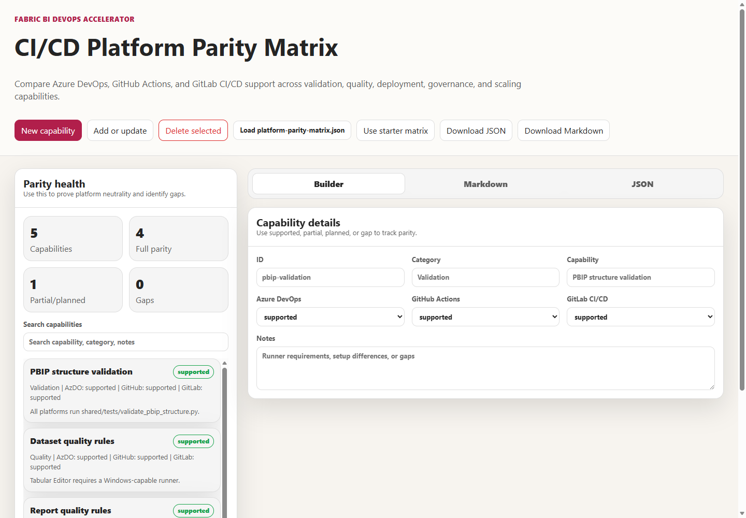
Use it as the output of parity testing: after the static and behavioral checks run, update the statuses from the results and commit the JSON beside the pipeline files. Note two inconsistencies in its data. The starter matrix in shared/examples/ marks Dev deployment supported everywhere. The workshop answer key at docs/workshops/accelerator-toolkit/reference-output/platform-parity-matrix.example.json marks it partial for GitHub and GitLab. And TODO.md lists the tool&#39;s data file as shared/platform-parity-matrix.json, a path that doesn&#39;t exist.
The Pipeline Config Generator at tools/pipeline-config-generator/index.html emits YAML for any of the three platforms from one profile. It is the tool most likely to be mistaken for the adapters themselves, so read its output with care. Its quality jobs print that they will &quot;Download Tabular Editor&quot; and run Prepare-QualityRules.ps1, but they never download or run either engine. Its rule preparation passes the pushed branch—Build.SourceBranch, github.ref, or CI_COMMIT_REF_NAME—and never the pull-request target. Its single deploy job has no branch condition, so it runs on pull-request builds too. And its deploy command doesn&#39;t match the script it calls.
Listing 7.6 — tools/pipeline-config-generator/index.html, lines 187–193. The generator&#39;s Azure DevOps deploy step passes parameters deploy-dynamic.ps1 doesn&#39;t define.
javascript example
- job: DeployWorkspace
pool:
vmImage: 'windows-2022'
steps:
- pwsh: |
& "$(DEPLOY_SCRIPT_PATH)" -TenantId "$(TenantId)" -AppId "$(AppId)" -ClientSecret "$(ClientSecret)" -WorkspaceName "$(DEV_WORKSPACE_NAME)" -ArtifactPath "$(PBIP_PATH)"
displayName: 'Deploy PBIP artifacts'`);

deploy-dynamic.ps1 has no -WorkspaceName or -ArtifactPath parameters, and its mandatory -Branch and -PbipPath are missing. When I ran the script with the generator&#39;s arguments on September 24, 2026, PowerShell stopped at parameter binding with &quot;A parameter cannot be found that matches parameter name &#39;WorkspaceName&#39;,&quot; and exited 1 before any network call. The GitHub and GitLab variants use the same arguments. Running the static checker with the workshop&#39;s generated Azure DevOps example in place of the real file flagged the missing PR target, both missing rule engines, and the missing JUnit publication. The generator also recommends .gitlab-ci.yml at the repository root for GitLab, while the repository&#39;s own GitLab file lives at gitlab/gitlab-ci.yml, and its Azure DevOps Publish stage depends on Validate and Test but not on the Quality stage. The GitHub and GitLab variants&#39; publish jobs likewise don&#39;t wait for the rule jobs, so in generated YAML a quality failure blocks neither publication nor deployment.
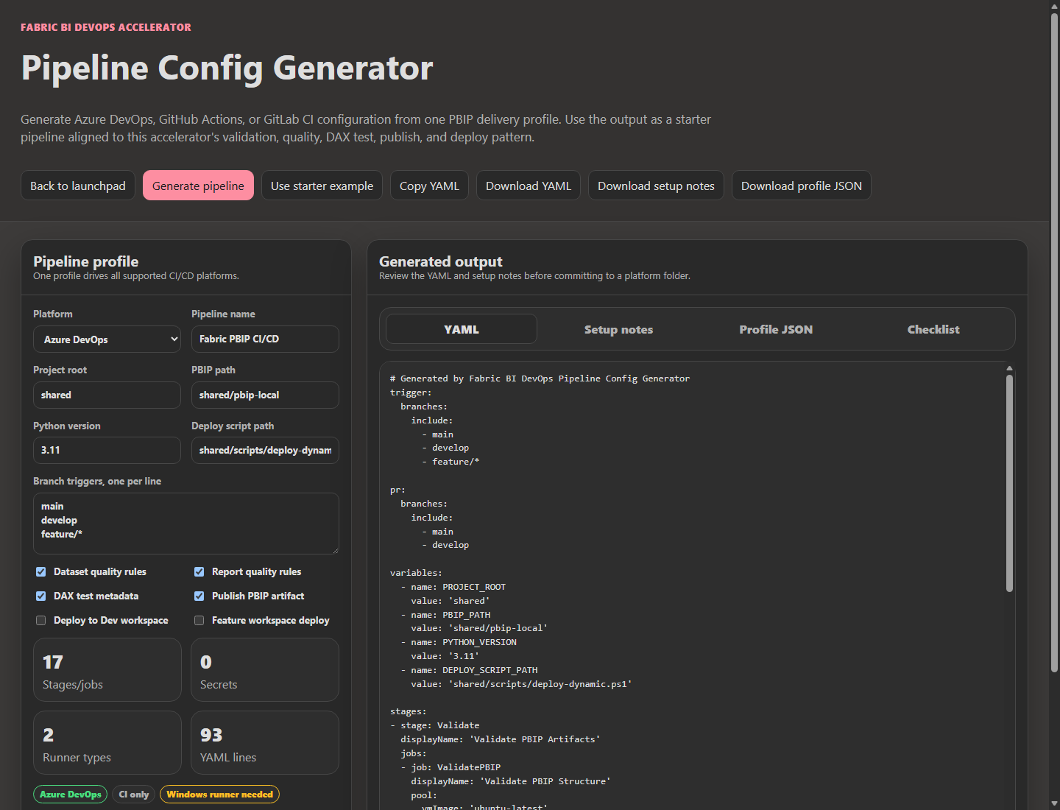
Treat the generator as a scaffold that shows the shape of an adapter, and treat the checked-in files as the adapters. Lab 6 asks participants to generate YAML and compare it with the reference output. Lab 2 asks them to compare it with the checked-in pipeline. The second comparison is the one that teaches parity.

The shared template and why only one platform has it
For Azure DevOps, the repository offers a reusable template under shared/universal-pipeline/: a thin consumer file uses extends to pull templates/fabric-ci.yml from a separate templates repository. The template covers Validate, Test, and Publish. It has no deploy stages, and its skip switches are compile-time parameters. The parity matrix correctly marks GitHub and GitLab equivalents as planned. GitHub&#39;s reusable workflows and GitLab&#39;s include are the natural mechanisms when those are built.
One detail in the template deserves a test before adoption.
Listing 7.7 — shared/universal-pipeline/templates/fabric-ci.yml, lines 86–99. The template checks out two repositories and runs the validator against a relative PBIP path.
yaml example
- job: ValidatePBIP
displayName: 'Validate PBIP Structure'
steps:
- checkout: self
- checkout: ${{ parameters.templatesRepoAlias }}

- task: UsePythonVersion@0
inputs:
versionSpec: '$(PYTHON_VERSION)'
displayName: 'Set Python version to: $(PYTHON_VERSION)'

- script: |
python $(TEMPLATES_REPO)/tests/validate_pbip_structure.py --pbip-path "$(PBIP_PATH)"
displayName: 'Run PBIP structure validation'

Microsoft&#39;s multi-repository checkout documentation says that when a job has multiple checkout steps, each repository is checked out into a folder named after the repository under the sources directory. With two checkouts and no path on the first, the consumer&#39;s files land in a subfolder named after the consumer repository, while $(PBIP_PATH) defaults to pbip-local relative to the parent. The rules steps build paths from $(Build.SourcesDirectory) and $(PROJECT_ROOT) the same way. I didn&#39;t run the template against Azure DevOps, so treat this as a risk to verify, not a confirmed defect. If the consumer&#39;s paths don&#39;t resolve, the structure check fails and the rules jobs quietly fall back to the downloaded rule files. Adding an explicit path to the self checkout, or setting projectRoot to the repository&#39;s folder name, would make the behavior explicit.

Trade-offs and lighter paths
Full parity has a cost that grows with every platform you support. A team, or a whole organization, that uses one platform should adopt that platform&#39;s adapter, delete the other two from its copy, and spend the saved effort on the behavioral fixtures for the one that remains. Neutrality at the organizational level can mean &quot;each team uses exactly one adapter, and each adapter is tested.&quot; It doesn&#39;t have to mean &quot;every team maintains three.&quot;
An organization that must support all three has two viable designs. The repository&#39;s current design duplicates the logic in three YAML files and relies on reviewers to keep them aligned; it is transparent and easy to read, and it drifts. The alternative moves the logic into scripts the YAML only calls: one PowerShell entry point per gate that takes the policy branch, paths, and cloud mode as parameters, with each adapter reduced to runner selection, variable mapping, and artifact handling. Prepare-QualityRules.ps1 and deploy-dynamic.ps1 already work this way. Extending the pattern to tool download and invocation would remove most of the drift this chapter found. The cost is that the YAML stops telling the whole story, so the script&#39;s parameters become the contract&#39;s documentation.
A lighter step for any team is to accept documented gaps rather than chase parity everywhere. A GitLab team with no GCC High tenants can mark that row gap with a one-line reason and move on. What it shouldn&#39;t do is leave the row out.

Evidence and further reading
Repository sources: azdo/azure-pipelines.yml, azdo/azure-pipelines_ci.yml, .github/workflows/powerbi-ci.yml, gitlab/gitlab-ci.yml, gitlab/README.md, shared/universal-pipeline/ (template, consumer file, and README), shared/examples/platform-parity-matrix.json, docs/workshops/accelerator-toolkit/reference-output/platform-parity-matrix.example.json and azure-pipelines.generated.example.yml, tools/platform-parity-matrix/index.html, tools/pipeline-config-generator/index.html, shared/scripts/deploy-dynamic.ps1, docs/Troubleshooting.md, TODO.md, and Labs 2 and 6.
First-hand evidence, gathered September 24, 2026: the static parity check against the shipped pipelines and against the generated example; the parameter-binding failure of deploy-dynamic.ps1 with the generator&#39;s arguments; and the source reading of each adapter summarized in the tables above. No pipeline was run on a hosted platform for this chapter.
Official documentation:
- Azure Pipelines YAML schema: https://learn.microsoft.com/en-us/azure/devops/pipelines/yaml-schema/
- Azure Pipelines multi-repository checkout: https://learn.microsoft.com/en-us/azure/devops/pipelines/repos/multi-repo-checkout
- Azure Pipelines templates: https://learn.microsoft.com/en-us/azure/devops/pipelines/process/templates
- GitHub Actions workflow syntax: https://docs.github.com/en/actions/reference/workflows-and-actions/workflow-syntax
- GitHub Actions reusable workflows: https://docs.github.com/en/actions/reference/workflows-and-actions/reusing-workflow-configurations
- GitHub Actions dependency caching: https://docs.github.com/en/actions/reference/workflows-and-actions/dependency-caching
- GitLab CI/CD YAML syntax: https://docs.gitlab.com/ci/yaml/
- GitLab needs and optional needs: https://docs.gitlab.com/ci/yaml/#needs
- GitLab include: https://docs.gitlab.com/ci/yaml/includes/
- GitLab caching: https://docs.gitlab.com/ci/caching/
- Tabular Editor 2 command-line options: https://docs.tabulareditor.com/en/features/Command-line-Options.html

Freshness note
Last verified September 24, 2026. The adapter comparison reflects the repository&#39;s pipeline files as read that day, and the tool behaviors cited from earlier chapters reflect Tabular Editor 2.29.0 and Fab Inspector 3.4.0. Platform features change independently: GitHub&#39;s reusable workflows, Azure DevOps templates, and GitLab includes each evolve on their own schedule, and hosted runner images change their preinstalled software regularly. Rerun the static check after any pipeline edit, and rerun the behavioral fixtures after any runner-image or tool-version change.

Reader decision checklist
- Have you written the gate contract for your organization, including which clauses may differ by platform?
- For each platform you support, can you name the adapter file that is authoritative, and have you removed or renamed the others?
- Do all your adapters resolve the policy branch from the pull-request target, run both rule engines, and block publication on a non-zero exit?
- Is a skipped gate recorded somewhere a reviewer will see it, on every platform?
- Are tool versions pinned, and are they the same on every platform on the same day?
- Does your parity matrix contain rows for GCC High, environment approvals, and credential scoping, with honest statuses?
- Which fixtures would you run through each adapter to prove parity, and when do they run?
- If you use the Pipeline Config Generator, who reviews its output against the checked-in adapters before anything is committed?

