DOUGLAS COLLEGE
CSIS 4495 – Applied Research Project
Section 002

MIDCOURSE PROGRESS REPORT
AI-Powered Outdoor Trip Companion

Personalized Hiking Planning, Packing Assistance, Trail Discovery, and Trip Memories

Student | Jiayu Lou
Student ID | 300398003
Team Lead | Jiayu Lou
Project Type | Individual Project
Date | October 23, 2026

GitHub Repository: https://github.com/Coding-Lou/F26_4495_S2_JiayuL
MidCourse Demo Video: https://www.youtube.com/watch?v=qe1P9ekvAkM

1. Introduction
Outdoor activities such as hiking are very popular around Vancouver, and hiking is also one of my favourite activities. However, planning even a simple day hike can require information from several different places. A user may check one website for trail distance and elevation, another application for weather, a map for driving distance, and then think about clothing and equipment separately. For an experienced local hiker this may be manageable, but for a new user it can take more time and it is easy to miss an important condition.
Weather is especially important for outdoor planning. A trail that is comfortable on a dry day may become much less suitable when there is heavy rain, low temperature, snow, or strong wind. Difficulty also cannot be considered by itself. A moderate trail can still be a poor choice when the user has limited time, does not have suitable equipment, or wants a different type of scenery. Because of this, the project tries to combine several kinds of information instead of only showing a list of popular trails.
The project is called the AI-Powered Outdoor Trip Companion. The main idea is to support more of the outdoor trip journey in one web application. The original product flow was Plan → Pack → Explore → Memory. During development, this idea was kept, but the application also added public trail discovery, authentication, saved plans, a calendar, and a 3D gear experience. These additions were made to connect the individual features into a more complete user flow instead of making several unrelated demo pages.
The main research question for this project is: How can user preferences, trail information, weather conditions, and the user's own gear be combined to provide more useful hiking recommendations and preparation suggestions? A related question is how an AI conversation can collect a user's needs without making the whole system depend only on the language model. For example, the AI can understand a natural language request, but trail distance, weather risk, and gear readiness can still be checked by normal backend logic.
Many existing outdoor tools are strong at one area, such as trail browsing, maps, weather, or trip tracking. General weather applications also provide useful forecasts, but the user still needs to connect that forecast to a specific trail and their own preparation. The gap I am focusing on is not creating a new source of all hiking data. Instead, the project studies whether different sources can be connected into one practical planning flow. OpenStreetMap and geographic trail data can support location and route information, Open-Meteo can provide forecast data, and an AI assistant can help convert a user request into structured preferences.
My initial assumption was that a recommendation can become more useful when it considers more context than difficulty or popularity. Another assumption was that packing suggestions are more useful if the system knows what the user already owns. At MidCourse, these assumptions have not been fully evaluated with the planned test scenarios yet. The current work mainly demonstrates that the technical flow can be built and that the different types of data can be connected. The evaluation work will be completed later in the term.
The expected benefit is a prototype that makes outdoor planning easier to understand and more interactive. The project is not intended to replace official safety information or professional outdoor advice. Its purpose is to explore how AI, geographic data, weather data, user-owned gear, and trip memories can work together in one application.

2. Summary of the Initially Proposed Research Project
The initial proposal defined four main stages: Plan, Pack, Explore, and Memory. The main research focus was the first two stages, because they directly combine user preferences, trail information, weather, and equipment. The proposal expected a working web application that would allow a user to move from choosing a trail to preparing for it, and then record the trip afterwards.

2.1 Original Objectives
1. Develop an AI-assisted hiking recommendation feature that considers user preferences, trail information, and weather conditions.
2. Develop a personalized packing assistant based on the selected trail, weather conditions, and the user's own outdoor equipment.
3. Develop a map-based feature to show hiking activity on different trails using simulated user location data.
4. Develop a trip memory feature that can use GPS tracks and photos to create a trip summary, with a simple recap video as an optional feature if time allows.

2.2 Original Research Design and Data
The original approach was a design-and-implementation project. A user would describe a hiking request in natural language. The AI would help extract structured preferences, such as difficulty, available time, preferred scenery, travel distance, and trip date. The backend would then compare those preferences with available trail data and weather information before returning recommendations.
Trail data was planned to come mainly from OpenStreetMap and related public geographic sources. The prototype would focus on a limited number of trails around Vancouver. Weather data would come from the Open-Meteo API and be queried using the latitude and longitude of the trail. The weather information could include temperature, precipitation, wind speed, and forecast conditions.
For research evaluation, the proposal planned approximately 30 different hiking request scenarios. Example scenarios included a beginner who wants a short hike, an experienced user who wants a difficult route, a user who wants mountain views, a user who wants to avoid rain, and a user who does not own some required equipment. These scenarios were intended to test whether the recommendation and packing logic responded to different user needs.
The Explore feature originally planned to simulate about 20 to 50 users moving on different trails. This would allow the map to demonstrate activity without collecting real continuous GPS data from actual hikers. The Memory feature was planned to accept GPX tracks and photos, then create a trip recap page and possibly a short video.

2.3 Original Technology Plan

Area | Original Technology
Platform | Web Application / Cloud
Frontend | React, TypeScript
Backend | Java 21, Spring Boot
Database | PostgreSQL, DynamoDB
AI | OpenAI API
Trail Data | OpenStreetMap, Overpass API
Weather Data | Open-Meteo API
Map | Leaflet, OpenStreetMap
Location Data | GPS / GPX
Real-Time Updates | Spring WebSocket
Media Storage | Amazon S3
Video / Recap | GPX processing, FFmpeg if time allows
Deployment | AWS
Containerization | Docker
CI/CD | GitHub Actions
Source Control | GitHub

The original schedule was approximately 13 weeks. The first half focused on project setup, authentication, trail data, map, weather, AI planning, and recommendation. The second half focused on gear, packing, live activity, memory, deployment, and final integration.

3. Changes to the Proposal
The main project idea did not change. Plan, Pack, Explore, and Memory are still the main product areas. However, several implementation choices changed after the prototype became more detailed. Some changes were technical, while others were product decisions that made the user journey easier to demonstrate.

Change | Original Proposal | Current Direction | Reason
Map library | Leaflet | MapLibre GL | MapLibre supports a modern vector-map experience and works well with the current Discover interface.
Authentication | Basic registration/login was planned | Keycloak with PKCE and Spring Security | It provides a more realistic identity flow and keeps authentication outside the business services.
Spatial database | PostgreSQL | PostgreSQL with PostGIS | PostGIS makes nearby trail search and geographic operations easier to implement in the database.
Pack presentation | Gear list and packing suggestion | Gear Studio with inventory, recommended/equipped states, and a 3D avatar | This makes packing more visual and lets the user see selected equipment instead of only reading a checklist.
Explore | Simulated active hikers on a map | Public Discover map plus Daily Trail Activity; full live simulation is still incomplete | Discover gives a useful working map experience earlier. Live simulated activity can still be added later if time allows.
Memory | GPX + photos + recap/video | Photo-based Memory flow and visibility/community functions implemented first | Photo upload and sharing complete a usable end-to-end flow. GPX/video work remains a later task.
Trip management | Not a major original section | My Plans and Calendar added | Saved plans connect AI planning to a future trip and make the application easier to use after recommendation.
Frontend visual design | Standard web application | Cinematic public landing and game-inspired outdoor experience | The visual direction makes the project more engaging and supports the product idea of an outdoor companion.
3D | Not in the original proposal | Three.js avatar and equipment visualization | 3D provides a visual representation of packing readiness and became a technical learning goal during development.
Cloud deployment | AWS planned | Still planned; not yet completed at MidCourse | Local feature integration was prioritized first so the main user flow could be demonstrated before deployment work.
Real-time activity | Spring WebSocket and temporary activity storage | Not yet fully implemented | This part has lower priority than the research-focused planning, recommendation, and packing flow.

3.1 Main Direction That Stayed the Same
Even with these changes, the project still follows the original research idea. The user can describe a hiking need, receive trail recommendations, check weather and preparation information, manage personal gear, and save a trip. Explore and Memory still exist as major product areas. The largest change is that the project now connects these stages through a more complete product journey.

3.2 Features Moved Later or Not Yet Complete
Some proposal items are not complete at MidCourse. Full simulated live-hiker movement using WebSocket is not complete. GPX route parsing and automatic trip recap video are also not complete. AWS deployment and GitHub Actions deployment are planned but are not yet the main tested environment. The formal evaluation using approximately 30 request scenarios also still needs to be completed.
This change in priority is intentional. A smaller working user journey is more useful for the MidCourse demonstration than several partially connected technical experiments. The remaining features will be completed based on the time left and their importance to the research objectives.

4. Updated Project Planning and Timeline
The project is currently ahead of the original schedule in the number of frontend features, but some infrastructure and research-evaluation work is still behind the original plan. The updated schedule focuses on completing the remaining core functions, improving integration, deployment, and evaluation.

Period | Planned Work | Deliverable
Current / MidCourse | Stabilize Plan, Pack, Discover, Memory, My Plans, and authentication | Working integrated local demo
Late October | Complete remaining Gear Studio and 3D readiness work; improve feature integration | Stable Plan → Pack flow with avatar/equipment
Early November | Continue Explore activity implementation and improve trail data/Discover | Improved Explore experience
Early to Mid November | Add or improve GPX support and Memory recap if time allows | Expanded Memory feature
Mid November | AWS deployment, Docker/Helm/Kubernetes work if project schedule allows; CI/CD setup | Cloud-hosted prototype and automated build/deployment path
Late November | Run structured evaluation scenarios, bug fixing, usability review | Evaluation results and stable release candidate
End of Term | Final integration, documentation, final video/demo, final report | Final project submission

4.1 Simple Gantt View

Workstream | MidCourse | Late Oct | Early Nov | Mid Nov | Late Nov | Final
Plan / Recommendation | Done / Improve | Improve | Test | Test | Evaluate | Final
Pack / Gear / 3D | In progress | Complete | Test | Test | Evaluate | Final
Discover / Explore | Working | Improve | Improve | Activity work | Test | Final
Memory | Working basic flow | Improve | GPX if time | Recap if time | Test | Final
Cloud / CI/CD | Not complete | Prepare | Implement | Implement | Stabilize | Final
Evaluation | Not complete | Prepare cases | Prepare | Run cases | Analyze | Report
Documentation | Ongoing | Ongoing | Ongoing | Ongoing | Finalize | Submit

The exact end-of-term dates may change based on the course schedule. The main priority order is integration → remaining research features → deployment → evaluation → final reporting.

5. Implemented Features and MidCourse Progress
The GitHub work log shows development from Sep. 22 through Oct. 21. By MidCourse, the project has a working set of features that cover most of the main user journey. The following sections describe the major work completed so far.

5.1 Backend Foundation, User Service, and Trail Service
The backend is based on Java and Spring Boot. Early work created a microservice project structure and local PostgreSQL/PostGIS databases using Docker. The User Service stores the authenticated user's profile and personal gear items. Authentication is connected to Keycloak through Spring Security and JWT validation.
The Trail Service stores trail information and geographic data. PostGIS is used for spatial queries, especially nearby trail search. The service also supports filtering and returns trail details and GeoJSON data. This work helped me understand how geographic data is stored differently from normal text or numeric data and how database-level spatial queries can reduce application logic.
Soft delete is used for user-managed records where deletion is supported. This keeps the data model safer for the project because a record can be hidden without immediately removing it from the database.

5.2 Public Landing – FEATURE-001
The public landing page was built as the first main frontend feature. It uses three outdoor video scenes with poster fallbacks and sequential media loading. The goal was to make the application feel like an outdoor product instead of a normal school dashboard.
The landing page is mainly a presentation layer, but it is important for the full product flow because the user can understand the purpose of the application before authentication.
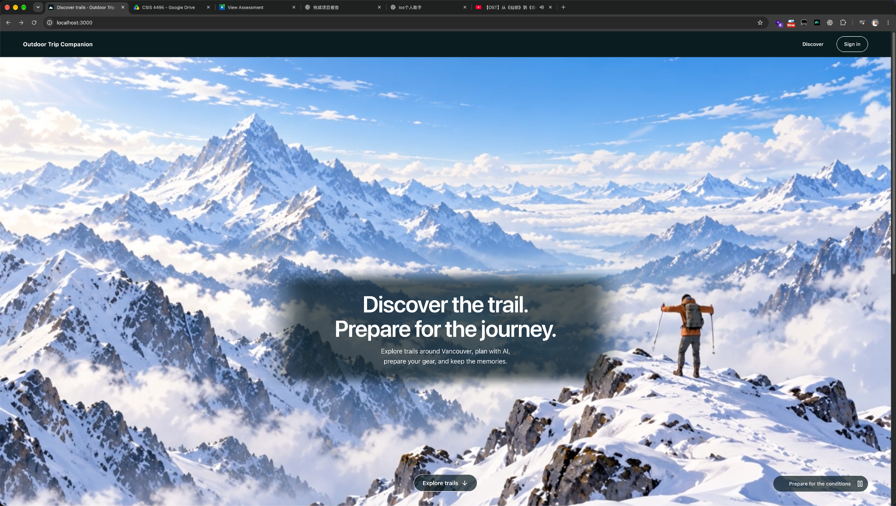

5.3 Authentication – FEATURE-002
Authentication uses Keycloak. The frontend uses the PKCE login flow and protected routes. After login, the session can be restored when the page refreshes, and sign out also ends the Keycloak session. A custom Keycloak theme is used for login and registration pages.
A custom login theme was added so the authentication page is visually closer to the Outdoor Trip Companion. This feature was not a main research topic, but it was necessary because personal gear, plans, and memories all belong to a specific user.
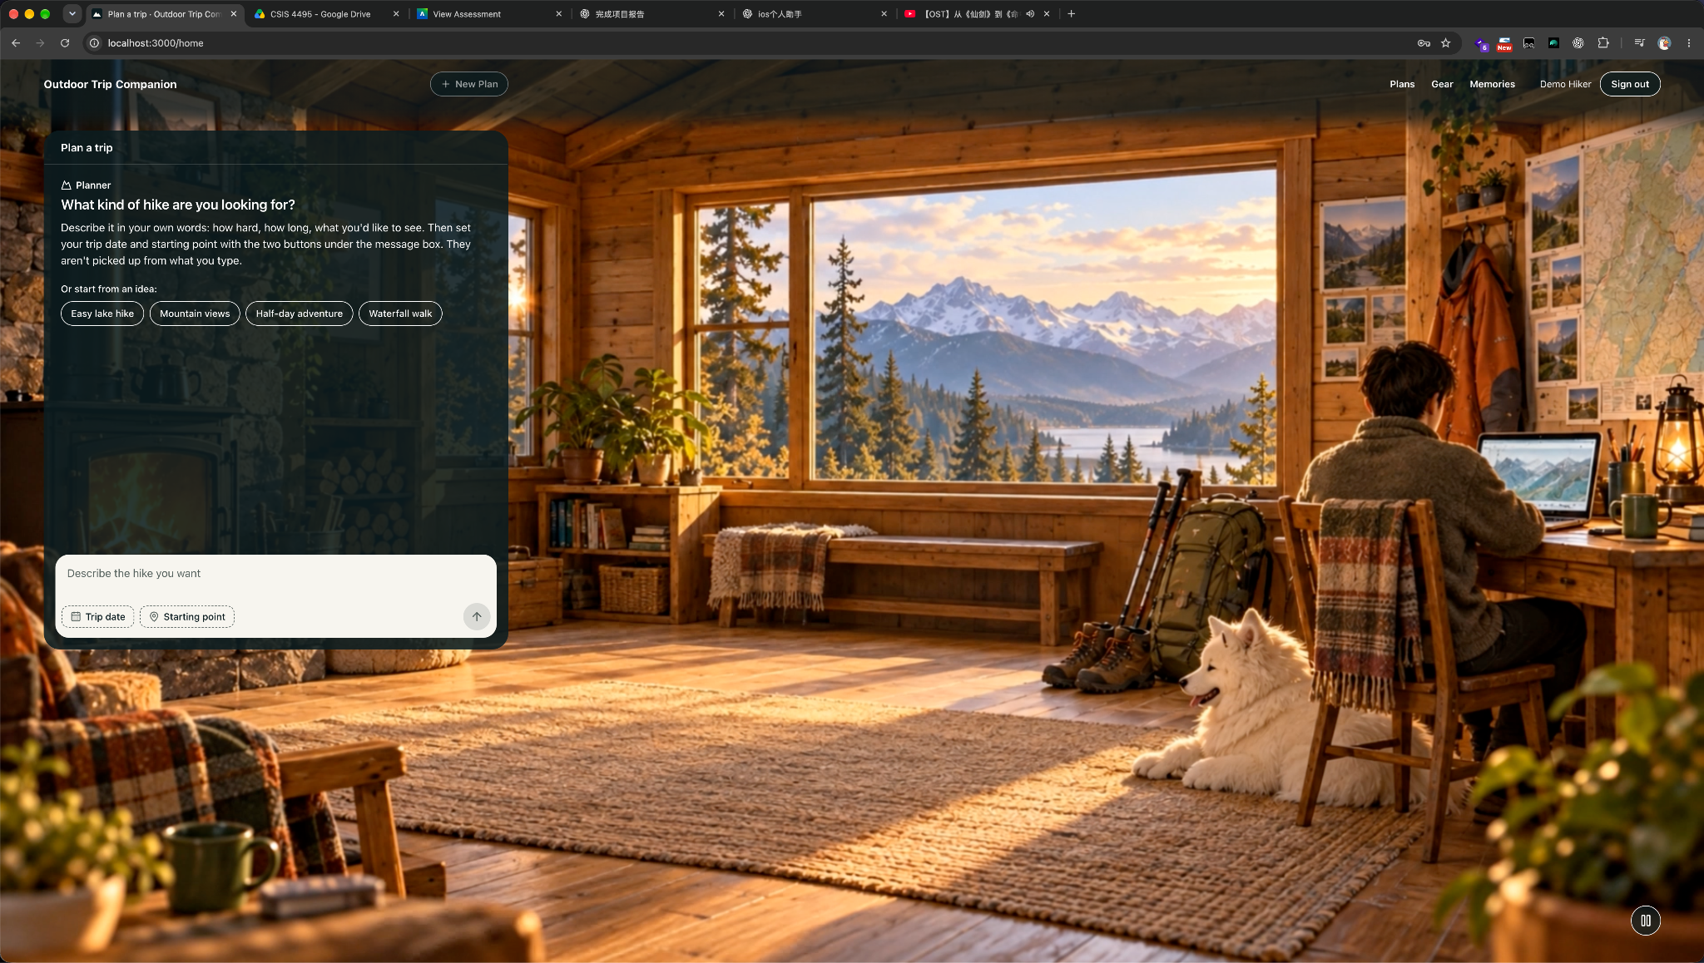

5.4 Conversational Planner – FEATURE-003
The Conversational Planner is one of the main research features. The user can describe a hike in natural language and continue the conversation over multiple turns. The planner extracts preferences and combines them with structured backend information instead of using the AI response alone.
The recommendation flow combines the user intent with trail data, weather, gear readiness, scenery preference, and proximity. The current implementation ranks and returns recommended trails. The user can also refine the request after receiving a recommendation, for example asking for something easier or changing the preferred scenery.
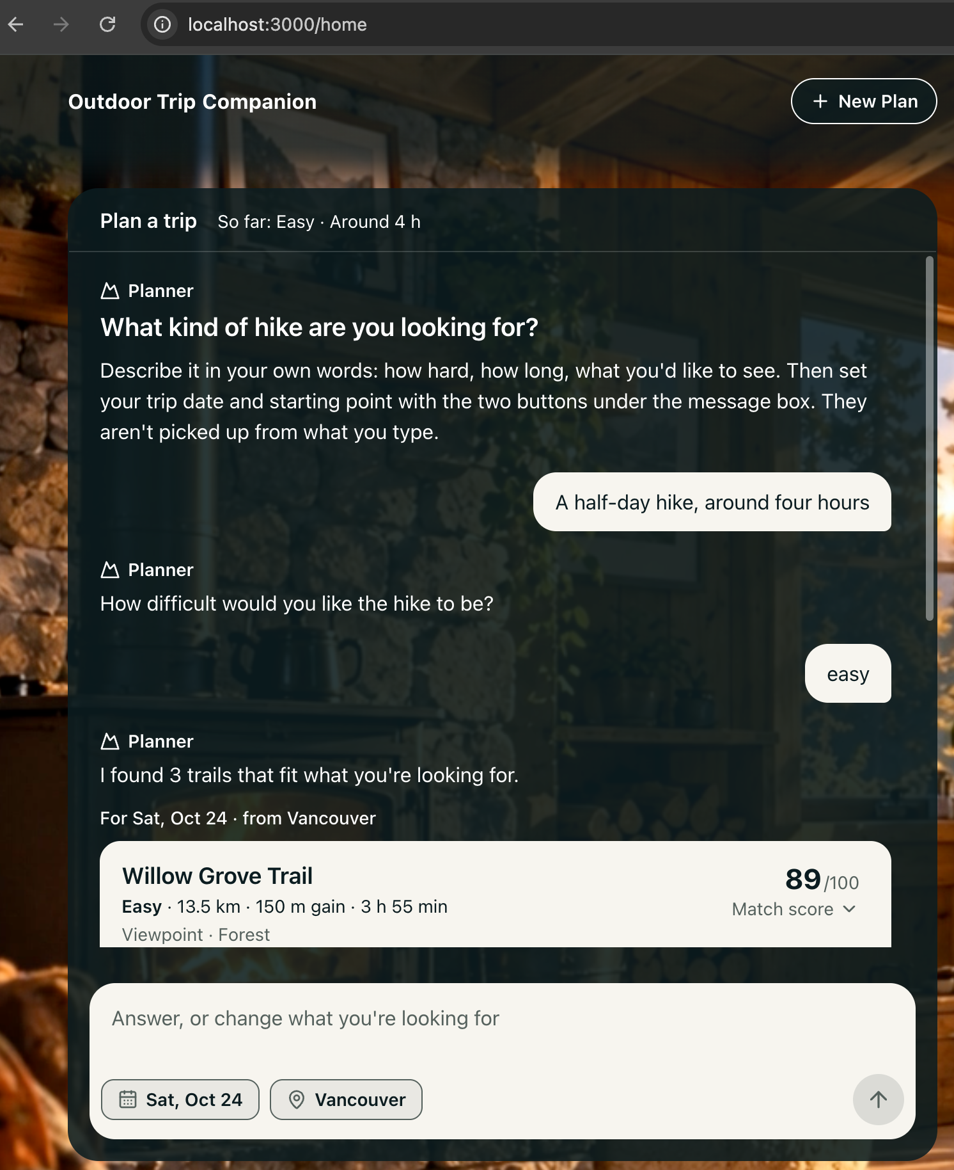

5.5 Trail Selection and Trip Preparation – FEATURE-004
After a recommendation is selected, the application shows more trail detail and preparation information. The feature connects the selected trail to weather and gear requirements. Gear readiness can be calculated by comparing required items with the user's owned gear.
This feature also demonstrates why the user gear inventory matters. A general checklist may always tell every user to bring the same items. In this project, the application can compare the suggestion with the user's own inventory and show missing or available items.
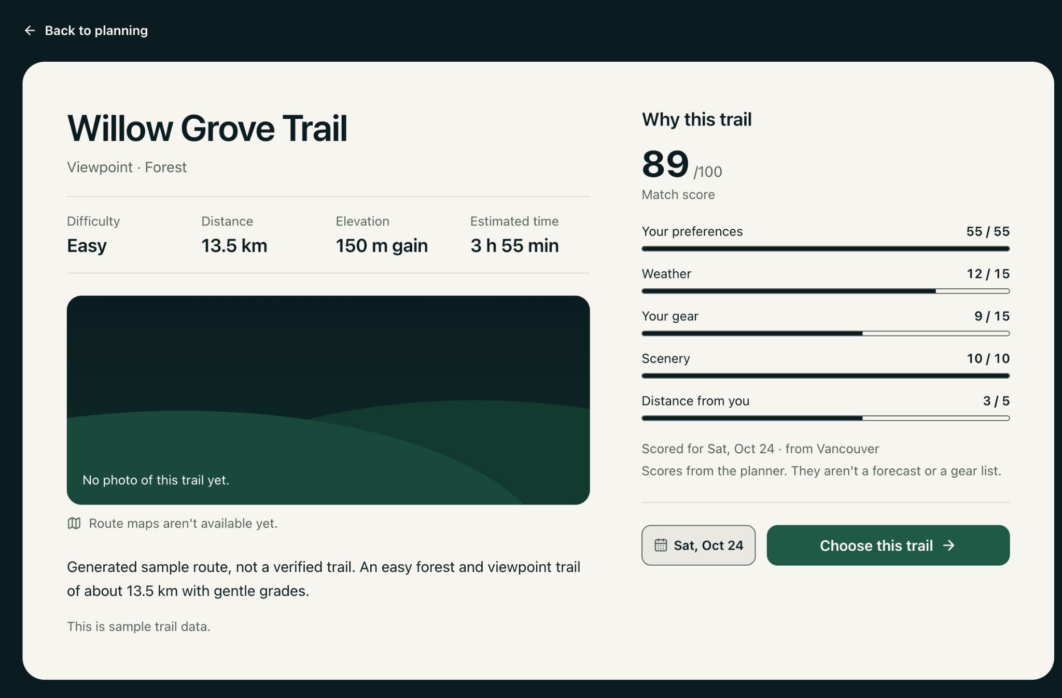

5.6 Gear Studio, Inventory, and 3D Avatar – FEATURE-005, 007, and 012
The Pack area developed further than the original proposal. A Gear Studio provides a personal gear inventory and separates recommended gear from equipped gear. The user can choose what to equip instead of automatically accepting every recommendation.
The application also uses a 3D avatar. Equipment can be visually connected to the avatar, which gives the packing stage a clearer visual result. Three.js is used for the real-time 3D part. This was not required in the original proposal, but it became an important implementation feature because it connects user choice with visual feedback.
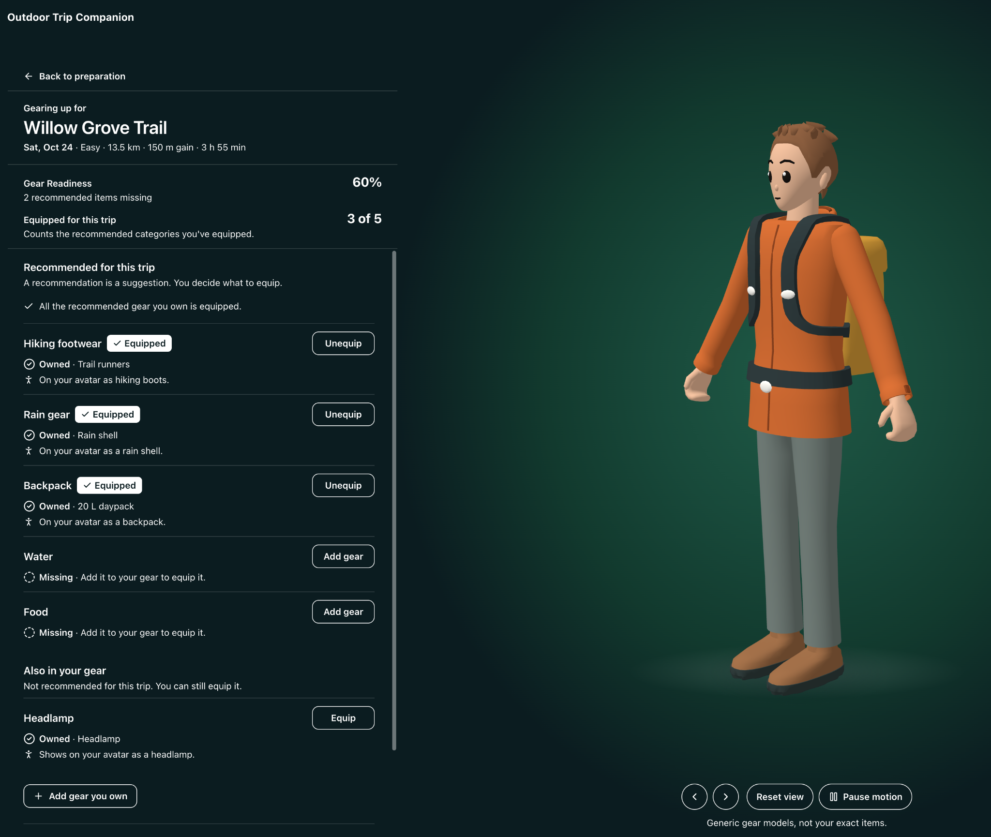

5.7 Discover and Daily Trail Activity – FEATURE-009 and 011
Discover provides a public map-first trail browsing experience. The application uses MapLibre GL and trail data to show trail locations. The user can search and open trail details from the map.
Daily Trail Activity adds an activity layer to the Discover experience. This is related to the original Explore idea, but the current version is not the same as a complete live GPS simulation. The original simulated WebSocket movement remains a possible later feature.

5.8 Memory and Community – FEATURE-008 and 010
The Memory feature currently allows the user to create a memory with photos and related trip information. Memory visibility can be controlled, and public memories can appear in the Community experience. This gives the trip a result after the planning and hiking stages.
The current Memory work does not yet fully match the original GPX and automatically generated recap-video design. The photo-based memory flow was completed first because it creates a usable vertical slice and is easier to validate. GPX parsing and video generation can be added later if time is available.

5.9 My Plans and Calendar – FEATURE-006
My Plans and Calendar were added to connect planning with actual future trips. A recommendation is more useful when the user can save the selected trail and trip date. The calendar provides another way to view upcoming plans.
This was an additional feature compared with the original proposal. I added it because without persistent plans the user would have to restart the planning process each time. It also makes the application workflow easier to demonstrate from recommendation to preparation.

5.10 Current Technical Architecture

Layer | Current Technology / Role
Frontend | React + TypeScript
Map | MapLibre GL + OpenStreetMap data
3D | Three.js / GLB avatar and gear assets
Authentication | Keycloak + PKCE
Backend | Java 21 + Spring Boot microservices
Security | Spring Security / JWT resource server
Primary database | PostgreSQL 17 + PostGIS
Database migrations | Flyway
AI integration | OpenAI API for structured planning intent
Weather | Open-Meteo
Local infrastructure | Docker Compose
Source control | GitHub
Cloud target | AWS, still in progress
CI/CD target | GitHub Actions, still in progress

The current architecture is still a prototype. Some services are more complete than others, and not every planned cloud component has been implemented. This is expected at MidCourse because the project is still under active development.

6. Testing and Evaluation Progress
Testing is being done in several ways. Backend services use unit and integration testing where practical. Testcontainers with PostgreSQL has been used for some database integration tests. Frontend features use build, lint, and browser-based acceptance checks during development.
The project also uses feature acceptance criteria. A feature is normally defined before implementation, then the frontend or backend work is checked against those requirements. This has been useful because the application has many connected screens and it is easy to accidentally change another part of the project.
The planned research evaluation is not complete yet. The proposal suggested approximately 30 hiking scenarios. These scenarios still need to be prepared and run in a more formal way. The evaluation should compare whether the recommendation reacts correctly when important inputs change, such as difficulty, available time, scenery, weather, or gear readiness.
Current known automated test count: [LEAVE BLANK / UPDATE FROM FINAL TEST RUN]
Current end-to-end test result: [LEAVE BLANK / UPDATE FROM FINAL TEST RUN]

7. Challenges and Learning
One challenge was controlling project scope. After the initial backend was working, there were many possible directions, including 3D, live activity, cloud deployment, video generation, and a larger trail dataset. It was not realistic to complete everything at the same time. I decided to prioritize a connected user experience first and leave some infrastructure work for later.
Another challenge was integrating different technologies. The frontend, Keycloak, Java microservices, PostgreSQL/PostGIS, OpenAI, weather API, and 3D assets all have different development workflows. Problems were often not isolated to one file. For example, authentication needs the Keycloak configuration, frontend session handling, and backend JWT validation to agree with each other.
I also learned that AI-generated code still needs clear scope and verification. During frontend development I used Claude Code with different agent roles, but I still needed to define acceptance criteria, decide which files were allowed to change, review the implementation, and verify the final behavior. AI made implementation faster in some areas, but it also made project management and code review more important.
The 3D work was another learning area. The main challenge was not only displaying a model. The avatar, gear models, scale, position, camera, animation, and frontend state all need to work together. This required more iteration than a normal 2D page.

8. AI Use Section

AI Tool Name | Version / Account Type | Specific Feature / Use | Value Added by Student
ChatGPT | GPT-5.6 Sol / ChatGPT Plus | Project brainstorming, architecture discussion, proposal/report drafting, technical explanations, UI/asset prompt design, and documentation support. | I defined the project problem and requirements, selected the architecture and technologies, reviewed the suggestions, changed unrealistic ideas, and verified that the final decisions fit the course project and current code.
Claude AI | Claude Code / Pro | Multi-agent coding workflow for frontend implementation, UI/UX support, QA, documentation, and some 3D feature coordination. | I created the feature scope and acceptance criteria, controlled which parts of the project could be changed, reviewed implementation results, fixed or rejected changes, and decided when a feature was complete enough to continue.
Kling AI | Web version | Converted static visual concepts into short outdoor video clips used on the public landing page. | I selected the source scenes, wrote and adjusted the motion prompts, reviewed failed or unrealistic movement, and selected the clips that matched the intended landing experience.
ChatGPT Image Generation | ChatGPT Plus | Created or refined visual concepts used as references for outdoor scenes and product design. | I defined the visual direction and composition, selected useful outputs, rejected unsuitable results, and used the images only as design inputs or media assets where appropriate.
Blender / AI-assisted 3D workflow | Local Blender / supporting AI tools | Used during avatar and gear asset work and 3D prototyping. | I decided the required assets, tested scale and placement in the application, integrated the models with the frontend, and adjusted the result based on the actual Pack experience.

AI tools were used as development assistants rather than as a replacement for understanding the project. Important architecture, scope, security, and product decisions were reviewed before they were added. Generated code or documentation was also checked against the project requirements.

9. Work Date / Hours Log
Student Name: Jiayu Lou

Date | Number of Hours | Description of Work Done
Sep. 22, 2026 | 1 | Reviewed the original invoice project idea and adjusted the project scope.
Sep. 22, 2026 | 3 | Worked on the first proposal draft, including the project idea, research questions, architecture, technologies, and evaluation plan.
Sep. 23, 2026 | 2 | Discussed the project with the professor and decided to reconsider the original invoice project direction.
Sep. 25, 2026 | 3 | Defined the new outdoor trip companion project with Plan, Pack, Explore, and Memory features. Continued writing the proposal.
Sep. 26, 2026 | 2 | Set up the backend microservice project structure and local PostgreSQL/PostGIS database using Docker.
Sep. 26, 2026 | 2 | Started the User Service implementation, including database migration, user entity, repository, and user profile storage.
Sep. 26, 2026 | 1 | Researched Keycloak and set up basic authentication with React and Spring Security.
Sep. 26, 2026 | 0.5 | Set up Keycloak with a new realm, React client, PKCE login flow, and test user account.
Sep. 26, 2026 | 0.5 | Connected Keycloak authentication with the User Service using Spring Security and JWT validation. Tested protected APIs and automatic user profile creation.
Sep. 28, 2026 | 1.5 | Worked on the Gear feature and added APIs to create, view, update, and delete gear items.
Sep. 28, 2026 | 0.5 | Added soft delete and made sure users can only manage their own gear.
Sep. 28, 2026 | 1 | Improved error handling for invalid requests, authentication, and missing gear items.
Sep. 28, 2026 | 1.5 | Added tests for the Gear feature and used Testcontainers with PostgreSQL for integration testing.
Sep. 28, 2026 | 0.5 | Fixed some testing issues and checked that all User Service tests passed.
Oct. 07, 2026 | 5.5 | Implement trail entity, PostGIS-backed nearby search, filtering, GeoJSON trail details, JWT security, CORS configuration, and demo trail seed data.
Oct. 10, 2026 | 3.5 | Implemented a context-aware trail recommendation flow that ranks the top three nearby trails using user intent, weather, gear readiness, scenery preferences, and proximity.
Oct. 11, 2026 | 3 | Completed FEATURE-001 – Public Landing, building the cinematic landing page with three outdoor video scenes, poster fallbacks, responsive layout, and sequential media loading.
Oct. 12, 2026 | 4 | Completed FEATURE-002 – Authentication, integrating Keycloak login and registration with PKCE, protected routes, session restoration, logout, and a customized Keycloak login theme.
Oct. 13, 2026 | 7 | Completed FEATURE-003 – Conversational Planner, implementing the multi-turn AI trail planning flow, preference extraction, no-preference handling, duration modes, trail scoring, weather integration, and recommendation testing.
Oct. 14, 2026 | 4 | Completed FEATURE-004 – Trail Selection & Trip Preparation, adding Trail Detail, trail selection, preparation recommendations, recommended/owned/missing gear states, and Gear Readiness calculation.
Oct. 15, 2026 | 6 | Completed FEATURE-005 – Pack Customization & 3D Avatar, building the Gear Studio, connecting equipped gear to a real-time Three.js avatar, creating 3D gear assets, and supporting one equipped item per visual category.
Oct. 15, 2026 | 6 | Completed FEATURE-006 – Public Discover & Trail Activity, building the MapLibre trail discovery experience with viewport-based nearby search, clustering, trail selection, trail-name search, URL state, and curated/synthetic trail handling.
Oct. 16, 2026 | 3.5 | Completed FEATURE-007 – Gear Inventory, creating the authenticated My Gear page with add, edit, view, and soft-delete operations using the same persistent gear inventory as Gear Studio.
Oct. 16, 2026 | 5 | Completed FEATURE-008 – Memory Foundation, creating the Memory Service, PostgreSQL persistence, private/public visibility, owner isolation, photo upload validation, signed photo URLs, soft deletion, and backend integration tests.
Oct. 17, 2026 | 5 | Completed FEATURE-009 – My Memories, building the authenticated Memory list, create, detail, edit, delete, photo upload/reordering, visibility controls, signed-image refresh, and cross-user cache isolation.
Oct. 18, 2026 | 4 | Completed FEATURE-010 – Community Memories, adding public trail-level Memory previews and browsing in Discover, including public Memory lists, detail views, pagination, responsive panels, and private/public visibility enforcement.
Oct. 19, 2026 | 4.5 | Completed FEATURE-011 – Plan Foundation & Finish Preparation, creating the Plan Service and plan_db, adding authenticated Plan persistence, soft delete, duplicate protection, owner isolation, and the Finish Preparation workflow in Gear Studio.
Oct. 20, 2026 | 5.5 | Completed FEATURE-012 – Ready-to-Go 3D Completion, creating a versioned avatar asset with a four-second ready_to_go animation, integrating it after successful Plan saves, preserving equipped gear, and adding reduced-motion and animation-failure fallbacks.
Oct. 20, 2026 | 6 | Completed FEATURE-013 – My Plans & Calendar, building the authenticated /plans page with Upcoming/Past Plan lists, monthly calendar, Plan-to-calendar selection, trail details, Review Gear, Plan deletion, pagination handling, account isolation, and the Ready-to-Go → My Plans flow.
Oct. 21, 2026 | 4 | Study and learn how to compose a Docker setup for the microservice.

10. Remaining Work
The most important remaining work is to make the current features stable as one complete product. The project already contains many separate features, so adding more features should not be the only goal. Integration, testing, and documentation are now more important.
The main remaining items are:
1. Complete remaining Gear Studio and 3D readiness work.
2. Improve Explore / activity functionality and decide how much of the original simulated real-time activity should be completed.
3. Add GPX route support and a more complete Memory recap if time allows.
4. Deploy the application to AWS and complete an appropriate CI/CD path.
5. Run the planned recommendation evaluation scenarios and record the results.
6. Add final screenshots, testing evidence, installation instructions, and a public demo video.
7. Complete the final report and demonstration.

11. Closing
At MidCourse, the Outdoor Trip Companion has developed from an early proposal into a working multi-feature web application. The main research idea remains the same: combine user preferences, trail information, weather, and personal gear to make hiking planning more useful. The project has also expanded with authentication, saved plans, a calendar, public trail discovery, community memories, and a 3D gear experience.
The project is not complete. Some original proposal items, especially live simulated trail activity, GPX/video recap, cloud deployment, CI/CD, and formal evaluation, still require work. The next stage should focus less on adding unrelated features and more on completing integration, evaluation, and final deployment.

12. References
OpenStreetMap contributors. OpenStreetMap geographic data. https://www.openstreetmap.org/
Open-Meteo. Weather Forecast API. https://open-meteo.com/
MapLibre. MapLibre GL JS documentation. https://maplibre.org/
Keycloak. Keycloak documentation. https://www.keycloak.org/documentation
PostGIS. PostGIS documentation. https://postgis.net/documentation/
Spring. Spring Boot and Spring Security documentation. https://spring.io/projects/spring-boot and https://spring.io/projects/spring-security
OpenAI. OpenAI API documentation. https://platform.openai.com/docs
GitHub. F26_4495_S2_JiayuL project repository. https://github.com/Coding-Lou/F26_4495_S2_JiayuL

