W26_3375_S1_G7_SmartTalk
Lou, Jiayu 300398003

This is the SmartTalk app.
It's an AI-powered application helps people handle daily small talk with different people in differnent suitiations.
Team mebmber: Jiayu Lou | 300398003
Course: 3375
Section: 001
Member | Percentage
Jiayu Lou 300398003 | 100%

2026

Checklist (CHECK EACH ENTRY TO VERIFY THAT IT HAS BEEN DONE)
☒ |  | Title Page on this report: Make sure all the details required in the title page is filled. Also, ensure that you provide overall percentage contributions of each member in the group. The total should add up to 100% and each student’s percentage contribution must reflect the work completed through out the project.
☒ |  | Final Report GitHub Repository Check-In: The final report must be checked into GitHub Repository under DocumentsAndReports. All reports and documents must be in the main branch of the repo.
☒ |  | Final Defense and Demo Preparation: The final defense and demo presentation should be no more than 5 minutes. This includes a very brief introduction to what your app does (keep slides only as backup if questions are posed), and DEMO of your project. It is you discretion to demo parts you want to showcase but I may ask you to demo other parts not presented that you have completed based on your report. Every person in the team should showcase work they have done in the project. Questions will be posed during your presentation. YOU MUST BE PRESENT AT THE FINAL PRESENTATION AND DEMO IN ORDER TO GET A GRADE IN THE PROJECT. See slides on blackboard for details
☒ |  | Completed Figma prototype: Updates to the ReadMe File stating clear project/product description, and a section indication installation instruction. How can I use the repository files, to see a demo of your product? Installation instructions can either be in the README file initially created or as a separate file in the GitHub repository and in the appendix of the final report

Contents
Part 1 – Project Proposal 4
Introduction 4
Background Research 4
PACT Framework 5
Part 2 - Requirements Gathering 6
Purpose or objectives 6
Choice of user study and user sample 6
Data Visualization and Analysis 7
Requirements Generation 0
Requirements Generation (done by you) 0
Part 3 Design and Prototype 1
Design 1
Prototype in Figma 2
User-based Prototype Evaluation ( Not completed ) 5
Reference 6
AI Use Section 6
Workload 6

Part 1 – Project Proposal

Introduction
It's an AI-powered application give people opening lines, follow up questions, topic transitions for everyday conversation based on the today's weather, news, or anything interesting. Saving people like me from the draining their head for the small talk topics, reducing awkward silences and social anxiety.

How is it novel?
Unlike generic "conversation helper" apps, Smart Talk dynamically gives the ideas and topics based on current weather, local news and trending topics based on your characteristic.
Enabled with AI, the app is learning your personality from you and becomes more smart. It will learn your conversational stylye over time and adapts its suggestions to sound more like you.
What is the transformative experience for the user
Before Smart Talk:
- Social interactions feel mentally exhausting
- Awkward silences create anxiety
- Users overthink what to say next
- Small talk feels forced or inauthentic
After Smart Talk:
- Users feel calm and prepared entering conversations
- Silences feel manageable, not threatening
- Conversations flow more naturally
- Users shift focus from what to say to how to connect
Motto for your app
AI that keeps the conversation going.

Background Research
What the market competitor apps?
These are existing apps that address similar user problems to Smart Talk—such as small talk assistance, social anxiety support, or guided conversation prompts.
- Chattio – Conversation Starters https://chattio.app/\ Provides situation-based, AI-generated conversation starters for various social contexts (dinner, networking, first dates). It’s focused on eliminating awkward silences with ready-made prompts.
- Yoodli - Interactive AI Roleplays https://yoodli.ai/
Improve your communication skills with private, real-time, and judgment-free roleplay coaching — powered by AI.
- Talkville – AI Social Practice https://www.klapke.com/
Lets users roleplay everyday social situations with AI characters to rehearse and build confidence in a low-pressure environment.

PACT Framework
P - People
Primary users, people who may have social anxiety, need improve their spontaneous communications, need to transmit words more effectively and make more connection with other people especially strangers.
A - Activity
Based on user personality and interests, leveraging with latest trends, Use generate AI to initiate conversations, give opening lines, sustains conversions like follow-up questions and transitioning topics smoothly.
C - Context
Social environments such as offices, cafes, parties or anywhere need small conversation to avoid awkward silence.
T - Technology
NLP and generate AI to understand your behavior and modeling your own style openers, follow-ups and transitions.
Also, needs mulitple apis like the weather APIs get the latest weather information, news API and social media API get the trending topics.
Value Proposition
Unlike static conversation starter apps or generic AI tools, Smart Talk adapts to the user’s conversational style over time and supports the full flow of conversation (openers, follow-ups, and transitions) in real-world, high-pressure social contexts.

Part 2 - Requirements Gathering

Purpose or objectives
The primary goal of this study is to validate the core value proposition of SmartTalk and understand the specific pain points of users regarding social interactions. The objectives are to:
- Identify User Characteristics: Determine the level of social anxiety and the frequency of "blanking out" during small talk among the target demographic.
- Analyze Conversation Behavior: Understand which stages of a conversation (openers, follow-ups, or transitions) are most challenging for users.
- Evaluate Contextual Needs: Identify which specific environments (work, parties, or networking) create the most pressure for users.
- Assess AI Trust and Personalization: Gauge user willingness to let an AI learn their personality to provide "authentic" sounding suggestions.
- Prioritize Feature Integration: Determine if users find weather, news, or trending social media topics more valuable for real-time conversation starters.

Choice of user study and user sample
User Study Method: Survey. A quantitative and qualitative survey is chosen to gather a broad range of data points on social behavior and tech-readiness.
Target Users: * Young Professionals: People in office environments who need to network or engage in "water cooler" talk.
- Post-Secondary Students: Specifically those looking to improve spontaneous communication with strangers or peers.
Dual Perspective: Yes. The study will target both "Social Initiators" (those who want to lead conversations) and "Social Responders" (those who want to avoid awkward silences when others talk to them).
Draft of the User Study Survey or Interview:
https://forms.gle/9Lj3LukU1yGe9RY56

Data Visualization and Analysis
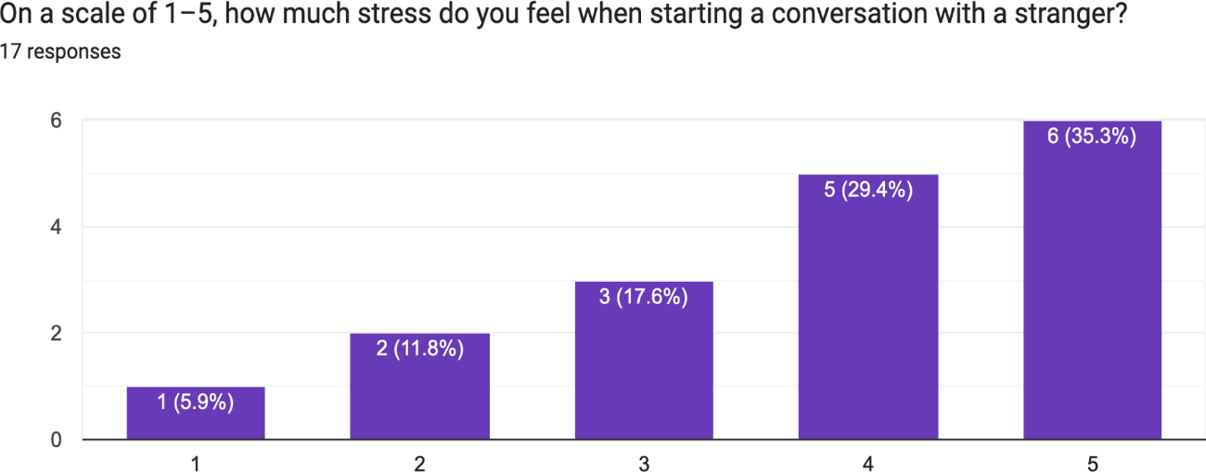

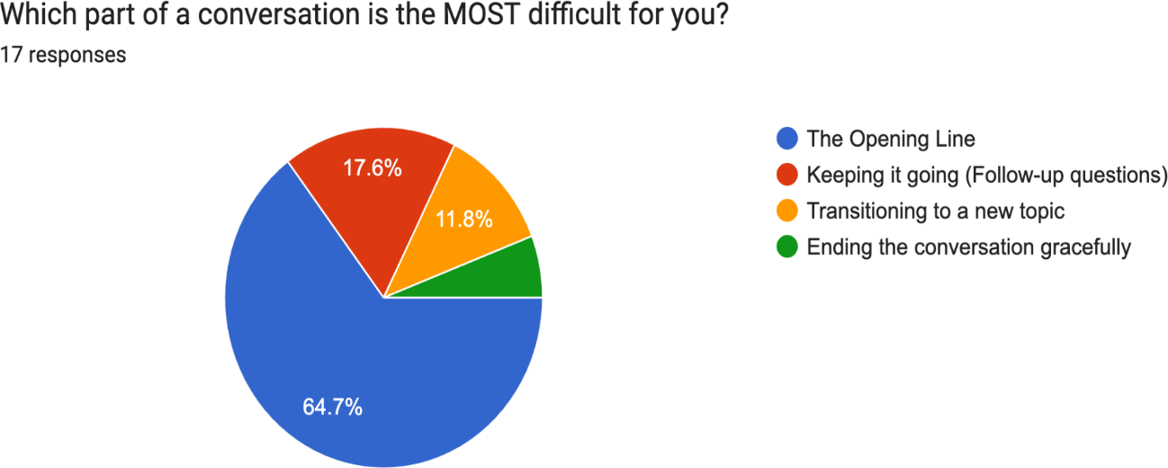
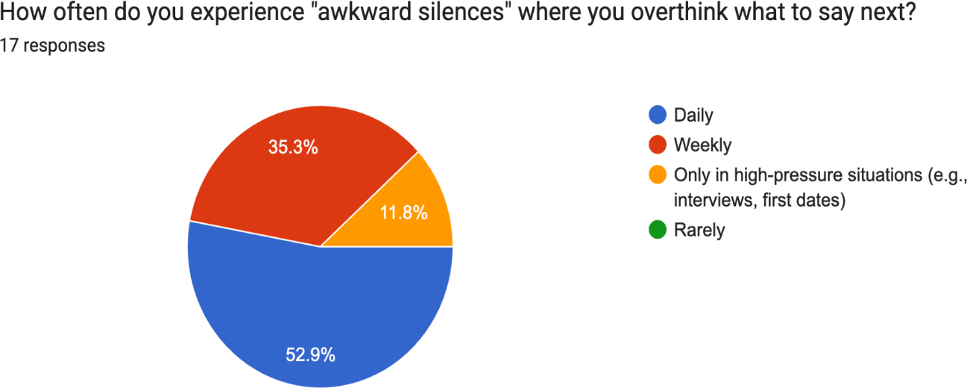

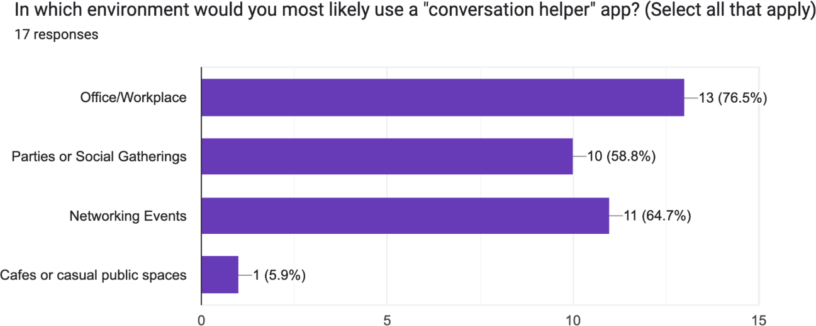

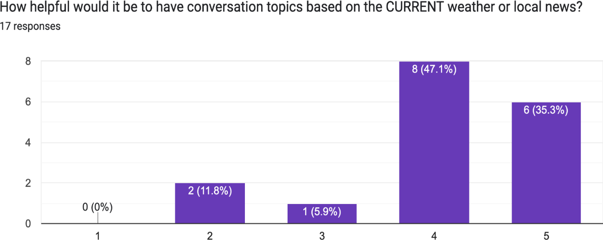

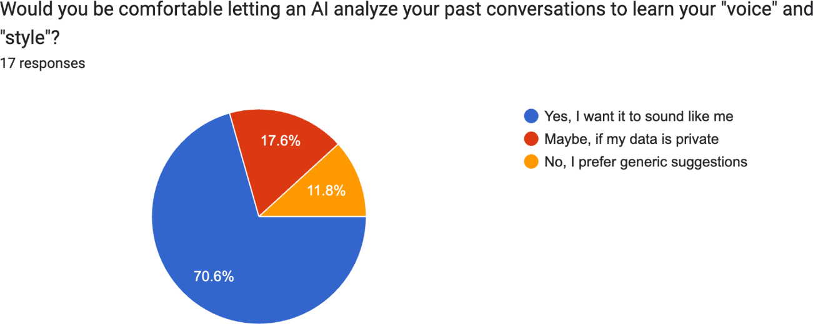

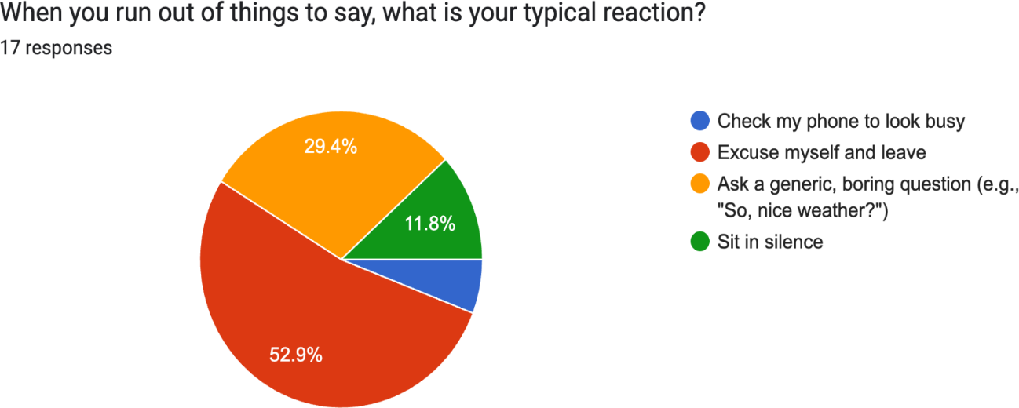

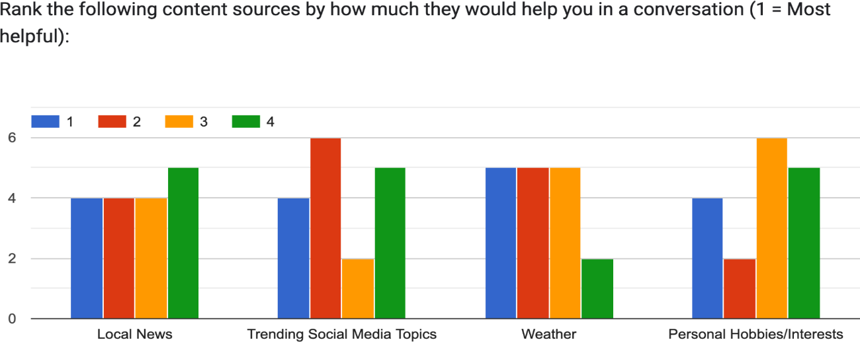

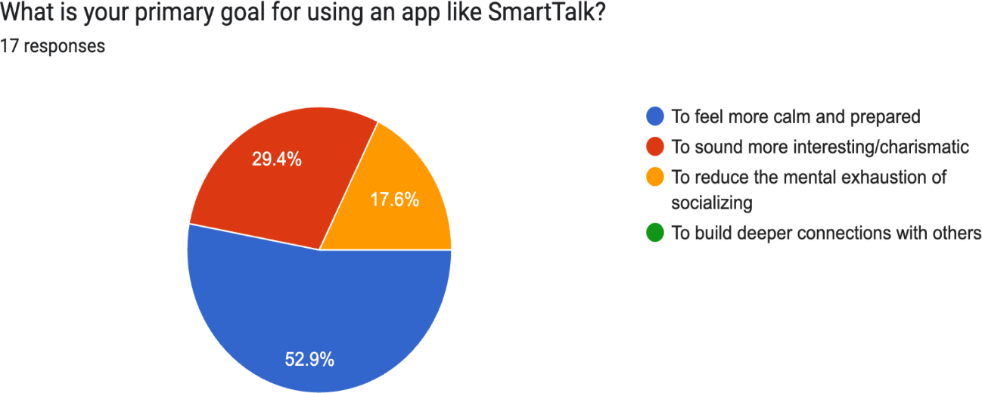

Insights from the Results
Based on the visualized and analyzed data, the following insights were derived:
- The "Opening Line" Bottleneck: Contrary to the initial assumption that "transitions" were the biggest pain point, 64% of respondents (11 out of 17) identified "The Opening Line" as their greatest challenge. Users struggle most with the very first step of engagement.
- Professional Context Dominance: The most frequent environments for app use were the Office/Workplace (13 mentions) and Networking Events (11 mentions). This suggests that SmartTalk is viewed more as a professional tool than a casual social helper for cafes or parties.
- High Demand for Personalization: 70% of users explicitly want the AI to "sound like them," and an additional 18% would consider it if privacy is guaranteed. This validates the proposal's focus on learning the user's conversational style.
- Weather as a Safe Anchor: Despite being a "cliché" small talk topic, users ranked
Weather as the most helpful content source. This indicates that users prefer "safe,"
low-risk topics to break the ice rather than diving into potentially polarizing news or niche hobbies.
- Preparation over Charisma: The primary goal for the majority of users (53%) is to feel "calm and prepared," rather than "sounding charismatic." The app should prioritize reducing cognitive load over providing "witty" or complex responses.

Requirements Generation
Personas and Scenarios
The Prepared Student (me): "Jiayu Lou the International Student"
Profile: A Douglas College student whose primary language is not English; he wants to improve spontaneous communication.
Motivation: He wants to build connections but often sits in silence because he doesn't know the "trending" topics in a new country.
Storyboard:
Frame 1: Jiayu sitting alone during the class break, wanting to talk to classmates but checking his phone to look busy.
Frame 2: He opens SmartTalk; the app uses the Social Media API to identify a local trending topics.
Frame 3: The app provides a specific "Opening Line" tailored to his student demographic. Frame 4: Jiayu asks a classmate about the concert. The app suggests a "Follow-up Question" to keep the momentum going.

Requirements Generation (done by you)
Functional Requirements
- Context Awareness Engine: The system must integrate Weather, Local News, and Social Media APIs to generate real-time topics.
- Multi-Stage Conversation Support: The app must provide distinct categories for "Opening Lines," "Follow-up Questions," and "Topic Transitions".
- Dynamic Personality Modeling: The AI must use NLP to analyze user input over time and adapt suggestions to match the user’s conversational style.
- Situation Toggles: Users must be able to select the social context (e.g., Office, Party, Networking) to filter the "vibe" of the suggestions.
- Quick-Access Widget: To assist in high-pressure situations, the app must offer a "one-tap" opening line feature accessible from a lock screen or smartwatch.
Non-Functional Requirements
- Low Latency: AI suggestions must be generated in under 2 seconds to be useful in real-time social situations.
- Authenticity Tone: Suggestions must avoid "robotic" phrasing to ensure the user feels the conversation is flowy and natural.
- Ease of Use: The UI must be high-contrast and scannable for users who are already feeling social anxiety or overthinking.
- Privacy & Data Security: As the app learns personality traits, it must provide clear documentation on how behavioral data is modeled and secured.

Part 3 Design and Prototype

Design
- Bottom Navigation Bar: Uses a standard four-tab pattern (Home, Scenarios, Practice, Profile) for high-level app navigation.
- Card-Based Layout: Information is grouped into rounded containers (cards), which helps separate "Weather," "Trending News," and "Scenarios" for better scannability.
- Gamification: Use of progress bars, "Advanced Proficiency" badges, and scoring (85/100) to encourage user retention.
- Dark Mode UI: A high-contrast dark theme with purple/neon accents, common in modern AI and utility apps.
Rationale for Specific Design Choices
- Typography: The use of a stylized, friendly serif font for headers creates a "personal coach" feel, while clean sans-serif text is used for data to ensure readability.
- Color Palette: Dark grey and deep purples evoke a sense of focus and technology (AI), while green and red are reserved for status indicators (Witty, Professional, Log Out).
- Visual Feedback: The "Live Practice" screen uses a waveform visualization to give the user immediate feedback that the AI is "listening," reducing user anxiety during roleplay.
Overall Workflow on Figma
- Discovery (Home): User checks daily context (weather/news) and selects a quick-start scenario.
- Preparation (Scenarios): User reviews AI-generated opening lines and transition phrases.
- Active Learning (Practice): User engages in real-time voice roleplay with coaching tools like "Pacing Guide."
- Feedback (Dashboard): After practice, the user receives a quantitative score and qualitative "Key Takeaways."
- Personalization (Profile): User adjusts settings, voice types, and data sharing.

Prototype in Figma
Home Scenario
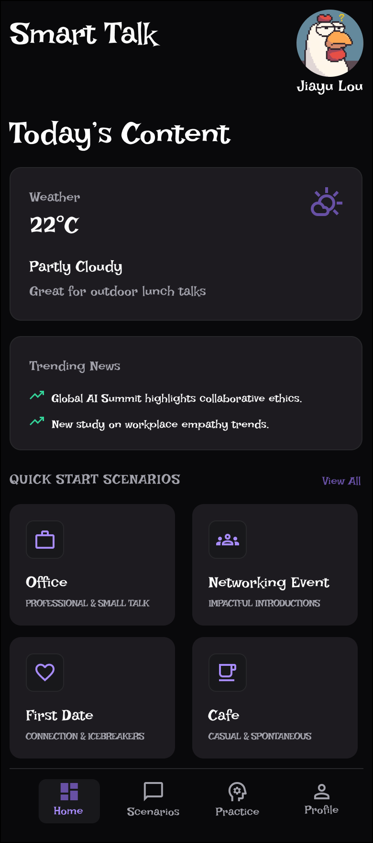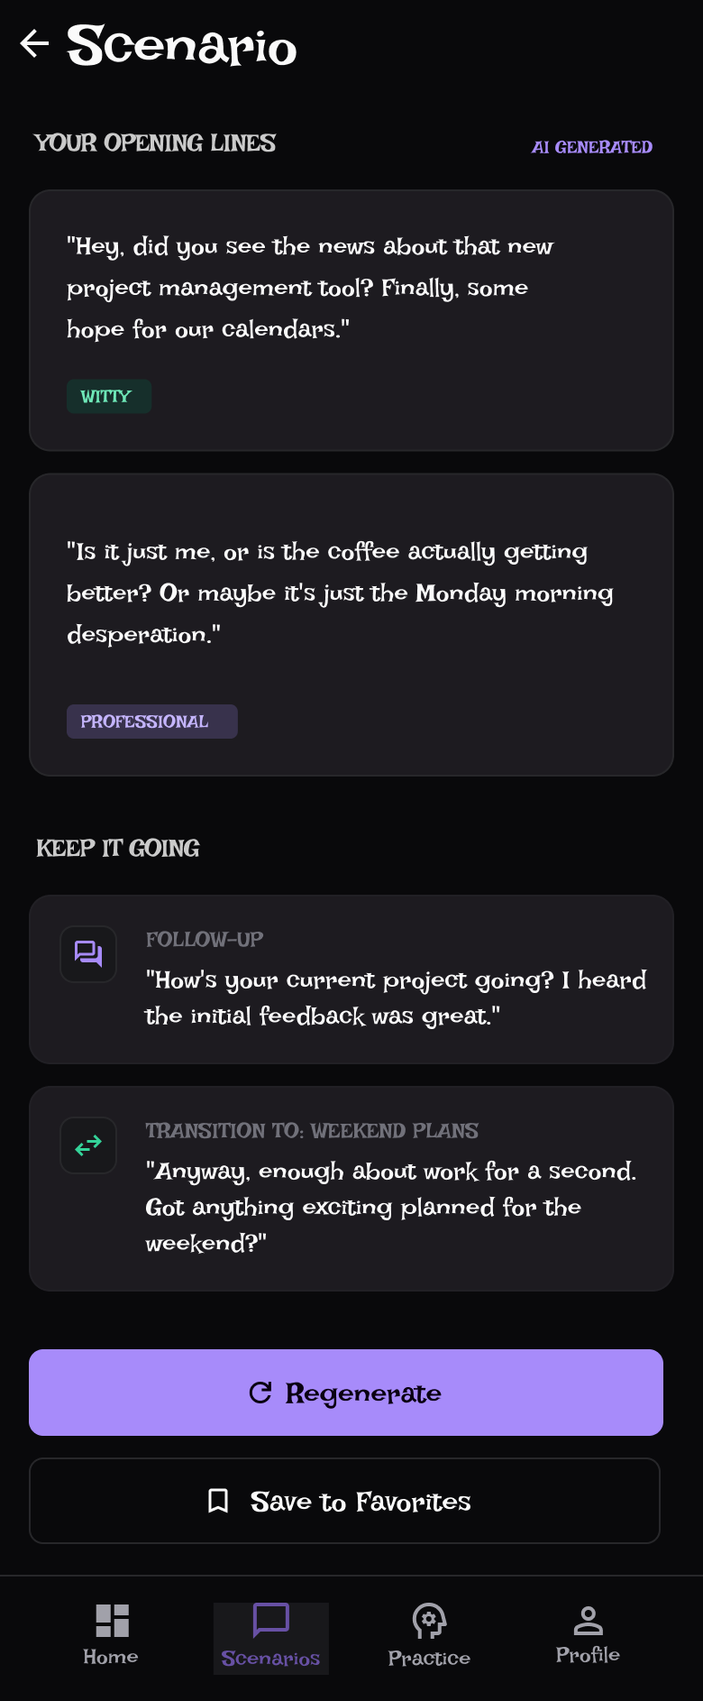

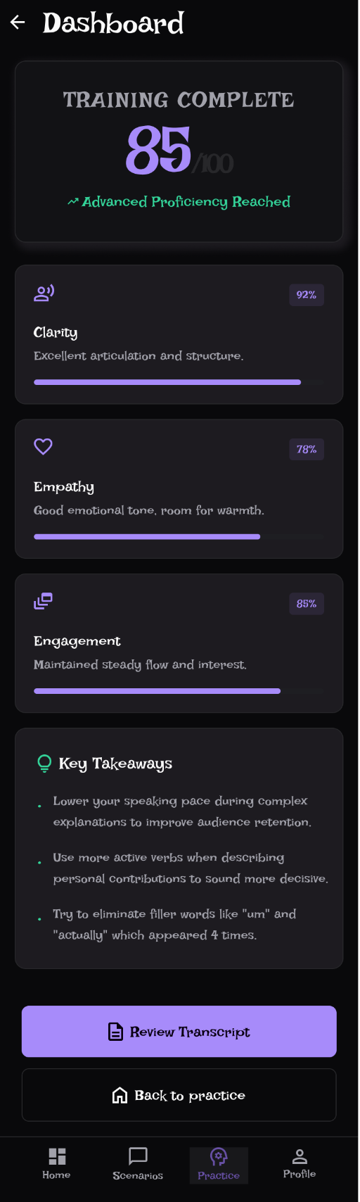
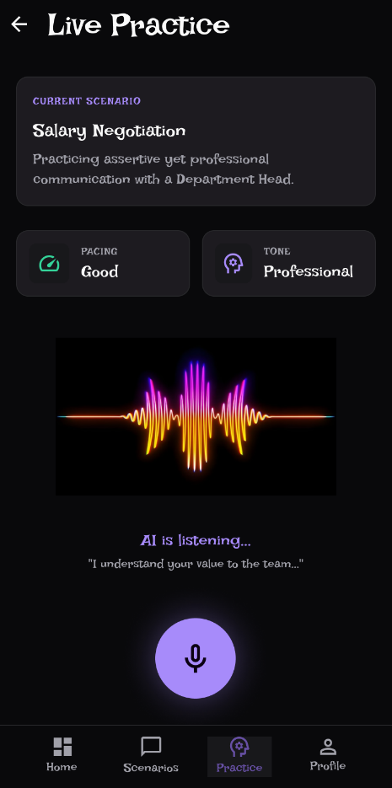
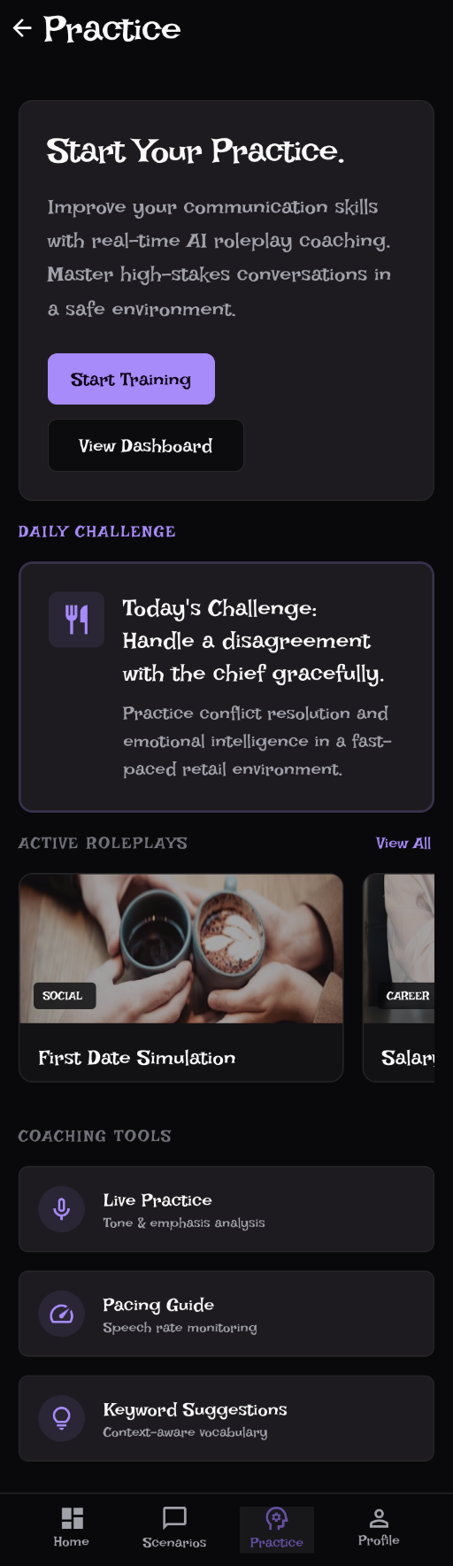
Practice Live Practice Dashboard

Profile
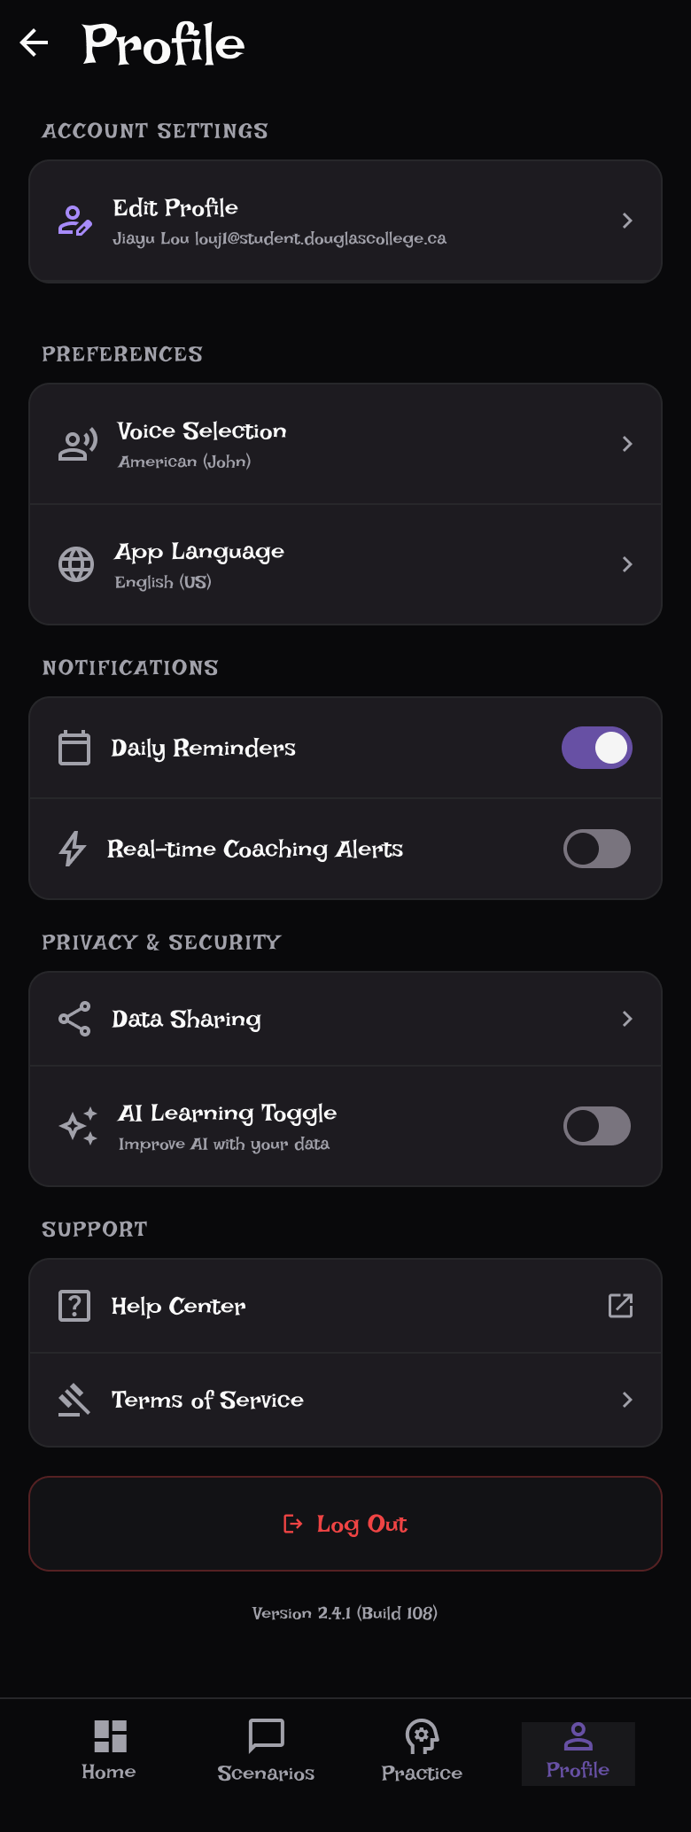

User-based Prototype Evaluation ( Not completed )
Objectives for User Study
- To determine if the "Live Practice" waveform provides enough confidence for users to speak naturally.
- To evaluate if the "Key Takeaways" are specific enough to lead to actual behavior change.
- To test the discoverability of the "Scenarios" tab vs. the "Quick Start" cards on the Home screen.
- To assess the legibility of the stylized header font for non-native English speakers.
Choice of User Study & User Sample
- Study Type: Interview & Usability Testing. I will observe users as they complete a "Practice" session and ask open-ended questions.
- Target Users: Douglas College students (specifically International Students or Business students) preparing for co-op interviews or networking.
- Perspective: Dual Perspective—Students (the primary learners) and Career Coaches/Faculty (to validate if the AI advice matches professional standards).

Reference

AI Use Section

AI Tool Name | Version, Account Type | Specific feature
Gemini | 2.5 | Cross-checking conversational tone suggestions  Generating alternative prompt styles  Generating the content of the content

Workload

Date | Number of hours | Description of work done
Feb 21 | 8 | Draft user study survey
Mar 6 | 8 | Collect feedback and finish the requirements generation
April 10 | 8 | Prototype in Figma
April 11 | 8 | Protype in Figma and final report

