W26_3375_S1_G7_SmartTalk_RequirementsDocument

Introduction
This is the SmartTalk app.
It's an AI-powered application that helps people handle daily small talk with different people in different situations.
Team member: Jiayu Lou | 300398003 Course: 3375
Section: 001

It's an AI-powered application give people opening lines, follow up questions, topic transitions for everyday conversation based on today's weather, news, or anything interesting. Saving people like me from the draining their head for the small talk topics, reducing awkward silences and social anxiety.

Requirements Gathering

Purpose or objectives for Requirements Gathering User Study
The primary goal of this study is to validate the core value proposition of SmartTalk and understand the specific pain points of users regarding social interactions. The objectives are to:
- Identify User Characteristics: Determine the level of social anxiety and the frequency of "blanking out" during small talk among the target demographic.
- Analyze Conversation Behavior: Understand which stages of a conversation (openers, follow-ups, or transitions) are most challenging for users.
- Evaluate Contextual Needs: Identify which specific environments (work, parties, or networking) create the most pressure for users.
- Assess AI Trust and Personalization: Gauge user willingness to let an AI learn their personality to provide "authentic" sounding suggestions.
- Prioritize Feature Integration: Determine if users find weather, news, or trending social media topics more valuable for real-time conversation starters.

Choice of user study and user sample
User Study Method: Survey. A quantitative and qualitative survey is chosen to gather a broad range of data points on social behavior and tech-readiness.
Target Users: * Young Professionals: People in office environments who need to network or engage in "water cooler" talk.
- Post-Secondary Students: Specifically those looking to improve spontaneous communication with strangers or peers.

Dual Perspective: Yes. The study will target both "Social Initiators" (those who want to lead conversations) and "Social Responders" (those who want to avoid awkward silences when others talk to them).

Draft of the User Study Survey or Interview:
https://forms.gle/9Lj3LukU1yGe9RY56

Data Visualization and Analysis

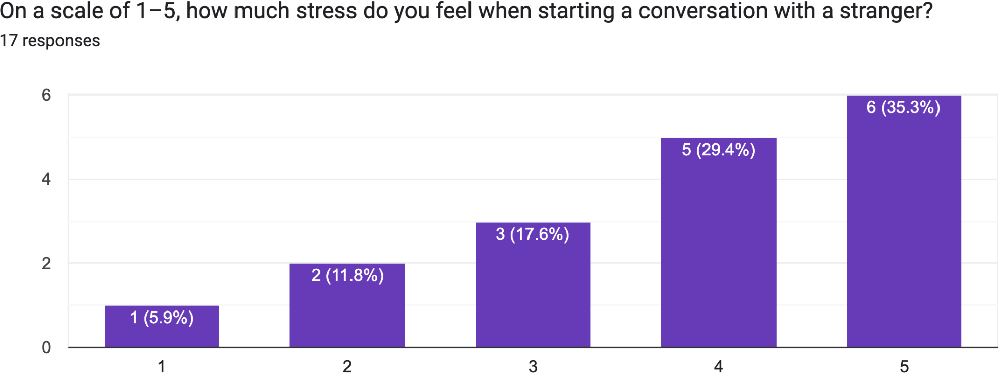

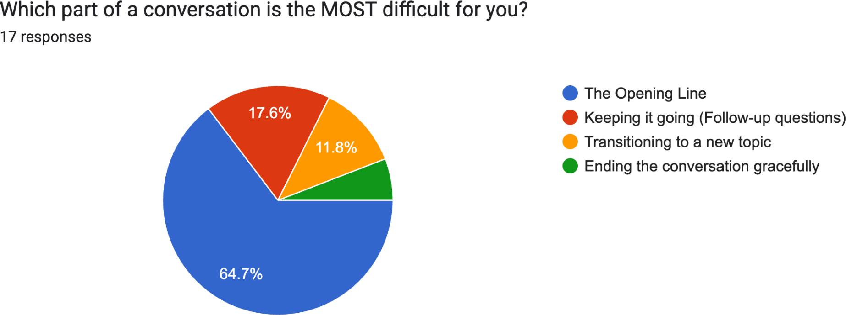

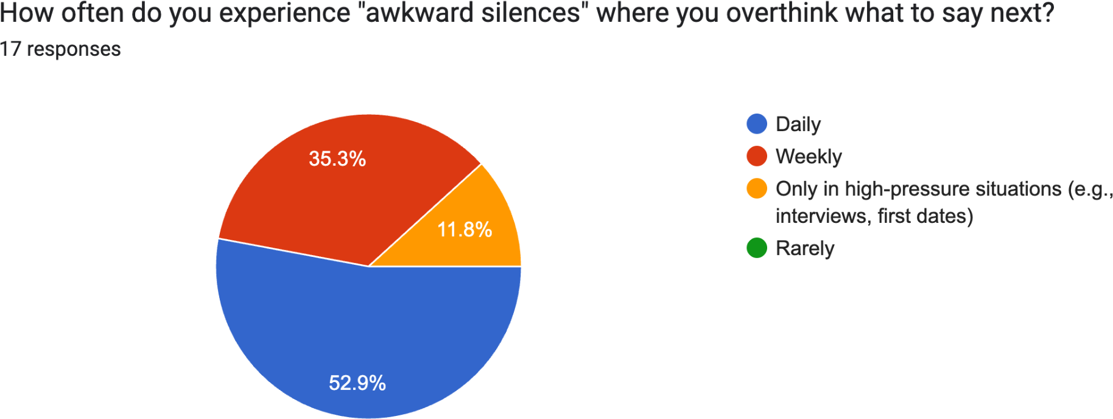

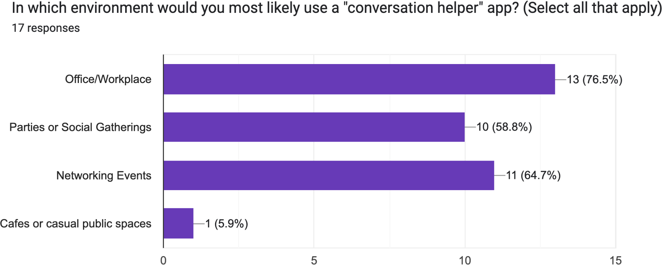

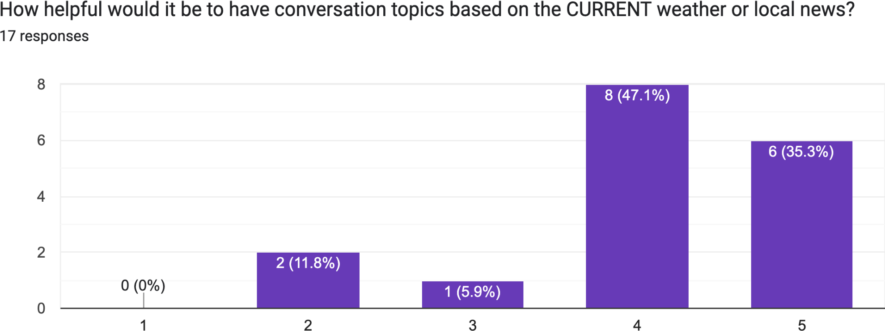

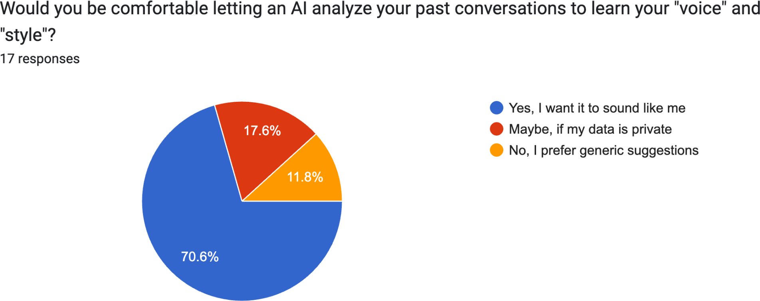

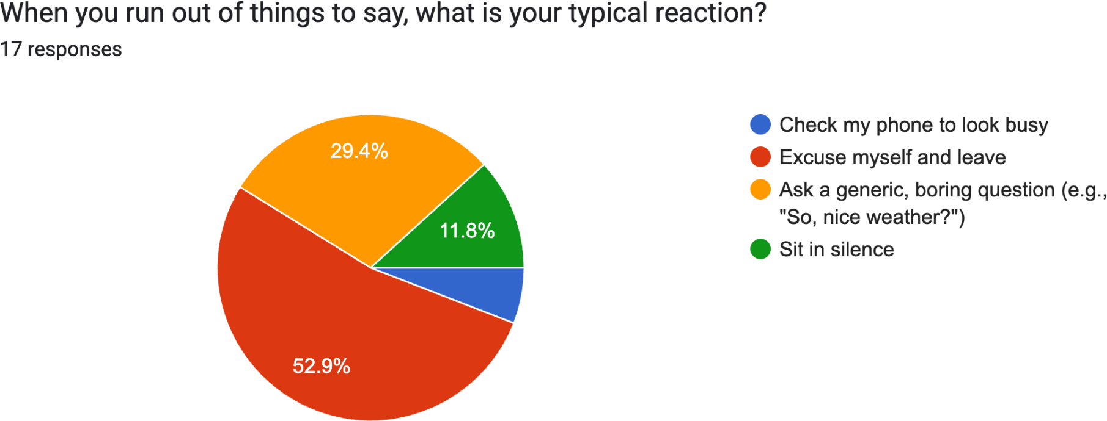

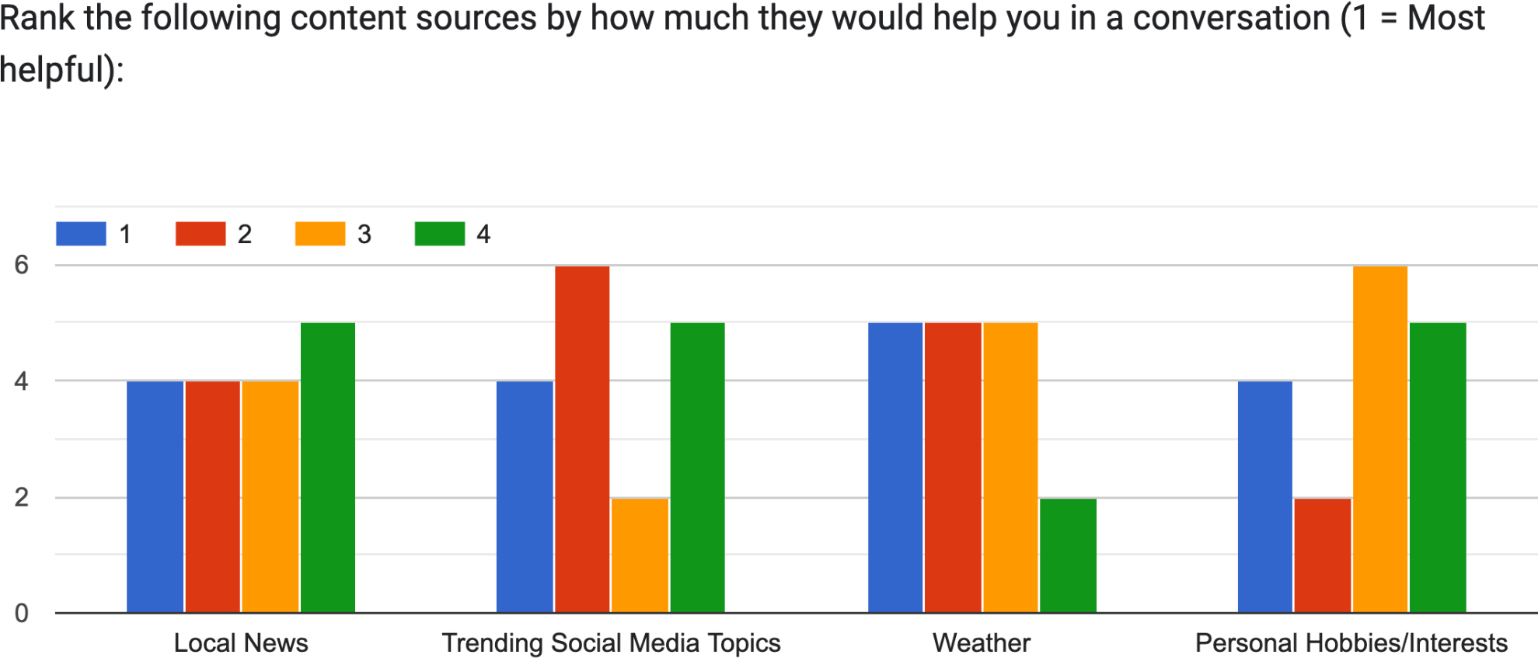

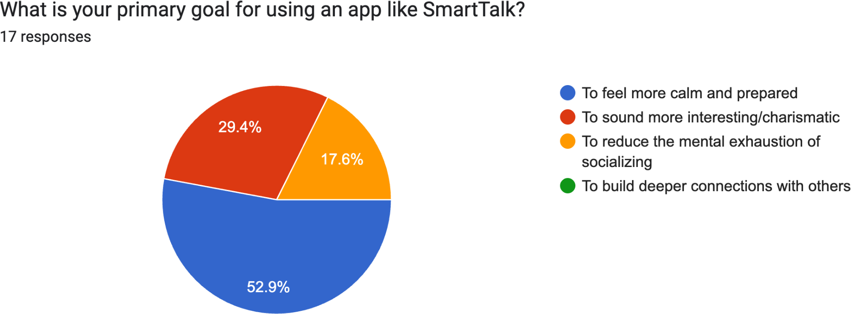

Insights from the Results
Based on the visualized and analyzed data, the following insights were derived:

- The "Opening Line" Bottleneck: Contrary to the initial assumption that "transitions" were the biggest pain point, 64% of respondents (11 out of 17) identified "The Opening Line" as their greatest challenge. Users struggle most with the very first step of engagement.
- Professional Context Dominance: The most frequent environments for app use were the Office/Workplace (13 mentions) and Networking Events (11 mentions). This suggests that SmartTalk is viewed more as a professional tool than a casual social helper for cafes or parties.
- High Demand for Personalization: 70% of users explicitly want the AI to "sound like them," and an additional 18% would consider it if privacy is guaranteed. This validates the proposal's focus on learning the user's conversational style.
- Weather as a Safe Anchor: Despite being a "cliché" small talk topic, users ranked
Weather as the most helpful content source. This indicates that users prefer "safe,"
low-risk topics to break the ice rather than diving into potentially polarizing news or niche hobbies.
- Preparation over Charisma: The primary goal for the majority of users (53%) is to feel "calm and prepared," rather than "sounding charismatic." The app should prioritize reducing cognitive load over providing "witty" or complex responses.

Requirements Generation

Personas and Scenarios
The Prepared Student (me): "Jiayu Lou the International Student"
Profile: A Douglas College student whose primary language is not English; he wants to improve spontaneous communication.
Motivation: He wants to build connections but often sits in silence because he doesn't know the "trending" topics in a new country.
Storyboard:
Frame 1: Jiayu sitting alone during the class break, wanting to talk to classmates but checking his phone to look busy.
Frame 2: He opens SmartTalk; the app uses the Social Media API to identify a local trending topics.
Frame 3: The app provides a specific "Opening Line" tailored to his student demographic. Frame 4: Jiayu asks a classmate about the concert. The app suggests a "Follow-up Question" to keep the momentum going.

Requirements Generation (done by you)

Functional Requirements
- Context Awareness Engine: The system must integrate Weather, Local News, and Social Media APIs to generate real-time topics.
- Multi-Stage Conversation Support: The app must provide distinct categories for "Opening Lines," "Follow-up Questions," and "Topic Transitions".
- Dynamic Personality Modeling: The AI must use NLP to analyze user input over time and adapt suggestions to match the user’s conversational style.
- Situation Toggles: Users must be able to select the social context (e.g., Office, Party, Networking) to filter the "vibe" of the suggestions.
- Quick-Access Widget: To assist in high-pressure situations, the app must offer a "one-tap" opening line feature accessible from a lock screen or smartwatch.

Non-Functional Requirements
- Low Latency: AI suggestions must be generated in under 2 seconds to be useful in real-time social situations.
- Authenticity Tone: Suggestions must avoid "robotic" phrasing to ensure the user feels the conversation is flowy and natural.
- Ease of Use: The UI must be high-contrast and scannable for users who are already feeling social anxiety or overthinking.
- Privacy & Data Security: As the app learns personality traits, it must provide clear documentation on how behavioral data is modeled and secured.

AI Use Section

AI Tool Name | Version, Account Type | Specific feature
Gemini | 2.5 | Cross-checking conversational tone suggestions  and generating alternative prompt styles

Workload

Date | Number of hours | Description of work done
Feb 21 | 8 | Draft user study survey
Mar 6 | 8 | Collect feedback and finish the requirements generation

