IERG_4180_Project4_Report

Note:

* This lab also implemented HTTP UDP mode.
* The generated certificate-related files are placed in the certificate/ directory of the main directory.

Experiment 1: Investigate the system performance impact of HTTPS over HTTP.

HTTP:

Command1.1: httperf --server localhost --port 4080 --num-conns=10000

Output:

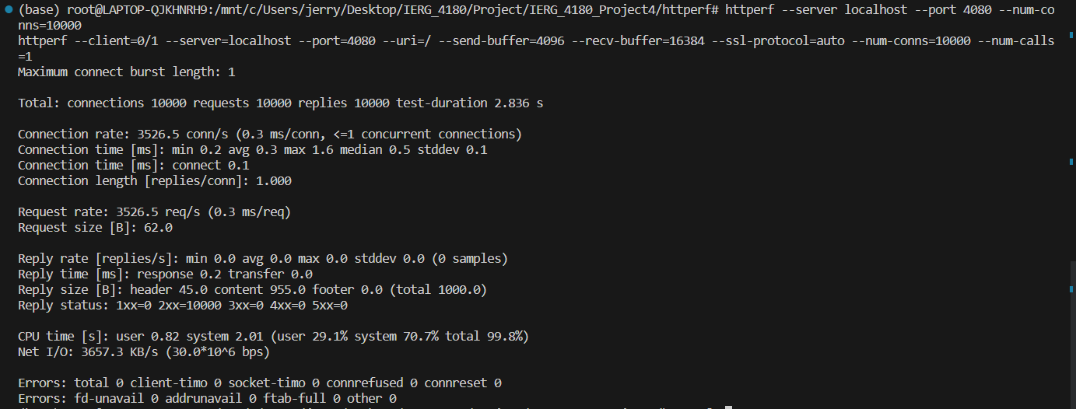

Command1.2: httperf --server localhost --port 4080 --num-conns=100000

Output:

HTTPs:

Command2.1: httperf --server localhost --port 4081 --num-conns=10000 --ssl

Output:

Command2.2: httperf --server localhost --port 4081 --num-conns=100000 --ssl

Output:

Setting:

* Both httperf and netprobserver are run locally
* Unplug the power of my laptop to add some degree of latency for measurement.
* The response packet of http and https is 1000 bytes.
* We performed two experiments for HTTP and HTTPS, with 10000 and 100000 HTTP requests in total, and observed the output.

Observation:

* Overall we can see that the performance of the HTTP is about 10 times faster than the HTTPS.
* For HTTP, the connection rate is around 3530 connections/second, and the reply rate is around 3370 replys/second.
* For HTTPS, the connection rate is around 327 connections/second, and the reply rate is around 311 replys/second.
* We also observed that the number of HTTP/HTTPS requests sent from httperf does not impact the performance overall.