Home

Logo in top left and name below the logo

Categories

Double beds

Almirah

Dining tables

Sofa cum beds

Sofa

Beside search , latest products , Instagram logo or link

3 carousels including a dining table and sofa

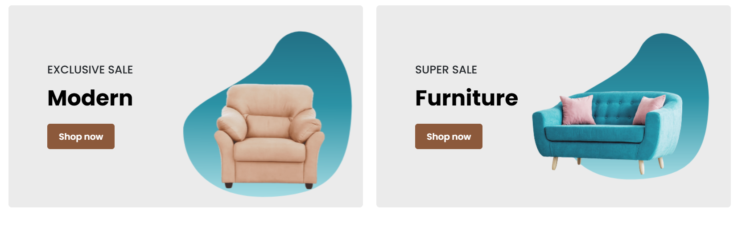

Instead of supersale provide latest

Below Latest and special discount, limited offers

Free shipping upto 5kms orders above 100000

Standardise products

Guaranteed quality

Latest Blog remove and put customer reviews

Products Page

Pictures required

About us page

Content required

<!DOCTYPE html>

<html lang="en">

<head>

    <meta charset="UTF-8" />

    <title>Product Details</title>

    <link rel="stylesheet" href="./assets/css/styles.css">

</head>

<body>

    <div class="product-detail" id="productDetail"></div>

    <script>

        const product = JSON.parse(localStorage.getItem('selectedProduct'));

        if (product) {

            const imagesHTML = product.images.map(img => `<img src="${img}" alt="${product.name}" />`).join('');

            document.getElementById('productDetail').innerHTML = `

      <div class="product-images">${imagesHTML}</div>

      <h1>${product.name}</h1>

      <p><strong>Price:</strong> ${product.price}</p>

      <p>${product.description}</p>

      <button onclick="window.history.back()">Go Back</button>

    `;

        } else {

            document.getElementById('productDetail').innerHTML = "<p>Product not found</p>";

        }

    </script>

</body>

</html>