ArtBot
Large-Scale Vertical Drawing Machine

Hardware Plan & Architecture Document

IIT Delhi — Abu Dhabi
March 2026

Table of Contents
1. Project Overview
2. Project Roadmap
3. System Architecture
4. Architecture Comparison (Why Dual-Y Cartesian?)
5. Drive System Comparison
6. Motor Selection
7. Stepper Driver Comparison
8. Pen Lift Mechanism
9. Controller & Firmware
10. Rail & Frame Selection
11. Counterweight System
12. Electronics & Wiring
13. Software Pipeline
14. Bill of Materials
15. Assembly Plan
16. GRBL Configuration
17. Failure Modes & Mitigations
18. References & Resources

1. Project Overview
ArtBot is a large-scale robotic drawing machine that converts digital images into pen drawings on a large vertical surface (whiteboard, paper, canvas). Unlike typical CNC plotters that operate on horizontal surfaces, this machine works on a vertical plane — meaning the mechanical design must account for gravity acting on all moving components.

Key Specifications
Parameter | Value
Board Size | 180 cm × 120 cm (vertical)
Buffer Zone | 5 cm on all sides
Usable Drawing Area | 170 cm × 110 cm
Origin | Top-left corner
Motion System | Dual-Y Cartesian with counterweights
Motors | 3× NEMA 17 steppers + 1× SG90 servo
Controller | Arduino Uno + CNC Shield V3 + GRBL firmware
Drivers | 3× TMC2209
Resolution | 80 steps/mm (0.0125 mm per step)
Pen Tip Width | 0.5–1.0 mm (40–80× larger than step size)

The Three Axes
Axis | Function | Mechanism
X | Horizontal (left–right) | Belt + motor on rail
Y | Vertical (up–down) | Dual motors + belts + counterweights
Z | Pen up/down | SG90 servo + compression spring

2. Project Roadmap
ArtBot is being developed in phases. The current focus is Phase 1: getting the machine to produce clean black-and-white line drawings with a single pen. Multi-color pen switching and advanced output techniques are planned for future phases.
Our architecture choices (Dual-Y Cartesian, rigid rails, precise homing) were made with all three phases in mind — so we won't have to rebuild the machine when we add capabilities.
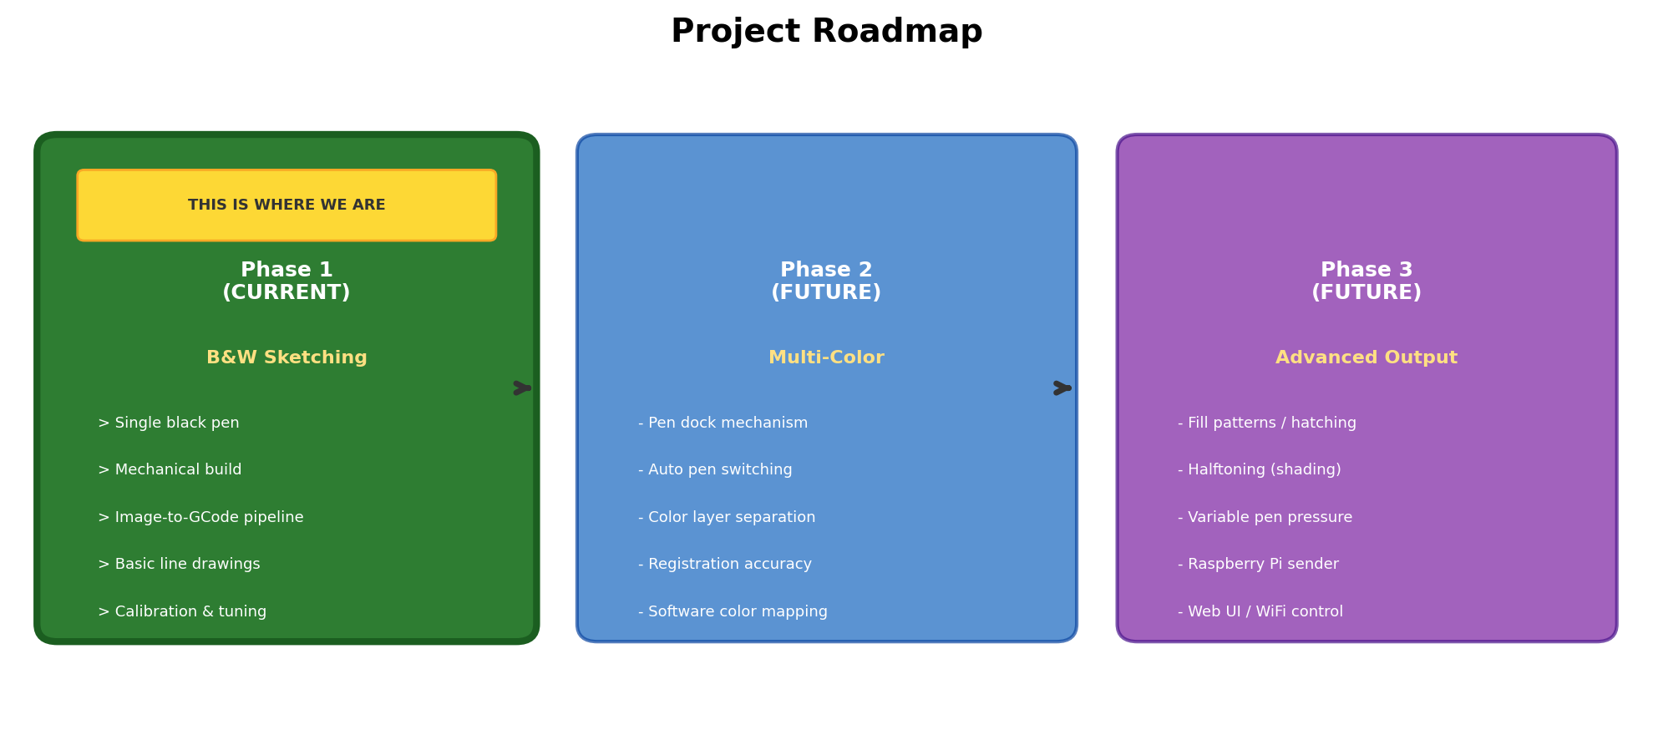

Phase 1 — Black & White Sketching (Current)
- Single black pen (marker, felt-tip, or ballpoint)
- Mechanical skeleton: frame, rails, motors, counterweights
- Electronics: Arduino + CNC Shield + GRBL + TMC2209 drivers
- Software pipeline: image to edge detection to contours to G-Code
- Calibration: homing, steps/mm tuning, test square verification
- Goal: produce clean, recognizable line drawings on the board

Phase 2 — Multi-Color (Future)
- Pen dock mechanism at top of board (row of pen holders at known coordinates)
- Automatic pen switching: carriage moves to dock, drops current pen, picks up next color
- Color layer separation in software (split image into color channels → separate G-Code passes)
- Registration accuracy: machine must return to exact coordinates between pen changes
- This is why we chose rigid rails over cables — cables can't guarantee return precision

Phase 3 — Advanced Output (Future)
- Fill patterns and hatching (parallel lines at varying density for shading)
- Halftoning (dots of varying size/spacing to simulate grayscale)
- Variable pen pressure via Z-axis stepper upgrade (replaces servo)
- Raspberry Pi as wireless G-Code sender (web UI, file storage, WiFi control)
- Integration with vpype (plotter-specific path optimization library)
Everything in this document focuses on Phase 1. Phases 2 and 3 are mentioned only to explain why certain architectural decisions were made (e.g., choosing rigid rails over cables for future pen-switch registration).

3. System Architecture
The diagram below shows the complete machine layout as seen from the front. Two Y-motors at the top corners move the horizontal X-rail up and down. A third motor on the X-rail moves the pen carriage left and right. Counterweights behind the board balance the X-rail's weight.
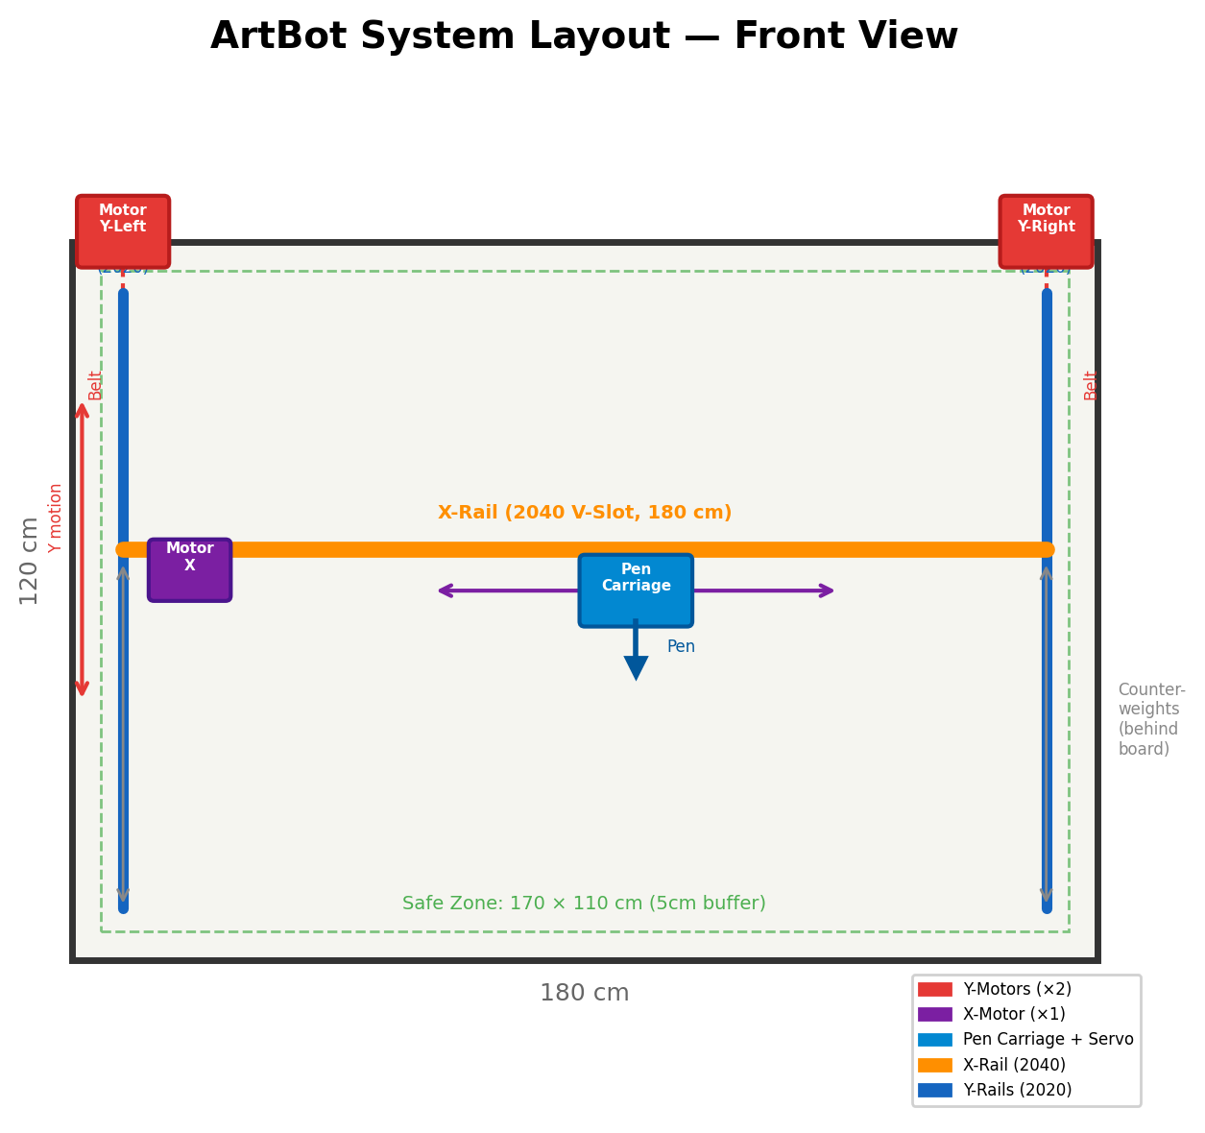

4. Architecture Comparison
We evaluated four motion architectures for a 180×120 cm vertical plotter. The diagram below shows all four side by side, followed by a detailed comparison.
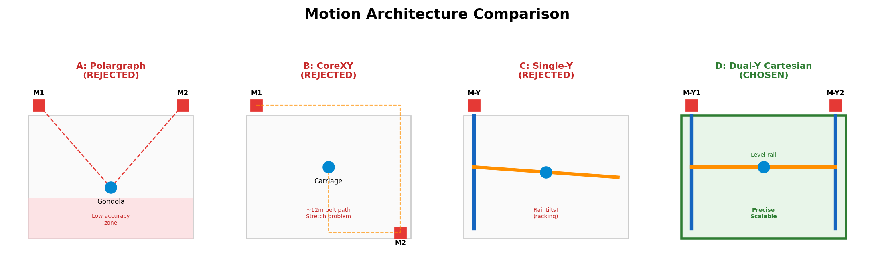

A: Polargraph / V-Plotter — REJECTED
Two motors at top corners suspend a pen gondola on cables. Used by: Makelangelo, Maslow CNC, Penelope, Stringent.
- Why rejected:
- Accuracy collapses at bottom corners — the Jacobian of the coordinate transform shows resolution drops dramatically below the motor line. Most builders recommend 15% margins, wasting ~30% of our board.
- Gondola swings on fast direction changes — must draw very slowly.
- Cable stretch accumulates over long drawings, causing drift.
- Multi-color pen switching is nearly impossible (gondola sways during docking).
- Penelope's builder reported accuracy issues 'especially near the bottom and on curves.'

B: CoreXY / H-Bot — REJECTED
Two stationary motors drive a single continuous belt loop. Used by: most modern 3D printers (Voron, Bambu Lab), Stefan van Seggelen's large plotter.
- At 180×120 cm, total belt path is ~12 meters — belt stretch is unmanageable with standard GT2.
- Stefan van Seggelen's build required 15mm steel-core GT2 belts (expensive, hard to source).
- Getting two 6-meter belt paths tensioned identically is nearly impossible for a first build.
- H-Bot variant introduces rotational torque on diagonal moves, causing skew.

C: Single-Y Cartesian — REJECTED
One motor per axis — simplest possible setup.
- Single motor driving one side of a 180 cm rail causes severe racking (rail tilts).
- No large-format CNC machine uses single-Y drive — it simply doesn't work at this scale.

D: Dual-Y Cartesian — CHOSEN
Two synchronized Y-motors (one per side) move the X-rail vertically. A third motor drives the pen carriage horizontally. Counterweights balance gravity. Used by: iDraw H (commercial, ±0.02mm precision), OpenBuilds ACRO, every large CNC router.
- Anti-racking: both sides of the rail move simultaneously, keeping it perfectly level.
- Short belt runs (~260 cm each) — minimal stretch compared to CoreXY's 12m.
- Counterweight-friendly: symmetric design enables easy balancing.
- Pen-switch ready: rigid rail means precise return to coordinates for multi-color.
- GRBL natively supports dual-Y axis with the CNC Shield's A-axis clone jumper.
- Proven at scale by commercial and DIY machines worldwide.

Architecture Decision Matrix
Criteria | Polargraph | CoreXY | Single-Y | Dual-Y (Ours)
Precision at corners | Poor | Good | Poor | Excellent
Scale to 180cm | Easy | Hard | OK | Proven
Belt stretch risk | N/A (cables) | Severe | Low | Low
Anti-racking | N/A | Good | None | Excellent
Multi-color future | Very hard | Possible | Hard | Easy
Build complexity | Low | High | Low | Medium
Cost | $15–100 | $200+ | $100 | $150–200
Community support | Large | Medium | N/A | Large

5. Drive System Comparison
Drive Type | Speed | Stretch | Self-Lock (Gravity Safe) | Cost | Verdict
GT2 Timing Belt | Fast (5000 mm/min) | ~0.2% | No — needs counterweight | $5–10 / 10m | CHOSEN
Lead Screw (T8) | Slow (500 mm/min) | ~0 | Yes — self-locking | $20–30 / 120cm | Rejected (too slow)
Ball Screw | Fast | ~0 | No | $100–300 / 120cm | Rejected (too expensive)
Cable / Fishing Line | Medium | High | No | $1 | Rejected (stretch)
Beaded Chain | Medium | Low | No | $5–10 | Rejected (backlash)
Rack & Pinion | Fast | ~0 | No | $50+ / 180cm | Rejected (cost)

GT2 timing belt wins on speed, cost, and community support. The self-locking disadvantage is solved by counterweights — when balanced, the rail stays in place even with power off.

6. Motor Selection
Motor | Frame Size | Torque | Weight | Current | Voltage | Cost | Verdict
NEMA 14 | 35mm | 10–20 Ncm | ~150g | 0.5–1A | 12V | $5–8 | Too weak
NEMA 17 | 42mm | 40–65 Ncm | ~280g | 1.2–2A | 12V | $8–15 | CHOSEN
NEMA 23 | 57mm | 100–300 Ncm | ~600g | 2–4A | 24V | $20–40 | Overkill
Closed-Loop Servo | Varies | High | ~400g | Varies | 24V+ | $50+ | Too expensive

With counterweights eliminating gravity load, NEMA 17 (>45 Ncm) provides more than enough torque to position the rail. NEMA 23 would add unnecessary weight to the carriage and require 24V power and higher-current drivers.

7. Stepper Driver Comparison
Driver | Max Current | Microstepping | Noise | Cost | Verdict
A4988 | 2A (1A safe) | 1/16 | Very loud | $1–2 | Rejected (noise)
DRV8825 | 2.2A (1.5A safe) | 1/32 | Loud | $2–3 | Rejected (noise)
TMC2209 | 2.8A RMS | 1/256 | Near silent | $3–5 | CHOSEN

TMC2209's StealthChop mode makes motor operation nearly silent — critical for a machine that may run 30+ minutes per drawing. The extra $1–2 per driver is a trivial cost. Drop-in compatible with CNC Shield V3 (same pinout as A4988).

8. Pen Lift Mechanism
On a vertical board, gravity pulls the pen AWAY from the surface. A compression spring pushes the pen toward the board. The servo retracts the pen when traveling between strokes.
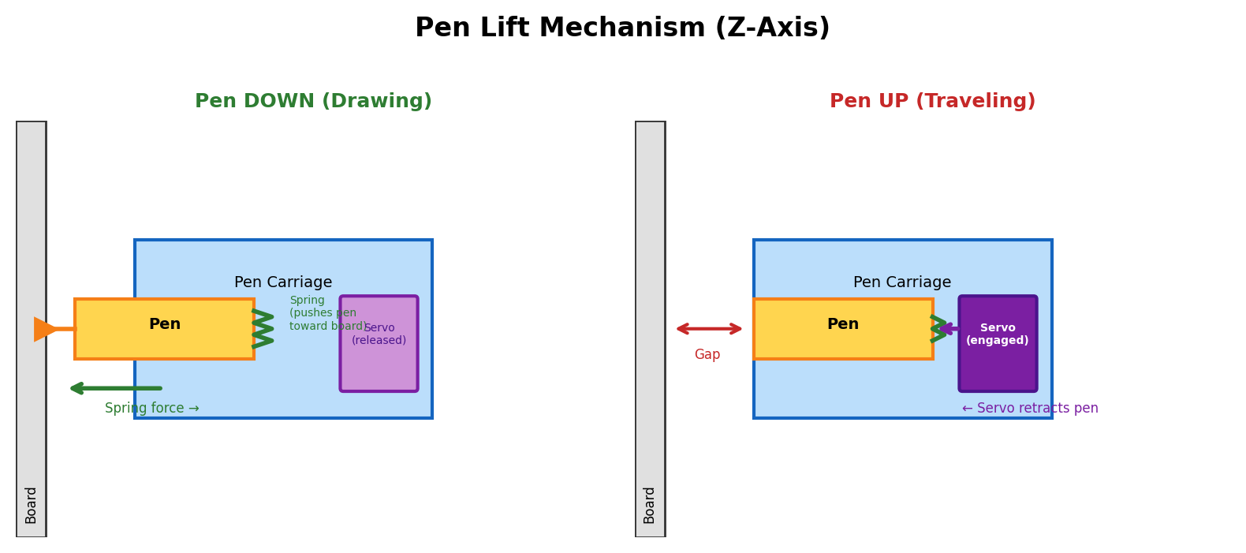
Mechanism | Weight | Speed | Power | Cost | Verdict
SG90 Servo | 9g | 0.1s / 60° | 5V (from Arduino) | $1–2 | CHOSEN
Solenoid | 30–80g | 5–10ms | 12V continuous | $5–10 | Rejected (thumps board)
Stepper Motor | 200g+ | Variable | Needs extra driver | $10+ | Rejected (too heavy)

9. Controller & Firmware
Option | Real-Time? | Dual-Y Support | WiFi | Complexity | Verdict
Arduino Uno + GRBL | Yes | Native (A-axis clone) | No | Low | CHOSEN (v1)
Arduino Mega + Marlin | Yes | Yes | No | Medium | Overkill (3D printer firmware)
ESP32 + FluidNC | Yes | Yes | Yes | Medium | Future upgrade path
Raspberry Pi (alone) | No | N/A | Yes | High | Rejected (not real-time)

GRBL on Arduino Uno is the proven standard for 3-axis CNC. It generates motor pulses with microsecond precision and has a look-ahead algorithm that smooths curves automatically. A Raspberry Pi can be added later as a wireless G-Code sender, but cannot replace the Arduino for real-time motor control.

10. Rail & Frame Selection
Profile | Cross Section | Stiffness (Iy) | Weight/m | Deflection at 180cm, 1kg | Use
V-Slot 2020 | 20×20 mm | ~0.7 cm⁴ | ~0.5 kg | ~4 mm (UNACCEPTABLE) | Y-rails, frame
V-Slot 2040 | 20×40 mm | ~3.3 cm⁴ | ~0.9 kg | ~0.9 mm (acceptable) | X-RAIL (chosen)
V-Slot 4040 | 40×40 mm | ~7.0 cm⁴ | ~1.6 kg | ~0.4 mm (excellent) | Not needed

The X-rail (180 cm horizontal span) must be 2040 or stiffer. A 2020 rail will visibly bow at the center. Adding a flat aluminum backing strip (3mm × 30mm × 180cm) to the 2040 provides additional rigidity at almost no cost.

11. Counterweight System
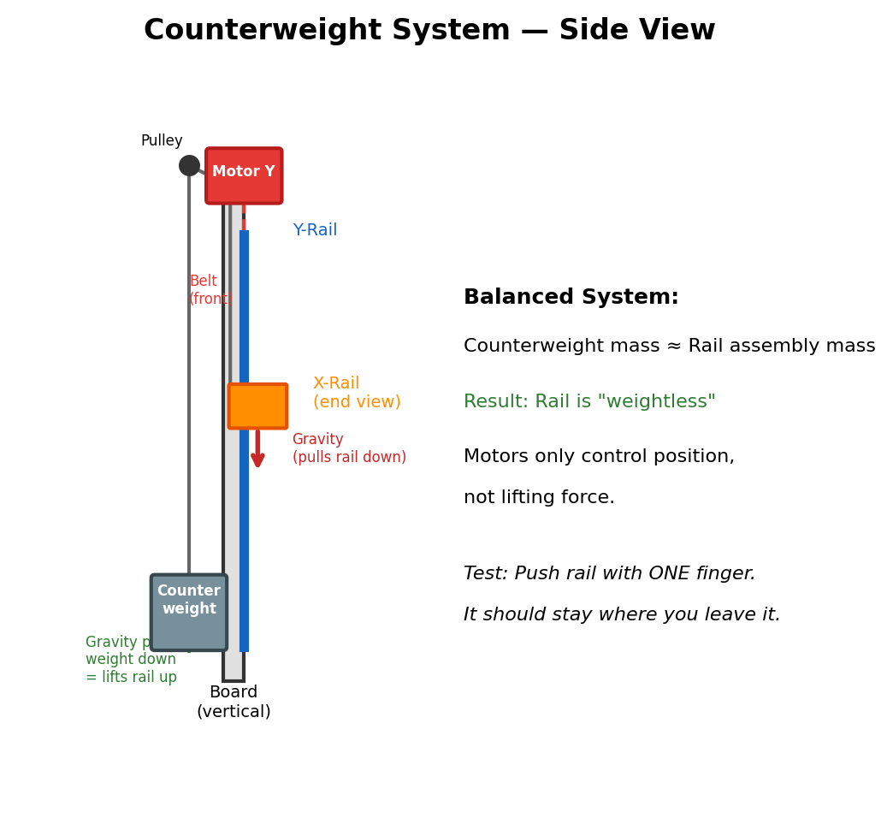

Balancing Procedure
1. Fully assemble the X-rail: rail + carriage + X-motor + servo + pen holder + all brackets.
2. Weigh the complete assembly on a kitchen scale.
3. Start with counterweight at ~95% of that mass (slightly under-balanced).
4. Hang counterweights behind the board via cables routed over top pulleys.
5. The One-Finger Test: push the rail with one finger. It should move smoothly and stay exactly where you leave it.
6. If the rail drifts down: add weight. If it drifts up: remove weight.
7. Once balanced, secure the counterweights so they cannot shift.

12. Electronics & Wiring
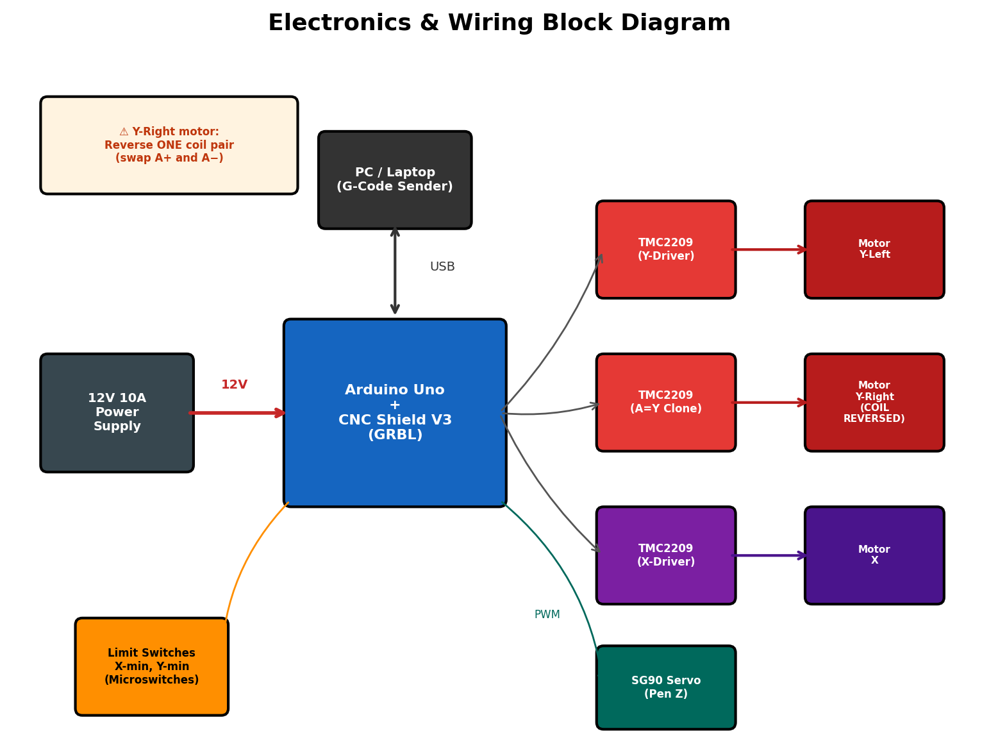

Critical Wiring Note — Dual Y-Motors
WARNING: The two Y-motors face opposite directions physically. If you clone them with identical signals (via the A-axis jumper), one will push UP while the other pushes DOWN. The rail will jam and potentially break.
Fix: On ONE of the two Y-motors, swap the wiring of one coil pair. If the motor connector has 4 wires [A+, A−, B+, B−], swap A+ and A− on that one motor. This reverses its rotation, making both motors move the rail in the same direction.

13. Software Pipeline
The software converts a digital image into G-Code instructions that the Arduino executes.
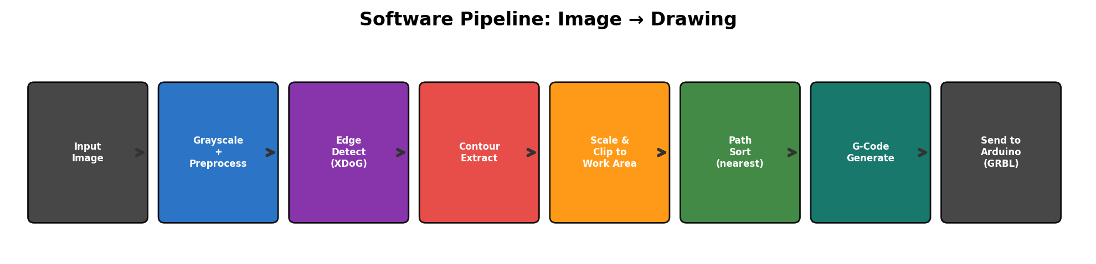
The pipeline is implemented in Python and is fully functional. Three CLI tools are provided:
- convert.py — converts an image to .gcode (the main pipeline)
- simulate.py — visualizes the G-Code as an animated pen plotter preview
- tune.py — interactive slider interface for tuning edge detection parameters

14. Bill of Materials

Structural
Item | Spec | Qty | Purpose
V-Slot 2040 Extrusion | 180 cm | 1 | X-axis horizontal rail
V-Slot 2020 Extrusion | 120 cm | 2 | Y-axis vertical rails
V-Slot 2020 Extrusion | 180 cm | 2 | Frame top & bottom
90° Angle Brackets | V-Slot compatible | 8 | Corner joints
T-Nuts + M5×8 Bolts | M5 | 50+ pack | Securing components
Flat Aluminum Bar | 3mm × 30mm × 180cm | 1 | X-rail stiffener

Motion
Item | Spec | Qty | Purpose
GT2 Timing Belt | 6mm wide, open-ended | 10m roll | All axis drive
GT2 Pulley (20-tooth) | 5mm bore | 3 | Motor shafts
GT2 Idler Pulley | 5mm bore | 5 | Belt routing
V-Slot Gantry Plate | Standard OpenBuilds | 3 | Rail carriages
Mini V-Wheels (Delrin) | Standard | 12 | 4 per gantry plate
Eccentric Spacers | Standard | 6 | Wheel tension adjust
Belt Tensioners | Adjustable, spring-loaded | 3 | One per belt run

Motors & Electronics
Item | Spec | Qty | Purpose
NEMA 17 Stepper Motor | >45 Ncm, 1.5–2A | 3 | X + Y-Left + Y-Right
SG90 Micro Servo | Standard | 1 | Pen lift (Z-axis)
Motor Mounting Bracket | NEMA 17 L-bracket | 3 | Motor mounting
Arduino Uno R3 | Original or clone | 1 | GRBL controller
CNC Shield V3 | Fits Arduino Uno | 1 | Driver interface
TMC2209 Driver Module | StepStick form factor | 3 | Motor drivers
12V 10A Power Supply | Mean Well or equiv. | 1 | Main power
Limit Switches | NO microswitch, lever | 3 | Homing (X, Y, spare)
Drag Chain | 10×10mm flexible | 2m | Cable management
USB-B Cable | Standard Arduino | 1 | PC connection

Counterweight & Pen
Item | Spec | Qty | Purpose
Nylon Cord / Paracord | 3mm, rated >20kg | 5m | Counterweight cables
Small Bearing Pulleys | 20–30mm diameter | 4 | Cable routing (top)
Counterweight Mass | Steel / sand / water | As needed | Balance X-rail
Compression Spring | ~10mm OD, ~20mm | 1 | Push pen toward board
Pen Holder | 3D-printed or purchased | 1 | Holds marker / pen

15. Assembly Plan
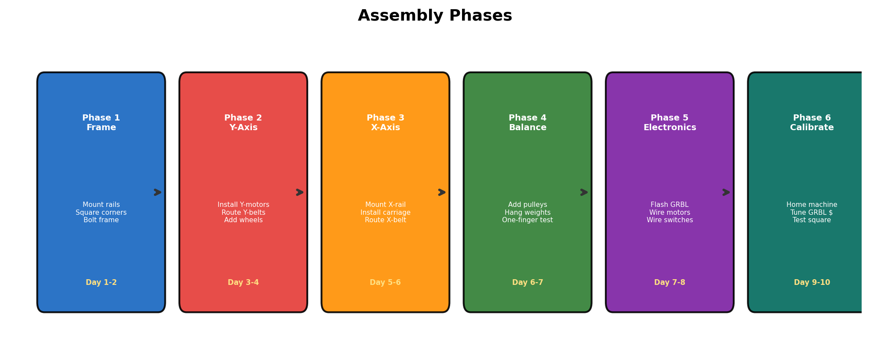

Phase 1: Frame (Day 1–2)
- Lay out all 4 frame extrusions on the floor.
- Bolt corners with angle brackets + T-nuts.
- CRITICAL: Measure BOTH diagonals — they must be equal (within 2mm) or drawings will be skewed.
- Mount frame to drawing surface or backing structure with at least 6 mounting points.

Phase 2: Y-Axis (Day 3–4)
- Install V-wheels on the two Y-axis gantry plates.
- Slide gantry plates onto left and right vertical rails.
- Adjust eccentric spacers: wheels should grip snugly but roll freely.
- Mount Y-Left motor at top-left, Y-Right motor at top-right.
- Install idler pulleys at the bottom of each vertical rail.
- Route Y-axis belts: motor → down to idler → back up to gantry plate.
- Test: turn both motor shafts BY HAND — both gantry plates should move smoothly.

Phase 3: X-Axis (Day 5–6)
- Bolt the 180cm 2040 rail between the two Y-axis gantry plates.
- Check level — the X-rail must be perfectly horizontal.
- Install pen carriage on the X-rail with V-wheels.
- Mount X-motor at the left end, idler pulley at the right end.
- Route X-axis belt and install belt tensioner.
- Optional: bolt mid-span aluminum stiffener to back of X-rail.

Phase 4: Counterweights (Day 6–7)
- Weigh the entire X-rail assembly.
- Install pulleys at the top of the frame behind the board.
- Attach cord to both ends of the X-rail, route over pulleys, hang weights.
- Perform the One-Finger Test (see Section 10).

Phase 5: Electronics (Day 7–8)
- Flash GRBL firmware onto the Arduino Uno.
- Plug CNC Shield onto Arduino, insert TMC2209 drivers.
- Set A-axis jumper on CNC Shield to clone Y.
- Wire motors: X→X slot, Y-Left→Y slot, Y-Right→A slot.
- REVERSE ONE Y-MOTOR'S COIL (swap A+ and A− on one motor).
- Wire servo to SpnEn pin.
- Wire and mount limit switches (X-min, Y-min).
- Connect 12V 10A PSU.

Phase 6: Calibration (Day 9–10)
- Connect to GRBL via Universal Gcode Sender.
- Configure GRBL $ parameters (see Section 15).
- Home the machine ($H) — should move to top-left and stop at switches.
- Test X and Y directions with small jog commands.
- Draw a test square and measure with a ruler.
- If dimensions are wrong, adjust $100 / $101 (steps/mm).

16. GRBL Configuration
Enter these via the serial console in Universal Gcode Sender:
Parameter | Value | Description
$100 | 80 | X steps/mm (200 steps × 16 microsteps / 20 teeth × 2mm)
$101 | 80 | Y steps/mm (same calculation)
$110 | 5000 | X max feed rate (mm/min)
$111 | 5000 | Y max feed rate (mm/min)
$120 | 200 | X acceleration (mm/s²) — start low, increase gradually
$121 | 100 | Y acceleration (mm/s²) — lower than X (heavy rail)
$130 | 1700 | X max travel (mm)
$131 | 1100 | Y max travel (mm)
$22 | 1 | Enable homing cycle
$23 | 3 | Homing direction invert (both X and Y home to min)
$24 | 25 | Homing feed rate (mm/min) — slow approach to switch
$25 | 500 | Homing seek rate (mm/min) — fast initial move

Test Square G-Code
Send this to verify calibration. Draws a 150mm square — measure with a ruler:
G21 ; Units: mm
G90 ; Absolute positioning
G0 X50 Y50 F5000 ; Move to start
M3 S90 ; Pen down
G4 P0.15 ; Wait for pen settle
G1 X200 Y50 F3000 ; Draw right
G1 X200 Y200 ; Draw down
G1 X50 Y200 ; Draw left
G1 X50 Y50 ; Draw up (close square)
M5 ; Pen up
G0 X0 Y0 F5000 ; Return home
M2 ; Program end

17. Failure Modes & Mitigations
Failure | Cause | Prevention
Rail crashes on power loss | No counterweight / belt breaks | Counterweights hold rail in place
Skipped steps (drawing shifts) | Accel too high, PSU weak, belt loose | Tune $120/$121, use 10A PSU, tension belts
Y-axis jams on startup | Y-motors fighting each other | Reverse one motor's coil wiring
Drawing is skewed (rhombus) | Frame not square | Measure diagonals during assembly
Pen doesn't touch board | Spring too weak / servo miscalibrated | Tune spring, calibrate servo angle
Belt skips teeth | Belt loose, pulley grub screw loose | Belt tensioners + Loctite on grub screws
X-rail bows at center | 180cm 2020 profile too flexible | Use 2040 + mid-span stiffener
Lines are wavy/vibrating | Rail chatter at high speed | Reduce feed rate, stiffen rail, lower accel
Homing fails | Switch not triggering / wrong config | Test switches manually, check $22/$23

18. References & Resources

Real-World Builds & Projects
- Makelangelo (Polargraph) — github.com/MarginallyClever/Makelangelo-software
- Maslow CNC (Wall-Mounted Router) — maslowcnc.com
- Penelope Vertical Pen Plotter — davidbliss.com/2021/09/13/penelope
- Stefan van Seggelen Large CoreXY Plotter — stefanvanseggelen.com/plotter.html
- iDraw H Large Format Plotter — uunatek.com/collections/large-format-size-drawing-robots
- OpenBuilds Pen Plotter — builds.openbuilds.com/builds/pen-plotter.10615
- OpenBuilds ACRO System — builds.openbuilds.com/tags/acro
- Jason Webb's GRBL Wall Plotter — github.com/jasonwebb/grbl-mega-wall-plotter
- Stringent $15 Wall Plotter — hackster.io/fredrikstridsman/stringent-the-15-wall-plotter-d965ca

Technical References
- GRBL Setup Guide — howtomechatronics.com/tutorials/how-to-setup-grbl-control-cnc-machine-with-arduino
- GRBL with CNC Shield — diyengineers.com/2023/01/05/grbl-with-arduino-cnc-shield-complete-guide
- CoreXY Belt Tensioning — drmrehorst.blogspot.com/2018/08/corexy-mechanism-layout-and-belt.html
- Belts vs Leadscrews in CNC — blanch.org/belts-vs-screws-in-cnc-design
- V-Slot Deflection Calculator — builds.openbuilds.com/threads/how-to-calculate-v-slot-deflection.4881
- NEMA 17 vs NEMA 23 — sss-motors.com/nema-17-vs-nema-23-stepper-motor
- TMC2209 vs TMC2208 — xecor.com/blog/tmc2208-vs-tmc2209
- Polargraph Mathematics — nexp.pt/vbot.html
- FluidNC (Modern GRBL Replacement) — wiki.fluidnc.com/en/config/kinematics

