Feastfreedom.com

Confidential: BrightRace & Summitworks Technologies

# Introduction

Primary Intent of this document is to provide a background and functional specification for a product which can be used as a platform. Examples are Uber, Grubhub etc.

There is a huge demand of homemade food in tri-estate area especially in south Asian communities. As a software provider company, we are going to develop a platform which can be used to connect consumer who are looking for home made food to a homemade service provider who cooks the food and provide delivery or pickup. This application will be a web-based application and it will be a responsive design application. For the sake of simplicity, there will be no payment processing involved in this development. An email will be sent to the user and service provider at the time of successful placement of an order.

Terminology: Kitchen and Service provider are the same, these will be used interchangeably throughout the document.

## Functional specification

Application will have two separate modules:

* Service Provider Module
* Regular User Module

**Phase 1: Service Provider Module:**

This module will allow a service provider to register his/her kitchen using a registration screen. Here are the primary functions of this module:

1. Allow a Kitchen to register on the application using a “Provider Register Now” Link at the top section of the application. Once clicked, it will open a screen with these entry/selection options:
   1. Service Provider Name (Unique varchar (50) Not NULL): This will be displayed to end user at the time of creation of an order.
   2. Email(Unique varchar(50) Not NULL)
   3. Password nVarchar(10) NOT NULL
   4. Confirm Password nVarchar(10) NOT NULL
   5. Next Button
   6. Cancel Button
2. When clicked on cancel button, user will be redirected to application landing screen without saving any data.
3. When clicked on Next button, here is what user will see:
   1. Kitchen working Days: checkbox selections for Monday to Sunday
   2. Kitchen working Time: two dropdown Start Time and End Time.
   3. Kitchen Image: browse control to upload an image. This image will be shown at kitchen display.
   4. Kitchen Menu. One Kitchen will have more than one Menu Item and each Menu Item will have these attributes:
      1. Item Name
      2. Veg/Non-Veg
      3. Price.
   5. Save Button
   6. Cancel Button
4. Once user register, they should see a success message.

**Phase 2: Regular User Module:**

With Phase 1, we should have all the Kitchen data available in the database, in this phase of the application, we will display Kitchen information to end-users so that they can place an order by selecting a menu item from the kitchen provider’s list.

1. When user browse the application, they will see a page having listed all the REGISTERED kitchens in this format:

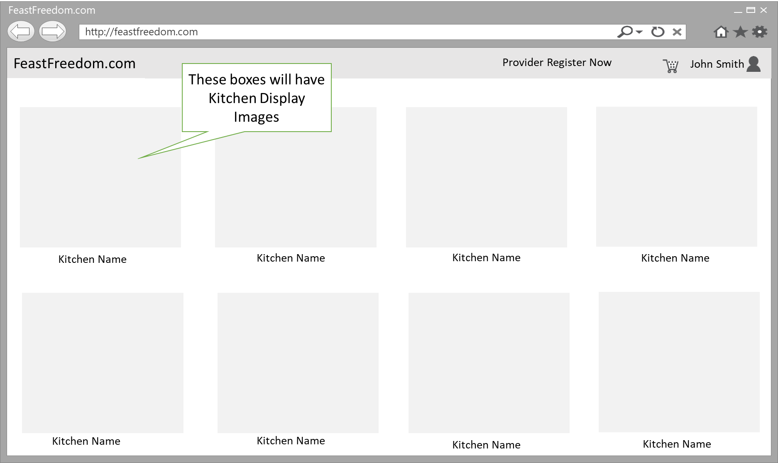

1. All the Kitchen Images will be clickable and once clicked, it will redirect the user to another screen which will show the Menu for that Kitchen along with prices.
2. Each menu item should have a checkbox next to it with “add to cart” and a button at the bottom with the display name “Add”.
3. Once user checks the checkboxes and clicks on “Add”, all the items should be added to the cart.
4. User should be able to register & Login himself/herself by clicking on user icon which is available.
5. If the user is logged in, application will display his/her name.
6. User Registration screen is a standard screen with options such as first name, last name, email, password and two security questions and answers.