Bulbasaur | #001
The Seed Pokémon
Type: Grass / Poison
Rarity: Common

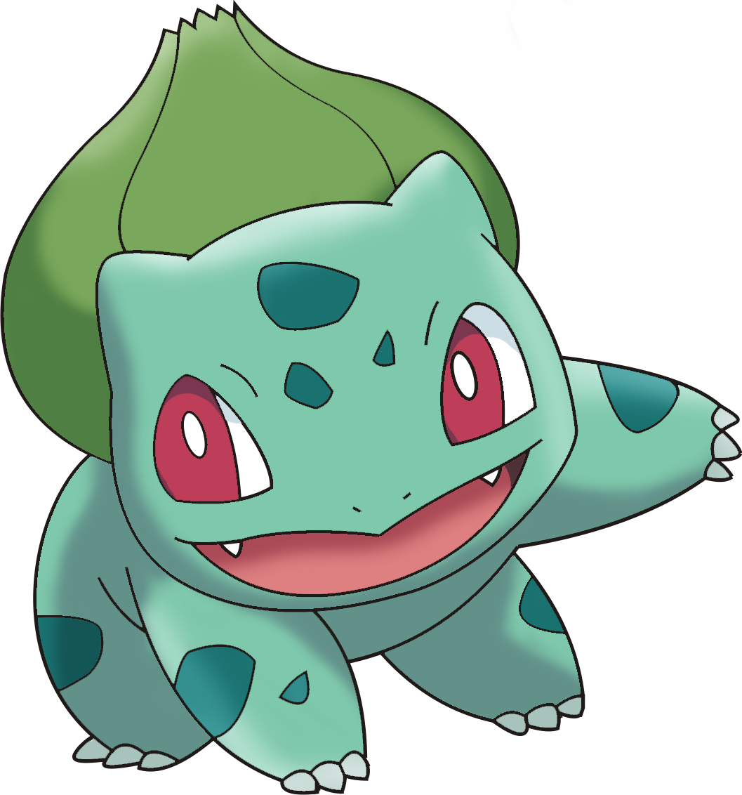
Bulbasaur | #001
Evolutions:
Bulbasaur → Ivysaur: Level 11
Ivysaur → Venusaur: Level 21
Ability Scores:
Strength  Constitution  Dexterity  Intelligence  Wisdom  Charisma | 12  10  10  14  12  14

Bulbasaur | #001
Skills:
Endurance, Perception, Nature
Habitat: Bulbasaur are usually bred in captivity and seldom found in the wild. Very rarely they can be found in secret gardens, plains near fresh water, or deep forests.

Bulbasaur | #001
Size: Small
Gender: 87% male, 13% female
Egg Groups: Grass, Monster
Biology: A seed is planted on Bulbasaur's back at birth and grows with it as it matures. It uses this bulb to store energy, and enjoys napping in bright sunlight to soak up energy from the sun.

Bulbasaur | #001
Happiness: Normal
Growth: Normal
Behavior: Bulbasaur are considered very mild-mannered and well-behaved. They like to sleep a lot, especially on sunny days. Bulbasaur can sometimes be found lying in the sun during the day to photosynthesize energy when food is scarce.

Bulbasaur |  | #001
Qualities: Overgrow, Chlorophyll
Basic Attack: Tackle
Powers:
1 | Growl | 17 | Growth
3 | Leech Seed | 19 | Double-Edge
5 | Vine Whip | 21 | Worry Seed
7 | Poisonpowder | 23 | Synthesis
9 | Sleep Powder | 25 | Seed Bomb
11 | Take Down | 27 | Leaf Blade
13 | Razor Leaf | 29 | Solarbeam
15 | Sweet Scent

Overgrow Quality
When bloodied, roll one extra damage die when using Grass attacks.

Chlorophyll Quality
When the Pokémon begins its turn in Intense Sunlight, its Speed is doubled for that turn.

Tackle Basic Attack
Charges the foe with a full-body tackle.

At-Will ♦ Physical
Standard Action Melee
Target: One Pokémon
Attack: Str vs. AC
Hit: 1d6 + Str untyped damage. You may push the target 1 square if it is your size, smaller, or one size category larger, and this deals additional equal to your level. You may then shift into the space that the target occupied.

Increase damage die to 2d6 at 11th level, and 3d6 at 21st level.

Quality

Quality

Basic Attack





Growl Power
The Pokemon growls cutely to reduce the foe’s attack.

Recharge 3 ♦ Normal, Status
Minor Action Close Burst 3
Target: One Pokémon In Burst
Attack: Char vs. Will
Hit: Target takes a penalty to damage from Physical powers equal to your level until end of your next turn.

Leech Seed Power
Plants a seed on the foe to steal health on every turn.

Recharge 5 ♦ Grass, Energy
Standard Action Close Burst 5
Target: One Pokémon in Burst
Attack: Int vs. Fort
Hit: Target takes ongoing Grass damage equal to your Int bonus, save ends. Each time this damage is dealt, you gain that damage in health.

Increase damage to 2 x Int mod at 11th level, and 3 x Int mod at 21st level.

Vine Whip Power
Strikes the foe with slender, whiplike vines.

Recharge 3 ♦ Grass, Physical
Standard Action Melee/Ranged 5
Target: One Pokémon
Attack: Dex vs. Ref
Hit: d6 + Dex Grass damage, and you may pull the target up to 2 squares.

Poisonpowder Power
Scatters a toxic powder that may poison the foe.

Recharge 3 ♦ Grass, Status
Standard Action Close Burst 2
Target: Each Pokémon In Burst
Attack: Int vs. Fort
Hit: Target is Poisoned, taking ongoing Poison damage equal to your Int bonus, save ends.

Increase damage to 2 x Int mod at 11th level, and 3 x Int mod at 21st level.

Sleep Powder Power
Scatters a powder that may cause the foe to sleep.

Recharge 5 ♦ Grass, Status
Standard Action Close Burst 2
Target: Each Pokémon In Burst
Attack: Int vs. Will
Hit: Target is Asleep, save ends.

Take Down Power
A reckless, full-body charge attack for slamming into the target. It also damages the user a little.

Recharge 4 ♦ Normal, Physical
Standard Action Melee
Target: One Pokémon
Attack: Str vs. AC
Hit: d10 + Str Normal damage. You may take your Strength modifier in damage to deal an extra 1d10 Normal damage.
Special: You may use this attack as part of a charge.

Razor Leaf Power
Cuts the enemy with leaves. High critical-hit ratio.

Recharge 3 ♦ Grass, Physical
Standard Action Close Blast 3
Target: Each Pokémon In Blast
Attack: Dex vs. AC
Hit: d8+Dex Grass damage.
Special: This attack's critical hit range is one higher than normal (20 becomes 19-20, etc)

Sweet Scent Power
Allures the foe to reduce evasiveness.

Recharge 4 ♦ Grass, Status
Minor Action Close Burst 1
Target: Each Pokémon In Burst
Attack: Char vs. Will
Hit: Target takes a -2 penalty to all defenses until end of your next turn.

Increase penalty to -3 at 11th level and -4 at 21st level.

Growth Power
Forces the body to grow and heightens the potency of special powers.

Recharge 3 ♦ Grass, Status
Minor Action Personal
Effect: Gain a +2 bonus to all attack rolls and damage until the end of your next turn.
Special: In Intense Sunlight, increase bonus by an additional +2.

Increase bonus to +3 at 11th level, and +4 at 21st level.

Power

Power

Power

Power

Power

Power



Power

Power

Power

Double-Edge Power
A reckless, full-body tackle It also damages the user by a fairly large amount, however.

Recharge 5 ♦ Normal, Physical
Standard Action Melee
Target: One Pokémon
Attack: Str vs. AC
Hit: d12 + Str Normal damage. You must take Str in damage, and deal an extra 2d12 Normal damage to the target.

Worry Seed Power
A seed that causes worry is planted on the target. It prevents sleep.

Recharge 5 ♦ Grass, Status
Minor Action Melee
Target: One Enemy or Ally
Effect: Target's active Quality is replaced by the Insomnia Quality for the duration of this battle.

Synthesis Power
Take in energy from the sun to regain health.

Recharge 6 ♦ Grass, Status
Standard Action Personal
Effect: Spend a healing surge and gain additional HP equal to 2 x Int bonus if it is in Intense Sunlight, 1 x Int bonus if the sun is visible, and none if sun cannot be seen (nightime, underground).

Seed Bomb Power
The user slams a barrage of hard-shelled seeds down on the target from above.

Recharge 4 ♦ Grass, Physical
Standard Action Area Burst 1 in 10
Target: Each Pokémon In Burst
Attack: Int vs. AC
Hit: d10 + Int Grass damage.

Leaf Blade Power
The user handles a sharp lead like a sword and attacks by cutting its target.
Recharge 5 ♦ Grass, Physical
Standard Action Melee
Target: One Pokémon
Attack: Dex vs AC
Hit: d10 + Dex Grass damage
Special: This attack's critical hit range is one higher than normal (20 becomes 19-20, etc)

Solarbeam Power
Slowly absorbs light, then releases it in a powerful beam.

Recharge 5 ♦ Grass, Energy
Standard Action x2 Ranged 20
Target: One Pokémon
Attack: Int vs. Ref
Hit: d12 + 2 x Int Grass damage
Miss: Half damage
Special: If sun is visible, roll twice the normal number of dice for this attack. Initiating this attack ends your turn. The attack occurs on the standard action at the beginning of your next turn. If in Intense Sunlight, attack occurs immediately.




Power

Power

Power

Power

Power

Power

