Hospital Appointment Microservices

01. Docker Compose — all services running
Capture `docker compose ps` showing the four microservices running and their health/status.
01-docker-compose-status.png
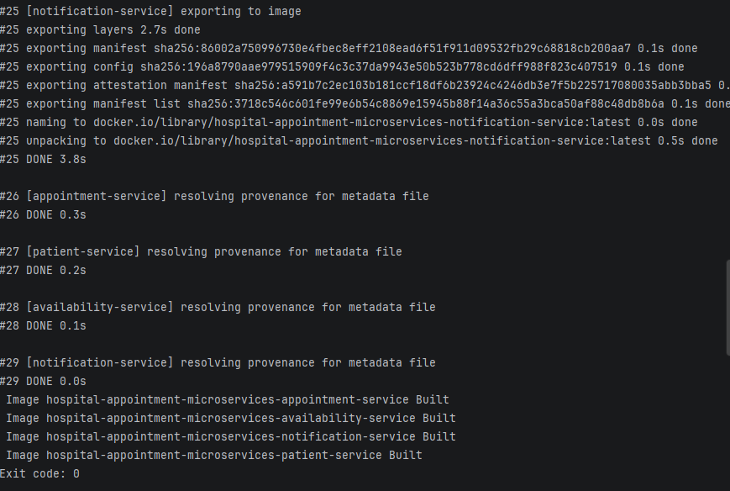
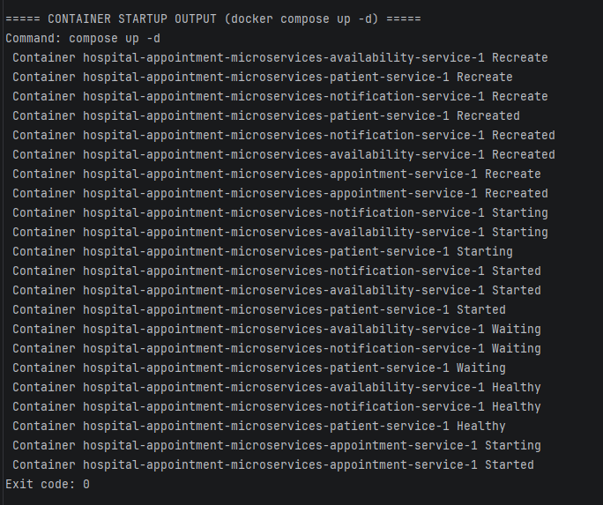

2. Successful Docker Compose booking
Show a successful POST /api/appointments response, including the appointment ID and notification status SENT.
02-docker-booking-success.png
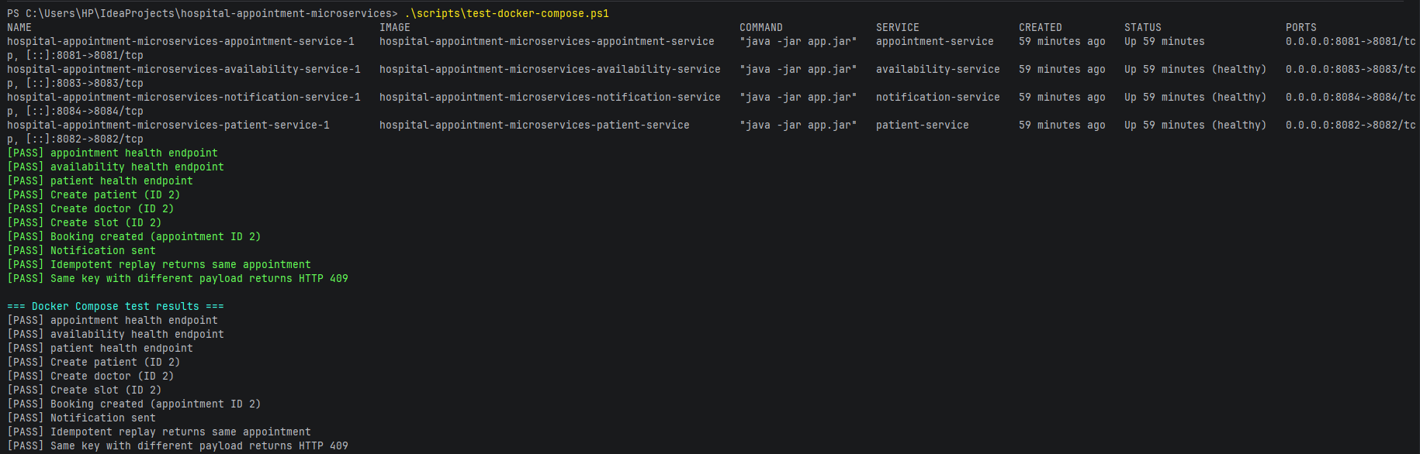

03. Idempotency and conflict protection
Show replay of the same Idempotency-Key returning the same appointment, followed by HTTP 409 when the key is reused with different booking data.
03-idempotency-conflict.png

04. Persistence after Docker restart
Show the original booking replayed after `docker compose restart`, with the same appointment and reservation IDs.
04-persistence-after-restart.png
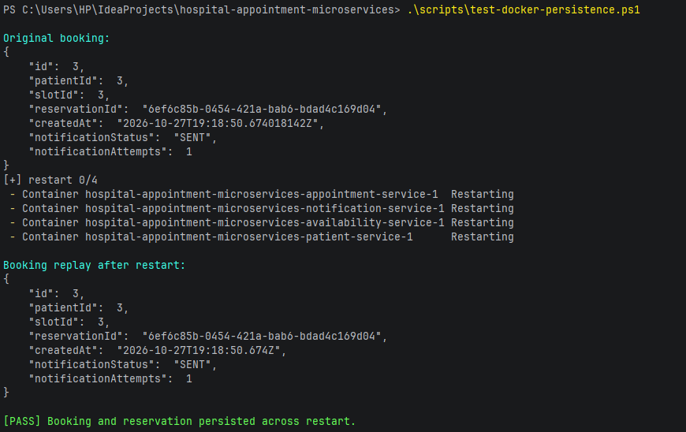

05. Kubernetes resources
Capture `kubectl get deployments,services,pods,pvc` showing the Deployments, Pods, Services and persistent volume claims.
05-kubernetes-resources.png
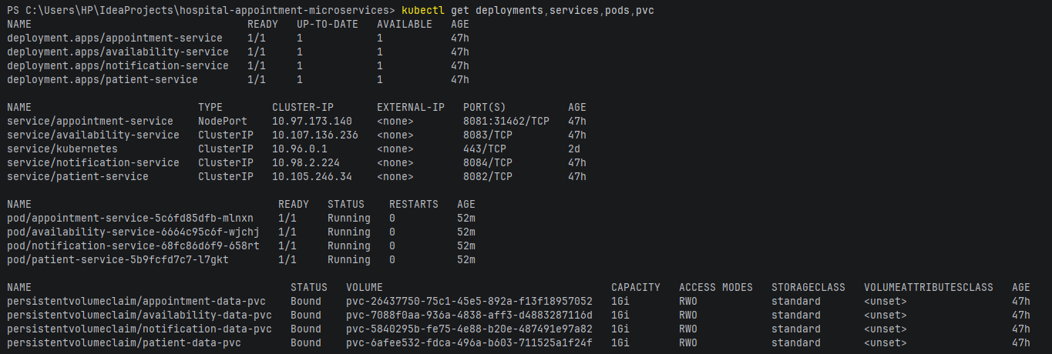

06. Automated Kubernetes end-to-end test
Capture the successful test script output showing health checks, patient/doctor/slot creation, booking, idempotency replay, HTTP 409 conflict, and the final pass/fail summary.
06-kubernetes-booking-tests.png
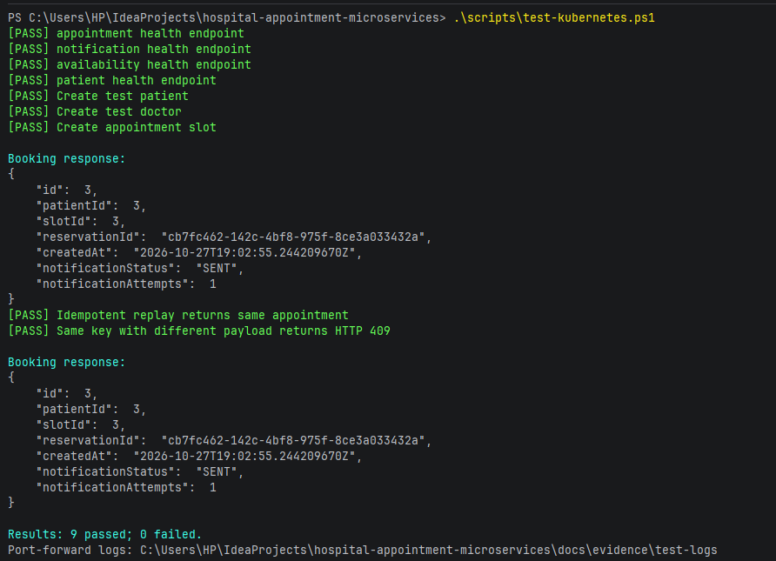

07. Kubernetes self-healing
Show the deleted Pod being replaced by a new Pod that reaches Running/Ready status.
07-kubernetes-self-healing.png
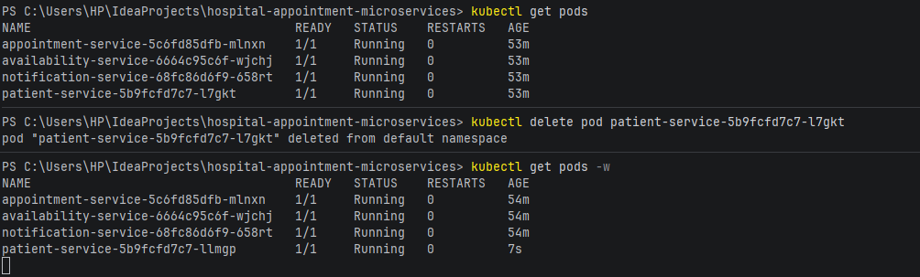

08. Kubernetes scaling

