Hospital Appointment Booking System
Design and Technical Report | Scalable Services — Assignment 1
DRAFT FOR TEAM REVIEW — verify names, links, API examples and submission details before submission
Technology: Java / Spring Boot / Maven / SQLite / REST

1. Problem and Scope
The Hospital Appointment Booking System demonstrates a distributed booking transaction across four independently runnable services. The focus is correctness when requests compete for limited appointment capacity, clients repeat booking requests, or a downstream notification service is slow or unavailable. This is not a complete hospital information system.
The application uses Java, Spring Boot, Maven, REST/HTTP and SQLite. Synthetic demo data is assumed. A frontend, authentication, payment processing and real email/SMS delivery are outside scope. The mandatory concurrency and idempotency challenges are implemented, and Challenge 3A resilience is selected.
Business rules
- BR1 — Patient eligibility: Only a known eligible/active patient can book. Covered by Patient eligibility and Appointment integration tests.
- BR2 — Capacity: Slot reservations must never exceed capacity. Captured test: 20 concurrent HTTP requests; 5 created, 15 capacity conflicts, 0 other statuses; final persisted count 5 for capacity 5.
- BR3 — Idempotent replay: Same Idempotency-Key and same payload must not create a second booking effect. Captured test: 10 concurrent callers, one created result and nine replays.
- BR4 — Key conflict: Reusing a key with a different payload is rejected. Appointment integration test expects HTTP 409.
- BR5 — Notification failure: Notification failure does not erase the persisted booking. Resilience tests verify booking persistence and visible FAILED notification status.
- BR6 — Lifecycle: Appointment cancellation and lifecycle transitions are not implemented. This is an explicit limitation; no cancellation endpoint or lifecycle state machine is claimed.

2. Service Decomposition
The system consists of four independently runnable Spring Boot microservices, each responsible for a distinct business capability. Each service uses a separate SQLite database file by default, with service-local entities and repositories. Service-to-service communication in the booking workflow is implemented through configurable REST endpoints.
Service | Port | Responsibility | Database configuration
Appointment Service | 8081 | Coordinates bookings; stores appointment records, idempotency information, and notification outcomes and attempt counts. | APPOINTMENT_DATABASE_URL — jdbc:sqlite:./appointment-service.db
Patient Service | 8082 | Manages patient profiles, eligibility, and active status. | PATIENT_DATABASE_URL — jdbc:sqlite:./patient-service.db
Availability Service | 8083 | Manages doctors, appointment slots, reservations, and capacity enforcement. | AVAILABILITY_DATABASE_URL — jdbc:sqlite:./availability-service.db
Notification Service | 8084 | Persists simulated notification events and supports deduplication by appointment. | NOTIFICATION_DATABASE_URL — jdbc:sqlite:./notification-service.db
The database URLs above are the configured defaults used when the corresponding environment variables are not overridden. The relative paths resolve against the process working directory. Database separation therefore depends on configuring each service to use its own database file. Appointment Service uses configurable REST endpoints to communicate with the Patient, Availability, and Notification services.

3. Architecture
The client calls Appointment Service. Appointment synchronously calls Patient, Availability and Notification over REST. Cross-service identifiers are passed as numeric IDs/DTO fields; no service reads another service’s database.
CLIENT → APPOINTMENT SERVICE (8081)
├── REST → PATIENT (8082) → patient DB
├── REST → AVAILABILITY (8083) → slot/reservation DB
└── REST → NOTIFICATION (8084) → notification DB
Each service accesses only its own database.
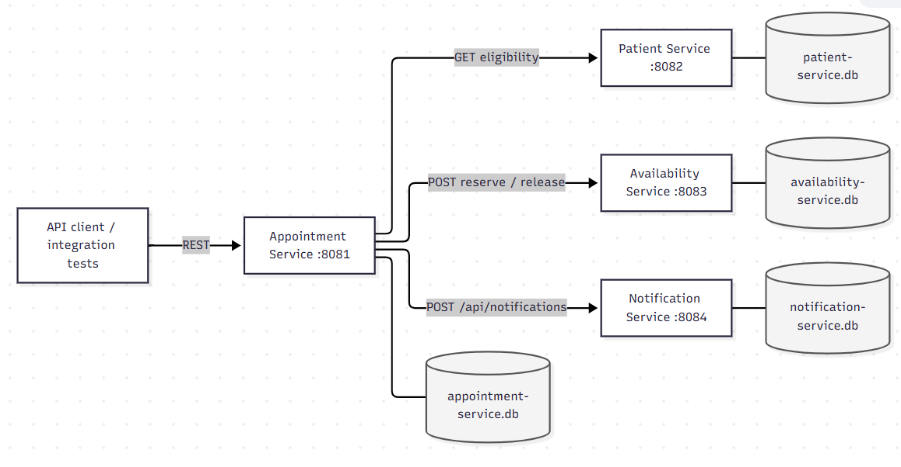
Happy-path sequence
- Client sends `POST /api/appointments` with `patientId`, `slotId` and `Idempotency-Key`.
- Appointment checks the key and request fingerprint; an exact replay returns the existing booking.
- Appointment validates patient eligibility through Patient Service.
- Appointment asks Availability Service to reserve a slot; a conditional database update enforces capacity atomically.
- Appointment persists the booking, then calls Notification using finite timeouts and bounded retries.
Failure path: notification unavailable
- Booking and slot reservation are persisted before notification attempts.
- Retryable notification failures are retried within a bounded policy.
- If retries are exhausted, the booking remains persisted and the response exposes `notificationStatus=FAILED` and `notificationAttempts`.
- Replaying the same key returns the existing booking and does not create a second reservation or resend notification.
There is no transactional outbox or background reconciliation worker, so failed notifications are visible but are not automatically recovered by a later booking replay.

4. Data Design and Ownership
The four services use separate local SQLite database files by default. The default filenames below are configured by each service’s spring.datasource.url property; the relative ./ path resolves from that process’s working directory. These defaults give each service a distinct file, while operators can override URLs, so database isolation depends on keeping the configured URLs separate.
Table 4.1. Service data ownership and default database files.
Service / port | Owned entities and data | Default SQLite file | Responsibility
Patient (8082) | patients: id, name, email, active | patient-service.db | Owns patient profiles and active / eligibility data.
Availability (8083) | doctors; appointment_slots; slot_reservations | availability-service.db | Owns doctors, slots, capacity, reservations, and releases.
Appointment (8081) | appointments: booking IDs, idempotency data, notification outcome | appointment-service.db | Coordinates bookings; owns appointment and idempotency records.
Notification (8084) | notification_events: event and cross-service identifier values | notification-service.db | Owns simulated notification acceptance records and deduplication.

Cross-service identifiers and API flow
Patient Service owns each patient record and its numeric patient ID. Appointment Service sends patientId in POST /api/appointments and checks eligibility through GET /api/patients/{id}/eligibility. The Appointment appointments row stores patient_id as a scalar value; it is not a foreign key.
Availability Service owns doctor IDs, slot IDs, and reservation IDs. Appointment Service sends a slot ID to POST /api/v1/slots/{id}/reservations; Availability returns reservationId and slotId. Appointment stores slot_id and reservation_id as scalar values. If booking persistence fails after a reservation is created, Appointment calls POST /api/v1/reservations/{reservationId}/release as compensation.
Appointment Service generates and owns the appointment ID. It passes appointmentId, patientId, slotId, and reservationId in the notification request to POST /api/notifications. Notification Service stores those values in its own notification_events row; appointment_id is unique there for local deduplication but is not a foreign key to the Appointment database.
These IDs are exchanged through REST request paths, JSON payloads, and responses. No service directly reads or writes another service’s SQLite file. The only mapped database foreign key among the four services’ entities is Availability appointment_slots.doctor_id to doctors.id.
Consistency and failure boundaries
Availability enforces capacity with a conditional database update (reserved_count < capacity) and creates the reservation within the Availability transaction. Appointment uses a unique idempotency key and request fingerprint; an exact replay returns the saved appointment without another reservation, while a persistence failure after reservation triggers a release attempt. These are local database transactions and REST calls, not a distributed ACID transaction.
A process failure after Availability has reserved a slot but before Appointment finalizes its appointment can leave a reservation without an appointment: the compensation runs for caught persistence failures, not for an abrupt process crash. There is no cross-service transaction, outbox, or background reconciliation process in the implementation.
Entity relationship diagrams

Figure 4.1. Patient Service
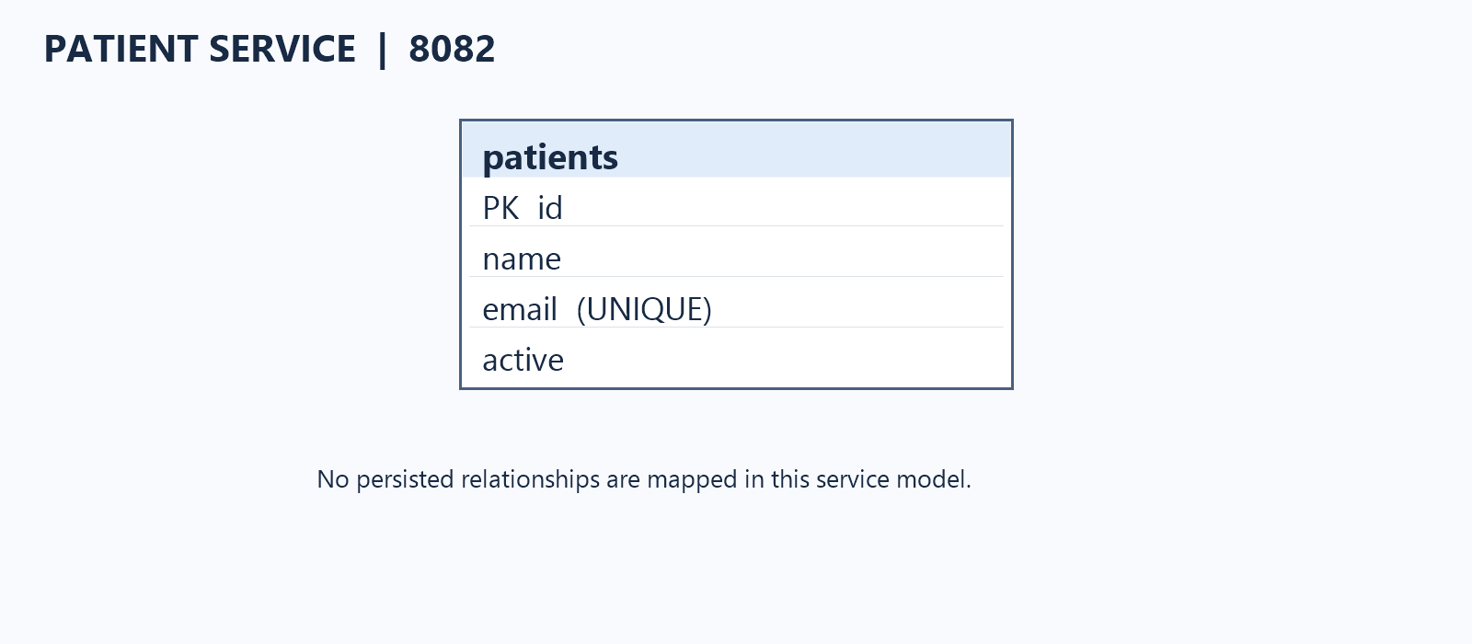
Figure 4.2. Availability Service
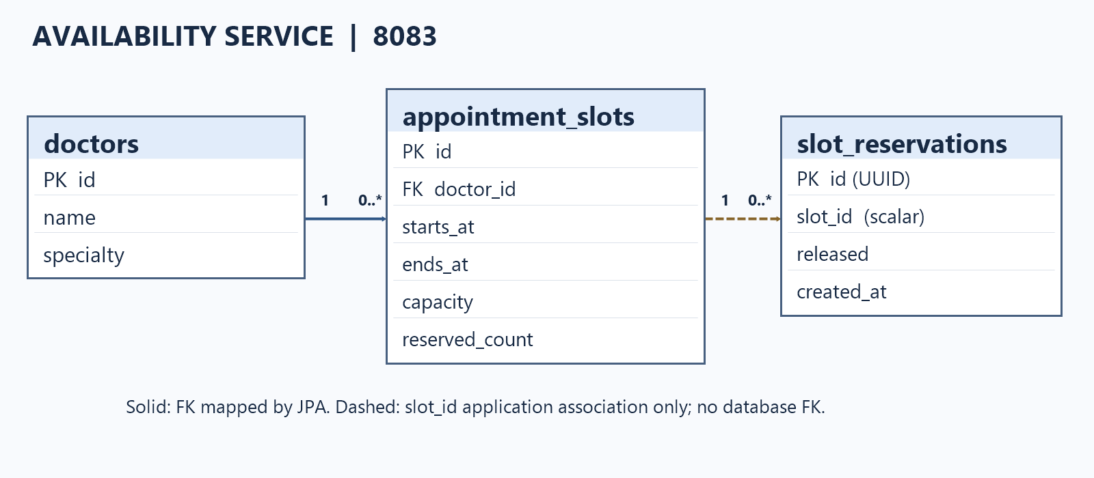

Figure 4.3. Appointment Service
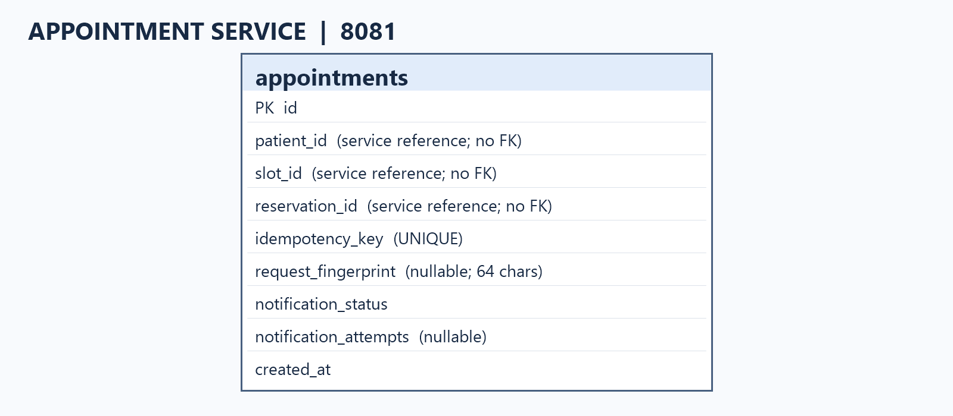
Figure 4.4. Notification Service
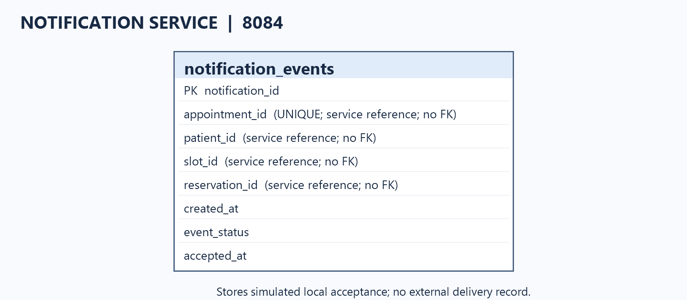

5. API Design
The routes below reflect the implementation as recorded in the repository audit. IDs are numeric. API versioning is mixed and error bodies differ by service; this report documents actual behavior rather than assuming a uniform contract.
- All services: `GET /health`.
- Patient: `POST /api/patients`; `GET /api/patients/{id}`; `GET /api/patients/{id}/eligibility`. Create returns 201; missing patient returns 404.
- Availability: `GET/POST /api/v1/doctors`; `GET/POST /api/v1/slots`; `GET /api/v1/slots/{id}`; `POST /api/v1/slots/{id}/reservations`; `POST /api/v1/reservations/{reservationId}/release`. Capacity exhaustion returns 409; missing resources return 404.
- Appointment: `POST /api/appointments`. New booking 201; exact replay 200; same key/different payload 409; ineligible patient 422; requires `Idempotency-Key`.
- Notification: `POST /api/notifications`. Accepted event returns 202; duplicate submissions for an appointment return the persisted event.
Booking request example
POST /api/appointments
Idempotency-Key: booking-demo-001
Content-Type: application/json
{
"patientId": 101,
"slotId": 501
}
The example IDs are illustrative and must be checked against current DTOs/test data before a live demo. Appointment responses include notificationStatus and notificationAttempts. Patient and Availability errors use an error field; Appointment and Notification use service-specific error shapes including code/message in relevant paths. Each service includes Springdoc OpenAPI support; use the running service’s OpenAPI/Swagger endpoint for the exact schema. There is no Notification GET-by-event or Appointment cancellation endpoint in this version.

6. Engineering Challenges
Challenge 1 — Concurrency
Concurrent clients may compete for the final available slots. A read-then-write check in application code can over-allocate capacity. Availability instead performs a conditional database update only while reserved_count is below capacity, inside the reservation transaction. The captured HTTP test sends 20 requests to capacity 5.
Captured result: 5 HTTP 201 created; 15 HTTP 409 capacity conflicts; 0 other statuses; persisted reserved_count=5; 6 Availability tests passed.
Evidence: evidence/challenge-1-concurrency/README.md and availability-maven-test-output.txt. This capture is dated 2026-10-23 and is historical, not a new run for this report. A conditional SQL update was chosen over application-only locking because the database enforces the invariant at the persistence boundary.
Challenge 2 — Idempotency
Appointment persists an Idempotency-Key and canonical SHA-256 request fingerprint. Same key/body replays the existing booking; changed payload with the same key returns 409. A database uniqueness constraint arbitrates concurrent inserts. If a losing request already reserved a slot, its reservation is released.
Captured result: 10 concurrent callers; 1 created result; 9 replays; 1 appointment row; 1 active linked reservation; final slot count 1.
Evidence: evidence/challenge-2-idempotency/README.md and appointment-availability-test-output.txt. The multi-context test uses two independent Spring contexts in one JVM sharing SQLite, not separate operating-system processes. This capture reports the earlier 25-test Appointment count; the later full-reactor capture reports 29.
Challenge 3A — Resilience
Downstream HTTP clients use finite configurable timeouts. Notification attempts are bounded (default maximum 3), with exponential backoff and jitter. Retryable conditions include I/O/timeouts, HTTP 408, 429 and 5xx; permanent 400 is not retried. Booking is persisted before notification; final notification status and attempt count are visible. Replay does not create another reservation or resend notification.
Evidence: evidence/challenge-3a-resilience/README.md and appointment-notification-test-output.txt. Tests cover success, transient retry, exhaustion, timeout, non-retryable 400, booking persistence after failure and replay without duplicate notification. Appointment’s downstream behavior uses HTTP mocks rather than a separately running Notification process.
Notification persistence evidence: evidence/notification-persistence/README.md and notification-appointment-test-output.txt. Tests cover 20 concurrent duplicate submissions and persistence across application-context recreation. This demonstrates durable local acceptance/deduplication, not exactly-once delivery to an external email/SMS provider.
A full-reactor run once observed different acceptedAt values in concurrent Notification responses. The Notification suite then passed alone and the full reactor passed on rerun without service source changes. Treat this as an intermittent, unreproduced test flake, not a definitively fixed defect.

7. Testing Strategy and Results
Testing includes service-level controller/business tests, HTTP integration tests, concurrent requests, persistence assertions and downstream failure simulation. These figures are from captured logs, not a fresh test run performed while preparing this report.
| Service / run | Tests | Captured result |
|---|---:|---|
| Patient Service | 4 | All passed |
| Availability Service | 6 | All passed |
| Notification Service | 7 | All passed |
| Appointment Service | 29 | All passed |
| Latest captured full Maven reactor | 46 total | BUILD SUCCESS; 0 failures, 0 errors, 0 skipped |
The captured full reactor used IntelliJ Maven 3.9.16 and JDK 24.0.2 with Java 21 compilation settings (mvn -o test). A fresh full build should be run from the repository README environment before final submission if possible.
Test-scope limitations: idempotency multi-context coverage runs in one JVM; Appointment downstream tests use HTTP mocks; no captured result establishes a clean-clone run or all-four-services live end-to-end run.

8. Design Decisions and Trade-offs
- Database per service: Private SQLite file per service. A shared DB is simpler but weakens ownership. SQLite is suitable for demo setup, not proof of production write scale.
- Synchronous REST orchestration: Simpler to demonstrate than a broker, but the request chain needs finite timeouts. Messaging could decouple services but adds broker and consumer complexity.
- Atomic capacity protection: Conditional SQL update instead of read-then-write application checks. Distributed locks add operational complexity.
- Idempotency: Unique key plus fingerprint and reservation compensation. Process-local locks alone do not arbitrate across contexts; durable uniqueness is stronger but compensation adds complexity.
- Notification failure: Bounded retries and visible failure while preserving the booking. An outbox/reconciliation worker would improve recovery but is not implemented.

9. Limitations and Future Work
- No appointment cancellation endpoint or appointment lifecycle state machine.
- No transactional outbox or background retry/reconciliation worker.
- No real email/SMS provider; persisted acceptance does not guarantee external delivery or exactly-once delivery.
- Error response schemas differ between services; API versioning is inconsistent.
- No `X-Correlation-ID` propagation is implemented; do not claim it in the report or demo.
- SQLite is for a small demo. Production would require a suitable database, authentication/authorization, secrets management, monitoring, backups and deployment automation.
- No captured evidence establishes a clean-clone build or full four-process end-to-end run.
Priorities for future work: transactional outbox and idempotent worker, consistent error contract and API versioning, cancellation/state transitions with tests, correlation-ID propagation, and automated clean-clone system testing.

10. Repository and Demonstration Links
Source repository: https://github.com/CodingEsoteric/hospital-appointment-microservices
Evidence:
Demo video and supporting documents: [INSERT VERIFIED GOOGLE DRIVE / SHARED FOLDER URL].
Evidence lives under evidence/, with challenge READMEs and captured test output. Insert only verified links accessible to the instructor.

Appendix A. Team Contributions — To Be Verified

Team Member | Assigned Responsibility | Actual Contribution / Status
Tejashree Pawar | Integration and Appointment Service | Implemented Appointment Service functionality, coordinated service integration, supported end-to-end testing, and prepared integration evidence and documentation.
[Member 2 Name] | Patient Service | Assigned responsibility for Patient Service. Actual implementation and contribution to be confirmed.
[Member 3 Name] | Availability Service | Assigned responsibility for Availability Service. Actual implementation and contribution to be confirmed.
[Member 4 Name] | Notification Service | Assigned responsibility for Notification Service. Actual implementation and contribution to be confirmed.
Note: The table distinguishes assigned responsibilities from verified contributions. Update it before submission if team members provide evidence of completed work, including local code, tests, documentation, or other contributions that have not yet been pushed to GitHub.

Appendix B. Individual Reflections

Individual Reflection — Tejashree Pawar
Working on the Hospital Appointment Booking System gave me practical experience in designing and integrating a distributed application using Spring Boot microservices. My main focus was the Appointment Service and integrating the booking workflow with the Patient, Availability, and Notification Services. I also contributed to coordinating the overall implementation, reviewing service interactions, and ensuring that the system addressed the assignment’s key requirements.
One of the most challenging aspects was maintaining correctness when multiple requests attempted to book the same limited-capacity slot or when clients submitted duplicate booking requests. I learned that checking availability in application code alone is insufficient under concurrency. The solution required atomic capacity enforcement at the database level and persistent idempotency handling so that repeated requests would not create duplicate bookings. Testing these scenarios with concurrent HTTP requests helped me better understand race conditions, database constraints, and the importance of validating persisted results rather than relying only on HTTP responses.
I also worked on the resilience aspects of the booking workflow. Notification failures should not invalidate a booking that has already been persisted. Implementing bounded retries, timeouts, and visible notification status helped demonstrate how a microservice can handle downstream failures while preserving the primary business transaction. The work also highlighted limitations: distributed operations are not automatically atomic, and reliable recovery would benefit from an outbox pattern and a background retry mechanism.
Overall, this assignment strengthened my understanding of service boundaries, database ownership, REST-based integration, automated testing, and failure handling. If I were to extend the system, I would prioritize automated end-to-end testing across independently running services, improve consistency in API error responses, and implement a transactional outbox for notification recovery. The experience reinforced that building microservices is not simply about splitting an application into services; it is about ensuring that their interactions remain reliable and consistent under real-world failure conditions.
[Insert Member 2 reflection.]
[Insert Member 3 reflection.]
[Insert Member 4 reflection.]

Appendix C. AI-Use Declaration

Declaration of AI Tool Usage
AI tools were used as support during the development, testing, documentation, and preparation of this assignment.
- ChatGPT (OpenAI): Used for technical guidance on Spring Boot microservices, API design, concurrency handling, idempotency, error handling, resilience testing, troubleshooting, and assistance with documentation and the final report.
- OpenAI Codex: Used to assist with code review and implementation tasks, investigate defects, review configuration and database settings, and audit test results and submission evidence. Code and test outcomes were reviewed by the team.
- IntelliJ IDEA and Maven: Used as development and build tools to run the application and tests. These are not declared as AI tools unless AI-enabled features were specifically used.
AI assistance supported the team's work; it did not replace the need to understand, verify, test, and take responsibility for the submitted implementation.

