Remote Windows PowerShell Canned Demo Scripts

Barry Castle, Microsoft Senior Product Marketing Manager

# Learn and Demo Remote PowerShell for Lync Online

Regular NextHop readers will remember that we released Remote Windows PowerShell for Lync Online back in [August, 2013](http://blogs.office.com/2013/08/19/remote-powershell-for-lync-online/). As I worked on this release I came to realize the importance of Windows PowerShell, not just to Lync Online but to the complete range of Microsoft solutions. The net benefit to IT departments is that whatever platforms or services they deploy, the commands they need should use a familiar syntax, data-structure and behavior. Where Lync is concerned:

*Windows PowerShell provides a single management interface for delivering universal communications across the enterprise, from robust server deployments to cost-effective online services.*

I now work in Lync technical marketing but my background is actually ops. So, as I carried out demos and briefings on the topic of Lync Online and PowerShell management, I quickly realized I was repeating myself. Going back to my roots, I decided to build a few scripts to help automate the task. I built menu-based demo scripts that let you quickly choose a Lync function and display the commands and the corresponding output. My demos improved because I no longer needed to write code in front of people, and I realized that the script itself was becoming a useful ‘how-to’ guide for managing Lync Online.

Based on the feedback I’ve received from ‘real’ PowerShell users, I believe there’s enough interest that I’m willing to take the hit for being an out-of-practice marketing guy making beginner-level coding mistakes. In my defense, my sysop days ended back in the 90’s when I got involved in a crazy idea to put voice onto the Internet and moved into standardization.

# Starting the Demos

Detailed information on starting the Demos script can be found in the Readme.txt file. Note, however, that when you start the script you’ll be given two options for logging on to Office 365 running the demos:

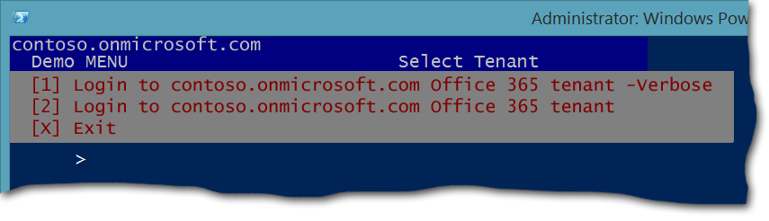

If you select the first option, you’ll see all the underlying Windows PowerShell commands displayed on screen as the demo runs. If you select the second option, those commands will *not* be displayed onscreen. Either way, keep in mind that it could take a minute or two for the script to connect to Office 365, Lync Online, and Exchange Online, and then be ready for use.

# Demos Menus

The menus basically follow the natural flow of my demo sessions:

**Initiate Sessions.** Shows how to initiate a Remote PowerShell session with Lync Online, Windows Azure Active Directory, and Exchange Online – you need all three if you want to manage communications, licenses, and reporting.

In the screenshot below, you can see the Lync Online session being initiated.

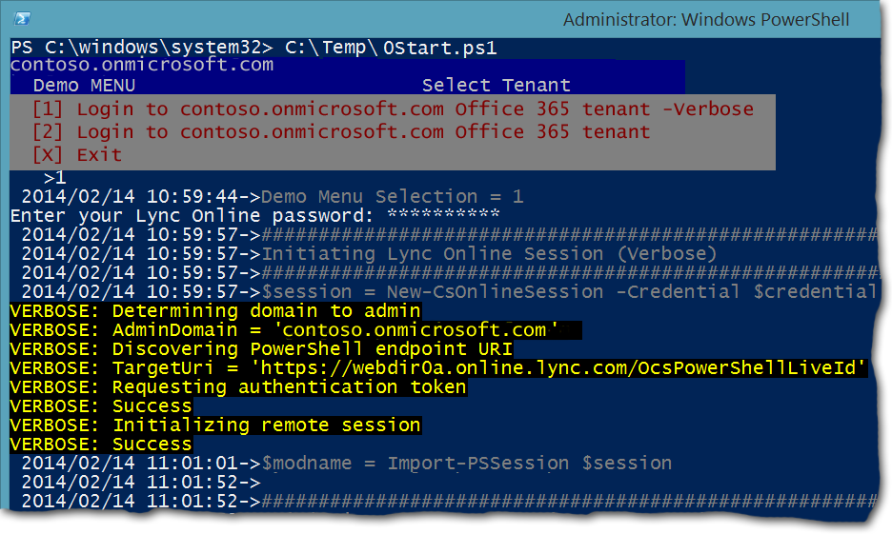

*Session Initiation*

**High Level Functions.** This is my main tenant menu and I show each session is active by listing options for available commands; for managing users and groups; and for querying Exchange Online in order to produce a high level usage report.

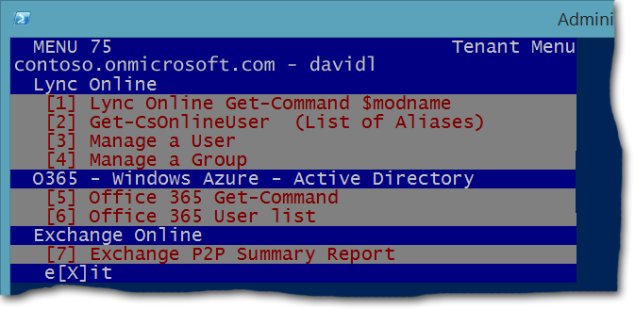

*Tenant Menu*

For example, here’s what you’ll see if you select the option **Lync Online Get-Command**; these are the available Lync Online Windows PowerShell cmdlets:

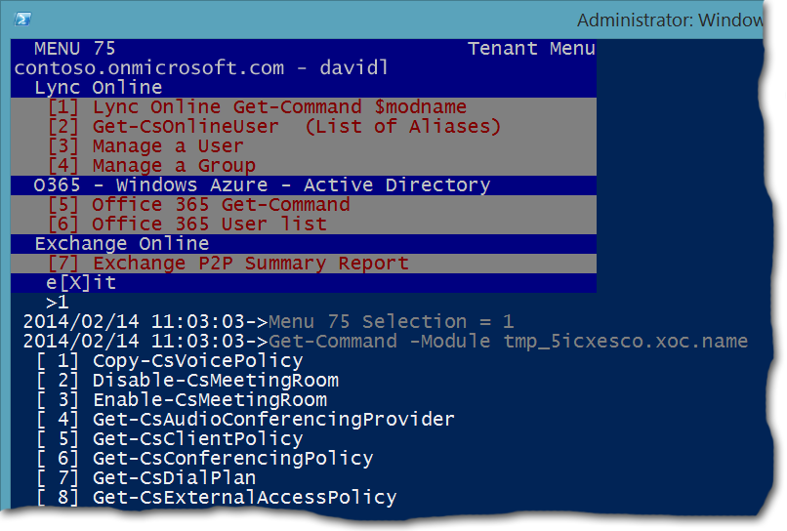

*Get-Command for Lync Online*

If you choose the **Get-CsOnlineUser** option you’ll see a list of all your Lync-enabled users as well as the conferencing policy that has been assigned to them:

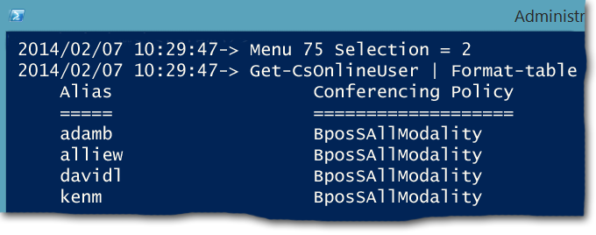

*Listing Users*

**Tip**. If a user doesn’t appear to have a conferencing policy that simply means that the user is managed by the global policy and not by an assigned per-user policy.

And here’s an example of the kind of output you might see if you select **Exchange P2P Summary Report**:

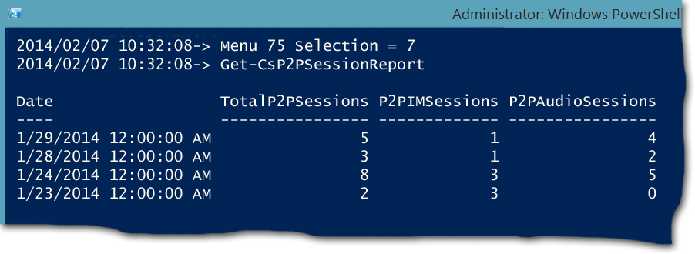

*High Level Usage Report*

That summarizes the high-level functionality. Now we can drill down into User management – Option 3 in my menu.

**Manage a User**

If you select this option, I’ll prompt you for a user to manage – just enter an alias and then work through that user’s current configuration:

1. Show conferencing options.
2. Set and change the conferencing policy for this user.
3. Display and set blocked domains. When a domain is blocked, users from that blocked domain cannot send unsolicited instant messages to your users.

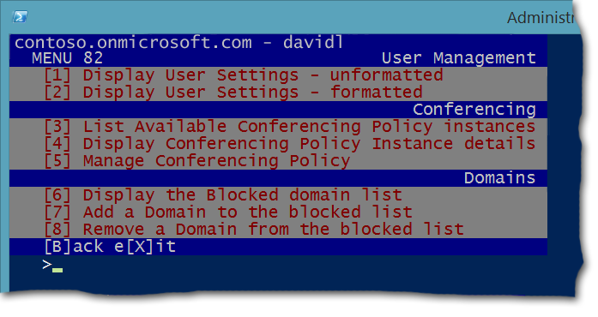

Typically after showing domain management, I head back to the top level Tenant menu and select option 4 to manage a group.

**Manage Groups** – or manage all users at once (showing how you can quickly scale your scripts)

1. Set conferencing policy for members of a group (department).
2. Do the same for all members of the tenant.

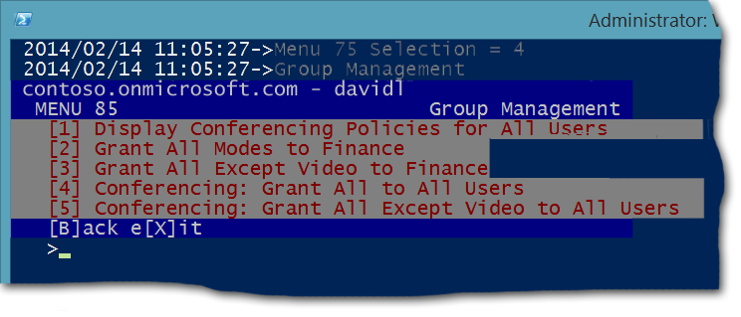

And that’s it. It’s not very sophisticated, but it touches on a wide enough range of features to give beginning Lync Online admins working scripts that they can use as they get started.

# Installation and Configuration

## Disclaimer

These scripts are provided for educational purposes only. There is no implied guarantee they will work as stated.

Neither the author of these scripts nor his employer (Microsoft) are liable for any harm, damage or loss of revenue caused by the use of these scripts.

## Pre-Requisites

Please follow the installation and configuration instructions located here: <http://technet.microsoft.com/en-us/library/dn362831.aspx>. In addition, make sure that:

1. You are running Windows 8 or 8.1
2. You have a valid Office 365 tenant and have admin privileges for that tenant,
3. Your [.Net Framework](http://www.microsoft.com/net) is version 4.5 or later (as should be the case for Windows 8+).
4. You have installed the [Microsoft Online Services Sign-In Assistant for IT Professionals RTW](http://www.microsoft.com/en-us/download/details.aspx?id=28177).
5. You have installed the [Windows PowerShell module for Windows Azure Active Directory](http://go.microsoft.com/fwlink/p/?linkid=236297).
6. You have downloaded and installed the [Lync Online Remote Windows PowerShell Connector](http://www.microsoft.com/en-us/download/details.aspx?id=39366).

## Instructions

1. Create a folder to contain the scripts and copy the following scripts into this folder:   
   * 0Start.ps1
   * 1Demo.ps1
   * 75Tenantmenu.ps1
   * 82User.ps1
   * 85Group.ps1
   * 92Conf.ps1
   * logit.ps1
2. Using Notepad or any other text editor, edit 0Start.ps1 and change the variables to reflect your username, tenant and installation directory, etc.  
     
   The scripts assume that you have a department (Technical Marketing) that is specified in the 0start.ps1 script. If you don't need to demo group changes you can ignore this, but if you want to demo these changes use the Office 365 Admin center to add department settings to your user accounts.
3. Run 0Start.ps1 as Administrator. I like to run my demos using an icon on my desktop, which I configure by completing the following procedure:  
   1. Right click your Windows desktop, point to **New**, then click **Shortcut**.
   2. Browse to: C:\Windows\System32\WindowsPowerShell\v1.0 and select **PowerShell.exe**.
   3. Give your new shortcut a name (i.e., **Lync Online Demo Scripts)** and then click **Finish**.
   4. Right click the new desktop icon and then click **Properties**.
   5. Edit the **Start in** field as follows:   
        
      C:\Windows\System32\WindowsPowerShell\v1.0\powershell.exe -noexit c:\users\YOURUSERNAME\documents\YOUR_SCRIPT_DIRECTORY\0Start.ps1  
        
      For example, if you saved the scripts the folder C:\Scripts you would type the following command:  
        
      C:\Windows\System32\WindowsPowerShell\v1.0\powershell.exe -noexit C:\Scripts\0Start.ps1  
        
      Note that you may also want to change the display settings, using a wider screen and a larger font for demos.
   6. Click **Advanced**, select **Run as administrator**, and then click **OK**. If you do not run Windows PowerShell as an Administrator then the script will fail with the following error message:  
        
      WARNING: ...this doesn't feel right  
      WARNING: Recommendation: Exit and run as Administrator
   7. Click **OK**.

Depending on your Windows PowerShell settings, you might receive an error message similar to the following when you try to run the script:

C:\scripts\0Start.ps1 : File C:\scripts\0Start.ps1 cannot be loaded. The file

C:\scripts\0Start.ps1 is not digitally signed. You cannot run this script on the current system. For more information about running scripts and setting execution policy, see about_Execution_Policies at <http://go.microsoft.com/fwlink/?LinkID=135170>.

If this happens, start Windows PowerShell as an administrator and run the following command:

Get-ExecutionPolicy

Take note of the current value (for example, RemoteSigned), then run this command:

Set-ExecutionPolicy Bypass -Force

Close Windows PowerShell and try running the script again. When you finish working with the demo scripts, you can (if you choose) reset Windows PowerShell to its previous execution policy. For example:

Set-ExecutionPolicy RemoteSigned -Force

Note, too, that when you exit the demo script you will still be connected to Lync Online and to Exchange Online. This should not cause any problems: your sessions will eventually time out and you will be automatically disconnected. However, you can always disconnect all your remote Windows PowerShell sessions by running this command:

Get-PSSession | Remove-PSSession

## Signing off

Knowing I have my Demo menus ready and waiting any time someone asks me to hop onto a call to talk about manageability has given me a lot more confidence. And whenever I learn something new, I add a new menu item to the script. The demos tend to be:

* Repeatable: My demos certainly are.
* Powerful: Scripts beat clicks for group changes.
* Simple to use: I can do powerful things without hunting for syntax.
* Customizable: PowerShell can be customized for anyone’s needs.

Yeah baby!

Let me know if you found this useful and if you have suggestions to make this learning tool even better.

For more information on managing Lync Online by using Windows PowerShell, see the TechNet site [Using Windows PowerShell to Manage Lync Online](http://technet.microsoft.com/en-us/library/dn362831.aspx).