Project 2: Clustering the Dry Bean Dataset
KMeans and Gaussian Mixture Models with k = 7
Khai Kieu
CSC 4850, Fall 2026

Summary
This report describes an unsupervised analysis of the Dry Bean dataset, which contains 13,611 beans described by 16 size and shape measurements. The goal was to assign every bean to one of seven clusters without using the variety label. Two clustering methods were compared, KMeans and a Gaussian Mixture Model (GMM), each applied to standardized features and to standardized features reduced with principal component analysis (PCA). The final choice is KMeans on the standardized features. It had the highest silhouette score in a fair comparison (0.309), almost identical results across ten random seeds (stability 0.9999), and clusters that can be read directly in the original measurements.

1. Introduction
Dry bean varieties are normally sorted by size, shape, and appearance. The Dry Bean dataset of Koklu and Ozkan (2020) contains measurements taken from images of 13,611 grains from seven registered varieties. The original task is classification. In this project the same data is treated as a clustering problem: if only the size and shape of each bean are used, can groups that make sense be found without ever looking at the variety label?
The deliverable is a CSV file, Kieu_DryBeanClusters.csv, with one row per bean containing its sample_id and a cluster number (Class_id) from 0 to 6. The code and this report accompany it. The true labels were not used at any stage. The instructor will compute the adjusted Rand index (ARI) between the submitted clusters and the true varieties.

2. Data
The Excel file has 13,611 rows. Each row has a sample_id, 16 numeric features, and the Class column. The features describe the size of a bean (Area, Perimeter, MajorAxisLength, MinorAxisLength, ConvexArea, EquivDiameter) and its shape (AspectRation, Eccentricity, Extent, Solidity, roundness, Compactness, and ShapeFactor1 to ShapeFactor4). The column name AspectRation is spelled this way in the source file and is kept as it is.

3. Data Preparation
Three checks were made before clustering.
Missing values. There are none, so nothing needed to be filled in or removed.
Duplicates. 68 rows have exactly the same feature values as another row. They were kept, because every sample must receive a cluster in the final file.
Extreme values. 477 rows (about 3.5 percent) have at least one feature more than four standard deviations from its mean. They were also kept. The extreme values look like genuinely large or elongated beans rather than measurement errors, and every bean needs an assignment.
Scaling. The features are on very different scales. Area is around 50,000, while ShapeFactor1 is below 0.01. KMeans and GMM both depend on distances in feature space, so without scaling the large features would decide the clusters. Every feature was standardized to mean 0 and standard deviation 1 with StandardScaler.
Class column. The Class column was dropped before any computation, so it could not influence preprocessing, PCA, clustering, or the choice of configuration. The sample_id column was used only to label the output.

4. Methods

4.1 Clustering methods
KMeans was run with k = 7 clusters and 10 random initializations, keeping the best run. The Gaussian Mixture Model was fitted with 7 components, full covariance matrices, and 3 initializations. Each bean was assigned to the component with the highest probability. The number of clusters was fixed at seven in every configuration, as the assignment requires.

4.2 Principal component analysis
PCA was fitted on the standardized features, and the smallest number of components that explains at least 95 percent of the variance was kept. A separate two component PCA was used only to draw the clusters in two dimensions. The clustering itself never used that two component version.

4.3 Configurations
The two methods and the two feature sets give four configurations: KMeans on standardized features, KMeans on standardized features plus PCA, GMM on standardized features, and GMM on standardized features plus PCA.

4.4 Evaluation
Because the true labels are not available, the clusterings were compared with internal measures.
Silhouette score. This measures how well separated the clusters are. It ranges from negative one to one, and higher is better. It was computed in the space the clustering was done in, and again in the standardized feature space for every configuration. The second version is needed because silhouette values from different spaces are not directly comparable.
Stability. Each configuration was run with ten random seeds (0 to 9). Stability is the average ARI over all pairs of those runs. A value near 1 means the seed hardly matters.
Agreement. The ARI between the final clusterings of two configurations (seed 42) shows how much they differ, for example how much PCA changes the result.

4.5 Selection rule
For each method, the feature set with the higher silhouette in the standardized space was selected, with stability as the tiebreaker. The final configuration is the better of the two selected ones by the same rule. All code uses a fixed random seed of 42 and runs in Python with pandas, numpy, scikit learn, and matplotlib.

5. Results

5.1 Choosing the number of PCA components
The first four components explain 55.5, 81.9, 89.9, and 95.0 percent of the variance in total, so four components were kept (Figure 1). Many of the 16 features are close to copies of each other, for example Area, Perimeter, ConvexArea, EquivDiameter, and the two axis lengths all grow together, which is why 16 features can be reduced to 4 with little loss.
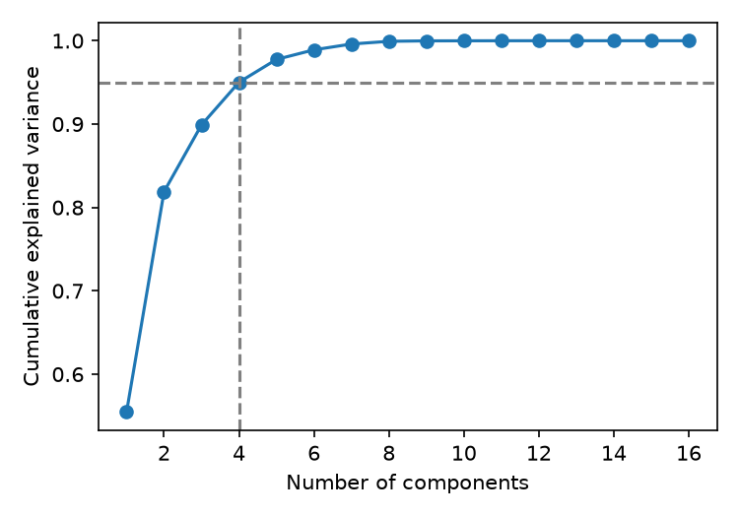
Figure 1. Cumulative explained variance. The dashed lines mark 95 percent and 4 components.

5.2 Comparison of the four configurations
Table 1 gives the results for all four configurations. The PCA rows have a higher silhouette in their own space (0.328 and 0.302), but that number is measured in a different space and cannot be compared with the standardized rows. In the standardized space, which is the fair comparison, KMeans on standardized features is best at 0.3094. It is essentially tied with KMeans plus PCA at 0.3076, and both GMM configurations are lower. Stability is above 0.997 for all four, so the random seed has almost no effect on any of them.
Table 1. Results for the four configurations.
Method | Features used | Silhouette, own space | Silhouette, standardized space | Stability (ARI)
KMeans | Standardized | 0.3094 | 0.3094 | 0.9999
KMeans | Standardized plus PCA (4) | 0.3277 | 0.3076 | 0.9971
GMM | Standardized | 0.2898 | 0.2898 | 1.0000
GMM | Standardized plus PCA (4) | 0.3020 | 0.2836 | 0.9974

The cluster sizes are shown in Table 2. KMeans produces five large clusters and two small ones of about 520 and 540 beans. GMM produces a similar pattern, but its sizes are less even, and with PCA its largest cluster grows to 3,546 beans.
Table 2. Cluster sizes, from largest to smallest.
Method | Features used | Cluster sizes
KMeans | Standardized | 3157, 3111, 2480, 2033, 1769, 541, 520
KMeans | Standardized plus PCA (4) | 3262, 3042, 2476, 2021, 1770, 521, 519
GMM | Standardized | 3191, 2836, 2514, 1984, 1873, 693, 520
GMM | Standardized plus PCA (4) | 3546, 2699, 2547, 1875, 1591, 831, 522

5.3 Agreement between configurations
Table 3 shows how similar the clusterings are. PCA barely changes KMeans (ARI 0.942) but changes GMM more (ARI 0.724). KMeans and GMM agree with each other at about 0.77 to 0.80, so they find similar but not identical groups.
Table 3. Adjusted Rand index between configurations.
 | KMeans | KMeans plus PCA | GMM | GMM plus PCA
KMeans | 1.000 | 0.942 | 0.795 | 0.788
KMeans plus PCA | 0.942 | 1.000 | 0.766 | 0.796
GMM | 0.795 | 0.766 | 1.000 | 0.724
GMM plus PCA | 0.788 | 0.796 | 0.724 | 1.000

5.4 Selected configuration
Applying the selection rule, KMeans selects the standardized features (0.3094 against 0.3076) and GMM also selects the standardized features (0.2898 against 0.2836). Between the two, KMeans has the higher silhouette. The final configuration is therefore KMeans on standardized features with k = 7, and its assignments are the ones saved in Kieu_DryBeanClusters.csv.

5.5 The clusters in two dimensions
Figure 2 draws the selected KMeans and GMM clusterings on the first two principal components. These two components keep about 82 percent of the variance, so some of the information the algorithms used is missing from the picture. Clusters that overlap here may still be separated in the full 16 dimensional space. One group, the very large beans at the top right, is clearly separate in both panels. The rest blend into each other rather than forming sharp islands. In the GMM panel, one component is spread thinly around the edges of the others, which is consistent with its lower silhouette.
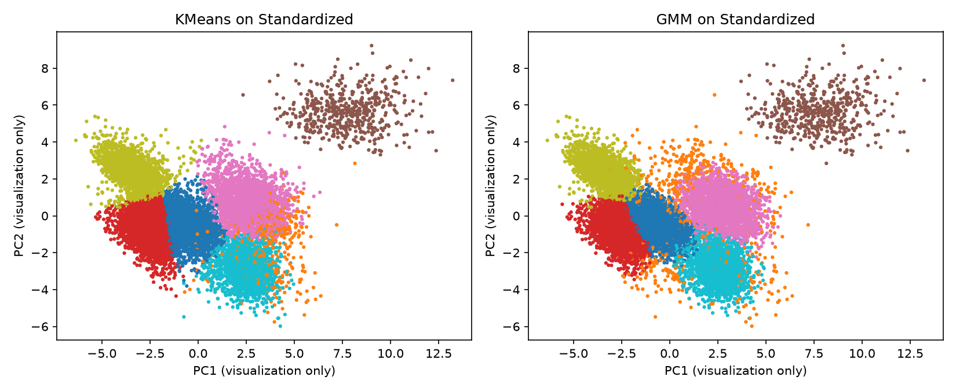
Figure 2. Selected KMeans and GMM clusterings on the first two principal components (drawing only).

5.6 What the final clusters look like
Figure 3 shows the average of each feature in each final cluster, measured in standard deviations from the overall mean. Table 4 gives some of the same averages in the original units.
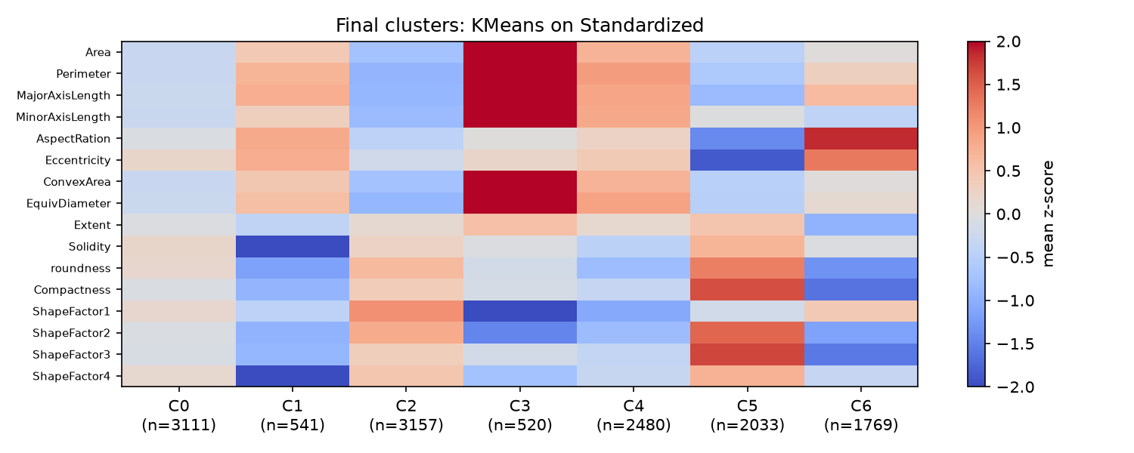
Figure 3. Mean z score of each feature in each final cluster. Red is above average and blue is below.
Table 4. Cluster sizes and feature averages in original units.
Cluster | Beans | Area | Aspect ratio | Roundness | Solidity | Eccentricity
0 | 3,111 | 44,435 | 1.57 | 0.88 | 0.988 | 0.77
1 | 541 | 65,249 | 1.79 | 0.80 | 0.973 | 0.82
2 | 3,157 | 31,541 | 1.48 | 0.91 | 0.988 | 0.73
3 | 520 | 173,668 | 1.59 | 0.86 | 0.987 | 0.77
4 | 2,480 | 74,020 | 1.65 | 0.83 | 0.985 | 0.79
5 | 2,033 | 39,397 | 1.24 | 0.95 | 0.990 | 0.58
6 | 1,769 | 53,677 | 2.04 | 0.79 | 0.987 | 0.87

The clusters can be described as follows.
Cluster 3 holds the very large beans. It has 520 beans and an average area of 173,668, more than five times that of cluster 2.
Cluster 5 is small and round. It has the lowest aspect ratio (1.24) and eccentricity (0.58) and the highest roundness (0.95).
Cluster 6 holds the most elongated beans, with the highest aspect ratio (2.04) and eccentricity (0.87) and the lowest roundness (0.79).
Cluster 1 has irregular outlines. Its solidity of 0.973 is the lowest, while the other clusters are all between 0.985 and 0.990.
Clusters 2, 0, and 4 are mostly small, medium, and large versions of a similar shape. Their average areas are 31,541, 44,435, and 74,020, and their aspect ratios are close, from 1.48 to 1.65.

6. Discussion
PCA did not help. PCA is a reasonable step here because the features are so redundant, and it cut 16 features to 4. In the fair comparison, however, it did not improve either method. For KMeans the two versions give almost the same partition (ARI 0.942), so PCA mostly compressed the data. For GMM it changed the result more and lowered the silhouette. PCA also makes the clusters harder to explain, since the components are mixtures of the original measurements.
KMeans over GMM. GMM can fit elliptical clusters of different sizes, which in principle suits this data. In practice it scored lower than KMeans on silhouette, and Figure 2 shows one broad component that overlaps the others. Both methods were very stable across seeds, so the difference is not a matter of unlucky starting points.
Structure in the data. The silhouette of about 0.31 indicates modest separation. Only the very large beans form a clearly isolated group. The remaining clusters divide a continuous spread of sizes and shapes, which is why several of them differ mainly in size. This fits the nature of the data, since beans from different varieties have similar shapes.
Limitations. The number of clusters was fixed at seven in advance, so no other values were tried and the silhouette cannot say whether seven is the right number. High stability shows that the results are reproducible, not that they are correct. Without access to the true labels, it is not possible to check here how well the clusters match the seven varieties. Duplicates and extreme rows were kept, and extreme rows can pull KMeans centroids slightly. The results also depend on the choice to standardize every feature equally.

7. Conclusion
Seven clusters were found for 13,611 dry beans using only their size and shape measurements. KMeans on standardized features was selected as the final configuration. It has the best silhouette in the fair comparison (0.309), near perfect stability across ten seeds (0.9999), cluster sizes from 520 to 3,157 beans, and clusters that can be explained with the original features: very large, small and round, elongated, irregular, and three groups that differ mostly in size. PCA reduced the data to four dimensions without improving the result, and GMM was a reasonable alternative that scored lower. The adjusted Rand index against the true varieties will be computed by the instructor.

8. Files and Reproducibility
The analysis is a single script that reads the Excel file and writes every output. The random seed is fixed at 42, so rerunning it gives the same files.
File | Contents
Dry_bean_clustering_Khai_Kieu.py | Complete code for the analysis
Kieu_DryBeanClusters.csv | Final assignments: sample_id and Class_id
clustering_comparison.csv | Table 1 and Table 2 values
config_agreement_ARI.csv | Table 3 values
final_cluster_profile_means.csv | Average of every feature in each final cluster
summary.json | Preparation counts, PCA size, and selected configuration
pca_cumulative_variance.png | Figure 1
pca2d_selected_configs.png | Figure 2
final_cluster_profile_heatmap.png | Figure 3

Reference
Koklu, M. and Ozkan, I. A. (2020). Multiclass classification of dry beans using computer vision and machine learning techniques. Computers and Electronics in Agriculture, 174, 105507. https://doi.org/10.1016/j.compag.2020.105507

