A Cloud-Native Distributed Application Composed Of Interacting Microservices.
Student Name: Kirthika Alagar
Student ID: A00336252
Course: MSc Software Design with Cloud Native Computing
Module: Microservices Architecture
GitHub: https://github.com/CodingKirthi/Microservice-RestAPI

Table of Contents

1. Introduction & System Context 3
2. Architecture Overview 3
2.1 System Components 4
2.2 Technology Stack 5
2.3 Domain Model 5
3. Service Discovery & Interaction 7
3.1 Eureka Service Discovery 7
3.2 Service-to-Service Communication 7
4. Configuration Management 10
5. Resilience & Fault Handling 12
5.1 Circuit Breaker Configuration 12
5.2 Failure Scenarios and Evidence 13
6. Observability 15
7. Security Considerations 17
8. Evaluation & Reflection 19
References 21

1. Introduction & System Context
This report documents the design, implementation, and evaluation of a cloud-native distributed application composed of interacting microservices. The system was built as an e-commerce order processing platform where an Order Service depends on a Product Service to validate stock availability and process purchases. The application demonstrates core cloud-native behaviours including service discovery, externalised configuration, resilience patterns, distributed tracing, and gateway-based security.
The rationale for a distributed solution stems from the fundamental separation of concerns between product catalogue management and order processing. In a monolithic architecture, these two domains would share a single database, a single deployment unit, and a single failure boundary. A change to the product pricing logic could break order processing. A spike in order volume could degrade product browsing performance. A database schema migration would require downtime for the entire system.
By decomposing the system into independent microservices, each domain can be developed, deployed, and scaled independently. The Product Service can be scaled horizontally to handle catalogue browsing traffic without affecting order processing. The Order Service can be deployed with multiple instances behind a load balancer to handle peak ordering periods. Most importantly, each service owns its data and its failure boundary, which means a failure in one service does not necessarily cascade to the other.
The cloud-native behaviours demonstrated in this system go beyond simple REST API design. The focus is on how services discover each other at runtime, how configuration is managed externally, how failures are handled gracefully, how requests are traced across service boundaries, and how security is enforced at the system perimeter.
All source code is available at: https://github.com/CodingKirthi/Microservice-RestAPI

2. Architecture Overview
The system follows a standard cloud-native microservices architecture pattern. Client requests enter through a single API Gateway, which handles authentication and routes requests to the appropriate backend service using service discovery. All services retrieve their configuration from a centralised Configuration Server at startup and register themselves with a Discovery Server.
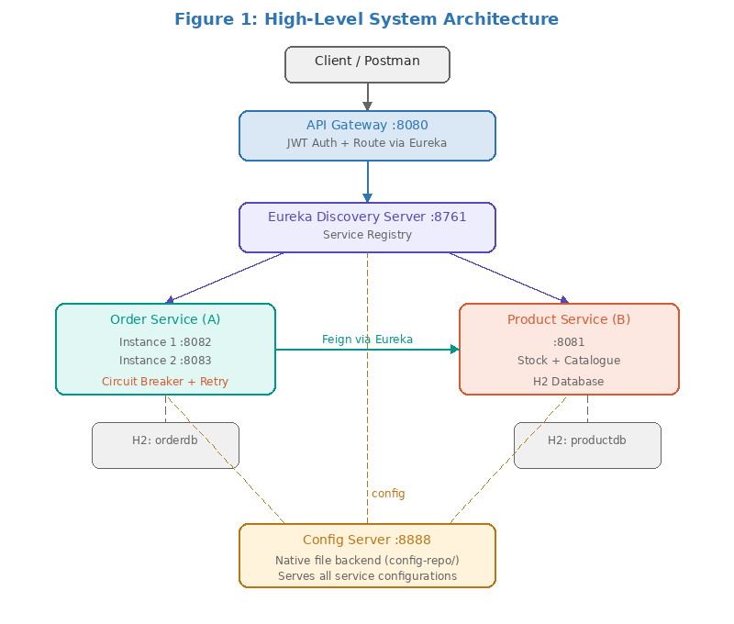

2.1 System Components
The application consists of six components, each running as an independent Spring Boot process:
Component | Role | Port
Config Server | Serves externalised configuration to all services from a file-based repository | 8888
Discovery Server (Eureka) | Service registry where all services register at startup and discover each other at runtime | 8761
API Gateway (Spring Cloud Gateway) | Single entry point for all client requests. Enforces JWT authentication and routes to backend services via Eureka | 8080
Product Service (Service B) | Owns the product catalogue domain. Manages products, stock levels, and pricing. Exposes stock-check and stock-reduction endpoints consumed by Order Service | 8081
Order Service (Service A) | Owns the order processing domain. Creates orders by calling Product Service to validate stock and calculate pricing. Deployed with multiple instances | 8082, 8083

The request flow through the system is as follows: a client sends an HTTP request to the API Gateway on port 8080. The gateway’s JwtAuthenticationFilter validates the JWT token. If valid, the gateway uses Eureka service discovery to locate the target service (PRODUCT-SERVICE or ORDER-SERVICE) and routes the request. When Order Service receives a create-order request, it calls Product Service directly via Feign (also resolved through Eureka, not through the gateway) to check stock and reduce inventory.

2.2 Technology Stack
Component | Technology / Version
Framework | Spring Boot 3.2.3
Cloud Platform | Spring Cloud 2023.0.1
Service Discovery | Netflix Eureka (spring-cloud-starter-netflix-eureka)
Configuration | Spring Cloud Config Server (native file backend)
API Gateway | Spring Cloud Gateway (reactive, WebFlux-based)
Inter-Service Communication | OpenFeign (spring-cloud-starter-openfeign)
Resilience | Resilience4j (circuit breaker, retry, time limiter)
Tracing | Micrometer Tracing with Brave + Zipkin reporter
Security | JWT (jjwt library 0.12.3) with custom GlobalFilter
Persistence | Spring Data JPA + H2 in-memory database
Build Tool | Apache Maven
Java Version | Java 17

2.3 Domain Model
Product Service manages the Product entity. The entity class is annotated with JPA and Bean Validation annotations:
@Entity
@Table(name = "products")
public class Product {
@Id @GeneratedValue(strategy = GenerationType.IDENTITY)
private Long id;

@NotBlank(message = "Product name is required")
private String name;
private String description;

@NotNull @Positive
private BigDecimal price;

@PositiveOrZero
private Integer stockQuantity;
}

Order Service manages the Order entity with a status enum that includes a FALLBACK value for graceful degradation:
public enum OrderStatus {
PENDING, // Initial state
CONFIRMED, // Stock verified and reduced
FAILED, // Insufficient stock
FALLBACK // Product Service unavailable
}

The FALLBACK status is a cloud-native design decision: when Product Service is unavailable, Order Service saves the order with FALLBACK status and a descriptive failure reason rather than returning a 500 error. This enables graceful degradation and potential later reconciliation.

3. Service Discovery & Interaction

3.1 Eureka Service Discovery
All services register with Netflix Eureka at startup. The Discovery Server is annotated with @EnableEurekaServer:
@SpringBootApplication
@EnableEurekaServer
public class DiscoveryServerApplication {
public static void main(String[] args) {
SpringApplication.run(DiscoveryServerApplication.class, args);
}
}

The shared configuration (served by Config Server to all services) registers each service with Eureka:
# config-repo/application.yml (shared by ALL services)
eureka:
client:
service-url:
defaultZone: http://localhost:8761/eureka/
instance:
prefer-ip-address: true

At runtime, the Eureka dashboard (http://localhost:8761) shows all registered instances. When Order Service is deployed with two instances (ports 8082 and 8083 via the start-order-instance2.bat script), both appear under the same service ID ORDER-SERVICE. Eureka’s client-side load balancing distributes requests across instances.
Without service discovery, every service would need hardcoded hostnames and ports. Adding a new Order Service instance would require updating the API Gateway configuration and restarting it. Service discovery eliminates this coupling: new instances register themselves, and consumers discover them dynamically.

3.2 Service-to-Service Communication
Order Service communicates with Product Service using OpenFeign, a declarative HTTP client that resolves service addresses through Eureka:
@FeignClient(name = "PRODUCT-SERVICE",
fallback = ProductClientFallback.class)
public interface ProductClient {

@GetMapping("/api/products/{id}/check-stock")
ProductResponse checkStock(
@PathVariable("id") Long productId,
@RequestParam("quantity") int quantity);

@PostMapping("/api/products/{id}/reduce-stock")
void reduceStock(
@PathVariable("id") Long productId,
@RequestParam("quantity") int quantity);
}

The name attribute "PRODUCT-SERVICE" is the Eureka service ID, not a URL. At runtime, Feign resolves this through Eureka to obtain the actual host and port. This communication occurs directly between services, not through the API Gateway.
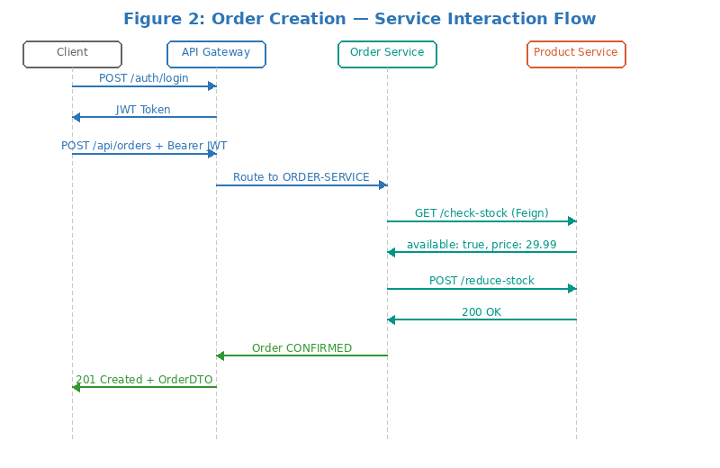
The interaction is genuine business logic. When creating an order, Order Service: (1) calls Product Service’s /api/products/{id}/check-stock to verify stock, (2) if available, calls /api/products/{id}/reduce-stock to decrement inventory, and (3) calculates total price from the product’s unit price and requested quantity. The core logic in OrderService.createOrder():
@CircuitBreaker(name = PRODUCT_SERVICE,
fallbackMethod = "createOrderFallback")
@Retry(name = PRODUCT_SERVICE)
public OrderDTO createOrder(CreateOrderRequest request) {
// Call Product Service via Feign (Eureka-resolved)
ProductResponse stockInfo = productClient.checkStock(
request.getProductId(), request.getQuantity());

if (!stockInfo.isAvailable()) {
Order order = new Order(request.getProductId(),
stockInfo.getProductName(), request.getQuantity(),
BigDecimal.ZERO, OrderStatus.FAILED);
order.setFailureReason("Insufficient stock");
return toDTO(orderRepository.save(order));
}

BigDecimal totalPrice = stockInfo.getPrice()
.multiply(BigDecimal.valueOf(request.getQuantity()));
productClient.reduceStock(
request.getProductId(), request.getQuantity());

Order order = new Order(request.getProductId(),
stockInfo.getProductName(), request.getQuantity(),
totalPrice, OrderStatus.CONFIRMED);
return toDTO(orderRepository.save(order));
}

4. Configuration Management
All services retrieve configuration from a centralised Spring Cloud Config Server. The Config Server uses the native profile with a file-based backend:
# config-server/application.yml
spring:
profiles:
active: native
cloud:
config:
server:
native:
search-locations: file:///C:/Microservice-Assignment2/config-repo

Each service’s local application.yml contains only the service name and config server directive:
# order-service/application.yml (entire file)
spring:
application:
name: order-service
config:
import: "configserver:http://localhost:8888"

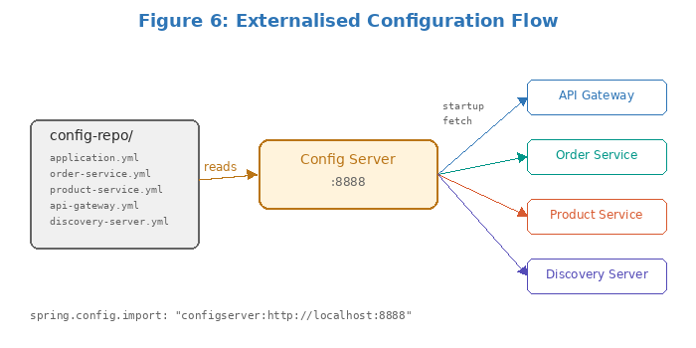

The configuration files in config-repo/ are:
- application.yml — Shared: Eureka client settings, actuator endpoints, tracing (sampling probability 1.0), and structured log pattern with traceId/spanId
- order-service.yml — Port 8082, H2 database (jdbc:h2:mem:orderdb), complete Resilience4j circuit breaker/retry/time-limiter configuration
- product-service.yml — Port 8081, H2 database (jdbc:h2:mem:productdb), JPA settings
- api-gateway.yml — Port 8080, gateway routes mapping paths to Eureka service IDs, JWT secret and expiration
- discovery-server.yml — Port 8761, self-preservation disabled, standalone mode

The separation between code and configuration is complete. No service contains hardcoded ports, database URLs, JWT secrets, or resilience parameters. To move from development to production, only the config-repo files need to change — no code recompilation is required.
A key example of the operational benefit: the gateway route configuration uses Eureka service IDs rather than hardcoded URLs:
# config-repo/api-gateway.yml
spring:
cloud:
gateway:
routes:
- id: product-service
uri: lb://PRODUCT-SERVICE # Eureka-resolved
predicates:
- Path=/api/products/**
- id: order-service
uri: lb://ORDER-SERVICE # Eureka-resolved
predicates:
- Path=/api/orders/**

5. Resilience & Fault Handling
Service-to-service communication in a distributed system is inherently unreliable. The Order Service implements three Resilience4j patterns to handle failures gracefully.

5.1 Circuit Breaker Configuration
All resilience parameters are externalised in order-service.yml (served by Config Server):
# config-repo/order-service.yml
resilience4j:
circuitbreaker:
instances:
product-service:
sliding-window-size: 5
minimum-number-of-calls: 3
failure-rate-threshold: 50
wait-duration-in-open-state: 10s
permitted-number-of-calls-in-half-open-state: 2
sliding-window-type: COUNT_BASED
retry:
instances:
product-service:
max-attempts: 3
wait-duration: 2s
exponential-backoff-multiplier: 2
timelimiter:
instances:
product-service:
timeout-duration: 5s

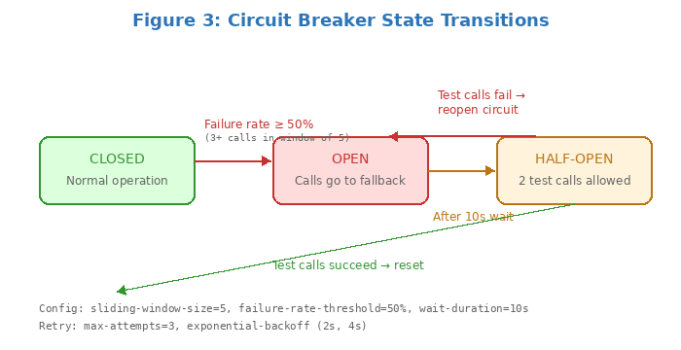

Parameter | Value | Purpose
sliding-window-size | 5 | Evaluates the last 5 calls to determine failure rate
minimum-number-of-calls | 3 | Requires at least 3 calls before the circuit can open
failure-rate-threshold | 50% | Opens the circuit when 50% or more of calls fail
wait-duration-in-open-state | 10s | Stays open for 10 seconds before transitioning to half-open
permitted-number-of-calls-in-half-open-state | 2 | Allows 2 test calls in half-open state
sliding-window-type | COUNT_BASED | Uses call count rather than time-based window

5.2 Failure Scenarios and Evidence
Scenario: Product Service becomes unavailable
When Product Service is stopped, subsequent order creation requests trigger the resilience chain:
- The Feign call fails with a connection refused error
- The retry mechanism attempts the call up to 3 times with exponential backoff (2s, 4s)
- After retries are exhausted, the circuit breaker’s fallback method is invoked
- The fallback saves the order with FALLBACK status and a descriptive failure reason
- The client receives a 201 Created response (not a 500 error)
- Once failure rate exceeds 50% in the sliding window, the circuit opens and subsequent calls skip retries entirely

Fallback implementation (ProductClientFallback.java):
@Component
public class ProductClientFallback implements ProductClient {

@Override
public ProductResponse checkStock(Long productId, int qty) {
log.warn("FALLBACK: Product Service unavailable.");
ProductResponse fallback = new ProductResponse();
fallback.setProductId(productId);
fallback.setProductName("UNKNOWN (service unavailable)");
fallback.setPrice(BigDecimal.ZERO);
fallback.setAvailable(false);
return fallback;
}
}

Service-level fallback (OrderService.java):
public OrderDTO createOrderFallback(CreateOrderRequest req, Throwable t) {
log.error("CIRCUIT BREAKER FALLBACK triggered for productId={}.",
req.getProductId());
Order order = new Order(
req.getProductId(),
"UNAVAILABLE (Product Service down)",
req.getQuantity(), BigDecimal.ZERO,
OrderStatus.FALLBACK);
order.setFailureReason(
"Product Service unavailable: " + t.getMessage());
return toDTO(orderRepository.save(order));
}

Expected log evidence during failure:
ERROR [order-service,abc123,span-1] CIRCUIT BREAKER FALLBACK triggered
for productId=1. Reason: Connection refused
WARN [order-service,abc123,span-1] Fallback order 5 saved with status FALLBACK

Why this strategy is appropriate: In an e-commerce system, rejecting all orders when the product catalogue service is temporarily down would result in lost revenue. The fallback approach acknowledges the order, records the failure reason, and allows fulfilment once Product Service recovers. This is a deliberate availability-over-consistency trade-off. In production, a background reconciliation process would match FALLBACK orders against restored product data.

6. Observability
The system implements distributed tracing using Micrometer Tracing with the Brave bridge and Zipkin reporter. The shared configuration sets sampling probability to 1.0 and structures the log format:
# config-repo/application.yml (shared)
management:
tracing:
sampling:
probability: 1.0

logging:
pattern:
level: "%5p [${spring.application.name:},%X{traceId:-},%X{spanId:-}]"
level:
com.microservices: DEBUG

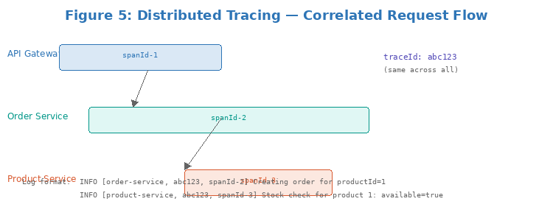
Every log line includes the service name, trace ID (shared across all services handling the same request), and span ID (unique to each service’s processing). A single order creation request generates correlated entries across three services:
- API Gateway: Logs authenticated user and path, with the initial traceId
- Order Service: Logs order creation, stock check call, and confirmation — same traceId, different spanId
- Product Service: Logs stock check and reduction — same traceId propagated from Order Service via Feign

Interpreting observability data:
To diagnose a latency issue, an operator would: (1) identify the traceId from gateway logs, (2) grep all service logs for that traceId, (3) examine timestamps on each span to pinpoint where delay occurred. For example, if an order takes 8 seconds, the trace reveals whether the delay is in Order Service business logic, the Feign call, or Product Service’s database query.

Feign tracing integration:
The order-service pom.xml includes feign-micrometer, which automatically propagates trace context across Feign HTTP calls. Without this dependency, the traceId would be lost at the service boundary and the Product Service logs would show a different (unrelated) trace.
Additionally, all services expose Spring Boot Actuator endpoints (management.endpoints.web.exposure.include: "*"), providing runtime health checks, metrics, and environment information. The circuit breaker is registered as a health indicator (register-health-indicator: true), so /actuator/health reports the circuit state (CLOSED, OPEN, or HALF_OPEN).

7. Security Considerations
The system implements JWT-based authentication enforced at the API Gateway. The security architecture follows a perimeter-based model.
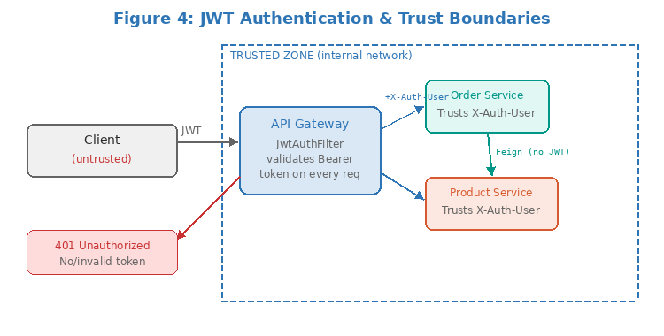

Authentication Flow:
- Client sends POST /auth/login with username and password
- AuthController validates credentials against a user map (admin/password, user/password — demo)
- JwtUtil generates a signed JWT using HMAC-SHA with a Base64-encoded secret key (24-hour expiry)
- Token is returned in the response body

JWT Generation (JwtUtil.java):
@Component
public class JwtUtil {
@Value("${jwt.secret}")
private String secret; // From config server

@Value("${jwt.expiration}")
private long expiration; // 86400000ms = 24 hours

public String generateToken(String username) {
return Jwts.builder()
.subject(username)
.issuedAt(new Date())
.expiration(new Date(
System.currentTimeMillis() + expiration))
.signWith(getSigningKey())
.compact();
}
}

Gateway enforcement (JwtAuthenticationFilter.java):
@Component
public class JwtAuthenticationFilter implements GlobalFilter {

private static final List<String> OPEN_ENDPOINTS = List.of(
"/auth/login", "/auth/register");

@Override
public Mono<Void> filter(ServerWebExchange exchange,
GatewayFilterChain chain) {
String path = exchange.getRequest().getPath().toString();
if (OPEN_ENDPOINTS.stream().anyMatch(path::startsWith))
return chain.filter(exchange);

String authHeader = exchange.getRequest().getHeaders()
.getFirst("Authorization");
if (authHeader == null || !authHeader.startsWith("Bearer ")) {
exchange.getResponse().setStatusCode(UNAUTHORIZED);
return exchange.getResponse().setComplete();
}

String token = authHeader.substring(7);
if (jwtUtil.validateToken(token)) {
String username = jwtUtil.extractUsername(token);
ServerWebExchange mutated = exchange.mutate()
.request(r -> r.header("X-Authenticated-User",
username))
.build();
return chain.filter(mutated);
}
exchange.getResponse().setStatusCode(UNAUTHORIZED);
return exchange.getResponse().setComplete();
}
}

Trust boundaries:
The gateway is the trust boundary. Clients must authenticate with JWT. Backend services trust the X-Authenticated-User header set by the gateway. Service-to-service Feign calls do not require JWT tokens — both services are within the trusted internal network. The JWT secret is externalised in api-gateway.yml served by Config Server, not hardcoded in source code.

8. Evaluation & Reflection
Limitation 1: In-Memory Databases
Both services use H2 in-memory databases with ddl-auto: create-drop. All data is lost on restart. In production, each service would use a persistent database (MySQL/PostgreSQL) with its own schema. H2 was a deliberate simplification to avoid managing multiple database servers.

Limitation 2: Hardcoded User Store
Authentication uses a hardcoded Map in AuthController. In production, this would be replaced with a database-backed user store integrated with an identity provider (Keycloak/Auth0) using password hashing (bcrypt). The current implementation also lacks role-based access control.

Limitation 3: No FALLBACK Order Reconciliation
When orders are saved with FALLBACK status, there is no mechanism to reconcile them once Product Service recovers. In production, a scheduled job or event-driven process would detect FALLBACK orders and attempt validation against restored product data.

Limitation 4: Single Config Server Instance
The Config Server is a single point of failure. If it is down when services start, they cannot retrieve their configuration. In production, the Config Server would be deployed with high availability (multiple instances behind a load balancer) or configuration would be backed by a Git repository with local caching.

One Improvement for Production
The most impactful improvement would be replacing synchronous Feign-based communication with an asynchronous, event-driven approach using a message broker (RabbitMQ or Apache Kafka). Order Service would publish an OrderCreated event; Product Service would consume it, validate stock, and publish StockConfirmed or StockRejected. This provides: (1) temporal decoupling — services need not run simultaneously; (2) natural resilience — messages are persisted and retried automatically; (3) better scalability — consumers scale independently; (4) an audit trail — complete event history.

Lesson Learned About Cloud-Native Systems
The most significant lesson is that infrastructure code (configuration, discovery, resilience, tracing, security) is at least as important as business logic, and often more complex. The actual business logic — checking stock, calculating prices — is straightforward Java. The cloud-native behaviours that make the system production-ready required significantly more design thought and configuration than the business logic itself. This inversion of complexity is characteristic of distributed systems: the challenge is not making individual services work, but making them work together reliably when the network is unreliable and services fail independently.

References
[1] Richardson, C. (2018). Microservices Patterns: With Examples in Java. Manning Publications.
[2] Newman, S. (2021). Building Microservices: Designing Fine-Grained Systems. 2nd ed. O’Reilly Media.
[3] Spring Cloud Documentation (2024). Spring Cloud Netflix — Service Discovery: Eureka. Available at: https://docs.spring.io/spring-cloud-netflix/docs/current/reference/html/
[4] Spring Cloud Documentation (2024). Spring Cloud Config. Available at: https://docs.spring.io/spring-cloud-config/docs/current/reference/html/
[5] Resilience4j Documentation (2024). Getting Started. Available at: https://resilience4j.readme.io/docs/getting-started
[6] Spring Cloud Documentation (2024). Spring Cloud Gateway. Available at: https://docs.spring.io/spring-cloud-gateway/docs/current/reference/html/
[7] Nygard, M. (2018). Release It! Design and Deploy Production-Ready Software. 2nd ed. Pragmatic Bookshelf.
[8] Burns, B. (2018). Designing Distributed Systems: Patterns and Paradigms for Scalable, Reliable Services. O’Reilly Media.
[9] Micrometer Documentation (2024). Micrometer Tracing. Available at: https://micrometer.io/docs/tracing
[10] Spring Boot Reference Documentation (2024). Production-ready Features (Actuator). Available at: https://docs.spring.io/spring-boot/docs/current/reference/html/actuator.html

GitHub Repository: https://github.com/CodingKirthi/Microservice-RestAPI

