**Age & Race Voting Trends**

Eligible voters are US citizen ages 18 and older. The % here is w.r.t the % of eligible registered voter population.

**Age chart**

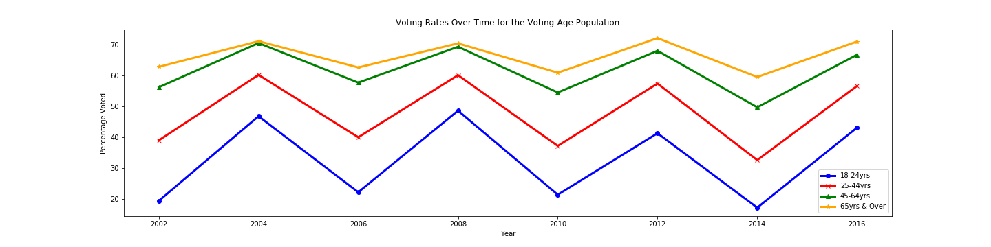

Older population participates at greater rates. The chart above illustrates this point clearly.

While comparing voting rates between 2012 and 2016 were not statistically different for any age groups.

Across all age groups the 2nd term elections have seen lesser turnouts.

**Race chart**

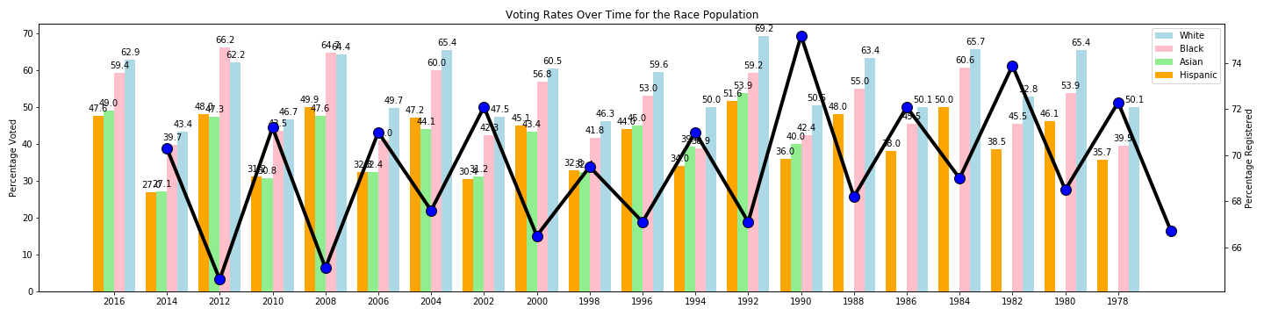

White, Black and Asian populations include only those who reported single race. Data for Asian not available prior to 1990.

Black voters % have improved over time compared with white voter %.

The black voter turnout rate declined to 59.6% in 2016 after reaching a record-high 66.6% in 2012.

Hispanic and Asian Americans are not getting to the polls in adequate numbers.