NAME:MANVITH BALAJI

SECTION:A

MIS NO. :112315115

1.Python code for version

INPUT CODE:

import sys

print(sys.version)

output:

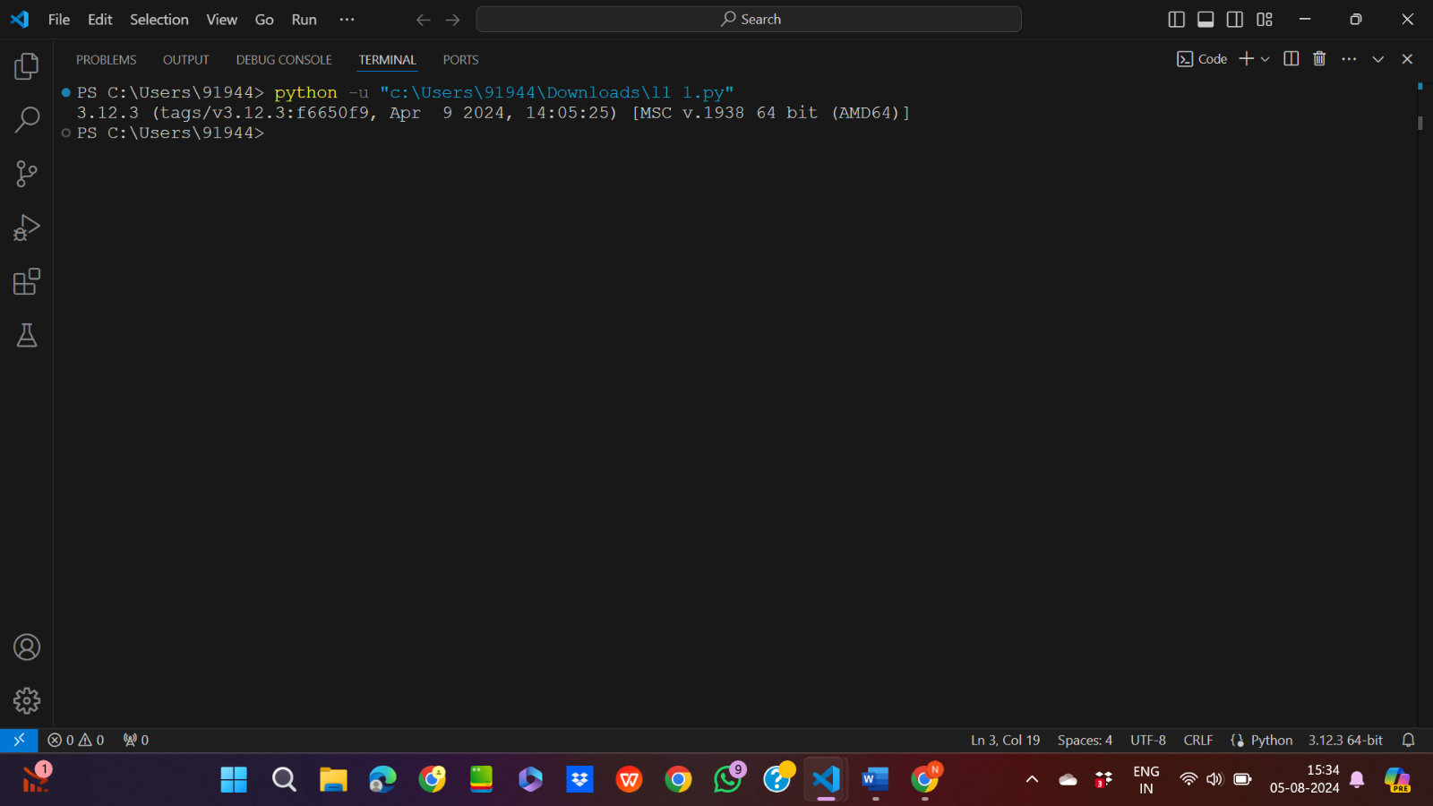

2.Python code for list of keywords

Input code:

import keyword

print(keyword.kwlist)

output:

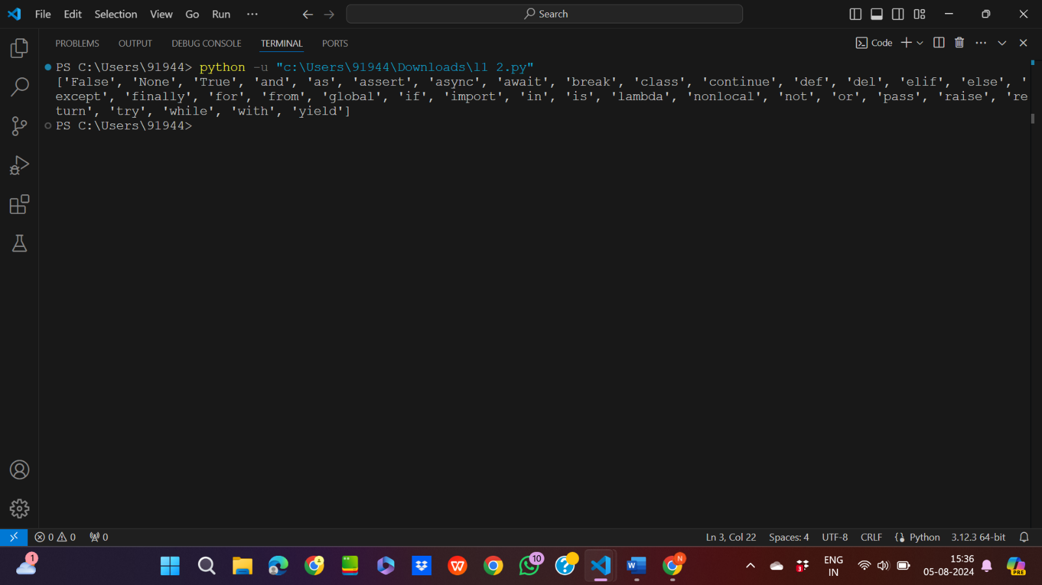

3.Python code for age at 100 years

Input code:

name=input("Enter your name: ")

age=int(input("Enter your age: "))

dob=2024-age

print(f"{name} will turn 100 years at ",dob+100," A.D")

output:

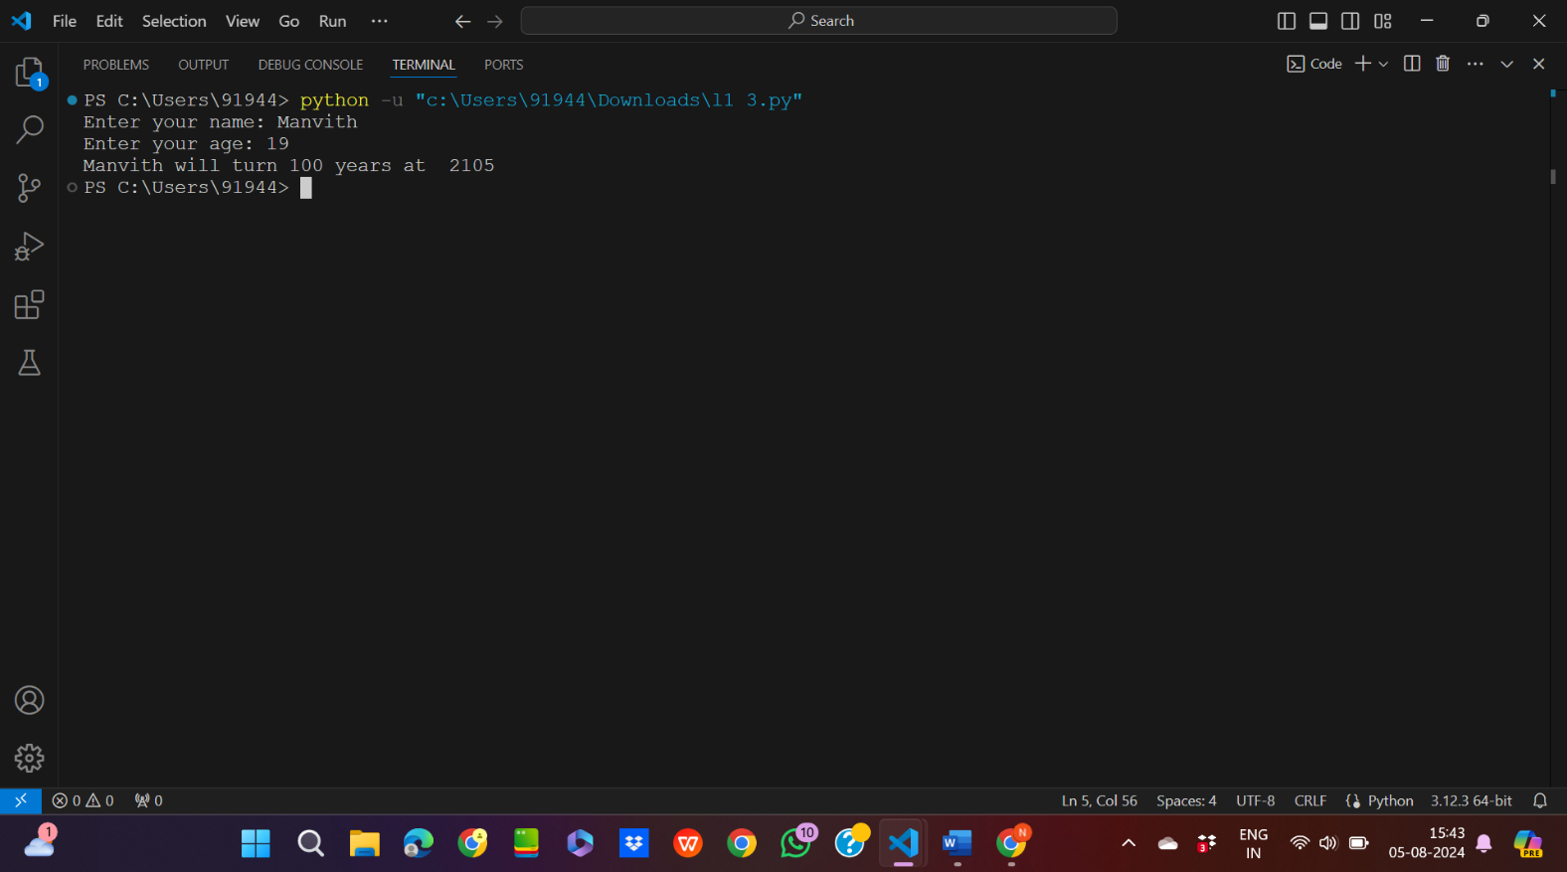

4.Python code for area of circle

Input code:

import math

radius=int(input("Enter the radius of circle: "))

area=math.pi\*radius\*radius

print("The area of circle is ",area)

output:

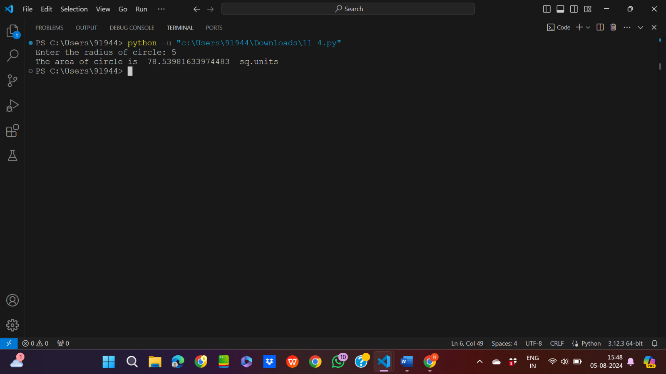

5.Python code for even or odd

Input code:

num=int(input("Enter a number: "))

if(num%2==0):

    print(f"The given number {num} is even")

else:

    print(f"The given number {num} is odd")

ouput:

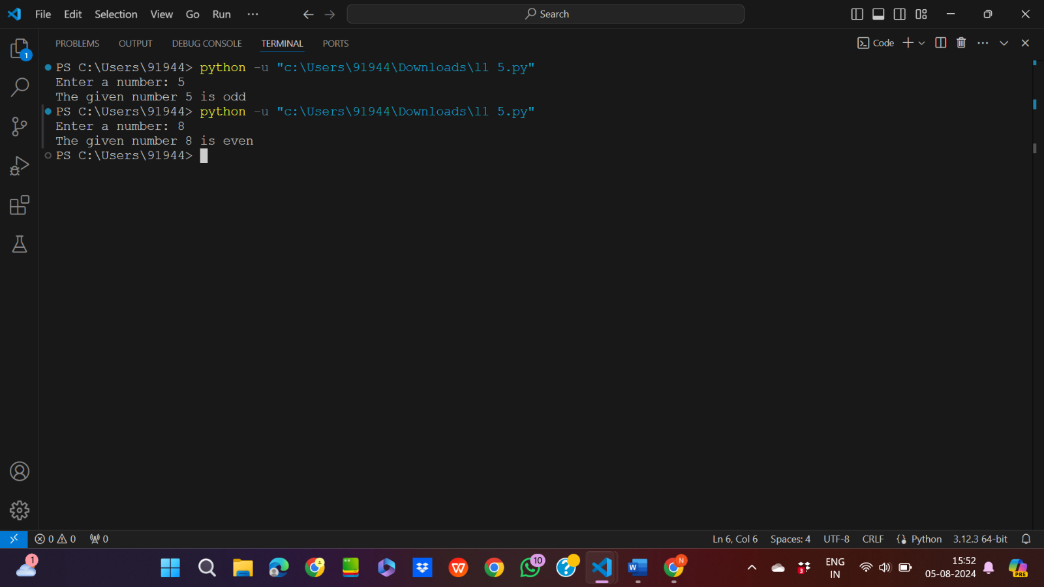

6.Python code for checking of palindrome

Input code:

a=input("Enter a string: ")

count=0

for i in range(len(a)//2):

    if(a[i]==a[len(a)-1-i]):

        count=count+1

if(count==len(a)//2):

    print(f"The given string {a} is a palindrome")

else:

    print(f"The given string {a} is not a palindrome")

output:

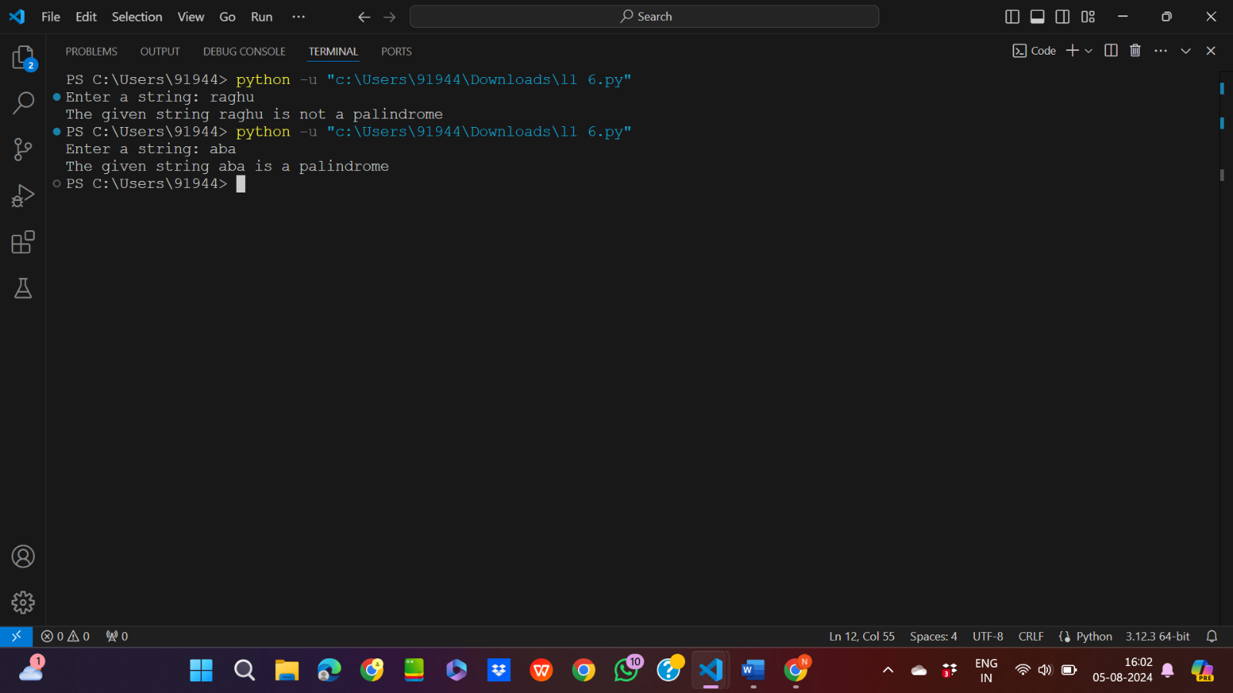

7.Python code for exchange of first two characters of string

Input code:

a=input("Enter the string 1: ")

b=input("Enter the string 2: ")

print("The resultant string is ",b[0:2]+a[2:]," ",a[0:2]+b[2:])

output:

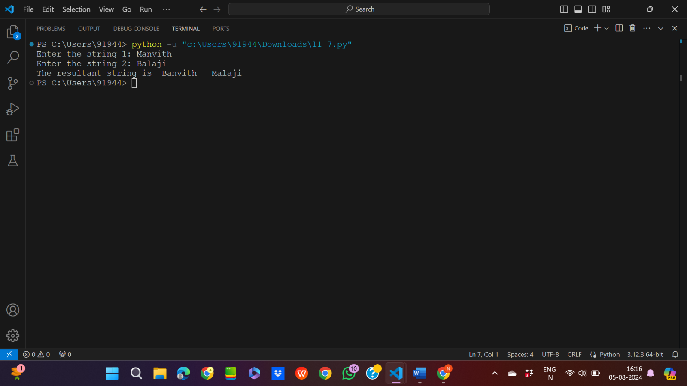

8.Python code for checking of identifier

Input code:

a=input("Enter a string with lowercase,uppercase,digits and underscores: ")

if(a.isidentifier()):

    print("The given string is a valid identifier")

else:

    print("The given string is not a valid identifier")

output:

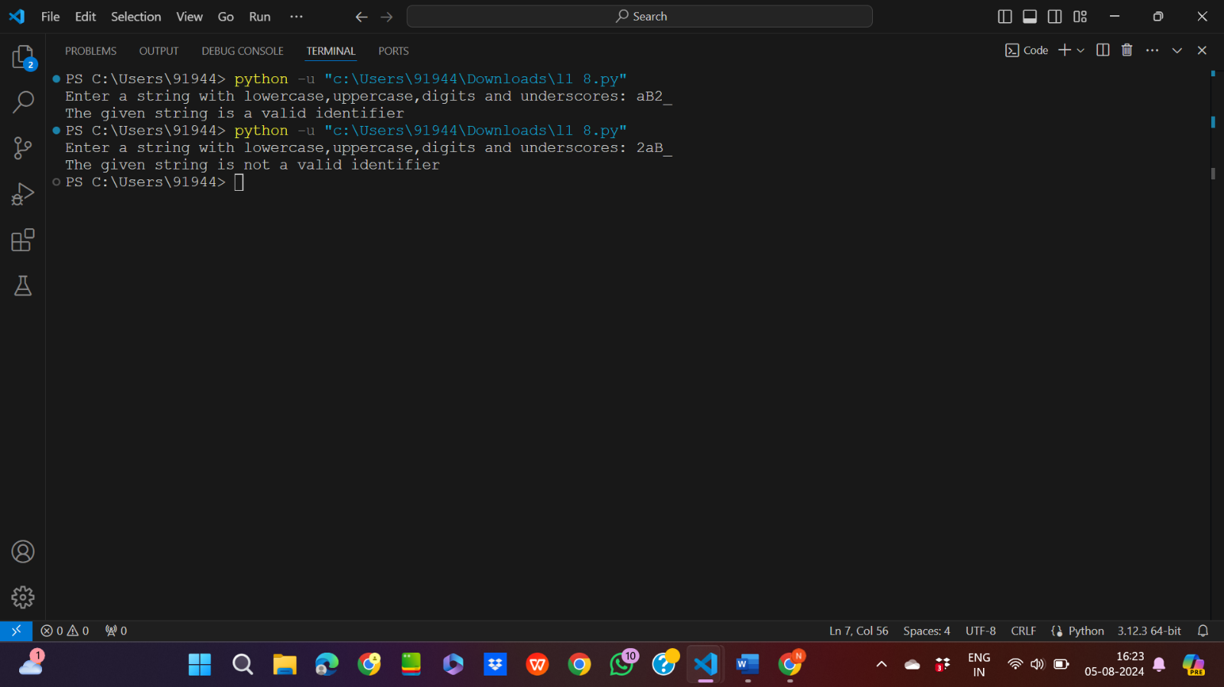

9.Python code for exchange of first and last character

Input code:

a=input("Enter a string: ")

print("The new string is ",a[len(a)-1]+a[1:len(a)-1]+a[0])

output:

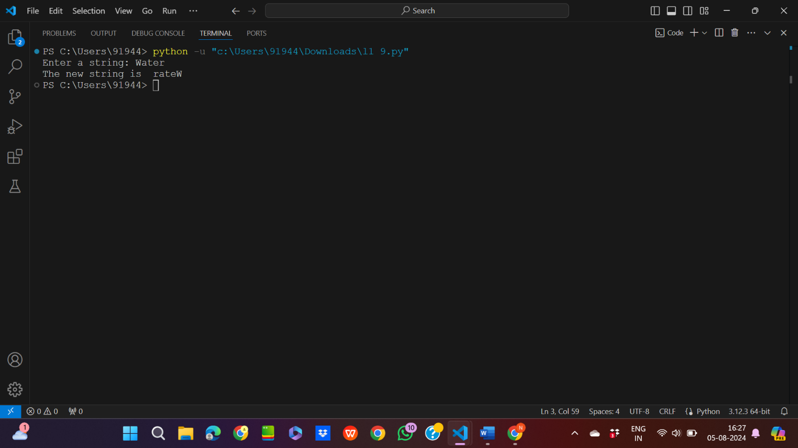

10.Python code for upper and lower case

Input code:

a=input("Enter a string: ")

print(f"The upper case of {a} is ",a.upper())

print(f"The lower case of {a} is ",a.lower())

output:

