NAME:MANVITH BALAJI

SECTION:A

MIS NO. :112315115

1.

Input code:

fil_obj=open("lab11 1inpu.txt","r")

mystr=fil_obj.read()

myset=set(mystr.split(" "))

fil_obj.close()

fil_obj2=open("lab11 1outp.txt","w")

mylist2=sorted([(word,mystr.split(" ").count(word)) for word in myset])

for a in mylist2:

    fil_obj2.write(f"{a[0]}:{a[1]}")

fil_obj2.close()

Output:

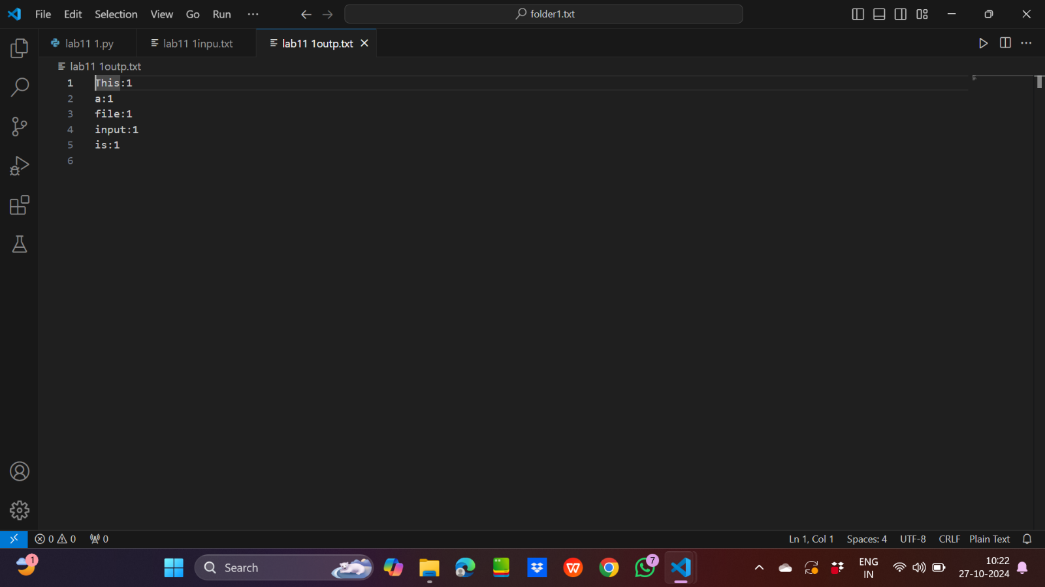

2.

Input code:

mult_files=['file3.txt','lab11 1inpu.txt','lab11 2inpu.txt']

mylist=[]

for file in mult_files:

    f=open(file,"r")

    mylist.append(f.read())

merged_content="".join(mylist)

with open("lab11 2outp.txt","w") as f2:

    f2.write(merged_content)

Output:

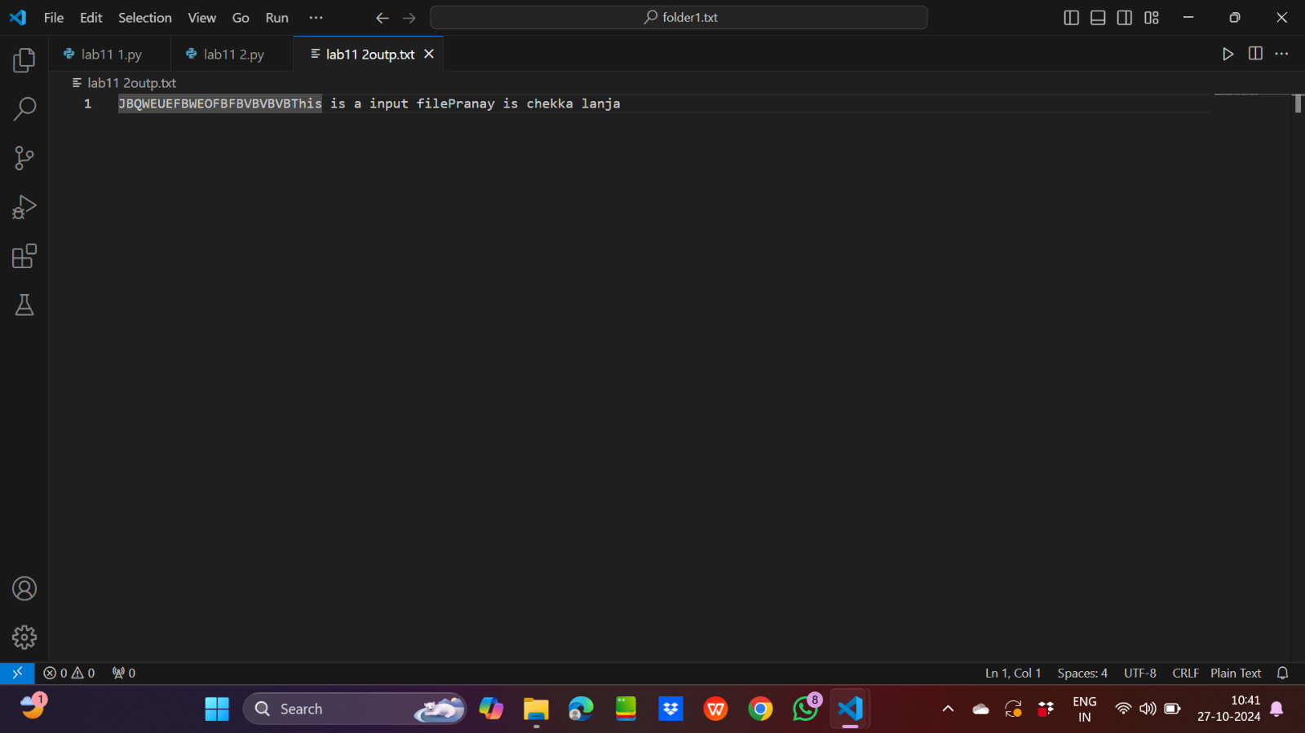

3.

Input code:

import keyword

a=keyword.kwlist

with open("lab11 3inpu.txt","r") as f:

    mylist=f.readlines()

print(mylist)

mylist2=[]

for line in mylist:

    for keyw in a:

        if keyw in line:

            mylist2.append(line)

            break

with open("lab11 3outp.txt","w") as f2:

    f2.writelines(mylist2)

Output:

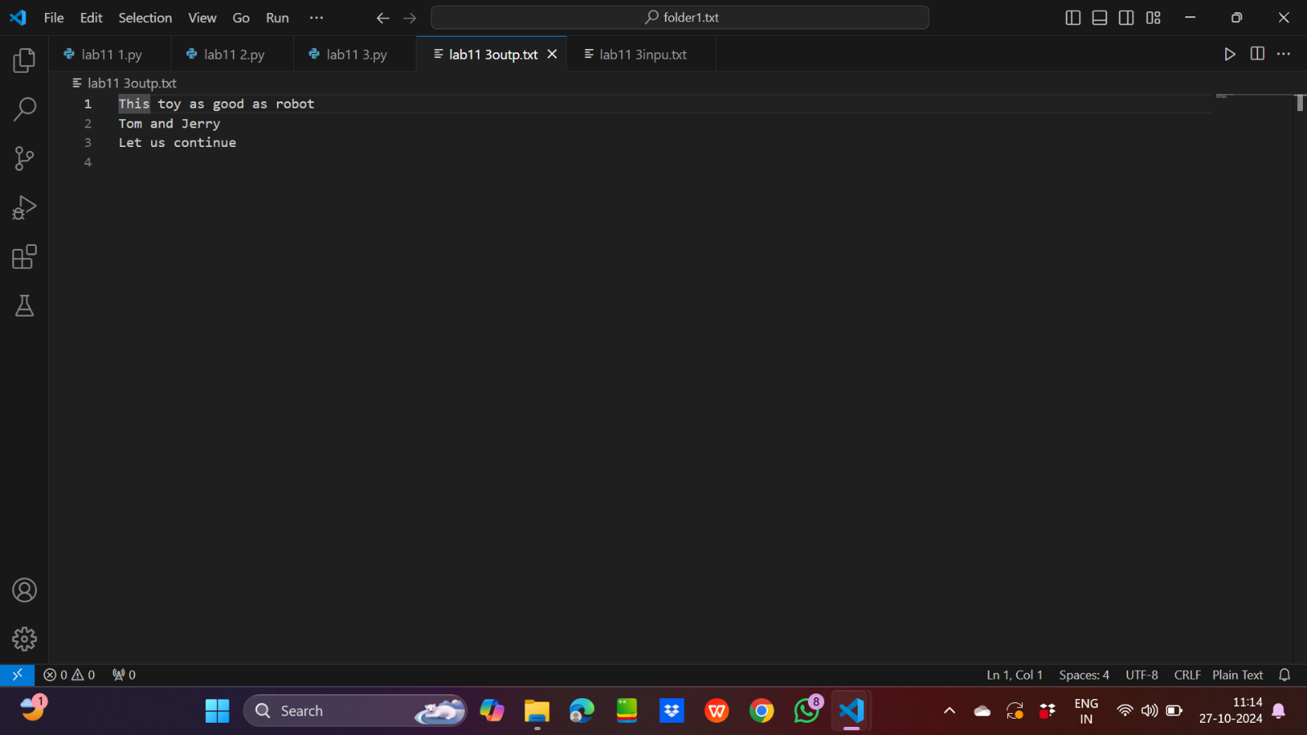

4.

Input code:

import os

path=r"C:\\Users\\91944\\OneDrive\\Desktop\\file_handling\\folder1.txt"

path1=r"C:\\Users\\91944\\OneDrive\\Desktop\\backup_directory"

try:

    for root,dir,files in os.walk(path):

        for file in files:

            os.system(f'copy "{os.path.join(path,file)}" "{path1}"')

except:

    print("File is not found")

Output:

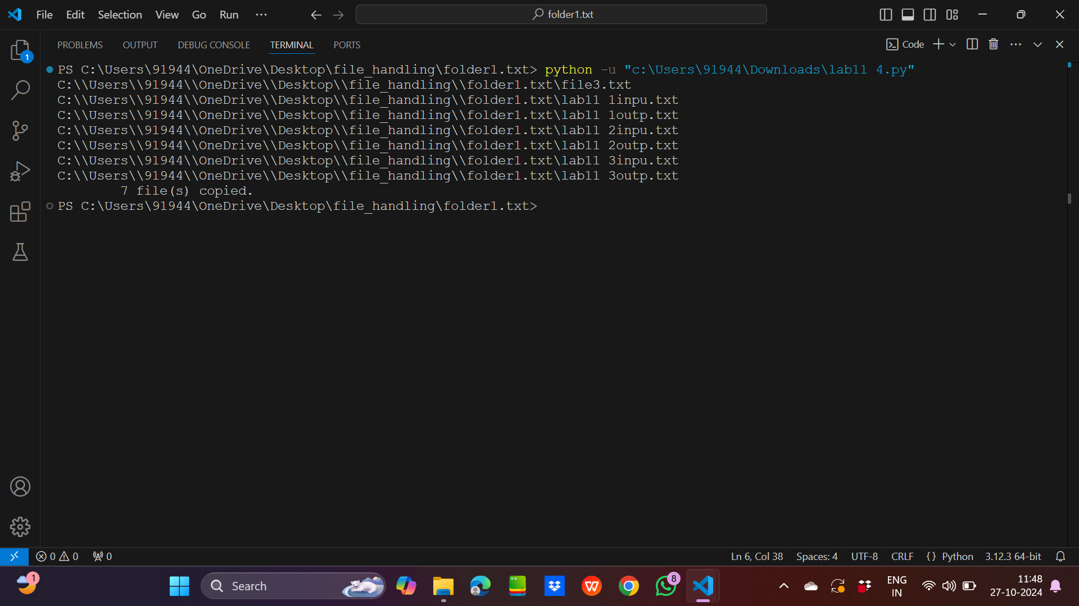

5.

Input code:

with open("lab11 5inpu.txt","r") as f:

    mystr=f.read()

    mylist=mystr.split("\n")

    mylist2=[i[::-1] for i in mylist]

with open("lab11 5outp.txt","w") as f2:

    for line in mylist2:

        f2.write(line+"\n")

Output:

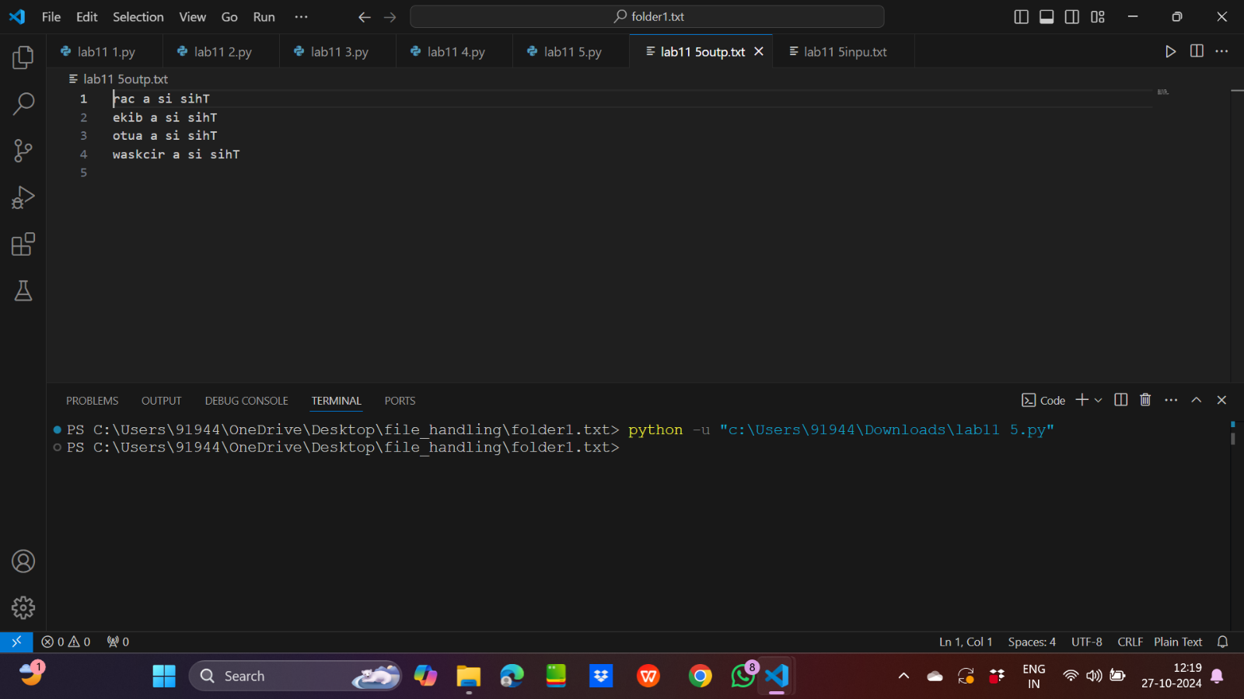

6.

Input code:

import os

path=r"C:\\Users\\91944\\OneDrive\\Desktop\\file_handling"

def direc_size(path):

    ts=0

    for root,dirs,files in os.walk(path):

        for file in files:

            ts+=os.path.getsize(os.path.join(root,file))

    return ts

for root,dir,files in os.walk(path):

    print(f"The size of {root} is {direc_size(root)}")

Output:

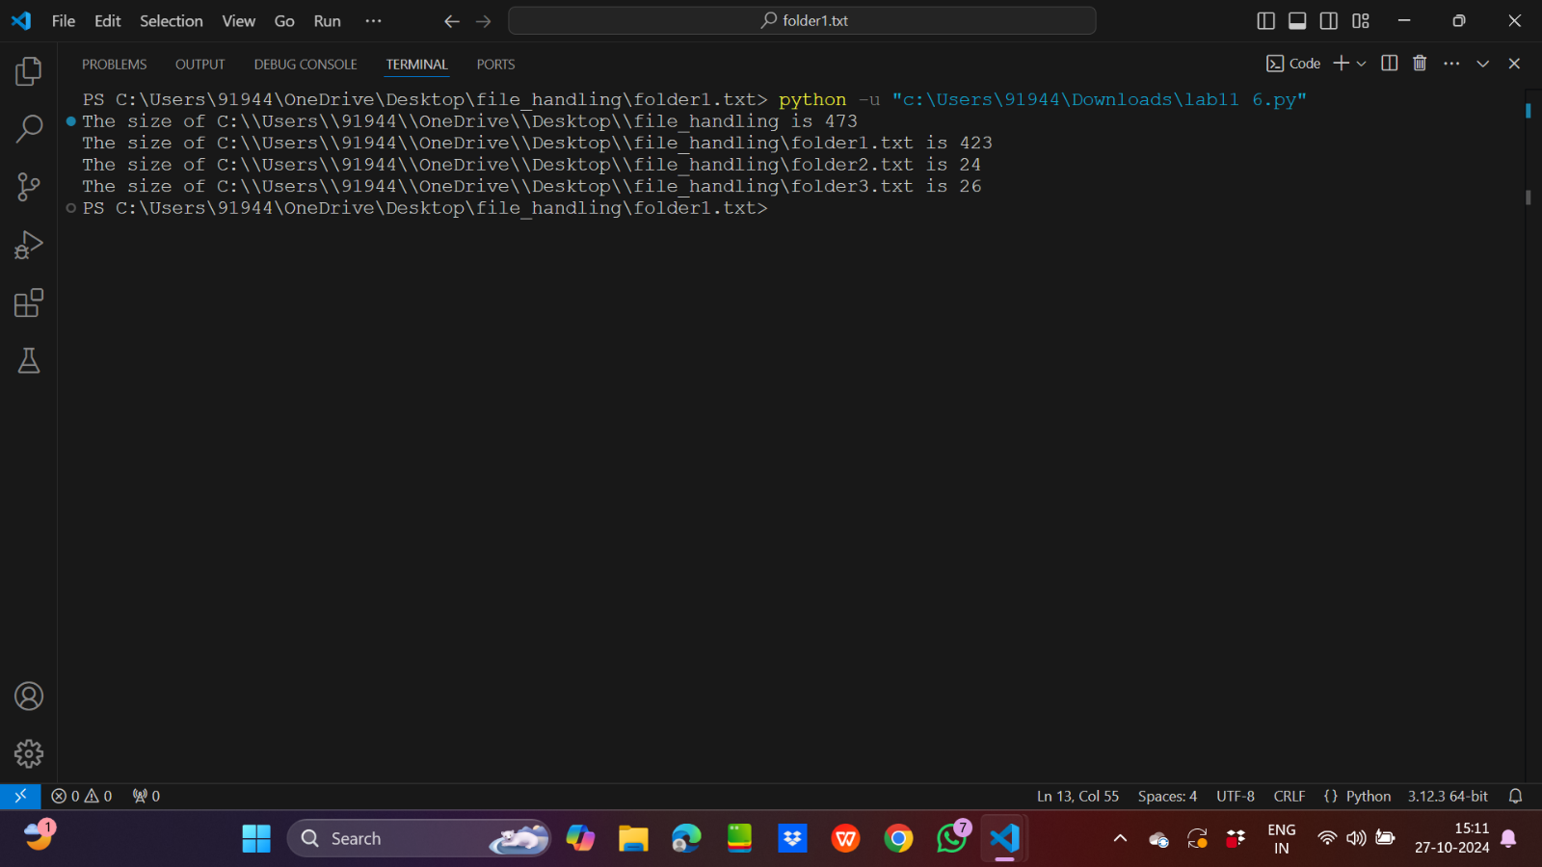

7.

Input code:

import os

from datetime import datetime

path=r"C:\\Users\\91944\\OneDrive\\Desktop\\pypd"

for root,dir,files in os.walk(path):

    for file in files:

        ls=os.path.getmtime(os.path.join(root,file))

        if(datetime.fromtimestamp(ls)<datetime(year=2024,month=9,day=27)):

            print(f"The file ->{os.path.join(root,file)} is deleted")

            os.remove(os.path.join(root,file))

Output:

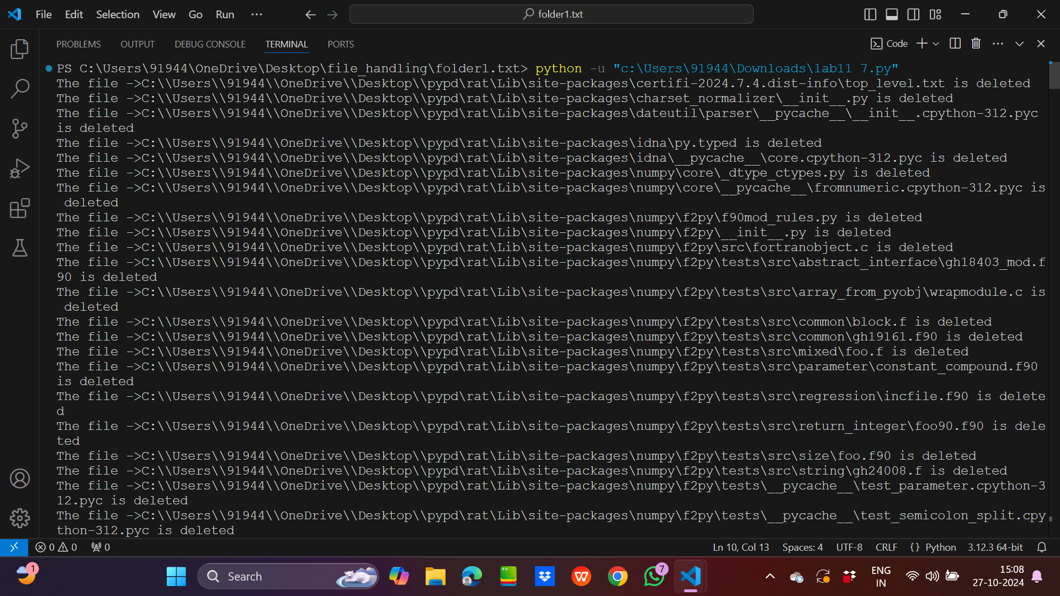

8.

Input code:

import os

path=r"C:\\Users\\91944\\OneDrive\\Desktop"

def organize_files_by_extension(directory):

    for filename in os.listdir(directory):

        if os.path.isdir(filename):

            continue

        extension = os.path.splitext(filename)[1][1:]

        if not extension:

            continue

        if not os.path.exists(extension):

            os.makedirs(extension)

        os.rename(filename, os.path.join(extension, filename))

organize_files_by_extension(path)

Output:

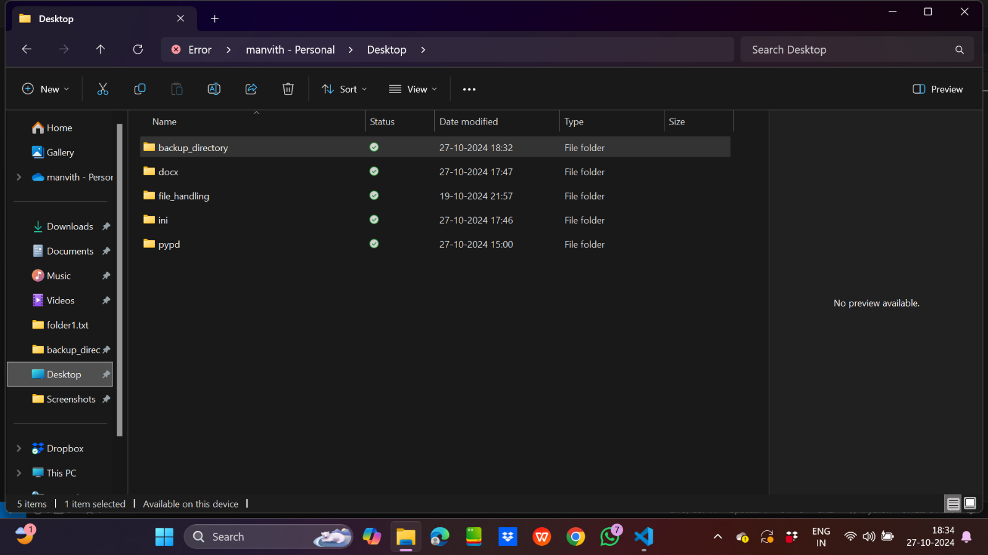

9.

Input code:

import os

from datetime import datetime

path=r"C:\\Users\\91944\\OneDrive\\Desktop\\backup_directory"

for root,dirs,files in os.walk(path):

    for file in files:

        print(f"Name of file:{file}")

        print(f"Size :{os.path.getsize(os.path.join(root,file))}")

        ls=os.path.getmtime(os.path.join(root,file))

        print(f"Last Modified date:{datetime.fromtimestamp(ls)}")

        print("\n")

Output:

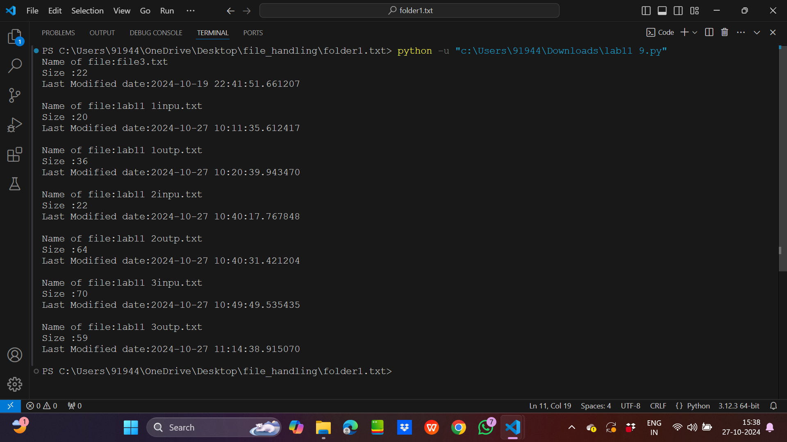

10.

Input code:

import os

path=r"C:\\Users\\91944\\OneDrive\\Desktop\\backup_directory"

my_files=[]

seen=[]

for root,dirs,files in os.walk(path):

    for file in files:

        with open(os.path.join(root,file),'r') as f:

            my_files.append((os.path.join(root,file),f.read()))

for a in my_files:

    if a[1] not in seen:

        seen.append(a[1])

    else:

        print(a[0])

Ouptut:

