NAME:MANVITH BALAJI

SECTION:A

MIS NO. :112315115

1.

INPUT CODE:

def factorial(n):

    if(n==0 or n==1):

        return 1

    else:

        return n*factorial(n-1)

# num=int(input("Enter a number: "))

list1=[2,3,6,7,8,8]

print("The sequence is: ")

# for i in range(0,num):

#     print(factorial(i+1),end=",")

b=[factorial(k) for k in list1]

print(b)

Output:

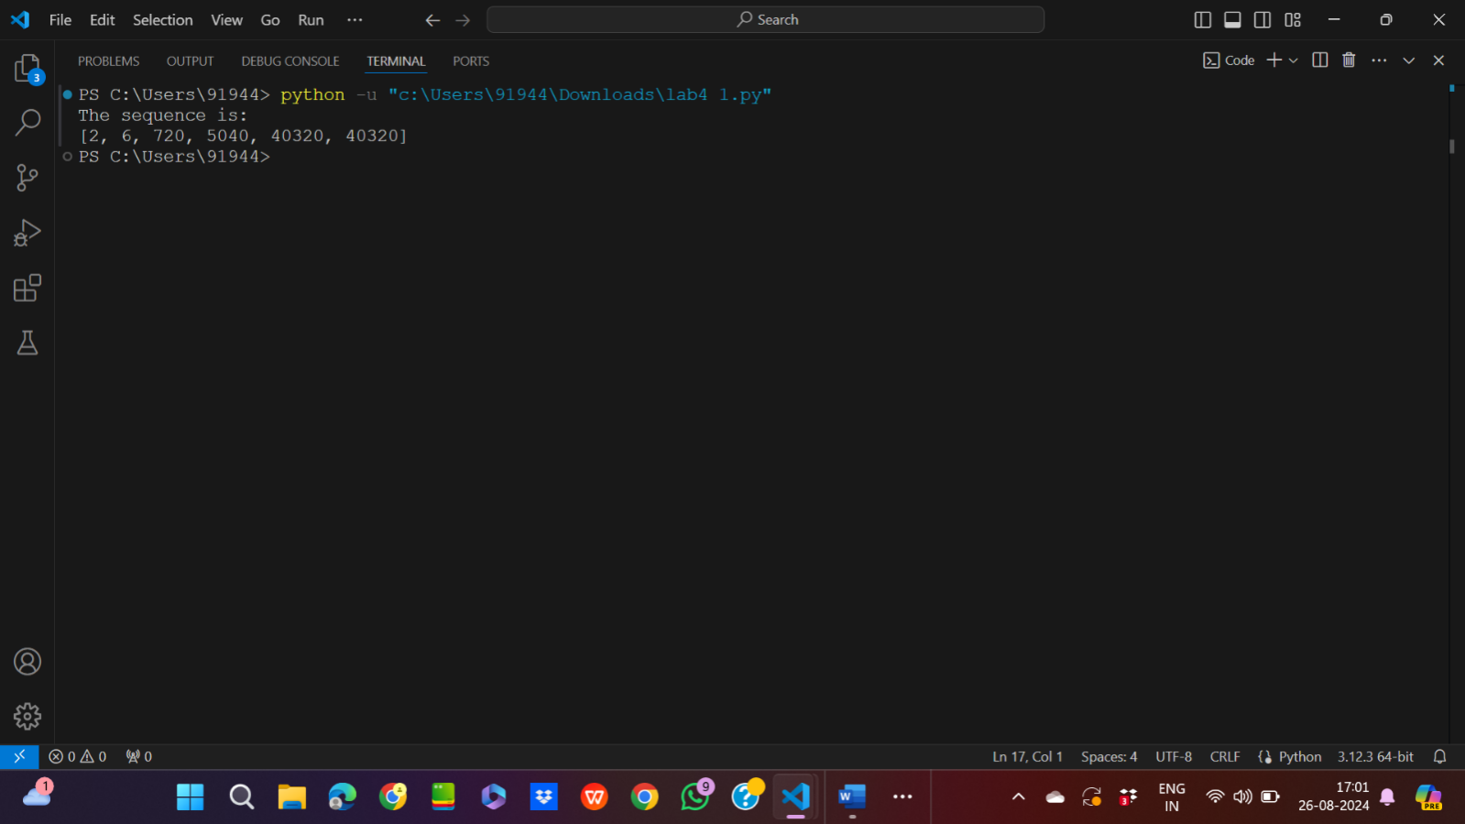

2.

Input code:

a=input("Enter a comma seperated sequence of numbers: ")

list1=a.split(",")

list1=[int(k) for k in list1]

print(f"The list form is {list1}")

print(f"The list form is {tuple(list1)}")

Output:

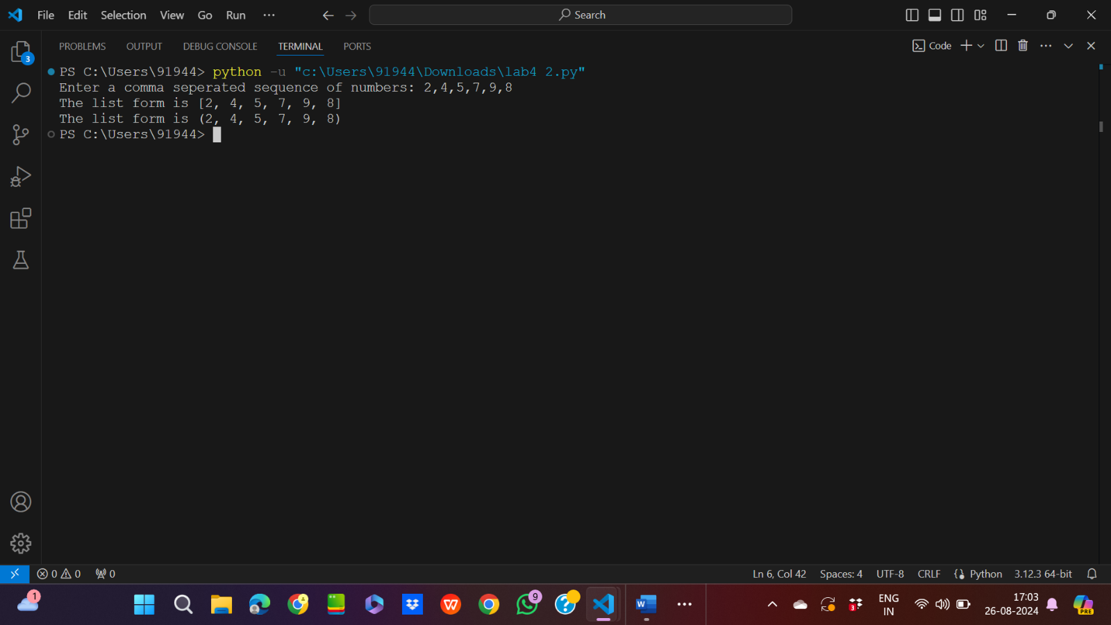

3.

Input code:

from math import sqrt

D=input("Enter a comma seperated sequence of numbers: ")

list1=D.split(",")

C=50

H=30

list1=[str(int(sqrt((2*C*int(k))/H))) for k in list1]

print("The output is: ",",".join(list1))

Output:

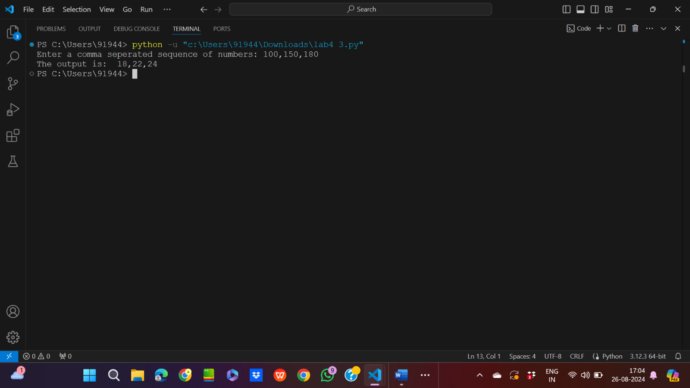

4.

Input code:

a=input("Enter the comma seperated sequence of words: ")

list1=a.split(",")

list1.sort()

print(",".join(list1))

Output:

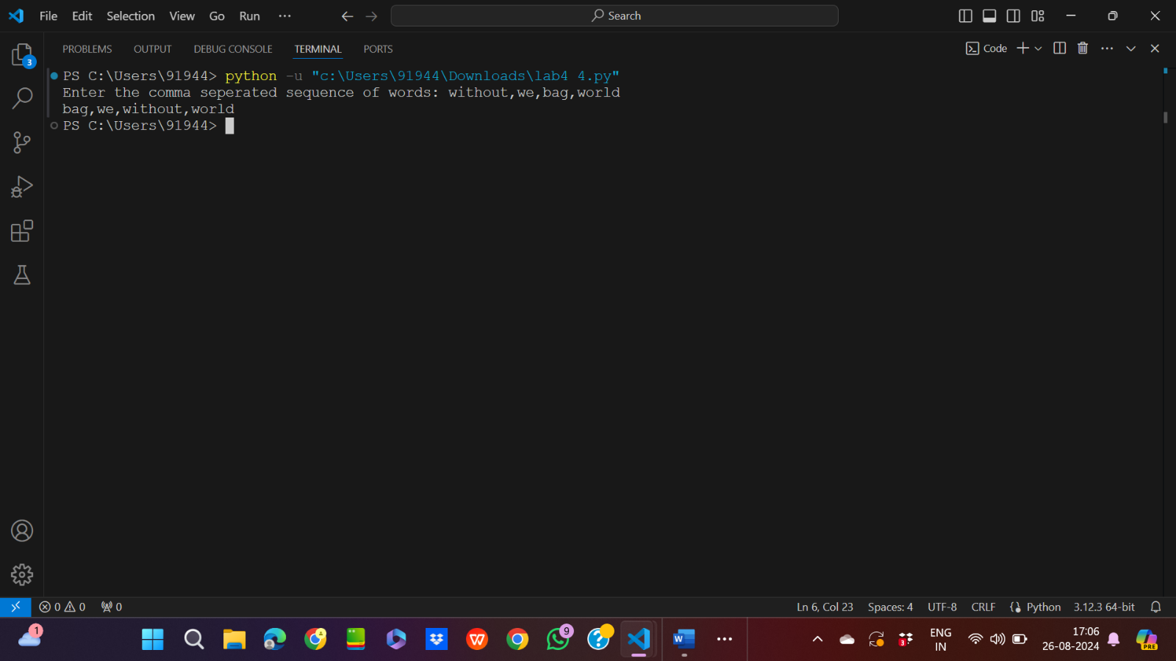

5.Input code:

a=input("Enter the comma seperated sequence of 4 digit binary numbers: ")

list1=a.split(",")

b=[]

for i in list1:

    sum=0

    h=3

    for j in i:

        sum=sum+(2**h)*int(j)

        h=h-1

    b.append(sum)

b=[bin(k)[2:] for k in b if k%5==0]

print(",".join(b))

Output:

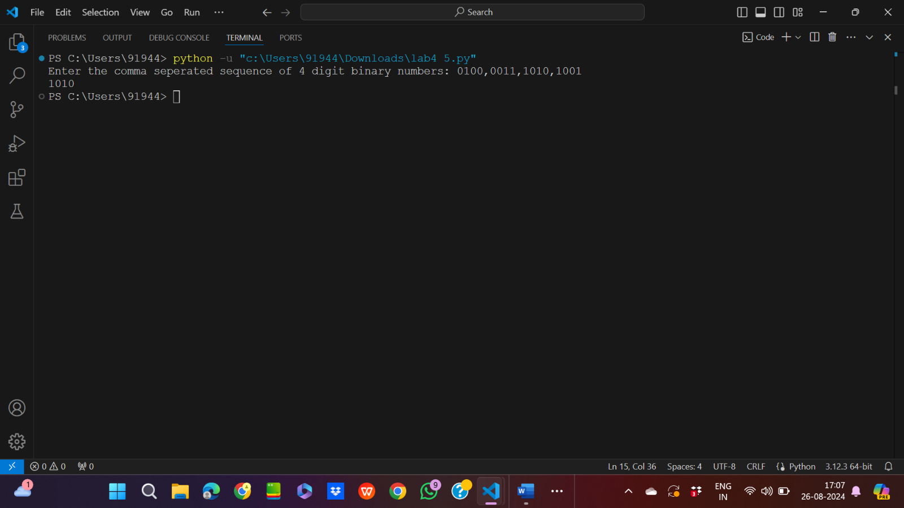

6.

Input code:

test_list=[[5,6],[4,7,10,17]]

test_list=[tuple([j]) for i in test_list for j in i]

print(test_list)

Output:

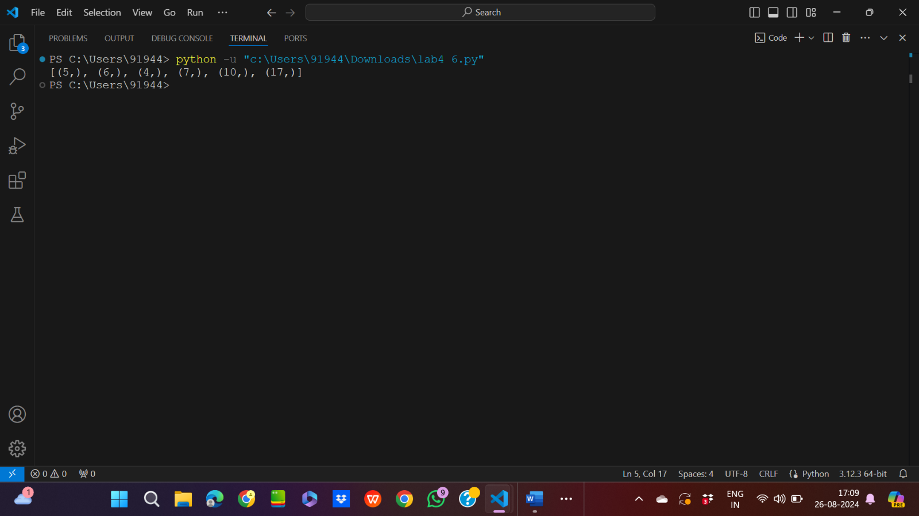

7.

Input code:

from operator import itemgetter

n=int(input("Enter the no. of tuples: "))

stud=[]

for i in range(0,n):

    a=input("Enter the name,age,height in the given form: ")

    list1=a.split(",")

    stud.append(tuple(list1))

my_list=sorted(stud,key=itemgetter(0,1,2))

print(my_list)

Output:

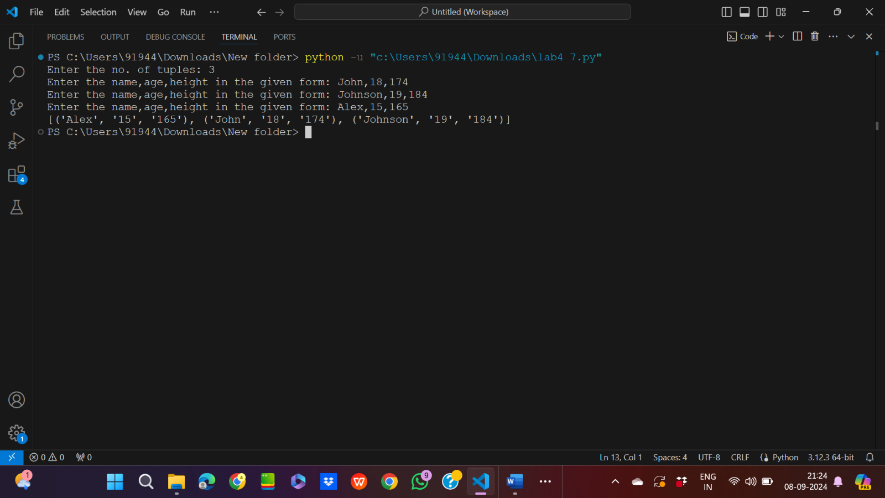

8.

Input code:

from math import sqrt

n=int(input("Enter the no. of commands: "))

inpoint=(0,0)

lpoint=list(inpoint)

steps=[]

for i in range(0,n):

    a=input("Enter the direction and distance: ")

    list1=a.split(" ")

    steps.append(tuple(list1))

for step in steps:

    if step[0]=="UP":

        lpoint[1]=lpoint[1]+int(step[1])

    if step[0]=="DOWN":

        lpoint[1]=lpoint[1]-int(step[1])

    if step[0]=="LEFT":

        lpoint[0]=lpoint[0]-int(step[1])

    if step[0]=="RIGHT":

        lpoint[0]=lpoint[0]+int(step[1])

fpoint=tuple(lpoint)

print(f"The distance between points is {int(sqrt((fpoint[0]-inpoint[0])**2 + (fpoint[1]-inpoint[1])**2))}")

Output:

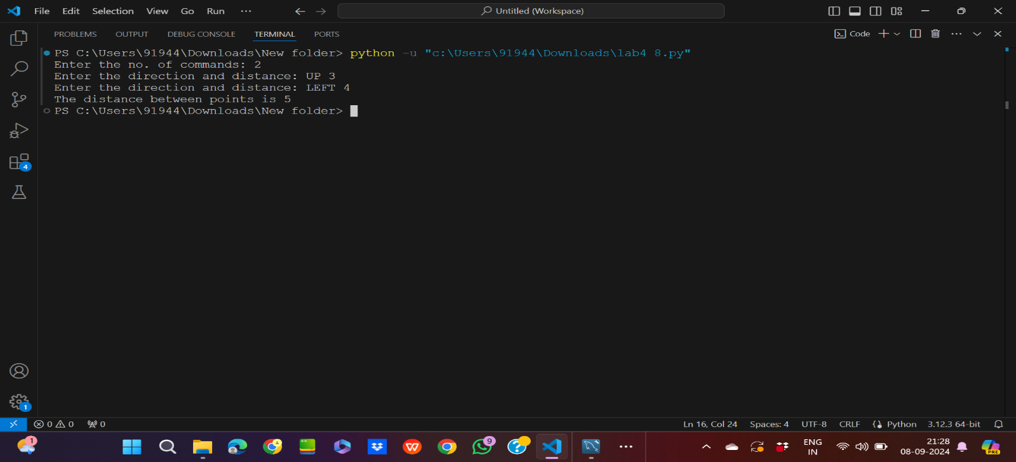

9.

Input code:

a=input("Enter your sentence: ")

b=[]

list1=a.split(" ")

for word in list1:

    if word not in b:

        b.append(word)

b.sort()

for k in b:

    print(f"{k}:{list1.count(k)}")

Output:

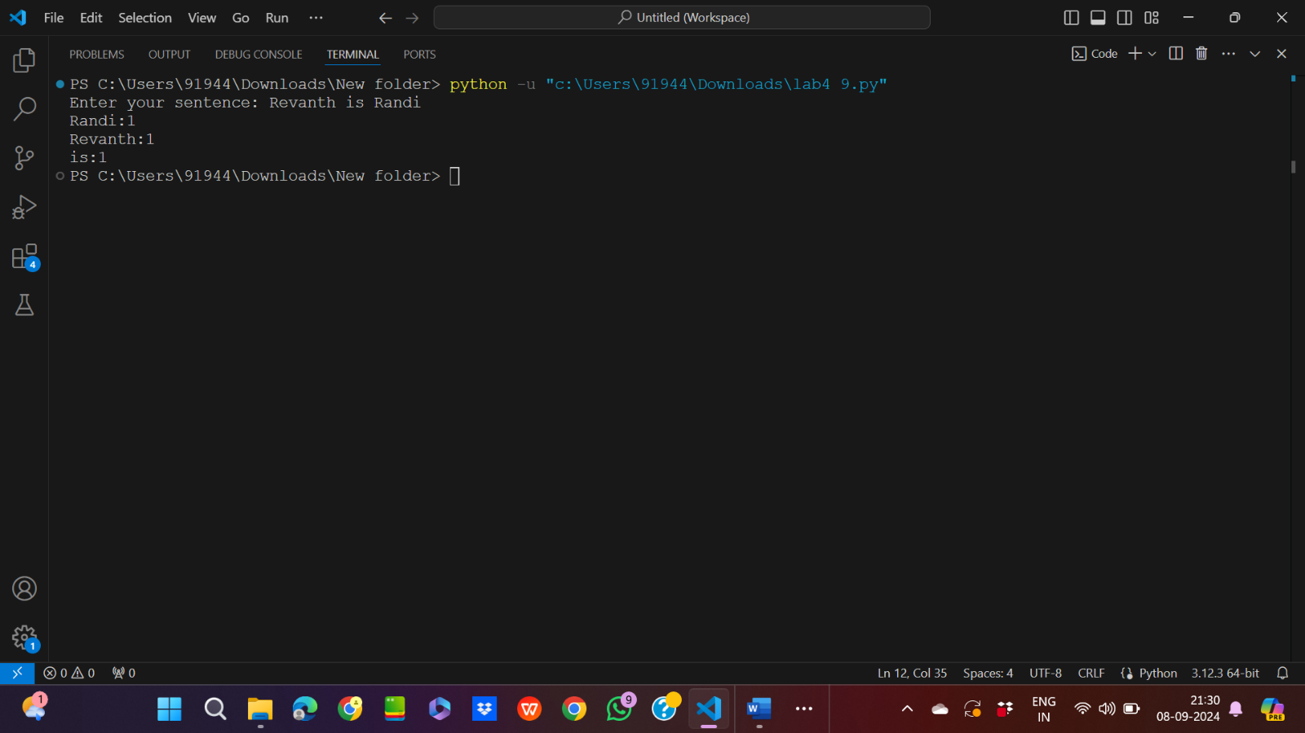

10.

Input code:

test_list=[(15,6),(16,7),(16,8),(16,10),(17,13)]

for i in range(0,len(test_list)):

    for j in range(i+1,len(test_list)):

        if(test_list[i][0]==test_list[j][0]):

            test_list[i]=test_list[i]+test_list[j]

            test_list.remove(test_list[j])

print(test_list)

Output:

