NAME:MANVITH BALAJI

SECTION:A

MIS NO. :112315115

1.

Input code:

def sum(a,b):

    return a+b

x=int(input("Enter the integer no. 1: "))

y=int(input("Enter the integer no. 2: "))

print(f"The sum of {x} and {y} is {sum(x,y)}")

Output:

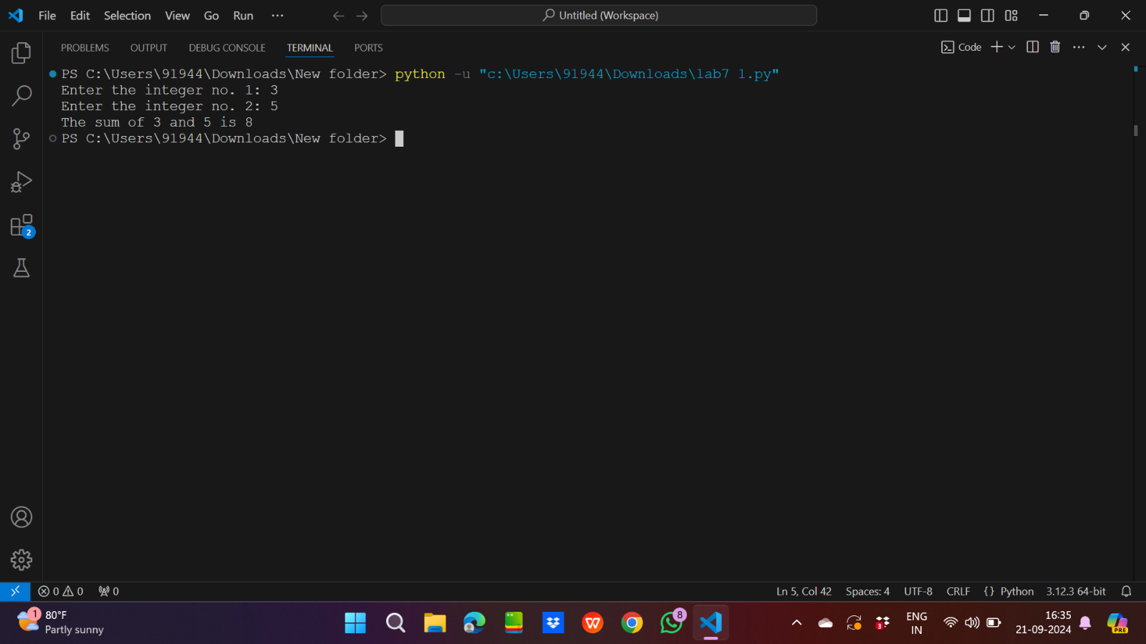

2.

Input code:

def caeser_cipher(x):

    for letter in x:

        print(chr(65+(ord(letter)-42)%26),end="")

caeser_cipher("PRANAY")

Output:

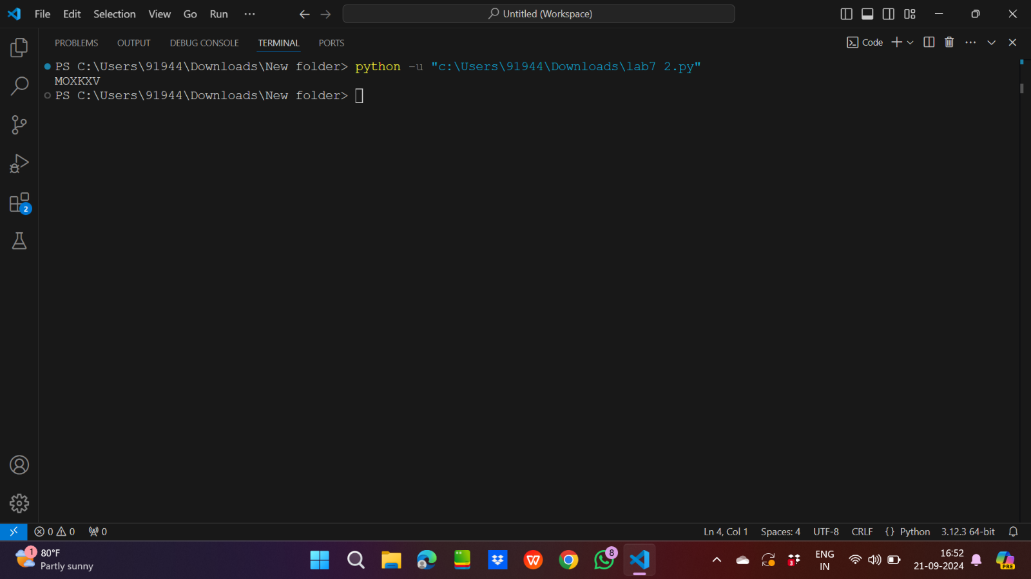

3.

Input code:

def cipher_encrypt(x,y):

    for letter in x:

        print(y[letter],end="")

def cipher_decrypt(x,z):

    for letter in x:

        print(z[letter],end="")

mydict={chr(k):chr(65+((k-42)%26)) for k in range(65,91)}

mydict_reverse={chr(k):chr(65+((k-62)%26)) for k in range(65,91)}

cipher_encrypt("PRANAY",mydict)

print("\n")

cipher_decrypt("MOXKXV",mydict_reverse)

Output:

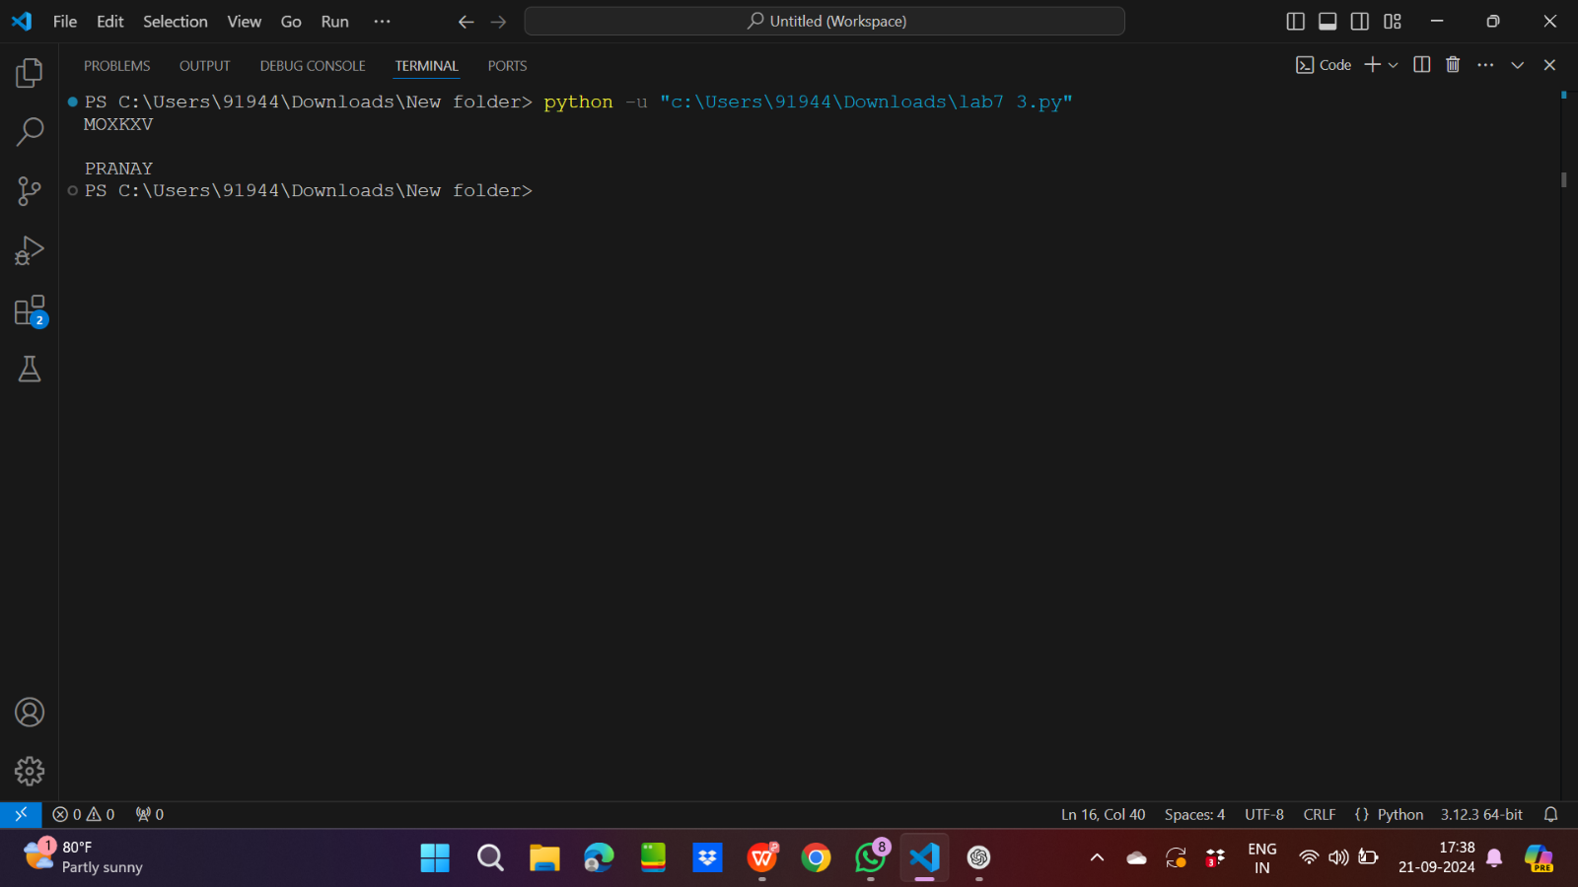

4.

Input code:

def stringcon(x,y):

    return x+y

a=input("Enter the string no.1: ")

b=input("Enter the string no.2: ")

print(stringcon(a,b))

Output:

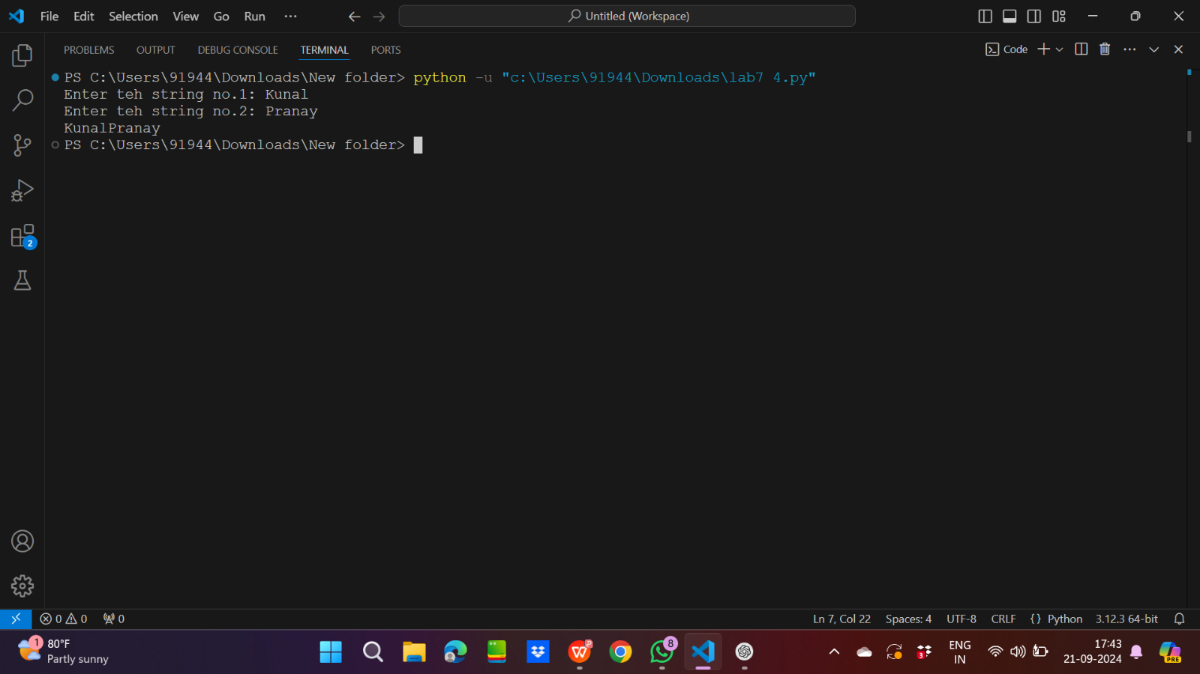

5.

Input code:

def square():

    mydict={k:k**2 for k in range(1,21)}

    return mydict

print(square())

Output:

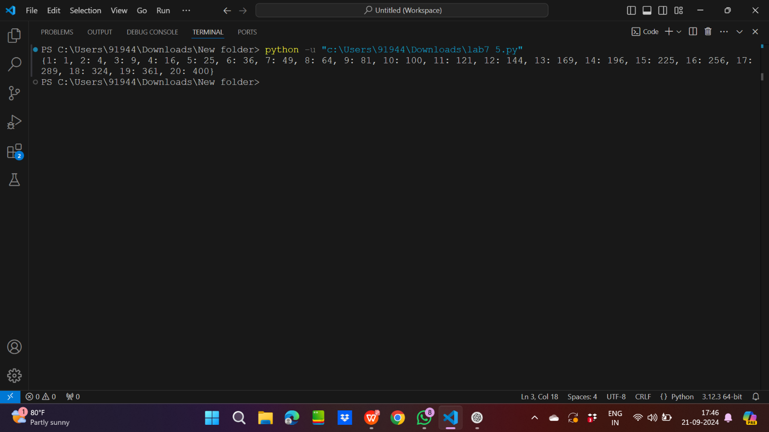

6.

Input code:

def square():

    mylist=[k**2 for k in range(1,21)]

    print(mylist[0:5])

square()

Output:

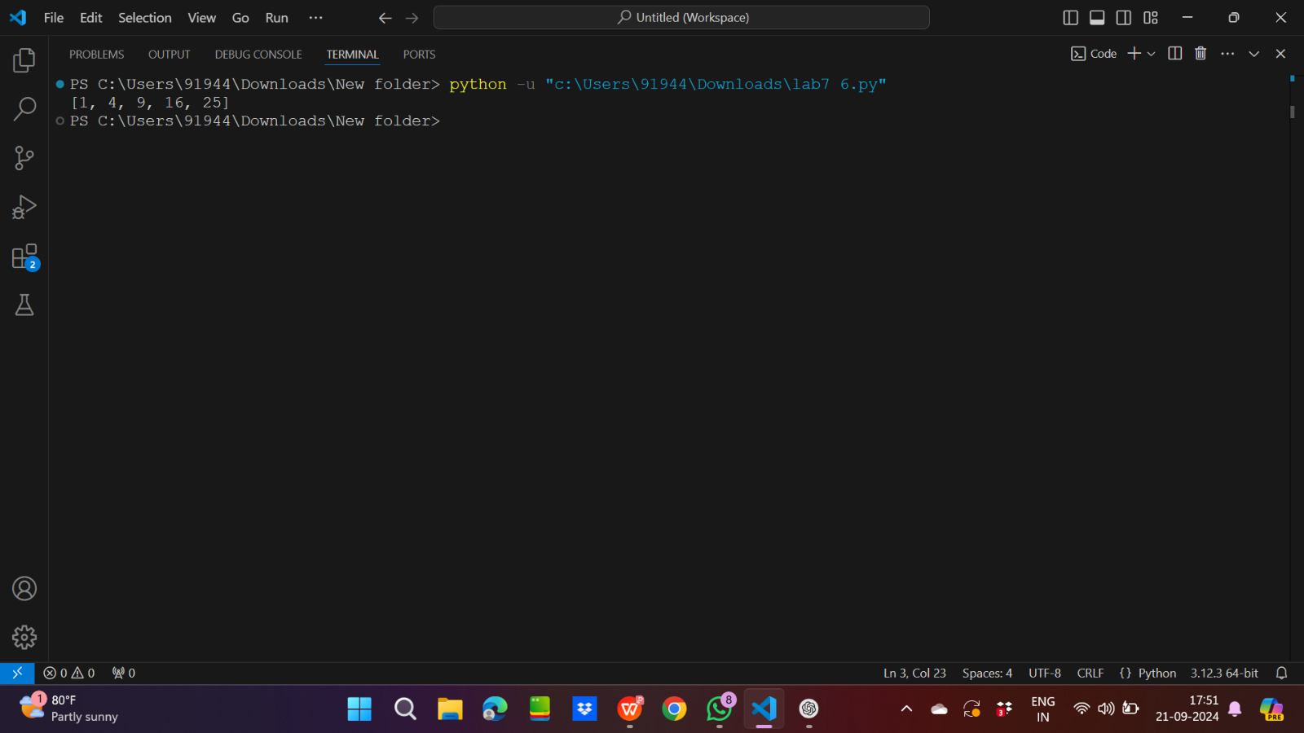

7.

Input code:

def fibonacci(n):

    if(n==0 or n==1):

        return n

    else:

        return fibonacci(n-1)+fibonacci(n-2)

x=int(input("Enter a number: "))

print(fibonacci(x))

Output:

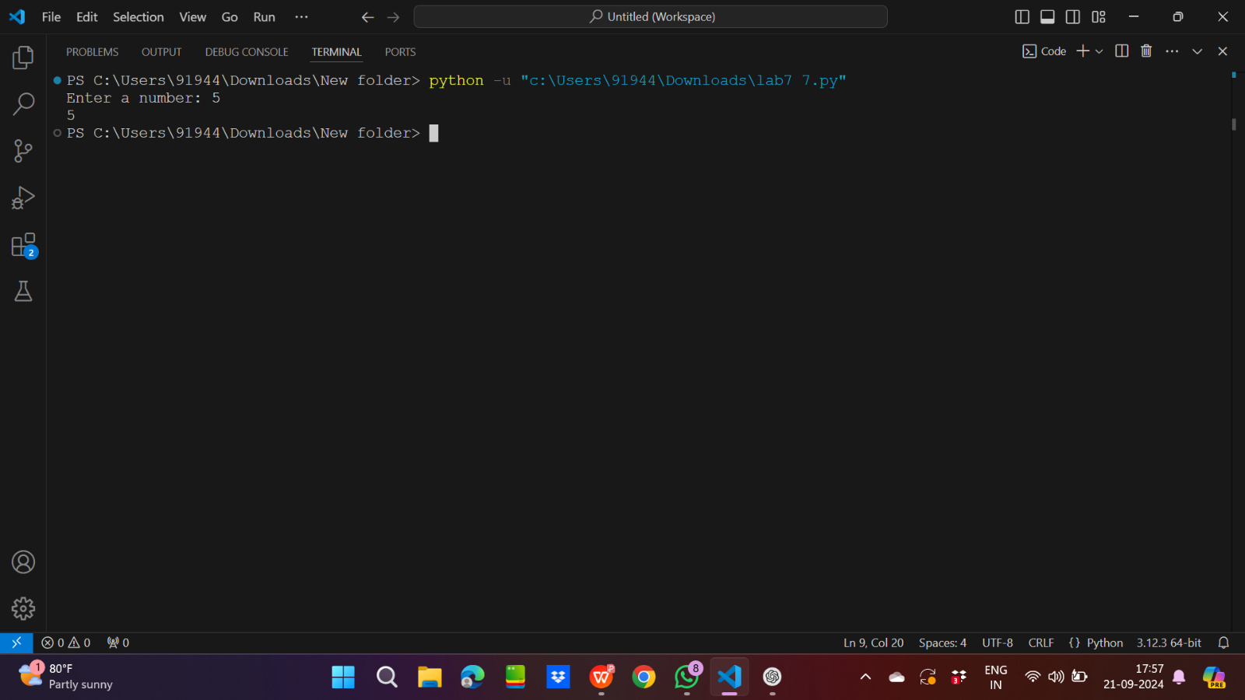

8.

Input code:

def loc():

    a=2

    b=3

    c=4

    d=5

    print(len(locals()))

print("The no. of local variables is: ",end="")

loc()

Output:

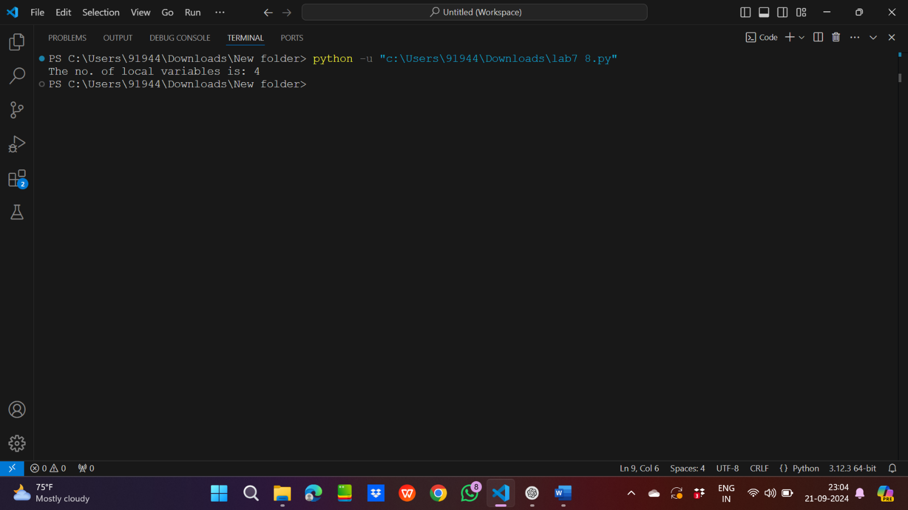

9.

Input code:

a=2

def loglo():

    loc=a*2

    return loc

print(f"Before:{loglo()}")

a=4

print(f"After:{loglo()}")

Output:

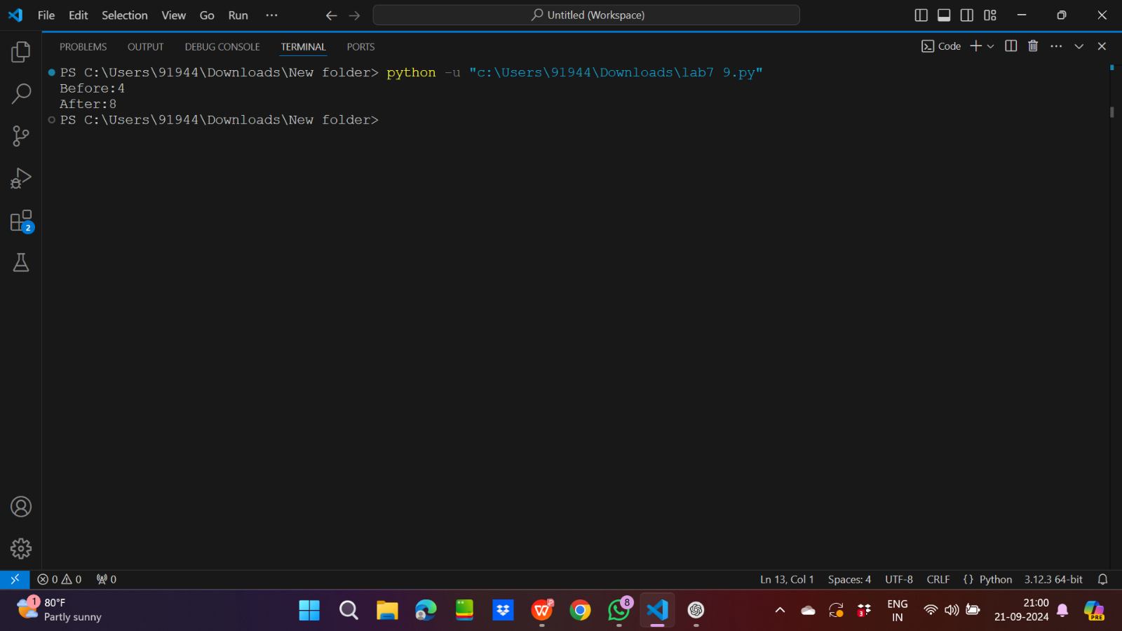

10. i)

Input code:

def append_item(item,item_list=[]):

    item_list.append(item)

    return item_list

print(append_item(2))

print(append_item(2))

print(append_item(2))

print(append_item(2))

print(append_item(2))

Output:

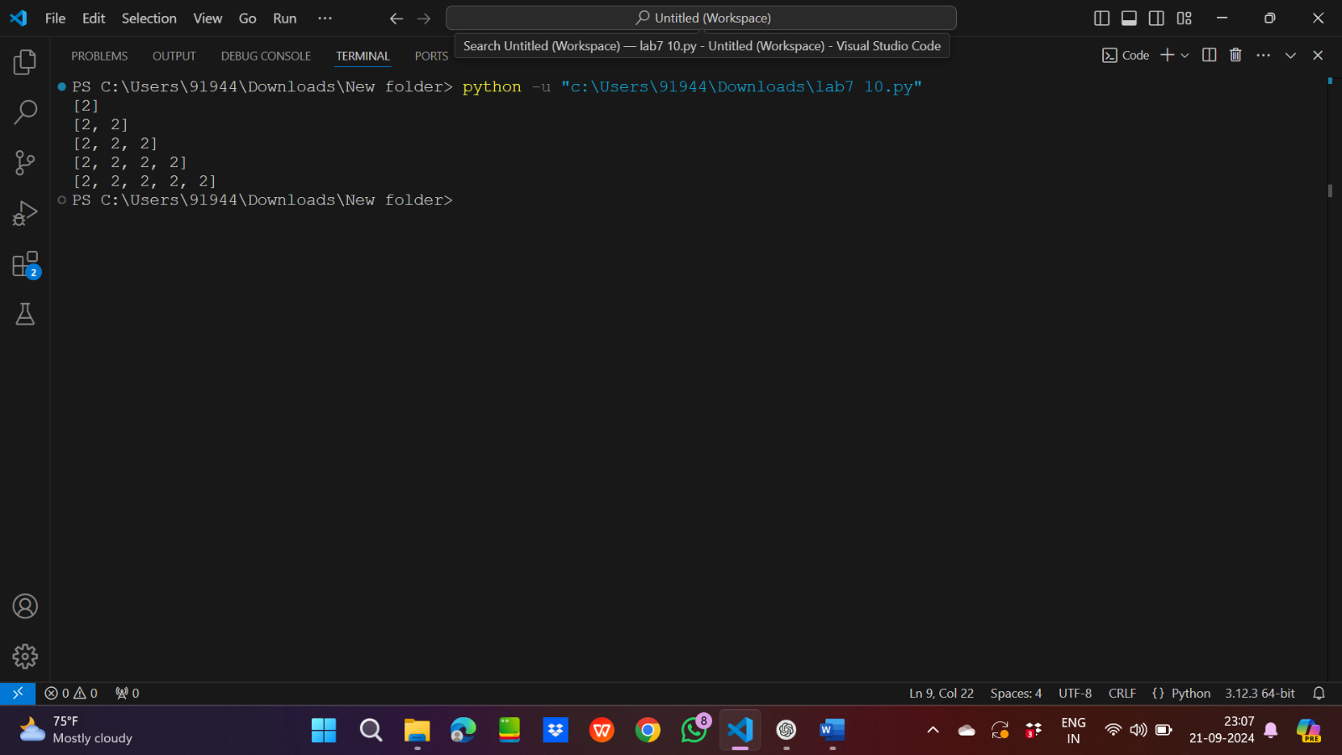

ii)

As mylist keeps updating with previous values so it retains its values

iii)

Input code:

def append_item(item,item_list=None):

    if item_list==None:

        item_list=[]

    item_list.append(item)

    return item_list

print(append_item(2))

print(append_item(2))

print(append_item(2))

print(append_item(2))

print(append_item(2))

Output:

