NAME:MANVITH BALAJI

SECTION:A

MIS NO. :112315115

1.

Input code:

from math import pi

class Circle:

    def __init__(self,radius):

        self.radius=radius

    def area(self):

        print(f"The area of the circle is {pi*self.radius**2}")

r=int(input("Enter the radius of circle: "))

obj=Circle(r)

obj.area()

Output:

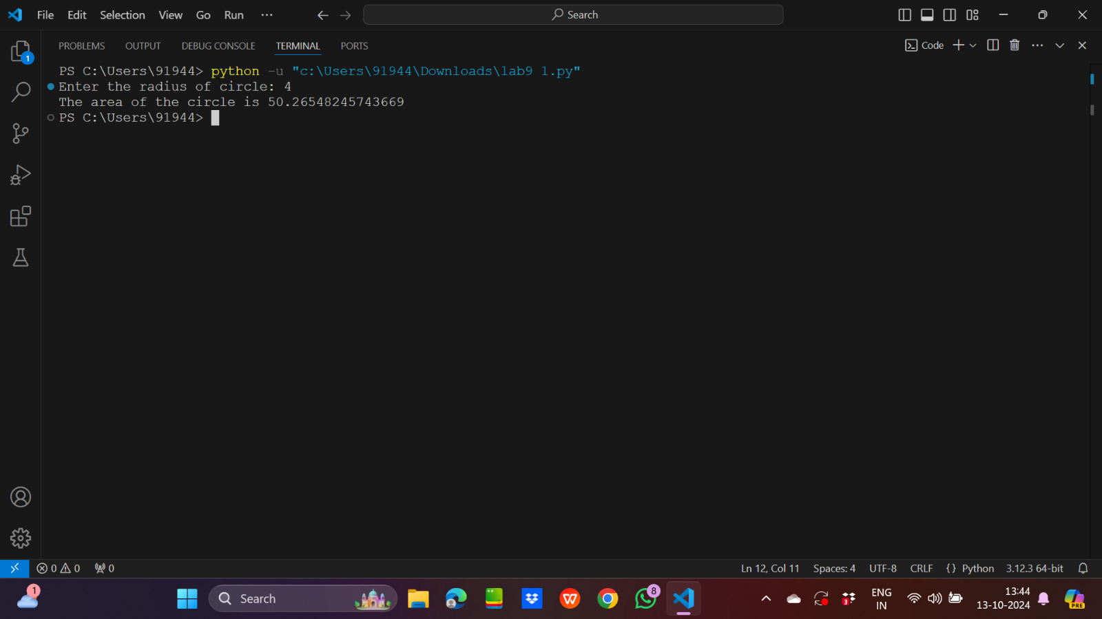

2.

Input code:

class Rectangle:

    def __init__(self,length,width):

        self.length=length

        self.width=width

    def area(self):

        print(f"The area of the rectangle is {self.length*self.width}")

l=int(input("Enter the length of the reactangle: "))

w=int(input("Enter the width of the reactangle: "))

obj=Rectangle(l,w)

obj.area()

Output:

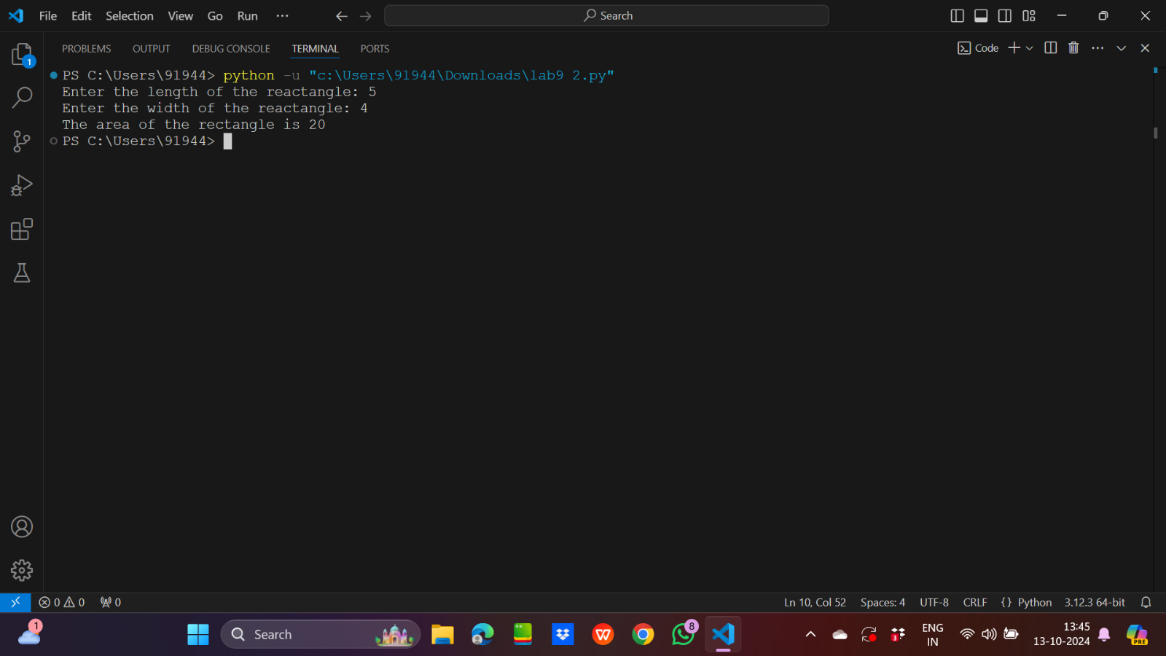

3.

Input code:

class gen_ite7:

    def iterator(self,end):

        i=0

        while(i<end):

            if(i%7==0):

                yield i

            i=i+1

n=int(input("Enter the last number: "))

obj=gen_ite7()

for i in obj.iterator(n):

    print(i,end=" ")

Output:

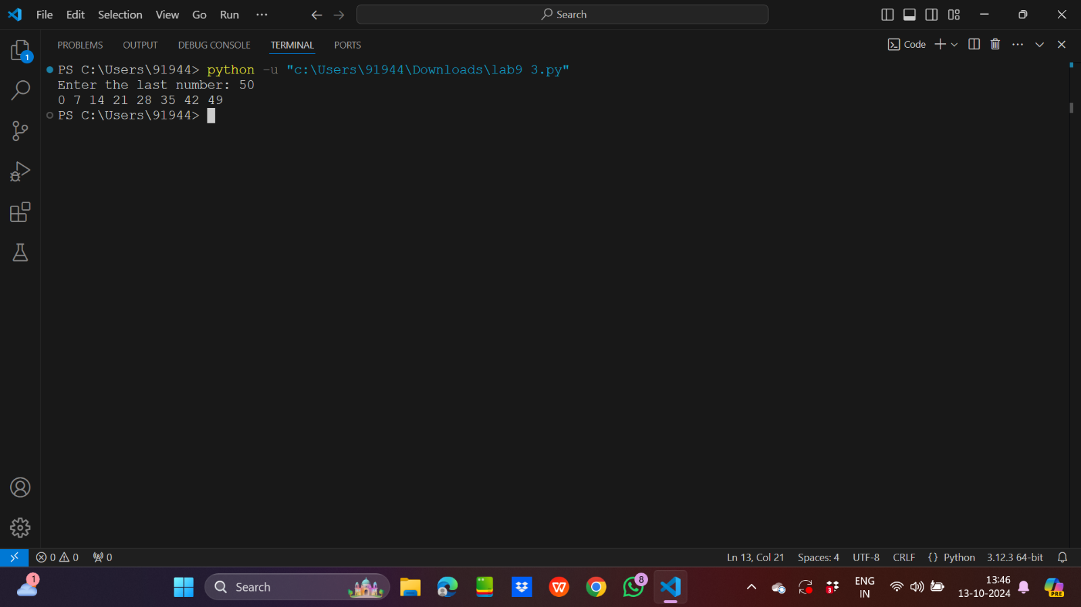

4.

Input code:

class Shape:

    def area(self,a=0):

        self.a=a

        print(f"The area of the Shape is {self.a}")

class Square(Shape):

    def __init__(self,length):

        self.length=length

    def area(self):

        print(f"The area of Square is {self.length**2}")

side=int(input("Enter the length of side of square: "))

obj=Square(side)

obj.area()

Output:

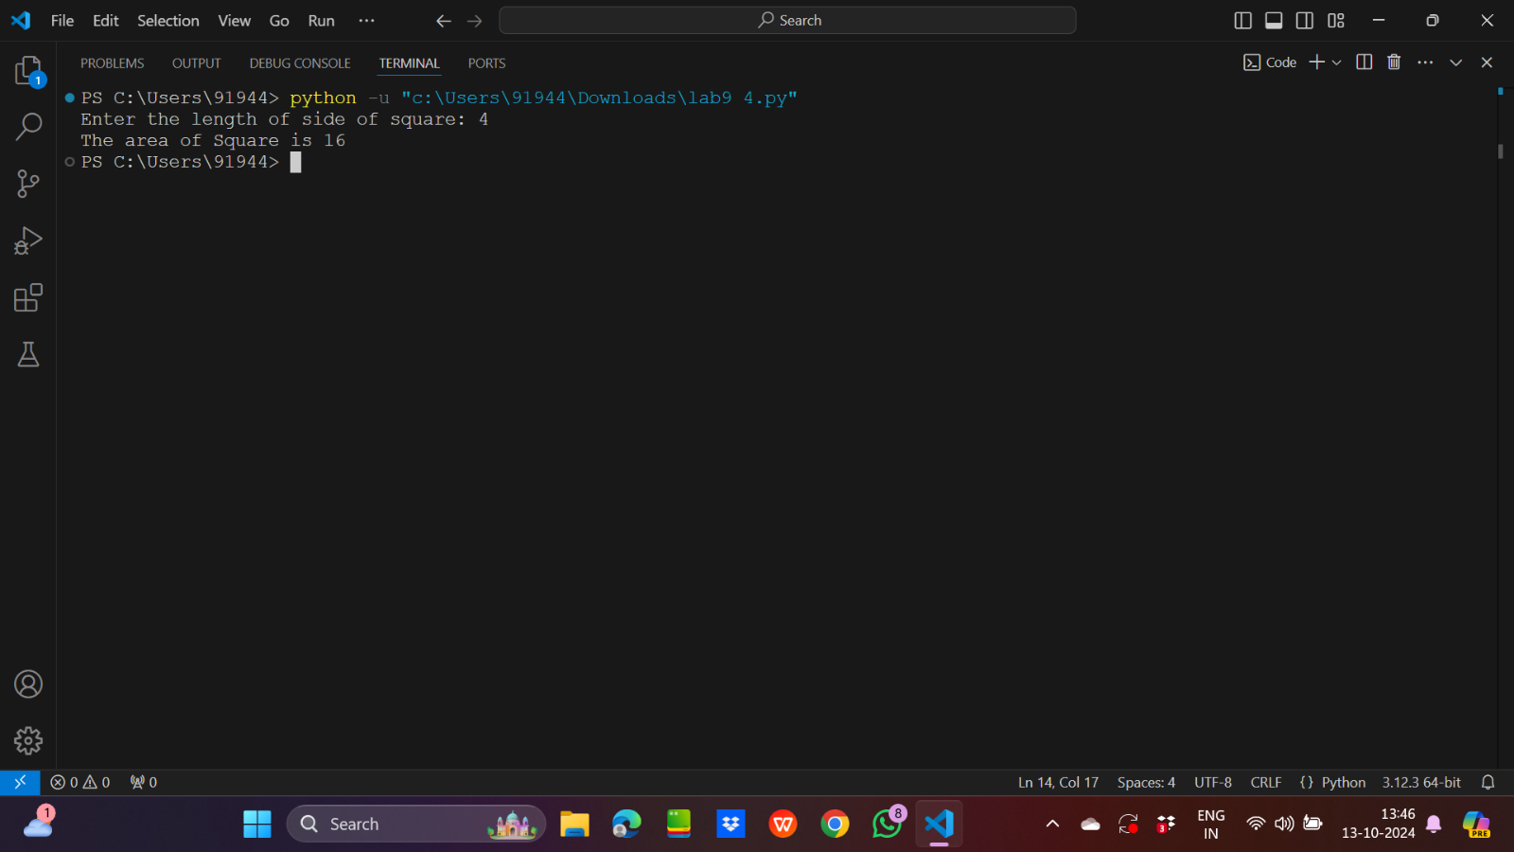

5.

Input code:

class String:

    @classmethod

    def getString(cls):

        cls.x=input("Enter a string: ")

    @classmethod

    def printString(cls):

        cls.b=cls.x.upper()

        print(f"The string is {cls.b}")

    @classmethod

    def test(cls):

        if(cls.b.isupper()):

            print("The class methods are working good")

        else:

            print("The class methods are not working good")

String.getString()

String.printString()

String.test()

Output:

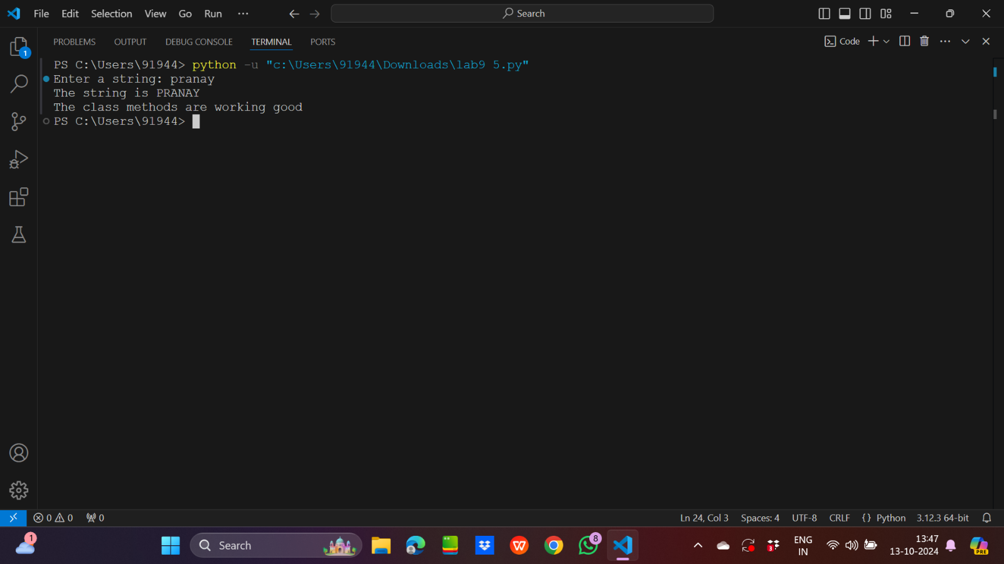

6.

Input code:

class Person:

    def getGender(self):

        print("The gender may be male or female")

class Male(Person):

     def getGender(self):

        print("Male")

class Female(Person):

     def getGender(self):

        print("Female")

obj=Person()

obj1=Male()

obj2=Female()

obj1.getGender()

obj2.getGender()

Output:

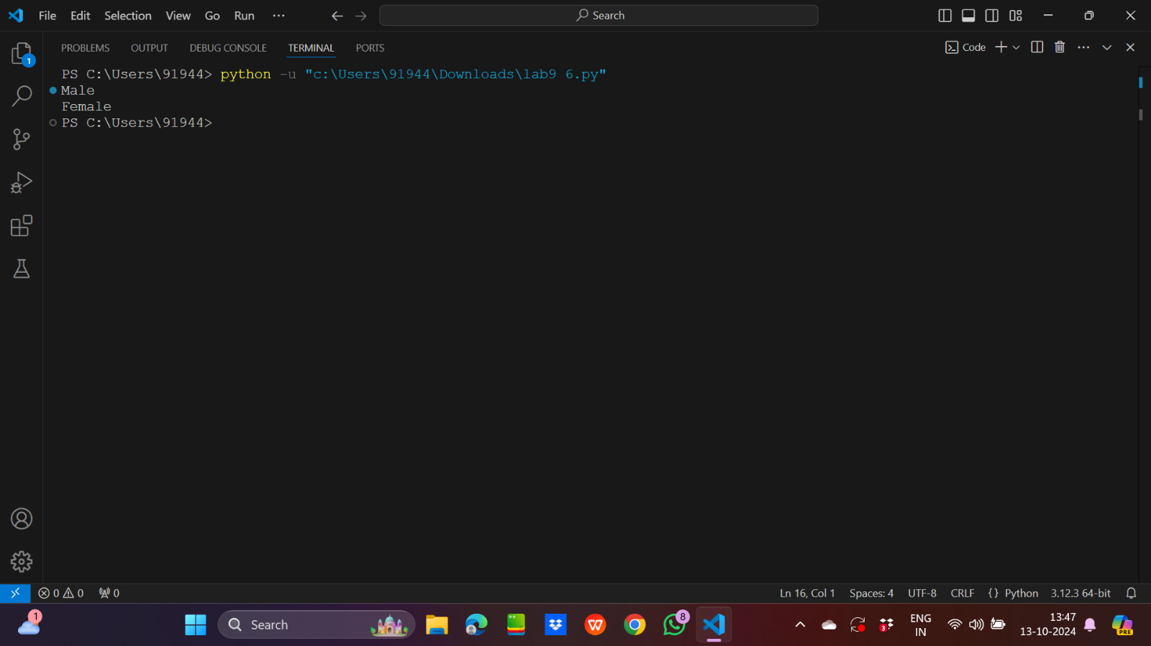

7.

Input code:

class Package:

    def __init__(self,package_id,destination,weight,status):

        self.package_id=package_id

        self.destination=destination

        self.weight=weight

        self.status=status

    def deliver(self):

        self.status="delivered"

class Vehicle:

    def __init__(self,vehicle_id,capacity,current_packages):

        self.vehicle_id=vehicle_id

        self.capacity=capacity

        self.current_packages=current_packages

    def load_package(self,pack_obj):

        total_weight=sum([i.weight for i in self.current_packages])

        if total_weight+pack_obj.weight<=self.capacity:

            self.current_packages.append(pack_obj)

        else:

            print("Vehicle is full")

    def deliver_packages(self):

        for i in self.current_packages:

            i.deliver()

class Truck(Vehicle):

    def deliver_packages(self):

        print("Vehicle Type:Truck")

        deli_count=0

        for i in self.current_packages:

            if i.status=="delivered":

                deli_count=deli_count+1

        print(f"No. of packages delivered:{deli_count}")

class Drone(Vehicle):

    def load_package(self):

        for i in self.current_packages:

            if i.weight>5:

                raise ValueError("This package is more than 5kg")

    def deliver_packages(self):

        print("Vehicle Type:Drone")

        for i in self.current_packages:

            if i.status=="delivered":

                deli_count=deli_count+1

        print(f"No. of packages delivered:{deli_count}")

class DeliverySystem:

    def assign_vehicle(self,veh_obj,list_pack):

        self.veh_obj=veh_obj

        self.veh_obj.current_packages=list_pack

    def dispatch(self,veh_obj):

        self.veh_obj=veh_obj

        for i in self.veh_obj.current_packages:

            yield i.deliver()

def main():

    pack_list1=[Package("P1","Mumbai",2,"pending"),Package("P2","Chennai",3,"intransit"),Package("P3","Pune",4,"intransit")]

    pack_list2=[Package("P4","Mumbai",2,"pending"),Package("P5","Chennai",3,"pending"),Package("P6","Pune",4,"pending")]

    tru_obj=Truck("V1-Truck",1000,pack_list1)

    dron_obj=Drone("V2-Drone",10,pack_list2)

    deli_obj=DeliverySystem()

    for i in deli_obj.dispatch(tru_obj):

        pass

    for i in deli_obj.dispatch(dron_obj):

        pass

    for i in pack_list1+pack_list2:

        print(f"Package->{i.package_id} Status:{i.status}")

main()

Output:

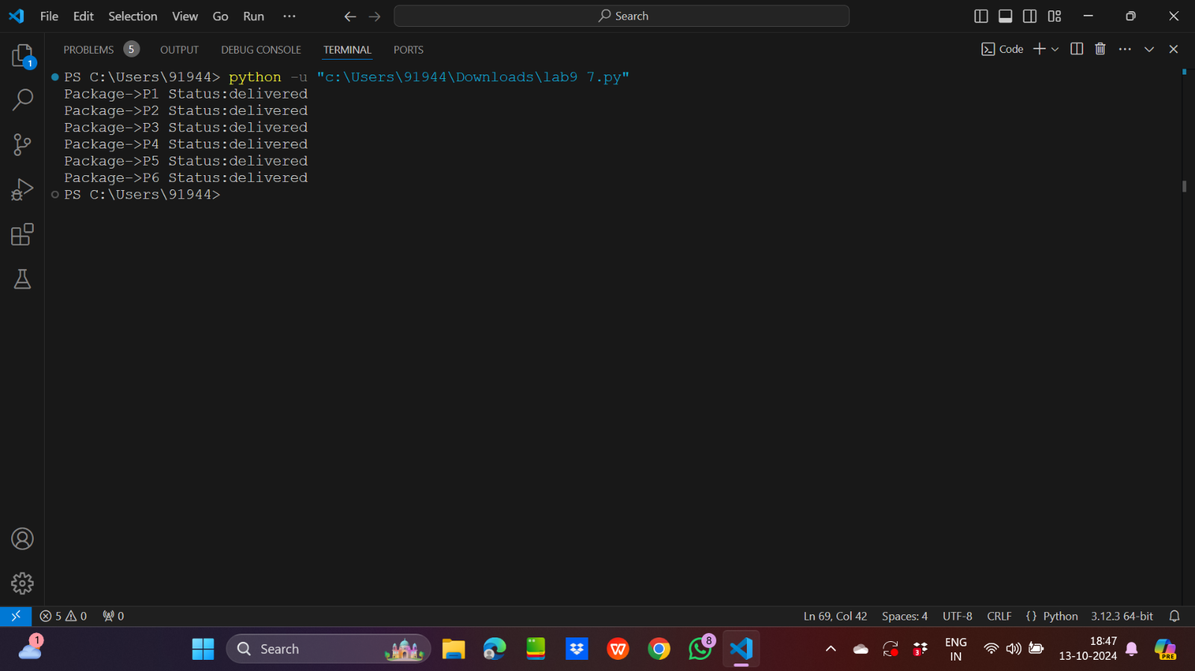

8.

Input code:

from datetime import *

from random import *

count=0

def sensor_data():

    while True:

        yield (f"{datetime.now()}",randint(-10,50))

def filter_by_threshold():

    for i in sensor_data():

        if i[1]>=0 and i[1]<=40:

            yield i

mylist=[]

def smooth_temperature():

    for i in filter_by_threshold():

        mylist.append(i[1])

        if(len(mylist)<3):

           smoothed_temperature=sum(mylist)/len(mylist)

        else:

           smoothed_temperature=(mylist[-1]+mylist[-2]+mylist[-3])/3

        yield (f"{datetime.now()}",smoothed_temperature)

def convert_to_farenheit():

    for i in smooth_temperature():

        temperature_farenheit=(1.4*i[1])+32

        yield (f"{datetime.now()}",temperature_farenheit)

def main():

    for i in convert_to_farenheit():

        print(i)

        global count

        count=count+1

        if(count==20):

            break

main()

Output:

