Time Management
Assignment 1 DEADLINE | Assignment 1 CRITICAL PATH | PROJECT FINISH | CRITICAL TASKS
Wk 4 | 7 tasks | Wk 12 | 20 of 33
11 Oct (day 18) | via 5.2 (gating)

1. Scheduling Approach

The project schedule is derived directly from the Work Breakdown Structure. Each work package is assigned a work duration, dependency relationship and responsible owner. Scheduling uses the precedence method (Start the next task only when the tasks before are completed) with a small number of tasks (documentation, meeting minutes) running in parallel as ongoing activities. The schedule is baselined against the two fixed deadlines: Assignment 1 due 11 October (Week 4) and the full project delivered by the end of semester.

2. Development Schedule

Task list with durations, finish-to-start predecessors, owners and milestones. Start and Finish are given in weeks of a five-day working week, counted from project kickoff. Tasks on the critical path are shaded and starred.
WBS | Task | Duration | Predecessor | Owner | Start | Finish | Milestone
1.1 | Confirm topic & problem statement | 2 days | — | Team | Wk 1 | Wk 1 | ★
1.2 | Define scope & acceptance criteria | 3 days | 1.1 | PM lead | Wk 1 | Wk 1 | ★
1.7 | Repo & environment setup | 2 days | 1.2 | Dev lead | Wk 2 | Wk 2 | ★
1.3 | WBS + dictionary | 3 days | 1.2 | PM lead | Wk 2 | Wk 2 | ★
1.4 | Gantt chart / schedule | 2 days | 1.3 | PM lead | Wk 2 | Wk 2 | ★
1.5 | Risk register & plan | 3 days | 1.3 | Team | Wk 2 | Wk 3 | ★
1.6 | Monitor/control & closure plans | 2 days | 1.3 | PM lead | Wk 2 | Wk 2 | ★
5.1 | UI/UX wireframes | 5 days | 1.2 | Design lead | Wk 2 | Wk 2 | ★
5.2 | Usability principles write-up | 2 days | 5.1 | Design lead | Wk 3 | Wk 3 | ★
5.3 | Prototype team review | 1 day | 5.2 | Team | Wk 3 | Wk 3 | Prototype approved
7.1 | Report writing (Assignment 1) | 4 days | 1.4, 1.5, 1.6, 5.2 | Team | Wk 3 | Wk 4
7.3 | Contribution form completed & signed | 1 day | 7.1 | PM lead | Wk 4 | Wk 4
7.4a | Assignment 1 review & submit | 1 day | 7.1, 7.3 | Team | Wk 4 | Wk 4 | A1 due 11 Oct
2.1 | Dataset search & evaluation | 4 days | 1.7 | Data lead | Wk 2 | Wk 3
2.2 | Dataset selection & documentation | 2 days | 2.1 | Data lead | Wk 3 | Wk 3
2.3 | Exploratory data analysis | 3 days | 2.2 | Data lead | Wk 3 | Wk 4
2.4 | Cleaning & normalization | 4 days | 2.3 | Data lead | Wk 4 | Wk 4
2.5 | Encode & split data | 2 days | 2.4 | Data lead | Wk 5 | Wk 5
3.1 | Feature extraction | 4 days | 2.5 | ML lead | Wk 5 | Wk 6
3.2 | Fit vectorizer | 1 day | 3.1 | ML lead | Wk 6 | Wk 6
3.3 | Baseline model | 2 days | 3.2 | ML lead | Wk 6 | Wk 6
3.4 | Train & tune candidate models | 5 days | 3.3 | ML lead | Wk 6 | Wk 7
3.5 | Select best model | 2 days | 3.4 | ML lead | Wk 7 | Wk 8 | ★ Model selected
3.6 | Evaluation on test set | 3 days | 3.5 | ML lead | Wk 8 | Wk 8
3.7 | Serialize model | 1 day | 3.6 | ML lead | Wk 8 | Wk 8
4.1 | Dataset visualizations | 3 days | 2.3 | Data lead | Wk 4 | Wk 4
4.2 | Model-performance visualizations | 3 days | 3.6 | ML lead | Wk 8 | Wk 9
6.1 | Front-end build | 5 days | 5.3 | Dev lead | Wk 3 | Wk 4
6.2 | Back-end / model serving | 5 days | 3.7, 6.1 | Dev lead | Wk 9 | Wk 9
6.3 | Integrate visualizations | 3 days | 4.2, 6.2 | Dev lead | Wk 10 | Wk 10
6.4 | Application testing | 4 days | 6.3 | Team | Wk 10 | Wk 11
7.1b | Final report & documentation | 5 days | 6.4 | Team | Wk 11 | Wk 12

WBS | Task | Duration | Predecessor | Owner | Start | Finish | Milestone
7.4b | Final submission | 1 day | 7.1b, 7.3 | Team | Wk 12 | Wk 12

3. Gantt Chart (Timeline View)

Assignment 1 tasks are front-loaded into Weeks 1–4. Bar positions are generated from the durations and finish-to-start dependencies in the table above, so the chart and the table are consistent by construction. ◆ marks a milestone; the grey band is the ongoing meeting-minutes activity; a blue outline marks a critical-path task. Week numbers are relative to project kickoff and should be mapped to the unit's calendar dates.
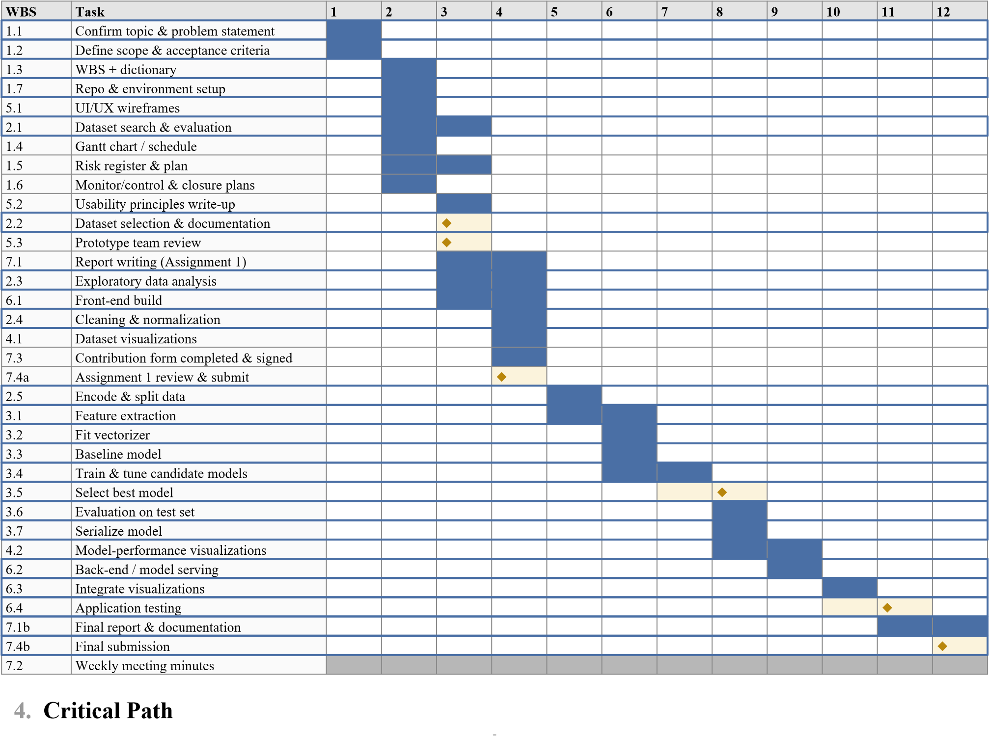
4. Critical Path
Assignment 1 critical path: 1.1 → 1.2 → 1.3 → 1.5/1.6 → 7.1 → 7.4a. The report cannot be finalized until the WBS, risk plan, control plan, and usability write-up are complete, so any delay in these directly moves the 11 Oct deadline.
Full-project critical path: 1.7 → 2.1 → 2.2 → 2.3 → 2.4 → 2.5 → 3.1 → 3.4 → 3.5 → 3.6 → 3.7 → 6.2 → 6.3
→ 6.4 → 7.4b. Data preparation and modeling feed model serving in the app, so slippage there cascades to final delivery.
Float: Visualization tasks (4.1, 4.2) and the front-end (6.1) have slack because they run alongside the modeling chain; use that float to absorb delays elsewhere.

5. Schedule Control

- Progress is reviewed at weekly team meetings against this baseline.
- Tasks are marked not started / in progress / complete; slipping tasks trigger reallocation of team members from float tasks.
- Any change to scope or a milestone date follows the change-control process in the Monitoring & Control plan.

Risk Management

1. Risk Management Approach

Risks are identified at project inception and reviewed weekly. Each risk is scored on Likelihood (1–5) and Impact (1–5); the product gives a Risk Score (1–25) used to prioritize. Each risk has a nominated owner responsible for monitoring triggers and executing the response. Response strategies follow the standard set: Avoid, Mitigate, Transfer, or Accept.

2. Risk Scoring Matrix

Score Range | Priority | Action
1–6 | Low | Monitor; accept where cost-effective
8–12 | Medium | Active mitigation plan required
15–25 | High | Immediate mitigation + contingency; escalate at meetings

3. Risk Register

ID | Risk | Category | L | I | Score | Priority | Response | Mitigation / Contingency | Owner
R1 | Suitable labeled dataset can't be found or has licensing issues | Technical/Data | 3 | 5 | 15 | High | Mitigate | Shortlist ≥2 datasets early (2.1); verify licence before committing; keep backup dataset | Data lead
R2 | Poor model accuracy / high false-negative rate | Technical | 3 | 4 | 12 | Medium | Mitigate | Compare multiple models; tune hyperparameters; use F1/recall not just accuracy; allow buffer in  3.4 | ML lead
R3 | Class imbalance skews results | Technical/Data | 4 | 3 | 12 | Medium | Mitigate | Stratified split; resampling (SMOTE/undersampling); report per-class metrics | ML lead
R4 | Team member unavailable (illness, drops unit) | Resource | 3 | 4 | 12 | Medium | Mitigate | Cross-train on key tasks; document work in shared repo; redistribute via float tasks | PM lead
R5 | Scope creep (adding features beyond plan) | Management | 3 | 3 | 9 | Medium | Avoid | Enforce scope statement; route additions through change control | PM lead
R6 | Schedule slip on modeling delays app build | Schedule | 3 | 4 | 12 | Medium | Mitigate | Track critical path weekly; use visualization/front-end float; start front-end in parallel | PM lead
R7 | Integration failure between model and web app | Technical | 2 | 4 | 8 | Medium | Mitigate | Serialize model early (3.7); agree input/output contract before 6.2; test with sample inputs | Dev lead
R8 | Data loss / version confusion | Technical | 2 | 4 | 8 | Medium | Mitigate | Use Git version control; never edit raw data; regular commits and backups | Dev lead
R9 | Accidental use of generative AI / academic-integrity breach | Compliance | 2 | 5 | 10 | Medium | Avoid | Write all materials in own words; cite in Harvard style; pre-submission Turnitin check | Team
R10 | Missing weekly meeting minutes / contribution records | Management | 3 | 3 | 9 | Medium | Mitigate | Assign a rotating scribe; template minutes; store centrally each week | Scribe
R11 | Skill gaps in ML or web development | Resource | 3 | 3 | 9 | Medium | Mitigate | Allocate learning time early; pair programming; use documented libraries | Team
R12 | Tooling/environment inconsistency between members | Technical | 2 | 2 | 4 | Low | Accept | Shared requirements.txt and virtual environment; document setup | Dev lead

4. Risk Response Plan (High-Priority Detail)

R1 — Dataset availability (High, 15): This is the top risk because everything downstream depends on it. The team commits to locking a dataset with a verified licence by Week 5 (milestone: Dataset locked), keeping a second candidate in reserve. Trigger: no viable dataset confirmed by end of Week 5 → escalate and switch to the backup immediately.
R2 / R3 — Model performance & imbalance (Medium, 12): Handled together, since imbalance is a leading cause of weak recall. Mitigations run inside WBS 3.3–3.6: baseline first, then tuned models, resampling where needed, and evaluation focused on recall/F1 given that a missed threat is the costly error.
R4 / R6 — Resource & schedule (Medium, 12): Managed through the weekly review against the baseline schedule. Float tasks (4.1, 4.2, 6.1) are the shock absorbers; if a critical-path task slips, members are pulled from float work to recover it.

5. Monitoring & Review

The risk register is a living document reviewed at each weekly meeting: scores are updated, closed risks retired, and new risks logged. High-priority risks are a standing agenda item, and any risk that materializes is recorded in the meeting minutes alongside the action taken.

