Exercise 1:

1. // To Run the application, enter the following command
2. java -jar user-registration-app-0.1.0.jar

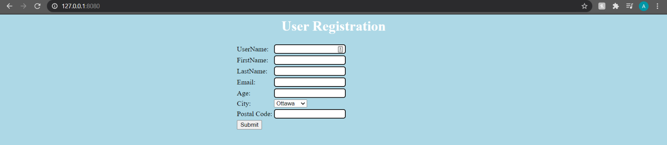

|  |  |  |  |  |
| --- | --- | --- | --- | --- |
| **#Test Case** | **Test Case** | **Expected Result** | **Actual Result** | **Verdict**  **(Pass, Fail, Inconclusive)** |
| 1 | UserName: A00000  FirstName: “”  LastName: “”  Age: 18  Email: [+@-.AA](mailto:+@-.AA)  City: Halifax  PostalCode: A0A0A0 | registration request accepted | registration request accepted | Pass |
| 2 | UserName: zzzzzzzzzzzz  FirstName: A  LastName: zzzzzzzzzzzzzzzzz  Age: 64 Email:zzZZz.zz999@zzz.zzzz99999zzzzzzz.zzzzz zz9999zzzzz.zzzzzz  City:Toronto  PostalCode: Y9Z9Z9 | registration request accepted | Err3 | Fail |
| 3 | UserName: Aure723xxz  FirstName: “A ”  LastName: “Bob The Great”  Age: 35  Email: [boByy4534@some.where.com](mailto:boByy4534@some.where.com)  City: Ottawa  PostalCode: A9A 9A9 | registration request accepted | registration request accepted | Pass |
| 4 | UserName: X56565z0  FirstName: Bond  LastName: James  Age: 60  Email: [jb007@mi6.org](mailto:jb007@mi6.org)  City: Montreal  PostalCode: Y0Z 0Z0 | registration request accepted | registration request accepted | Pass |
| 5 | UserName: “”  FirstName: “”  LastName: “”  Age: 18  Email: [+@-.AA](mailto:+@-.AA)  City: Halifax  PostalCode: A0A0A0 | Err1 | Err1  (Username must be between 6 and 12) | Pass |
| 6 | UserName: z  FirstName: A  LastName: zzzzzzzzzzzzzzzzz  Age: 64 Email:zzZZz.zz999@zzz.zzzz99999zzzzzzz.zzzzz zz9999zzzzz.zzzzzz  City:Toronto  PostalCode: Y9Z9Z9 | Err3 | Err 1  And  Err 3 | Inconclusive |
| 7 | UserName: zzzzz  FirstName: “A ”  LastName: “Bob The Great”  Age: 35  Email: [boByy4534@some.where.com](mailto:boByy4534@some.where.com)  City: Ottawa  PostalCode: A9A 9A9 | Err3 | Err1 | Fail |
| 8 | UserName: @adr278a  FirstName: Bond  LastName: James  Age: 60  Email: [jb007@mi6.org](mailto:jb007@mi6.org)  City: Montreal  PostalCode: Y0Z 0Z0 | Err1 | Err1  (Wrong username format) | Pass |