Detailed Diagnostic Report (DDR)
Prepared by: AI DDR System

1. Property Issue Summary
Observed issues include: leak, damp, crack, seepage, hotspot.

2. Area-wise Observations

Wall
- Visual findings are available in source inspection document.
- Thermal findings are referenced from thermal document where relevant.

inspection_page1_img1.png

Bedroom
- Visual findings are available in source inspection document.
- Thermal findings are referenced from thermal document where relevant.

inspection_page2_img1.png

Kitchen
- Visual findings are available in source inspection document.
- Thermal findings are referenced from thermal document where relevant.

inspection_page3_img1.png

Bathroom
- Visual findings are available in source inspection document.
- Thermal findings are referenced from thermal document where relevant.
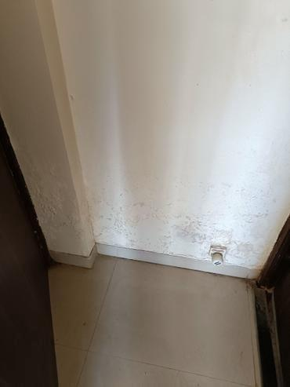
inspection_page3_img2.jpeg

Ceiling
- Visual findings are available in source inspection document.
- Thermal findings are referenced from thermal document where relevant.
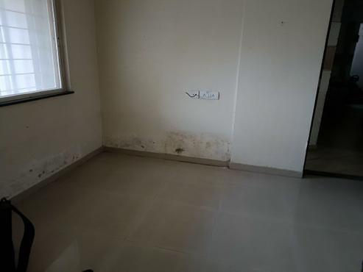
inspection_page3_img3.jpeg

Balcony
- Visual findings are available in source inspection document.
- Thermal findings are referenced from thermal document where relevant.
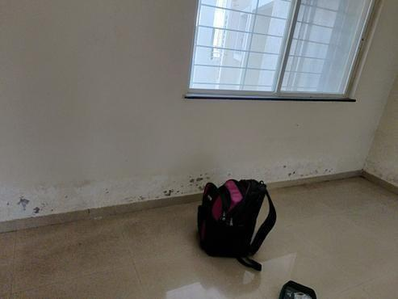
inspection_page3_img4.jpeg

Roof
- Visual findings are available in source inspection document.
- Thermal findings are referenced from thermal document where relevant.
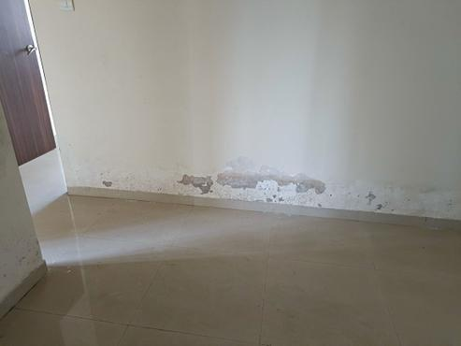
inspection_page3_img5.jpeg

3. Probable Root Cause
- Likely causes include moisture ingress, material deterioration, or thermal insulation gaps based on reported observations.
- Exact engineering validation is Not Available in the provided reports.

4. Severity Assessment (with reasoning)
- High: Areas with active moisture/leak indicators, because continued exposure can cause structural and health risks.
- Medium: Areas with repeated thermal anomalies, because they may indicate hidden defects needing near-term checks.
- Low: Cosmetic observations without supporting thermal or progression evidence.

5. Recommended Actions
- Conduct targeted on-site validation for high severity areas first.
- Repair moisture ingress pathways and damaged finishes.
- Re-scan affected zones after corrective action.
- Keep dated photo/thermal evidence for closure reporting.

6. Additional Notes
- This version is generated via fallback mode due to API availability limits.
- Statements are restricted to provided document context and generic reporting language.

7. Missing or Unclear Information
- Exact moisture source confirmation: Not Available
- Engineering test measurements beyond report scope: Not Available
- Conflicting statements across reports: Not Available
- Source completeness note: Not Available

