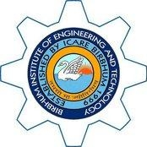**BIRBHUM INSTITUTE OF ENGINEERING & TECHNOLOY, SURI, BIRBHUM**