# Tremella Mushrooms: The Science Behind the Folk Legend

Author : Amy Niu

Tremella Mushrooms: The Science Behind the Folk Legend

Author : Amy Niu

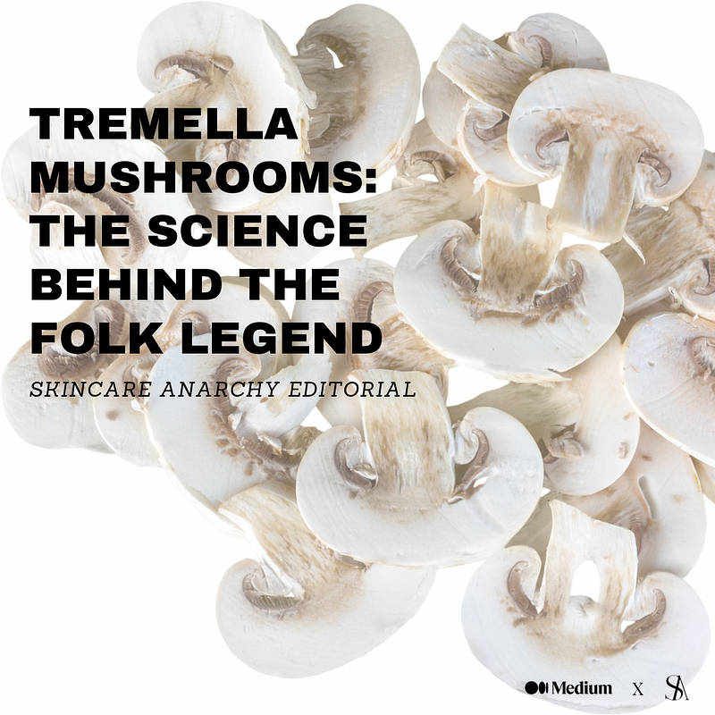(Photo courtesy of Shutterstock)

Mushrooms have moved from the kitchen and the dining table to the bathroom and medicine cabinet with the advent of anti-aging skincare products that use tremella mushrooms.

In ancient Chinese medicine, tremella mushrooms (scientific name: *tremella fuciformis*; also called snow fungus, snow ear, silver ear mushroom, and white jelly mushroom [1]) believed to boost one’s immune system, reduce inflammation, and support healthy lungs and skin [2].

One of the celebrated Four Beauties of ancient China, Yang Guifei, was reported to have used the mushroom to maintain a youthful complexion during China’s Tang Dynasty, as she often drank tremella mushroom soup and even bathed in water infused with the mushroom [3]. The benefits of tremella mushroom for the skin are supported by science as well.

According to Lindsey DeSoto’s article, “What Are Tremella Mushrooms?” published in *Health* [4], the beauty and personal care industry uses tremella mushrooms for their anti-aging and moisturizing properties. Tremella is similar to hyaluronic acid, in that it keeps skin moisturized even as the amount of hyaluronic acid in the body decreases with age and factors such as environment, diet, and stress [2].

Additionally, tremella protects against oxidative stress — a condition that occurs when there are too many free radicals in the body and not enough antioxidants — because they are a good source of antioxidants [4]. Over time, oxidative stress can lead to chronic inflammation and conditions such as heart disease, kidney disease, diabetes, and cancer [4]. Oxidative stress is also a key cause of skin aging [3].

The high volume of polysaccharides in tremella mushrooms account for their anti-inflammatory and antioxidant properties [4].

Shen et al. (2017) found that tremella polysaccharides prevent the spread of inflammation, and they could potentially treat inflammatory diseases such as heart disease, tumors, and obesity [5]. Shen et al. (2017) verified that certain concentrations (100 to 200 μg/ml) of hot water extract of *tremella fuciformis* polysaccharides treated hydrogen peroxide-induced injuries to human dermal fibroblasts by reducing oxidative stress and cell apoptosis. Fibroblasts are a type of cell that contributes to connective tissue formation and secretes collagen to help maintain tissue structure [6]. As hydrogen peroxide plays a role in the development of skin injury and aging, Shen et al. (2017) has implications for testing the role of extracted *tremella fuciformis* polysaccharides in anti-aging skincare products.

Ma et al. (2021) found that tremella mushroom polysaccharides help skin retain moisture and collagen, as well as reduce UV ray damage to skin [7]. Additionally, they found that it is not a smooth process to industrialize tremella mushroom polysaccharides for three reasons [7]. First, the polysaccharides found in edible tremella are unstable and the fermentation process is expensive [7]. Second, studies on tremella polysaccharides are mainly carried out on cells and

animal models, with a lack of clinical data and experiments on live subjects [7]. Third, tremella polysaccharides are complex structures that are not understood easily [7]. The implication of Ma et al. (2021) is that biologists and dermatologists need more robust clinical studies before making grandiose claims as to its benefits.

Lourith et al. (2020) suggest the efficacy of hand sanitizer with tremella mushroom extract in moisturizing the skin, compared to a placebo [8]. Ganeson and Xu (2018) found that tremella mushrooms prevented weight gain in rodents [9]. Though these studies are promising, more research on humans is needed to confirm the benefits of tremella mushrooms.

Companies like ReLiv Organics are selling tremella mushroom serums for the skin, citing the above-mentioned benefits of the mushroom on all different skin types [10].

Tremella mushrooms have attained a mythical status from their roots in ancient Chinese medicine, and recent scientific studies point towards its anti-inflammatory, hydrating, antioxidant properties. More research is needed, but the early results are promising nonetheless.

Sources:

[1] <https://www.sciencedirect.com/topics/biochemistry-genetics-and-molecular-biology/tremella-fuc> iformis#:~:text=Tremella%20fuciformis%2C%20an%20edible%20medicinal,fungus%2C%20an d%20white%20jelly%20mushroom.

[2] <https://learn.freshcap.com/tips/tremella-mushroom/>

[3] <https://mushroomwisdom.com/blog/tremella-the-beauty-mushroom/#:~:text=Legend%20has%20> it%20that%20Yang,bathed%20in%20Tremella%2Dinfused%20water.

[4] <https://www.health.com/tremella-mushrooms-7500900>

[5] <https://www.ncbi.nlm.nih.gov/pmc/articles/PMC5561887/>

[6] <https://www.genome.gov/genetics-glossary/Fibroblast#:~:text=A%20fibroblast%20is%20a%20t> ype,the%20structural%20framework%20of%20tissues.

[7] <https://journals.sagepub.com/doi/10.1177/20587384211000541> [8]

[8] <https://onlinelibrary.wiley.com/doi/10.1111/jocd.13543>

[9] <https://www.ncbi.nlm.nih.gov/pmc/articles/PMC6278646/>

[10] <https://www.relivorganics.com/blogs/news/top-4-reasons-to-love-our-tremella-mushroom-serum>

FOLLOW OUR SOCIALS:Apple Podcast: <https://podcasts.apple.com/us/podcast/skincare-anarchy/id1522162686>

Spotify Podcast: <https://open.spotify.com/show/298oIu74qjd3pXaaBMDr19>

Instagram: <https://www.instagram.com/skincareanarchy/?hl=en>

Facebook: <https://www.facebook.com/skincareanarchhy/>

Twitter: <https://twitter.com/SkincareAnarchy>

Reddit: <https://www.reddit.com/r/Skincare_Anarchy/>

LinkedIn: <https://www.linkedin.com/company/skincareanarchy/>

Pinterest: <https://cz.pinterest.com/skincareanarchy/_created/>

TikTok: <https://www.tiktok.com/@skincareanarchy>

Medium Blog:

[https://skincareanarchy.medium.com](https://skincareanarchy.medium.com/)

**Apple Podcasts**

[**‎Skincare Anarchy on Apple Podcasts**](https://podcasts.apple.com/us/podcast/skincare-anarchy/id1522162686)

‎Arts · 2023 (189 kB)

<https://podcasts.apple.com/us/podcast/skincare-anarchy/id1522162686>

[**Spotify**](https://spotify.com/)

[**Skincare Anarchy**](https://open.spotify.com/show/298oIu74qjd3pXaaBMDr19)

**X (formerly Twitter)**

[**Skincare Anarchy The Podcast (@SkincareAnarchy) / X**](https://twitter.com/SkincareAnarchy)

A podcast dedicated to answering your biggest skin health questions by renowned industry and medical professionals. Check us out on Spotify, Itunes, Google, etc

By [Skincare Anarchy](https://medium.com/@skincareanarchy) on [November 10, 2023](https://medium.com/p/260fc06acfe4).

[Canonical link](https://medium.com/@skincareanarchy/tremella-mushrooms-the-science-behind-the-folk-legend-260fc06acfe4)

Exported from [Medium](https://medium.com) on December 15, 2023.