Variables that are outside methods are called fields…

Its recommended to specify an access modifier when we declare a field outside a method…

Unlike these variables inside methods, java assigns values to those variables…

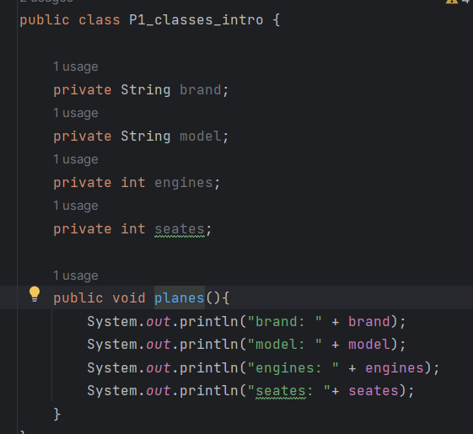

When we run the method planes in another class by creating an object the console will get updated as follows…

Variable with the access modifier “private” cant get changed outside the class…

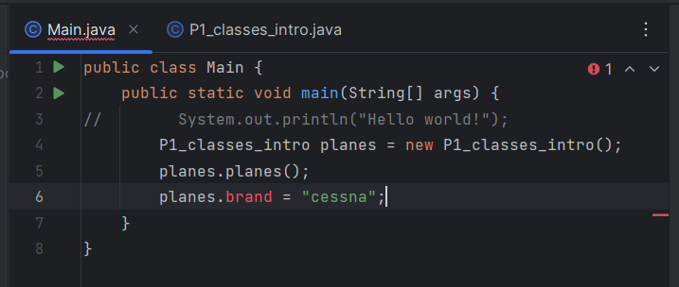

So make this work we have getter and setter methods…

Getters get values while setters set values to private variables…

When defining getter methods we usually add a prefix of “get” in front of the field name…

And we have to set the return statement and the return type as the field data type…

Take a look at the image below…

