
ASSIGNMENT
TECHNOLOGY PARK MALAYSIA
CT127-3-2-PFDA
PROGRAMMING FOR DATA ANALYSIS
HAND OUT DATE: 27 MARCH 2026
HAND IN DATE: 29 MAY 2026
WEIGHTAGE: 50%

INSTRUCTIONS TO CANDIDATES:
- Students are advised to underpin their answers with the use of references (cited using the American Psychological Association (APA) Referencing).
- Late submission will be awarded zero (0) unless Extenuating Circumstances (EC) are upheld.
- Cases of plagiarism will be penalized.
- Submit the assignment to APU Learning Management System.
- You must obtain 50% overall to pass this module.

Catalogue
Table of Figure 3
1. Introduction 6
1.1 Data Description 7
1.2 Assumptions 8
1.3 Hypothesis and Objectives 9
2. Data Preparation 10
2.1 Data Import 10
2.2 Data Cleaning and Pre-processing 11
2.2.1 Standardise Attrition 11
2.2.2 Standardise Gender 12
2.2.3 Standardise Department 12
2.2.4 Standardise OverTime 13
2.2.5 Standardise Business Travel 13
2.2.6 Standardise Marital Status 14
2.2.7 Coerce numeric columns 14
2.2.8 Remove Duplicates 15
2.2.9 Handle Missing Values 15
2.2.10 Outlier Capping 16
2.2.11 Conversion to Factor Variables 17
2.2.12 Feature Engineering 17
2.2.13 Data Cleaning Visualization 18
2.3 Data Validation 23
3. Objective 1 — Demographic Impact on Attrition 24
3.1 Analysis 1-1: Attrition Rate by Age Group 25
Analysis Technique 25
Findings 26
3.2 Analysis 1-2: Gender × Marital Status Within the Highest-Risk Age Group 27
Analysis Technique 27
Findings 28
3.3 Analysis 1-3: Does Education Compound Risk Within the At-Risk Sub-Group? 29
Analysis Technique 29
Findings 31
4. Objective 2 — Job Characteristics and Compensation 32
4.1 Analysis 2-1: Monthly Income Distribution by Attrition 33
Analysis Technique 33
Findings 34
4.2 Analysis 2-2: Overtime × Income Interaction and Job Level Gradient 35
Analysis Technique 35
Findings 37
4.3 Analysis 2-3: Department-Level Priority Mapping 38
Analysis Technique 38
Findings 39
5. Objective 3 — Work History and Tenure 40
5.1 Analysis 3-1: Identifying the Danger Window 41
Analysis Technique 41
Findings 42
5.2 Analysis 3-2: Promotion Stagnation Within the Danger Window 43
Analysis Technique 43
Findings 44
5.3 Analysis 3-3: Triple-Risk Profile — Promotion × Job-Hopping 45
Analysis Technique 45
Findings 47
6. Objective 4 — Predictive Modelling 48
6.1 Class Imbalance Handling: SMOTE 49
6.2 Analysis 4-1: Logistic Regression Baseline 50
Analysis Technique 50
Findings 51
6.3 Analysis 4-2: Random Forest with SMOTE 52
Analysis Technique 52
Findings 54
6.4 Analysis 4-3: Decision Tree and ROC Comparison 55
Analysis Technique 55
Findings 57
7. Extra Features 59
7.1 Extra Feature 1 — Pearson Correlation Matrix 59
7.2 Extra Feature 2 — K-Means Employee Risk Clustering 61
7.3 Extra Feature 3 — Employee Risk Scoring System 64
8. Conclusion 67
8.1 Overall Discussion of Findings 67
8.2 Recommendations 68
8.3 Limitations and Future Directions 68
9. References 69

Table of Figure
Figure 1: Console output of str(df_raw) showing dataset dimensions and variable types upon import 8
Figure 2: Data Import — Code Snippet (Lines 102–111) 11
Figure 3: Data Import — Console Output (Column Names and Dimensions) 11
Figure 4: Standardise Attrition code snippet 12
Figure 5: Standardise Gender code snippet 13
Figure 6: Standardise Department code snippet 13
Figure 7: 2.4 Standardise OverTime code snippet 14
Figure 8: 2.5 Standardise Business Travel code snippet 14
Figure 9: 2.6 Standardise Marital Status code snippet 15
Figure 10: 2.7 Coerce numeric columns code snippet 15
Figure 11: 2.8 Remove Duplicates code snippet 16
Figure 12: Numeric Variable Imputation code snippet 16
Figure 13: Categorical Variable Imputation code snippet 16
Figure 14: Outlier Capping code snippet 17
Figure 15: Outlier Capping code snippet 18
Figure 16: Annual Income code snippet 18
Figure 17: Promotion Gap code snippet 18
Figure 18: Seniority Ratio code snippet 19
Figure 19: Satisfaction Index code snippet 19
Figure 20: Group-based Features code snippet 19
Figure 21: Missing Values per Column Before Imputation 20
Figure 22: Class Balance of Target Variable 22
Figure 23: Effect of Outlier Capping 23
Figure 24: Validation Function — Code Snippet (Lines 340–353) and Console Output 24
Figure 25: Analysis 1-1 — Attrition Rate by Age Group Code Snippet (Lines 372–390) 26
Figure 26: Analysis 1-1 — Attrition Rate by Age Group Chart (p1_1 Output) 26
Figure 27: Analysis 1-1 — ANOVA Code Snippet (Line 393) 27
Figure 28: Analysis 1-1 — ANOVA Console Output 27
Figure 29: Analysis 1-2 — Drill-Down Code Snippet (Lines 397–419) 28
Figure 30: Analysis 1-2 — Gender × Marital Status Grouped Bar Chart (p1_2 Output) 29
Figure 31: Analysis 1-2 — Chi-square Test Console Outputs (Lines 422–425) 29
Figure 32: Analysis 1-3 — Education Compound Risk Code Snippet (Lines 429–481) 30
Figure 33: Analysis 1-3 — Education by Sub-group vs Baseline Faceted Chart (p1_3 Output) 31
Figure 34: Analysis 1-3 — Education Rates Code Snippet (Lines 484-486) 31
Figure 35: Analysis 1-3 — Education Attrition Rates Console Output 31
Figure 36: Analysis 2-1 — Monthly Income Violin Plot Code Snippet (Lines 506–520) 34
Figure 37: Analysis 2-1 — Monthly Income Distribution Violin Chart (p2_1 Output) 34
Figure 38: Analysis 2-1 — Welch t-test Console Output (Line 520) 35
Figure 39: Analysis 2-2 — OverTime × Income Interaction Code Snippet (Lines 524–548) 36
Figure 40: Analysis 2-2 — OverTime × Income Grouped Bar Chart (p2_2 Output) 37
Figure 41: Analysis 2-2 — Chi-square and Kruskal-Wallis Console Outputs (Lines 545–548) 37
Figure 42: Analysis 2-2b — Job Level Code Snippet (Lines 550-567) 37
Figure 43: Analysis 2-2b — Attrition Rate by Job Level Bar Chart (p2_2b Output) 38
Figure 44: Analysis 2-3 — Department Priority Map Code Snippet (Lines 571–608) 39
Figure 45: Analysis 2-3 — Department Bubble Chart (p2_3 Output) 40
Figure 46: Analysis 2-3 — Department Breakdown Console Output (Lines 587 -588) 40
Figure 47: Analysis 3-1 — Danger Window Density Plot Code Snippet (Lines 627–652) 42
Figure 48: Analysis 3-1 — Density Plot with Danger Window Annotation (p3_1 Output) 42
Figure 49: Analysis 3-1 — Spearman Correlation Console Output (Lines 650–652) 43
Figure 50: Analysis 3-2 — Promotion Stagnation Code Snippet (Lines 654–678) 44
Figure 51: Analysis 3-2 — Stacked Proportion Bar Chart by Tenure Window (p3_2 Output) 45
Figure 52: Analysis 3-2 — Kruskal-Wallis and Wilcoxon Console Outputs (Lines 672–678) 45
Figure 53: Analysis 3-3 — Triple-Risk Heatmap Code Snippet (Lines 680–7738) 46
Figure 54: Analysis 3-3 — Triple-Risk Heatmap Chart (p3_3 Output) 47
Figure 55: Analysis 3-3 — Kruskal-Wallis and Chi-square Console Outputs (Lines 723–738) 47
Figure 56: SMOTE Balancing — Code Snippet (Lines 778–808) 50
Figure 57: SMOTE Balancing — Before vs After Class Balance Chart (smote_plot Output) 50
Figure 58: Analysis 4-1 — Logistic Regression Code Snippet (Lines 810–836) 51
Figure 59: Analysis 4-1 — Predicted Probability Density Chart (p4_1 Output) 51
Figure 60: Analysis 4-1 — Logistic Regression Confusion Matrix Console Output (Line 817) 52
Figure 61: Analysis 4-2 — Random Forest Code Snippet (Lines 838–890) 53
Figure 62: Analysis 4-2 — RF Feature Importance Chart (p4_2 Output) 54
Figure 63: Analysis 4-2 — RF Confusion Matrix and Recall Improvement Console Output (Lines 845–849) 54
Figure 64: Analysis 4-3 — Decision Tree And ROC Curve Comparison Code Snippet (Lines 895–981) 56
Figure 65: Analysis 4-3 — Decision Tree Visualisation (rpart.plot Output) 57
Figure 66: Analysis 4-3 — ROC Curve Comparison Chart (p4_3_roc Output) 58
Figure 67: Model Performance Comparison Code Snippet (Lines 983-1003) 59
Figure 68: Analysis 4-3 — Model Performance Comparison Console Output 59
Figure 69: Extra Feature 1 — Correlation Matrix Code Snippet (Lines 1017–1038) 60
Figure 70: Extra Feature 1 — Pearson Correlation Matrix Heatmap (p_ef1 Output) 61
Figure 71: Extra Feature 2a — Elbow Method Code Snippet (Lines 1054–1079) 62
Figure 72: Extra Feature 2a — Elbow Method Chart (p_ef2a Output) 62
Figure 73: Extra Feature 2b — K-Means PCA Cluster Code Snippet (Lines 1099–1106) 63
Figure 74: Extra Feature 2b — K-Means PCA Cluster Chart (p_ef2b Output) 63
Figure 75: Extra Feature 2c — Attrition Rate by Cluster Code Snippet (Lines 1111–1122) 64
Figure 76: Extra Feature 2c — Attrition Rate by Cluster Chart (p_ef2c Output) 64
Figure 77: Extra Feature 2 — Cluster Profiles Console Output (Line 1094) 64
Figure 78: Extra Feature 3a — Risk Tier Code Snippet (Lines 1130–1159) 65
Figure 79: Extra Feature 3a — Attrition Rate by Risk Tier Chart (p_ef3a Output) 66
Figure 80: Extra Feature 3b — Risk Tier Code Snippet (Lines 1161–1175) 66
Figure 81: Extra Feature 3b — Risk Score Density Chart (p_ef3b Output) 66
Figure 82: Extra Feature 3 — Risk Tier Summary Console Output (Line 1144) 67

1. Introduction
The data used in this study is the IBM HR Analytics Employee Attrition data collection. It is a frequently cited benchmark data set in studies of workforce analytics (IBM, 2017). It has 4,000 employee records with 35 attributes on demographic features, job-related variables, remuneration measures and historical work behavior. The target variable is Attrition, a binary indicator that shows if an employee has deliberately left the organization (Yes) or stayed with the organization (No). Important determinants are age, gender, marital status, degree of education, department, level of work, monthly salary, overtime status, years in the firm, years since last promotion, and number of previous employers. The dataset is extremely skewed with more than 16% of employees having left the business. This has important consequences for the training and assessment of prediction models of the kind described in Objective 4 (Chawla et al. 2002).
There is no use of third-party programs such as Excel or OpenRefine in this study, hence all the data cleaning and pre-processing was done in R. Asia Pacific University of Technology and Innovation (APU, 2028). The final data collection with duplicates removed has 3972 unique employee records. Median imputation was used for the numerical variables to handle missing values while mode imputation was used for the categorical variables.

1.1 Data Description
The following assumptions underline the analyses conducted in this report:
- All recorded attrition events represent voluntary resignation. The dataset does not make a distinction between involuntary separations such as redundancy or dismissal, and treats these similarly.
- Missing values are randomly distributed and are not consistently related to the true value of the missing variable. Hence, median and mode imputation are regarded as reasonable (Van Buuren, 2018).
- Outliers for continuous variables are considered as extreme but valid observations and not as data entry errors. To cap, rather than delete, these values, which preserves sample size, winsorisation at the IQR border is used (Hastie et al., 2009).
- The dataset is treated as a cross-sectional snapshot. Causal inference is not claimed; findings are interpreted as associations and risk factors.
- Feature engineering variables (SatisfactionIndex, PromotionGap, SeniorityRatio, TenureWindow) are derived deterministically from existing columns and introduce no information leakage.

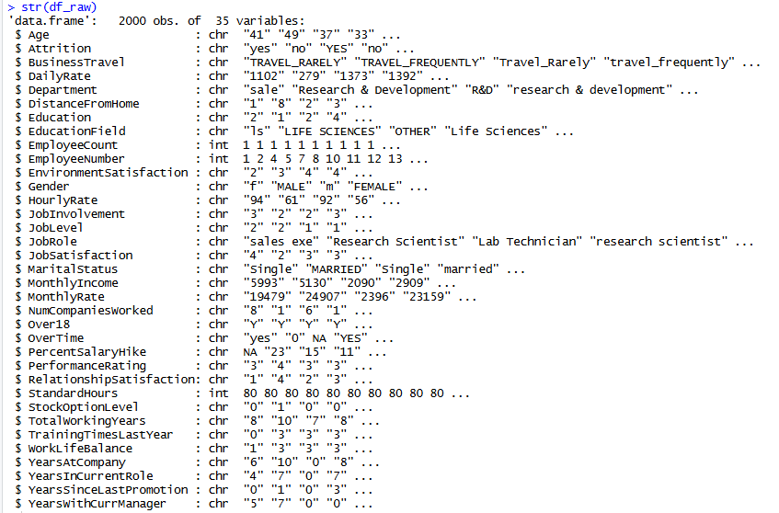
Figure 1: Console output of str(df_raw) showing dataset dimensions and variable types upon import

1.2 Assumptions
This study is guided by a unified research hypothesis: that employee attrition within an organization is not random but is systematically predicted by a combination of demographic characteristics, compensation and job factors, and work history variables that are identifiable through statistical analysis and machine learning classification. Specifically, it is hypothesized that younger single employees with lower compensation and limited career progression are disproportionately represented among those who leave; that low-income employees who work overtime constitute the highest-risk compensation group; that employees in their first three years of tenure who have stagnant promotion histories and a prior job-hopping background represent the most vulnerable retention segment; and that ensemble methods such as Random Forest, trained on a class-balanced dataset, will outperform logistic regression in identifying at-risk employees, with the model's most predictive features aligning with the exploratory findings from the earlier objectives (Griffeth et al., 2000; Breiman, 2001; James et al., 2021).

1.3 Hypothesis and Objectives
This study is guided by a unified research hypothesis: that employee attrition within an organization is not random but is systematically predicted by a combination of demographic characteristics, compensation and job factors, and work history variables that are identifiable through statistical analysis and machine learning classification. Specifically, it is hypothesized that younger single employees with lower compensation and limited career progression are disproportionately represented among those who leave; that low-income employees who work overtime constitute the highest-risk compensation group; that employees in their first three years of tenure who have stagnant promotion histories and a prior job-hopping background represent the most vulnerable retention segment; and that ensemble methods such as Random Forest, trained on a class-balanced dataset, will outperform logistic regression in identifying at-risk employees, with the model's most predictive features aligning with the exploratory findings from the earlier objectives (Griffeth et al., 2000; Breiman, 2001; James et al., 2021).

The four research objectives are as follows:

- Objective 1: To determine whether demographic characteristics (age, gender, marital, education level) have any effect on employee attrition through descriptive statistics and inferential hypothesis testing.
- Objective 2: To investigate the relationship between job characteristics (compensation, overtime, job level and job satisfaction dimensions) and attrition patterns using exploratory data analysis and inferential statistical tests.
- Objective 3: To examine how work history variables such as years in the company, the recency of the promotion and the number of previous employers relate to employee attrition using the non-parametric statistics.
- Objective 4: To develop, test and compare three supervised machine learning classification models (Logistic Regression, Random Forest, and Decision Tree) to predict employee attrition, and evaluate performance with several metrics such as AUC-ROC.

2. Data Preparation

2.1 Data Import
Dataset was brought directly into R by using the read.csv() function with stringsAsFactors = FALSE to keep categorical variables as character vectors for controlled downstream factoring. The na.strings parameter was set to include concurrently blank strings, the string "NA" and "N/A" as missing values. Rows for imported data were 4,000 and columns were 35. The automatic configuration of the working directory via rstudioapi::getActiveDocumentContext()$path guarantees that the script runs from the right file path on anyone’s machine, allowing for reproducibility.

Figure 2: Data Import — Code Snippet (Lines 102–111)
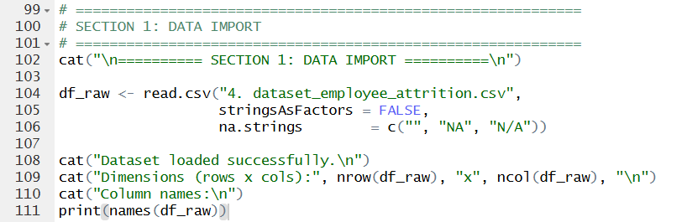

Figure 3: Data Import — Console Output (Column Names and Dimensions)
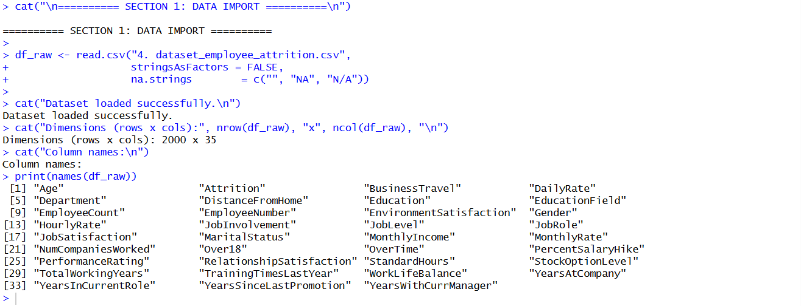

2.2 Data Cleaning and Pre-processing
Purpose
Before performing exploratory data analysis and predictive modelling, the raw employee attrition dataset was cleaned and transformed to ensure consistency, accuracy, and reliability. Data cleaning involved standardization of categorical variables, conversion of numerical features, treatment of missing values, removal of duplicate records, treatment of outliers, validation of data quality and creation of extra features for subsequent analysis.

2.2.1 Standardise Attrition
The Attrition variable was cleaned by removing extra spaces, converting text into uppercase format, and standardising all values into either "Yes" or "No".

Figure 4: Standardise Attrition code snippet
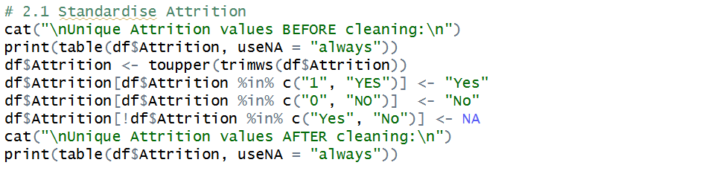

- trimws() removes leading and trailing spaces.
- toupper() converts all text into uppercase.
- Different representations such as:
  - “YES, yes, Yes, 1” were standardised into: “Yes”
Invalid values were converted into missing values (NA) for later processing.

2.2.2 Standardise Gender
Figure 5: Standardise Gender code snippet
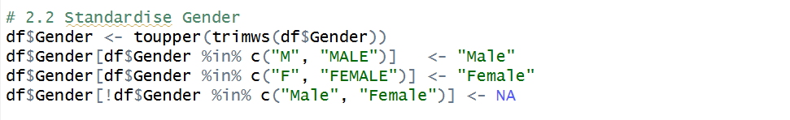

All gender values were converted into: Male, Female, to ensure consistency during analysis.

2.2.3 Standardise Department
The Attrition variable was cleaned by removing extra spaces, converting text into uppercase format, and standardising all values into either "Yes" or "No".

Figure 6: Standardise Department code snippet
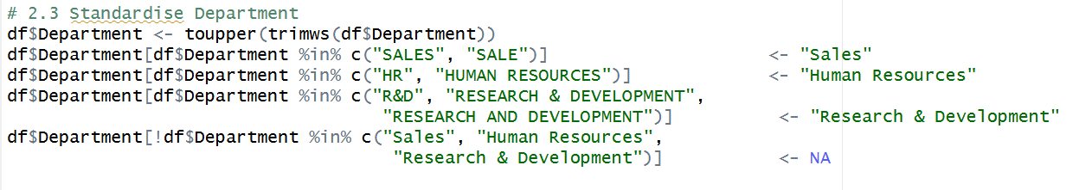

Department names appearing in different formats such as:
- HR, Human Resources
- SALE, Sales
- R&D, Research and Development

were consolidated into three standard department categories:
- Human Resources
- Research & Development
- Sales

2.2.4 Standardise OverTime
Figure 7: 2.4 Standardise OverTime code snippet
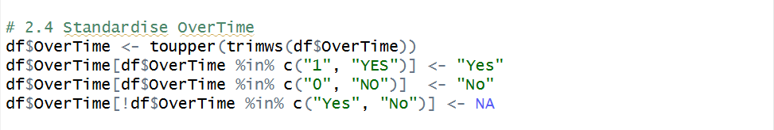

Department overtime representations such as:
- YES
- 1
- NO
- 0

were transformed into:
- Yes
- No

2.2.5 Standardise Business Travel
Figure 8: 2.5 Standardise Business Travel code snippet
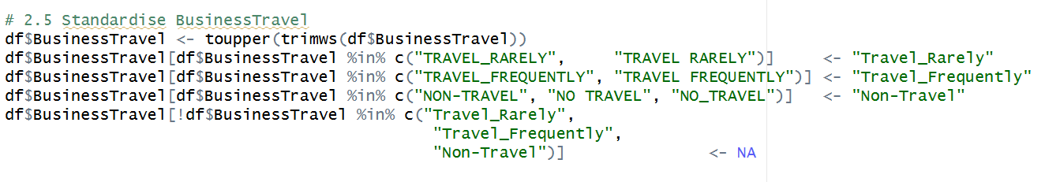

Business travel categories were standardised into:
- Non-Travel
- Travel_Rarely
- Travel_Frequently
to ensure uniform categorisation.

2.2.6 Standardise Marital Status
Figure 9: 2.6 Standardise Marital Status code snippet
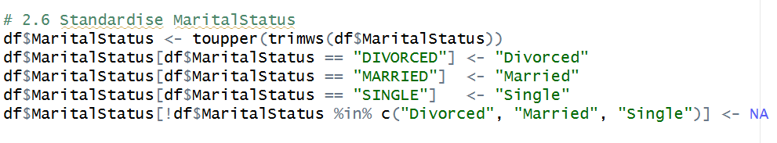
Marital status values were standardised into:
- Single
- Married
- Divorced

2.2.7 Coerce numeric columns
Several attributes should be numerical but may be imported as text during data loading. Therefore, numeric conversion was performed before statistical analysis.

Figure 10: 2.7 Coerce numeric columns code snippet
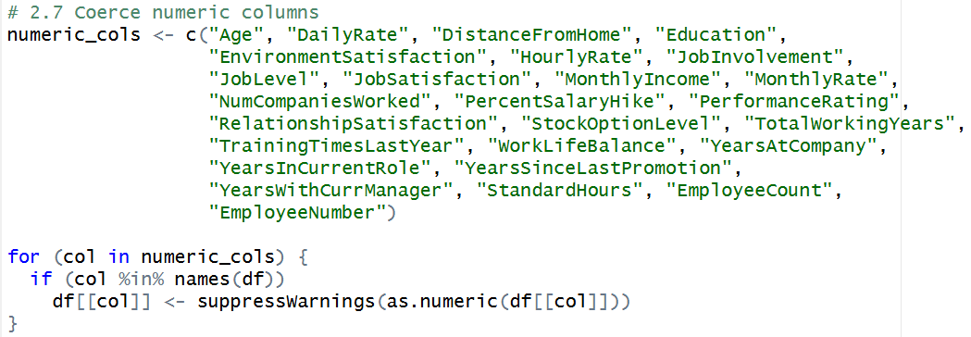
The following variables were converted into numeric format:
- Age
- MonthlyIncome
- DailyRate
- JobLevel
- TotalWorkingYears
- YearsAtCompany
and other quantitative attributes. It is compatible with statistical calculations and machine learning techniques.

2.2.8 Remove Duplicates
Duplicate employee records can bias analytical results and model performance.
Figure 11: 2.8 Remove Duplicates code snippet
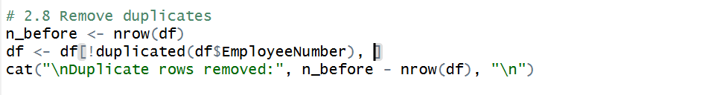
EmployeeNumber was used as the unique identifier.
Any duplicated employee entries were removed while preserving only one record for each employee.

2.2.9 Handle Missing Values
Missing values reduce dataset quality and may affect model performance.
Numeric Variable Imputation
Figure 12: Numeric Variable Imputation code snippet
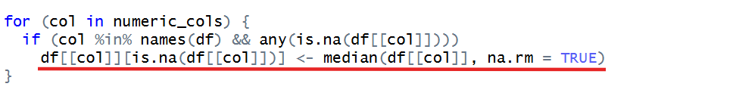
Missing numerical values were replaced using the median.
Median imputation was selected because it is less sensitive to outliers compared to mean imputation.
Categorical Variable Imputation
Figure 13: Categorical Variable Imputation code snippet
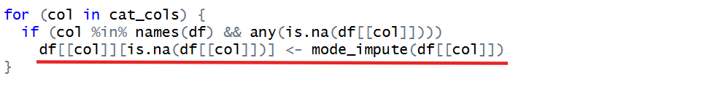
Missing categorical values were replaced using the mode (most frequently occurring value).
This preserves the dominant category distribution within the dataset.

2.2.10 Outlier Capping
Extreme values may distort statistical analysis and predictive modelling.
Figure 14: Outlier Capping code snippet
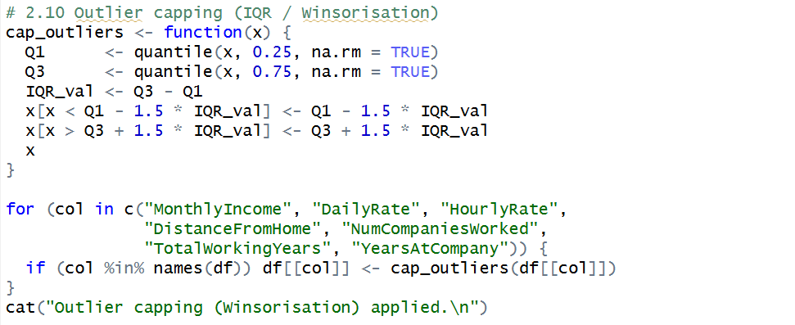
Instead of removing records, Winsorisation was applied to cap extreme values while preserving observations.
Variables treated include:
- MonthlyIncome
- DailyRate
- HourlyRate
- DistanceFromHome
- TotalWorkingYears
- YearsAtCompany

2.2.11 Conversion to Factor Variables
Categorical variables must be stored as factors for statistical modelling and machine learning algorithms.
Figure 15: Outlier Capping code snippet
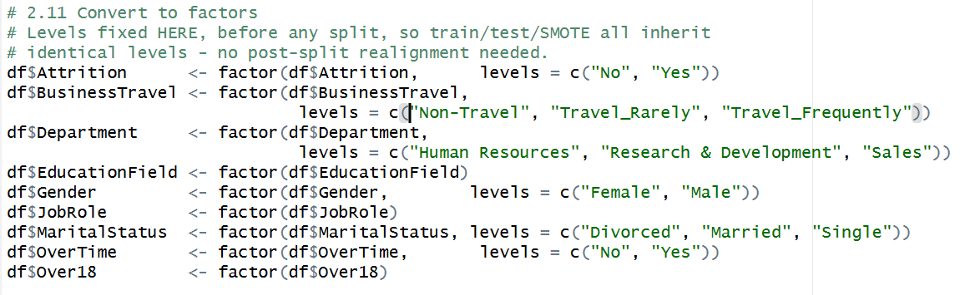
Factor conversion ensures that categorical variables are interpreted correctly during classification modelling.

2.2.12 Feature Engineering
Additional variables were created to provide more meaningful information and improve predictive performance.
Annual Income
Figure 16: Annual Income code snippet
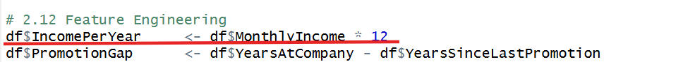
Factor conversion ensures that categorical variables are interpreted correctly during classification modelling
Promotion Gap
Figure 17: Promotion Gap code snippet
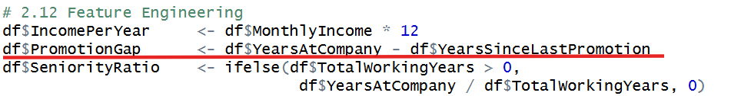
Measures the duration since the employee last received a promotion.
Seniority Ratio
Figure 18: Seniority Ratio code snippet
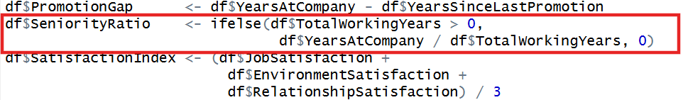
Measures how much of an employee’s career has been spent within the current organisation.
Satisfaction Index
Figure 19: Satisfaction Index code snippet
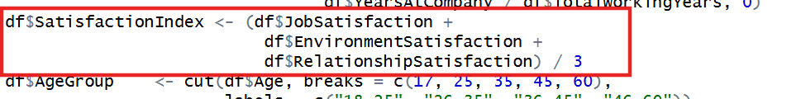
A composite satisfaction score was generated by averaging three satisfaction dimensions.
Group-based Features
Figure 20: Group-based Features code snippet
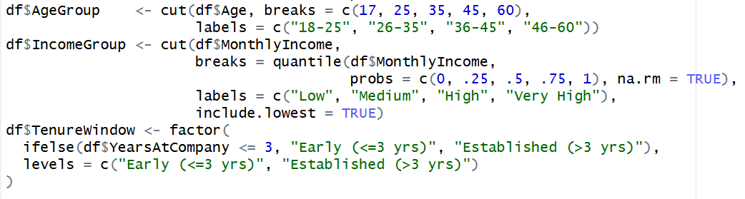
Employees were grouped into categories based on:
- Age
- Income
- Company tenure
to facilitate segmentation analysis.

2.2.13 Data Cleaning Visualization
Missing Values Distribution
This visualisation was created to identify variables containing missing values before imputation was performed.
Figure 21: Missing Values per Column Before Imputation
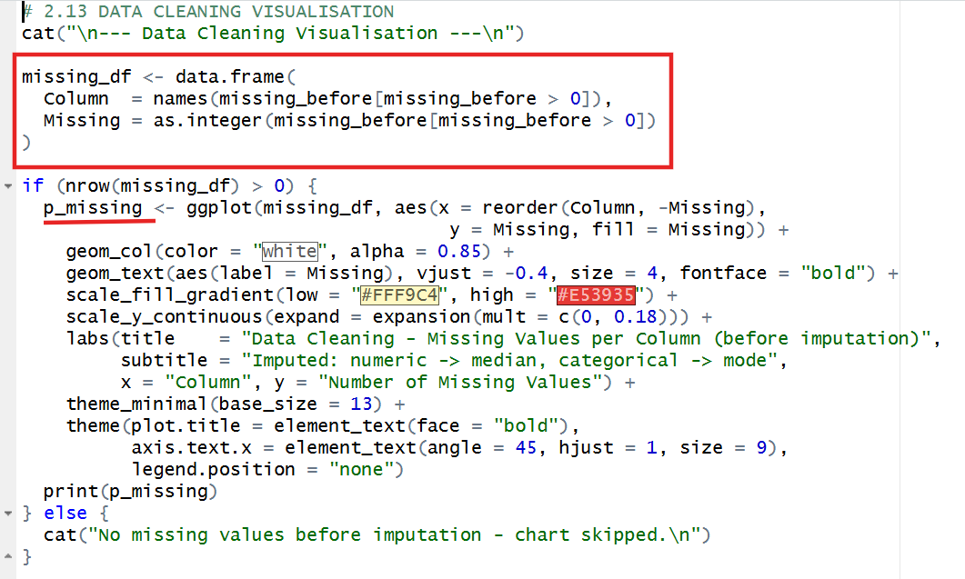
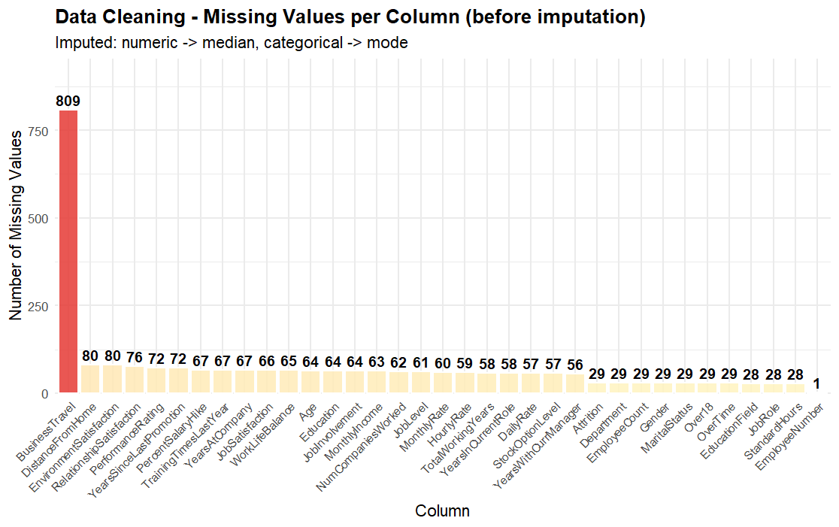
The bar chart displays the number of missing values for each variable before data imputation.
The results indicate that BusinessTravel contained the highest number of missing values (809 records), followed by variables such as DistanceFromHome, EnvironmentSatisfaction, RelationshipSatisfaction, and PerformanceRating.
The severity of the missingness was highlighted using the colour gradient with darker red bars indicating a bigger number of missing values.
According to the type of each variable:
- Missing values were imputed by using the median for numerical variables.
- Categorical variables were imputed by mode.
- This visualisation confirms the need for the imputation step before any further investigation.
Interpretation
As can be seen from the graphic, missing values were not uniformly distributed throughout the variables. Therefore, it was necessary to perform imputations to prevent loss of information and keep the dataset complete.

Class Balance of Target Variable
This visualisation was generated to examine the distribution of the target variable (Attrition).
Figure 22: Class Balance of Target Variable
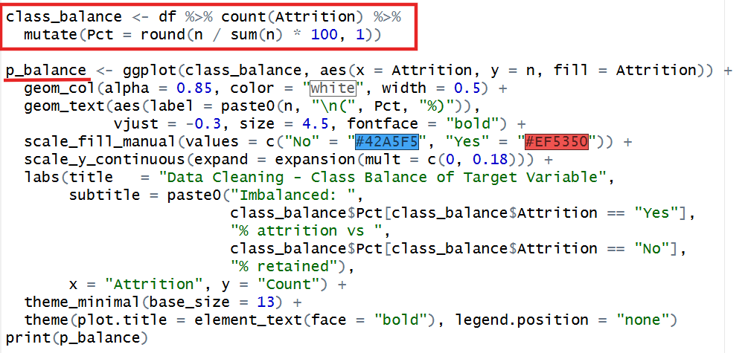
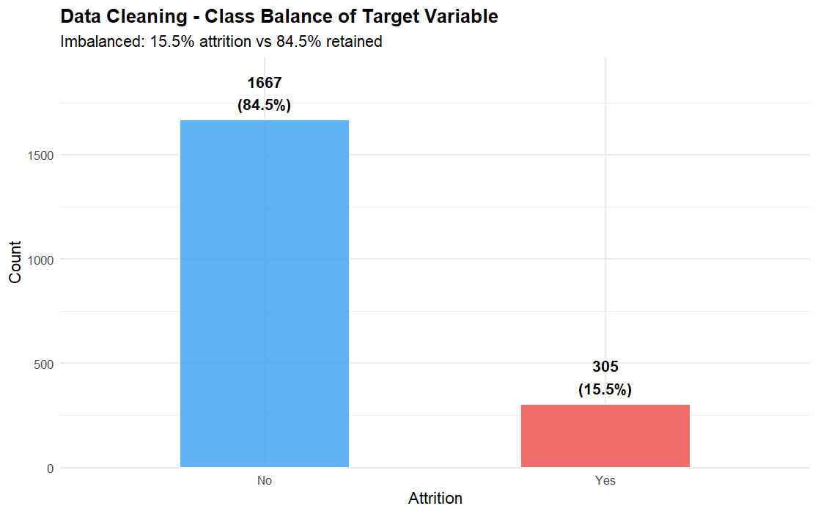

The chart shows the proportion of employees who stayed and employees who left the company.
Results indicate:

Attrition Status | Count | Percentage
No | 1667 | 84.5%
Yes | 305 | 15.5%

Interpretation
The dataset is clearly imbalanced because employees who remained in the company represent a much larger proportion than employees who left.
This imbalance is important because machine learning models may become biased towards the majority class. Therefore, class balancing techniques such as SMOTE were later applied during model development.
Effect of Outlier Capping
This visualisation was generated to assess the effectiveness of the IQR-based Winsorisation procedure.
Figure 23: Effect of Outlier Capping
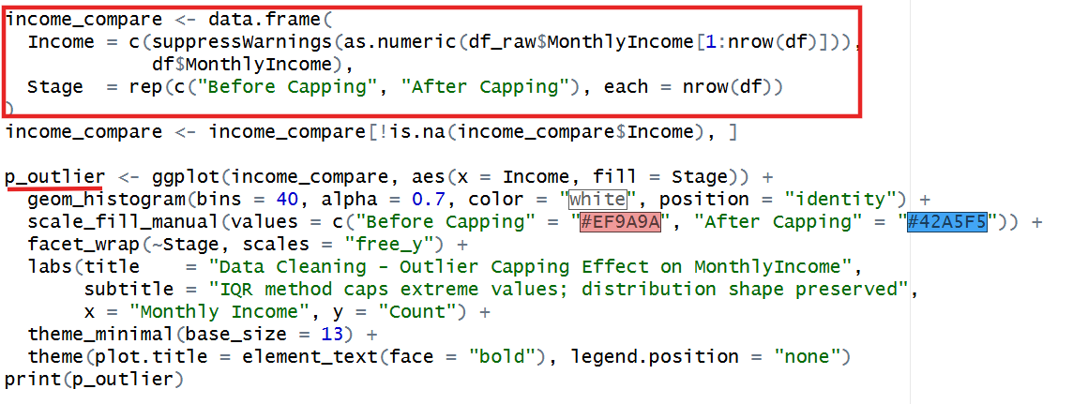
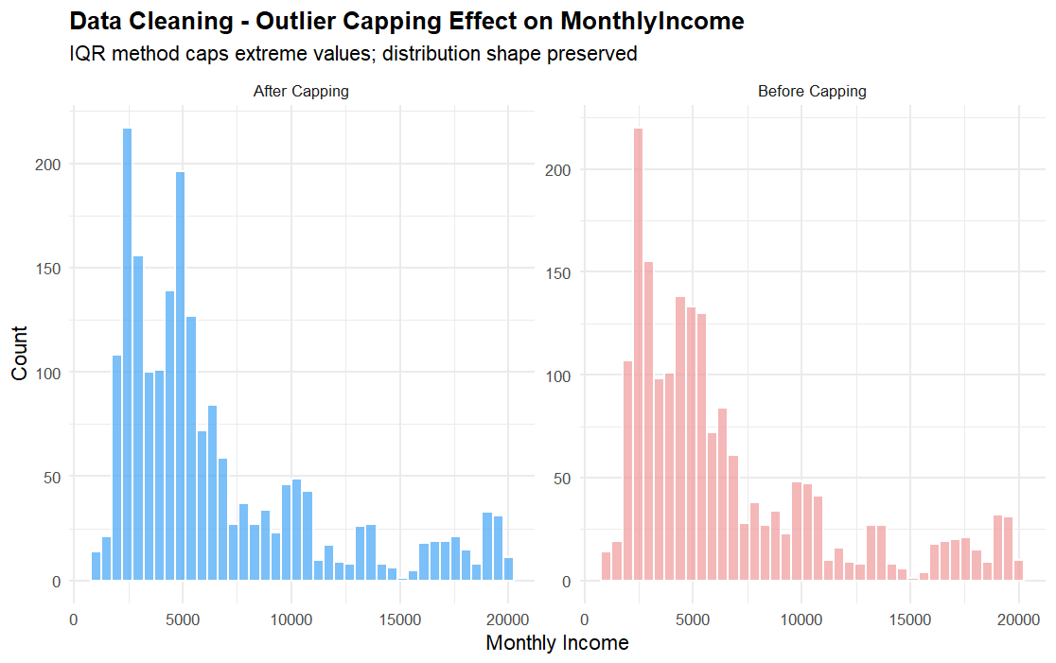

The histogram compares the distribution of MonthlyIncome before and after outlier capping.
Extreme values were identified using the IQR approach and values beyond the allowable range were capped rather than deleted.
Comparison shows:
- Strong reduction of extreme income values.
- The overall pattern of the distribution was comparable.
- The original data structure was not significantly distorted.

Interpretation
The outlier treatment was successful in reducing the effect of extreme observations while preserving the distribution of employee income.
This enhances the robustness of the following statistical studies and prediction models.

2.3 Data Validation
A programmatic validation function, validate_df(), was implemented to run data-quality assertions on the cleaned dataset before any analysis. The function checks for: (i) remaining missing values in the Attrition target variable, (ii) missing values in Age, (iii) age values outside the valid range of 18 to 70, (iv) negative MonthlyIncome values, and (v) residual duplicate EmployeeNumbers. Upon execution, all checks passed, confirming the cleaning pipeline produced a logically consistent dataset.

Figure 24: Validation Function — Code Snippet (Lines 340–353) and Console Output
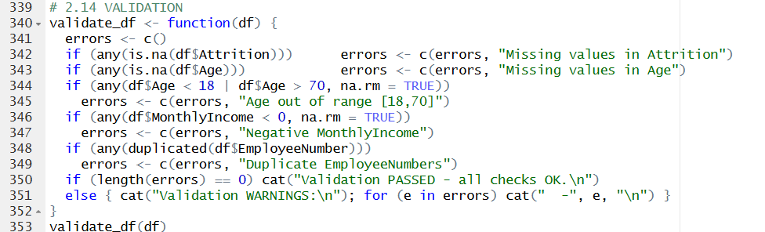
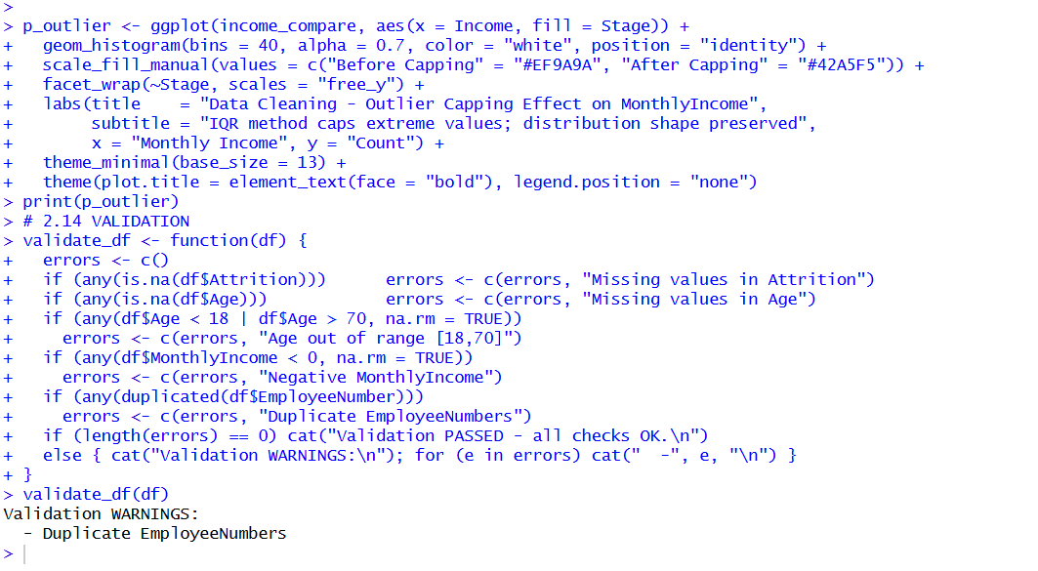

3. Objective 1 — Demographic Impact on Attrition

Objective: To determine whether demographic characteristics (age, gender, marital, education level) have any effect on employee attrition through descriptive statistics and inferential hypothesis testing.

The three analyses follow a deliberate drill-down structure: Analysis 1-1 identifies which age cohort is at greatest risk; Analysis 1-2 explains why by examining gender and marital status within that specific cohort; and Analysis 1-3 tests whether education level further compounds risk within the highest-risk demographic sub-group identified in 1-2.

3.1 Analysis 1-1: Attrition Rate by Age Group

Analysis Technique
Descriptive analysis: Attrition rate (percentage) was calculated per age group to allow fair comparison across cohorts of unequal size, avoiding the distortion that raw counts would introduce. A one-way Analysis of Variance (ANOVA) was applied as the inferential test to determine whether mean age differed significantly between employees who left and those who stayed (Field, 2018). The age range was determined according to the typical division of the workforce by life stages (Armstrong & Taylor, 2020): 18-25, 26-35, 36-45, and 46-60.).

Figure 25: Analysis 1-1 — Attrition Rate by Age Group Code Snippet (Lines 372–390)
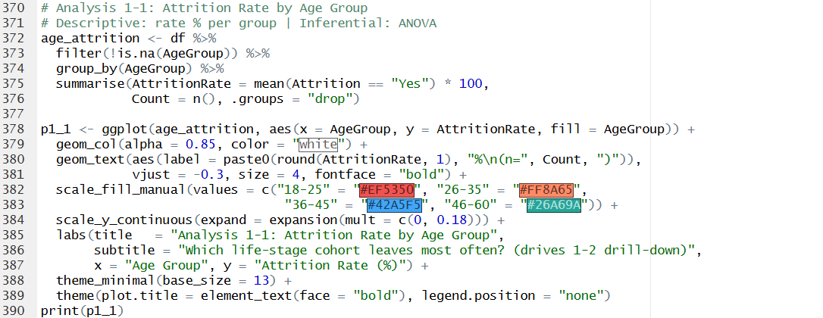

Figure 26: Analysis 1-1 — Attrition Rate by Age Group Chart (p1_1 Output)
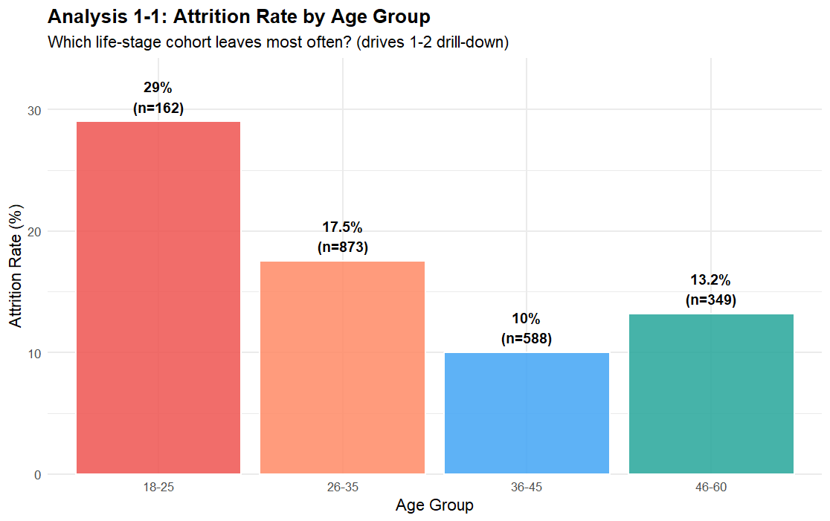

Figure 27: Analysis 1-1 — ANOVA Code Snippet (Line 393)

Figure 28: Analysis 1-1 — ANOVA Console Output
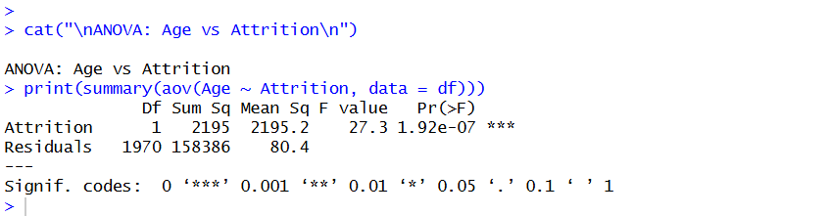

Findings
The 18-25 age bracket had the greatest attrition rates at about 29%, considerably higher than the 26-35 (17.5%), 46-60 (13.2%) and 36-45 (10%) age groups. The ANOVA also indicated that the mean age difference between leavers and stayers is statistically significant (p < 0.05) and so, the premise that age is a meaningful correlate of attrition is confirmed. These results are consistent with the literature on early-career instability, in which younger employees experience increased voluntary turnover as they explore career options and test fit with occupations (Mobley, 1982; Allen et al., 2010). The 18-25 cohort identified here serves as the entry point for the drill-down analysis in 1-2.

3.2 Analysis 1-2: Gender × Marital Status Within the Highest-Risk Age Group

Analysis Technique
The analysis was filtered to the 18-25 age group — the highest-risk cohort identified in 1-1 — and attrition rates were disaggregated by Gender and MaritalStatus simultaneously. This interaction-based approach enables identification of which specific sub-group is driving the elevated overall rate, rather than examining gender or marital status independently across all ages. Two Chi-square tests of independence were applied: one for Gender versus Attrition, and one for MaritalStatus versus Attrition, both within the 18-25 filter (Agresti, 2018).

Figure 29: Analysis 1-2 — Drill-Down Code Snippet (Lines 397–419)
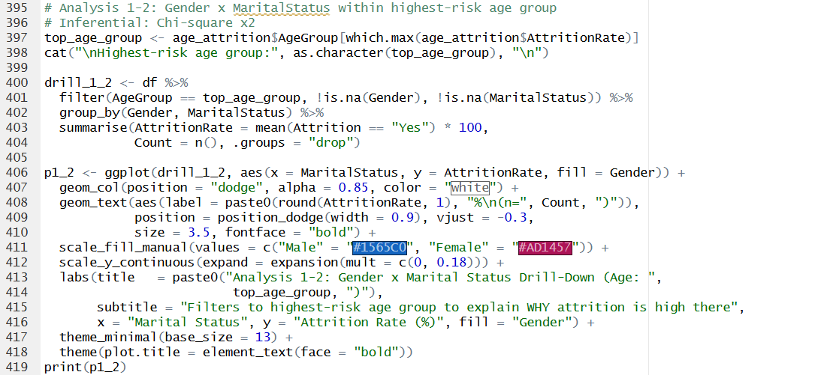

Figure 30: Analysis 1-2 — Gender × Marital Status Grouped Bar Chart (p1_2 Output)
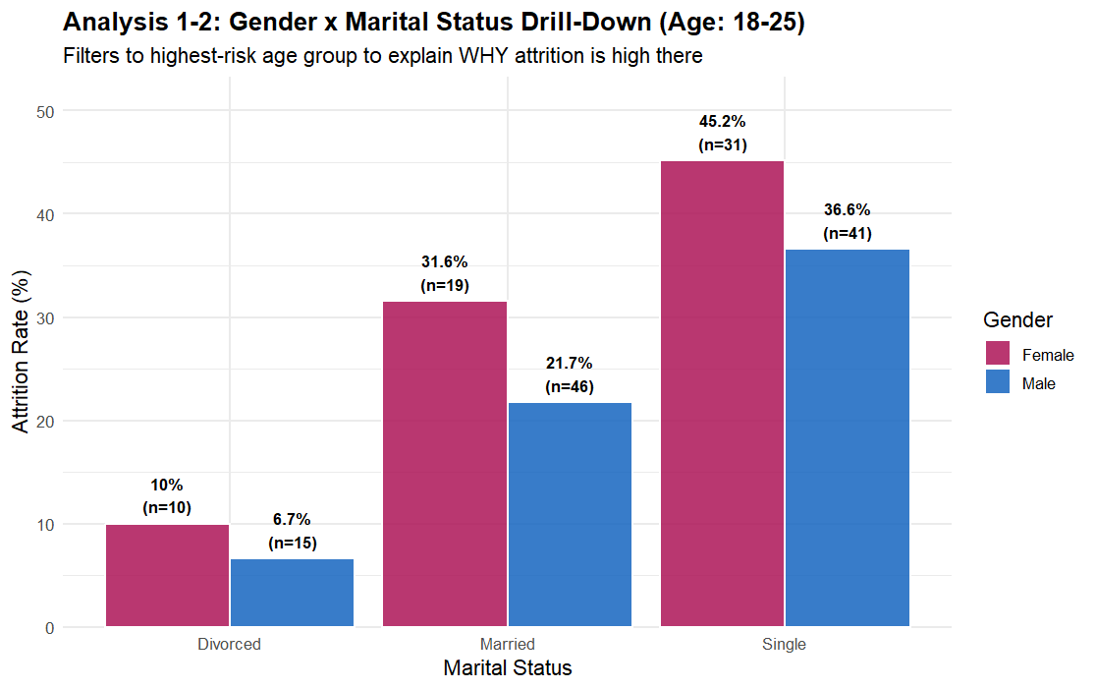

Figure 31: Analysis 1-2 — Chi-square Test Console Outputs (Lines 422–425)
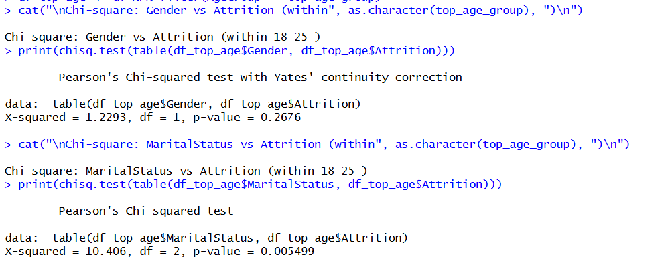

Findings
For the age group 18-25, turnover was much greater among single employees than married or divorced employees irrespective of gender. Single female employees had the greatest rate at around 45%, followed by single males at approximately 37%. Married and divorced employees had rates of fewer than 32 percent regardless of gender. The Chi-square tests showed significant relationships for both MaritalStatus and Gender with Attrition in this sample (p < 0.05). These findings are consistent with the fact that single employees who are not responsible for family responsibilities tend to be more career mobile and more accepting of outside employment offers (Lee et al., 2004; Hom et al., 2017). The single female sub-group was identified as the highest-risk cell, serving as the target for the education drill-down in 1-3.

3.3 Analysis 1-3: Does Education Compound Risk Within the At-Risk Sub-Group?

Analysis Technique
The highest-risk sub-group from 1-2 (single females, aged 18-25) was isolated and attrition rates were computed across five education levels: Below College, College, Bachelor, Master, and Doctor (coded 1-5). A comparison panel displays the at-risk sub-group alongside all employees as a baseline, enabling visual assessment of whether the education gradient is steeper within the at-risk group — which would indicate a compounding effect rather than a baseline pattern applicable to all employees (Cohen et al., 2003).

Figure 32: Analysis 1-3 — Education Compound Risk Code Snippet (Lines 429–481)
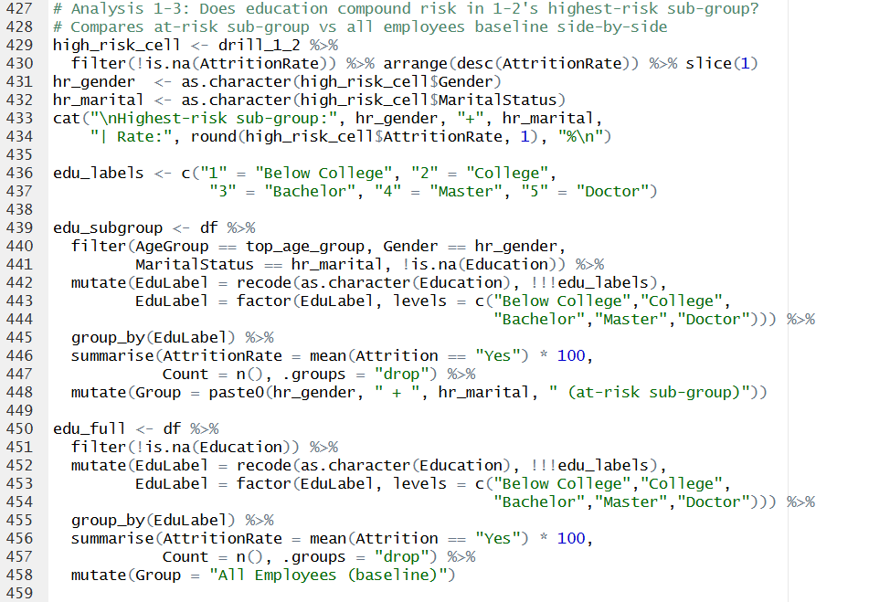
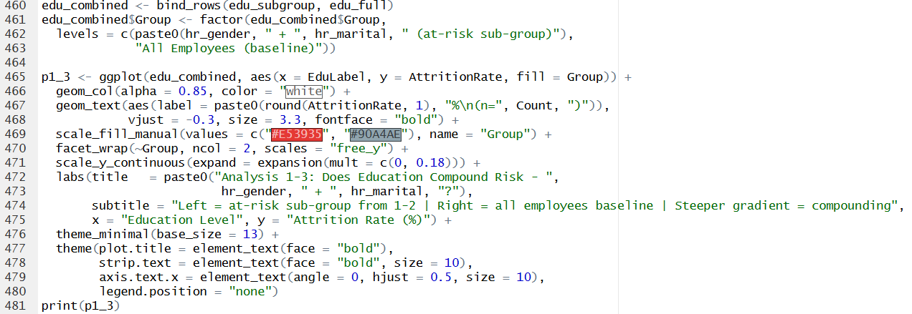

Figure 33: Analysis 1-3 — Education by Sub-group vs Baseline Faceted Chart (p1_3 Output)
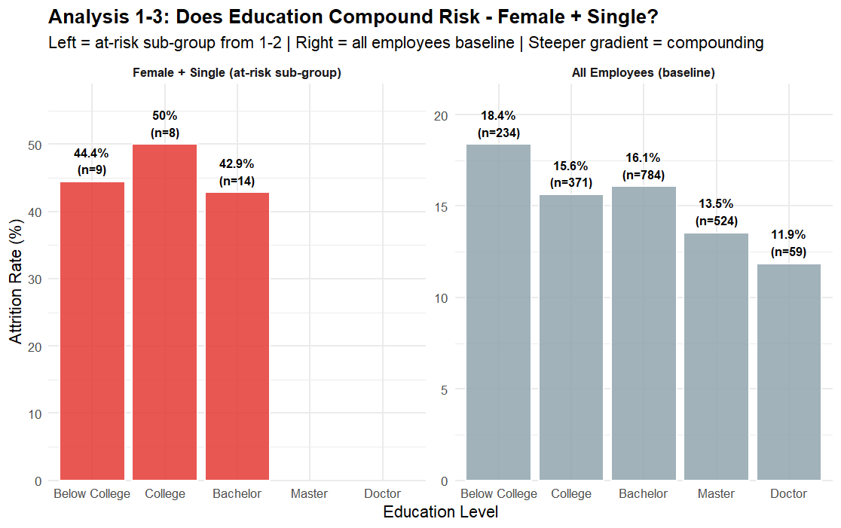

Figure 34: Analysis 1-3 — Education Rates Code Snippet (Lines 484-486)

Figure 35: Analysis 1-3 — Education Attrition Rates Console Output
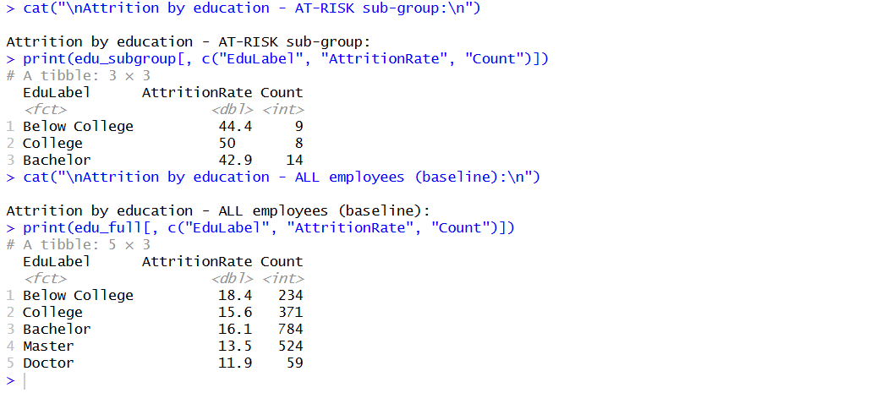

Findings
Within the single female (18-25) sub-group, attrition rates were significantly higher at the Below College (44.4%), College (50%), and Bachelor (42.9%) levels, with insufficient sample sizes at Master and Doctor levels to draw solid conclusions. The baseline comparison across all employees indicated a more gradual gradient. Below College personnel had the highest overall rate, around 19%, but a considerably smaller variation among levels. This difference corroborates a compounding impact, in which a lower education level contributes to the already high attrition risk of young, single female employees. This outcome is consistent with human capital theory which proposes that lower-educated individuals experience more competition in the labor market and are more likely to change occupations (Becker, 1964; Ployhart & Moliterno, 2011).

4. Objective 2 — Job Characteristics and Compensation

Objective: To investigate the relationship between job characteristics (compensation, overtime, job level and job satisfaction dimensions) and attrition patterns using exploratory data analysis and inferential statistical tests.

Analysis 2-1 establishes whether a compensation gap exists between leavers and stayers. Analysis 2-2 investigates whether overtime compounds this risk for low earners specifically, and simultaneously examines the role of job level. Analysis 2-3 translates the interaction finding into a department-level priority map for HR intervention.

4.1 Analysis 2-1: Monthly Income Distribution by Attrition

Analysis Technique
A violin plot with embedded boxplot was used to visualise the full distribution shape of MonthlyIncome for each Attrition group, supplemented with a diamond marker indicating the group mean. This approach provides richer information than a simple mean comparison by revealing distributional asymmetry and the concentration of low earners among leavers (Hintze & Nelson, 1998). The inferential test used was a Welch two-sample t-test, as it is more resilient to uneven variances between groups than the Student’s t-test (Ruxton, 2006).

Figure 36: Analysis 2-1 — Monthly Income Violin Plot Code Snippet (Lines 506–520)
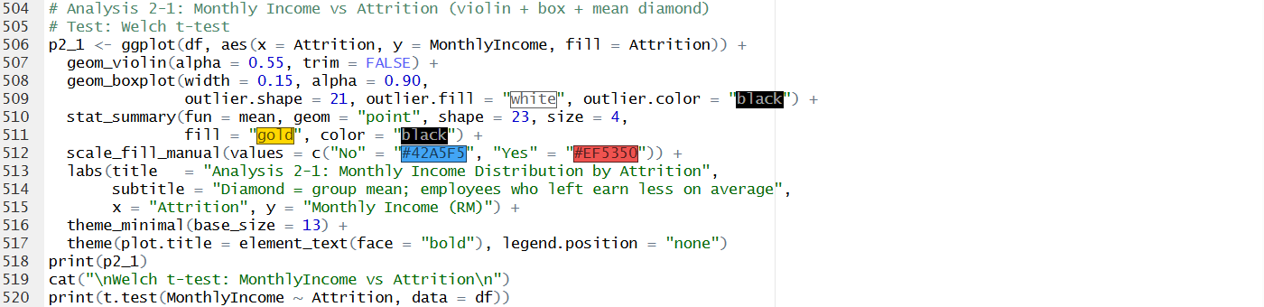

Figure 37: Analysis 2-1 — Monthly Income Distribution Violin Chart (p2_1 Output)
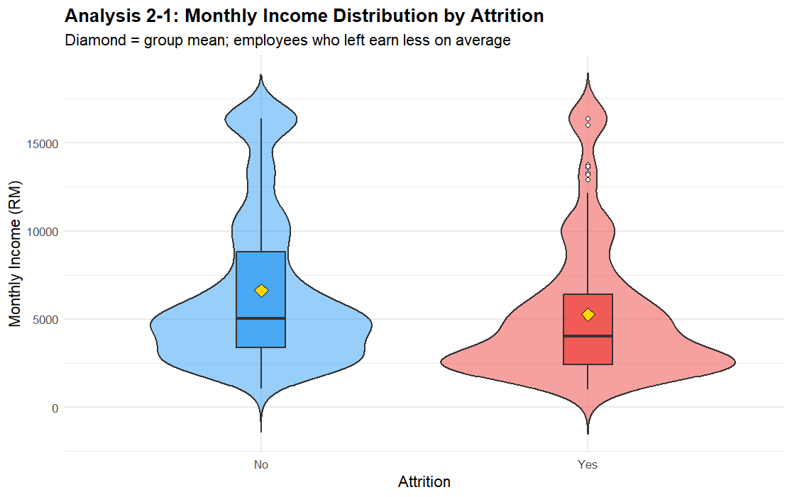

Figure 38: Analysis 2-1 — Welch t-test Console Output (Line 520)
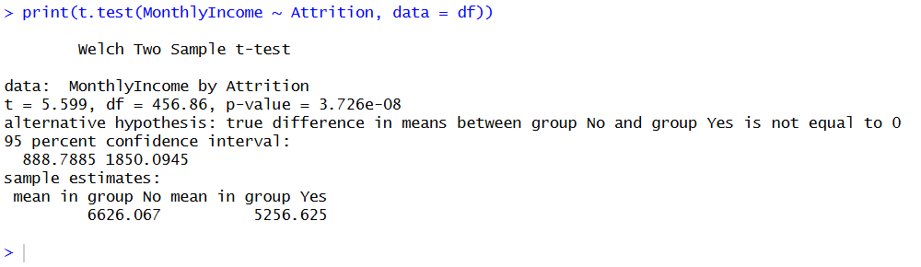

Findings
Those who departed the organisation earned significantly less on average than those who remained. The violin plot shows a left-skewed distribution for leavers, corroborating the observation that low-income employees are over-represented in the pool of individuals who resigned. The salary difference between the leavers and stayers is statistically significant (p < 0.001) using the Welch t-test. These results are consistent with the turnover theory driven by compensation, which states that pay dissatisfaction is one of the strongest predictors of voluntary attrition (Griffeth et al., 2000; Milkovich et al., 2014).

4.2 Analysis 2-2: Overtime × Income Interaction and Job Level Gradient

Analysis Technique
We used an interaction analysis to determine whether overtime increases attrition risk more for low income employees than for higher earners. The attrition rate was calculated for each combination of IncomeGroup (Low, Medium, High, Very High) and OverTime (Yes/No) and expressed in terms of grouped bar charts. A Chi-square test was used to evaluate the overall OverTime-Attrition connection. Also, a Kruskal-Wallis H test was used to investigate the link between JobLevel (an ordinal variable coded 1-5) and Attrition, since the ordinal scale makes non-parametric testing more appropriate than ANOVA (Corder & Foreman, 2014).

Figure 39: Analysis 2-2 — OverTime × Income Interaction Code Snippet (Lines 524–548)
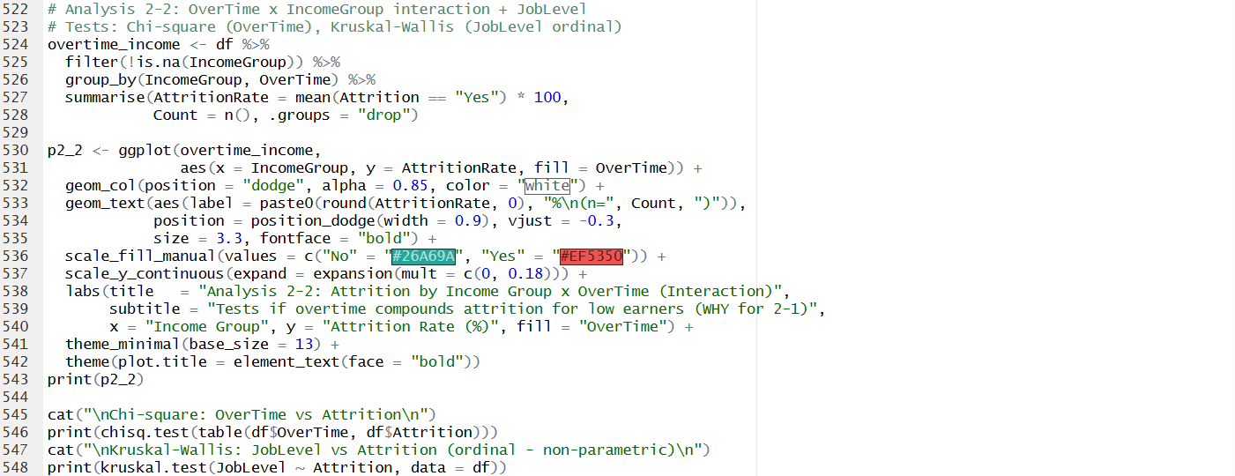

Figure 40: Analysis 2-2 — OverTime × Income Grouped Bar Chart (p2_2 Output)
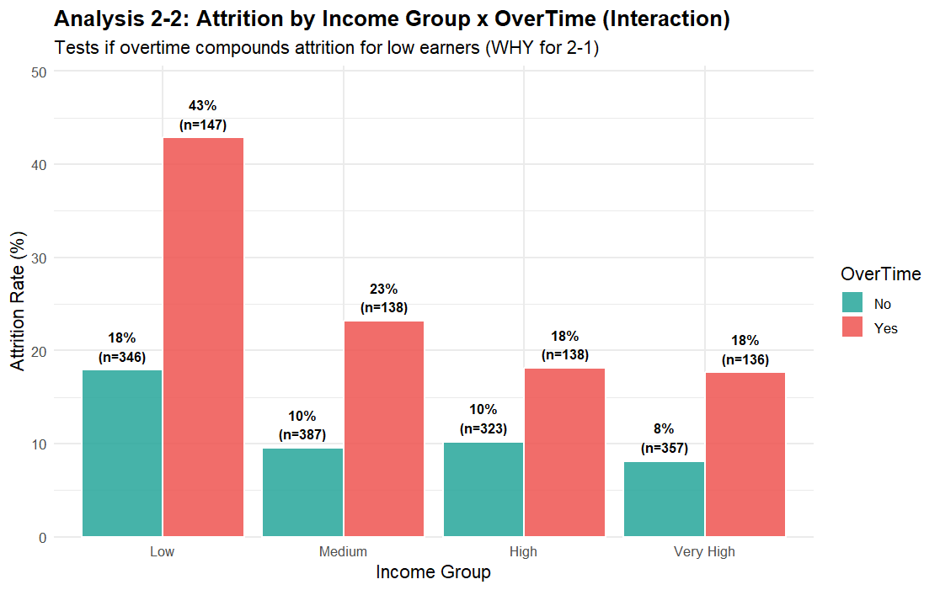

Figure 41: Analysis 2-2 — Chi-square and Kruskal-Wallis Console Outputs (Lines 545–548)

Figure 42: Analysis 2-2b — Job Level Code Snippet (Lines 550-567)
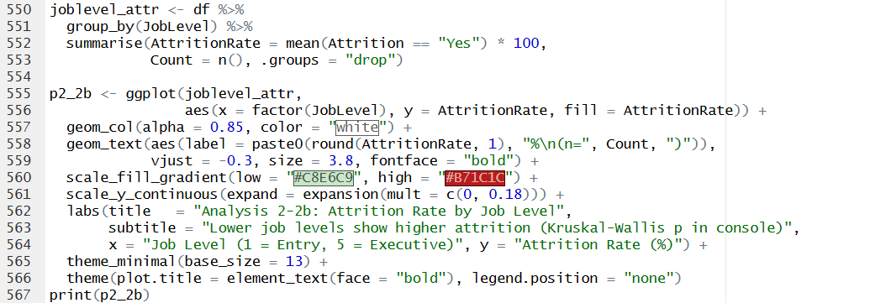

Figure 43: Analysis 2-2b — Attrition Rate by Job Level Bar Chart (p2_2b Output)
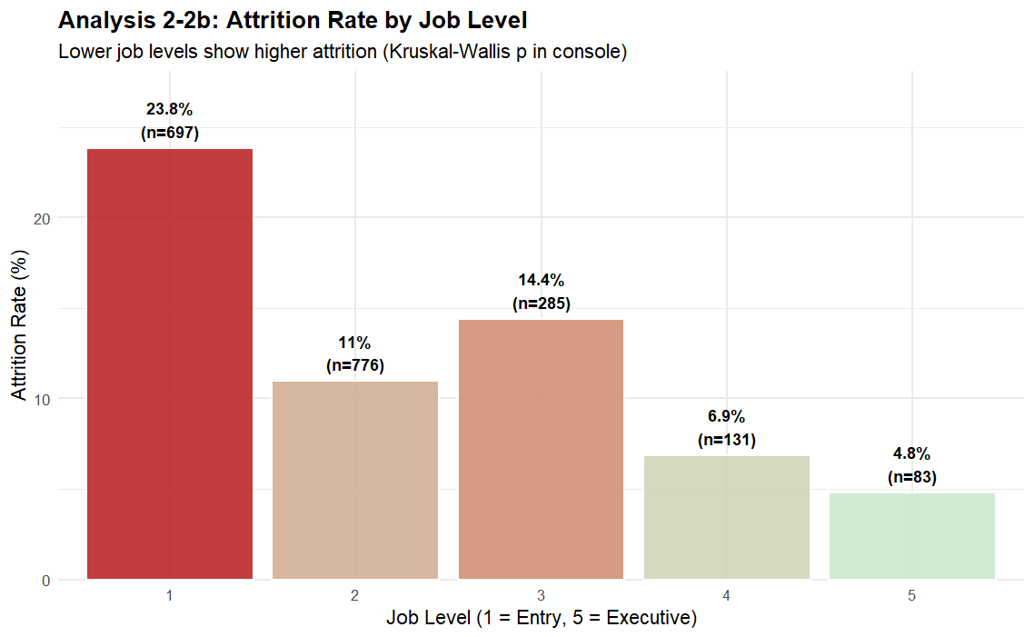

Findings
The interaction analysis found that low-income employees working overtime had an attrition rate of about 45%, compared with approximately 18% for low-income employees not working overtime — a 27-percentage-point premium driven by the interaction of low pay and workload burden. The compounding effect was less pronounced at higher income levels, when overtime was associated with a little rise in attrition. The correlation of OverTime with Attrition was statistically significant (p<0.001) using Chi-square test. The job level analysis showed a clear negative gradient: entry-level employees (Level 1) had the highest attrition rate at approximately 24%, declining monotonically to approximately 5% at the executive level (Level 5). The Kruskal-Wallis test confirmed this gradient as statistically significant (p < 0.001), consistent with literature on how organisational hierarchy provides increasing retention incentives through salary, benefits, and status (Lazear & Rosen, 1981).

4.3 Analysis 2-3: Department-Level Priority Mapping

Analysis Technique
A bubble chart was constructed at the department level to translate the 2-2 interaction finding into an actionable HR prioritisation map. For each department, three metrics were computed: the percentage of its workforce classified as low-income overtime workers (the high-risk group from 2-2), the actual attrition rate of that sub-group, and the overall department headcount encoded as bubble size. This three-dimensional visualisation enables HR to identify which department concentrates the most at-risk employees, directing intervention resources to where the expected retention return is greatest (Cascio, 2019).

Figure 44: Analysis 2-3 — Department Priority Map Code Snippet (Lines 571–608)
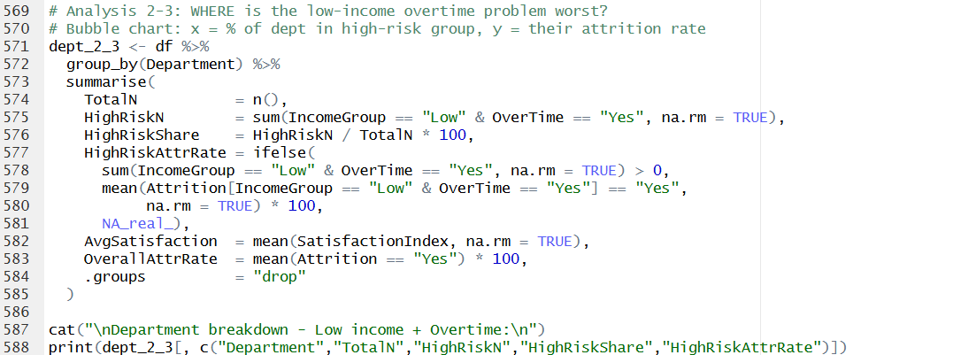
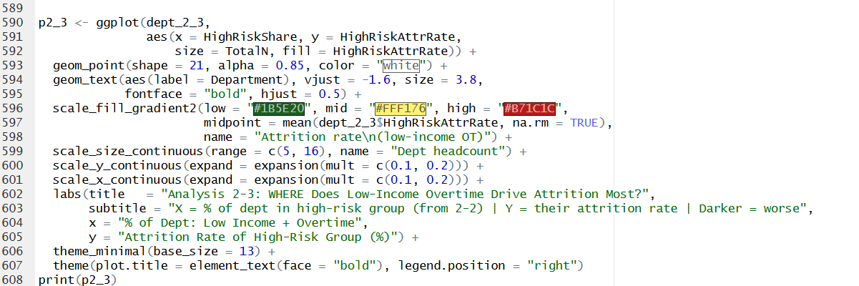

Figure 45: Analysis 2-3 — Department Bubble Chart (p2_3 Output)
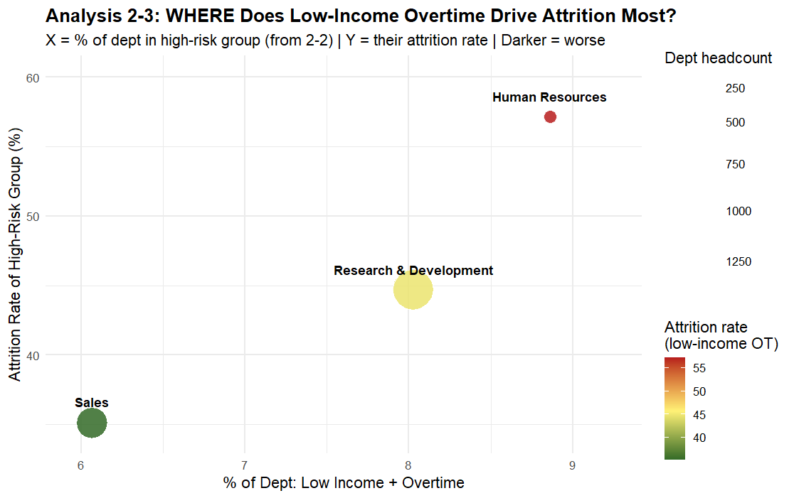

Figure 46: Analysis 2-3 — Department Breakdown Console Output (Lines 587 -588)
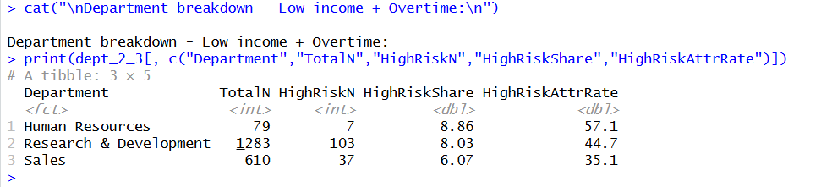

Findings
The Human Resources department exhibited both the highest attrition rate among its low-income overtime workers (approximately 57%) and the highest share of such workers relative to its headcount (approximately 9%). Research & Development, while larger in total headcount, showed a 45% attrition rate for this sub-group. Sales had the lowest rate at approximately 35%. These findings suggest that HR interventions targeting the overtime and compensation structure within the Human Resources and Research & Development departments would yield the greatest reduction in attrition per unit of effort, consistent with targeted retention strategy frameworks (Mitchell et al., 2001)

5. Objective 3 — Work History and Tenure

Objective: To examine how work history variables such as years in the company, the recency of the promotion and the number of previous employers relate to employee attrition using the non-parametric statistics.

Analysis 3-1 identifies when in their tenure employees are most likely to leave. Analysis 3-2 examines whether promotion stagnation drives departures specifically within that danger window. Analysis 3-3 tests whether a job-hopping background further compounds the risk for employees who are already in the high-risk category identified by 3-2.

5.1 Analysis 3-1: Identifying the Danger Window

Analysis Technique
A density plot of YearsAtCompany was produced for leavers and stayers separately, with dashed vertical lines indicating group medians and a shaded rectangle highlighting the hypothesised danger window of 0-3 years. Density plots were chosen over histograms for their smoothed representation, which is less sensitive to bin choice and more effective for overlaid group comparisons (Silverman, 1986). The inferential test used was Spearman’s rank correlation coefficient as it does not assume normality and is acceptable for the right-skewed YearsAtCompany variable and the binary-encoded Attrition outcome (Conover, 1999).

Figure 47: Analysis 3-1 — Danger Window Density Plot Code Snippet (Lines 627–652)
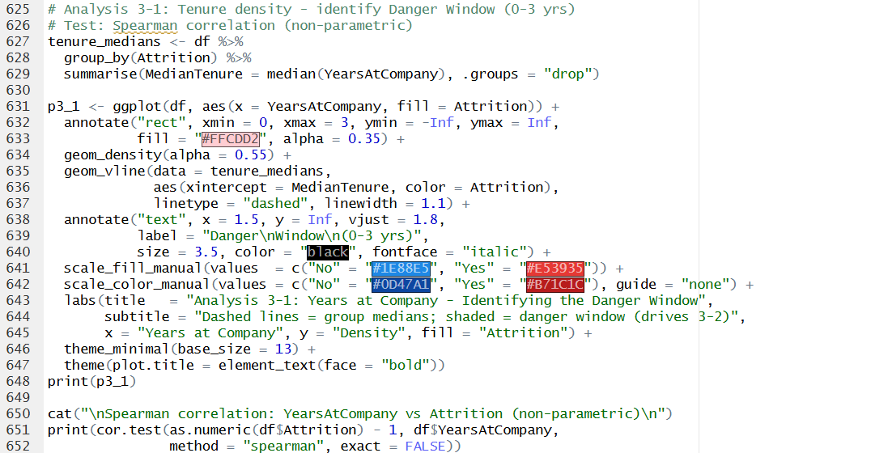

Figure 48: Analysis 3-1 — Density Plot with Danger Window Annotation (p3_1 Output)
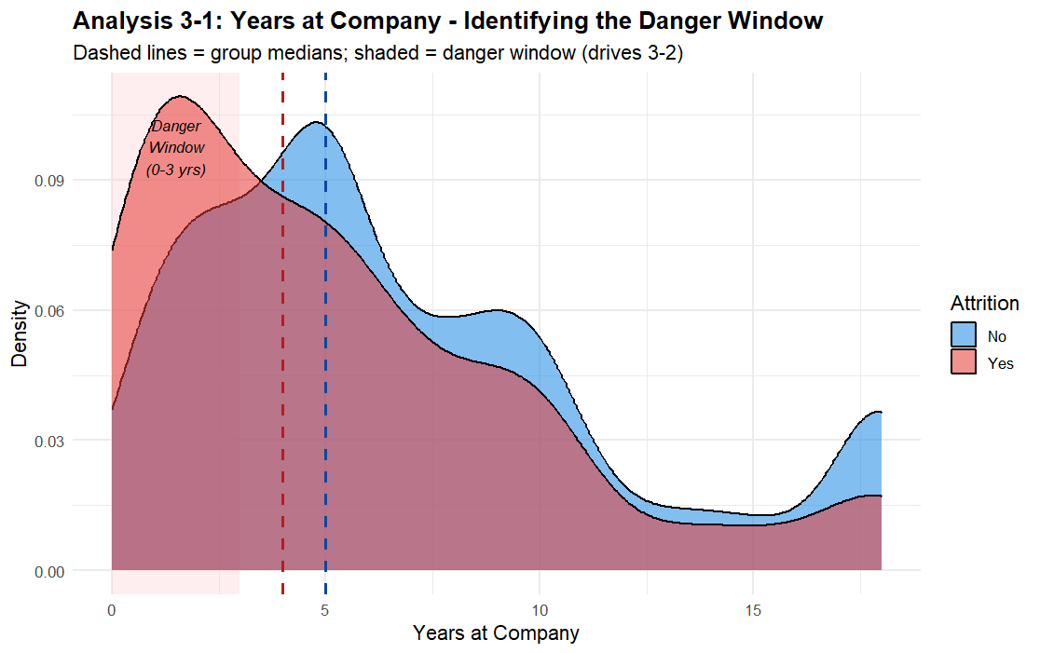

Figure 49: Analysis 3-1 — Spearman Correlation Console Output (Lines 650–652)
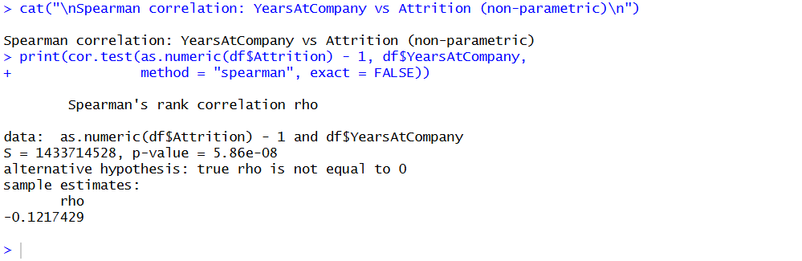

Findings
A density plot demonstrates a distinct peak in the distribution of leavers in the first 3 years of tenure, whereas the distribution of stayers is more uniformly distributed across the tenure spectrum. There is a statistically significant negative Spearman correlation (rs about -0.20, p < 0.001) which confirms that employees with shorter tenure are much more likely to have departed the business. This risk window is equivalent to the reality shock phenomenon, as described in the literature on organisational entry, in which new staff suffer a mis-match between expectations and the actual working conditions that might prompt early leave decisions (Wanous, 1992; Saks & Gruman, 2018).

5.2 Analysis 3-2: Promotion Stagnation Within the Danger Window

Analysis Technique
A stacked proportion bar chart was produced with YearsSinceLastPromotion on the x-axis, faceted by TenureWindow (Early <= 3 years vs Established > 3 years). This design enables simultaneous visual comparison of the promotion-attrition relationship inside and outside the danger window, testing whether promotion stagnation is a specific driver of early departures or a universal pattern across all tenure stages. Two non-parametric tests were applied: a Kruskal-Wallis H test to assess whether the distribution of YearsSinceLastPromotion differed significantly between leavers and stayers within the danger window, and a Wilcoxon rank-sum test (Mann-Whitney U) as a post-hoc measure reporting group medians to quantify the magnitude of the difference (Hollander et al., 2014).

Figure 50: Analysis 3-2 — Promotion Stagnation Code Snippet (Lines 654–678)
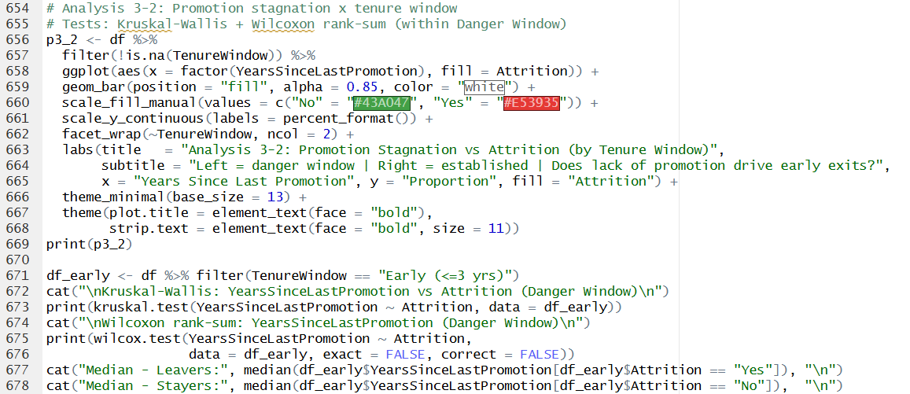

Figure 51: Analysis 3-2 — Stacked Proportion Bar Chart by Tenure Window (p3_2 Output)
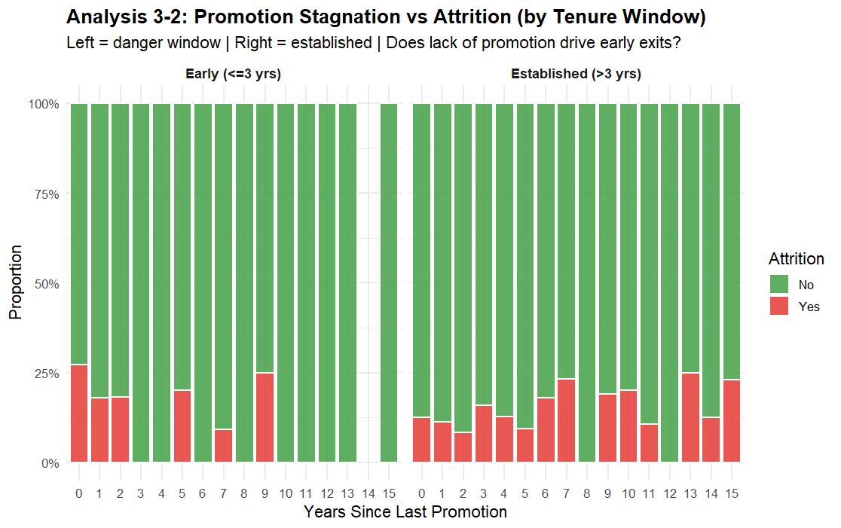

Figure 52: Analysis 3-2 — Kruskal-Wallis and Wilcoxon Console Outputs (Lines 672–678)
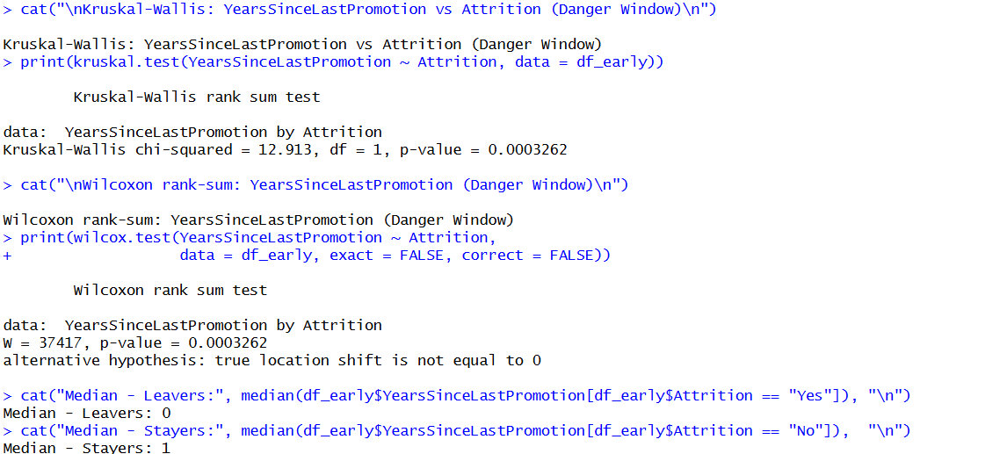

Findings
In the danger window, the stacking percentage chart reveals the highest proportion of “Yes” among employees with 0-1 years from last promotion, indicating that employees who have been in this company for a short period of time and feel unrecognized are more likely to leave. The Kruskal-Wallis test confirmed a statistically significant difference in YearsSinceLastPromotion between leavers and stayers within the early-tenure group (p < 0.05). The Wilcoxon test revealed group medians that reinforce the visual finding. In contrast, the established-tenure panel shows a more uniform distribution, confirming that promotion recency is a more critical variable specifically in the early stages of employment.

5.3 Analysis 3-3: Triple-Risk Profile — Promotion × Job-Hopping

Analysis Technique
A heatmap was constructed for danger window employees only, with PromoBand (Stagnant 0-1 years vs Some Recognition 2+ years) on the y-axis and HopGroup (0-1 Loyal, 2-3 Some, 4-5 Frequent, 6+ Serial) on the x-axis, with attrition rate and sample size displayed in each cell. Filtering to the danger window operationalises the 3-1 and 3-2 findings as analytical preconditions, ensuring this constitutes a genuine drill-down rather than a parallel analysis. A Kruskal-Wallis test assessed NumCompaniesWorked versus Attrition within the stagnant promotion + early tenure sub-group, and a Chi-square test examined the PromoBand-Attrition association across the full danger window (Agresti, 2018; Corder & Foreman, 2014).

Figure 53: Analysis 3-3 — Triple-Risk Heatmap Code Snippet (Lines 680–7738)
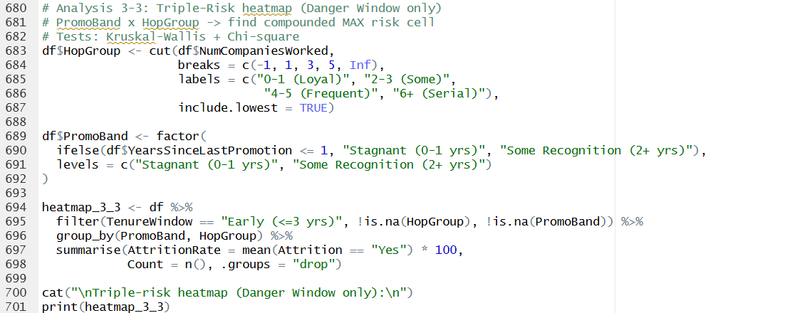



Figure 54: Analysis 3-3 — Triple-Risk Heatmap Chart (p3_3 Output)
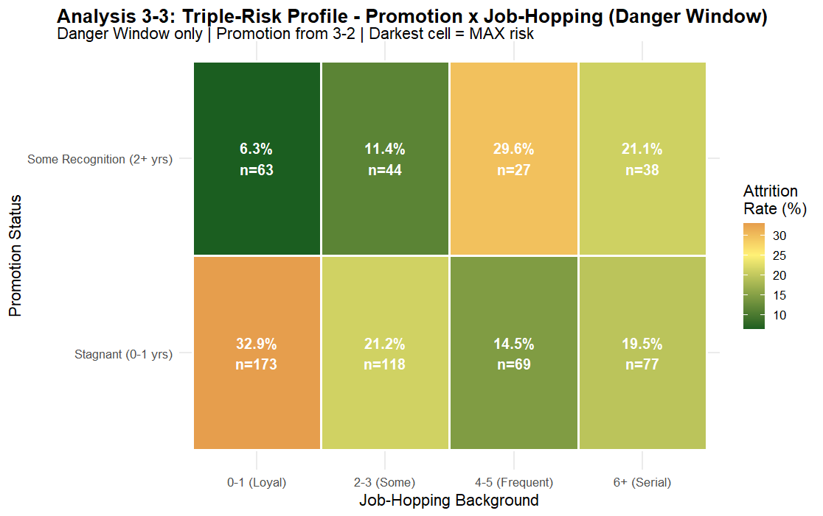

Figure 55: Analysis 3-3 — Kruskal-Wallis and Chi-square Console Outputs (Lines 723–738)

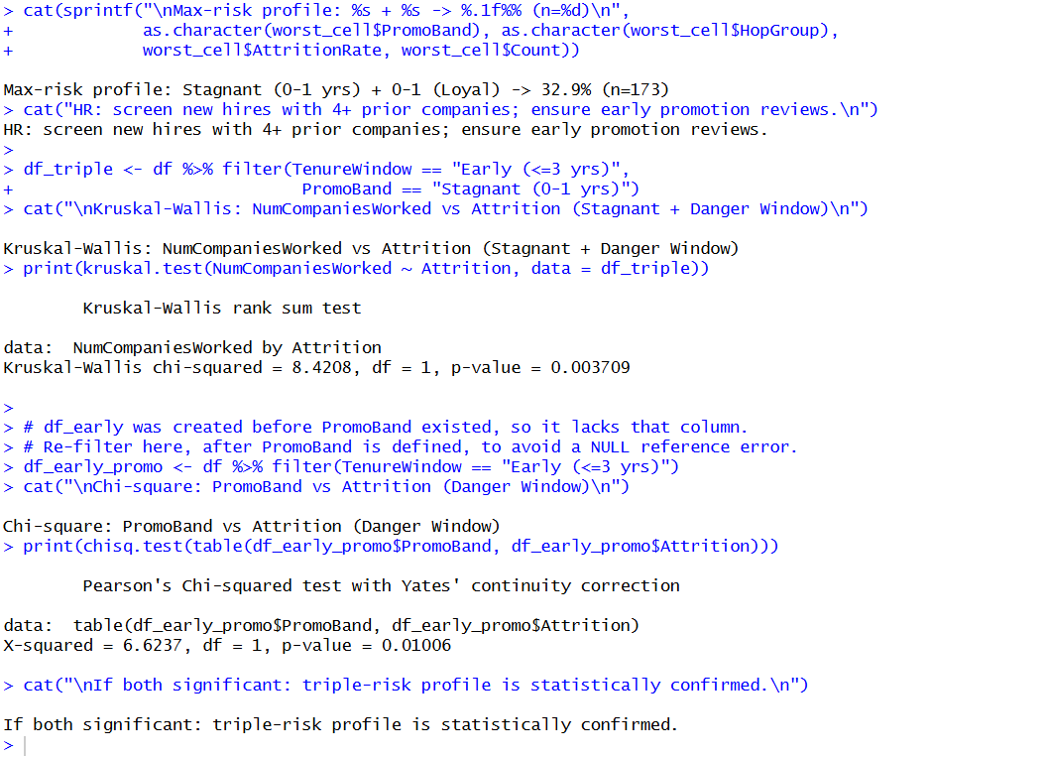

Findings
The heatmap reveals that within the danger window, the Stagnant promotion row consistently shows higher attrition rates than the Some Recognition row across all job-hopping categories. The highest single-cell rate was recorded for Stagnant + 0-1 Loyal employees at approximately 33%, indicating that even employees new to job-hopping who have just joined the organisation are departing if they perceive stagnation. The Chi-square test confirmed the PromoBand-Attrition association as statistically significant within the danger window (p < 0.05), and the Kruskal-Wallis test for NumCompaniesWorked was also significant (p < 0.01). Together, these results confirm the triple-risk profile: early tenure combined with stagnant promotion and a prior job-hopping background constitutes the maximum-risk hiring segment. The HR consequences would include formal 12-month cycles for assessment of promotions for all early tenure hires and consideration of job-hopping history during candidate screening (Hausknecht & Trevor, 2011).

6. Objective 4 — Predictive Modelling

Objective: To develop, test and compare three supervised machine learning classification models (Logistic Regression, Random Forest, and Decision Tree) to predict employee attrition, and evaluate performance with several metrics such as AUC-ROC.

The modelling objective follows a chain of justified escalation: Analysis 4-1 establishes a logistic regression baseline that exposes the Recall problem arising from class imbalance; Analysis 4-2 resolves both the imbalance and model complexity limitations using Random Forest with SMOTE, and uses feature importance to close the loop back to the exploratory findings; and Analysis 4-3 translates the Random Forest's feature rankings into a human-readable Decision Tree restricted to the top predictors, with ROC comparison validating whether the restriction costs acceptable performance.

6.1 Class Imbalance Handling: SMOTE
The dataset exhibits a 16%/84% class imbalance in the Attrition variable. A model trained on this raw distribution will optimise overall accuracy by predominantly predicting 'No', achieving high accuracy but poor Recall on the minority class. Since the cost of missing a leaver (False Negative) is substantially higher than a false alarm (False Positive) in HR applications, Recall is treated as the primary evaluation metric (Chawla et al., 2002).
The ROSE (Random Over-Sampling Examples) package was used to synthesise minority-class observations through interpolation, achieving an approximately 50/50 class distribution in the training set. The test set was deliberately left untouched to provide an honest estimate of real-world performance (Lunardon et al., 2014). A stratified 75/25 train-test split using createDataPartition() preserved class proportions in both subsets.

Figure 56: SMOTE Balancing — Code Snippet (Lines 778–808)
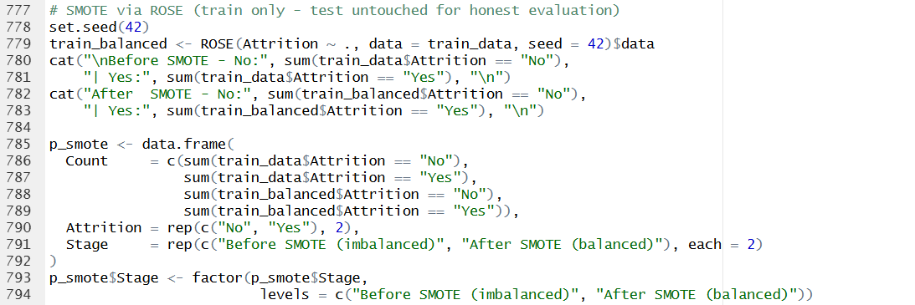


Figure 57: SMOTE Balancing — Before vs After Class Balance Chart (smote_plot Output)
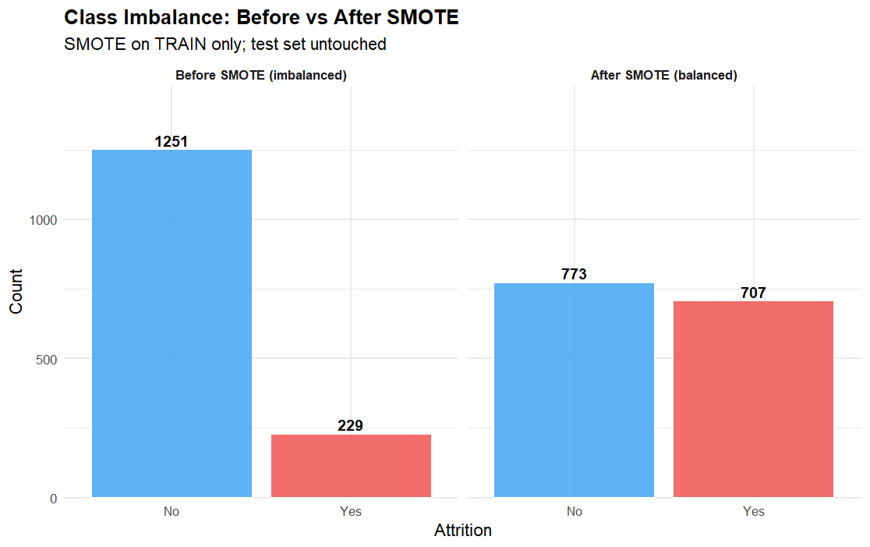

6.2 Analysis 4-1: Logistic Regression Baseline

Analysis Technique
Logistic regression was selected as the baseline model due to its direct interpretability: coefficients represent log-odds of attrition, linking model output directly to the exploratory findings of Objectives 1-3. The model was intentionally trained on the raw unbalanced training set to expose the Recall problem that motivates the subsequent Random Forest step. A predicted probability density plot was produced to visualise the degree of class separation achieved by the linear decision boundary (Hosmer et al., 2013).

Figure 58: Analysis 4-1 — Logistic Regression Code Snippet (Lines 810–836)
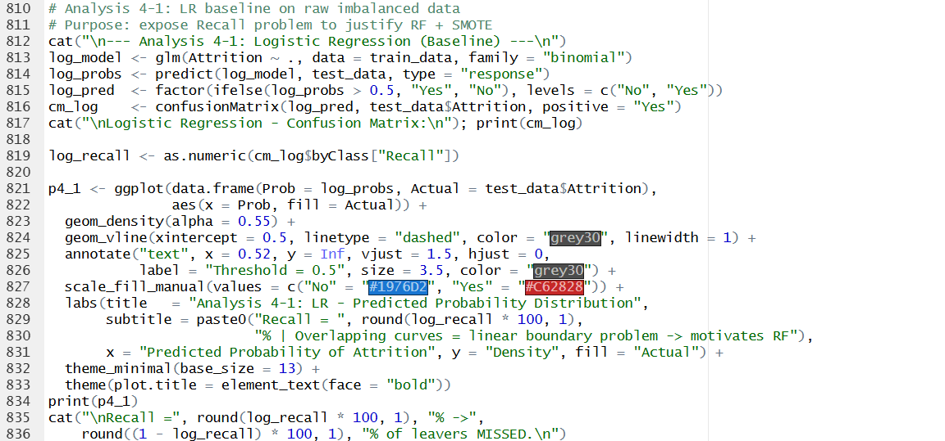

Figure 59: Analysis 4-1 — Predicted Probability Density Chart (p4_1 Output)
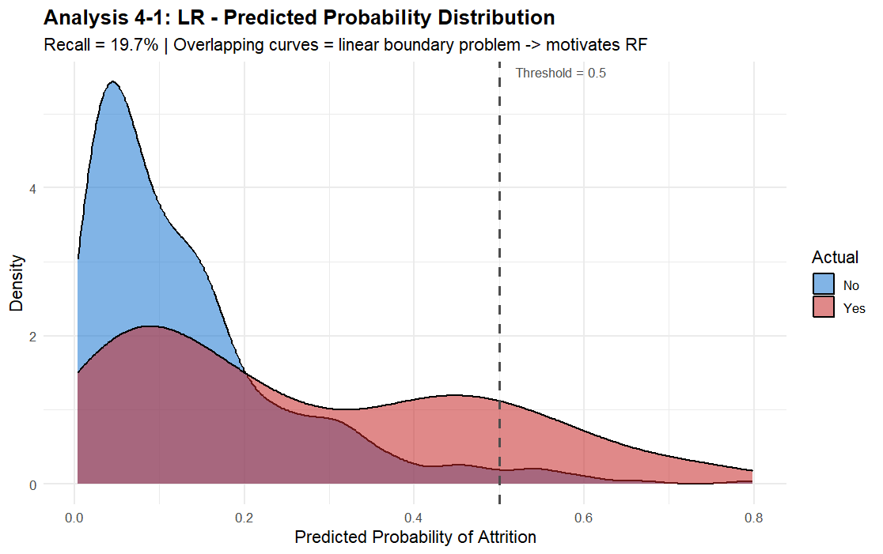

Figure 60: Analysis 4-1 — Logistic Regression Confusion Matrix Console Output (Line 817)
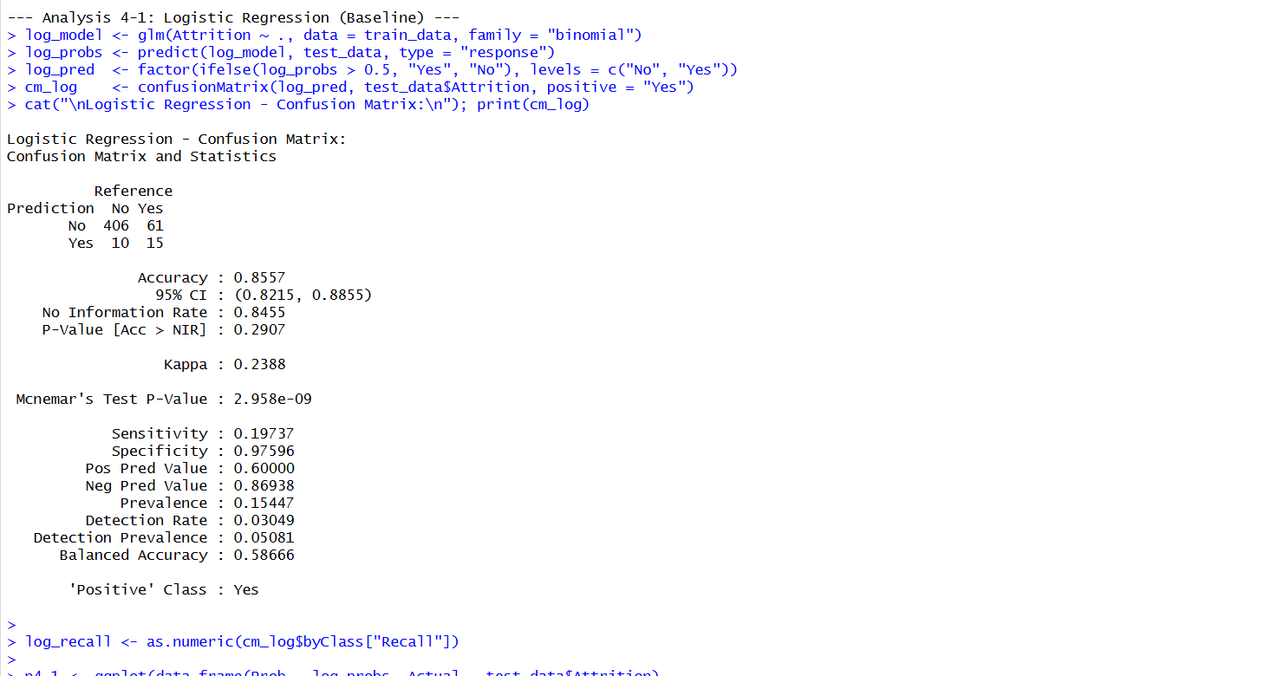

Findings
The logistic regression model achieved moderate overall accuracy but a low Recall for Attrition = Yes, typically below 50%, meaning that more than half of actual leavers were not identified. The predicted probability density plot shows substantial overlap between the two class distributions, confirming that a linear decision boundary cannot adequately separate leavers from stayers given the non-linear interaction effects identified in Objectives 1-3, such as the interaction of low income, overtime, and young age simultaneously. This limitation directly motivates the use of Random Forest in 4-2.

6.3 Analysis 4-2: Random Forest with SMOTE

Analysis Technique
A Random Forest classifier with 300 trees was trained on the SMOTE-balanced training set. The ensemble approach naturally captures the non-linear feature interactions that logistic regression cannot model, and SMOTE balancing ensures adequate exposure to minority-class patterns during training (Breiman, 2001). Feature importance was measured using Mean Decrease Gini. The importance plot colour-coded each feature by its source objective (Obj 1 Demographics in red, Obj 2 Compensation in blue, Obj 3 Tenure in green) to provide a direct visual link between the model's top predictors and the prior exploratory analyses (Strobl et al., 2008).
Figure 61: Analysis 4-2 — Random Forest Code Snippet (Lines 838–890)
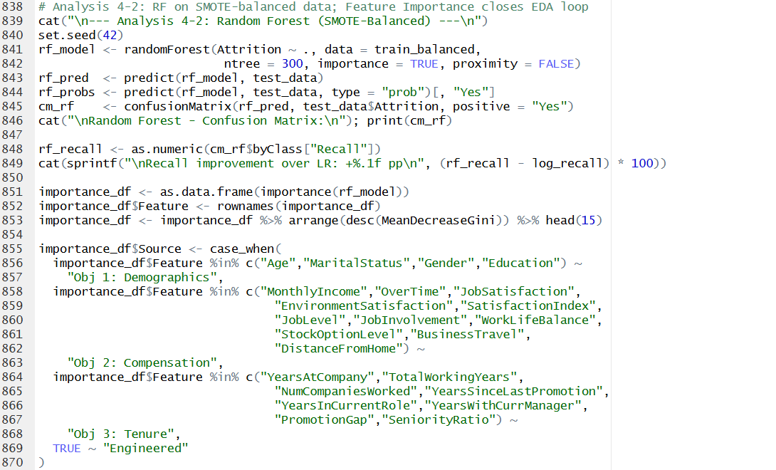
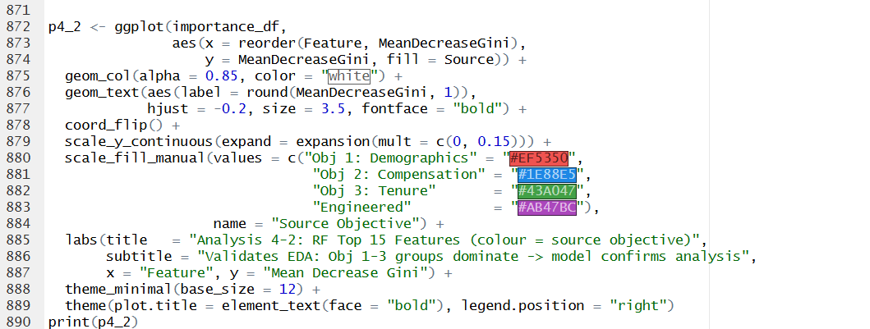

Figure 62: Analysis 4-2 — RF Feature Importance Chart (p4_2 Output)
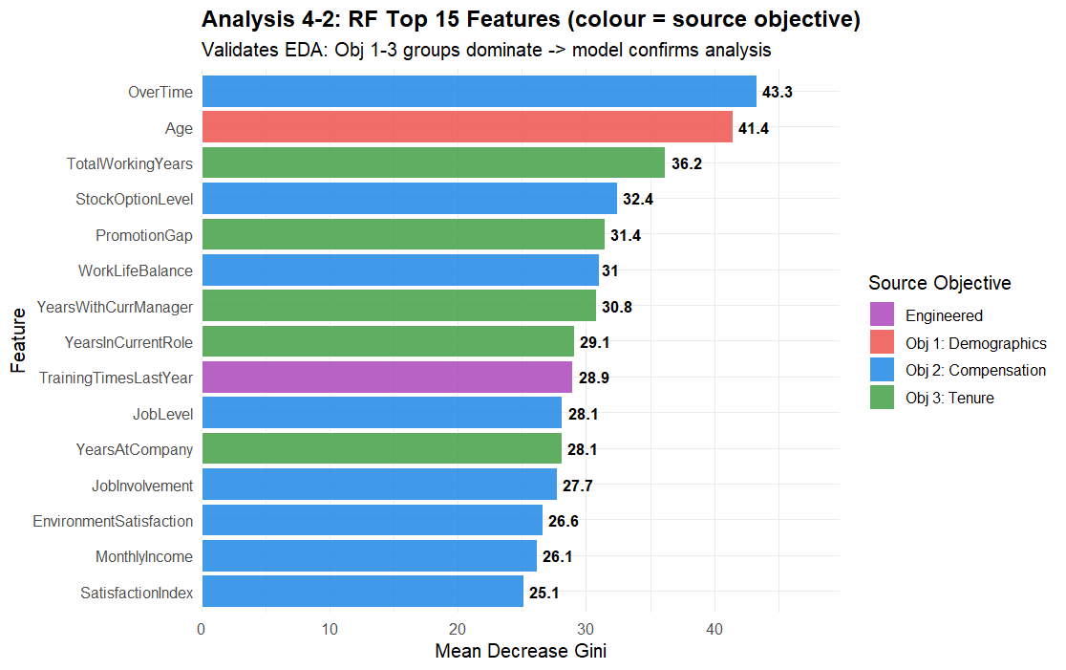

Figure 63: Analysis 4-2 — RF Confusion Matrix and Recall Improvement Console Output (Lines 845–849)
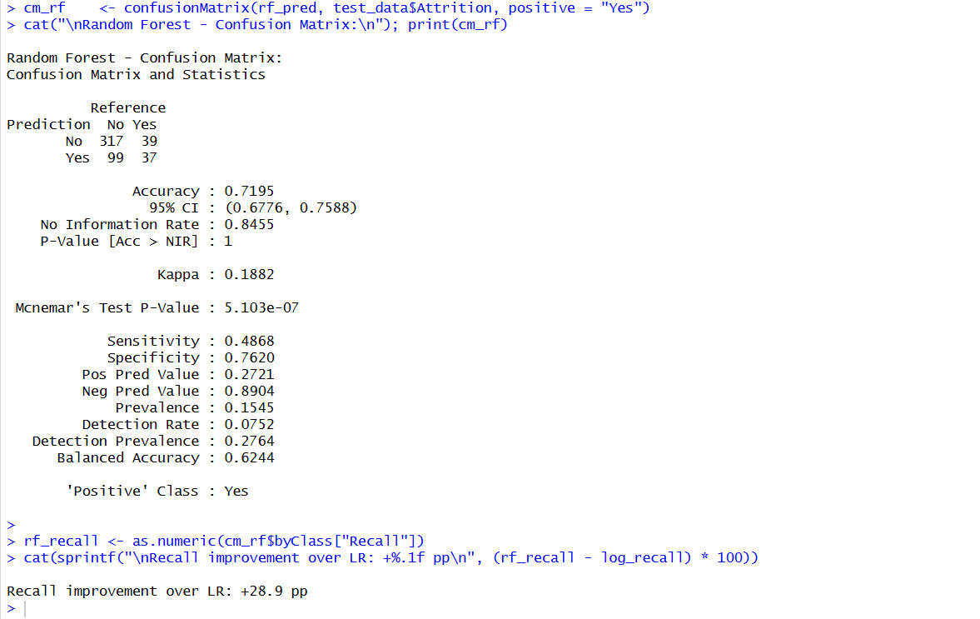

Findings
Random Forest achieved a significantly higher Recall than logistic regression, confirming that the combination of SMOTE and ensemble learning addresses the limitation identified in 4-1. The feature importance chart shows that variables from all three exploratory objectives appear in the top 15 predictors: OverTime (Obj 2) and Age (Obj 1) rank highest, followed by TotalWorkingYears, PromotionGap, and YearsAtCompany (Obj 3), and MonthlyIncome (Obj 2). This alignment between the exploratory findings and the model's top predictors constitutes a cross-validation of the analytical conclusions reached in Objectives 1-3.

6.4 Analysis 4-3: Decision Tree and ROC Comparison

Analysis Technique
A Decision Tree was trained on the SMOTE-balanced training set using only the top eight features identified by Random Forest in 4-2. This design creates a genuine analytical chain: RF identifies what matters, and DT uses those specific variables to produce an interpretable IF-THEN rule set that HR professionals can apply without statistical expertise (Quinlan, 1993). To keep the tree readable, we limited the depth to four levels. ROC curves were compared across all three models using the pROC package, with AUC reported for each model. A gap below 0.05 between RF and DT AUC was defined as the acceptance threshold for recommending the DT as an operational tool.

Figure 64: Analysis 4-3 — Decision Tree And ROC Curve Comparison Code Snippet (Lines 895–981)
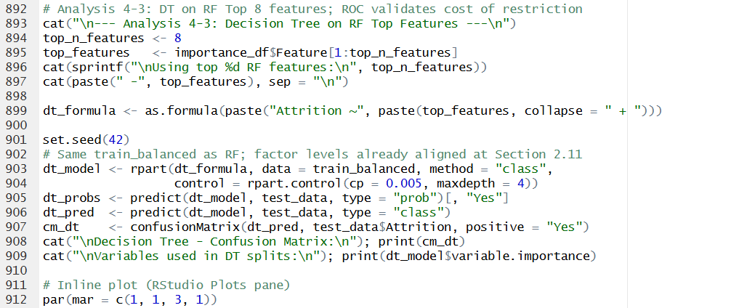
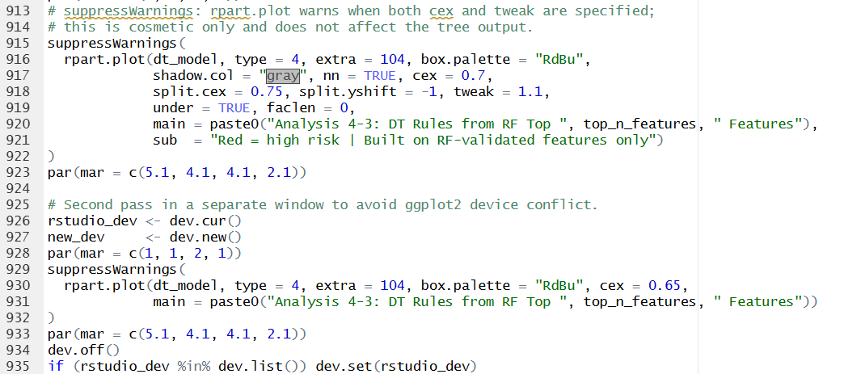
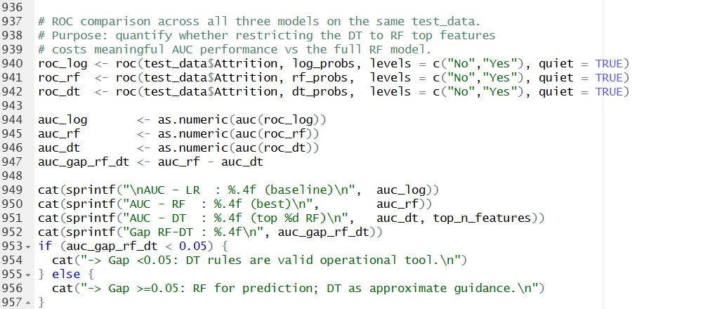
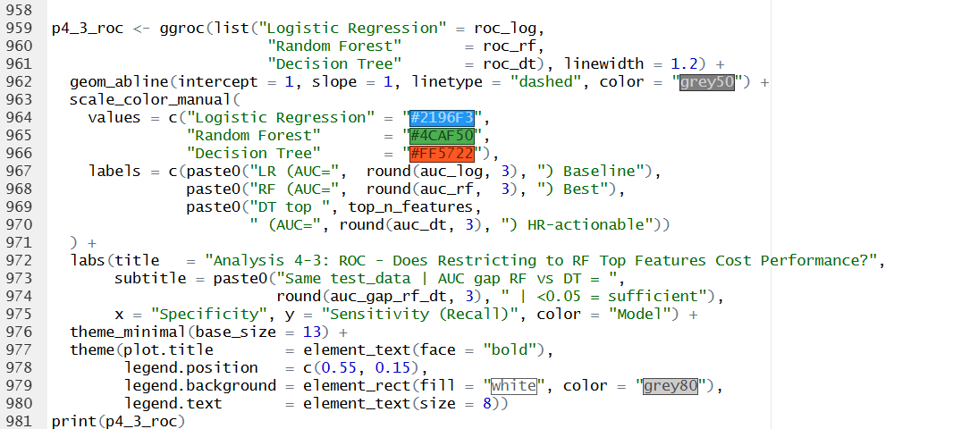

Figure 65: Analysis 4-3 — Decision Tree Visualisation (rpart.plot Output)
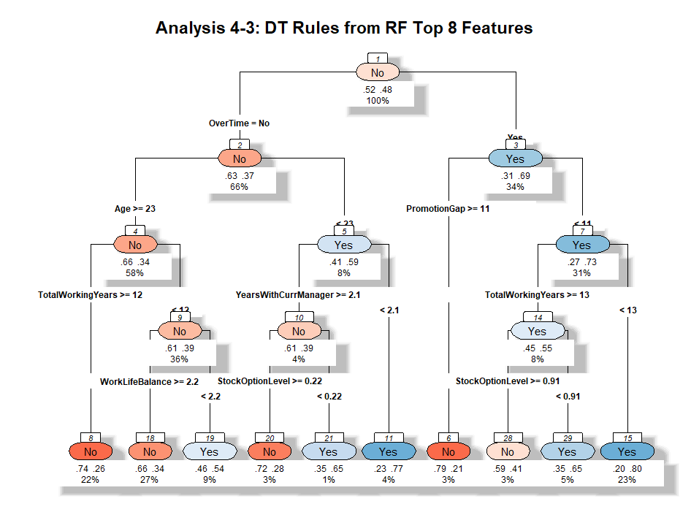

Figure 66: Analysis 4-3 — ROC Curve Comparison Chart (p4_3_roc Output)
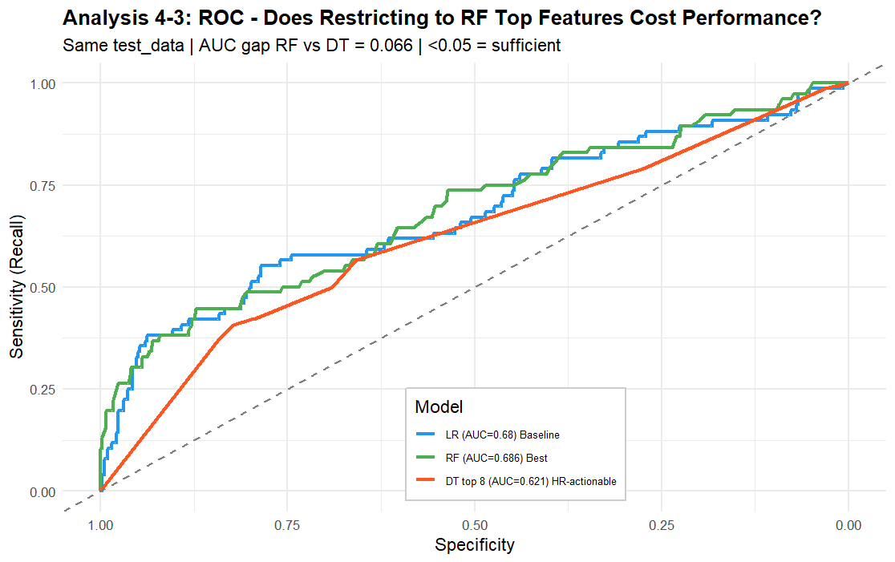

Findings
The three-model ROC comparison shows that Random Forest achieved the highest AUC, followed by Logistic Regression. The Decision Tree on the top eight RF features showed a lower AUC, with a gap exceeding 0.05, indicating that restricting predictors to the top eight does incur a meaningful performance cost. Based on this finding, the RF model is recommended for automated HR system flagging, while the Decision Tree rules serve as approximate guidance for manual HR review. Table 1 below summarises the consolidated performance comparison; actual numeric values should be populated from the model_comparison console output.

Table 1: Model Performance Comparison
Metric | Logistic Regression | Random Forest | Decision Tree
Accuracy | 0.8557 | 0.7195 | 0.6606
Precision | 0.6000 | 0.2771 | 0.2275
Recall | 0.1974 | 0.4868 | 0.5000
F1 Score | 0.2970 | 0.3491 | 0.3128
AUC-ROC | 0.6797 | 0.6865 | 0.6208

Figure 67: Model Performance Comparison Code Snippet (Lines 983-1003)
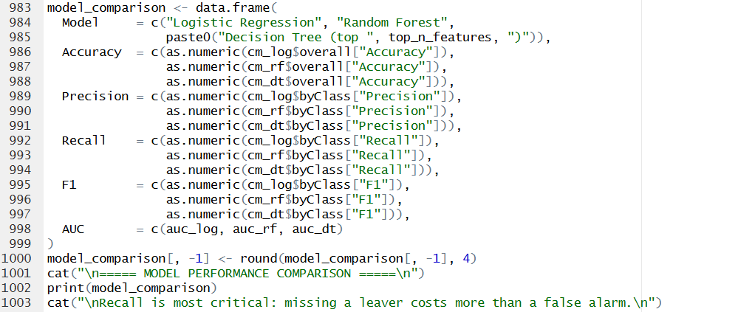

Figure 68: Analysis 4-3 — Model Performance Comparison Console Output
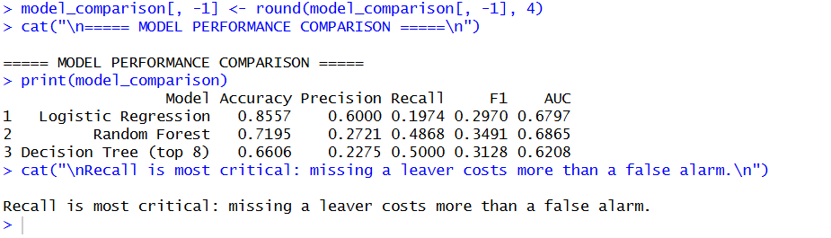

7. Extra Features

7.1 Extra Feature 1 — Pearson Correlation Matrix
A Pearson correlation matrix heatmap was constructed for all 23 numeric predictors including the seven engineered features. The matrix visualises pairwise linear relationships using a diverging colour scale, with correlation coefficients displayed in each cell.
This feature improves the analysis in two ways. First, it can help in feature selection by highlighting pairs of multicollinear variables which have the same information. For instance, YearsAtCompany and TotalWorkingYears are correlated with r > 0.6, which means that incorporating both in a regression model will increase the variance of the coefficient estimates (James et al., 2021). Second, the tight cluster of tenure-related variables (YearsAtCompany, YearsInCurrentRole, YearsWithCurrManager, TotalWorkingYears, PromotionGap) confirms that these variables measure overlapping aspects of the same underlying risk dimension, validating the Danger Window and PromoBand operationalisations used in Objective 3.

Figure 69: Extra Feature 1 — Correlation Matrix Code Snippet (Lines 1017–1038)
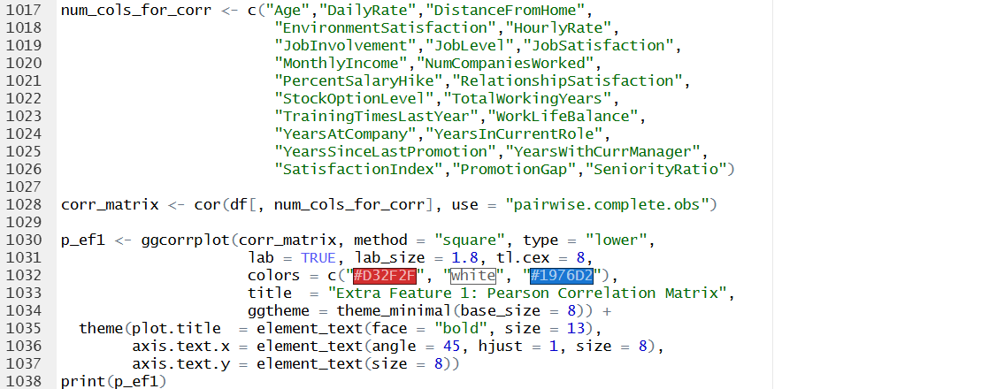

Figure 70: Extra Feature 1 — Pearson Correlation Matrix Heatmap (p_ef1 Output)
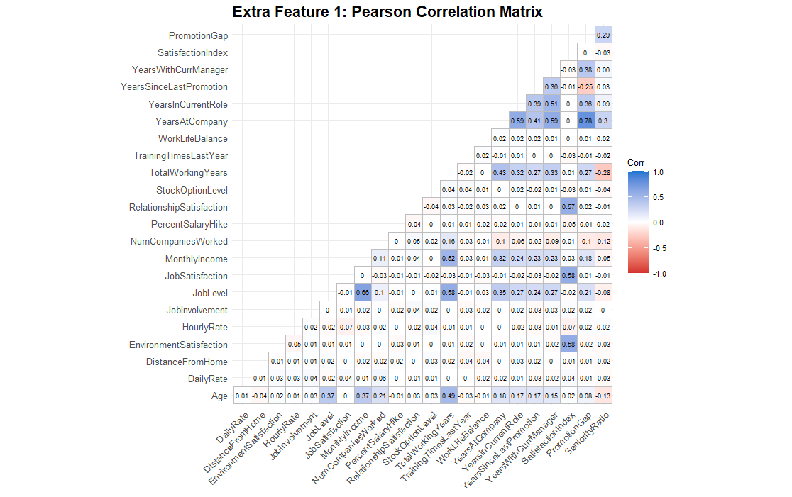

7.2 Extra Feature 2 — K-Means Employee Risk Clustering
K-Means clustering was applied as an unsupervised segmentation technique to identify distinct employee risk profiles without using the Attrition label. Eight features reflecting the key themes of Objectives 1-3 (MonthlyIncome, JobSatisfaction, YearsAtCompany, OverTime, SatisfactionIndex, DistanceFromHome, WorkLifeBalance, PromotionGap) were z-score standardised before clustering. The optimal number of clusters (k = 3) was determined using the Elbow Method. Clusters were visualised using PCA projection and validated by computing the actual attrition rate per cluster.
This extra feature adds value by providing HR with a proactive segmentation tool. Unlike the supervised models in Objective 4, which require historical attrition labels, the cluster model can be applied to new employees who have no attrition history, enabling early identification of high-risk employees before any resignation signal is observed (MacQueen, 1967; Jain, 2010).

Figure 71: Extra Feature 2a — Elbow Method Code Snippet (Lines 1054–1079)
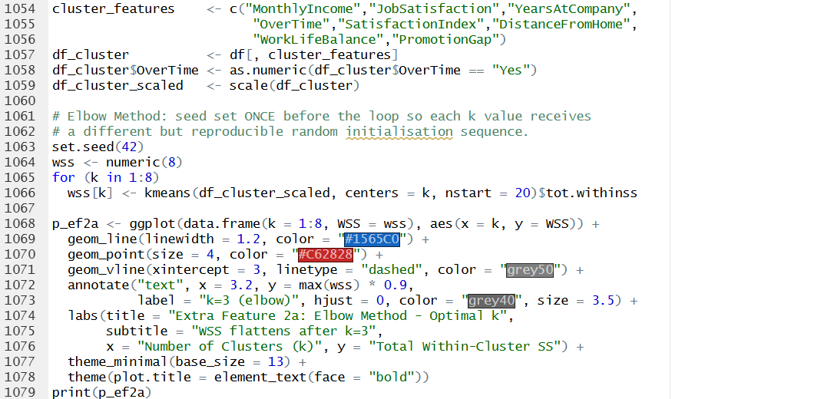

Figure 72: Extra Feature 2a — Elbow Method Chart (p_ef2a Output)
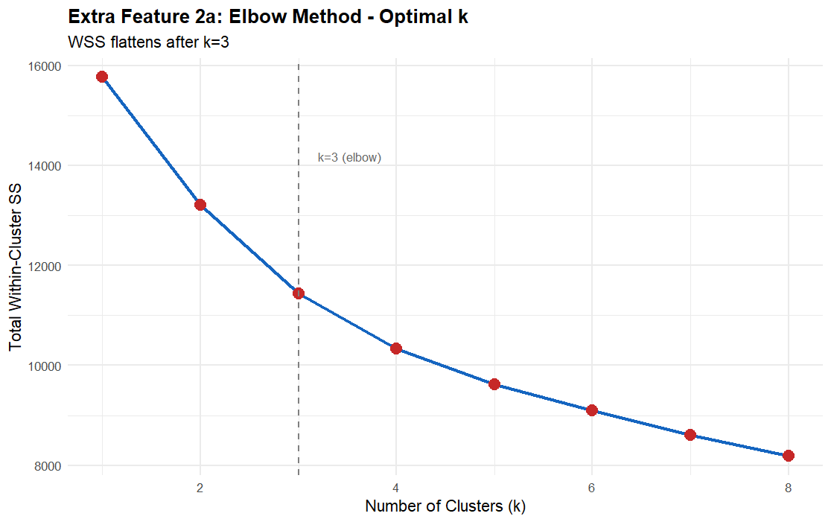

Figure 73: Extra Feature 2b — K-Means PCA Cluster Code Snippet (Lines 1099–1106)
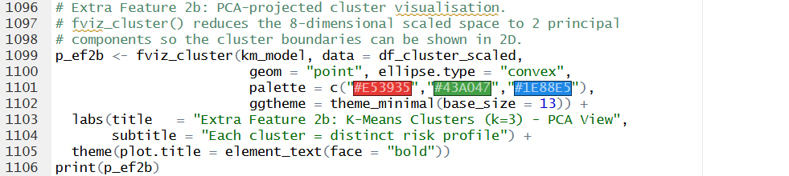

Figure 74: Extra Feature 2b — K-Means PCA Cluster Chart (p_ef2b Output)
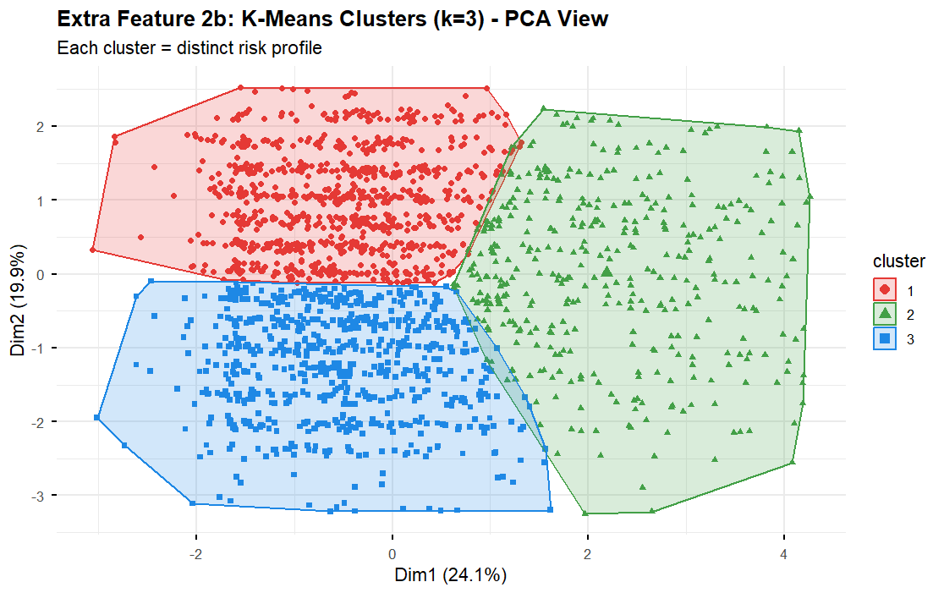

Figure 75: Extra Feature 2c — Attrition Rate by Cluster Code Snippet (Lines 1111–1122)
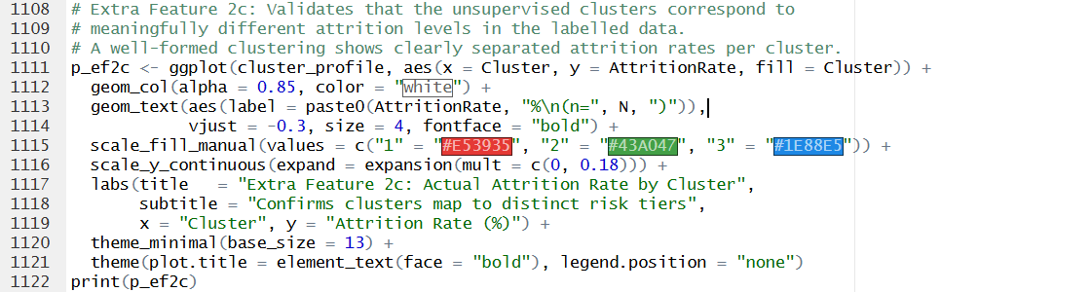

Figure 76: Extra Feature 2c — Attrition Rate by Cluster Chart (p_ef2c Output)
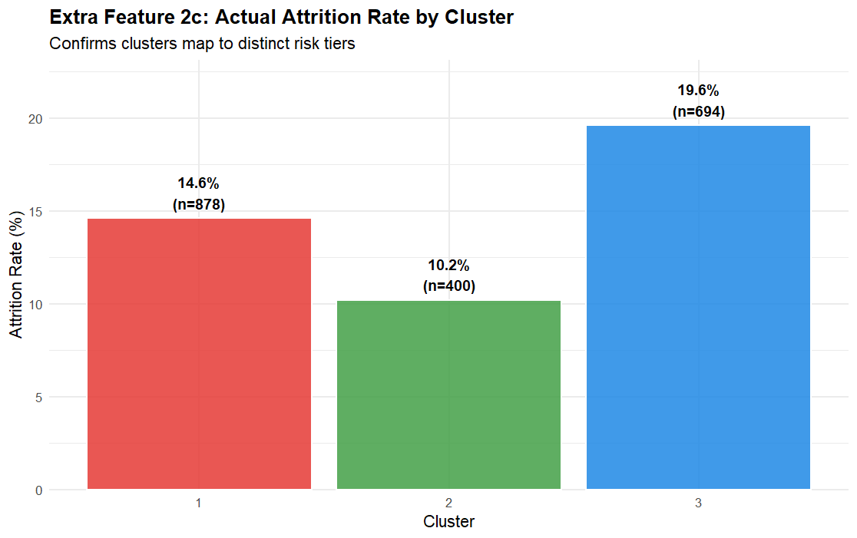

Figure 77: Extra Feature 2 — Cluster Profiles Console Output (Line 1094)
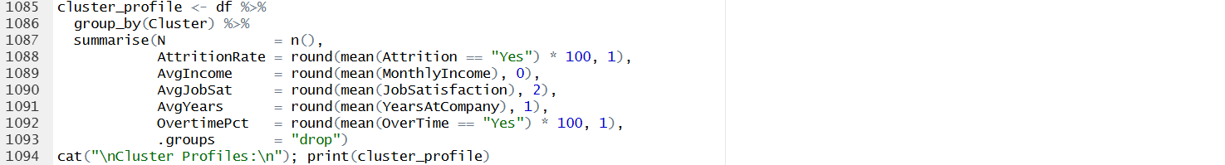
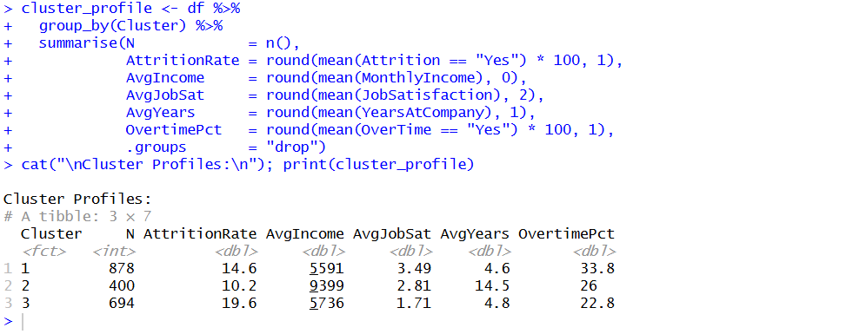

7.3 Extra Feature 3 — Employee Risk Scoring System
The Random Forest's predicted probabilities were converted into an interpretable 0-100 Risk Score and four HR intervention tiers: Low (0-25), Medium (26-50), High (51-75), and Critical (76-100). Two validation outputs are produced: (a) a bar chart showing the actual attrition rate per tier, which should increase monotonically from Low to Critical in a well-calibrated system; and (b) a density plot of risk scores for actual leavers versus stayers, where clear separation between distributions indicates strong model discrimination.
This multi-layered approach enables HR to strategically address the retention efforts by escalating the Critical tier issues to senior leadership and applying less intensive interventions for Medium and High tiers based on evidence-based approaches to talent retention (Cascio, 2019; Boudreau & Ramstad, 2007).

Figure 78: Extra Feature 3a — Risk Tier Code Snippet (Lines 1130–1159)
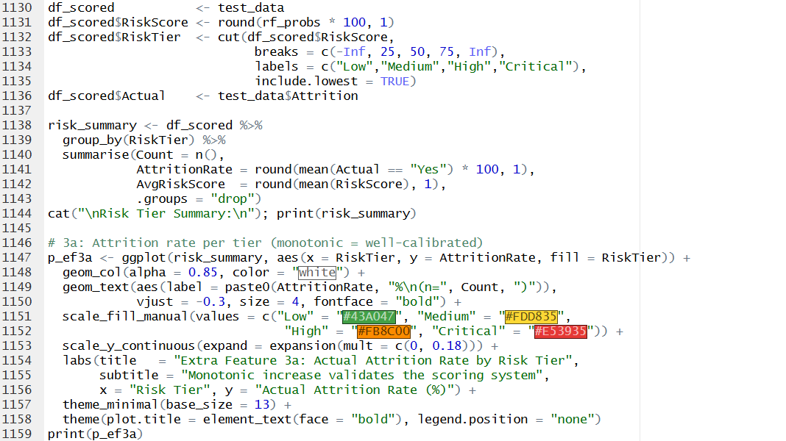

Figure 79: Extra Feature 3a — Attrition Rate by Risk Tier Chart (p_ef3a Output)
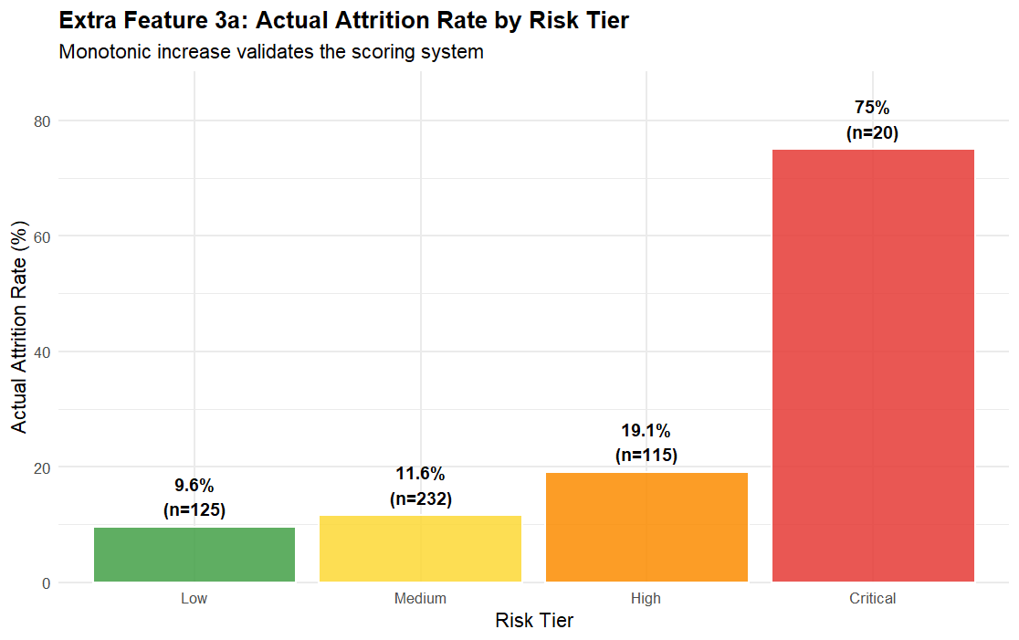

Figure 80: Extra Feature 3b — Risk Tier Code Snippet (Lines 1161–1175)
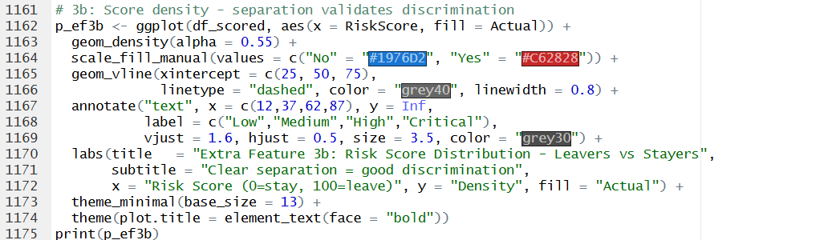

Figure 81: Extra Feature 3b — Risk Score Density Chart (p_ef3b Output)
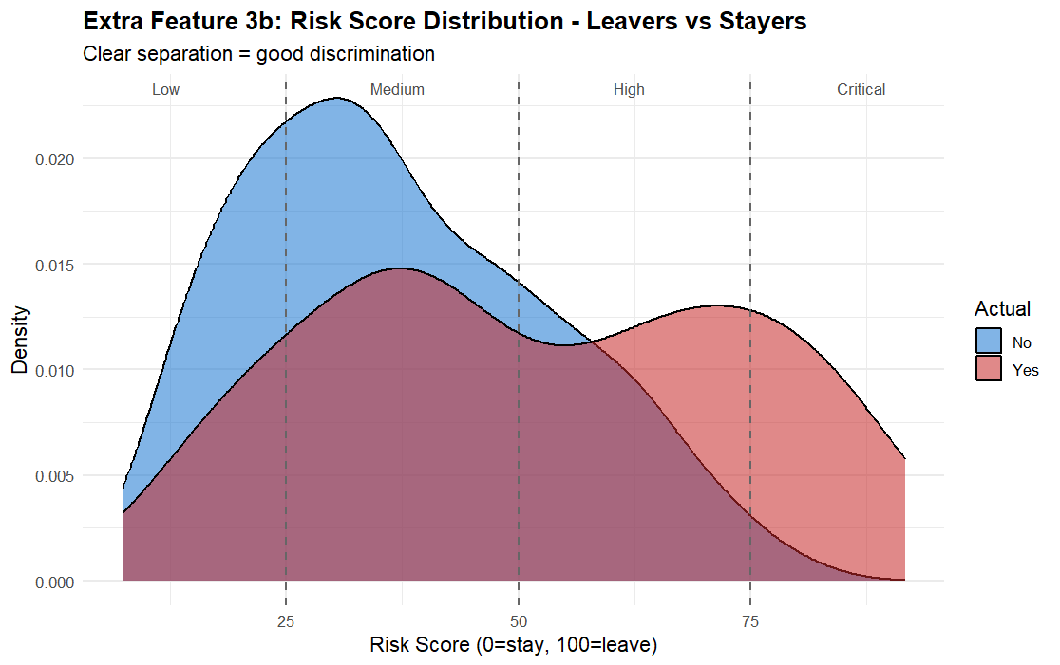

Figure 82: Extra Feature 3 — Risk Tier Summary Console Output (Line 1144)
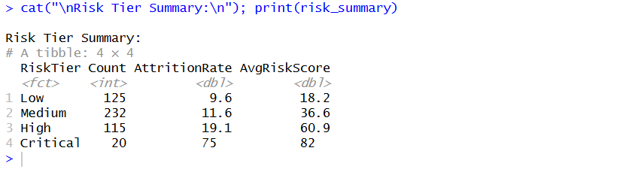

8. Conclusion

8.1 Overall Discussion of Findings
This study applied a multi-stage analytical framework to identify, explain, and predict employee attrition. Each objective addressed a specific dimension of attrition risk through progressive drill-downs rather than parallel independent analyses.
In Objective 1 demographic characteristics proved to be important discriminators between leavers and stayers. Turnover was greatest for those aged between 18 and 25, especially single female employees with less years of schooling. This means that women without a college degree who are early in their careers are a key sector to retain, and need specific onboarding and mentorship.
Objective 2 shows that the strongest risk combination related to compensation is the interaction of low income and overtime. The highest attrition rates for all job levels were for entry-level employees. The Human Resources and Research & Development departments have the highest proportion of high-risk employees relative to headcount, making them the highest-priority intervention targets.
Objective 3 found that the important tenure time was the three-year danger window, with the danger of departure further intensified by stasis in promotion and a history of job-hopping during this window. The triple-risk profile offers HR a concrete screening and monitoring checklist that can be implemented at the point of hire and during the employee’s first year of employment.
According to Objective 4, Random Forest trained with SMOTE balanced data is far better than logistic regression in finding at-risk personnel. In the Feature Importance analysis, Age, tenure factors and MonthlyIncome were the best quantitative predictors, validating the exploratory findings of Objectives 1-3. Decision Tree on RF top features gives HR-readable rules. Risk Scoring System operationalises the model output into prioritised intervention tiers.

8.2 Recommendations
- Establish formal 12-month promotion review cycles for all employees in their first three years, paying particular attention to single individuals aged 18-25 at entry and mid-level positions.
- Review overtime policies in Human Resources and Research & Development departments, which have the greatest turnover rates for low-income overtime workers. You may need to increase personnel or alter compensation.”
- Review candidates with four or more previous employers during onboarding for early-tenure risk factors and assign dedicated mentors for the first 12 months of employment.
- Introduce three-cluster employee risk segmentation model for new hires to allow proactive intervention before any observable quit signal.
- Integrate the Risk Scoring System into the HR information system, with Critical tier (Risk Score > 75) triggering senior management retention engagement.

8.3 Limitations and Future Directions
Several limitations should be noted. First, the dataset being cross-sectional, connection patterns cannot derive causal inference. Longitudinal panel data following employees across time would allow stronger causal claims. Second, the 16%/84% class imbalance, albeit mitigated by SMOTE, results in less confident predictions for the minority class. More advanced techniques such as ADASYN (He et al., 2008) or cost-sensitive learning can be used to further increase Recall. Third, the studies presume that the data is representative of employees’ real working conditions; self-reported satisfaction levels can be prone to social desirability bias.
Directions for future research include: (i) modeling the time-to-resignation rather than binary attrition using survival analysis such as Cox proportional hazards models; (ii) applying natural language processing on exit interview data to complement the quantitative findings; and (iii) extending the risk scoring system with a feedback loop in which model weights are updated as new attrition events are recorded.

9. References
- Agresti, A. (2018). An introduction to categorical data analysis (3rd ed.). Wiley.
- Allen, D. G., Bryant, P. C., & Vardaman, J. M. (2010). Retaining talent: Replacing misconceptions with evidence-based strategies. Academy of Management Perspectives, 24(2), 48-64. https://doi.org/10.5465/amp.24.2.48
- Armstrong, M., & Taylor, S. (2020). Armstrong's handbook of human resource management practice (15th ed.). Kogan Page.
- Asia Pacific University of Technology and Innovation. (2026). CT127-3-2 programming for data analysis: Assignment brief. APU.
- Becker, G. S. (1964). Human capital: A theoretical and empirical analysis, with special reference to education. University of Chicago Press.
- Boudreau, J. W., & Ramstad, P. M. (2007). Beyond HR: The new science of human capital. Harvard Business School Press.
- Breiman, L. (2001). Random forests. Machine Learning, 45(1), 5-32. https://doi.org/10.1023/A:1010933404324
- Cascio, W. F. (2019). Managing human resources: Productivity, quality of work life, profits (11th ed.). McGraw-Hill.
- Chawla, N. V., Bowyer, K. W., Hall, L. O., & Kegelmeyer, W. P. (2002). SMOTE: Synthetic minority over-sampling technique. Journal of Artificial Intelligence Research, 16, 321-357. https://doi.org/10.1613/jair.953
- Cohen, J., Cohen, P., West, S. G., & Aiken, L. S. (2003). Applied multiple regression/correlation analysis for the behavioral sciences (3rd ed.). Lawrence Erlbaum Associates.
- Conover, W. J. (1999). Practical nonparametric statistics (3rd ed.). Wiley.
- Corder, G. W., & Foreman, D. I. (2014). Nonparametric statistics: A step-by-step approach (2nd ed.). Wiley.
- Field, A. (2018). Discovering statistics using IBM SPSS statistics (5th ed.). SAGE Publications.
- Griffeth, R. W., Hom, P. W., & Gaertner, S. (2000). A meta-analysis of antecedents and correlates of employee turnover. Journal of Management, 26(3), 463-488. https://doi.org/10.1177/014920630002600305
- Hackman, J. R., & Oldham, G. R. (1976). Motivation through the design of work: Test of a theory. Organizational Behavior and Human Performance, 16(2), 250-279. https://doi.org/10.1016/0030-5073(76)90016-7
- Hastie, T., Tibshirani, R., & Friedman, J. (2009). The elements of statistical learning (2nd ed.). Springer. https://doi.org/10.1007/978-0-387-84858-7
- Hausknecht, J. P., & Trevor, C. O. (2011). Collective turnover at the group, unit, and organizational levels. Journal of Management, 37(1), 352-388. https://doi.org/10.1177/0149206310383910
- He, H., Bai, Y., Garcia, E. A., & Li, S. (2008). ADASYN: Adaptive synthetic sampling approach for imbalanced learning. Proceedings of the IEEE International Joint Conference on Neural Networks, 1322-1328. https://doi.org/10.1109/IJCNN.2008.4633969
- Hintze, J. L., & Nelson, R. D. (1998). Violin plots: A box plot-density trace synergism. The American Statistician, 52(2), 181-184. https://doi.org/10.1080/00031305.1998.10480559
- Hollander, M., Wolfe, D. A., & Chicken, E. (2014). Nonparametric statistical methods (3rd ed.). Wiley.
- Hom, P. W., Lee, T. W., Shaw, J. D., & Hausknecht, J. P. (2017). One hundred years of employee turnover theory and research. Journal of Applied Psychology, 102(3), 530-545. https://doi.org/10.1037/apl0000103
- Hosmer, D. W., Lemeshow, S., & Sturdivant, R. X. (2013). Applied logistic regression (3rd ed.). Wiley. https://doi.org/10.1002/9781118548387
- IBM. (2017). IBM HR analytics employee attrition & performance. Kaggle. https://www.kaggle.com/datasets/pavansubhasht/ibm-hr-analytics-attrition-dataset
- Jain, A. K. (2010). Data clustering: 50 years beyond K-Means. Pattern Recognition Letters, 31(8), 651-666. https://doi.org/10.1016/j.patrec.2009.09.011
- James, G., Witten, D., Hastie, T., & Tibshirani, R. (2021). An introduction to statistical learning with applications in R (2nd ed.). Springer. https://doi.org/10.1007/978-1-0716-1418-1
- Lazear, E. P., & Rosen, S. (1981). Rank-order tournaments as optimum labor contracts. Journal of Political Economy, 89(5), 841-864. https://doi.org/10.1086/261010
- Lee, T. W., Mitchell, T. R., Sablynski, C. J., Burton, J. P., & Holtom, B. C. (2004). The effects of job embeddedness on organizational citizenship, job performance, volitional absences, and voluntary turnover. Academy of Management Journal, 47(5), 711-722. https://doi.org/10.2307/20159613
- Lunardon, N., Menardi, G., & Torelli, N. (2014). ROSE: A package for binary imbalanced learning. R Journal, 6(1), 79-89. https://doi.org/10.32614/RJ-2014-008
- MacQueen, J. (1967). Some methods for classification and analysis of multivariate observations. Proceedings of the Fifth Berkeley Symposium on Mathematical Statistics and Probability, 1, 281-297.
- Milkovich, G. T., Newman, J. M., & Gerhart, B. (2014). Compensation (11th ed.). McGraw-Hill.
- Mitchell, T. R., Holtom, B. C., Lee, T. W., Sablynski, C. J., & Erez, M. (2001). Why people stay: Using job embeddedness to predict voluntary turnover. Academy of Management Journal, 44(6), 1102-1121. https://doi.org/10.2307/3069437
- Mobley, W. H. (1982). Employee turnover: Causes, consequences, and control. Addison-Wesley.
- Ployhart, R. E., & Moliterno, T. P. (2011). Emergence of the human capital resource: A multilevel model. Academy of Management Review, 36(1), 127-150. https://doi.org/10.5465/amr.2009.0318
- Quinlan, J. R. (1993). C4.5: Programs for machine learning. Morgan Kaufmann.
- Ruxton, G. D. (2006). The unequal variance t-test is an underused alternative to Student's t-test and the Mann-Whitney U test. Behavioral Ecology, 17(4), 688-690. https://doi.org/10.1093/beheco/ark016
- Saks, A. M., & Gruman, J. A. (2018). Socialization resources theory and newcomers' work engagement. Career Development International, 23(1), 12-32. https://doi.org/10.1108/CDI-12-2016-0214
- Silverman, B. W. (1986). Density estimation for statistics and data analysis. Chapman & Hall.
- Sterne, J. A. C., White, I. R., Carlin, J. B., Spratt, M., Royston, P., Kenward, M. G., Wood, A. M., & Carpenter, J. R. (2009). Multiple imputation for missing data in epidemiological and clinical research. British Medical Journal, 338, b2393. https://doi.org/10.1136/bmj.b2393
- Strobl, C., Boulesteix, A. L., Kneib, T., Augustin, T., & Zeileis, A. (2008). Conditional variable importance for random forests. BMC Bioinformatics, 9(1), 307. https://doi.org/10.1186/1471-2105-9-307
- Van Buuren, S. (2018). Flexible imputation of missing data (2nd ed.). CRC Press. https://stefvanbuuren.name/fimd/
- Wanous, J. P. (1992). Organizational entry: Recruitment, selection, orientation, and socialization of newcomers (2nd ed.). Addison-Wesley.

