Sample Software Architecture Document

Velankani Coding Challenge 1.0

VCTI

SAD Revision History

Date | Version | Description | Author
2020-01-13 | 0.1 | Draft Version | VCTI Engineering Team

Table of Contents

1. Introduction 4
1.1 Purpose 4
1.2 Scope 4
1.3 Definitions, Acronyms and Abbreviations 4
1.4 References 4
2. Architectural Representation 5
3. Architectural Goals and Constraints 6
3.1 Technical Platform 6
3.2 Security 6
3.3 Persistence 7
3.4 Reliability/Availability (failover) 7
3.5 Performance 7
3.6 Internationalization (i18n) 7
4. Use-Case View 7
4.1 Manage Users 8
4.2 Manage Question 8
4.3 Schedule Coding Challenge 9
4.4 Take Coding Challenge 10
4.5 View Coding Challenge Result and Forwarding 11
4.6 Use-Case Realizations 11
5. Logical View 11
5.1 Overview 11
5.2 User Interface 13
6. Process View 17
7. Deployment View 17
8. Implementation View 18
8.1 Overview 18
8.2 Layers 18
9. Data View 18
10. Size and Performance 19
11. Quality 19

Introduction
An architectural overview is aimed at providing a shared understanding of the architecture across a broad range of people including the developers, management and possibly potential end-users. This document contains high level view of the layered architecture, technology stack used to develop the application, database design, different use case views, user interface design etc.

Purpose
The Software Architecture Document (SAD) provides a comprehensive architectural overview of the Velankani Coding Challenge offered by VCTI. It presents a number of different architectural views to depict different aspects of the system. It is intended to capture and convey the significant architectural decisions which have been made on the system.

In order to depict the software as accurately as possible, the structure of this document is based on the “4+1” model view of architecture [KRU41].

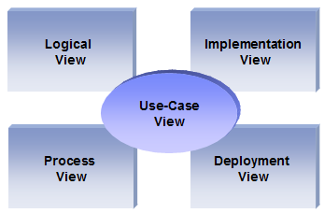
The “4+1” View Model allows various stakeholders to find what they need in the software architecture.

Scope
The scope of this SAD is to depict the architecture of the Coding Challenge tool created by the company VCTI.

Definitions, Acronyms and Abbreviations

RUP: Rational Unified Process
UML: Unified Modeling Language
SAD: Software Architecture Document

References

[KRU41]: The “4+1” view model of software architecture, Philippe Kruchten, November 1995, http://www3.software.ibm.com/ibmdl/pub/software/rational/web/whitepapers/2003/Pbk4p1.pdf

[RSA]: IBM Rational Software Architect
http://www-306.ibm.com/software/awdtools/architect/swarchitect/index.html

[RUP]: The IBM Rational Unified Process : http://www-306.ibm.com/software/awdtools/rup/index.html

[RUPRSA]: Developing a J2EE Architecture with Rational Software Architect using the Rational Unified Process®, IBM DeveloperWorks, Jean-Louis Maréchaux, Mars 2005, http://www-128.ibm.com/developerworks/rational/library/05/0816_Louis/

Architectural Representation

This document details the architecture using the views defined in the “4+1” model [KRU41], but using the RUP naming convention. The views used to document the Coding Challenge tool are:

Logical view
Audience: Designers.
Area: Functional Requirements: describes the design's object model. Also describes the most important use-case realizations.
Related Artifacts: Design model

Process view
Audience: Integrators.
Area: Non-functional requirements: describes the design's concurrency and synchronization aspects.
Related Artifacts: (no specific artifact).

Implementation view
Audience: Programmers.
Area: Software components: describes the layers and subsystems of the application.
Related Artifacts: Implementation model, components

Deployment view
Audience: Deployment managers.
Area: Topology: describes the mapping of the software onto the hardware and shows the system's distributed aspects.
Related Artifacts: Deployment model.

Use Case view
Audience: all the stakeholders of the system, including the end-users.
Area: describes the set of scenarios and/or use cases that represent some significant, central functionality of the system.
Related Artifacts : Use-Case Model, Use-Case documents

Data view (optional)
Audience: Data specialists, Database administrators
Area: Persistence: describes the architecturally significant persistent elements in the data model
Related Artifacts: Data model.

Architectural Goals and Constraints

Velankani is currently facing recruitment challenges in hiring good programmers at all levels.

Velankani is currently facing recruitment challenges in hiring good programmers at all levels.
The current hiring process has multiple rounds of interviews where coding rounds are sometimes done and sometimes skipped. It depends on the panel and the position being interviewed for. There is no standard way of assessing the candidate’s programming ability in the current process.

This project aims to overcome that by way of developing an internal coding challenge web application similar to the lines of hackerrank, codewars, challenge rocket and other tools. The objective is to have the aspiring candidate undergo a coding challenge round as the first round of interview using this project.
This project henceforth called the “Velankani Coding challenge Tool” is planned to be developed internally.

Technical Platform

The Coding Challenge application will be deployed onto a Apache Tomcat server (Tomcate 7). It will be based on micro service architecture and will connect to Cassandra DB to operate with data.

Security

The application must implement basic security behaviors:
- Authentication: Login using at least a user name and a password
- Authorization: Initially there are four different role defined
    - Admin User –
      - Display the past coding test reports
      - Display the objective type coding test reports
      - Display the tests in progress
      - Provision to upload questions and their answers
      - Provision to create new users and assign roles
  - Recruitment User –
    - Display the list of candidates for whom coding test should be scheduled
    - Display the list of questions for the test
    - Provision to choose a candidate and assign questions for test. It couple be objective type or coding test questions
    - View the test results
    - Provision to forward the result to interview panel via email

  - Candidate User –
    - This screen should be a minimal screen for the candidate to answer the preselected question
    - It should have provision to submit answers depending on the question type
  - Interview Panel User –
    - This screen will have the result of the questions answered by the candidate
    - The assigned interview panel can see the answers to the specific question as determined by the Recruitment user in the recruitment dashboard.

Persistence

Data persistence is addressed by using Cassandra database.

Reliability/Availability (failover)
To support HA and failover, client-side load balancing using Ribbon is used on server side component / service. The deployment model takes care of running more than one instance of each service to avoid failover. Also Cassandra supports HA configuration with multiple nodes.

Performance

The application must be fast enough to avoid large lag time.

Internationalization (i18n)

The Coding Challenge must be able to deal with several languages (at least English for now)
So the presentation layer must be able to support i18n.
Other layers must be generic enough to work with any internationalization context

Use-Case View

This section lists use cases or scenarios from the use-case model if they represent some significant, central functionality of the final system. Following use case scenarios exist
- Manage Users
- Manage Questions
- Schedule Coding Challenge
- Take Coding Challenge
- View Coding Challenge Result and Forwarding

Manage Users

By default the coding challenge tool supports one admin user. This user can further create more users with different role.
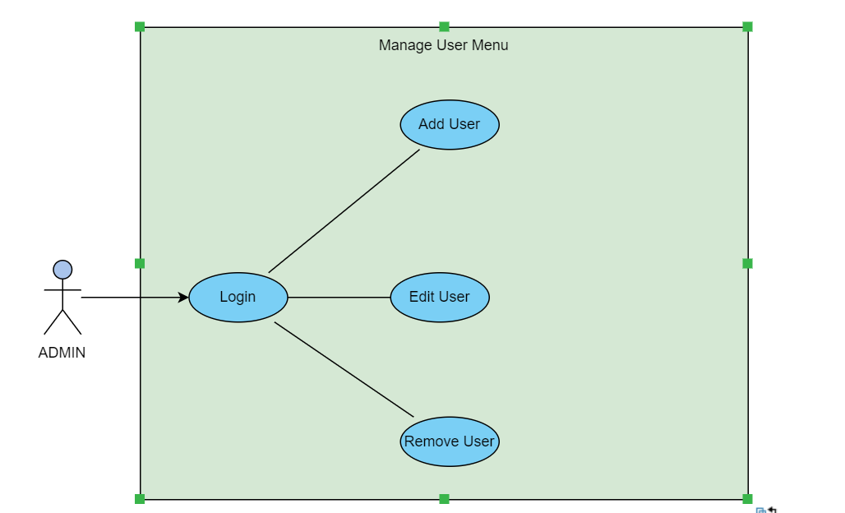

Manage Question

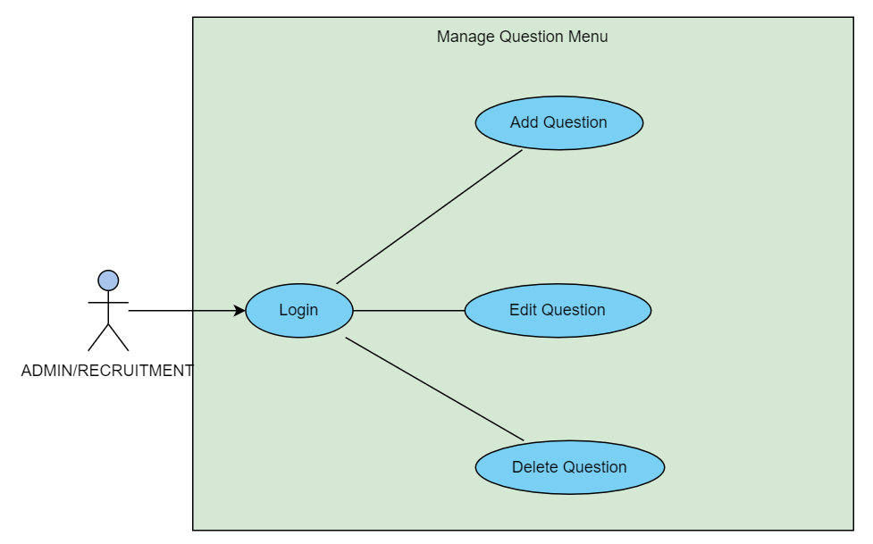

Schedule Coding Challenge
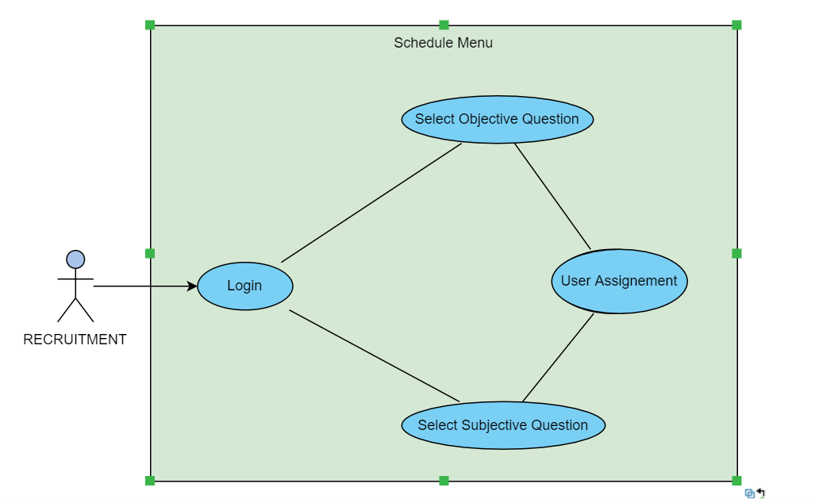

Take Coding Challenge

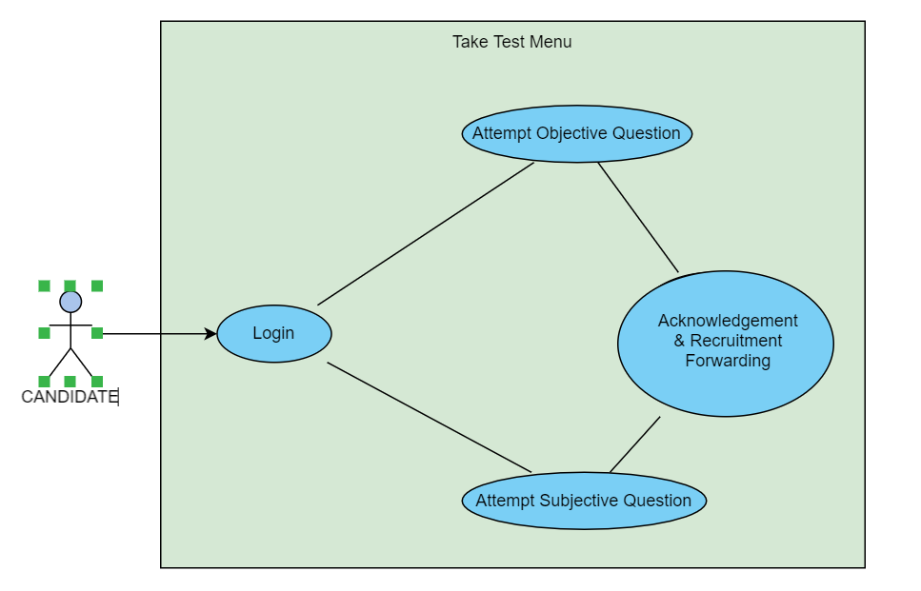

View Coding Challenge Result and Forwarding
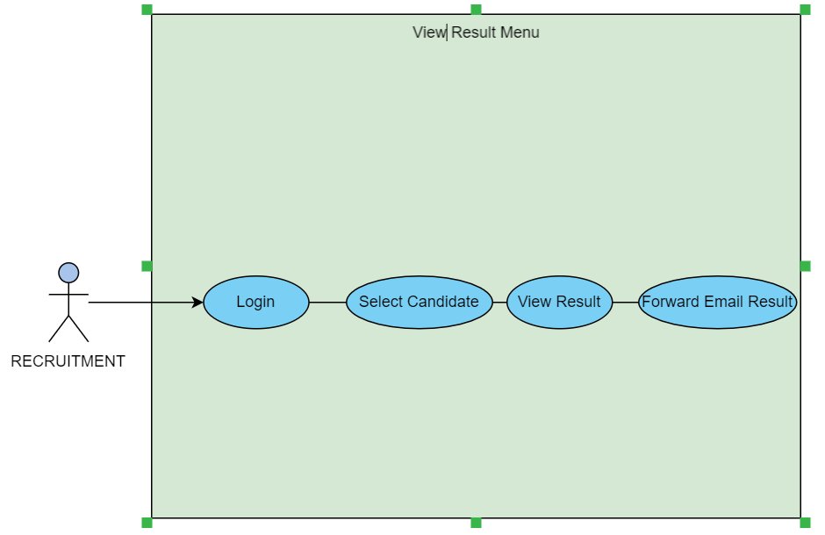

Use-Case Realizations
Refers to section 5.2 to see how design elements provide the functionalities identified in the significant use-cases.

Logical View

Overview

The coding challenge tool is based on micro service architecture based on Spring Cloud providing supported APIs.
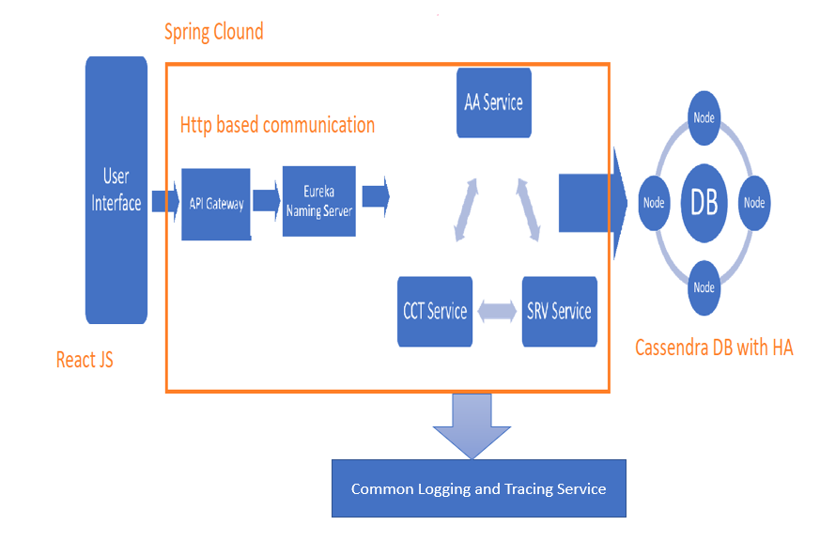

The application is supported by a monolithic user interface. User interface interacts with Zuul API Gateways which routes the requests to Eureka Naming Service. Eureka Naming Server with Ribbon supports client-side load balancing. The distributes micro services register themselves with Eureka Naming Server. Upon receipt of the request from user interface it resolves the request to route it to appropriate micro service.
This strategy has been chosen because it is easier to build and maintain apps. It helps scale the system in future.
Based on business case three micro services are identified and one service is created to manage logging / tracing.
- Authentication and Authorization Service (AA Service) – This service will render the request for authentication and authorization. It will support functionalities
  - Creation / Modification / Deletion of User
  - Creation / Modification / Deletion of User
- Coding Challenge Service (CCT Service) – This service will support following functionalities
  - Creation / Modification / Deletion of Question
  - Running the Subjective Question and storing the JUNIT test result.
  - Evaluating the object question and storing the result.
- Scheduler and Result Viewer Service – This service will help schedule the test and view the result. It will also help route the result to interviewers.
- Common Logging and Tracing Service – This service is used to log the information at single common location.

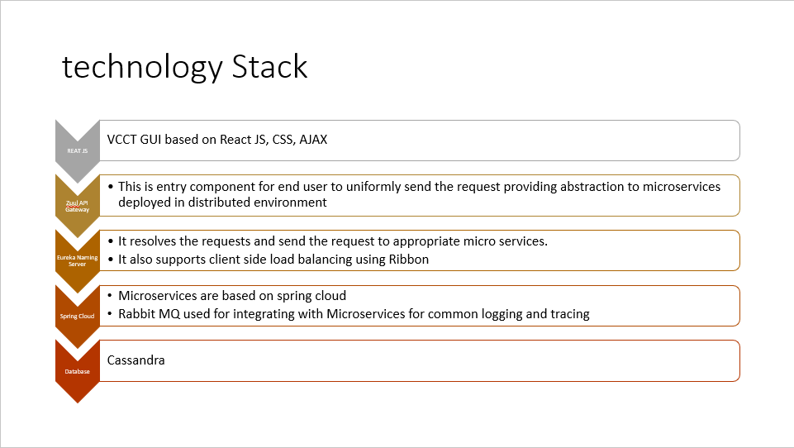

User Interface

Login Page – It provides an initial page upon hitting the application URL. To be able to login to application user needs to provide valid user id and password. It also provides option to sign up, it allows user to register to application, but user registered through this option contains Guest role

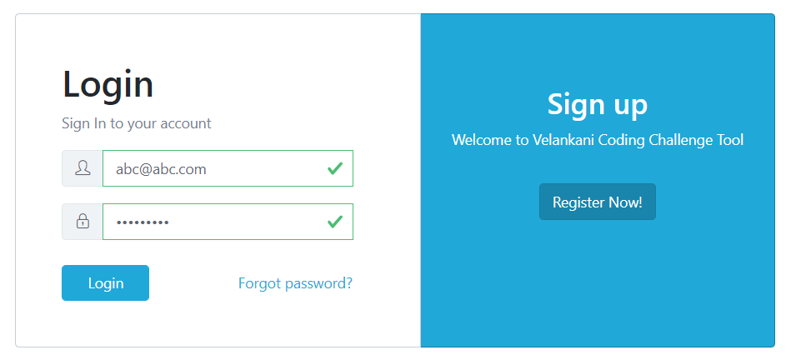

Reset Password page allows user to reset the password which sends the link to registered mail id for resetting the password.
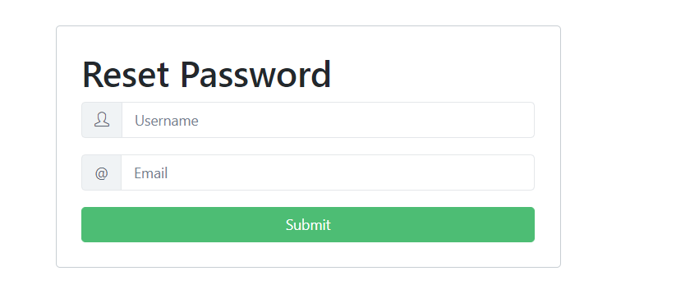

Manage User page lists down all existing users and allows editing upon selection.

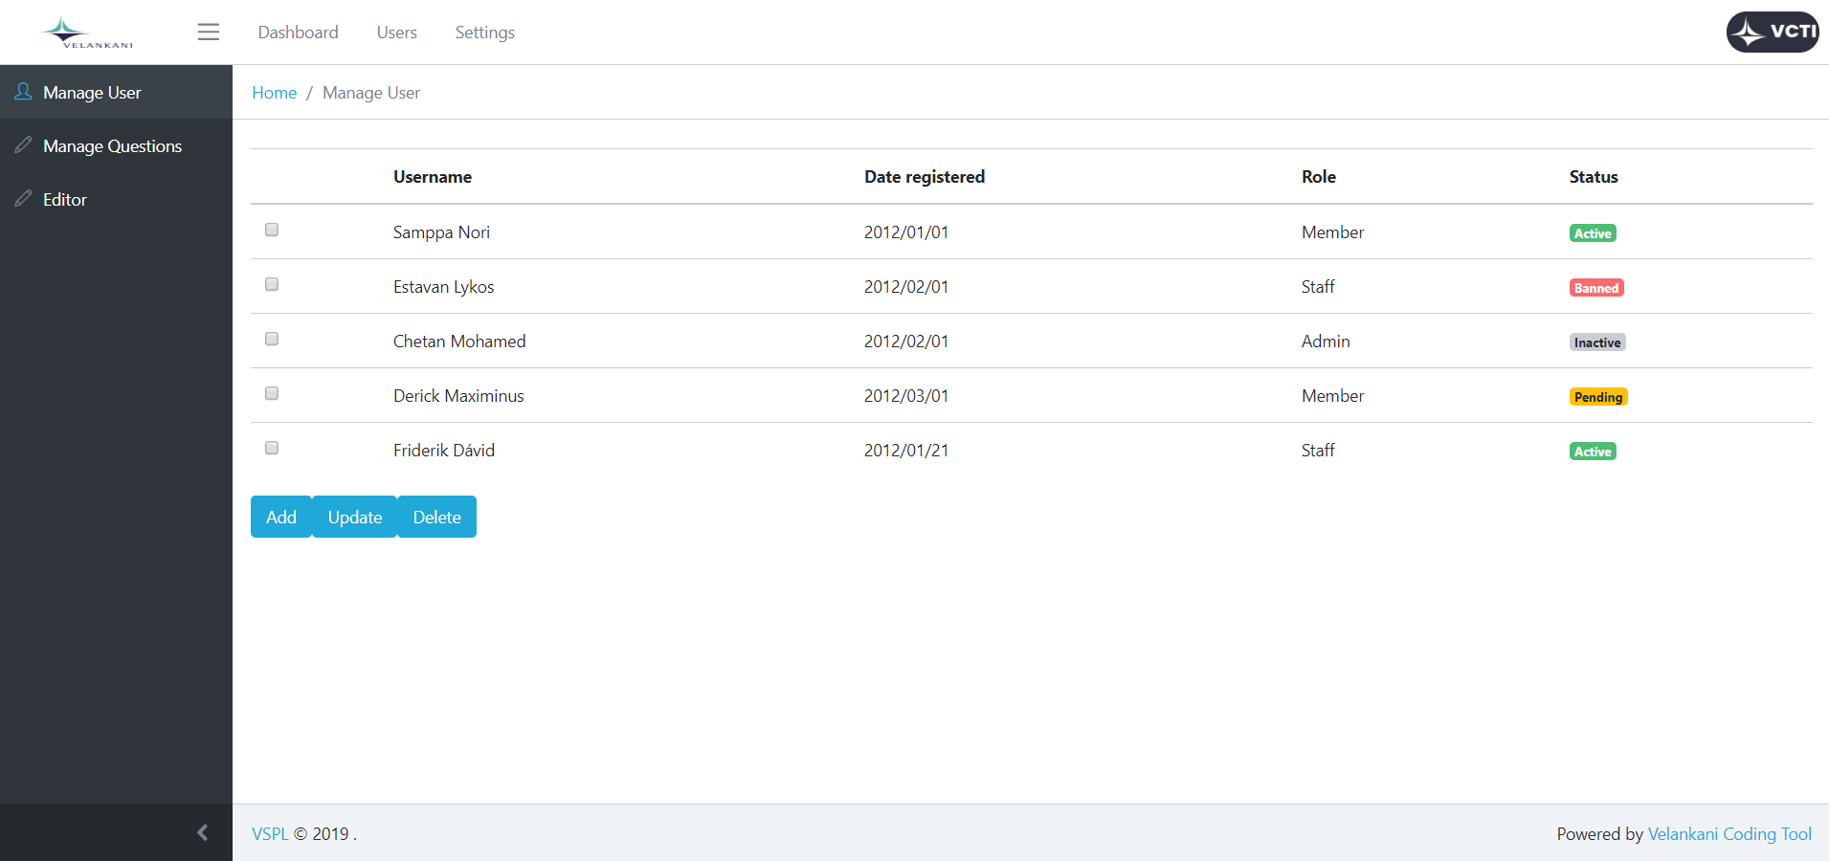

Manage Question page allows user to list down all the questions with option to add / edit / remove options.

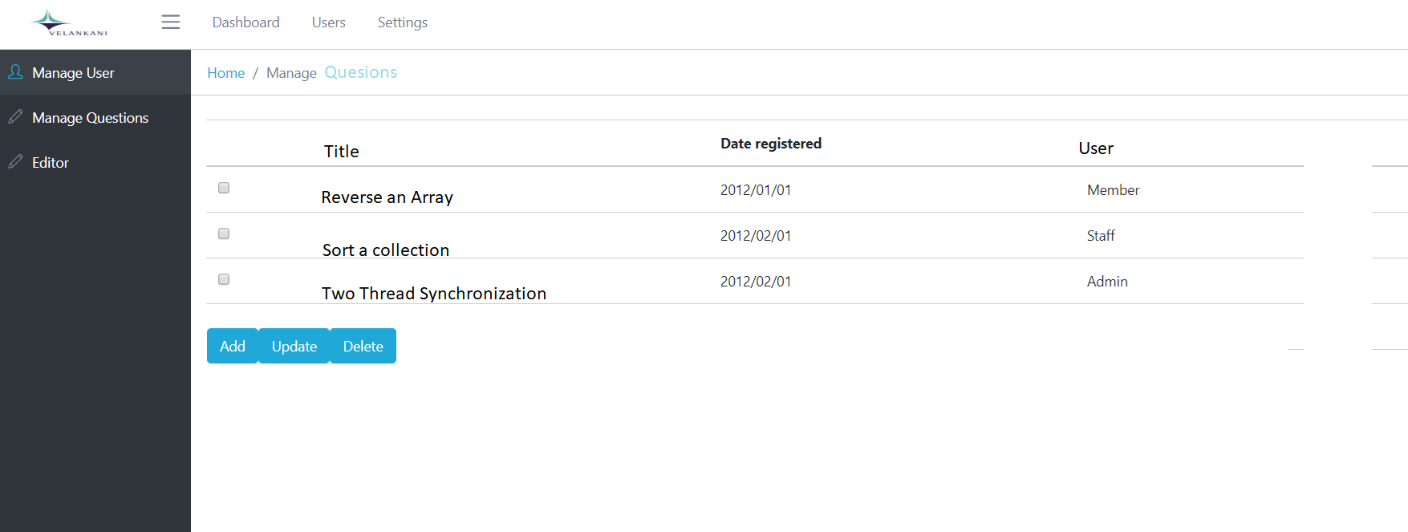

Add Question page allows user to add either subject or object Question

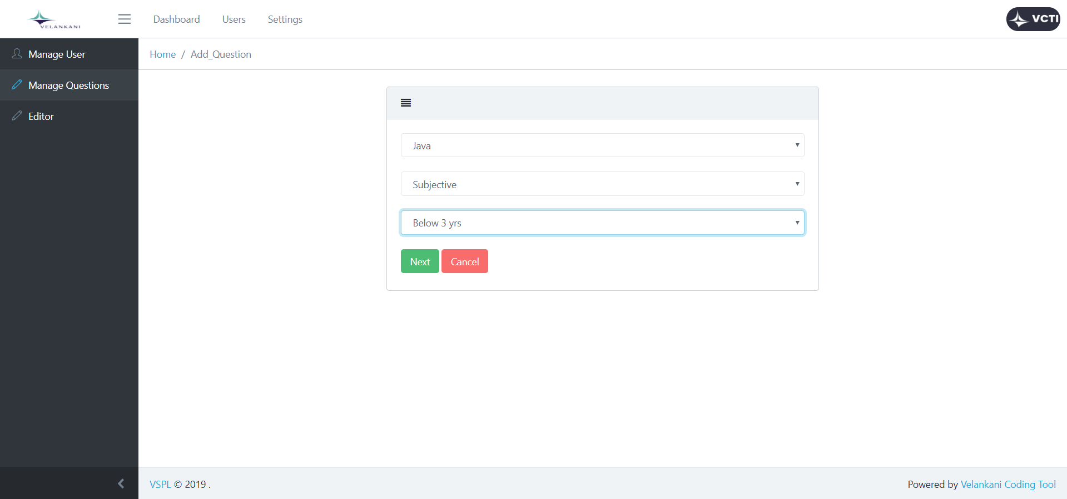

This page is based on work flow so initial page shows the option to select language, type of question (subjective or objective) and experience level. Upon clicking on next by selecting type as subjective

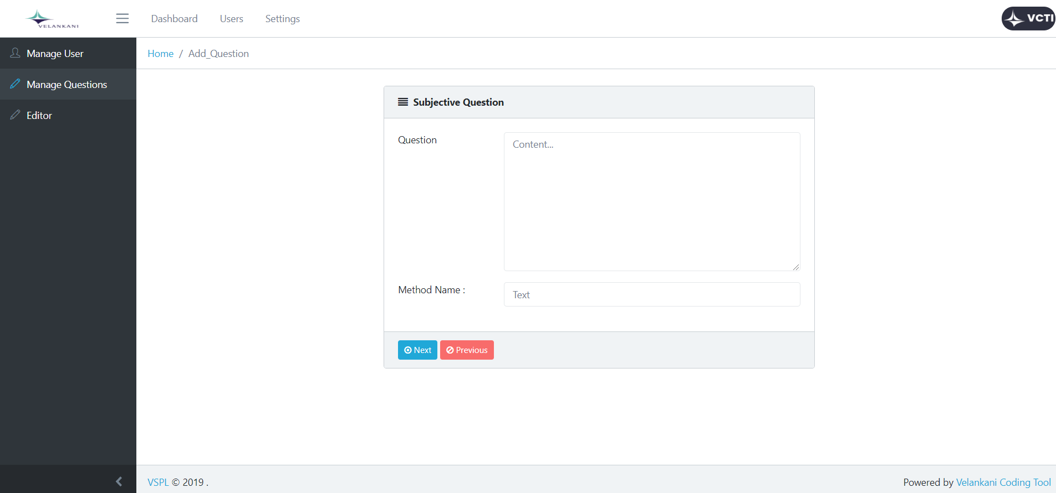

This page gives the option to write the complete text of the question. It also takes input the method name which will encapsulates logic at the time of taking test. Upon clicking next

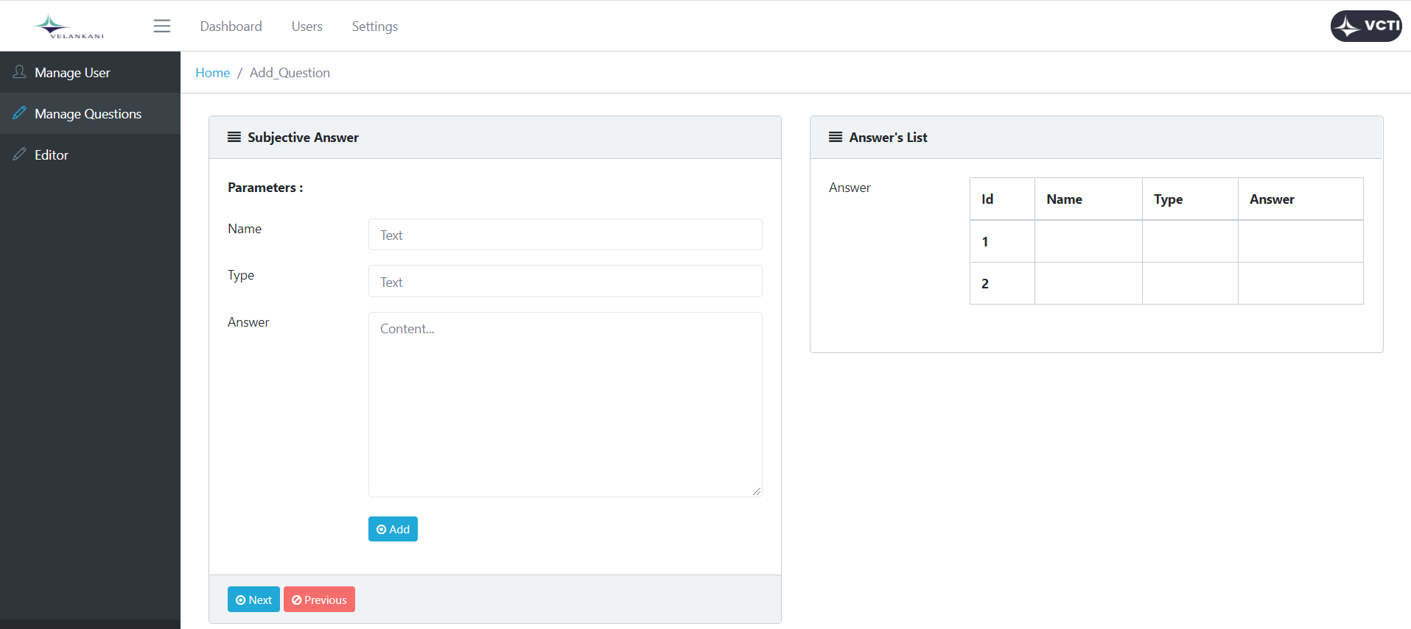

This page gives the option to specify the parameters which is going to be the input to the subjective question at the time of running the program. Also it contains the correct answer if the particular input is selected.

If user selects the type as objective then following page appears

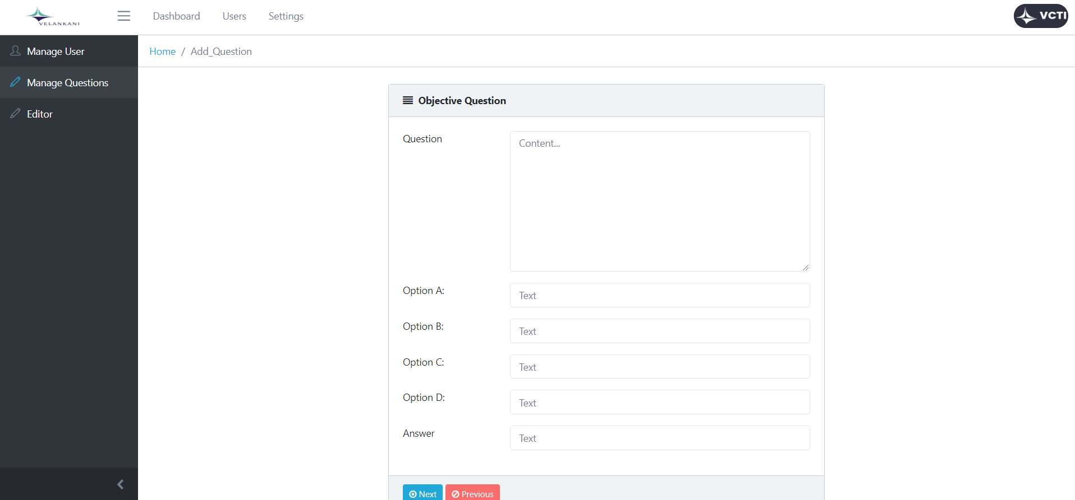

More User Interface pages will be defined later.

Process View

There’s only one process to take into account. The J2EE model automatically handles threads which are instances of this process.

Deployment View

Global Overview
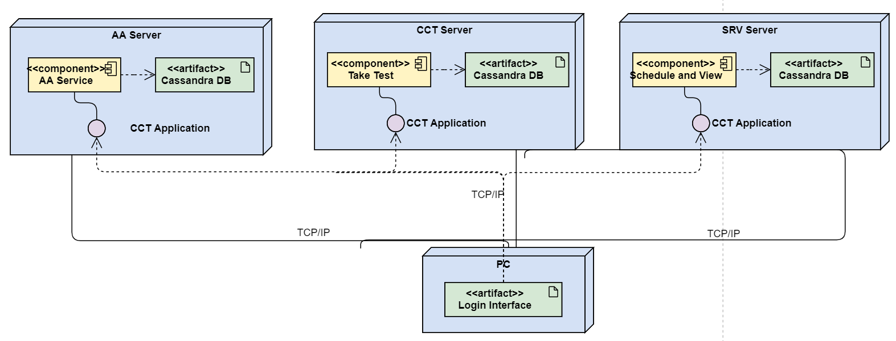

Detailed deployment model with clustering

- One IBM HTTP Server will dispatch requests to two different IBM WebSphere servers (load balancing + clustering)
- An IBM DB2 Database stores all the information related to online orders

Implementation View

Overview

TBD

Layers

TBD

Data View

Cassandra database is used to provide persistence support for the coding challenge tools. Below diagram shows the entity relation between User , Role , Role Permission Mapping and Permission table.

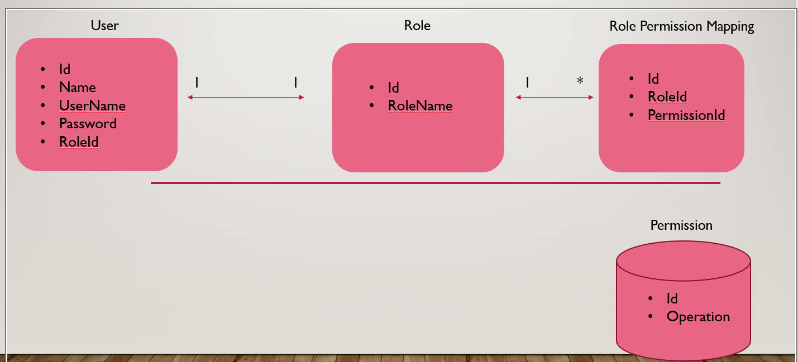

- During Start-up
  - Read permission from permission.properties file
  - Populate Role table and RolePermissionMapping table

Below diagram shows the entity relationship between different tables used during manage question use case.
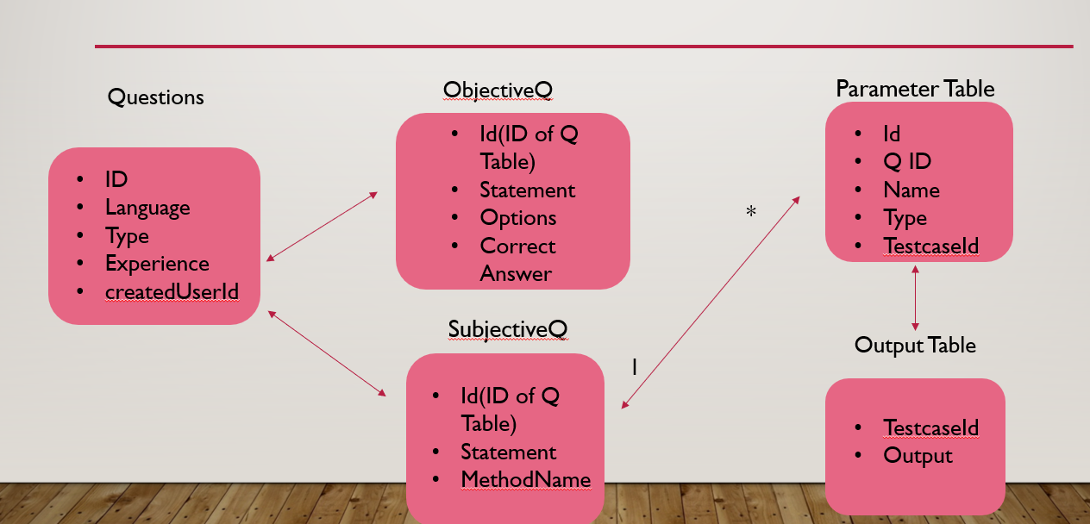

Below diagram shows the entity relationship for take test use case

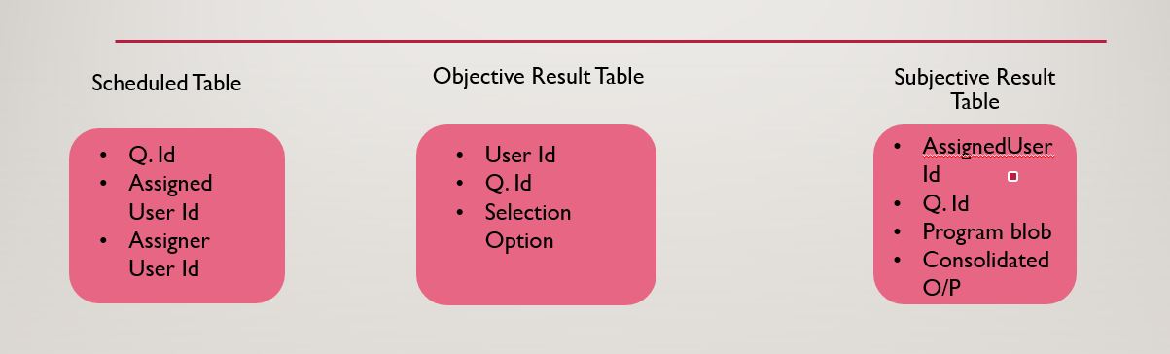

Size and Performance

TBD

Quality

TBD

