|  |  |
| --- | --- |
| Name | ALI HUSNAIN |
| Roll No | **024** |
| Class | **BSAI** |
| Section | **3A** |
| Task name | **FIZZBUZZ(GAME)** |
| Submitted to | **SIR RASIKH** |

THE SUPERIOR UNIVERSITY

**TASK 2**

**FIZZ BUZZ GAME USING PYTHON**

**A fizz Buzz is the game that is used to enhance your if else statements .** Fizz Buzz is a very popular beginner project in programming and is also a common interview question. It looks like a simple childhood counting game but is used by employers to test whether a person can use **loops, conditions, and the modulo operator**

**Rules of the Game**

1. Players count numbers starting from **1**.
2. If a number is divisible by **3**, say **Fizz** instead of the number.
3. If a number is divisible by **5**, say **Buzz** instead of the number.
4. If a number is divisible by **both 3 and 5**, say **FizzBuzz**.
5. If a player makes a mistake, they lose the game.

Example of the first 15 numbers:  
1, 2, Fizz, 4, Buzz, Fizz, 7, 8, Fizz, Buzz, 11, Fizz, 13, 14, FizzBuzz

**Flow Chart:**

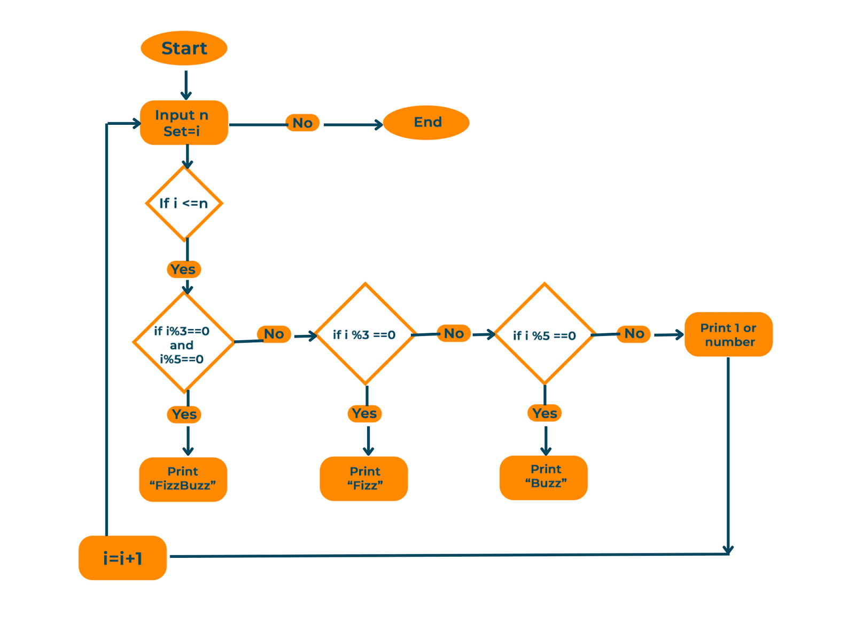

## Algorithm 2: Computer vs Player (1–20 example)

1. **Start**
2. Show message: Welcome to Fizz Buzz Game.
3. Repeat for each number from **1 to 20**:
   * If the number is **odd** (1, 3, 5 …):
     + Ask the player to enter the answer.
     + Compare the answer with the correct value (Fizz, Buzz, FizzBuzz, or number).
     + If the answer is wrong → Print You Lose and stop the game.
   * Else if the number is **even** (2, 4, 6 …):
     + Computer prints the correct answer.
4. If the loop finishes without mistakes → Print You Win.
5. **End**

**THANKS FOR READING 😊**