Comparing merge sort, quick sort and heap sort
algorithms
Maksym Semko
21/12/2021
1. Introduction
In this paper I’m going to compare merge sort, quick sort and heap sort algorithms using data which got during the comparison of these algorithms and also knowledge which I gained from the Algorithms & Complexity labs and lectures and from my own practice.

  - Merge sort
This algorithm should be on the second place in our list in terms of best and average time, though it seems that I’ve made not the best implementation for it, so on the graphs below it looks like it is the worst algorithm among all three, however it’s not. The working principle of this algorithm is based on 2 steps which are using recursion. The first one is dividing the array to the point where we only have multiple single element arrays which are already sorted. After that we are merging these arrays by comparing left and ride sides, finding the smallest element and adding it to the new allocated array( in classical implementation). It is stable algorithm and it’s best, worst and average time complexity is O(n*log n), it’s space complexity in classical not in place type implementation is O(n) , classical implementation might use a lot of space in case of working with big amounts of data however it might be reduced to O(log n) in case of in place type implementation

The key advantage of this algorithm is that is works very good with big sets of data because it goes through the whole set several time, it has consistent running time and has optimal performance(efficient).
The main disadvantages, on the other hand are that is has high usage of memory in classical model, works badly with small data sets and goes through the whole cycle even if the data is already sorted

  - Heap sort
This algorithm should be placed on the last position in terms of best and average time. It’s working principles consist of dividing input into unsorted and sorted areas and decreasing the size of the unsorted part by taking the largest value from the unsorted part and putting it into the sorted one. Heap sort works as binary tree with heap properties. It is not stable and has the same time complexity for best, average and worst cases as the Merge sort which is O(n*log n). It is in place type algorithm and it’s space complexity is O(n) which cannot be decreased any further.
The key advantages of this algorithm are that it doesn’t requires as much memory as merge sort and is in place type by default, it’s also consistent and has optimal performance(efficient)
The key disadvantages are that it might work very badly with big data sets, is unstable and the most of moments is slower then quick sort algortihm

  - Quick sort

This is so far the fastest algorithm in our list. It’s working principles are based on working with pivot. Pivot is an element which we choose at the beginning of the cycle. After finding the pivot we looking for a value which is smaller then pivot on the left side of the pivot and move the counter towards the pivot and together with that we starting searching for the value which is larger then the pivot but this time on the right side. After each iteration we check if the left element is less or equal to the right element and if yes then we swap their values, then we continue and if right and left elements won’t meet in the end then we repeat the cycle. It’s best time complexity is O(n*log n), average time complexity is also O(n*log n) and worst time complexity is O(n^2) and is appears when the array is sorted. Classical version of the algorithm is unstable. Quick sort is an in place algorithm and has space complexity O(log n) for in place type and unstable version requires O(1) for unstable partition
The advantages are small time complexity, short inner loop and optimal performance(efficient).
The disadvantages are fragility which may cause problems if algorithm implemented not accurately, quadratic time for worst case scenario.

2. Methodology
All the algorithms were implemented in C++ language using Visual studio IDE with latest installed updates. Algorithms were tested for both sorted and unsorted arrays in order to find best and average time for each size. The array size range which was used for testing is from 100 to 4300, each size of the array was used 100 times.

3. Results
On the graph below you can see the average and best time for all of the algorithms on the array size range from 100 to 4300

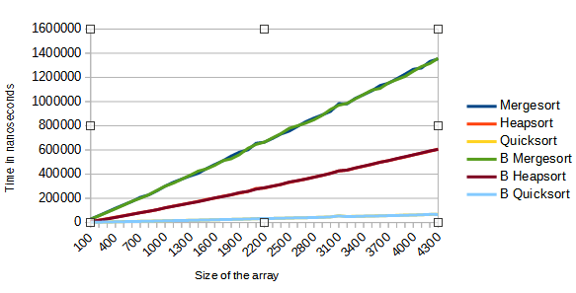

On the diagram below you can see average time of all the algorithms

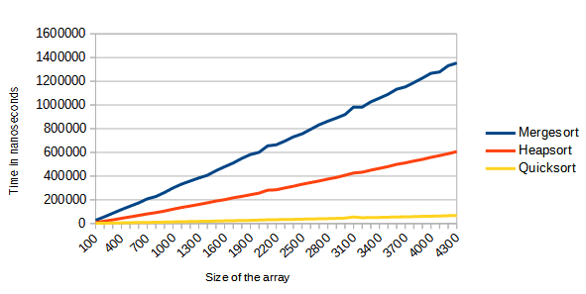

On the graph below you see the average time of all the algorithms but on a smaller range 100-500
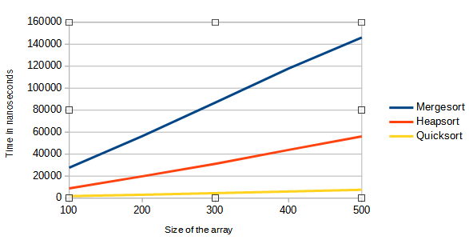

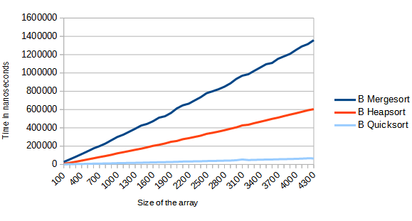

On the graph above you can see the best time for all the algorithms
4. Conclusion
So far, the best algorithm from all three in the list is the quick sort. As can be viewed from the information and data above, it showed the best results in both average and best time comparisons. The second best algorithm in our list should should have been the merge sort, however, as mentioned previously, because of some mistakes which I’ve made in my algorithm structure it displays incorrect data on the graphs above, so it might look like it is the slowest one, but it’s not. The real worst algorithm in our list in terms of time is heap sort. So the list from best to worst should look like this:
1.Quick sort
2.Merge sort
3.Heap sort

