SE212 Database System and Design
Lab 9: Joins — querying more than one table (20 points)

Name Thanwisit Angsachon SID 682115018
In Lab 8 you queried one table at a time. Real questions almost always need two or more tables: which customer placed this order?, what is in it?, which department does this employee work in? This lab practises the join types from Lecture 9:
- INNER JOIN — only rows that match in both tables
- LEFT JOIN — every row of the left table, matched or not
- Self join — a table joined to itself
- Joins combined with GROUP BY, ORDER BY and LIMIT
You use the Murach sample databases you installed in Lab 8: om (order management) and ex (examples). If they are missing, re-run create_databases.sql from Lab 8 (see Before the lab below). Save every statement you write in one file named Lab9_<SID>.sql so you can re-run it.

Before the lab
- Start MySQL Server and open MySQL Workbench (Lab 8, Option A or B).
- Check the two databases are there. Run:
USE om; SHOW TABLES; -- customers, items, order_details, orders
USE ex; SHOW TABLES; -- 11 tables, you need departments, employees, projects
- If om or ex is missing, run mysql -u root -p < create_databases.sql from the Lab8_murach
folder, or open the script in Workbench and execute it, exactly as in Lab 8 Part 2.
- Keep the ER diagram ER-diagram-OMdatabase-Murach.pdf open. You need the foreign keys to write every join.
Rules of the road. Give every table an alias (customers c, orders o) and qualify every column (c.customer_id). Write JOIN ... ON (the explicit form). The old comma form (FROM a, b WHERE
...) is accepted only where the task says so.

Part 1: om — order management (12 points)
The om database has four tables. Keys are underlined in the ER diagram.

customer_last_name, customer_state
Table | Columns you need | Foreign key
customers | customer_id, customer_first_name,

Table Columns you need Foreign key

orders order_id, customer_id, order_date, shipped_date customer_id → customers order_details order_id, item_id, order_qty order_id → orders, item_id →
items
items item_id, title, artist, unit_price

  - (2 points) Two tables. List every order with the name of the customer who placed it: order_id, order_date, customer_last_name, customer_first_name. Newest order first. How many rows come back, and which customer placed the newest order?
Rows returned: 47 Newest order placed by: 2011-08-02
  - (2 points) Order contents. Order 829 is the newest order. Show what is in it: title, artist, order_qty, unit_price, and a calculated column line_total = order_qty * unit_price. Then add up the line totals by hand (or with SUM) and write the order total.
Order total: 65.40
  - (3 points) Four tables. Show everything customer Randall has ever bought: customer_last_name, order_id, order_date, title, order_qty. Order by order_id then title. You must join all four tables in one statement. Take a screenshot (S1) of the result grid.
Rows returned: 5
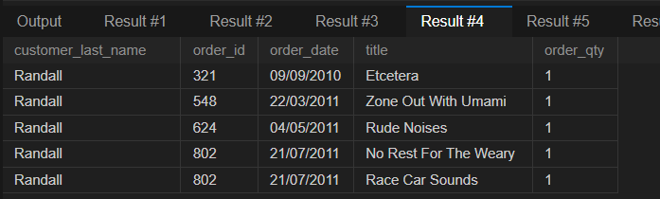
  - (3 points) Join + GROUP BY. Which items earn the most money? For every item show title, units_sold (total quantity ordered) and revenue (total of order_qty * unit_price). Show the three highest revenues first.
Top item and its revenue:
Umami In Concert: 233.35
More Songs About Structures and Comestibles: 143.60
Etcetera: 136.00
  - (2 points) Outer join. One order in om has no order lines at all. Find it with a LEFT JOIN from
orders to order_details and an IS NULL test. Give order_id and order_date.
Then answer in a comment: orders INNER JOIN order_details returns 68 rows. How many rows does orders LEFT JOIN order_details return, and why is it different?
= Inner join returns 68 rows, while Left join returns 69 rows. Because inner join will return only rows with match items in both columns of the ON clause, excluding the NULL on both table, while left join will only exclude NULL on the left table (table in FROM clause), but for the right table, if there is no match from the fk from left table it allows to join with NULL. (Inner join will not allow this and exclude this row from the return rows.)

Part 2: ex — employees and departments (8 points)
Three tables in ex. They have no foreign key constraints, which is why the data can be inconsistent on purpose.

Table Columns

departments department_number, department_name
employees employee_id, last_name, first_name, department_number, manager_id
projects project_number, employee_id

  - (2 points) Inner join. List employee_id, last_name, first_name and department_name for every employee, ordered by employee_id, using an INNER JOIN. There are 9 employees but the query returns fewer rows. Which employees are missing, and why? Look at their department_number.
Rows returned: 7
employee_id | last_name | first_name | department_name
1 | 'Smith' | 'Cindy' | 'Payroll'
2 | 'Jones' | 'Elmer' | 'Personnel'
3 | 'Simonian' | 'Ralph' | 'Payroll'
4 | 'Hernandez' | 'Olivia' | 'Accounting'
5 | 'Aaronsen' | 'Robert' | 'Payroll'
7 | 'Hardy' | 'Thomas' | 'Maintenance'
8 | 'O'Leary' | 'Rhea' | 'Personnel'
Missing: 2
employee_id | last_name | first_name | department_number | manager_id
6 | 'Watson' | 'Denise' | 6 | 8
9 | 'Locario' | 'Paulo' | 6 | 1
Because the missing 2 rows has the department_number = 6. There is no department with department_number = 6 in the departments table, so the inner join logic excludes those 2 rows.
  - (2 points) Left join. Change 2.1 so that every employee appears, with department_name shown as NULL when the department does not exist. Which join keyword did you change and which table must be on the left?
I added ‘left’ before ‘join’ to make it a left join instead of the default inner join, the table on the left is the ‘employees’ table.
  - (2 points) The other direction. Which department has no employees? Write a query that returns only that department’s number and name. Hint: start FROM departments, or use RIGHT JOIN.
Department number 3: Operations
  - (2 points) Self join. Every employee’s manager_id is the employee_id of another row in the same table. Show employee_id, the employee’s last_name as employee, and the manager’s last_name as manager, for all 9 employees. The company president has no manager and must still appear, with manager = NULL. Take a screenshot (S2).
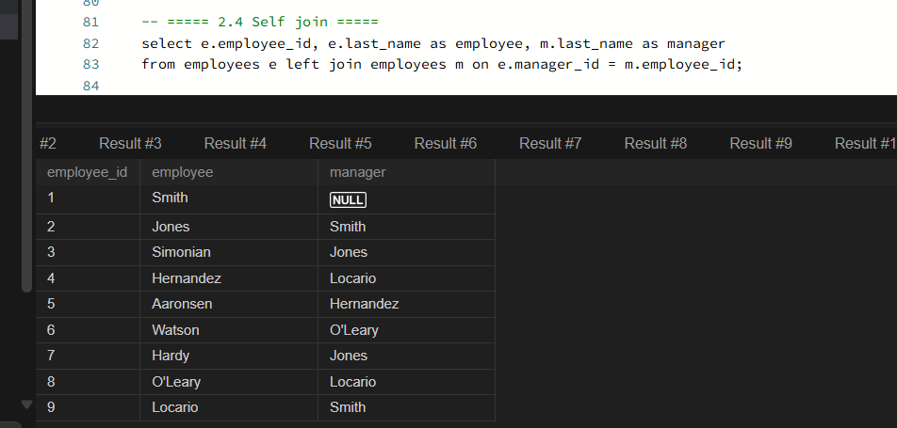

Submission checklist (read this before you upload)
Submit on Mango (CMU Canvas), assignment Lab 9, before the deadline shown there. This is individual work. Upload exactly two files, named with your student ID:
File 1: Lab9_<SID>.sql. One plain-text SQL script that the TA can run from top to bottom without any error, in this order and with these comment headers:
-- Lab 9 | Name: <your name> | SID: <your SID>

USE om;
-- SELECT here
-- rows: <number> newest order by: <last name>

-- ===== 1.2 Order 829 contents =====
-- SELECT here
-- order total: <amount>

-- ===== 1.3 Everything Randall bought =====
-- SELECT here
-- rows: <number>

-- ===== 1.4 Revenue per item =====
-- SELECT here
-- top item: <title>, <revenue>

-- ===== 1.5 Order with no lines =====
-- SELECT here
-- LEFT JOIN rows: <number> because: <one sentence>

USE ex;
-- ===== 2.1 Inner join =====
-- SELECT here
-- rows: <number> missing: <names>, because: <one sentence>

-- ===== 2.2 Left join =====

-- SELECT here
-- changed: <keyword>, left table: <table>

-- ===== 2.3 Department with no employees =====
-- SELECT here

-- ===== 2.4 Self join =====
-- SELECT here
File 2: Lab9_<SID>_screenshots.pdf (or two PNG files S1.png, S2.png). Each screenshot must show the whole Workbench window, not a cropped grid, so the connection name and the query are visible.

Screenshot | What it must show | From task
S1 | Result grid of 1.3 (Randall’s purchases) with the query above it | 1.3
S2 | Result grid of 2.4 (employee and manager) with 9 rows | 2.4

How you will be graded
Item | The TA checks | Evidence | Points
1.1 | Correct JOIN . . . ON, four columns, ORDER BY date DESC; 47 | File 1 | 2
1.2 JOIN to items, calculated line_total, correct order total |  | File 1 | 2
1.3 All four tables joined on the right keys, WHERE on last name, |  | File 1 + S1 | 3
1.4 | ORDER BY; row count  JOIN + GROUP BY item, SUM for both columns, ORDER BY | File 1 | 3
1.5 | revenue DESC, LIMIT 3  LEFT JOIN + IS NULL finds the order; row-count question | File 1 | 2
 | answered
2.1 INNER JOIN, correct row count, missing employees explained |  | File 1 | 2
2.2 LEFT JOIN with employees on the left; keyword and table named |  | File 1 | 2
2.3 Returns exactly one department |  | File 1 | 2
2.4 Self join with two aliases, LEFT JOIN so the president appears |  | File 1 + S2 | 2
Total |  |  | 20

rows and newest customer stated

Deductions. Script stops with an error: the TA grades only the parts that ran before the error. Missing alias or unqualified column that MySQL rejects as ambiguous: that task scores 0 until fixed. Wrong file names or missing SID: -1. Missing screenshot: 0 for that item. Submitted after the deadline: as per course syllabus.

