Lab 5— ER and Enhanced ER (EER) Modelling
Course: Database Systems
Duration: One lab session, plus completion at home
Deliverable: Business rules + EER diagrams in Chen notation, drawn in draw.io, Chen’ s/traditional Style. Submit to Mango on time.

What you will practise
By the end of this lab you should be able to:
- Extract business rules from prose and from spoken requirements.
- Resolve many-to-many relationships into associative entities.
- Recognise multivalued and composite attributes and notate them correctly.
- Identify weak entities and mark their partial keys correctly.
- Decide when a situation calls for a specialisation and when it calls for a category.
- Recognise requirements that an ER diagram cannot express at all.
The lab has two parts, and they cover different material.
Part A is guided, and uses ordinary ER only. The first rules are written for you and the entity list is half filled in. Outcomes 1 to 4 are practised here. There are no specialisations or categories in Part A — do not draw any.
Part B is independent, and adds EER. You get an interview conversation and no scaffolding. Outcomes 5 and 6 join the list.
Do Part A first even if you find it easy. Most diagrams that fail at EER fail because the ordinary ER underneath them was wrong.

Section 0 — Reference material

0.1 Notation
Construct | Symbol
Strong entity | Single rectangle
Weak entity | Double rectangle
Relationship | Diamond
Associative entity | Diamond carrying its own attribute ellipses
Identifying relationship | Double diamond
Attribute | Ellipse
Key attribute | Underlined
Partial key | Dashed underline
Multivalued attribute | Double ellipse
Derived attribute | Dashed ellipse
Composite attribute | Ellipse with child ellipses
Partial participation | Single line
Total participation | Double line
Specialisation | Circle on line; d = disjoint, o = overlapping
Category / union type | Circle marked ∪

0.2 Decision aid — do I need an associative entity? (Part A)
An Many-to Many relationship becomes an associative entity as soon as it has data of its own.
Q1. Is the relationship many-to-many? If not, you do not need one — put the foreign key on the “many” side.
Q2. Does the relationship have attributes? A grade for a student on a course, a quantity for an ingredient in a dish, a loading position for a parcel on a truck. If yes, those attributes have nowhere else to live.
Q3. Can the same pair occur more than once? If the same staff member can work at the same hub in two different periods, the pair alone is not unique and the associative entity needs a date in its key.
How to draw it in Chen notation: the relationship diamond gets its own attribute ellipses hanging off it. When you map to relations later, that diamond becomes a table whose key is the combination of both foreign keys, plus any discriminator from Q3.

0.3 Decision aid — multivalued or composite? (Part A)
These two are confused constantly because both attach several values to one entity.
 | Multivalued | Composite
Question it answers | “How many of these does one entity have?” | “What parts is this one value made of?”
Example | A customer’s phone numbers | A customer’s address
Count | Unknown, varies per entity | Fixed, the same parts every time
Notation | Double ellipse | Ellipse with child ellipses
Common mistake | Adding phone1, phone2, phone3 | Storing the whole address as one string
An attribute can be both: a customer with several addresses, each broken into parts, is a multivalued composite attribute.

0.4 Decision aid — specialisation or category? (Part B)
This is the choice students get wrong most often. Work through it in order:
Q1. Do the subtypes share a meaningful set of common attributes? If yes → specialisation. If no → probably a category.
Q2. Is there a natural supertype that exists in its own right? “Every courier IS A staff member, and staff members exist as a concept” → specialisation. “A locker is not really a kind of anything the branch is also a kind of” → category.
Q3. Which direction does the arrow of identity run? Specialisation: one supertype splits into many subtypes. Category: many unrelated supertypes merge into one subtype.
Then attach the two qualifiers, separately:
Question | If yes | If no
Must every supertype instance belong to some subtype? | Total (double line) | Partial (single line)
Can one instance belong to two subtypes at once? | Overlapping (o) | Disjoint (d)
These two are independent. All four combinations occur, and both problems in this lab contain more than one combination.

0.5 Decision aid — is it a weak entity?
Ask: can this thing be identified without naming its parent?
If the identifier restarts inside each parent — table 1 at every branch, line 1 on every order, parcel 1 in every shipment — it is weak, and the number is a partial key with a dashed underline. If it has a globally unique identifier of its own, it is strong, even if it depends on something else for meaning.

0.6 Decision aid — where does this attribute live?
If a value changes when you change either of two entities, it belongs to the relationship between them, not to either one.
Example: a stock level that differs per branch and per ingredient belongs to the branch–ingredient relationship. Putting it on INGREDIENT forces one number for the whole company; putting it on BRANCH is nonsense.

0.7 Worked example
From the cinema system you have already seen:
“A cinema contains many auditoriums. Each auditorium is numbered 1, 2, 3 within its cinema. An auditorium cannot exist without its cinema.”
Business rules extracted:
- BR-W1: A CINEMA contains one or more AUDITORIUMs.
- BR-W2: An AUDITORIUM belongs to exactly one CINEMA and cannot exist without it.
- BR-W3: An AUDITORIUM is identified by its screen number within its cinema.
What this becomes in the diagram:
- CINEMA — single rectangle, key attribute cinema_id underlined
- AUDITORIUM — double rectangle, partial key screen_no with dashed underline
- contains — double diamond (identifying)
- Cardinality 1 at the cinema end, N at the auditorium end
- Double line from AUDITORIUM to the diamond (total participation — every auditorium must have a cinema)
Notice that three separate notation decisions came out of one sentence. Read every sentence in the problems below this closely.

PART A — Parcel Delivery Network (guided)
Modelled on Thai last-mile carriers. Treat the company as fictional: Sabai Express.
Part A is ordinary ER only. There are no specialisations and no categories here — do not draw any. What you are practising instead is three things that students routinely get wrong long before EER becomes relevant:
- resolving many-to-many relationships into associative entities,
- recognising multivalued attributes,
- recognising composite attributes.

A.1 The scenario
Sabai Express operates a nationwide parcel delivery network from a head office in Bangkok, with regional sorting hubs in Chiang Mai, Khon Kaen, Hat Yai and elsewhere. Each hub serves a set of postal codes, and every postal code is served by exactly one hub.
The company keeps a record of every customer. A customer has a customer number and a name. Customers give the company several contact numbers — a mobile, sometimes a home number, sometimes a shop number — and the courier needs all of them. Each customer also has an address, which the system must break down into house number, street, sub-district, district and province, because the sorting machines read the sub-district separately from the province.
Customers create shipments. Every shipment has one customer as the sender and one customer as the recipient. The same customer can be the sender on one shipment and the recipient on another — many small online sellers do both all day.
A shipment contains one or more parcels. Parcels within a shipment are numbered 1, 2, 3, and that number means nothing outside the shipment. Each parcel records a weight, dimensions, and a declared value. The booking screen shows the total weight of the shipment, but no member of staff ever types it in.
Every parcel is scanned as it travels, producing a tracking event with a timestamp, a location and a status code. The events for a parcel are numbered in sequence.
Parcels travel between hubs on route legs. A route leg runs from one hub to another hub, on a particular date, operated by one vehicle. A single parcel passes through many route legs on its journey, and a route leg carries many parcels. For each parcel on each leg the system records the position it was loaded in, and the time it was loaded — the warehouse uses this to find a parcel inside a full truck.
Sabai Express employs staff, each with an employee number, a name, a hire date, and a monthly salary. Like customers, staff give the company more than one phone number, and their address is recorded in the same broken-down form.
Staff are assigned to work at hubs. A staff member works at different hubs over time, and a hub is worked by many staff. For each assignment the system records the date it started, the date it ended, and the shift pattern worked.
The company also runs service points where customers drop off and collect parcels. A service point has a code, a name, an address, and a type — company branch, locker, or partner store. Each service point is attached to exactly one hub. Service points offer a set of services: drop-off, collection, packaging sales, cash payment. Different service points offer different combinations, and a customer will ask which ones a given point supports.
Finally, each parcel may be insured. Insurance is bought per parcel, from one of several insurance products, and the system records the premium paid and the coverage limit agreed for that particular parcel. A given insurance product covers many parcels over time.

A.2 Business rules — started for you
The first six are done. Complete the list to at least eighteen rules.
- BR-A1: A HUB serves one or more POSTAL_CODEs.
- BR-A2: A POSTAL_CODE is served by exactly one HUB.
- BR-A3: A CUSTOMER has one or more contact phone numbers.
- BR-A4: A CUSTOMER’s address consists of house number, street, sub-district, district and province.
- BR-A5: A SHIPMENT contains one or more PARCELs; a PARCEL belongs to exactly one SHIPMENT and cannot exist without it.
- BR-A6: The total weight of a SHIPMENT is calculated from the weights of its parcels and is not stored.
- BR-A7: A TRACKING_EVENT records timestamp, location and status code. The event is being recorded as the parcel travels. (Like the travel log of that parcel.)
- BR-A8: A ROUTE_LEG carries many PARCEL, and a PARCEL passes through many ROUTE_LEGs as well.
- BR-A9: A ROUTE_LEG records the time and the position a parcel is loaded in.
- BR-A10: A STAFF has employee number, name, hire date, monthly salary, phone number, and address.
- BR-A11: STAFF’s phone number and address format is the same as that of the CUSTOMER. (More than one for phone number and address consists of house number, street, sub-district, district and province.)
- BR-A12: A STAFF may work at different HUB overtime, and a HUB has many staffs.
- BR-A13: For each work assigned to a STAFF at a HUB, start date, end date, and shift pattern are recorded.
- BR-A14: A SERVICE_POINT has code, name, address, and type.
- BR-A15: A SERVICE_POINT is attached to only one HUB
- BR-A16: A SERVICE_POINT offers a set of different services (aka SERVICE_TYPE), which each SERVICE_POINT offers different sets of services as well.
- BR-A17: An INSURANCE_PRODUCT is bought per PARCEL, while one INSURANCE_PRODUCT can cover many parcels overtime.
- BR-A18: The system records premium paid and coverage limit of the INSURANCE_PRODUCT for that PARCEL.
I forgot to add section
- BR-A19: A CUSTOMER also has customer number and name.
- BR-A20: A PARCEL has its weight, dimension, and (declared) value.
- BR-A21: A CUSTOMER creates SHIPMENT. They may be a sender, a receiver, or both.
(continue)

A.3 Entity worksheet — half filled in
Entity | Strong / Weak / Associative | Key or partial key | Notes
HUB | Strong | hub_id
POSTAL_CODE | Strong | postal_code
CUSTOMER | Strong | customer_id | See A.4 hints 1, 2
SHIPMENT | Strong | shipment_id | See A.4 hint 3
PARCEL | Weak | parcel_no (partial) | Parent = SHIPMENT
TRACKING_EVENT | Weak | event_no (partial) | Parent = PARCEL
ROUTE_LEG | Strong | route_leg_id
PARCEL_LOADING | Associative | parcel_no, route_leg_id (composite key) | See A.4 hint 4
STAFF | Strong | employee_no
HUB_ASSIGNMENT | Associative | work_id | See A.4 hint 5
SERVICE_POINT | Strong | code | See A.4 hint 6
SERVICE_TYPE | Strong | service_type_id
INSURANCE_PRODUCT | Strong | ins_pro_id
PARCEL_INSURANCE | Associative | parcel_no | See A.4 hint 7

A.4 Hints
- Phone numbers. A customer has several and you must keep them all. Do not add phone1, phone2, phone3 columns — that is the mistake this construct exists to prevent. Use the correct notation.
- Address. One attribute made of named parts, each of which you may need to search on separately. Draw the parent ellipse and hang the parts off it.
- Sender and recipient. These are two relationships between the same pair of entity types, not two entity types. Give each relationship a name, and think about whether one customer can appear at both ends of the same shipment.
- Loading position. Ask: does this value change if I change the parcel? Does it change if I change the route leg? If the answer is yes to both, it belongs to neither entity — it belongs to the relationship between them, which becomes an associative entity.
- Hub assignments. Apply the same test as hint 4. Note that a staff member may work at the same hub twice at different times, so think carefully about what makes each assignment unique.
- Service point type. This is a plain attribute with three possible values. Do not turn it into three entity types — that is EER, and Part A does not use it.
- Insurance. Premium and coverage limit are agreed per parcel, not fixed by the product. Where do they go?

A.5 Required constructs — Part A
- ☐ At least three associative entities, each resolving an M:N relationship and each carrying at least one attribute of its own
- ☐ At least two multivalued attributes
- ☐ At least two composite attributes
- ☐ A derived attribute
- ☐ Two weak entities with partial keys correctly marked
- ☐ Two different relationships between the same pair of entity types, with distinct names
- ☐ Correct participation marking on every relationship
- ☐ No specialisations and no categories — if you have drawn one, you have misread the scenario

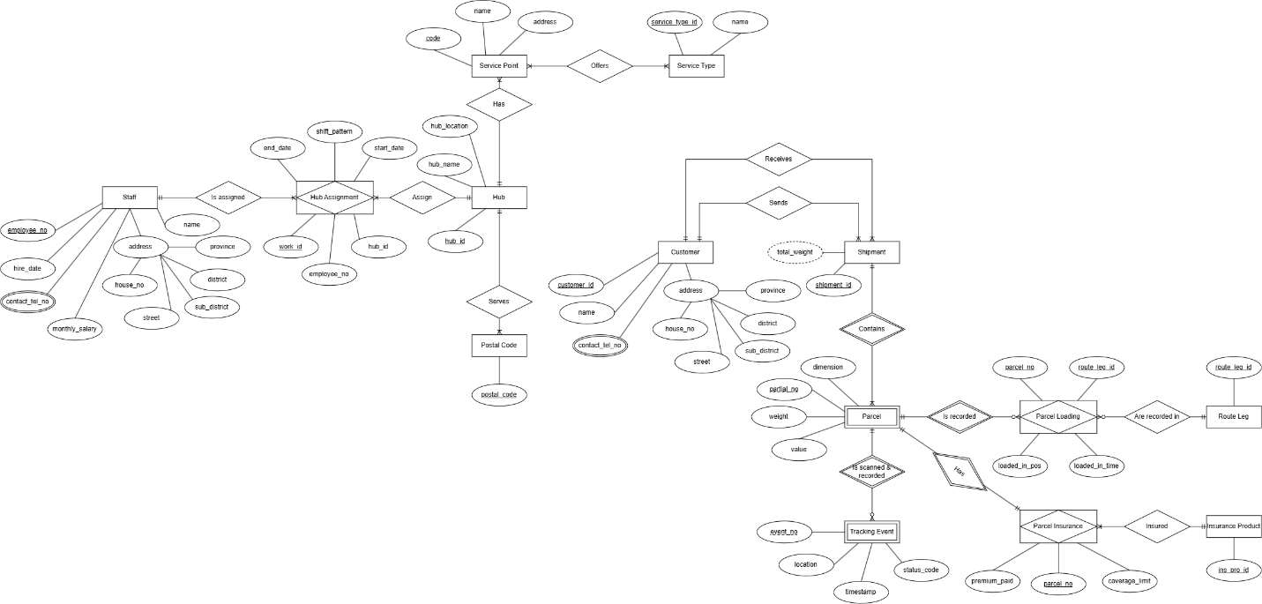

PART B — Restaurant Group (independent)
Fictional Chiang Mai restaurant group: Ban Suan Kitchen, four branches.

What to do
Read the conversation below between a database consultant and the owner of a small restaurant group. Everything you need is in it.
Hand in three things:
- A numbered list of business rules extracted from the conversation.
- An EER diagram in Chen notation covering those rules.
- A short note on anything you found that the diagram cannot express.

The conversation
Consultant: Thanks for making time. Let’s start simple — how many restaurants do you have?
Owner: Four. Nimman, Old City, Santitham, and Hang Dong. Hang Dong opened last year.
Consultant: What should the system store about each one?
Owner: The address, a phone number, and how many seats. Nimman is forty-two seats, Hang Dong is a hundred and ten because of the garden.
Consultant: And who runs each one?
Owner: Each branch has one manager. Just one. And a manager only runs one branch — I don’t want them driving between shops.
Consultant: Let’s talk about tables.
Owner: Every branch numbers its tables from one. Table one, table two, up to fourteen at Nimman and about thirty at Hang Dong.
Consultant: So there’s a table number one at all four branches?
Owner: Yes. The staff just say “table six” and everyone knows which one, because they’re standing in the shop.
Consultant: What do you record about a table?
Owner: How many people it seats, and which zone it’s in — indoor, terrace, or garden.
Consultant: If you ever closed a branch, what would happen to its tables?
Owner: They’d just be gone. A table doesn’t mean anything on its own. It belongs to the shop.
Consultant: Now the menu. Is it the same everywhere?
Owner: One menu, all four shops, same prices. Every item has a code, a Thai name, an English name, a description, and a price.
Consultant: Are all the items the same sort of thing?
Owner: No, there are three sorts. Food dishes, drinks, and sets.
Consultant: What’s different about each?
Owner: A food dish has a spice level and a cooking time. A drink has a size in millilitres and whether it’s alcoholic. A set is a package deal — like the lunch set, which is khao soi plus a Thai tea plus a dessert, and it has a discount percentage.
Consultant: So a set is built out of other menu items?
Owner: Right. And sometimes more than one of the same thing — the family set has four Thai teas in it, so I need to store the quantity.
Consultant: Can the same dish appear in several sets?
Owner: Khao soi is in about five of them. It’s what we’re known for.
Consultant: And is every item exactly one of those three sorts? Nothing is both a dish and a drink?
Owner: Exactly one. Never both.
Consultant: Anything else about menu items?
Owner: Allergies. This matters more every year, especially with foreign customers. A dish might contain peanut, or shellfish, or gluten, or dairy — and some dishes have three of those at once. It has to print on the menu.
Consultant: How about ingredients?
Owner: Every dish has a recipe. So much fish sauce, so much chilli, so much coconut milk. The kitchen needs the exact amounts. And one ingredient goes into lots of dishes — coconut milk is in half the menu.
Consultant: Do you track how much stock you have?
Owner: Yes, but branch by branch. Nimman might be out of galangal on a Tuesday while Hang Dong still has plenty. It’s never one number for the whole company.
Consultant: Let’s move on to orders. How does an order come in?
Owner: Three ways. Someone sits down at a table. Someone comes to the counter for takeaway. Or it arrives from a delivery app — Grab, LINE MAN, foodpanda.
Consultant: Do those three have anything in common, apart from being orders?
Owner: Honestly, not much. For a dine-in order I need the table and how many guests. For takeaway I need a name to call out and the time they said they’d collect. For a delivery order I need the app’s own reference number and the delivery fee, because they take a commission and I have to reconcile it at month end.
Consultant: Can one order be more than one of those at once?
Owner: No. It’s always exactly one.
Consultant: What goes on the order itself?
Owner: The time it was placed, which staff member took it, and a status — ordered, cooking, served, paid, or cancelled.
Consultant: And the individual items on it?
Owner: Each line has one menu item, a quantity, and sometimes a note. “No chilli.” “Extra rice.” The lines are numbered on the ticket — line one, line two — and it starts again at one for every new order.
Consultant: Which price goes on the line? Today’s menu price?
Owner: No, the price at the moment they ordered. We raised prices in April and my accountant found that all the old bills had changed to the new price. That can’t happen. A bill from March has to say the March price forever.
Consultant: Do you store the total for the order?
Owner: It prints on the receipt, but nobody types it in. The system adds it up from the lines.
Consultant: Tell me about staff.
Owner: Each one has an employee number, a name, the date they started, and an hourly wage.
Consultant: Are there different kinds of staff?
Owner: Three kinds. Kitchen staff have a station — wok, grill, prep, or pastry. Service staff have a section of the floor. Cashiers have a till number.
Consultant: Is every staff member exactly one of those three?
Owner: Not quite. On a quiet Tuesday at Santitham, Khun Pim serves tables and works the till in the same shift. So somebody can be two of them at once. And the managers aren’t any of the three — they don’t have a station or a section or a till.
Consultant: Does anyone supervise anyone else?
Owner: Yes. Each manager supervises the staff at their branch, and I supervise the managers. Everyone has one supervisor above them, except me.
Consultant: Last topic — reservations.
Owner: People phone up and book. I need the date and time, how many in the party, and a contact phone number.
Consultant: Do you decide which table they get when they book?
Owner: Sometimes. A big group goes straight onto the garden long table. But usually we leave it open and see what’s free when they arrive.
Consultant: And do all your tables get reserved sooner or later?
Owner: The little two-seaters by the kitchen door? Never. Nobody ever asks for those.
Consultant: That’s everything I need. Thank you.

Business Rules
BR-B01: A restaurant branch has an address, phone number, and total seats number
BR-B02: A restaurant branch is run by one manager, and each manager can only run one restaurant.
BR-B03: In a restaurant branch, there are many tables, which every tables has a label number.
BR-B04: A table also records the number of people it seats, and the zone it's in.
BR-B05: Once the restaurant branch is out of business, the tables data are also deleted.
BR-B06: Menus are shared across every branch.
BR-B07: The menu records the item code, Thai name, English name, description, and price. (Every item's price are the same in every branch)
BR-B08: The menu items can be categorized to only exactly one category, as food dishes, drink, and sets.
BR-B09: Attributes for each menu items are:
- Food dish: spice level, and cooking time.
- Drink: size (ml), is alcoholic?
- Set: a package mixes of food dishes and drinks. It also records the discount percentage.
BR-B10: A set can have more than one item of the same kind in it, so quantity record is required.
BR-B11: Other menu items can appear in many different set as well.
BR-B12: A menu item may contain more than one allergic ingredients (peanut, or shellfish, or gluten, or dairy).
BR-B13: One ingredient can be used in a lot of dishes.
BR-B14: Ingredient stocks are tracked branch by branch.
BR-B15: There are 3 ways to order from a restaurant, sit-down, takeaway, delivery. Customer pick only one way to order.
BR-B16: In each way of order collects the following data:
- Sit-down: table number, number of guests
- Takeaway: callout name, pickup time
- Delivery: app reference number, delivery fee.
BR-B17: Though, the order itself has placed time, responsible staff member, status, and the order items.
BR-B18: Each order item has one menu item, item number, quantity, item price, and sometimes a note.
BR-B18S: The item number of order item resets for every new order.
BR-B19: Item prices are immutable. It won't change in an old bill even after the price raises.
BR-B20: Every order is printed on a receipt, with the total of everything calculated from each order.
BR-B21: An employee has a number, name, started date, hourly wage.
BR-B22: There are 3 kinds of staff, which collect the following data:
- Kitchen staff: station
- Service staff: floor section
- Cashier: till number?
BR-B23: A staff may take more than one role in the same shift.
BR-B24: Manager is not one of the staff. (But technically, they are still an employee.)
BR-B25: Manager and staff has one supervisor: Owner supervises managers, and a manager supervises staffs.
BR-B26: Reservation requires date and time, number of people in the party, and a contact phone number data.
BR-B27: Reservation table is usually decided when the customer arrived, but it may have been decided before hand as well. (Choose the empty table.)
BR-B28: Some tables have never been reserved.
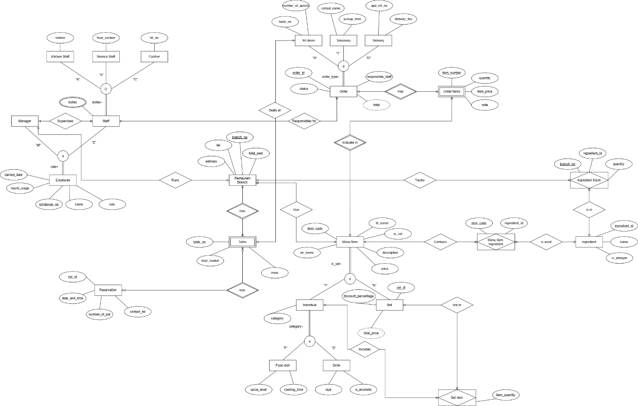

Check your diagram
Before you hand in, confirm your diagram contains all of the following. Each one is supported somewhere in the conversation — if you cannot find where, re-read.
- ☐ A 1:1 relationship
- ☐ A weak entity whose numbering restarts inside each parent
- ☐ A second weak entity
- ☐ A disjoint, total specialisation
- ☐ An overlapping, partial specialisation (Please point it out to me where it is. I can’t find it, even after getting some helps from AI too.)
- ☐ A category (union type) with three superclasses
- ☐ A recursive M:N relationship that carries an attribute
- ☐ A recursive 1:N relationship with role names
- ☐ A multivalued attribute
- ☐ A derived attribute
- ☐ At least two M:N relationships carrying their own attributes
- ☐ A relationship that is partial on both sides

Note: If you cannot see the diagrams clearly, check out the diagram images I sent along with.

Discussion questions
Answer briefly, in your own words.
- In Part A, a customer’s phone numbers are multivalued and the address is composite. Explain why swapping the two notations — a composite phone number and multivalued address parts — would be wrong in both directions.
= Doing that would mean customer can have multiple address and their phone number consists of multiple parts, which in this case, it’s just… wrong. (Maybe that is okay in some other cases, but it’s not necessary in the domestic logistic company)
- Part A tells you a staff member may work at the same hub in two different periods. What does this force you to add to the associative entity, and what would go wrong without it?
= Without associative entity, the data relationship can imply that a staff member may be able to work in different hub AT THE SAME TIME, which is not possible. So, the associative entity adds “work” that requires to work at a specific workplace for a staff to be assigned to, with the start and end period data recorded, to prevent works in other hub to overlap staff’s current hub works. This is more reasonable as staff is no longer required to be in different hub at the same time to work, while still follow the M:N rule that staff can work at different hub overtime.
- Part A’s service point has a type attribute with three values; Part B’s order sources have three kinds too, but need a category. What is different about the two situations?
= Because the situation/business rules in Part A doesn’t specify those three service point types their own different additional attributes, while in Part B, each type/category has its own additional attributes.
- Part B’s stock levels vary by branch. Which construct does this force, and what goes wrong if you attach the attribute to INGREDIENT instead?
= It’s not possible to attach the attribute directly to Ingredient when each branch has its own stock. Doing that would mean the ingredient stock is universal to every branch; when branch one runs out of 1 ingredient, the other branch also no longer have it too, which is not the case here. So, we need an Associative Entity.
- In Part B the owner describes a real incident caused by a modelling failure — old bills changing when prices rose. Name the failure and state the general principle about storing values that originate in another entity.
= The problem was probably caused from linking menu items price from order items to store a receipt/order, so when the menu items price get updated, it affects the order items and the receipt, causing the total bill to change. The failure may be named as “Unintentional Data Syncing” (ChatGPT names it Update Anomaly, but what do you think?). To prevent that, you should store a copy of prices and use that on the receipt/order instead.

Marking guide
Criterion | Part A | Part B
Business rules extracted correctly and completely | 20% | 30%
Entities, attributes and keys correctly identified | 20% | 20%
Associative entities correctly resolved, with their own attributes | 25% | —
Multivalued and composite attributes correctly notated | 20% | —
EER constructs used correctly | — | 25%
Cardinality and participation constraints correct | 15% | 20%
Inexpressible constraints noted | — | 5%
Parts A and B are weighted equally overall. Part A carries no EER marks at all; drawing a specialisation or a category there loses marks rather than gaining them.

Common mistakes
- Using a specialisation where a category is required, or the reverse. Re-read 0.4.
- Drawing a weak entity with a full key instead of a partial key.
- Marking a specialisation total when it is partial, or disjoint when it is overlapping. The two qualifiers are independent — decide them separately.
- Modelling a derived attribute as stored, or forgetting the dashed ellipse.
- Placing an attribute on an entity when it belongs to a relationship. Re-read 0.6.
- Creating a separate entity for a role in a recursive relationship (SUPERVISOR, MANAGER).
- Leaving participation unmarked. Every relationship line is either single or double — never bare.

