SE212 Database System and Design (Basic ER modeling)
Lab 3(Basic ER modeling)
Name_____Thanwisit Angsachon______________SID_______682115018______________

- (5 points ) Define each of the following terms and give an example.
- Business rule
Ans: Statement that defines or constrains some aspects of business, e.g. Defining who do what, has what, to whom -> Customer has username, and id, order many drinks from Barista.

- Binary relationship
Ans: Relationship between 2 entities, e.g. Students takes Courses (Students, and Courses are entities, the relationship between them is “take”).

- Relationship type
Ans: Relationship type classifies how the relationship between each entity instance works. There are 1-to-1, 1-to-many, and many-to-many, e.g. Any student can take any course up to 6 courses.
The course accepts more than 1 student: many
Students can choose more than 1 course: many
Hence many-to-many.

- Attributes
Ans: Property of an entity, e.g. Student has property of id, student_email, gpa, so is attribute.

- Entity instance
Ans: An actual instance that holds the data according to entity’s attributes. You may see it as a record in the table, e.g.

Student Table (Entity)
Student ID | Student Email | GPA
682115018 | thanwisit_ang@cmu.ac.th | 4.00

There is one instance in the table.

- (5 point) Giving the business rule below, identify entities for the model.
- A department employs many employees, but each employee is employed by one department.
- Some employees, known as "rovers," are not assigned to any department.
- A division operates many departments, but each department is operated by one division
- An employee may be assigned to many projects and a project may have many employees assigned to it.
- A project must have at least one employee assigned to it.
- One of the employees manages each department.
- One of the employees runs each division.

Ans:
- Department
- Division
- Employee
- Project

3. (5 point) For each of the following pairs of related entities, indicate whether (under typical circumstances) there is a one-to-many or a many-to-many relationship. Then, using the
shorthand notation (traditional) introduced in the slide and text, draw a diagram for each of the relationships. You are going to create a traditional ER diagram using draw.io. (10 points)
a. STUDENT and COURSE (students register for courses)
= Many-to-many
b. BOOK and BOOK COPY (books have copies)
= 1-to-many
c. COURSE and SECTION (courses have sections)
= 1-to-many
d. SECTION and ROOM (sections are scheduled in rooms)
= 1-to-many
e. INSTRUCTOR and COURSE
= Many-to-many
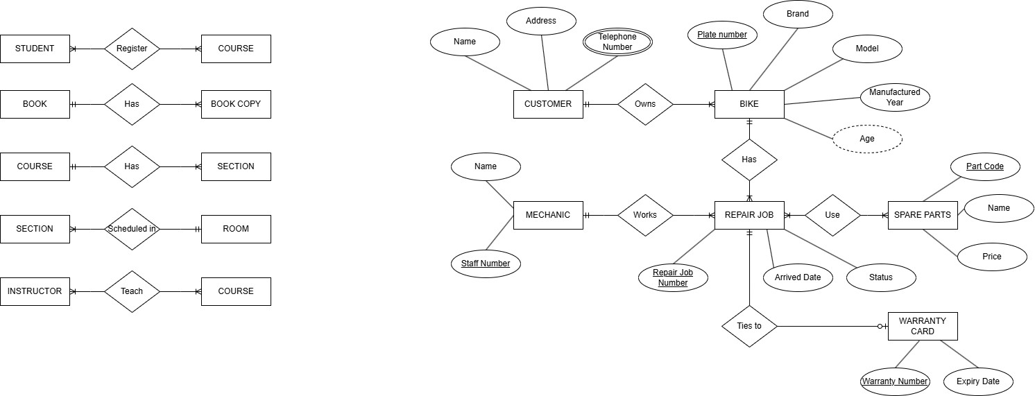

4.CM Fix is a busy motorbike repair garage in Chiang Mai. Right now the owner tracks everything in paper notebooks and wants a proper database. In her own words, here is how the garage works.
"Whenever someone new comes in, I write down their name, their address, and how to reach them. Most customers give me two or three phone numbers — a mobile, sometimes a home line, sometimes their shop's number — and I like to keep all of them so I can always get hold of them.
A lot of my regulars own more than one bike — a scooter for the wife, a big bike for the husband. But of course each bike has just one owner. For every bike I note the plate number, the brand, the model, and the year it was made. When customers ask 'how old is my bike now?' I just work it out from the year — I don't bother writing the age down anywhere.
When a bike comes in, I open a repair job for it: I give it a job number, note the date it arrived, and mark whether it's waiting, in progress, or done. One job is always for one bike, but a bike that's been with me for years might have a long history of jobs.
I've got a few mechanics. Each has a staff number and a name. I always hand a whole job to just one mechanic so there's no confusion about who's responsible, but naturally each of them is juggling lots of jobs.
I keep spare parts in stock — brake pads, spark plugs, oil filters, and so on, each with its own part code, a name, and a price. A single repair usually eats up several different parts, and honestly the same part goes into loads of different jobs.
Once a repair is finished, I sometimes issue a warranty card with a warranty number and an expiry date — but only for jobs that are actually completed. A job still sitting on the bench doesn't have one yet, and every card I hand out is tied to exactly one repair job."
  - Read the description and extract the business rules (write them as clear one-line statements, e.g. "A customer owns one or more motorbikes; each motorbike belongs to exactly one customer").
- Customer has name, address, and multiple telephone number—mobile, homeline, shop’s. They own one or more motorbikes; each motorbike belongs to exactly one customer.
- Bike has plate number, brand, model, and manufactured year. Bike age will be calculated from manufactured year.
- Repair job has repair job number, arrived date, status
- One repair job belongs to fixing one bike, but a bike may have many repair job history.
- Mechanic has staff number, and name.
- One repair job belongs to one mechanic, but mechanic works on a lot of repair jobs.
- Spare parts have their own part code, name, and price. Many parts go to many different repair jobs.
- Warranty card has warranty number, and expiry date. One card ties to exactly one repair job that is completed.
4.2 From those rules, draw the ER diagram in traditional ER notation. Make sure your diagram correctly shows the primary keys, any multivalued and derived attributes, and the cardinality and participation of every relationship. 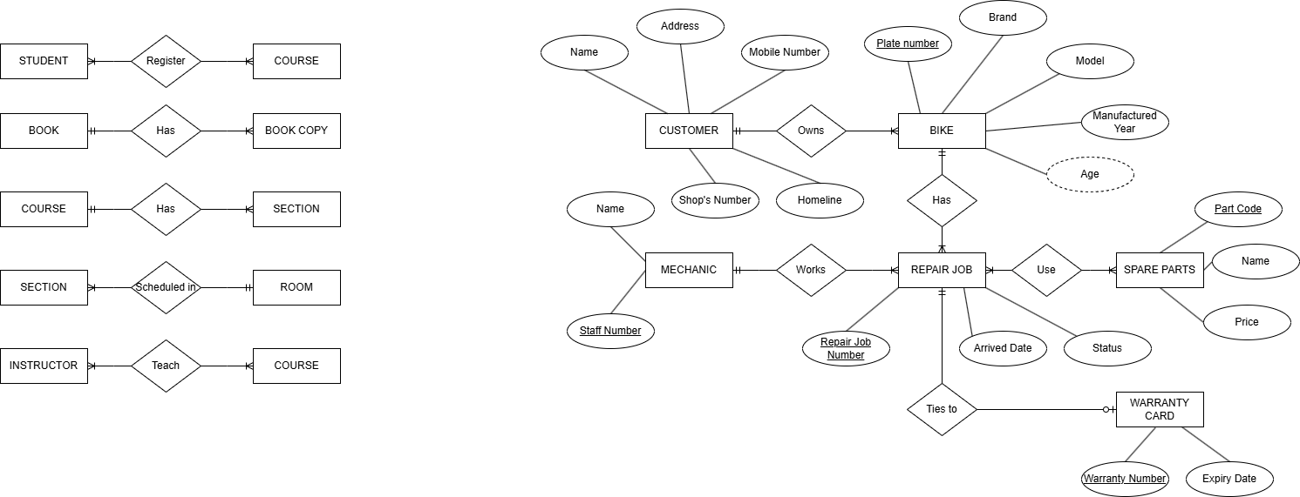
ER diagram notation for attributes.
