**Introduction**

**Apache Kafka™ is *a distributed streaming platform（apache的kafka是分布式流数据处理平台）*. What exactly does that mean?**

We think of a streaming platform as having three key capabilities:

1. It lets you publish and subscribe to streams of records. In this respect it is similar to a message queue or enterprise messaging system.
2. It lets you store streams of records in a fault-tolerant way.
3. It lets you process streams of records as they occur.

我们认为一个流数据处理平台具有三个关键的功能：

1. 可以发布和订阅流数据。在这个方面，apache kafka与消息队列和企业的消息系统相似
2. 高容错性的存储流数据
3. 当数据产生的时候可以处理这些流数据

What is Kafka good for?

It gets used for two broad classes of application:

1. Building real-time streaming data pipelines that reliably get data between systems or applications
2. Building real-time streaming applications that transform or react to the streams of data

Kafak适用于哪些场景：

1. 在系统和应用之间提供获取数据的实时的数据流管道
2. 实时的转换和处理流数据的应用

To understand how Kafka does these things, let's dive in and explore Kafka's capabilities from the bottom up.

First a few concepts:

* Kafka is run as a cluster on one or more servers.
* The Kafka cluster stores streams of *records* in categories called *topics*.
* Each record consists of a key, a value, and a timestamp.

一些概念：

1. kafka以集群的形式运行，集群可能包含一台或者多态服务器
2. kafka以topic的类别来存储流数据
3. 每一条记录包含一个key、value和timestamp

Kafka has four core APIs:

* The [Producer API](http://kafka.apache.org/documentation.html#producerapi) allows an application to publish a stream of records to one or more Kafka topics.
* The [Consumer API](http://kafka.apache.org/documentation.html#consumerapi) allows an application to subscribe to one or more topics and process the stream of records produced to them.
* The [Streams API](http://kafka.apache.org/documentation/streams) allows an application to act as a *stream processor*, consuming an input stream from one or more topics and producing an output stream to one or more output topics, effectively transforming the input streams to output streams.
* The [Connector API](http://kafka.apache.org/documentation.html#connect) allows building and running reusable producers or consumers that connect Kafka topics to existing applications or data systems. For example, a connector to a relational database might capture every change to a table.

Kafka包含四个核心的apis:

1. [Producer API](http://kafka.apache.org/documentation.html#producerapi):应用可以借用此api发布的数据流到一个或者多个kafka的topics
2. [Consumer API](http://kafka.apache.org/documentation.html#consumerapi):应用可以借用此api订阅一个或者多个topics，并且处理这些流数据
3. [Streams API](http://kafka.apache.org/documentation/streams)：应用可以借用此api作为一个stream处理器。从一个或者多个主题消费数据，并且向产生新的数据发布到一个或者多个topics。即有效的将输入转换为输出
4. [Connector API](http://kafka.apache.org/documentation.html#connect)：数据系统和应用可以借用此api构建和运行针对kafka主题的可重复使用的生产者或者消费者。例如，一个到关系型数据库的connector也许会捕获某个表的每一次改变。

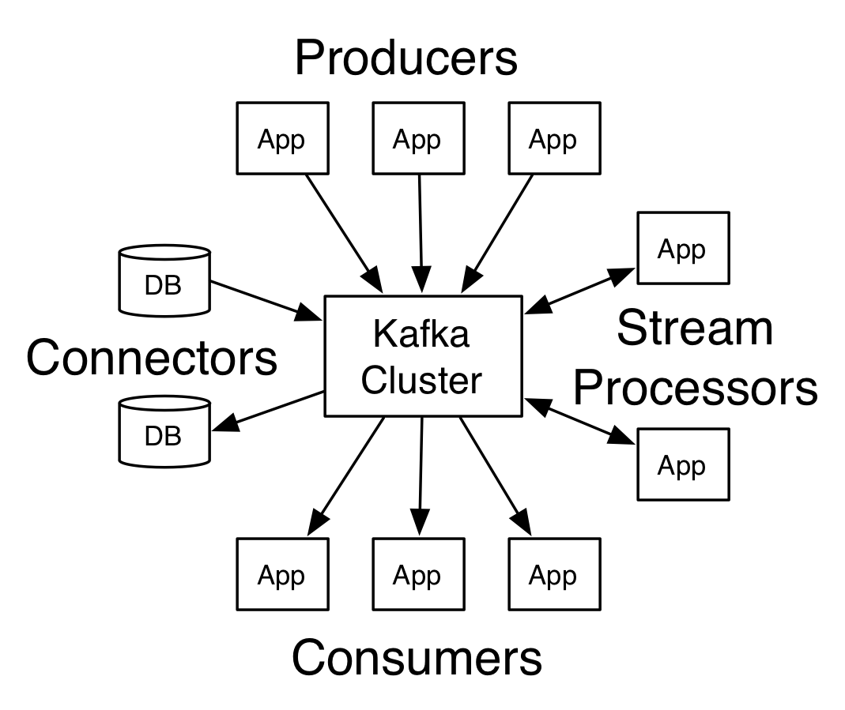

In Kafka the communication between the clients and the servers is done with a simple, high-performance, language agnostic [TCP protocol](https://kafka.apache.org/protocol.html). This protocol is versioned and maintains backwards compatibility with older version. We provide a Java client for Kafka, but clients are available in [many languages](https://cwiki.apache.org/confluence/display/KAFKA/Clients).

在kafka中，client和server的连接是通过简单的、高效的和语言无关的tcp协议。这个协议是分版本的并且是后向兼容的。我们为kafka提供了一个java的client，不过clients可以使用很多语言实现。

[**Topics and Logs**](http://kafka.apache.org/intro#intro_topics)

Let's first dive into the core abstraction Kafka provides for a stream of records—the topic.

先来讨论topic

A topic is a category or feed name to which records are published. Topics in Kafka are always multi-subscriber; that is, a topic can have zero, one, or many consumers that subscribe to the data written to it.

一个Topic是一个消息发布的分类或者feed 名字。在kafka中的topic总时可以被多个订阅者消费的(me：所以它不是peer-to-peer的消息系统)。那也就是说，一个topic可以有零个、一个或者多个消费者订阅这个数据。

For each topic, the Kafka cluster maintains a partitioned log that looks like this:

对于每个topic，kafka集群维护了一个partitioned日志，如下：

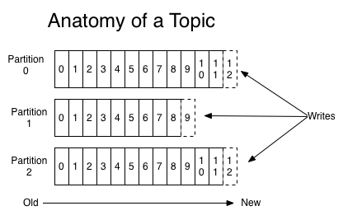

Each partition is an ordered, immutable sequence of records that is continually appended to—a structured commit log. The records in the partitions are each assigned a sequential id number called the *offset* that uniquely identifies each record within the partition.

每个partition都是一个有顺序的且顺序不可改变的记录队列，新的记录只能连续的被追加到一个结构化的commit日志。在partitions中的每条记录被给予了一个称为offset的序列化的id。这个id应为是序列化的，所以在partition中是唯一的，这个id即标识了partition中的每一条记录。

The Kafka cluster retains all published records—whether or not they have been consumed—using a configurable retention period. For example, if the retention policy is set to two days, then for the two days after a record is published, it is available for consumption, after which it will be discarded to free up space. Kafka's performance is effectively constant with respect to data size so storing data for a long time is not a problem.

无论记录是否被消费，kafka集群保存了所有发布的记录。可以配置该保留期限。例如，如果保存策略被设置为2天，那么在发布之后的两天之内该记录可以被消费。两天之后该记录即被删除以节省空间。Kafka的性能与存储的数据有关，所以记录可以在kafka中保存较长的时间。

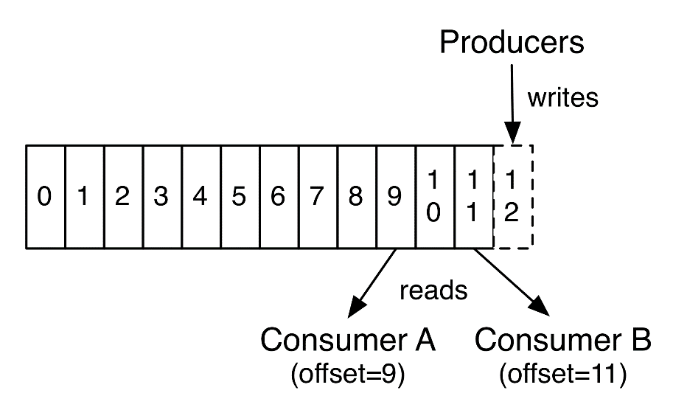

In fact, the only metadata retained on a per-consumer basis is the offset or position of that consumer in the log. This offset is controlled by the consumer: normally a consumer will advance its offset linearly as it reads records, but, in fact, since the position is controlled by the consumer it can consume records in any order it likes. For example a consumer can reset to an older offset to reprocess data from the past or skip ahead to the most recent record and start consuming from "now".

实际上，在每个消费者的metadata中维护的仅仅是offset或者日志中消费者的位置。这个offset是由这个消费者控制的：一般来讲，消费者会在读取数据的时候线性的推进其偏移量。但是，事实上，既然这个位置是由消费者控制的，那么消费者就可以以他希望的任何顺序来消费数据。例如，消费者可以重置offset为一个旧的值，从而能够再次消费数据；或者跳过最近的记录，从当前开始消费。

This combination of features means that Kafka consumers are very cheap—they can come and go without much impact on the cluster or on other consumers. For example, you can use our command line tools to "tail" the contents of any topic without changing what is consumed by any existing consumers.

Kafka的这些性质意味着kafka消费者非常的轻量级。消费者的参与对集群或者其他消费者不会有很大的影响。例如，可以使用命令行工具的tail命令来查看任何一个topic的消息而不会影响任何存在的消费者消费该数据。

The partitions in the log serve several purposes. First, they allow the log to scale beyond a size that will fit on a single server. Each individual partition must fit on the servers that host it, but a topic may have many partitions so it can handle an arbitrary amount of data. Second they act as the unit of parallelism—more on that in a bit.

日志中的partitions提供了多种功能。首先，他们允许日志扩展到以便符合某个单一的服务器。每个单独的partition必须符合保存它们的服务器。但是一个topic可能有多个partitions以便处理很大的数据。第二，更重要的是，它们作为一个平行单位

[**Distribution**](http://kafka.apache.org/intro#intro_distribution)

The partitions of the log are distributed over the servers in the Kafka cluster with each server handling data and requests for a share of the partitions. Each partition is replicated across a configurable number of servers for fault tolerance.

Each partition has one server which acts as the "leader" and zero or more servers which act as "followers". The leader handles all read and write requests for the partition while the followers passively replicate the leader. If the leader fails, one of the followers will automatically become the new leader. Each server acts as a leader for some of its partitions and a follower for others so load is well balanced within the cluster.

日志的partitions分布在kafka集群的服务器上。集群中的多台服务器可能为一个公用的partition提供数据处理和请求。每一个partition都可以存在多个副本以容错，可以配置副本的数量。

每个partition有一个服务器作为leader,一个leader服务器有0到多个followers。Leader服务器接收所有的读和写请求，follower会积极的与leader同步数据。如果leader宕机，那么其follower中的一个会自动成为一个新的leader。每一个服务器都作为它存储的某些partitions的leader并同时作为其他的partitions的follower，这样可以很好的在集群中负载均衡。

**[Producers](http://kafka.apache.org/intro" \l "intro_producers)**

Producers publish data to the topics of their choice. The producer is responsible for choosing which record to assign to which partition within the topic. This can be done in a round-robin fashion simply to balance load or it can be done according to some semantic partition function (say based on some key in the record). More on the use of partitioning in a second!

[**Consumers**](http://kafka.apache.org/intro#intro_consumers)

Consumers label themselves with a *consumer group* name, and each record published to a topic is delivered to one consumer instance within each subscribing consumer group. Consumer instances can be in separate processes or on separate machines.

If all the consumer instances have the same consumer group, then the records will effectively be load balanced over the consumer instances.

If all the consumer instances have different consumer groups, then each record will be broadcast to all the consumer processes.

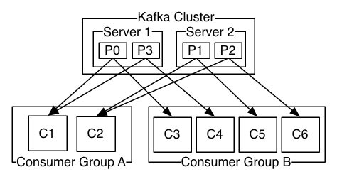

A two server Kafka cluster hosting four partitions (P0-P3) with two consumer groups. Consumer group A has two consumer instances and group B has four.

More commonly, however, we have found that topics have a small number of consumer groups, one for each "logical subscriber". Each group is composed of many consumer instances for scalability and fault tolerance. This is nothing more than publish-subscribe semantics where the subscriber is a cluster of consumers instead of a single process.

The way consumption is implemented in Kafka is by dividing up the partitions in the log over the consumer instances so that each instance is the exclusive consumer of a "fair share" of partitions at any point in time. This process of maintaining membership in the group is handled by the Kafka protocol dynamically. If new instances join the group they will take over some partitions from other members of the group; if an instance dies, its partitions will be distributed to the remaining instances.

Kafka only provides a total order over records *within* a partition, not between different partitions in a topic. Per-partition ordering combined with the ability to partition data by key is sufficient for most applications. However, if you require a total order over records this can be achieved with a topic that has only one partition, though this will mean only one consumer process per consumer group.

[**Guarantees**](http://kafka.apache.org/intro#intro_guarantees)

At a high-level Kafka gives the following guarantees:

* Messages sent by a producer to a particular topic partition will be appended in the order they are sent. That is, if a record M1 is sent by the same producer as a record M2, and M1 is sent first, then M1 will have a lower offset than M2 and appear earlier in the log.
* A consumer instance sees records in the order they are stored in the log.
* For a topic with replication factor N, we will tolerate up to N-1 server failures without losing any records committed to the log.

More details on these guarantees are given in the design section of the documentation.

[**Kafka as a Messaging System**](http://kafka.apache.org/intro#kafka_mq)

How does Kafka's notion of streams compare to a traditional enterprise messaging system?

Messaging traditionally has two models: [queuing](http://en.wikipedia.org/wiki/Message_queue) and [publish-subscribe](http://en.wikipedia.org/wiki/Publish%E2%80%93subscribe_pattern). In a queue, a pool of consumers may read from a server and each record goes to one of them; in publish-subscribe the record is broadcast to all consumers. Each of these two models has a strength and a weakness. The strength of queuing is that it allows you to divide up the processing of data over multiple consumer instances, which lets you scale your processing. Unfortunately, queues aren't multi-subscriber—once one process reads the data it's gone. Publish-subscribe allows you broadcast data to multiple processes, but has no way of scaling processing since every message goes to every subscriber.

The consumer group concept in Kafka generalizes these two concepts. As with a queue the consumer group allows you to divide up processing over a collection of processes (the members of the consumer group). As with publish-subscribe, Kafka allows you to broadcast messages to multiple consumer groups.

The advantage of Kafka's model is that every topic has both these properties—it can scale processing and is also multi-subscriber—there is no need to choose one or the other.

Kafka has stronger ordering guarantees than a traditional messaging system, too.

A traditional queue retains records in-order on the server, and if multiple consumers consume from the queue then the server hands out records in the order they are stored. However, although the server hands out records in order, the records are delivered asynchronously to consumers, so they may arrive out of order on different consumers. This effectively means the ordering of the records is lost in the presence of parallel consumption. Messaging systems often work around this by having a notion of "exclusive consumer" that allows only one process to consume from a queue, but of course this means that there is no parallelism in processing.

Kafka does it better. By having a notion of parallelism—the partition—within the topics, Kafka is able to provide both ordering guarantees and load balancing over a pool of consumer processes. This is achieved by assigning the partitions in the topic to the consumers in the consumer group so that each partition is consumed by exactly one consumer in the group. By doing this we ensure that the consumer is the only reader of that partition and consumes the data in order. Since there are many partitions this still balances the load over many consumer instances. Note however that there cannot be more consumer instances in a consumer group than partitions.

**Kafka as a Storage System**

Any message queue that allows publishing messages decoupled from consuming them is effectively acting as a storage system for the in-flight messages. What is different about Kafka is that it is a very good storage system.

Data written to Kafka is written to disk and replicated for fault-tolerance. Kafka allows producers to wait on acknowledgement so that a write isn't considered complete until it is fully replicated and guaranteed to persist even if the server written to fails.

The disk structures Kafka uses scale well—Kafka will perform the same whether you have 50 KB or 50 TB of persistent data on the server.

As a result of taking storage seriously and allowing the clients to control their read position, you can think of Kafka as a kind of special purpose distributed filesystem dedicated to high-performance, low-latency commit log storage, replication, and propagation.

For details about the Kafka's commit log storage and replication design, please read [this](https://kafka.apache.org/documentation/#design) page.

**Kafka for Stream Processing**

It isn't enough to just read, write, and store streams of data, the purpose is to enable real-time processing of streams.

In Kafka a stream processor is anything that takes continual streams of data from input topics, performs some processing on this input, and produces continual streams of data to output topics.

For example, a retail application might take in input streams of sales and shipments, and output a stream of reorders and price adjustments computed off this data.

It is possible to do simple processing directly using the producer and consumer APIs. However for more complex transformations Kafka provides a fully integrated [Streams API](http://kafka.apache.org/documentation/streams). This allows building applications that do non-trivial processing that compute aggregations off of streams or join streams together.

This facility helps solve the hard problems this type of application faces: handling out-of-order data, reprocessing input as code changes, performing stateful computations, etc.

The streams API builds on the core primitives Kafka provides: it uses the producer and consumer APIs for input, uses Kafka for stateful storage, and uses the same group mechanism for fault tolerance among the stream processor instances.

**Putting the Pieces Together**

This combination of messaging, storage, and stream processing may seem unusual but it is essential to Kafka's role as a streaming platform.

A distributed file system like HDFS allows storing static files for batch processing. Effectively a system like this allows storing and processing *historical* data from the past.

A traditional enterprise messaging system allows processing future messages that will arrive after you subscribe. Applications built in this way process future data as it arrives.

Kafka combines both of these capabilities, and the combination is critical both for Kafka usage as a platform for streaming applications as well as for streaming data pipelines.

By combining storage and low-latency subscriptions, streaming applications can treat both past and future data the same way. That is a single application can process historical, stored data but rather than ending when it reaches the last record it can keep processing as future data arrives. This is a generalized notion of stream processing that subsumes batch processing as well as message-driven applications.

Likewise for streaming data pipelines the combination of subscription to real-time events make it possible to use Kafka for very low-latency pipelines; but the ability to store data reliably make it possible to use it for critical data where the delivery of data must be guaranteed or for integration with offline systems that load data only periodically or may go down for extended periods of time for maintenance. The stream processing facilities make it possible to transform data as it arrives.

For more information on the guarantees, apis, and capabilities Kafka provides see the rest of the [documentation](http://kafka.apache.org/documentation.html).