搭建resin服务

环境：

[root@master conf]# cat /etc/redhat-release

CentOS release 6.9 (Final)

[root@master conf]# uname -sro

Linux 2.6.32-696.el6.x86_64 GNU/Linux

[root@master conf]# java -version

java version "1.8.0_131"

Java(TM) SE Runtime Environment (build 1.8.0_131-b11)

Java HotSpot(TM) 64-Bit Server VM (build 25.131-b11, mixed mode)

搭建resin服务器

目录准备

创建resiner用户并设置密码，将resin加入到sudo，切换到resiner，然后在家目录建立两个文件夹app和src.

[root@master conf]# useradd resiner

[root@master conf]# passwd resiner

Changing password for user resiner.

New password:

BAD PASSWORD: is too simple

Retype new password:

passwd: all authentication tokens updated successfully.

[root@master conf]# vim /etc/sudoers #添加resiner到sudo

[root@master conf]# su resiner

[resiner@master conf]$ cd

[resiner@master ~]$ mkdir app src

[resiner@master ~]$ ls

app src

下载resin到src

进入到src目录,下载resin

官网：<http://caucho.com/products/resin/download>

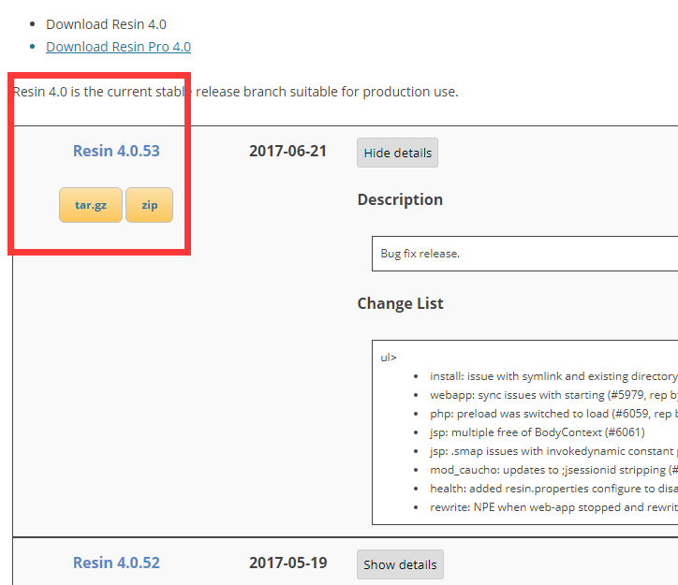

选择下载稳定版，右键复制链接地址

[resiner@master ~]$ cd src

[resiner@master src]$ wget http://caucho.com/download/resin-4.0.53.tar.gz

--2017-08-22 19:17:48-- http://caucho.com/download/resin-4.0.53.tar.gz

Resolving caucho.com... 54.235.109.78

Connecting to caucho.com|54.235.109.78|:80... connected.

HTTP request sent, awaiting response... 200 OK

Length: 27356235 (26M) [application/octet-stream]

Saving to: “resin-4.0.53.tar.gz”

100%[===============================================================>] 27,356,235 28.8K/s in 12m 47s

2017-08-22 19:30:35 (34.8 KB/s) - “resin-4.0.53.tar.gz” saved [27356235/27356235]

解压缩到app目录

[resiner@master src]$ tar -xzvf resin-4.0.53.tar.gz -C ../app

进入解压目录，执行预编译-编译-安装-配置-测试

由于我们下载的为安装好的版本

[resiner@master resin-4.0.53]$ ls

aclocal.m4 compat configure.ac endorsed keys licenses modules resin.exe webapps

automake conf contrib ext-lib lib Makefile.am project-jars setup.exe win32

bin configure doc init.d LICENSE Makefile.in README webapp-jars win64

我们只需要编辑conf目录中的resin.xml（不需要备份），然后执行bin目录中的resin.sh start即可以启动

[resiner@master resin-4.0.53]$ ll

total 1244

-rw-r--r-- 1 resiner resiner 351029 Jun 16 14:25 aclocal.m4

drwxr-xr-x 2 resiner resiner 4096 Aug 22 19:32 automake

drwxrwxr-x 2 resiner resiner 4096 Aug 22 19:32 bin 执行目录

drwxr-xr-x 2 resiner resiner 4096 Jun 16 14:25 compat

drwxr-xr-x 3 resiner resiner 4096 Aug 22 19:38 conf #配置文件目录

-rwxrwxr-x 1 resiner resiner 596224 Jun 16 14:25 configure

-rwxrwxr-x 1 resiner resiner 39509 Jun 16 14:25 configure.ac

drwxr-xr-x 4 resiner resiner 4096 Jun 16 14:25 contrib

drwxr-xr-x 5 resiner resiner 4096 Jun 16 14:25 doc

drwxr-xr-x 2 resiner resiner 4096 Aug 22 19:32 endorsed

drwxr-xr-x 2 resiner resiner 4096 Jun 16 14:25 ext-lib

drwxr-xr-x 2 resiner resiner 4096 Aug 22 19:32 init.d

drwxr-xr-x 2 resiner resiner 4096 Jun 16 14:25 keys

drwxr-xr-x 2 resiner resiner 4096 Aug 22 19:32 lib

-rw-r--r-- 1 resiner resiner 18009 Jun 16 14:24 LICENSE

drwxr-xr-x 2 resiner resiner 4096 Jun 16 14:25 licenses

-rw-r--r-- 1 resiner resiner 11577 Jun 16 14:24 Makefile.am

-rw-r--r-- 1 resiner resiner 33378 Jun 16 14:25 Makefile.in

drwxrwxr-x 3 resiner resiner 4096 Aug 22 19:32 modules

drwxr-xr-x 2 resiner resiner 4096 Aug 22 19:32 project-jars

-rw-r--r-- 1 resiner resiner 4313 Jun 16 14:24 README

-rwxrwxr-x 1 resiner resiner 30720 Jun 16 14:24 resin.exe

-rwxrwxr-x 1 resiner resiner 97280 Jun 16 14:24 setup.exe

drwxr-xr-x 2 resiner resiner 4096 Aug 22 19:32 webapp-jars

drwxr-xr-x 3 resiner resiner 4096 Jun 16 14:25 webapps

drwxrwxr-x 4 resiner resiner 4096 Aug 22 19:32 win32

drwxrwxr-x 2 resiner resiner 4096 Aug 22 19:32 win64

以默认配置文件，启动resin

[resiner@master resin-4.0.53]$ ./bin/resin.sh start #启动服务

查看状态

[resiner@master resin-4.0.53]$ ps axu |grep resin #查看状态

root 83423 0.0 0.1 163408 1968 pts/0 S 19:11 0:00 su resiner

resiner 83424 0.0 0.1 108364 1840 pts/0 S 19:11 0:00 bash

resiner 84233 3.2 9.2 2068700 92572 pts/0 Sl 19:51 0:02 /usr/local/lib64/jdk1.8.0_131/bin/java -Dresin.watchdog=app-0 -Djava.util.logging.manager=com.caucho.log.LogManagerImpl -Djavax.management.builder.initial=com.caucho.jmx.MBeanServerBuilderImpl -Djava.awt.headless=true -Djava.awt.headlesslib=true -Dresin.home=/home/resiner/app/resin-4.0.53/ -Dresin.root=/home/resiner/app/resin-4.0.53/ -Xrs -Xss1m -Xmx32m -d64 -server com.caucho.boot.WatchdogManager start --log-directory /home/resiner/app/resin-4.0.53/log

resiner 84282 5.6 12.6 2325284 126588 pts/0 Sl 19:52 0:03 /usr/local/lib64/jdk1.8.0_131/bin/java -Dresin.server=app-0 -Djava.util.logging.manager=com.caucho.log.LogManagerImpl -Djava.system.class.loader=com.caucho.loader.SystemClassLoader -Djava.endorsed.dirs=/usr/local/lib64/jdk1.8.0_131/jre/lib/endorsed:/home/resiner/app/resin-4.0.53//endorsed:/home/resiner/app/resin-4.0.53//endorsed -Djavax.management.builder.initial=com.caucho.jmx.MBeanServerBuilderImpl -Djava.awt.headless=true -Djava.awt.headlesslib=true -Dresin.home=/home/resiner/app/resin-4.0.53/ -d64 -server com.caucho.server.resin.Resin --root-directory /home/resiner/app/resin-4.0.53/ -conf /home/resiner/app/resin-4.0.53/conf/resin.xml -server app-0 -socketwait 35666 start --log-directory /home/resiner/app/resin-4.0.53/log

resiner 84358 0.0 0.1 110260 1144 pts/0 R+ 19:53 0:00 ps axu

resiner 84359 0.0 0.0 103332 844 pts/0 S+ 19:53 0:00 grep resin

浏览器访问

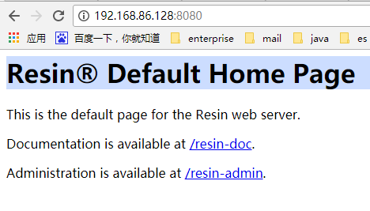

出现这个页面就说明启动成功了，也代表着安装成功。

**修改配置文件重启**

接下来是修改配置文件，使得它更满足我们的需要：

在内网，访问管理网页：<http://192.168.86.128:8080/resin-admin/>，根据提示创建一个用户

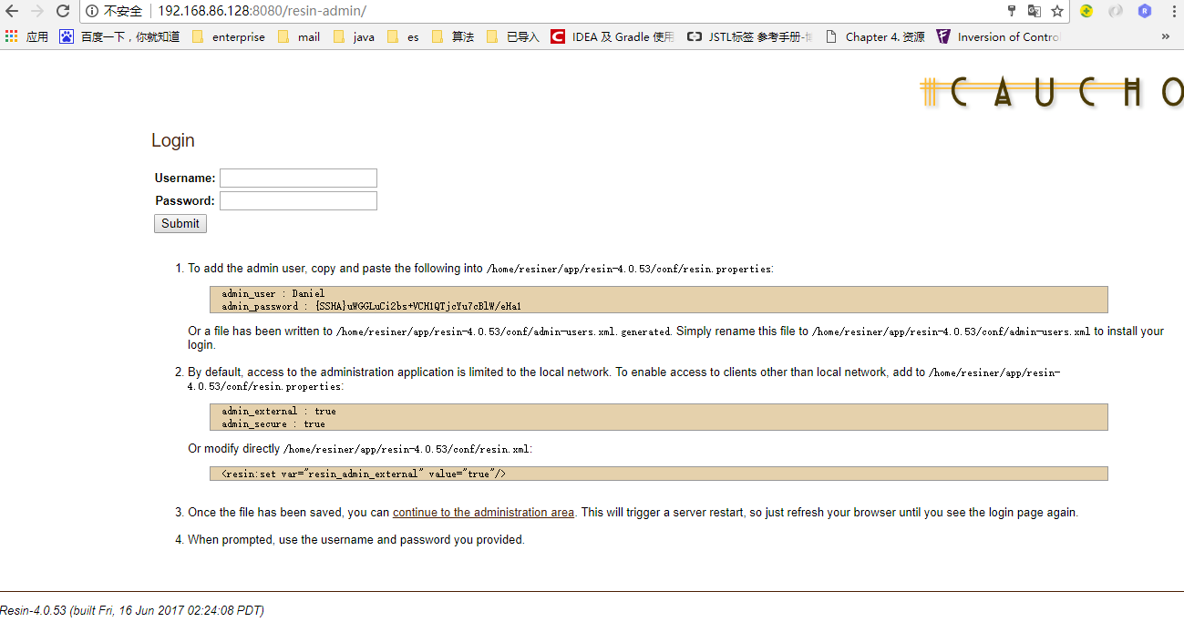将用户名和密码复制粘贴进resin.properties

然后，重启resin，使用刚才的用户名和密码登录，登录成功：

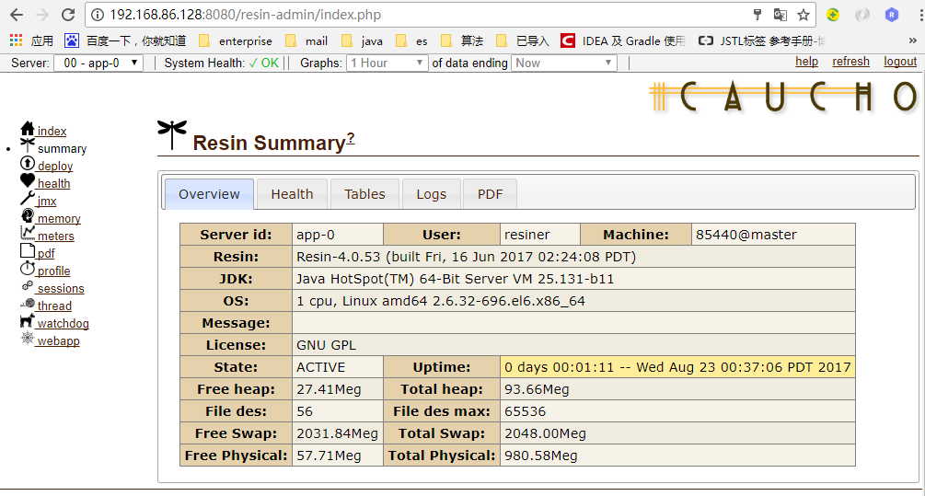

管理页面有好多的功能