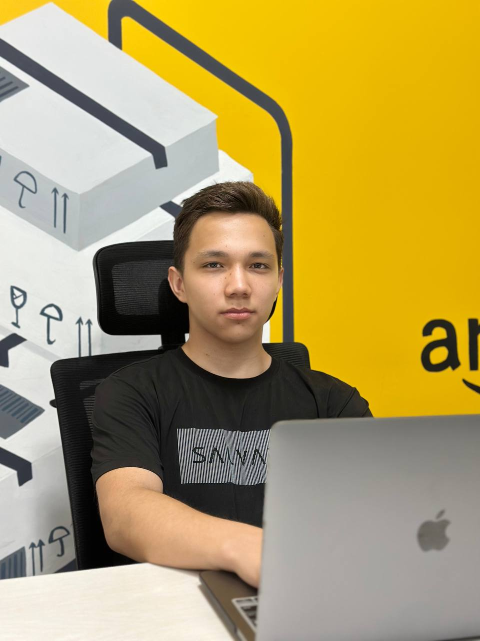­VOHIDOV

SARVARBEK

Front-end developer

**About Me­**

# C O N T A C T

I'm I'm a 15-year-old highly motivated front-end developer based in Tashkent, Uzbekistan. I’ve been learning and exploring the world of IT for the past 2–3 years through self-study and personal projects. My main focus is on building accessible and user-friendly websites using modern JavaScript. Throughout this journey, I’ve been constantly working on my weaknesses and gradually improving my skills. I enjoy tackling technical challenges and always strive to write clean, efficient code that serves a real purpose.

Even though I’m only 15, I don’t feel fully ready yet to start an internship. However, I aim to gain as much experience as possible by the time I turn 18. I have many big dreams, including becoming an experienced senior developer in the future. I also have side interests like drawing and solving computer-related problems, which often help me think creatively in my coding work. In my free time, I always try to spend it on something useful—especially activities that help me grow and improve even more.

+(998)77-071-02-23

tylertheunknownss@gmail.com Uzbekistan, Tashkent

# E D U C A T I O N

### IT Center

##### Front-end developer

2023 - 2024

### PDP School

##### Front-end developer (again)

2024 - 2025

# S K I L L S

#### Front-end

Main points

#### • 2 – 3 years experience

#### • Self-Teaching

#### • B2 English level

#### • Problem-solving

SARVARBEK

#### Creativity

Team-working

-

#### Problem-solving Critical Thinking

#### Supporting

# C O N T A C T

L A N G U A G E



English Uzbek

## Vohidov Sarvarbek

#### Uzbekistan / Tashkent

**Phone:** +(998) 77-071-0223

**Email** [tylertheunknownss@gmail.com](mailto:tylertheunknownss@gmail.com)

## 

#### PDP Shool / Ecosystem

**Phone:**

**Email :**