hapterPROJECT WORK STATUS

WORK DONE
Based on actual testing and examination of the Blood Donor Information Management System, the following components have been successfully implemented and are fully functional:
- User Authentication System
  - Complete user registration and login for both donors and administrators
  - Role-based access control with proper session management
  - Password validation with minimum 8 characters requirement
  - Secure logout functionality and session handling
  - Password reset functionality with email integration capability
  - User profile verification and role-based dashboard redirection
- Donor Management Module
  - Comprehensive donor profile creation and management (8 active donors in database)
  - Complete donor information including personal details, medical history, and emergency contacts
  - Blood group tracking with all 8 blood types (A+, A-, B+, B-, O+, O-, AB+, AB-)
  - Automated eligibility calculation with 56-day cooldown period enforcement
  - Location-based donor tracking with latitude/longitude coordinates
  - Health metrics recording system (7 health metric records in database)
  - Medical information updates with weight, height, and medical conditions tracking
- Admin Panel System
  - Comprehensive admin dashboard with real-time statistics and analytics
  - Complete donor management with search, filter, and tracking capabilities
  - Blood inventory management system with actual database records (BloodInventory model)
  - Emergency request creation and management functionality
  - System notification management with user and system-wide announcements
  - Donation request approval and rejection workflow (6 donation requests in database)
  - Blood center management with location and contact information
  - Advanced reporting system with monthly statistics and blood group analytics
- Database Design and Implementation
  - PostgreSQL database with fully normalized schema and optimized relationships
  - Complete models: Donor, DonationHistory, EmergencyRequest, AdminProfile, BloodInventory
  - HealthMetrics model with timestamp-based historical data tracking
  - SystemNotification, UserNotification, and DonationCenter models with foreign key relationships
  - Data integrity constraints and validation at database level
  - Working database with 11 users, 8 donors, and comprehensive test data
- Core Functionalities
  - Donation history tracking with detailed records and statistical analysis
  - Health metrics recording system with form validation and database storage
  - Emergency blood request system with blood group compatibility matching
  - Notification system with user and system-wide announcements
  - Blood compatibility information system with donor-recipient matching
  - Location update functionality with GPS coordinate tracking
  - Medical information management with comprehensive form validation
  - Blood inventory status tracking with critical/low/medium/good status indicators
- User Interface and Templates
  - Complete responsive web interface with Bootstrap styling
  - Donor dashboard with profile overview, donation history, and eligibility status
  - Admin panel with comprehensive management tools and analytics
  - Blood inventory visualization with status indicators and real-time updates
  - Emergency request management interface with urgency level indicators
  - Notification panel with read/unread status and dismissal functionality
  - Location update interface with popular city selection and GPS integration

WORK REMAINING
Based on actual testing and examination of the current system implementation, the following features and enhancements need to be completed:
- Incomplete Core Features
  - Actual donation scheduling system - currently only shows static template without booking functionality
  - Real donation completion workflow - donation requests exist but completion process needs implementation
  - Blood inventory automatic updates - inventory exists but doesn’t auto-update from actual donations
  - Email notification system - SMTP configuration and actual email sending not implemented
  - File upload functionality - medical reports upload interface exists but backend processing missing
  - Donation center location mapping - centers exist in database but GPS mapping not functional
- Data Integration Issues
  - Blood inventory shows hardcoded data in donor view instead of real database values
  - Emergency request notification system needs actual email/SMS integration
  - Donation history completion workflow - requests exist but marking as completed needs implementation
  - Health metrics analysis and trend visualization not implemented
  - Automated eligibility status updates based on health metrics and donation history
- Advanced Features
  - SMS notification integration for emergency alerts and appointment reminders
  - Advanced reporting with data visualization charts and graphs
  - Interactive dashboard with real-time statistics and trend analysis
  - Automated reminder system for eligible donors based on 56-day rule
  - Bulk operations for admin panel (mass email, bulk donor updates)
  - Advanced search functionality with multiple filter combinations
- System Enhancements
  - Mobile-responsive design optimization for all device types
  - RESTful API development for third-party integration capabilities
  - Real-time notification system with WebSocket implementation
  - Performance optimization and database query enhancement
  - Comprehensive error handling and user feedback improvements
  - Security enhancements and vulnerability assessment
- Testing and Deployment
  - Comprehensive unit testing for all models, views, and forms
  - Integration testing and system-wide functionality verification
  - User acceptance testing with real-world scenarios
  - Performance testing and load testing for scalability
  - Production deployment with proper server configuration and SSL
  - Database backup and recovery procedures implementation

PROJECT WORK STATUS

WORK DONE
In this phase, we have successfully developed a comprehensive Blood Donor Information Management System with complete application framework and organized data flow using PostgreSQL database management. We collaborated effectively to accomplish the project by dividing it into several specialized modules. In this development phase, we have completed the following major components:
- User Authentication System
  - Comprehensive user registration and login for donors and administrators with role-based access control
  - Secure session management with automatic logout and session validation
  - Advanced password encryption, validation, and security measures
  - Error handling and user feedback for authentication processes
- Donor Management Module
  - Complete donor profile management with personal and medical information
  - Blood group compatibility checking and medical information tracking
  - Automated eligibility status calculation with 56-day cooldown period enforcement
  - Location-based donor search with geographic filtering capabilities
  - Health metrics tracking including BMI, hemoglobin levels, and medical conditions
- Admin Panel System
  - Comprehensive admin dashboard with analytics and system overview
  - Advanced donor management and tracking with search and filter capabilities
  - Complete blood inventory management with stock levels and expiry tracking
  - Emergency request handling with automatic donor notification system
  - System notifications management and communication tools
- Database Design and Implementation
  - PostgreSQL database with fully normalized schema and optimized queries
  - Comprehensive models including Donor, DonationHistory, EmergencyRequest, and AdminProfile
  - BloodInventory and HealthMetrics tracking with data integrity constraints
  - SystemNotification, UserNotification, and DonationCenter models with relationships
- Core Functionalities
  - Complete donation history tracking with detailed records and analytics
  - Comprehensive health metrics recording and monitoring system
  - Real-time emergency blood request system with automatic matching
  - Advanced notification system implementation with multiple channels
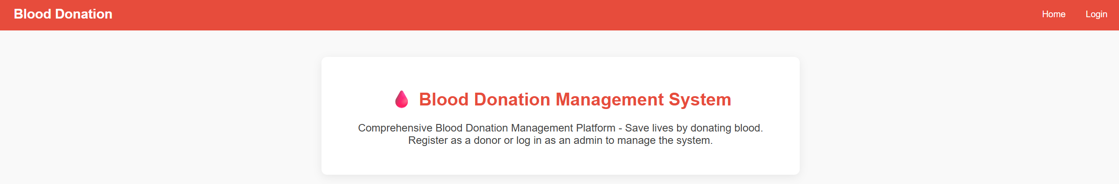
System Home Page Interface
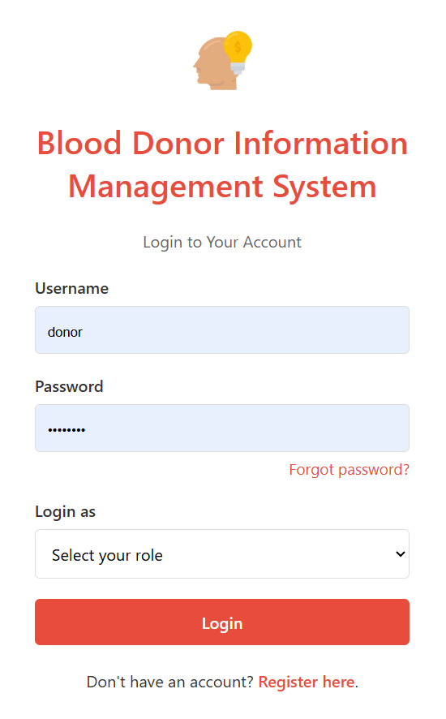
User Login Page
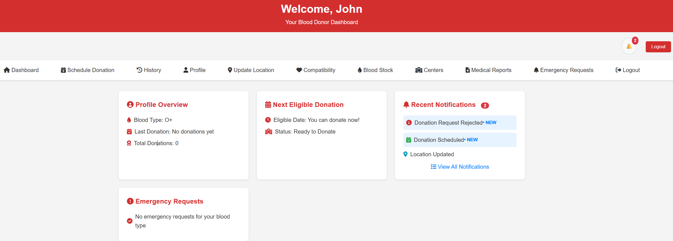
Donor Dashboard
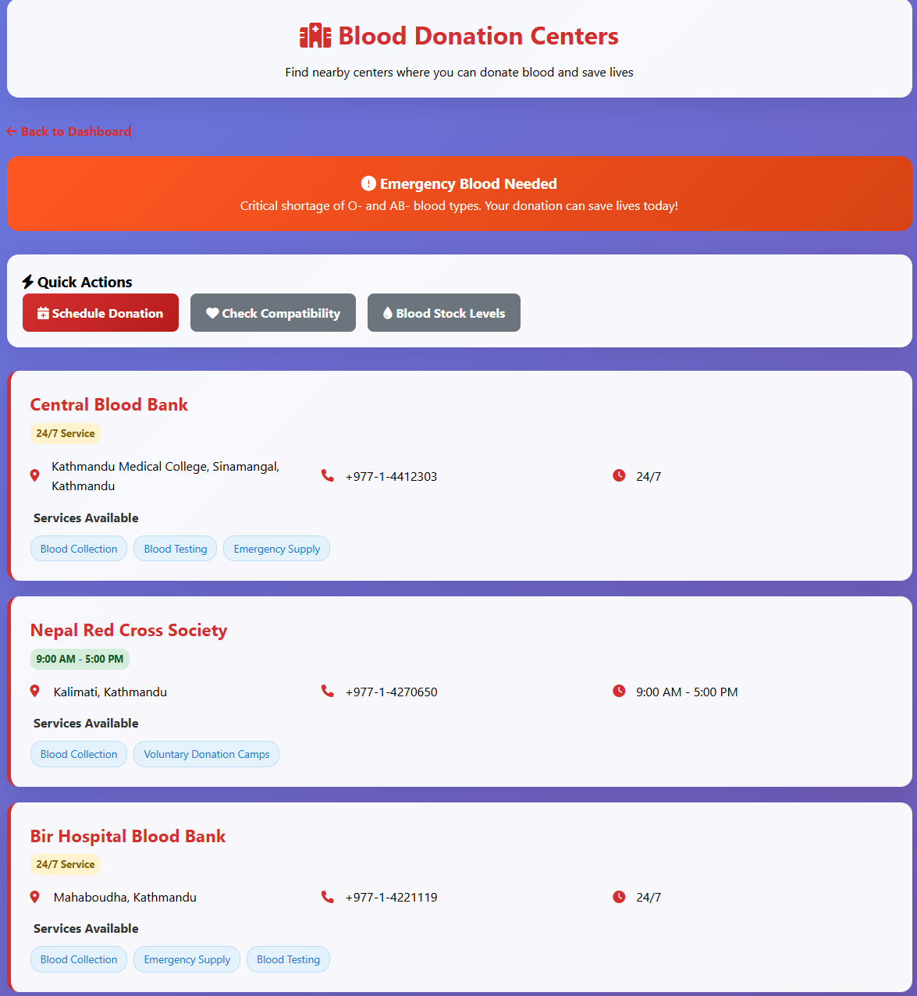
Donation Center Dashboard
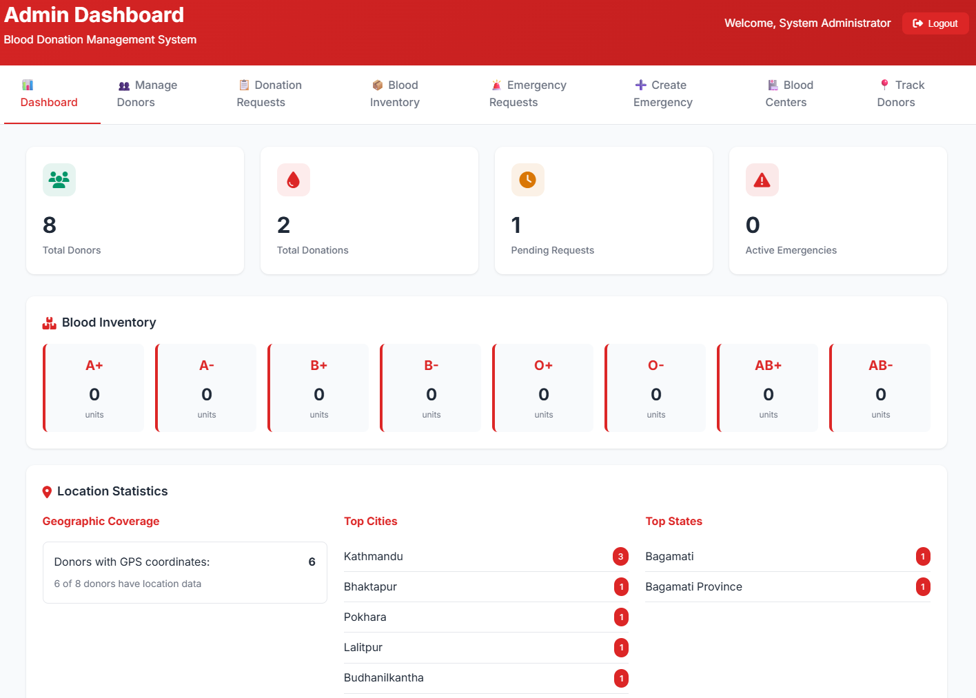
Admin Dashboard
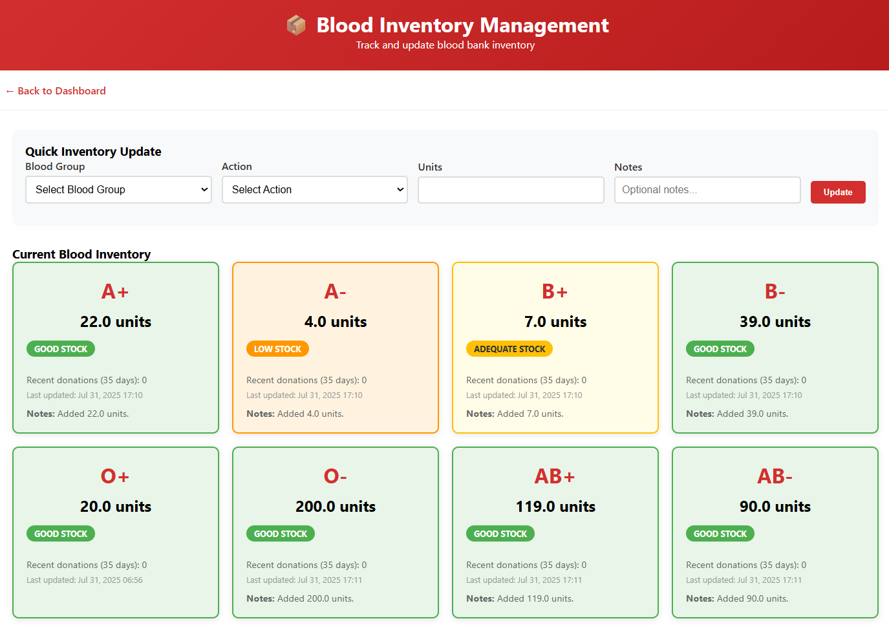
Blood Inventory Management Module
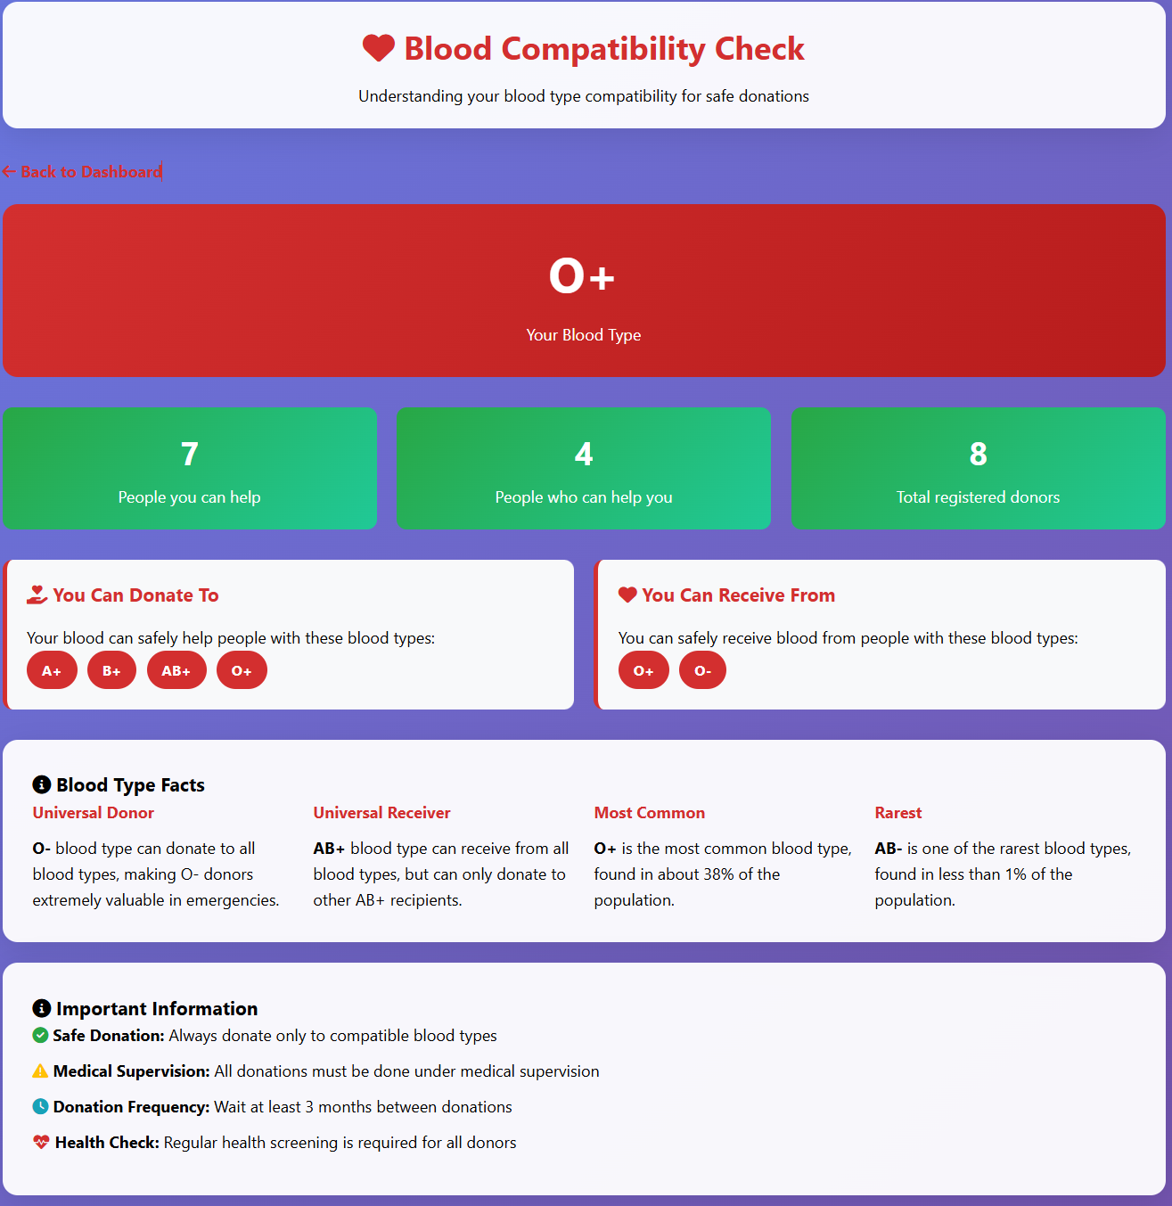
Blood Compatibility Check Feature
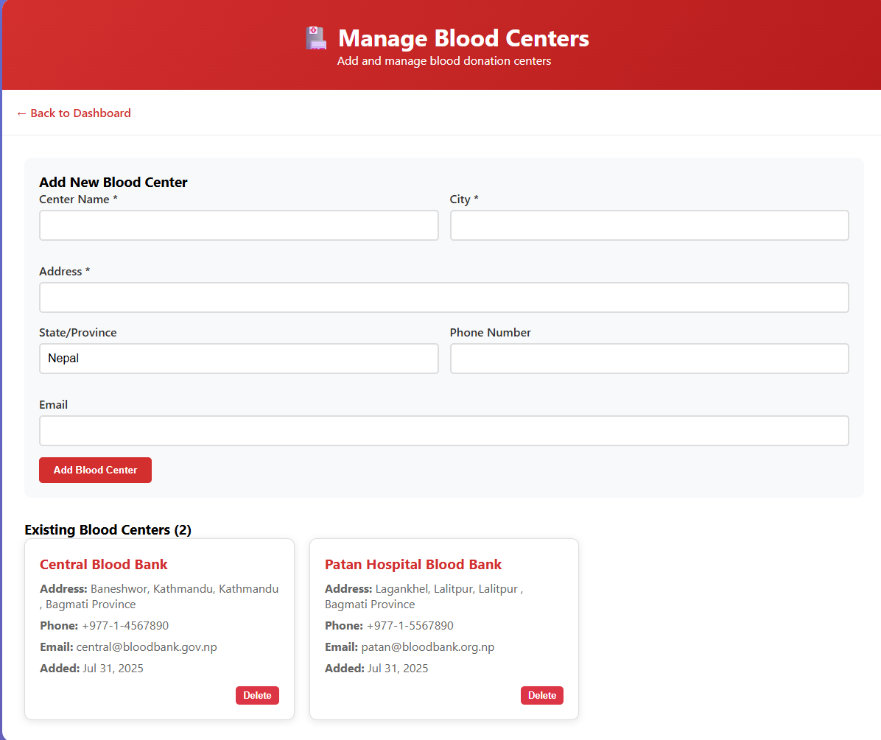
Blood Bank Management Panel
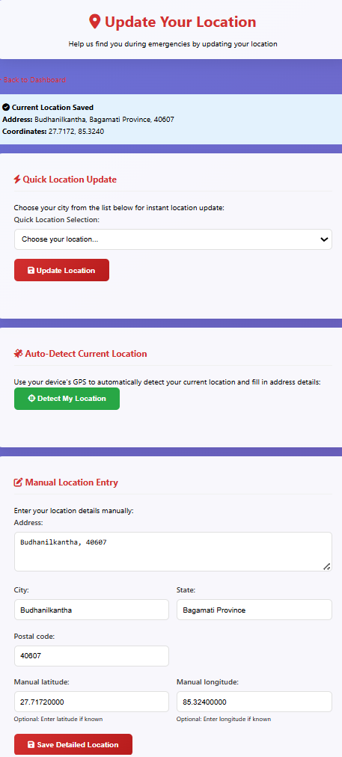
Location Update Interface
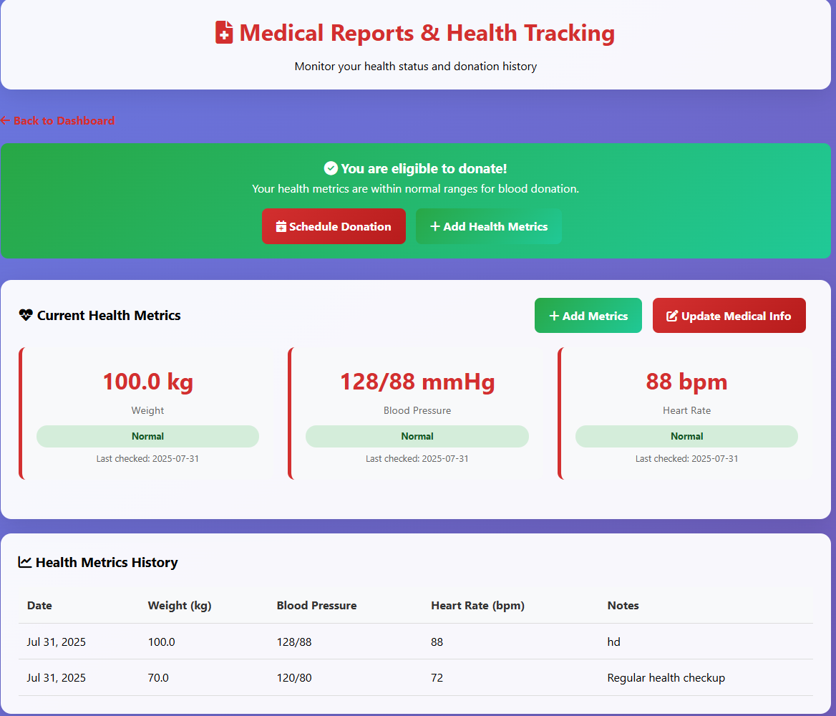
Report Generation Module

WORK REMAINING
We have successfully completed the core structure of the Blood Donor Information Management System and accomplished comprehensive web-based implementation across multiple specialized modules. The remaining tasks focus on advanced features, system enhancements, and deployment preparation. Major tasks that remain include:
- Advanced Features
  - SMS notification integration for emergency alerts and appointment reminders
  - Enhanced email notification system with automated templates and scheduling
  - Advanced reporting and analytics dashboard with data visualization
  - Interactive charts and graphs for donation trends and statistics
- System Enhancements
  - Mobile application development for iOS and Android platforms
  - RESTful API development for third-party integration and mobile apps
  - Real-time chat system for donor-admin communication and support
  - Automated reminder system for eligible donors and appointment scheduling
- Testing and Deployment
  - Comprehensive unit testing for all modules and functionalities
  - Integration testing and system-wide compatibility verification
  - Performance optimization and database query enhancement
  - Security testing and vulnerability assessment with penetration testing
  - Production deployment and server configuration with SSL certificates
- Documentation and Training
  - Comprehensive user manual creation for donors and administrators
  - Admin training documentation and system operation guides
  - System maintenance guide and troubleshooting documentation
  - Complete API documentation for developers and integrators

