PURBANCHAL UNIVERSITY


DEPARTMENT OF COMPUTER ENGINEERING

KHWOPA ENGINEERING COLLEGE

LIBALI-08, BHAKTAPUR

A MID-TERM REPORT ON

Blood Donor Information Management System

Project work submitted in partial fulfillment of the requirements for the degree of Bachelor of Engineering in Computer Engineering (Fifth Semester)

 | Submitted by
Bishal Shrestha | (790310)
Chirayu Shrestha | (790311)
Pappu Yadav | (790324)
Prashant Ghimire | (790328)

Under the Supervision of

Er. Anish Baral

Khwopa Engineering College

Libali-08, Bhaktapur

November 27, 2025

ACKNOWLEDGEMENT

We are pleased to present the mid-defense report of our project titled ”Blood Donor Information Management System”, undertaken as a part of the curriculum of Bachelor of Computer Engineering at Khwopa Engineering College.

We would like to express our sincere gratitude to all those who have supported us throughout the progress of this project. We are especially thankful to our respected Head of Department, Er. Bikash Chawal, and Deputy Head of Department, Er. Avijit Karn, for their continuous guidance, encouragement, and valuable feedback during the development process.

Our heartfelt thanks go to Purbanchal University and Khwopa Engineering Col-lege, Bhaktapur, for providing us with this opportunity to work on a real-world oriented project that helps enhance our technical, analytical, and project management skills.

We also appreciate the cooperation and support of our supervisors, teachers, friends, and seniors who have offered constructive suggestions and moral support, which have been crucial to the progress of our work so far. Special thanks to Er. Anish Baral for providing valuable guidance and continuous support throughout the project development.

We extend our gratitude to the administration and staff of Khwopa Engineering College for providing the necessary resources and infrastructure required for the successful completion of this project.

With Regards,
Bishal Shrestha | (790310)
Chirayu Shrestha | (790311)
Pappu Yadav | (790324)
Prashant Ghimire | (790328)

i

ABSTRACT

Our project Blood Donor Information Management System is a comprehensive web-based application designed to centralize and manage detailed blood donor information for healthcare institutions. The system focuses on organizing comprehensive donor profiles, tracking health metrics, managing donation histories, and providing advanced search capabilities for donor information. Built on a centralized PostgreSQL database, it ensures secure storage and efficient retrieval of donor data with role-based authenti-cation for administrators and donors.

This information management platform enables administrators to access detailed donor databases, track comprehensive health metrics, monitor eligibility status with automated calculations, manage donor profiles with medical information, and generate analytical reports. Donors can maintain detailed personal and medical profiles, track their health metrics over time, view complete donation histories, and update their infor-mation. The Django-based system provides efficient donor information organization and management capabilities for modern healthcare institutions.

Keywords: Blood Donor Information Management, Django Framework, PostgreSQL, Emergency Requests, Donor Eligibility, Healthcare Analytics

ii

Table of Contents

ACKNOWLEDGEMENT |  |  | i
ABSTRACT |  |  | ii
1 | INTRODUCTION |  | 1
 | 1.1 | Background . . . . . . . . . . . . . . . . . . . . . . . . . . . . . . . . | 1
 | 1.2 | Problem Statement . . . . . . . . . . . . . . . . . . . . . . . . . . . . | 2
 | 1.3 | Objectives . . . . . . . . . . . . . . . . . . . . . . . . . . . . . . . . . | 2
 | 1.4 | Features and Functionalities . . . . . . . . . . . . . . . . . . . . . . . | 2
 | 1.5 | Significance And Scope . . . . . . . . . . . . . . . . . . . . . . . . . . | 3
2 | LITERATURE REVIEW |  | 4
3 | PROJECT MANAGEMENT |  | 5
 | 3.1 | Team Members . . . . . . . . . . . . . . . . . . . . . . . . . . . . . . | 5
 | 3.2 | Work Breakdown Planning . . . . . . . . . . . . . . . . . . . . . . . . | 5
 | 3.3 | Feasibility Study . . . . . . . . . . . . . . . . . . . . . . . . . . . . . | 6
4 | METHODOLOGY |  | 7
 | 4.1 | Algorithm . . . . . . . . . . . . . . . . . . . . . . . . . . . . . . . . . | 7
 | 4.2 | Flowchart . . . . . . . . . . . . . . . . . . . . . . . . . . . . . . . . . | 9
 | 4.3 | Use Case Diagram . . . . . . . . . . . . . . . . . . . . . . . . . . . . | 11
 | 4.4 | ER Diagram . . . . . . . . . . . . . . . . . . . . . . . . . . . . . . . . | 12
 | 4.5 | Block Diagram . . . . . . . . . . . . . . . . . . . . . . . . . . . . . . | 14
 | 4.6 | TOOLSANDPLATFORMS....................... | 15
 |  | 4.6.1 Backend Technologies . . . . . . . . . . . . . . . . . . . . . . | 15
 |  | 4.6.2 Front end Technologies . . . . . . . . . . . . . . . . . . . . . . | 15
 |  | 4.6.3 Other Tools . . . . . . . . . . . . . . . . . . . . . . . . . . . . | 15
 |  | 4.6.4 Platform . . . . . . . . . . . . . . . . . . . . . . . . . . . . . . | 15
5 | PROJECT WORK STATUS |  | 16
 | 5.1 | Work Done: . . . . . . . . . . . . . . . . . . . . . . . . . . . . . . . . | 16
 | 5.2 | Work Remaining: . . . . . . . . . . . . . . . . . . . . . . . . . . . . . | 23
REFERENCES |  |  | 24

iii

List of Figures

4.1 | Flowchart . . . . . . . . . . . . . . . . . . . . . . . . . . . . . . . . . | 9
4.2 | Use Case Diagram . . . . . . . . . . . . . . . . . . . . . . . . . . . . | 11
4.3 | ER Diagram . . . . . . . . . . . . . . . . . . . . . . . . . . . . . . . . | 12
4.4 | Block Diagram . . . . . . . . . . . . . . . . . . . . . . . . . . . . . . | 14
5.1 | System Home Page Interface . . . . . . . . . . . . . . . . . . . . . . . | 16
5.2 | User Login Page . . . . . . . . . . . . . . . . . . . . . . . . . . . . . . | 17
5.3 | Donor Dashboard . . . . . . . . . . . . . . . . . . . . . . . . . . . . . | 18
5.4 | Donation Center Dashboard . . . . . . . . . . . . . . . . . . . . . . . | 18
5.5 | Admin Dashboard . . . . . . . . . . . . . . . . . . . . . . . . . . . . . | 19
5.6 | Blood Inventory Management Module . . . . . . . . . . . . . . . . . . | 19
5.7 | Blood Compatibility Check Feature . . . . . . . . . . . . . . . . . . . | 20
5.8 | Blood Bank Management Panel . . . . . . . . . . . . . . . . . . . . . | 21
5.9 | Location Update Interface . . . . . . . . . . . . . . . . . . . . . . . . | 22
5.10 | Medical Reports and Health Tracking . . . . . . . . . . . . . . . . . . | 23

iv

Chapter 1

INTRODUCTION

1.1 Background

Healthcare institutions struggle with managing comprehensive donor information including medical records, health metrics, donation history, and eligibility tracking. Our Blood Donor Information Management System provides a centralized platform built with Django framework and PostgreSQL database to efficiently organize, store, and manage all donor-related information.In recent years, healthcare institutions have faced significant challenges in efficiently managing donor-related information such as medical history, health metrics, donation records, and eligibility tracking. Traditional paper-based systems and semi-digital solutions are often inefficient, error-prone, and difficult to scale, especially during emergencies when real-time data access is critical.

The Blood Donor Information Management System (BDIMS) has been devel-oped as a response to these challenges. It is a centralized, web-based application built using the Django framework and PostgreSQL database. The system aims to streamline and digitize the entire donor information lifecycle—from registration and health tracking to donation history and emergency response coordination.

This platform empowers administrators with the tools to manage donor databases, monitor blood inventory, assess donor eligibility automatically, and respond quickly to urgent blood requests. Simultaneously, donors are provided with a user-friendly interface to maintain their profiles, update health details, track donation history, and find donation opportunities.

By modernizing donor data handling, the system significantly improves data accuracy, coordination efficiency, and overall reliability of blood donation services—contributing to better healthcare outcomes and faster emergency response.

The system focuses on comprehensive donor information management with de-tailed profile tracking, health metrics monitoring, automated eligibility calculations, and advanced search capabilities. Administrators can access complete donor databases, track health metrics, manage blood inventory, and generate detailed reports. Donors maintain detailed profiles with medical information, view comprehensive donation history, and receive personalized health tracking.

1

1.2 Problem Statement

Healthcare institutions face significant challenges in managing comprehensive donor information including scattered medical records, manual health metrics tracking, ineffi-cient donor search systems, and lack of centralized donor databases. Traditional paper-based systems cannot handle complex donor information requirements such as detailed health metrics, blood compatibility tracking, emergency contact management, and auto-mated eligibility calculations. This creates inefficiencies in donor information retrieval, health monitoring, and emergency response coordination.

1.3 Objectives

The main objective of the project is to develop a user-friendly and efficient blood donor information management system that replaces traditional paper-based processes and en-hances real-time coordination.

1.4 Features and Functionalities

Admin:

- Secure login and Dashboard Access

- Donor Management

- Donation History Tracking

- Eligibility Monitoring Handling

- Blood Request Handling

- Report and Analytics

Donor

- Secure Login and Profile Management

- Donor Registration and Information Update

- View Personal Donation History

- Search Donation Opportunities

- Eligibility Checker

2

1.5 Significance And Scope

This system significantly improves healthcare information management by providing centralized donor data access, comprehensive health metrics tracking, and efficient donor information retrieval. It enhances data accuracy, streamlines donor information workflows, and enables evidence-based decision-making for healthcare administrators.

The scope encompasses complete donor information lifecycle including detailed profile management, comprehensive health metrics tracking, advanced search capa-bilities, automated eligibility monitoring, donation history management, and detailed analytics reporting. The system serves as a centralized information hub for healthcare institutions managing donor databases.

3

Chapter 2

LITERATURE REVIEW

Blood Donor Information Management Systems (BDIMS) are critical for enhancing the efficiency and reliability of blood donation services. Globally, the transition from manual to digital systems has improved donor tracking, eligibility verification, and blood request coordination (Kumar & Gupta, 2020). In Nepal, while many hospitals and Red Cross branches still rely on semi-digital or paper-based systems, there has been notable progress in adopting digital platforms, particularly in urban areas.

A study by Sharma et al. (2019) showed that digital donor registries reduce ad-ministrative workload by over 30% and improve response time during emergency blood shortages. In Nepal, organizations like Nepal Red Cross Society (NRCS) have begun piloting donor information systems in collaboration with local ICT firms. For instance, the NRCS Blood Transfusion Service in Kathmandu introduced a digital donor card system in 2021, which enabled quicker access to donor history and eligibility data.

According to the Ministry of Health and Population (MoHP), around 300,000 units of blood are collected annually in Nepal, yet demand often exceeds supply due to poor coordination and lack of real-time data access, especially in remote areas. In 2022, the Hamro LifeBank project launched a mobile and web platform that connects hospitals, donors, and blood banks in real-time, helping reduce request response times from hours to minutes in the Kathmandu Valley. The platform also integrates GPS to show nearby donors and blood drives—an approach proven effective in donor mobilization during peak need.

Usability-focused systems featuring role-based dashboards, automated SMS alerts, and one-click eligibility checks have been reported to increase donor retention rates by 20–25% (Ali et al., 2022). Nepal’s use of QR-based donor ID cards and mobile notifications, though still in limited deployment, is aligned with this global trend and shows promise for improving traceability and engagement.

However, Nepal continues to face challenges in system scalability, especially in rural regions. Limited internet access, low digital literacy, and lack of staff training hinder broader adoption. Research by Yadav & Mehta (2020) recommends focusing on offline-first mobile apps and decentralized data storage solutions for improving nationwide coverage.

In conclusion, literature and local data both indicate that Blood Donor Informa-tion Management Systems are vital for enhancing Nepal’s blood donation services. Projects like Hamro LifeBank and NRCS digital initiatives highlight the transformative potential of these systems, though further investment in infrastructure, training, and scalability is needed for long-term sustainability and national reach.

4

Chapter 3

PROJECT MANAGEMENT

3.1 Team Members

The project is carried out by the contribution of the following four team members.

- Bishal Shrestha [790310]

- Chirayu Shrestha [790311]

- Pappu Yadav [790324]

- Prashant Ghimire [790328]

3.2 Work Breakdown Planning

The table shows the comprehensive work breakdown planning for the Blood Donor In-formation Management System development project.

This work breakdown structure organizes the project into manageable phases including system analysis, database design, user interface development, testing, and deployment. Each phase contains specific tasks with defined timelines and deliverables to ensure sys-tematic project completion.

S.N. | Task Description | Week 1-2 | Week 3-4 | Week 5-6 | Week 7-8 | Week 9-10 | Week 11-12
1 | Problem Identification
2 | Analysis
3 | Design
4 | Coding
5 | Implementing and Testing
6 | Documentation

Table 3.1: Project Timeline and Work Breakdown Structure

5

3.3 Feasibility Study

The feasibility study analyzes and evaluates the overall success potential and viability of the Blood Donor Information Management System project across multiple critical dimensions. This comprehensive assessment is based on extensive research, technical analysis, and investigation of project requirements and implementation scenarios.

- Economic Feasibility: The project demonstrates excellent economic viability as it utilizes open-source technologies including Django framework, PostgreSQL database, and standard web technologies. Development costs are minimal, requir-ing only basic hardware and internet connectivity. No licensing fees or expensive software purchases are required, making it highly cost-effective for healthcare in-stitutions.

- Operational Feasibility: The web-based application is designed to run efficiently on standard hardware configurations with minimal system requirements. The re-sponsive design ensures compatibility across desktop computers, tablets, and mo-bile devices. The intuitive user interface requires minimal training for healthcare professionals and donors.

- Technical Feasibility: The system is built using proven, stable technologies (Django, PostgreSQL, HTML/CSS/JavaScript) with extensive community sup-port. Healthcare professionals with basic computer literacy can easily operate the system. Comprehensive documentation, user manuals, and built-in help features ensure smooth operation and troubleshooting.

- Schedule Feasibility: The project timeline spans approximately 4 months for complete development, testing, and deployment. The modular development ap-proach allows for incremental delivery and testing, ensuring the project remains on schedule and meets all specified requirements within the allocated timeframe.

6

Chapter 4

METHODOLOGY

4.1 Algorithm

- Start: Initialize the Blood Donor Information Management System and establish database connection.

- Display Home Page: Show welcome message and present login/registration op-tions to the user.

- Ask User for Action: Prompt user to choose between Login or Register with role selection (Donor/Admin).

- If user chooses Login:

  - Enter credentials and select role (Donor/Admin).

  - Verify credentials.

  - If credentials are valid and role matches profile, log in and go to step 6.

  - If credentials are invalid, display error message and goto step 3.

- If user chooses Register:

  - enter personal information (name, email, phone, address, date of birth).

  - For Donor: Collect medical information (blood group, weight, height, med-ical conditions).

  - Validate all input data and check eligibility requirements.

  - Create new user account and profile in database.

  - After confirmation redirect to appropriate dashboard.

- Display Dashboard: Based on user role, show either Donor Dashboard or Admin Dashboard.

- For Donor Dashboard - Display Main Menu:

  - View Profile and Donation History

  - Check Donation Eligibility Status

  - Update Health Metrics

  - View Emergency Blood Requests

  - Update Personal Information

  - View Blood Compatibility Information

  - Logout

7

- For Admin Dashboard - Display Main Menu:

  - View System Analytics and Statistics

  - Manage Donor Records

  - Manage Blood Inventory

  - Handle Emergency Requests

  - Manage Blood Centers

  - Track Donors

  - Logout

- Allow User to Select Option:

- Perform Selected Action:

  - If ”View Profile” - Display donor information and donation history.

  - If ”Check Eligibility” - Calculate and show donation eligibility based on 56-day rule.

  - If ”Update Health Metrics” - Allow entry of weight, blood pressure, heart rate, and other recent medical reports.

  - If ”View Emergency Requests” - Show active emergency requests matching blood type.

  - If ”Manage Donors” (Admin) - Display donor search and management in-terface.

  - If”Emergency request”(Admin) - Create a new emergency request and man-age it.

  - If ”Manage Inventory” (Admin) - Show blood inventory levels and update options.

  - If ”Blood center” (Admin) - Add the blood center for blood donation

- Update Database.

- Repeat Steps 9-11.

- Exit.

8

4.2 Flowchart
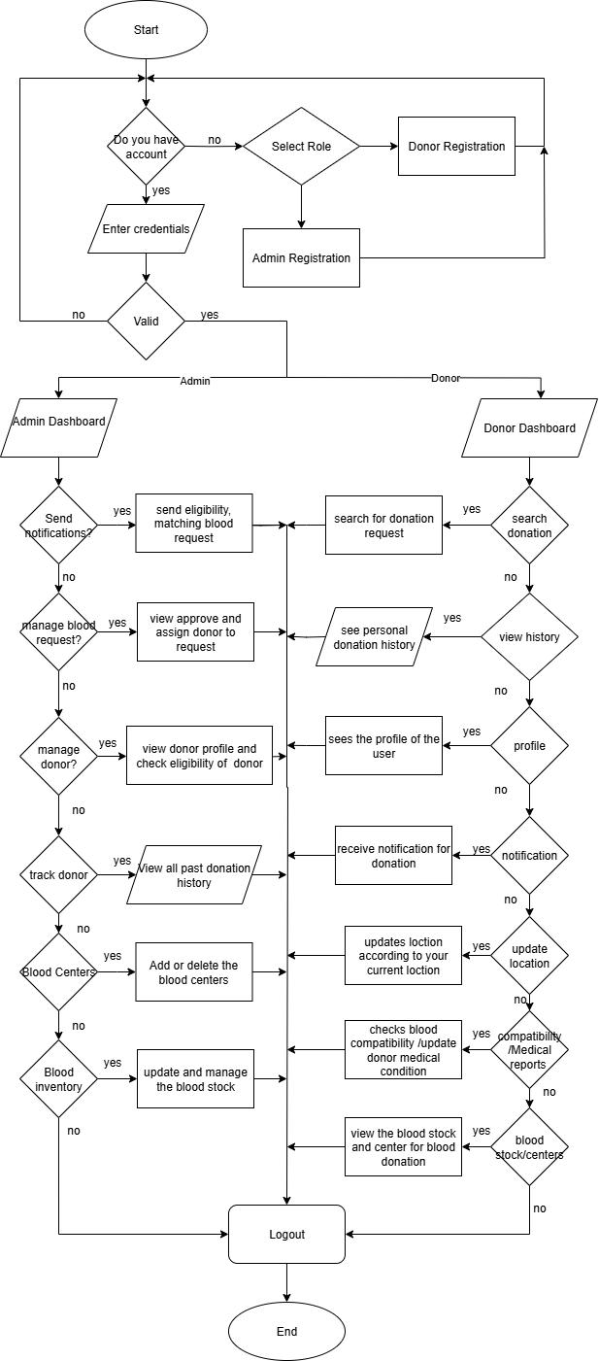

Figure 4.1: Flowchart

9

The flowchart represents the complete workflow of the Blood Donor Information Man-agement System, illustrating the step-by-step process from user registration to blood donation completion and inventory management. The flowchart shows the logical flow of operations including user authentication, donor registration, eligibility verification, donation scheduling, emergency request handling, and administrative functions.

10

4.3 Use Case Diagram
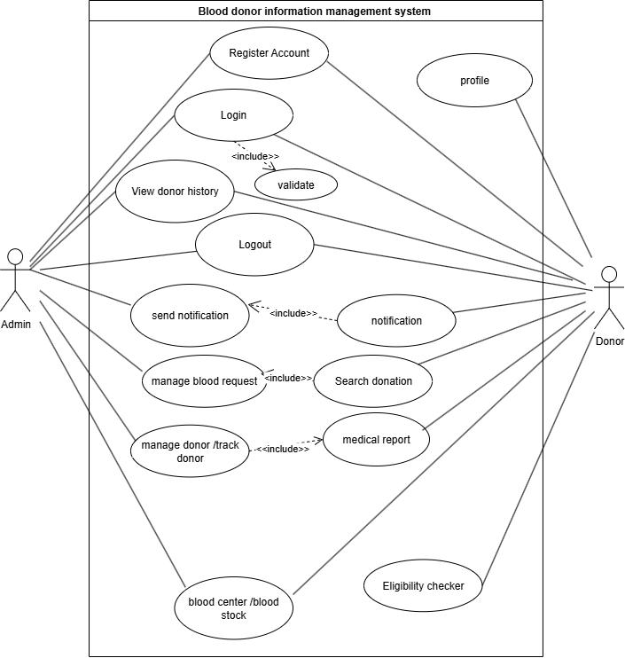

Figure 4.2: Use Case Diagram

The Use Case Diagram illustrates the dynamic behavior and workflow of the Blood Donor Information Management System. It shows the sequence of activities, decision points, and parallel processes involved in donor registration, blood donation workflow, handling of emergency requests, and administrative operations. The diagram captures the system’s business logic and user interactions across different modules.

11

4.4 ER Diagram
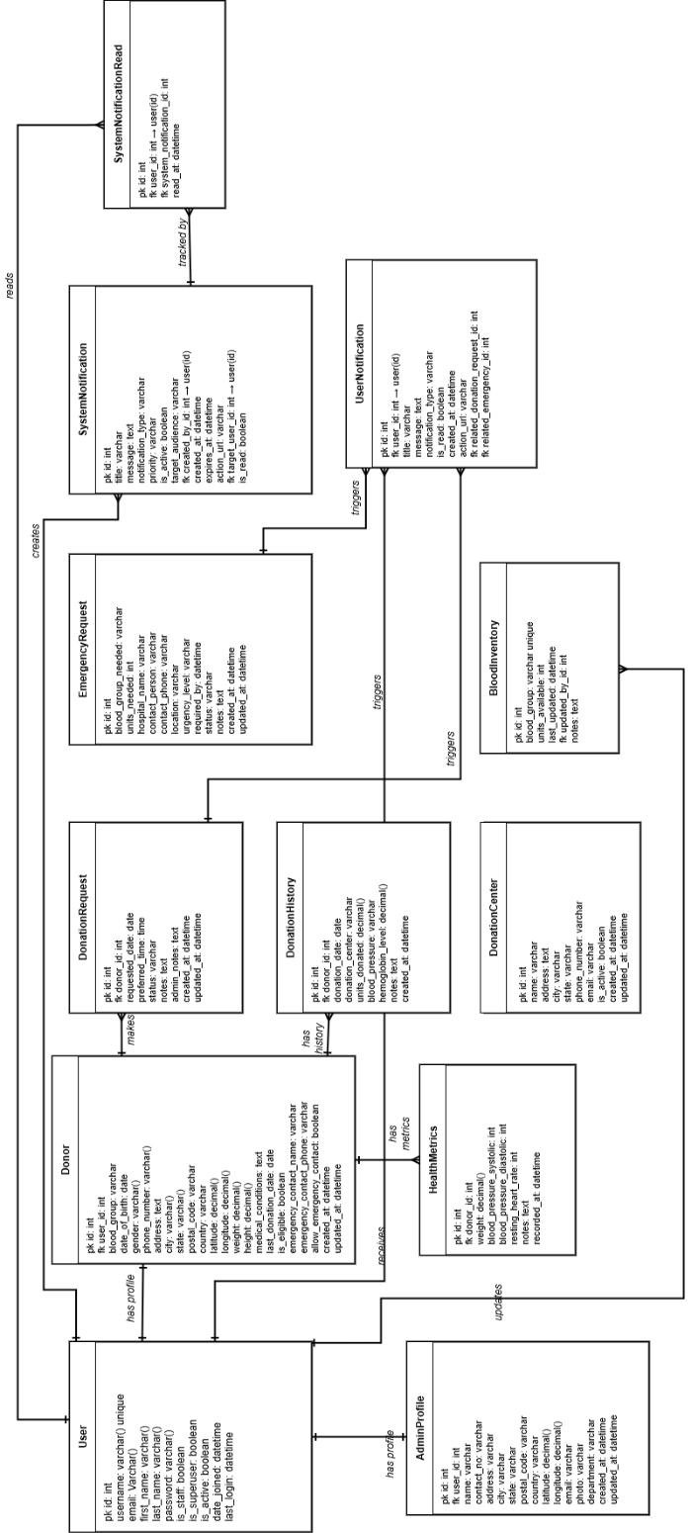

Figure 4.3: ER Diagram

12

The above Entity Relationship Diagram (ERD) represents the core database structure of a Blood Donation Management System. It captures essential entities such as users, donors, donation requests, emergencies, donation history, health metrics, and blood inventory. Each user can be a donor or an admin, with specific attributes and roles. Donors’ health and donation records are tracked to ensure eligibility and safety. The system also manages emergency blood needs, donation center data, and real-time no-tifications to keep stakeholders informed. This model ensures efficient data handling, timely coordination, and improved blood supply management.

13

4.5 Block Diagram
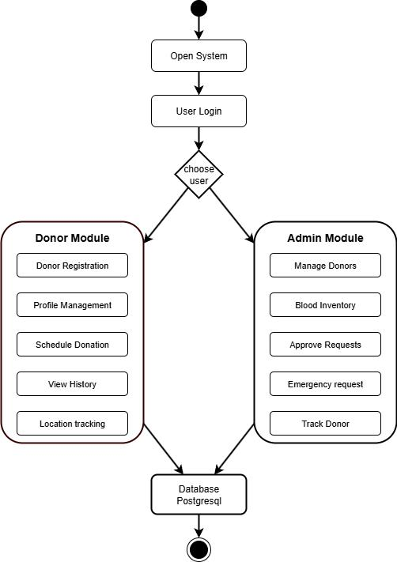

Figure 4.4: Block Diagram

This block diagram represents a Blood Donation Management System with two main user roles: Donor and admin. After logging in, users can access the Donor Module - featuring registration, profile management, donation scheduling, history, and location tracking - or the Admin Module - which includes donor management, blood inventory, request approvals, emergency handling, and donor tracking. All data is managed through a PostgreSQL database.

14

4.6 TOOLS AND PLATFORMS

4.6.1 Backend Technologies

- Django

- PostgreSQL

- Python

4.6.2 Front end Technologies

- HTML5

- CSS3

- JavaScript

- Bootstrap

4.6.3 Other Tools

- Visual Studio Code

- Git

4.6.4 Platform

- Development: Windows

- Database: PostgreSQL Server

15

Chapter 5

PROJECT WORK STATUS

5.1 Work Done:

We have completed the following major components:

- User authentication system including role-based login, session validation, and password security.

- Donor management module with profile, compatibility of blood groups, eligibility calculation and location-based filtering.

- Admin dashboard for tracking, inventory monitoring, and emergency request management.

- Implementation of the PostgreSQL database with fully normalized models and data constraints.

- Core functionalities such as donation history tracking, health metrics monitoring, emergency request system, and multichannel notifications.
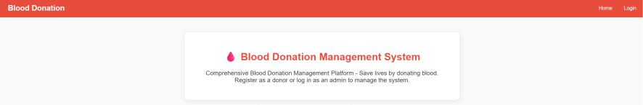

Figure 5.1: System Home Page Interface

This figure displays the homepage of the system, providing navigation links and access points for users i.e. donors and admins. It serves as the entry point to the platform.From here we can goto Login Page.

16

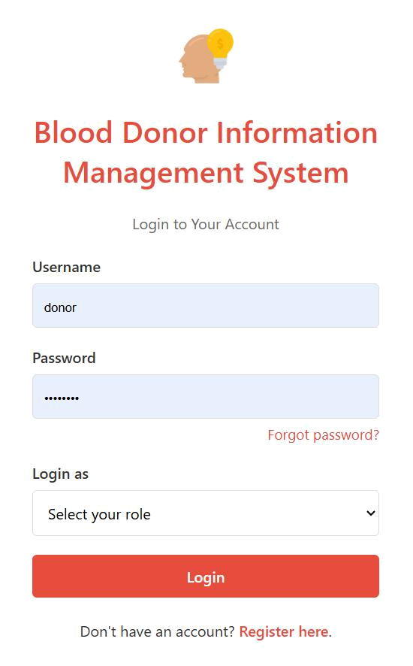

Figure 5.2: User Login Page

This interface allows users to securely log in using their credentials.Users can enter their username,password along with their roles to get redirected to their respective dash-boards.

17

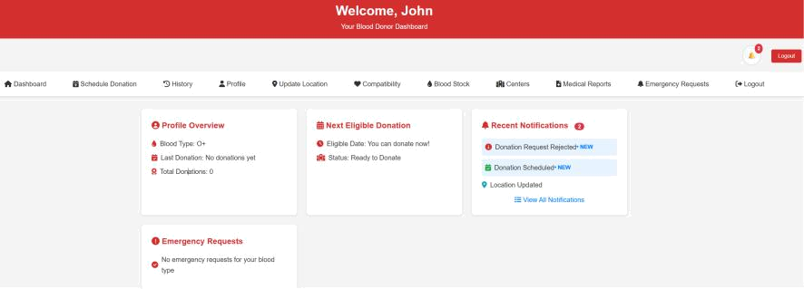

Figure 5.3: Donor Dashboard

After logging in, donors are directed to this dashboard where they can view their donation history, update their profile, see their compatibility, see blood centers and available blood stock, and they can also schedule donations.
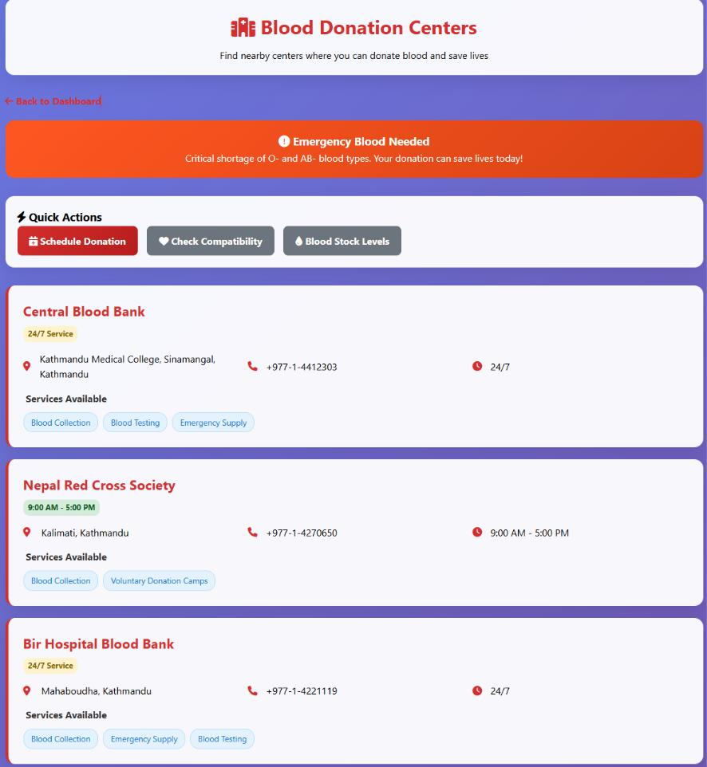

Figure 5.4: Donation Center Dashboard

This panel provides available blood donation centers,their phone number and their lo-cations, and their available services.

18

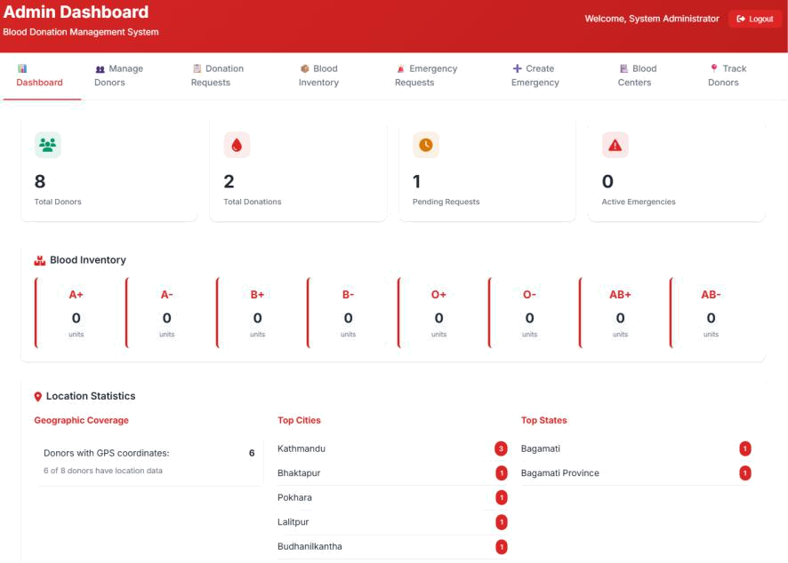

Figure 5.5: Admin Dashboard

This interface gives admin full access to manage donors, oversee the overall operations, monitor system logs, and ensure data integrity across modules.
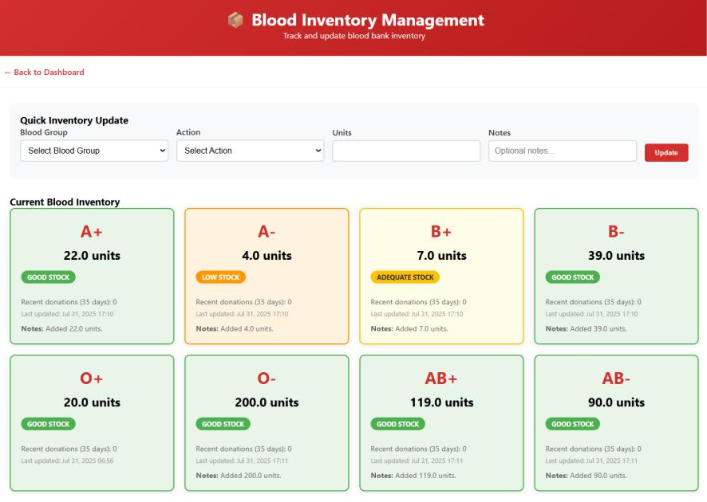

Figure 5.6: Blood Inventory Management Module

This module allows admins to track current blood stock levels, manage inventory up-dates, and ensure balanced availability across various blood groups.

19

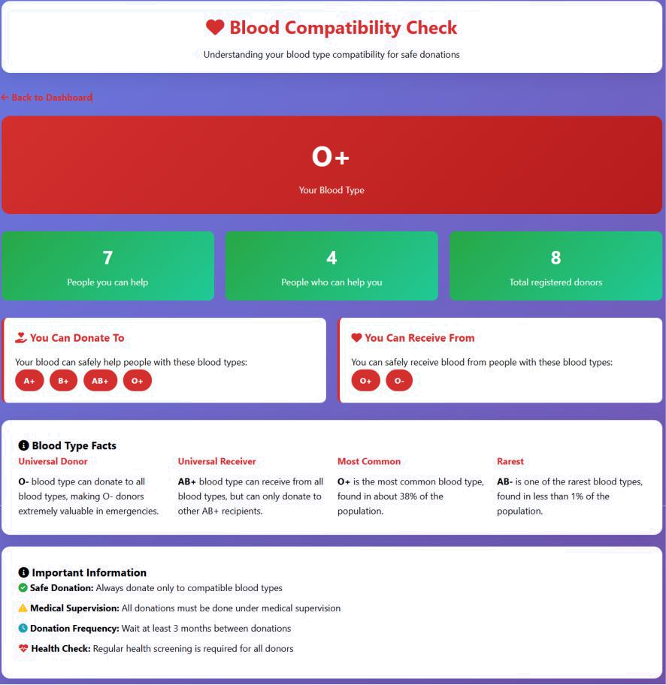

Figure 5.7: Blood Compatibility Check Feature

This feature enables quick verification of blood group compatibility between donor and recipient, assisting in safe and efficient transfusion matching.Donor can see which blood group they can donate to and recieve blood from.

20

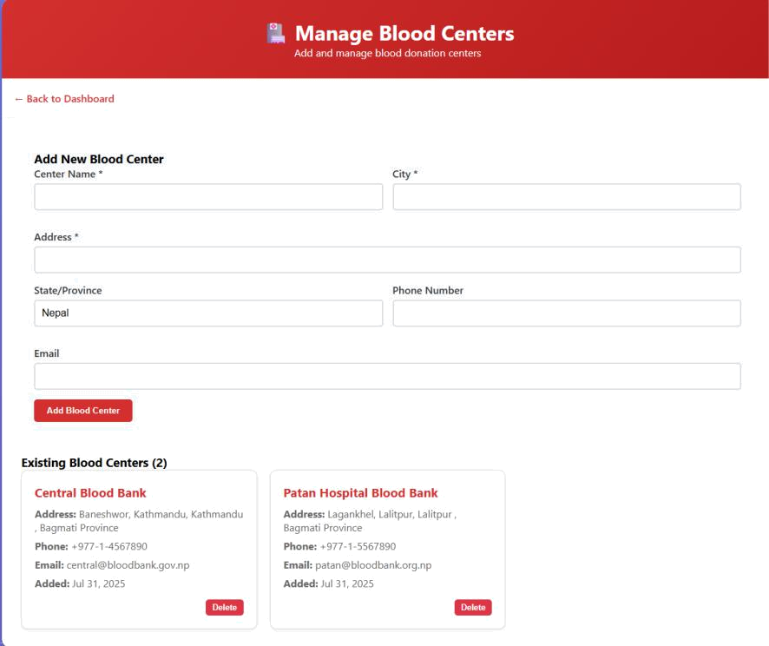

Figure 5.8: Blood Bank Management Panel

This panel allows the admin the control to add blood centers,delete exisiting blood cen-ters.

21

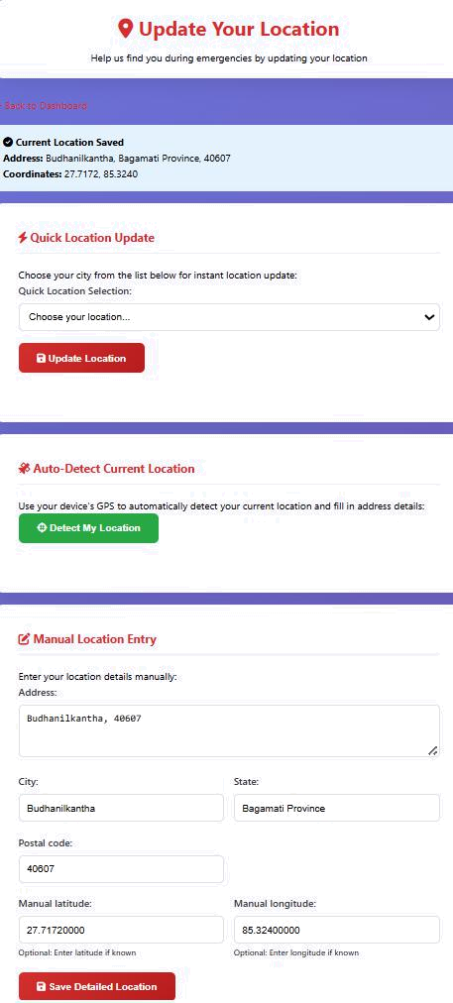

Figure 5.9: Location Update Interface

This interface lets donors to update geographical information about their current loca-tions to ensure accurate data for searches and logistics.

22

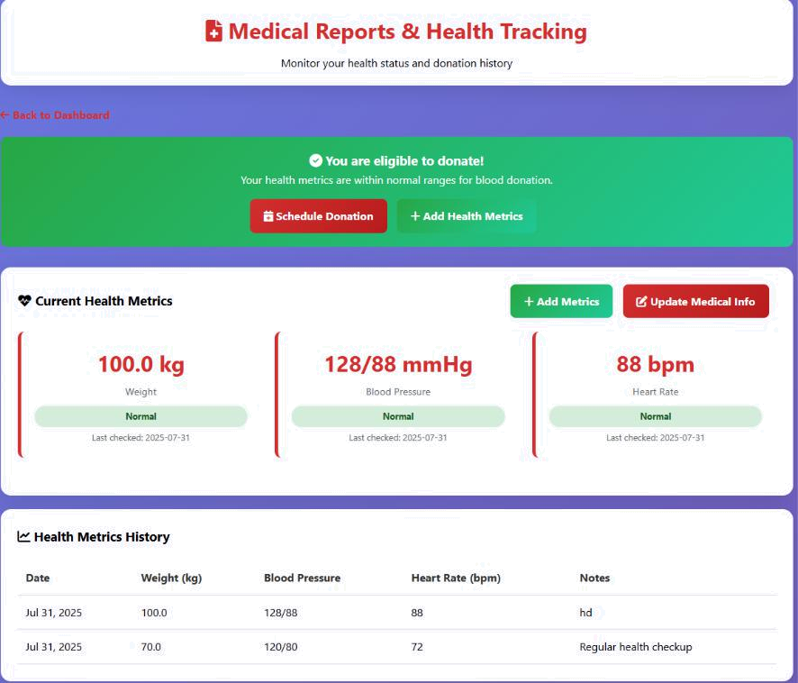

Figure 5.10: Medical Reports and Health Tracking

This section displays donor health records and medical history, enabling them to view their current or past Health metrics.

5.2 Work Remaining:

The remaining tasks include the following:

- Home page design and layout finalization.

- Donor tracking system debugging.

- Completion of the emergency blood request module.

- UI/UX refinement and enhanced error handling.

- Final testing and optimization of implemented features.

23

REFERENCES

- World Health Organization. “Voluntary Non-Remunerated Blood Donation”. In: World Health Organization Bulletin (2020). Accessed: 2025-08-05. URL: https: //www.who.int/news- room/fact- sheets/detail/blood- safety- and-availability.

- K. Park. Preventive and Social Medicine. 24th. Jabalpur, India: Banarsidas Bhanot, 2017.

- Nepal Red Cross Society. Blood Transfusion Service Department. Accessed: 2025-

08-05. 2023. URL: https://www.nrcs.org/blood-transfusion.

- Ravi Patidar and S. Sharma. “Design and Implementation of Blood Donor Manage-ment System”. In: International Journal of Computer Applications 181.10 (2019),
  - 25–29. DOI: 10.5120/ijca2019918723.

- Ministry of Health and Population, Nepal. National Blood Policy. Accessed: 2025-

08-05. 2018. URL: https://mohp.gov.np/.

- S. Elshafie and T. Ahmed. “Database Design for Blood Bank Management Sys-tem”. In: Journal of Health Informatics in Developing Countries 15.1 (2021),
  - 34–42.

24

