UUN: S1525701
Task1

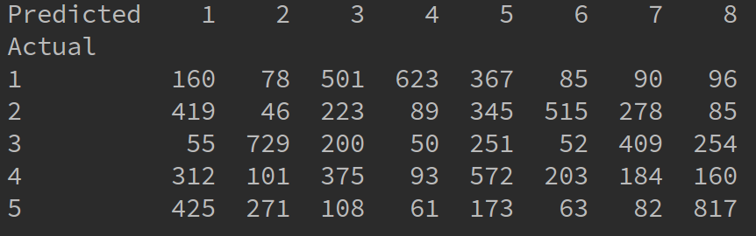
Task 1.2

In the confusion matrix for the train data above the rows represent the actual class labels – numbered from 1 to 5 - and columns represent the 8 classes, as labelled by the K-means clustering – labelled 1 through 8.

Final SSE value when running with 8 clusters originally positioned at first 8 points of the data: 135.541445399

Task 1.3
Discussion
By performing clustering with different cluster centres, and by inspecting the results of the 30 runs of K-means clustering with random centres we can observe the following:

- SSE generally converges to a similar number

- There is little difference between the maximum and minimum SSE observed
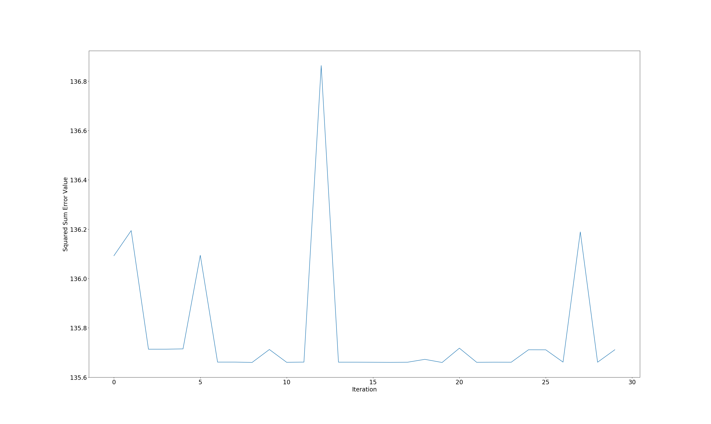
In my latest 30 runs of K-means clustering I have gathered the following data
Maximum SSE: 136.863054832
Minimum SSE: 135.659783905
Difference between minimum and maximum SSE: 1.20327092693
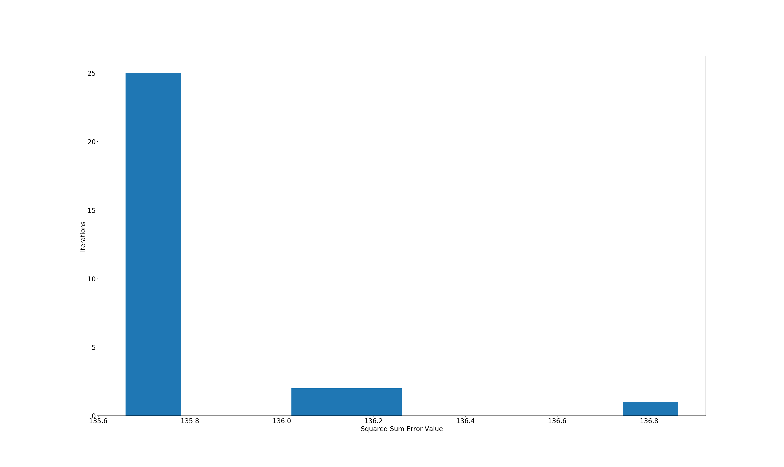

The plots above clearly reflect the convergence of Squared Sum Error to a single value.

Improving the performance of clustering

There are few ways in which we can improve our clustering performance:

- Better way to pick initial K centroids – it has been studied that by maximizing inter-cluster distances we get better clustering. So one way of improving the current clustering is choosing clusters so that we maximize the distance between them, instead of choosing them at random. However, we need to bare in mind that, as we saw in the 30 run experiment, different initial centres improve the performance just slightly.

- Number K of centroids – in the coursework we use 8 clusters. We can pick K value after we have studied the data and chosen a value that we seem fit. Another approach is to pick K randomly and dynamically converge or split clusters as the clustering runs on the basis of some observation.

- Setting a maximum limit on the number of times the algorithm runs - we currently stop running the clustering converges or reaches maximum iterations. However, in some cases centroids change only slightly after certain amount of runs or oscillate between values indefinitely. We currently have maximum amount of iterations, however, we can additionally measure the value of change in cluster position between runs and set a threshold, which once reached stops the clustering.

- Distance measure – we use Euclidean distance, which in some cases is not optimal. We can pick another distance measure or even a combination of such.

