UUN:S1525701
Task2

Task 2.3
Determinants of covariance matrix of:
- Class 1: 8.94933712801e⁻²⁵
- Class 2: 2.82852645141e⁻³⁷
- Class 3: 2.52810991847e⁻⁶⁵
- Class 4: 2.4690437482e⁻²³
- Class 5: 6.40249199698e⁻⁴⁴

Confusion matrix for the test data reduced to 100 dimensions:
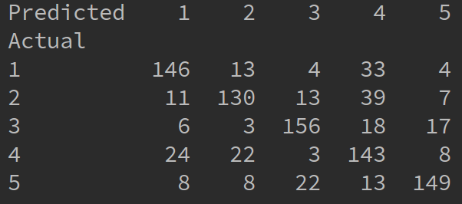
After we normalize the table we get the following classification rates:

- Class 1: 74.9%
- Class 2: 73.9%
- Class 3: 78.8%
- Class 4: 58.1%
- Class 5: 80.5%

Task 2.4

For the investigation on the effect of dimensionality on classification rate I used a Python script classification_performance.py , which can be found in Task2 directory.

Files related to this task:
- classification_performance.py – script to perform the experiment and plot the results
- performance_results.txt – full results of classification performance with different dimensionality

The experiment
We train the model with train_x data reduced to a specified dimensionality and test the model on the reduced dimensionality test_x data. Additionally, the data is centred around the mean of the train data.

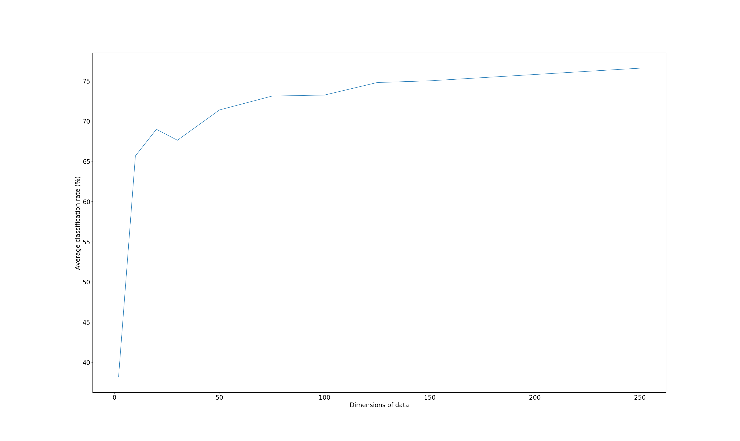
The experiment has been run with the following dimensions: 2, 10, 20, 30, 50, 75, 100, 125, 150, 250. A graph with the average classification rate is presented below.
Results
Discussion: Average classification performance increases with proportionally to the increase of dimensionality. However, for higher dimensional data we can observe the “curse of dimensionality”, where data is too sparse to classify efficiently and performance drops (not shown on the graph). This is the reason we apply Principle Component Analysis to the data to reduce its dimensions.

Below are listed exact results for 2, 100, 250 dimensions. Full results can be found in performance_results.txt in Task2 directory.

Classification rate for data with dimensionality reduced to: 2
- Class 1: 37.9%
- Class 2: 40.8%
- Class 3: 28.6%
- Class 4: 42.5%
- Class 5: 41.0%
Average classification rate: 38.16%

Classification rate for data with dimensionality reduced to: 100
- Class 1: 74.9%
- Class 2: 73.9%
- Class 3: 78.8%
- Class 4: 58.1%
- Class 5: 80.5%
Average classification rate: 73.24%

Classification rate for data with dimensionality reduced to: 250
- Class 1: 76.1%
- Class 2: 80.0%
- Class 3: 88.5%
- Class 4: 59.5%
- Class 5: 78.8%
Average classification rate: 76.58%

