UUN: S1525701
Task 3

Task 3.3

To classify Polygon A I used neural network with the following structure.
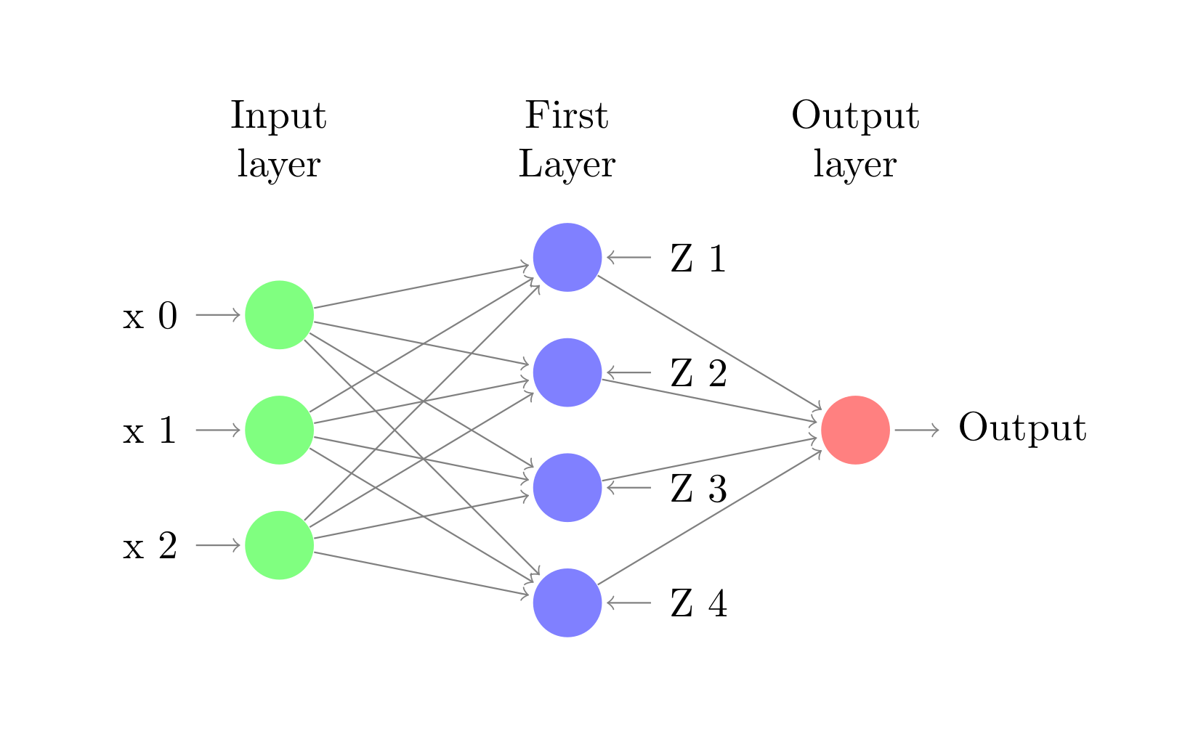
For input we have a point (x₁,x₂) and x₀ bias. In our case x₀ is 1.
Neurons Z1-Z4 in the first layer represent neurons for decision regions given by the 4 lines of our polygon.

Not drawn on the diagram are the weights associated with each layer- W(L,i, j) is the weight of neuron “i” at level L, coming from neuron “j” at level L-1.

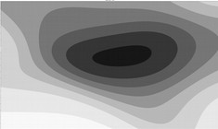
multiplierA=1, multiplierB=1
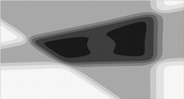
multiplierA=5, multiplierB=1
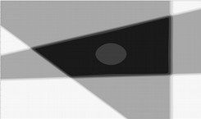multiplierA=20, multiplierB=1
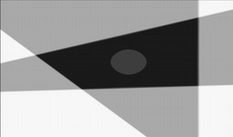multiplierA=50, multiplierB=1
Finding the weights
To find the weights I first found the inequalities for the 4 lines of Polygon A.
In order to model them with a step function neuron I presented the inequalities in the form:
w_{b} + w₁x₁ + w₂x₂ ≥ 0
Using this inequality I take w_{b} as the bias weight (being multiplied by x₀ = 1) and w₁ and w₂ as the corresponding weight for the coordinates of a points (x₁,x₂).

Task 3.10
Description
Experiment was conducted with weight vectors, which form the described shape for hNN_AB with applied multipliers.
Example: [w₀, w₁, w₂] → [w₀, w₁, w₂]*multiplier
For weights responsible for the decision region of Polygon A let’s call the multiplier multiplierA and for decision region of Polygon B let’s use multiplierB.

Experiments are done with different values for both multipliers and picture representation of the results is seen below.

multiplierA=50, multiplierB=5

multiplierA=50, multiplierB=10
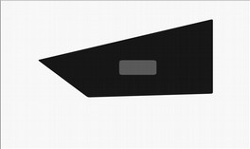
multiplierA=50, multiplierB=30
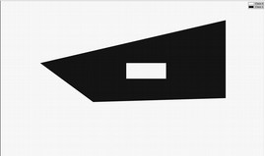
Classification of hNN_AB function

Discussion

We can see that with increase in weights the structure becomes very close to the structure constructed by hNN_AB network. With increase of the multipliers the decision boundaries become close to the linear classification of the step function. With lower multipliers we can see that the data is classified by smoother non-linear boundaries.

The main difference between the sigmoid and the step activation functions on how they affect our results is that Polygon B is classified as a different class than the outer region of Polygon A. This is due to the nature of the sigmoid function – it turns linear inputs to non-linear outputs.

Our classification problem is linearly separable and contains only 2 classes so the step activation function performs better in this case. However, if we had a multilayer neuron network and we wanted to learn the weights by back propagation that would be impossible with the step function – because it is not differentiable.

Besides the fact that inner polygon and the space out of Polygon A should be the same class, the sigmoid function, with adequately adjusted weights, did a good job at classifying the data.

