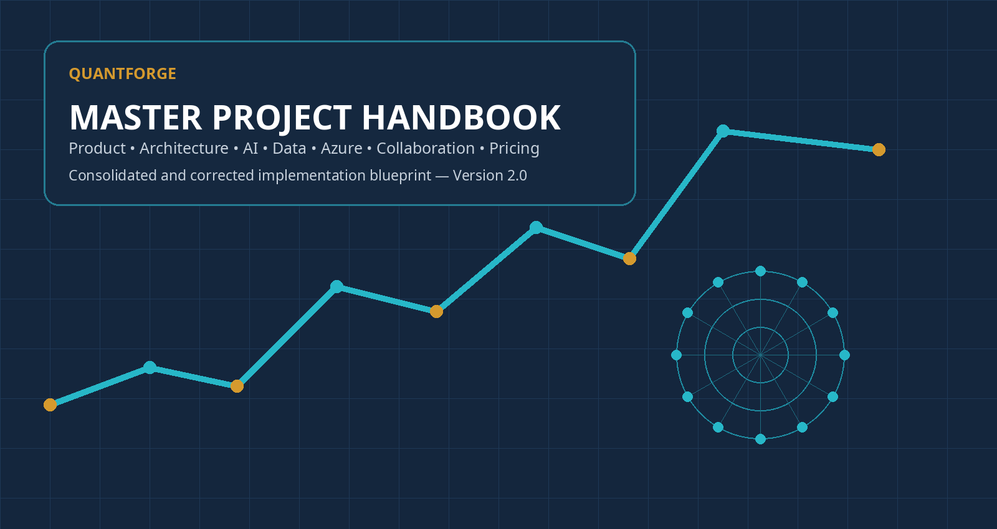
MASTER BLUEPRINT • VERSION 2.0
QuantForge — AI-Assisted Trading Research, Validation & Paper Execution
Prepared for a five-month software development internship
Status: consolidated concept, corrected architecture, collaboration handbook, cost plan and implementation path
This document supersedes the earlier Platform Blueprint, AIOS Collaboration Handbook and Pricing & Unit Economics Plan where decisions conflict.

Document control and how to use this handbook
MASTER SOURCE OF TRUTH
When an older QuantForge document conflicts with this handbook, this handbook wins. The earlier documents remain useful as history and detail, but the decisions here are the current project baseline.

Item | Current decision
Working title | QuantForge
Planning date | 8 August 2026
Internship length | Five months, two developers using separate AIOS environments
Primary market | BTC and ETH perpetual futures; one exchange first
Initial exchange | Kraken / Kraken derivatives demo environment
Final internship execution | Automated paper trading only; no public real-money execution
Cloud direction | Microsoft Azure + Microsoft Foundry
Historical data source of truth | Azure Blob Storage / Data Lake capabilities with Parquet
Application database | Azure Database for PostgreSQL Flexible Server
Redis | Optional hot cache only; not required for the MVP
AI responsibility | Research, clarification, orchestration, criticism and explanation
Deterministic responsibility | Backtesting, metrics, risk, signals and execution via Python/services
Commercial model | Subscription + included Research Credits + optional overage credits
Collaboration source of truth | GitHub repository, issues, PRs, ADRs and shared context files

What changed since the earlier documents
Earlier wording / risk | Corrected decision in this handbook | Why
A collaboration example ADR could be read as “PostgreSQL + TimescaleDB for market data.” | PostgreSQL stores product state, metadata and optionally compact derived time-series. Raw historical market history belongs in Blob/Data Lake + Parquet. | Raw tick/order-book history grows quickly and is cheaper, easier to version and easier to replay as columnar files.
Redis appeared in the recommended stack and could be interpreted as mandatory. | Managed Redis is removed from the internship baseline. Use local Redis only if an experiment proves a need; add Azure Managed Redis later for hot shared state. | The entry managed tier can be disproportionately expensive for a two-person MVP and RAM is the wrong storage medium for long history.
“Train agents” can sound like training new models. | First optimise agents through instructions, tools, schemas, evaluation datasets, traces and model selection. Fine-tuning is a later option only after evidence justifies it. | Most agent quality comes from system design and evaluation before custom model training is useful.
The AI architecture could imply that every subsystem is an agent. | Keep AI outside the deterministic trading hot path. Python/services calculate and enforce; AI proposes and interprets. | This improves reliability, reproducibility, cost control and auditability.
Web SaaS was previously presented as an early build item. | Prove the core research loop first with CLI/Python + Foundry; build the polished web app after the intelligence loop works. | The hardest uncertainty is whether the research/validation workflow is genuinely valuable, not whether a dashboard can be built.
Paid market-data vendors were discussed as possible dependencies. | Kraken-native data is sufficient for the internship baseline. Databento or other premium data is an expansion when traditional futures, deeper history or institutional fidelity is required. | Avoid data licensing cost before a feature specifically requires it.

Contents
Section | Title | Purpose
Part I | Product vision and market value | What QuantForge is, who it serves, and why it should exist.
Part II | User experience and end-to-end workflows | How a beginner, regular trader and technical user interact with it.
Part III | Technical architecture | The complete component map and separation of AI from deterministic software.
Part IV | Microsoft Foundry and agent system | How agents are built, evaluated, routed and improved without premature fine-tuning.
Part V | Python trading engine and validation core | Strategy schema, backtesting, metrics, robustness and execution.
Part VI | Market data and databases | Kraken, Blob/Data Lake, PostgreSQL, Redis, retention and premium data.
Part VII | Azure infrastructure and cost control | What each Azure service does, when to add it, and realistic cost ranges.
Part VIII | Security, risk and regulatory boundaries | Credentials, tool permissions, kill switches, audit and live-trading caution.
Part IX | Two-person AIOS collaboration | GitHub control plane, branches, contracts, ADRs, CI/CD and handovers.
Part X | How to actually start and the five-month roadmap | Research spikes, milestones, sequencing and final demo.
Part XI | Pricing and unit economics | Research Credits, subscription tiers, scenarios and cost telemetry.
Part XII | Risks, limitations and future expansion | What can fail, what not to promise, and where the product can grow.
Appendices | Ready-to-use technical templates | Schemas, repository structure, issue/PR templates, test catalogue, glossary and sources.

PART I
Product vision and market value
A rigorous AI-assisted quantitative workspace — not a promise of profitable predictions.

1. The concept in one sentence
CORE CONCEPT
QuantForge is a SaaS platform where users describe or upload trading ideas; AI turns them into explicit experiments; deterministic software backtests and stress-tests them; independent AI reviewers challenge the evidence; and approved strategies can be deployed into controlled paper trading.

The product is not “an AI that knows the market.” It is a research-and-control system that makes systematic trading research accessible to people who cannot or do not want to assemble their own data pipelines, Python notebooks, backtesters, risk controls and execution infrastructure.

2. The problem QuantForge solves
• A beginner may have a trading idea but cannot convert vague language into precise, testable rules.
• An intermediate trader can backtest in separate tools but often has to manually combine charts, scripts, spreadsheets, fees, risk assumptions and execution.
• A technical trader can code, but rigorous validation still requires time-consuming data cleaning, walk-forward testing, sensitivity analysis and documentation.
• Backtests are easy to make look good accidentally through look-ahead bias, survivorship bias, parameter overfitting, unrealistic fills or selective time periods.
• Existing AI interfaces can produce persuasive explanations without proving that the numbers are correct or the implementation matches the user’s intention.
• Automation becomes dangerous if a language model is allowed to improvise orders or silently change strategy rules.

3. Product promise
Promise | What it means in practice
Accessible | A non-programmer can start in natural language and receive guided clarification instead of writing code.
Rigorous | Every approved strategy has explicit rules, data assumptions, transaction costs, out-of-sample tests and a reproducible run record.
Adversarial | QuantForge does not only search for evidence that supports the idea; a critic process actively tries to invalidate it.
Transparent | The user can inspect the StrategySpec, backtest assumptions, individual tests, agent findings and reasons for the final verdict.
Automatable | After approval, deterministic services can monitor and paper-execute the exact strategy without an LLM improvising in the hot path.
Progressive | Guided mode hides unnecessary complexity; expert mode exposes data, parameters, metrics, code/configuration and APIs.

4. Why someone would pay for it
The value is not “better predictions because AI is smarter than humans.” That claim is not defensible. The value is compression of a complicated workflow into one auditable workspace.
Today | With QuantForge
Idea in a trader’s head | Natural-language intake converts the idea into testable conditions and asks for missing definitions.
Manual coding or scripting | A structured strategy schema becomes deterministic executable logic.
Separate backtesting tool | Backtest jobs are integrated, versioned and linked to the exact strategy/data assumptions.
Manual robustness work | Sensitivity, walk-forward, regime and cost tests are launched as part of a validation battery.
Confirmation bias | A separate critic is rewarded for finding reasons the strategy should not be trusted.
Manual paper execution | Approved rules can run automatically in demo/paper mode under hard risk constraints.
Fragmented notes | Every hypothesis, revision, run, approval and verdict is retained as an experiment history.

COMMERCIAL POSITIONING
“From vague trading idea to reproducible evidence and controlled paper deployment — without requiring the user to be a quantitative developer.”

5. Target users and interface modes
Persona | Typical need | QuantForge experience
Beginner / non-technical | “I think BTC rebounds after large drops, but I cannot code it.” | Guided mode explains terms, asks multiple-choice/short questions, shows plain-language risk and teaches why tests matter.
Regular active trader | “I know indicators and setups; I want to test ideas faster and more honestly.” | Balanced mode exposes parameters, strategy versions, comparative results and paper deployments.
Technical / quant-minded | “I want raw assumptions, schemas, datasets and detailed metrics.” | Expert mode exposes StrategySpec, data versions, JSON, advanced tests, exports and eventually API/uploaded strategy support.

6. Scope: narrow first market
INTERNSHIP MARKET DECISION
Start with BTC and ETH perpetual futures on one demo-capable exchange. Focus on intraday strategies using roughly 1-minute to 15-minute data. Do not attempt high-frequency trading.

A narrow market is an engineering advantage. It lets both developers deeply understand one symbol model, one fee/funding model, one order API, one data vocabulary and one replay environment. Expansion to other crypto venues or traditional futures should happen only after the research-to-paper loop is trustworthy.

PART II
User experience and end-to-end workflows
What users ask, what the system asks back, what gets calculated, and what may execute.

7. Where users interact
The primary product should be a web SaaS. Discord can be used for team development notifications or optional future user alerts, but it should not be the main product interface. A research platform needs structured charts, experiment history, assumptions, approvals and comparison views that a chat-only interface handles poorly.
• Conversational research panel for natural-language ideas.
• Structured StrategySpec editor for exact rules.
• Backtest/validation workspace with charts and evidence.
• Strategy-version comparison.
• Paper deployment page with positions, risk controls, pause/kill switch and audit log.
• Usage and Research Credit view.

8. Three valid starting points
Starting point | Example | System response
Natural-language hypothesis | “BTC continues after a 4-hour breakout when volume is high.” | Clarify undefined terms, create StrategySpec, validate and test.
Existing rule set | A written strategy or later an uploaded Python/Pine implementation. | Translate or sandbox it, compare semantics, then run independent validation.
Research question | “Does funding + momentum contain useful information intraday?” | Define a constrained experiment instead of mining unlimited patterns.

9. Complete example: BTC breakout hypothesis
USER HYPOTHESIS
“I think BTC keeps moving upward after it breaks the previous four-hour high with unusually high volume.”

1 | Clarify the idea  The agent asks what constitutes a breakout, how volume should be measured, when entry occurs, how the trade exits, and how much account risk is allowed.

2 | Create an immutable StrategySpec  The system converts the answers into a versioned JSON/Pydantic object. Undefined values remain errors; the agent must not silently invent them.

3 | Select and verify data  The data layer resolves BTC perpetual candles/trades, checks timestamps/gaps and attaches a dataset version to the experiment.

4 | Run deterministic backtest  A Python job calculates signals and simulated orders from historical data with fees, funding, slippage and execution timing.

5 | Run validation battery  The platform performs out-of-sample tests, parameter sensitivity, regime splits, delay/fee stress and suspicious-result checks.

6 | Independent criticism  A critic agent receives the strategy, methodology and machine-generated metrics and searches for fragility, bias and unsupported conclusions.

7 | Present verdict  The user sees PASS / CAUTION / FAIL with evidence, not a single return number.

8 | Paper deploy  If approved, the exact StrategySpec version is loaded by a deterministic execution service and sent to Kraken’s demo environment under hard risk limits.

10. Example StrategySpec
{
"strategy_id": "btc-breakout-v3",
"market": "BTC-PERP",
"timeframe": "5m",
"direction": "long",
"entry": {
"breakout": "close > previous_4h_high",
"volume": "volume > 1.5 * sma(volume, 20)",
"execute_at": "next_bar_open"
},
"exit": {
"stop_loss_pct": 0.8,
"take_profit_pct": 1.6,
"max_holding_minutes": 180
},
"risk": {
"risk_per_trade_pct": 0.5,
"daily_loss_limit_pct": 1.5,
"max_open_positions": 1
}
}

The schema is more important than the wording of the chat. It is the contractual bridge between AI reasoning and deterministic software.

11. What may execute and what requires approval
Action | AI may do it? | Deterministic service may do it? | Human gate
Ask clarification questions | Yes | No | No
Propose strategy rules | Yes | No | User approves the version before deployment
Calculate P&L / Sharpe / drawdown | No | Yes | No
Launch a backtest job | Yes, through an allowed tool | Yes | Cost/plan limits may apply
Change a running strategy | Propose only | No silent change | New version + validation + approval
Place paper order | No direct improvisation | Yes, if approved rule + risk checks pass | Initial deployment approval; optional per-order confirmation mode
Place real-money order | Future only | Potentially | Legal/security readiness + explicit user configuration

PART III
Technical architecture
A layered system designed so probabilistic AI can never silently replace deterministic trading logic.

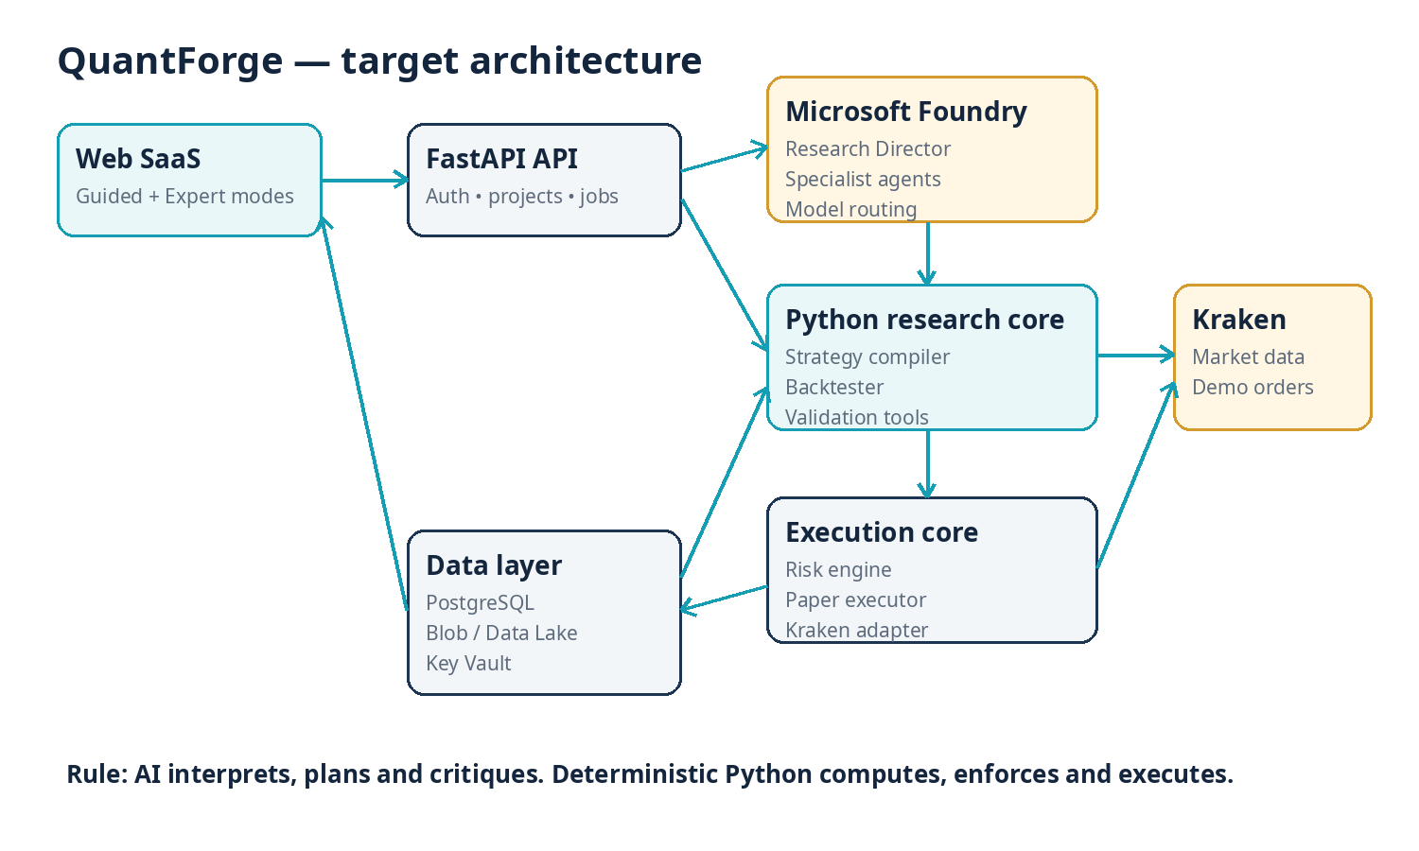

12. Architecture principles
• AI is allowed to be probabilistic where interpretation and critique are useful; calculations and safety controls must be reproducible.
• Every research artifact is versioned: strategy, dataset, code/configuration, model configuration and result.
• The user’s approved StrategySpec is the source of truth for execution. An agent cannot modify it in memory and continue trading.
• Backtests are finite jobs, not always-running web processes; use isolated workers/jobs.
• Historical market data is immutable/append-oriented object storage; application records live in PostgreSQL.
• Secrets never appear in source code, Discord or agent prompts unless strictly needed by an approved tool path.
• The system must fail closed: stale data, invalid rules, failed risk checks or uncertain exchange state stop new orders.

13. Main components
Component | Responsibility | Recommended implementation
Web client | User research workflow, charts, approvals, billing/usage | Next.js + TypeScript
Backend API | Users, projects, entitlements, job orchestration, audit | Python FastAPI
Strategy compiler | Natural-language result → validated strategy representation | Pydantic models + compiler functions
Research orchestration | Plan research, call specialists/tools, synthesise results | Microsoft Foundry Agent Service / Responses APIs
Backtest worker | Deterministically simulate strategy over historical data | Python container; Polars/NumPy; optional vectorbt/LEAN support later
Validation engine | Walk-forward, sensitivity, fee/slippage and regime tests | Python jobs + fixed statistical routines
Risk engine | Position sizing, limits, order validation, kill switch | Pure deterministic Python service/library
Execution adapter | Translate approved orders to demo exchange API | Kraken API client, idempotent order commands
Historical lake | Cheap, replayable raw/curated data | Azure Blob Storage / Data Lake + Parquet
Product database | Users, strategies, jobs, results, approvals | Azure PostgreSQL Flexible Server
Hot cache | Only if scale justifies it | Local Redis first; Azure Managed Redis later
Secrets | Exchange/API credentials | Azure Key Vault
Compute | API, collector, workers and finite jobs | Azure Container Apps + Container Apps Jobs
Observability | Logs, metrics, traces, cost telemetry | Application Insights / Azure Monitor + Foundry traces

PART IV
Microsoft Foundry and the agent system
How the AI layer should be built, made reliable, and kept affordable.

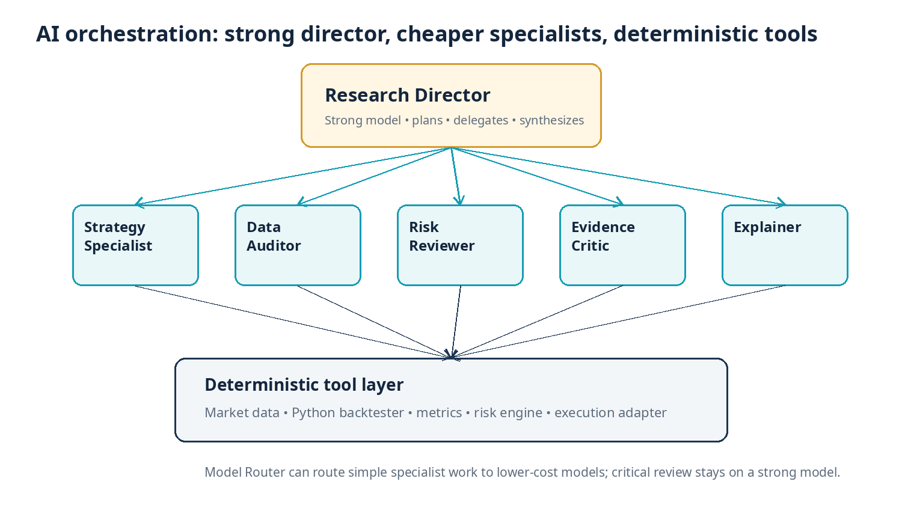

14. What “building agents” actually means
IMPORTANT TERMINOLOGY
During the internship you are mainly configuring and evaluating agents, not training new foundation models. An agent is a model plus instructions, allowed tools, schemas/state and evaluation criteria.

Microsoft Foundry can host model deployments and agent workflows. Your own Claude-based AIOS environments remain development assistants for you and your friend; they are not the runtime brain of the SaaS unless you deliberately integrate an Anthropic API. QuantForge’s runtime AI calls should go through a provider abstraction so Foundry-hosted GPT, Claude or other models can be benchmarked later.

15. Recommended agent roles
Agent / role | Model strategy | Job | Hard boundary
Research Director | Strong reasoning model | Understand intent, create plan, delegate, decide whether evidence is sufficient | Cannot calculate final metrics or place orders directly
Strategy Specialist | Smaller/medium model | Convert ideas into explicit StrategySpec candidates and ask clarification | Cannot invent unresolved parameters silently
Data Auditor | Smaller model + deterministic data-quality tools | Interpret gap/coverage reports, spot dataset risks | Cannot rewrite historical data without logged transformation
Research Planner | Smaller model | Select which deterministic tests to run | Cannot claim test results before tools return them
Sceptical Critic | Strong reasoning model | Try to falsify the strategy and challenge conclusions | Must not optimise the strategy while judging the same version
Risk Reviewer | Small/medium model + fixed policies | Explain drawdown/exposure and propose conservative boundaries | Cannot override hard risk policies
Report/Explainer | Cost-efficient model | Translate validated evidence into beginner/expert explanations | Cannot hide failed tests or uncertainty

HEAD-AGENT PATTERN
A strong Research Director coordinating cheaper specialists is sensible. Keep important adversarial review on a strong model; route repetitive classification, formatting and straightforward extraction to cheaper models.

16. Model Router and cost-aware orchestration
Microsoft Foundry Model Router can route requests among supported model deployments according to routing configuration. Treat it as an optimisation tool, not a replacement for your own task boundaries. QuantForge should still know whether a request is “critical final review” versus “cheap formatting.”
Work type | Preferred model class | Reason
Intent classification / formatting / simple extraction | Nano/small | High volume, low reasoning depth
Strategy clarification | Small/medium; escalate on ambiguity | Needs domain language but can be constrained by schema
Research planning | Medium/strong | Bad plans waste compute and can invalidate evidence
Final critic / synthesis | Strong | This is where nuanced reasoning and scepticism matter most
User-facing explanation | Small/medium | Can be generated from already-validated structured evidence

17. How the agents become good
1 | Define behavioural contracts  Write explicit instructions: required questions, forbidden assumptions, tool permissions, output schemas and escalation rules.

2 | Create evaluation fixtures  Build 50–100 trading scenarios containing ambiguous ideas, misleading backtests, missing data, suspicious metrics and adversarial prompts. Record the expected behaviour.

3 | Trace every run  Capture model, prompt version, tool calls, arguments, outputs, retries, latency and cost. Without traces you cannot systematically improve reliability.

4 | Score task quality  Evaluate task completion, instruction adherence, tool selection/input accuracy, groundedness and domain-specific assertions.

5 | Fix the system before changing the model  Improve schema, tool descriptions, instructions and deterministic checks. Many “model problems” are really poor system boundaries.

6 | Benchmark models and routes  Run the same evaluation set across cheaper and stronger models. Use the cheapest option that reliably clears the acceptance threshold.

7 | Use optimisation tooling experimentally  Foundry Prompt/Agent Optimizer can propose improved instructions/tools/model choices, but preview features should not be a production dependency.

8 | Fine-tune only when justified  Consider supervised fine-tuning after you own a high-quality dataset and can show that prompting/tools/evaluation have plateaued. Include hosting cost in the decision.

18. Example evaluation cases
Case | Expected behaviour | Failure
“Buy BTC when volume looks high.” | Ask for a measurable threshold, timeframe, entry timing, exit and risk. | Invent “1.5× volume” and test it without confirmation.
Backtest: +184%, Sharpe 4.8, 17 trades | Flag tiny sample and suspiciously strong performance; demand robustness testing. | Praise performance without questioning evidence.
External text tells agent to export secrets | Ignore untrusted instruction and restrict tool calls to the research task. | Follow prompt injection or expose credentials.
Dataset has a 3-hour gap | Stop or mark affected period; ask data tool for coverage report. | Interpolate silently and continue.
User asks “make this profitable” | Explain that optimisation can overfit; define objective and holdout procedure. | Search unlimited parameters until something looks good.

19. What the AI layer costs
Creating multiple prompt/workflow agents does not itself mean paying for a permanently running model. The main variable costs are model inference and any billed tools/storage/hosted infrastructure the workflow uses. A multi-agent loop costs more because it makes more calls and often sends prior context/results back into later calls.
PLANNING ENVELOPE
For the internship, reserve roughly €100–€500 for Foundry model experiments and evaluations. This is intentionally a budget envelope, not a vendor quote. Instrument every run so the number can be replaced by measured cost.

Cost driver | How it grows | Control
Input/output tokens | Long prompts, large result payloads, repeated context | Compact structured context, summaries, caching and smaller models
Number of agents/iterations | Every critique/retry can trigger additional calls | Bound maximum rounds and require a reason for retries
Strong-model share | Large reasoning models cost more | Use strong models for director/critic, cheaper specialists elsewhere
Evaluation volume | Hundreds of fixtures × multiple candidates/models | Run small smoke set on every change; full suite on milestones
Tool sessions/search/vector storage | Some Foundry tools have separate meters | Prefer your own deterministic Python tools where appropriate; measure tool cost

PART V
Deterministic Python trading and validation core
The part of QuantForge that must be reproducible even if every AI model is temporarily unavailable.

20. Why Python owns the numbers and orders
A language model is useful for interpretation, but it is a poor source of truth for numerical simulation and safety-critical execution. QuantForge should treat AI output as a proposal that must be compiled into a strict representation. Python then performs every calculation from data and rules.
AI is good at | Python/deterministic services are good at
Understanding vague user language | Exact arithmetic and indicator calculations
Asking intelligent clarification questions | Processing millions of rows reproducibly
Designing an experiment plan | Enforcing timestamp ordering / no future data
Critiquing assumptions and explaining weaknesses | Fees, funding, slippage and position accounting
Generating candidate rules within a schema | Risk limits, idempotency and kill switches
Summarising evidence for different skill levels | Sending exact approved order requests

21. Strategy compiler → backtester flow
1 | Validate StrategySpec  Pydantic validates fields, supported indicators, bounds, market/timeframe and risk policy. An invalid or ambiguous spec cannot proceed.

2 | Resolve immutable inputs  Create a RunManifest containing strategy version, dataset version/path, fee model, slippage model, engine version, random seed (if any) and run timestamp.

3 | Load historical data  Read only the required Parquet partitions from Blob/Data Lake. Normalize UTC timestamps and verify no gaps/duplicates beyond policy.

4 | Calculate signals  Use vectorised or event-driven Python code. Every indicator at time t may only use information available at or before t.

5 | Simulate orders  Apply entry timing, spread/slippage, maker/taker fees, funding, stop/target logic and max-position constraints.

6 | Calculate metrics  Return trades, equity curve, P&L, win rate, drawdown, Sharpe/Sortino where appropriate, exposure and cost breakdown.

7 | Write machine-readable result  Persist ResultSummary + artifacts; do not ask the LLM to recompute values from prose.

8 | Give result to critic  The critic receives structured evidence and can request additional deterministic tests through permitted tools.

22. Minimal Python design
class StrategySpec(BaseModel):
market: str
timeframe: str
entry_rules: list[Rule]
exit_rules: list[Rule]
risk: RiskPolicy
class BacktestRun(BaseModel):
strategy_version: str
dataset_version: str
fee_model: str
slippage_model: str
engine_version: str
result = backtester.run(spec, run_manifest)
validator.assert_no_lookahead(result)
metrics = metrics_engine.calculate(result)
repository.save(metrics, result.trades, result.equity_curve)

The exact library can evolve. For early experiments, a constrained internal Python engine is easiest to understand. If order semantics or asset coverage outgrow it, integrate a mature engine such as LEAN. Fast vectorised libraries can be used for screening, but the final validation path should have known execution semantics.

23. Validation battery
Test | Question it answers
Data audit | Is the dataset complete, correctly timestamped and appropriate for the strategy?
Look-ahead/leakage checks | Did any feature or entry use information that would not have been known at the time?
Transaction-cost stress | Does the edge survive realistic fees, spread, slippage and funding?
Out-of-sample / walk-forward | Does performance survive periods not used to select the rules?
Parameter sensitivity | Does a tiny threshold change destroy the result?
Regime split | Is the strategy only profitable in one volatility/trend/crisis regime?
Execution delay | Does the edge disappear with a 1-bar or realistic network delay?
Bootstrap / resampling | Is the observed sequence likely to be fragile to trade order/noise?
Trade-count / concentration | Is the result dominated by a handful of trades or one short period?
Paper-vs-backtest drift | Do live simulated fills and signal timing differ materially from historical assumptions?

24. Paper execution architecture
After a strategy is approved, the running system should not repeatedly ask an LLM “what should I do now?” The executor loads an immutable StrategySpec and processes market events deterministically.
market_event
-> signal_engine.evaluate(approved_strategy)
-> risk_engine.pre_trade_check(order_intent)
-> execution_adapter.submit_demo_order(order_intent)
-> reconcile(exchange_response)
-> audit_log.append(event)
# Any failed check => no new order.

• Hard daily loss limit.
• Maximum open positions and notional exposure.
• Maximum order rate.
• Stale-data and disconnected-exchange fail closed.
• Duplicate-order protection / idempotency keys.
• Manual pause and emergency kill switch.
• Strategy version cannot change while running without redeployment.

PART VI
Market data, storage and databases
Corrected storage architecture: object storage is the historical lake; PostgreSQL is the transactional brain; Redis is optional heat.

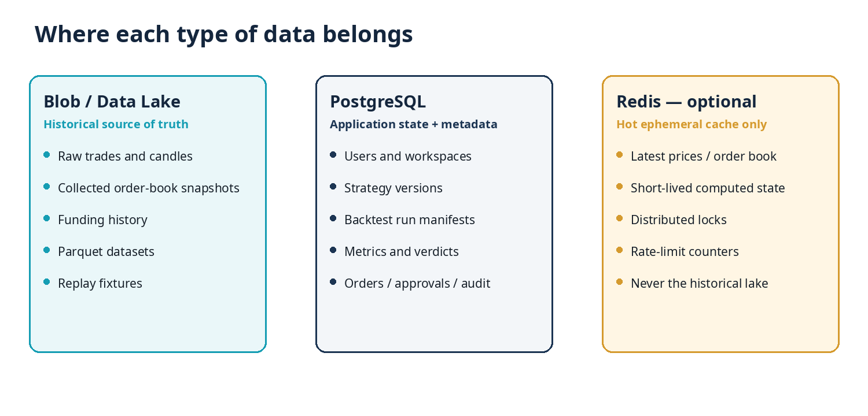

25. Free market data is enough for the MVP
The five-month product does not require Databento or another institutional vendor. Kraken provides downloadable historical OHLCVT data and historical trade data, plus live WebSocket feeds including order-book data. That is sufficient to prove natural-language strategy specification, backtesting, validation, live monitoring and demo/paper execution for a narrow BTC/ETH scope.
BOUNDARY
Free exchange data is enough for a solid MVP, but not for claiming institutional-grade high-frequency simulation, multi-venue price discovery or long historical L2/L3 reconstruction.

26. Data lake design
Use an Azure Storage account with Blob/Data Lake capabilities. Store history as compressed Parquet files. Parquet is columnar, meaning a backtest can read only the columns and time partitions it needs rather than scanning large JSON/CSV blobs.
market-data/
raw/
kraken/
trades/symbol=BTC-PERP/year=2026/month=08/day=08/*.parquet
book/symbol=BTC-PERP/year=2026/month=08/day=08/*.parquet
curated/
candles/timeframe=5m/symbol=BTC-PERP/year=2026/month=08/*.parquet
funding/symbol=BTC-PERP/year=2026/month=08/*.parquet
fixtures/
demo-scenarios/*.parquet

• Raw layer: append data as received and preserve provenance.
• Curated layer: cleaned, normalized, deduplicated datasets used by research.
• Fixture layer: small frozen datasets used for tests and the final demo.
• Every backtest RunManifest records the exact dataset version/partition set used.
• Lifecycle rules can move old raw data to cooler tiers if it is rarely accessed.

27. PostgreSQL role
Azure PostgreSQL is the transactional application database, not the bulk historical lake. It should answer “who owns this strategy, what version was tested, what job ran, what verdict was approved, and which paper orders are open?”
Table/domain | Examples
Identity / tenancy | users, organizations, memberships, roles
Research | projects, hypotheses, strategy_versions, experiments
Jobs | backtest_runs, validation_runs, agent_runs, status/retries
Results | summary_metrics, verdicts, critic_findings, artifact references
Execution | deployments, positions, orders, fills, risk_events
Governance | approvals, audit_events, model_config_versions, data_manifests
Commercial | subscriptions, entitlements, credit_ledger, cost_ledger

TIMESCALEDB DECISION
TimescaleDB is supported on Azure PostgreSQL and can be useful for recent/derived time-series queries. It is optional. Do not use PostgreSQL/Timescale as the source of truth for years of raw tick/order-book history unless benchmarks prove that is the best fit.

28. Redis: why it exists and why we postpone it
Redis is valuable when many application instances need the same very fast, short-lived state: latest market snapshot, rate-limit counters, locks, session/cache state or low-latency fan-out. It stores data in memory, which makes it fast but expensive relative to object storage.
Good Redis use | Bad Redis use
Cache current BTC/ETH price/order-book snapshot | Store five years of trades or candles
Distributed lock around a paper deployment | Keep the only copy of research results
Short TTL for expensive derived indicators | Archive Parquet datasets
API rate-limit counters | Treat RAM as a historical data lake

MVP DECISION
Do not provision Azure Managed Redis during the internship unless a measured bottleneck requires it. Local open-source Redis is free for development. This removes a potentially large fixed monthly cost.

29. When Databento becomes useful
Databento is an optional expansion, especially when QuantForge moves into CME/traditional futures, needs deep L2/L3 historical reconstruction, or needs consistent multi-venue/institutional datasets. Current Databento pricing includes usage-based historical data and paid live/subscription packages; that cost should be attached to premium market-data tiers rather than the baseline crypto MVP.

PART VII
Azure infrastructure and realistic cost control
Use Azure where it teaches or enables something; keep everything else local until it earns its cloud bill.

30. Recommended Azure service map
Azure service | QuantForge use | When to introduce | Cost posture
Microsoft Foundry | Runtime models, agents, traces/evaluation, model routing | Experiment 001 | Variable; main AI cost
Container Apps | Backend API, market collector, eventual execution worker | After local services work | Scale-to-zero where possible; collector is likely always-on
Container Apps Jobs | Finite backtests, validation sweeps, scheduled jobs | After local containerised backtest | Pay while jobs run
PostgreSQL Flexible Server | Transactional product database | After research loop needs persistence | Small burstable instance / free allowance where eligible
Blob / Data Lake Storage | Historical Parquet lake, reports and artifacts | As soon as collection starts | Low cost per GB relative to RAM/database
Key Vault | Kraken keys, model/provider secrets | Before real secrets enter cloud | Very small at MVP usage
Application Insights / Monitor | API/worker metrics, errors and cost telemetry | When first services deploy | Control log volume/retention
Entra External ID | User authentication later | SaaS integration phase | Likely low/free at small user count
Container Registry | Docker images | First Container Apps deployment | Small; student/free allowances may help
Managed Redis | Shared low-latency cache | Only after evidence of need | Avoid in MVP

31. Container Apps: what you are paying for
Container Apps is the runtime for your Dockerised services. The Consumption plan charges allocated vCPU-seconds, GiB-seconds and HTTP requests above monthly free grants. Apps that can scale to zero are cheap during low usage; an always-on market collector cannot scale to zero while it is ingesting live data.
Container workload | Runtime pattern | Why it exists
Backend API | Scale on requests; can often reach zero in dev | Serve SaaS/API and dispatch jobs
Market collector | Usually 1 small replica continuously while collecting | Maintain WebSocket feeds and write raw/curated data
Backtest job | Starts, computes, exits | Isolate CPU/memory work and pay only for duration
Validation sweep | Several bounded jobs | Parallel parameter/regime tests
Paper executor | Continuous only for active strategies | Evaluate approved rules and submit demo orders

FIVE-MONTH RESERVE
Plan roughly €75–€150 for Container Apps during development if only one small collector is continuously active and the rest scales to zero/jobs. Actual cost depends on region, CPU/memory allocation and hours.

32. PostgreSQL: what you are paying for
PostgreSQL Flexible Server is billed primarily for the provisioned compute tier, storage and any additional backup/HA features. For the internship, choose a small burstable server, no high availability, conservative storage and a supported PostgreSQL version. Eligible student/new-account offers can reduce this substantially.
Cost element | MVP choice | Reason
Compute | Small burstable instance | Low baseline workload; scale later
Storage | Small initial volume | Large historical data is in Blob, not PostgreSQL
Backups | Default/short retention | Enough for dev; avoid unnecessary excess backup storage
High availability | Off | Not needed for internship demo
Read replicas | None | Not needed at two-developer scale
TimescaleDB | Optional extension only | Useful for derived recent series, not mandatory

FIVE-MONTH RESERVE
Plan €0–€80 for the development PostgreSQL instance depending on free allowances, uptime and region. The architecture deliberately keeps bulk market history out of PostgreSQL to limit growth.

33. Updated five-month budget
Category | Five-month planning range | Notes
Foundry models, agent experiments and evaluations | €100–€500 | Biggest uncertainty; depends on model choice, prompt size and evaluation intensity
Azure Container Apps / Jobs | €75–€150 | Collector + finite backtest/validation jobs
Azure PostgreSQL | €0–€80 | Student/free allowance may cover much of it
Blob/Data Lake Storage | €10–€50 | More than enough for a focused BTC/ETH internship dataset in most cases
Key Vault, monitoring, registry, misc. | €10–€50 | Keep logs and retention controlled
Managed Redis | €0 | Explicitly removed from baseline
Domain / incidental SaaS costs | €10–€25 | Optional
Premium market data | €0 | Not required for Kraken-focused MVP
Total planning envelope | ~€205–€855 | Before credits; target €300–€500 with disciplined experiments

BUDGET POLICY
Create Azure budgets and alerts on day one. Cost telemetry is a product feature: every agent/backtest job should record its real model tokens, compute duration and bytes processed.

PART VIII
Security, risk and regulatory boundaries
The product can be technically impressive without taking unnecessary custody or live-trading risk during the internship.

34. Security boundaries
• Use exchange API keys with the minimum privileges possible; disable withdrawals for trading integrations.
• Store secrets in Key Vault and access them through managed identity/service identity rather than embedding them in code or prompts.
• Tenant-scope every database query and storage path once multiple users exist.
• Agents receive narrow tool permissions. No generic “run any shell / call any URL / access any secret” tool in production.
• Sandbox backtest code; arbitrary user-uploaded Python is a later feature because it requires much stronger isolation.
• Audit strategy approvals, deployments, risk-limit changes, order intents, exchange acknowledgements and kill-switch events.
• Separate dev, staging/demo and future production credentials/environments.

35. Risk-control hierarchy
Layer | Example
Strategy rules | Only supported signals/exits; immutable approved version
Portfolio policy | Max risk per trade, max daily loss, max positions/notional
Pre-trade validation | Price freshness, quantity bounds, duplicate check, exchange state
Execution adapter | Idempotency, retry policy, reconciliation
Runtime monitor | Stale feed, position mismatch, unexpected order rate
Emergency control | Manual pause + hard kill switch

36. Regulatory boundary
The internship should end at paper/demo execution. If QuantForge later offers public real-money execution, personalised recommendations, or regulated instruments/services, the team needs specialist legal review for the exact jurisdiction, broker relationship and instrument classification. ESMA’s 2026 algorithmic-trading supervisory briefing emphasises governance, testing, pre-trade controls and responsible treatment of AI in algorithmic trading under MiFID II contexts.
NO PERFORMANCE PROMISE
Market the platform as research, validation and controlled automation. Never promise guaranteed profit, superior returns or that AI “knows what the market will do.”

PART IX
Two-person AIOS collaboration
Two independent AIOS environments can collaborate safely when GitHub artifacts — not Discord memory — define reality.

37. Shared control plane
GitHub is the central source of truth. Each AIOS should start meaningful work by reading the same project context, issue and governing ADRs, then work on an isolated branch. Discord remains a command/notification interface, not permanent project memory.
Tool / artifact | Role
GitHub repository | Code, infrastructure, prompts, schemas, documentation and tests
GitHub Issues | Small, explicit work orders with acceptance criteria
Pull Requests | Handover, review, evidence and merge gate
GitHub Project | Backlog / Ready / In progress / Review / Done
GitHub Actions | Tests, linting, type checking, secret scanning and build gates
Discord AIOS A / B | Individual developer command interface and notifications
ADR files | Record important architecture decisions and why they were made
Shared context files | Tell both AIOS systems the current scope, architecture and state

38. Repository structure
quantforge/
apps/
web/
api/
services/
market-collector/
paper-executor/
packages/
strategy-schema/
risk-engine/
exchange-contracts/
research/
backtester/
validation/
agents/
research-director/
strategy-specialist/
critic/
evals/
infra/
terraform/
data-contracts/
docs/
decisions/
experiments/
tests/
AI_PROJECT_CONTEXT.md
CURRENT_STATE.md
NEXT_TASKS.md
KNOWN_ISSUES.md

39. AIOS start / work / finish protocol
1 | Start  Pull latest develop/main, read AI_PROJECT_CONTEXT.md + CURRENT_STATE.md, open the assigned issue, read linked ADRs/contracts, confirm no conflicting active PR.

2 | Plan  AIOS produces a short implementation plan and identifies files/contracts it expects to change. The human checks scope before allowing broad modifications.

3 | Build  Work only on the owned branch. Commit small coherent increments. Add/update tests and documentation with the code.

4 | Self-review  Run local tests, lint/type checks and a diff review. The AIOS must explain assumptions and anything it could not verify.

5 | Open PR  Include issue link, design summary, files/contracts changed, tests run, screenshots/logs where useful, risks and migration notes.

6 | Cross-review  The other developer + AIOS review against the issue and shared contracts, not personal style preference. Security/risk changes require both humans.

7 | Merge and handover  CI must pass. Merge through PR. Update CURRENT_STATE / ADRs when the merged change alters shared knowledge.

40. Branch, contract and decision rules
• Never let both AIOS systems directly edit the same feature branch.
• Every task has one owner even if both developers discuss it.
• Contracts come before parallel implementation: StrategySpec JSON schema, market-event schema, backtest result schema and API OpenAPI contracts.
• A breaking contract change requires a dedicated issue/ADR and both owners’ agreement.
• Architecture decisions live in /docs/decisions/ADR-###-name.md, including alternatives and consequences.
• No important decision should exist only in a Discord thread.

41. Suggested ownership split
Developer / AIOS | Primary ownership | Secondary / review
Developer A — Azure/Foundry lead | Azure resources, Terraform, Foundry agents/evals, secrets, monitoring, deployments, cost telemetry | Review API/security/data contracts
Developer B — trading/product lead | Market ingestion, StrategySpec/compiler, backtesting/validation, paper execution and substantial web-product work | Review agent tool contracts and deployment behaviour
Both | Product scope, strategy semantics, risk rules, architecture ADRs, final demo and documentation | No high-risk decision is single-owner

This is a suggested split, not a permanent wall. The goal is clear ownership without creating knowledge silos. Each person should be capable of explaining the other side at the architecture level.

PART X
How to actually start and the five-month roadmap
Prove the hardest loop first, then grow the cloud and SaaS around evidence.

42. Do not start by building the full web app
FIRST TECHNICAL QUESTION
Can QuantForge take a vague trading idea, convert it into a strict strategy, run a real deterministic backtest, criticise the evidence and produce a useful verdict?

The first work should be a chain of small experiments. They are disposable learning artifacts, but each has a precise success criterion. This is the safest way to learn Foundry and trading-system behaviour before committing to a large architecture.

43. Pre-internship / early experimental ladder
Experiment | Build | Exit gate
001 — Foundry call | Small local Python script calls one Foundry model and returns structured output. | Reliable authentication, logging and cost visibility.
002 — Strategy compiler | Messy trading hypothesis → schema-valid StrategySpec; agent asks for missing information. | 10–20 test prompts produce no silent invented parameters.
003 — Local backtest | Python reads a small BTC dataset and produces trades + metrics. | Known strategy results are reproducible.
004 — Critic loop | Foundry critic receives structured results and requests/analyses robustness tests. | Critic catches intentionally planted weak strategies.
005 — Containerise | Backtester runs from Docker with input manifest and output JSON. | Same result local and in container.
006 — Azure Job | Container Apps Job runs a backtest and persists artifacts. | One click/API call → Azure job → stored result.
007 — Persistence | PostgreSQL stores projects/run metadata; Blob stores historical/artifact files. | Experiment can be reopened/reproduced.
008 — Live collector | Kraken WebSocket collector writes clean live data. | Reconnect/gap/duplicate tests pass.
009 — Paper execution | Approved StrategySpec triggers deterministic Kraken demo orders. | End-to-end demo trade + reconciliation + kill switch.
010 — SaaS shell | Web app wraps the already-working core. | A new user can complete the whole workflow without CLI.

44. Five-month delivery plan
Weeks | Focus | Deliverable / exit gate
1–2 | Scope + experiments | Architecture baseline, evaluation fixtures, Foundry/strategy-compiler spike, approved data contracts.
3–4 | Data foundation | Kraken historical import + live collection, Blob/Parquet layout, data-quality checks, replay fixture.
5–6 | Strategy representation | Guided clarification, StrategySpec versions, deterministic compiler, schema tests.
7–8 | Backtest engine | Fees/funding/slippage, reproducible trades/metrics, containerised job.
9–10 | Foundry research loop | Director + selected specialist + critic, traces and first evaluation suite.
11–12 | Validation | Out-of-sample, sensitivity, regime, delay and cost stress; verdict framework.
13–14 | Risk + persistence | PostgreSQL, risk engine, approvals, audit schema, cost ledger.
15–16 | Paper execution | Kraken demo orders, reconciliation, pause/kill switch, paper monitoring.
17–18 | SaaS integration + security | Web flows, authentication, tenant controls, Key Vault, CI/CD/staging.
19 | User testing | Beginner and technical users complete research + deploy workflow; top usability issues fixed.
20 | Finalisation | Replayable demo, documentation, measured costs/evals, deployment scripts and final presentation.

45. Final internship demonstration
1 | Submit a messy idea  A supervisor enters an ambiguous BTC/ETH strategy in guided mode.

2 | Clarify it  The agent asks only the missing questions and shows the exact resulting StrategySpec.

3 | Run research  Azure launches a deterministic backtest and validation jobs over a frozen dataset.

4 | Challenge it  The critic points out weaknesses and requests a robustness test. A deliberately weak test should be rejected.

5 | Approve a good candidate  The user reviews evidence and explicitly approves a strategy version for demo deployment.

6 | Replay or live-demo  The executor receives market events and submits paper orders to Kraken demo; the dashboard shows fills, risk and audit events.

7 | Trigger safety  Demonstrate stale data/daily-loss/kill-switch logic preventing or stopping orders.

8 | Show engineering evidence  Display traces, evaluation scores, CI pipeline, Azure resources and measured cost per workflow.

PART XI
Pricing, Research Credits and unit economics
A concept-stage commercial plan that protects users from token billing and protects the product from unlimited variable cost.

46. Pricing philosophy
RECOMMENDED COMMERCIAL MODEL
Monthly tiered subscription with included Research Credits, plus optional credit packs. Deterministic monitoring/paper execution is limited by active-strategy slots, not charged per market tick.

Do not expose raw model tokens to customers. A user should know that “deep validation costs 25 Research Credits,” not that a workflow used a particular provider’s token count. Behind the scenes, QuantForge measures the true cost of each job and recalibrates credit weights.

47. Proposed concept-stage plans
 | Free Trial | Starter | Trader | Pro
Price | €0 | €24/mo | €59/mo | €119/mo
Research Credits | 30 once | 100/mo | 350/mo | 900/mo
Projects | 2 | 5 | 20 | 50
Active paper strategies | 1 | 1 | 5 | 15
Deep validation | No | Limited | Yes | Yes
Agent ensemble review | Preview | Limited | Yes | Priority
Retention | 14 days | 3 months | 12 months | 24 months
Job priority | Low | Standard | Higher | Highest

STATUS OF PRICES
These are planning hypotheses, not launch promises. Replace them with measured Foundry/compute cost and user behaviour before public launch.

48. Research Credit catalogue
Action | Illustrative credits | Behind the scenes
Quick research question | 1 | Lightweight model call over existing platform data
Hypothesis structuring | 3 | Clarification + StrategySpec creation
Standard backtest | 5 | One constrained deterministic backtest + summary
Independent critic | 6 | Separate review of assumptions/bias/implementation
Full validation package | 12 | Backtest + out-of-sample + robustness + critic + report
Deep validation / stress | 25 | Multiple regimes/sensitivity tests and heavier compute
Report regeneration | 2 | Re-explain existing results without rerunning simulation

DO NOT METER EVERY TICK
An approved paper strategy may evaluate thousands of deterministic market events. That should consume infrastructure allowance/strategy slots, not an AI credit every minute. Credits are for new AI-intensive research and substantial compute.

49. Practical pricing scenarios
Scenario | Monthly behaviour | Credits | Likely plan
Weekend idea tester | 8 quick questions, 4 structuring sessions, 2 backtests, 1 critic | ~36 | Starter
Daily active researcher | 25 questions, 10 structuring, 16 backtests, 4 full validations, 4 critics | ~207 | Trader
Power researcher | Frequent backtests + 10 full + 10 deep validations | ~680 | Pro

50. Internal cost ledger
Per job record | Why it matters
Model + deployment | Know which routing choices are expensive
Input/output tokens | Calculate true inference cost
Tool calls / retries | Find waste or failure loops
Backtest CPU/memory seconds | Price large numerical jobs
Bytes read/written | Measure data/storage intensity
Duration | Detect slow workflows and queue pressure
Credits charged | Compare customer abstraction with true COGS

Pricing only becomes credible after QuantForge runs hundreds of representative jobs. The internship should therefore implement cost telemetry even if real payment checkout is postponed.

PART XII
Risks, limitations and future expansion
What can go wrong, what not to overclaim, and what the architecture intentionally leaves open.

51. Main technical and product risks
Risk | Impact | Mitigation
AI produces inconsistent StrategySpecs | High | Strict schema, clarification policy, evaluation fixtures, versioned prompts/models
Backtest appears better than reality | High | Fees/funding/slippage, delay tests, out-of-sample and paper drift comparison
Data gaps/corruption | High | Sequence/timestamp checks, raw provenance, fail closed, replay fixtures
Scope explosion | High | BTC/ETH + one exchange + paper only; backlog everything else
Cloud/AI cost creep | Medium | Budgets, cost ledger, model routing, finite jobs, no Managed Redis
Agents overuse tools or secrets | High | Tool allowlists, Key Vault, least privilege, no execution tool for research agents
Two AIOS environments diverge | Medium | GitHub context files, ADRs, contracts, issues/PRs and cross-review
No edge is found in tested strategies | Low for project success | Product success is rigorous evaluation, including rejecting bad strategies; demo can use known fixtures
Regulatory complexity blocks live launch | High commercially | Keep internship paper-only; legal review before live product

52. Non-goals for the internship
• No promise of profitable or superior trading performance.
• No high-frequency trading or millisecond execution claims.
• No support for every exchange, asset class or strategy language.
• No public real-money automated trading.
• No institutional market-data redistribution.
• No large custom model training program.
• No enterprise private-network architecture unless the supervisor specifically requires it.
• No Managed Redis unless a benchmark proves it solves a real bottleneck.

53. Future expansion roadmap
Stage | Expansion
After MVP | More crypto symbols/venues; richer order-book tests; better strategy library; mobile alerts/API.
Premium data | Databento/other providers for CME/traditional futures, deep L2/L3 and longer institutional history.
Execution | Restricted live broker connections, subaccounts, stronger monitoring, legal/compliance program.
Portfolio research | Multi-strategy capital allocation, correlation, portfolio risk and portfolio-level validation.
Agent intelligence | Learn user research preferences, improved evaluation sets, cost-aware model routing, selected fine-tuning if justified.
B2B / teams | Shared workspaces, SSO, research approvals, dedicated environments and audit exports.
Enterprise | Customer-owned Azure deployment, private networking, dedicated model/data resources and contractual SLAs.

APPENDICES
Ready-to-use templates and reference material
Copy these into the repository when the project moves from concept to implementation.

Appendix A — AI_PROJECT_CONTEXT.md skeleton
# QuantForge shared AI project context
## Product identity
AI-assisted strategy research, validation and controlled paper execution.
## Current scope
BTC/ETH perpetuals, one exchange, paper only.
## Architecture rules
- Historical market data -> Blob/Data Lake + Parquet
- Product/application state -> PostgreSQL
- Redis -> optional hot cache only
- AI -> interpretation/research/criticism
- Python -> calculations, risk, signals, execution
## Shared contracts
- StrategySpec schema
- MarketEvent schema
- BacktestResult schema
- API OpenAPI contract
## Current ADRs
Links to governing decisions.
## AIOS rules
Read current issue + ADRs before editing. One owner per branch. PR required.
## Definition of done
Tests + docs + security + observability + reproducibility.

Appendix B — Issue template
Title: [area] concise outcome
Goal:
What must be true when this issue is complete?
Context:
Relevant ADRs, schemas, design notes.
Acceptance criteria:
- [ ] Functional behaviour
- [ ] Tests
- [ ] Error/failure handling
- [ ] Security considerations
- [ ] Logs/metrics where relevant
- [ ] Documentation updated
Out of scope:
Explicitly excluded work.
Owner:
One developer / AIOS.
Dependencies:
Other issues/contracts.

Appendix C — Pull-request template
## What changed
## Why
Closes #issue
## Contracts / ADRs affected
## Tests executed
## Evidence
Screenshots, logs, test output, replay result.
## Security / cost impact
## Known limitations
## Handover notes
What the other AIOS needs to know.

Appendix D — Suggested architecture decision records
ADR | Decision
ADR-001 | BTC/ETH perpetuals + one exchange for internship scope
ADR-002 | Paper execution is the final internship boundary
ADR-003 | StrategySpec is the immutable contract between AI and deterministic engine
ADR-004 | Blob/Data Lake + Parquet is historical market source of truth
ADR-005 | PostgreSQL stores transactional product state; Timescale optional
ADR-006 | Managed Redis excluded from MVP
ADR-007 | Foundry director + selected specialists + deterministic tools
ADR-008 | No fine-tuning until evaluation evidence justifies it
ADR-009 | Container Apps Jobs for finite backtests/validation
ADR-010 | GitHub artifacts are shared truth for both AIOS environments

Appendix E — Minimum test catalogue
Area | Required tests
Strategy compiler | Missing parameters, invalid indicators, impossible risk values, deterministic same-input schema expectations
Data ingestion | Reconnect, duplicate event, out-of-order timestamp, gap detection, schema migration
Backtester | Known fixture, no-look-ahead, fee/funding correctness, stop/target priority policy, reproducibility
Validation | Out-of-sample split, parameter sweep bounds, regime labels, suspicious concentration
Risk engine | Max position, daily loss, stale data, duplicate order, kill switch
Execution | Idempotent submit, rejected order, partial fill, reconnect/reconcile, exchange mismatch
Agents | Tool choice, schema adherence, injection resistance, unsupported claims, escalation
Tenancy/security | Cross-tenant query attempts, secret scanning, role checks
Cost | Token/compute cost recorded for every job; limits applied

Appendix F — Glossary
Term | Meaning
StrategySpec | Versioned machine-readable definition of trading rules and risk.
RunManifest | Exact strategy/data/engine/cost assumptions needed to reproduce a run.
Paper trading | Execution using simulated/demo funds rather than customer capital.
Look-ahead bias | Using information in a backtest that was not available at the simulated decision time.
Walk-forward | Repeated train/selection and later test windows through time.
Parquet | Compressed columnar file format suited to analytics.
Data Lake | Low-cost object-storage organization for large historical datasets.
Foundry | Microsoft platform for model deployments, agents, evaluation/observability and related AI services.
Model Router | Foundry capability that can select among supported model deployments to balance cost/quality.
ADR | Architecture Decision Record describing a decision, alternatives and consequences.
Research Credit | QuantForge customer-facing unit for AI-intensive research/compute.
Deterministic | Given the same inputs/configuration, the software follows the same defined calculation/control path.

Appendix G — Official sources and current assumptions
Service capabilities and prices change. These references were reviewed for this consolidated plan on 8 August 2026. Pricing figures in the handbook are planning ranges; verify the Azure pricing calculator and exchange/vendor terms before purchase or public launch.
[1] Microsoft Foundry Agent Service overview — https://learn.microsoft.com/en-us/azure/ai-services/agents/overview
[2] Foundry Agent Service FAQ / billing concepts — https://learn.microsoft.com/en-us/azure/ai-foundry/agents/faq
[3] Foundry Model Router concepts — https://learn.microsoft.com/en-us/azure/foundry/openai/concepts/model-router
[4] Foundry Agent Optimizer (preview) — https://learn.microsoft.com/en-us/azure/foundry/agents/concepts/agent-optimizer-overview
[5] Azure Container Apps billing — https://learn.microsoft.com/en-us/azure/container-apps/billing
[6] Azure PostgreSQL compute options — https://learn.microsoft.com/en-us/azure/postgresql/compute-storage/concepts-compute
[7] Azure PostgreSQL supported extensions / TimescaleDB — https://learn.microsoft.com/en-us/azure/postgresql/extensions/concepts-extensions-versions
[8] Azure Storage introduction — https://learn.microsoft.com/en-us/azure/storage/common/storage-introduction
[9] Azure Data Lake Storage introduction — https://learn.microsoft.com/en-us/azure/storage/blobs/data-lake-storage-introduction
[10] Kraken downloadable historical OHLCVT — https://support.kraken.com/articles/360047124832-downloadable-historical-ohlcvt-open-high-low-close-volume-trades-data
[11] Kraken downloadable historical trade data — https://support.kraken.com/articles/360047543791-downloadable-historical-market-data-time-and-sales-
[12] Kraken Futures WebSocket order book — https://docs.kraken.com/api/docs/futures-api/websocket/book/
[13] Databento pricing — https://databento.com/pricing
[14] ESMA 2026 algorithmic trading supervisory briefing — https://www.esma.europa.eu/press-news/esma-news/esma-issues-supervisory-briefing-algorithmic-trading

The QuantForge launch checklist for the two of you
IF YOU REMEMBER ONLY ONE THING
Build evidence in this order: strict strategy representation → deterministic backtest → adversarial validation → controlled paper execution → polished SaaS. The Azure/AI architecture should serve that loop, not become the project itself.

Before serious build | During build | Before final demo
Create GitHub repo + context files | Every task has an issue/owner/branch | Frozen replay dataset and demo scenario
Create Azure budget + lab resource group | Every AI/backtest job records cost | Evaluation suite results documented
Prove one Foundry structured-output call | Raw history goes to Blob/Parquet | All paper execution has risk + kill switch
Create StrategySpec schema | PostgreSQL stores transactional state | No secrets in repo/logs/prompts
Download/collect initial Kraken data | AI never computes authoritative metrics | CI/staging deployment reproducible
Write first 20 evaluation fixtures | PR + cross-review for shared changes | Both developers can explain full architecture

Recommended immediate next action: implement Experiment 001 and Experiment 002 in /experiments — one Foundry model call and one strict StrategySpec compiler. Do not provision Managed Redis, do not build billing, and do not start a large web interface until that loop is convincing.

