Target: Vantage Credit Union

* Corporate
  + Locations
    - Headquarters: 4020 Fee Fee Road Bridgeton, MO. 63044 4
  + Branches:
    - 4020 Fee Fee Rd Bridgeton, MO 63044
    - 1330 YMCA Dr Festus, MO 63028
    - PO Box 4433 Bridgeton, MO 63044
    - 332 Festus Centre Dr Festus, MO 63028
    - 13 Collinsville Ave East Saint Louis, IL 62201
    - 16260 Truman Rd Ballwin, MO 63011
    - 1077 Cave Springs Blvd Saint Peters, MO 63376
    - 11654 W Florissant Ave Florissant, MO 63033
  + Owner: Hubert Hoosman
  + Land/Tax Records:
    - Charter Number: 67804
    - Parcel Number: 12M530515
    - Locator Number 12M530515
    - Built in 1984, this property features 5.47 acres lot, and 0.97 acres lot space
    - Central Heat and Air
  + Businesses near Vantage Headquarters:
    - Certified Power Solutions
    - Extended Stay America
    - Embassy Suites
    - Ergonomic Partners
    - Certified Power Solutions
    - Credit Union Insurance Agency
    - Mortgage Solutions,
    - Vantage investment Services Group
  + Timezone: Central U.S. Zone
  + Hosts/NOC
* Logical
* Relaionships
* Affiliations:
  + Northwest chamber of commerce
  + Chesterfield Chamber of Conference
* Business Partners:
  + Turbo Tax
  + Enterprise Rent A Car Six Flags
  + Members Resource, LLC,
  + Credit Union Insurance Agency (CUIA), LLC,
  + Mortgage Solutions, LLC,
* Competitors:
  + 1st Financial Credit Union,
  + Neighbors Credit Union
* Touchgraph
* 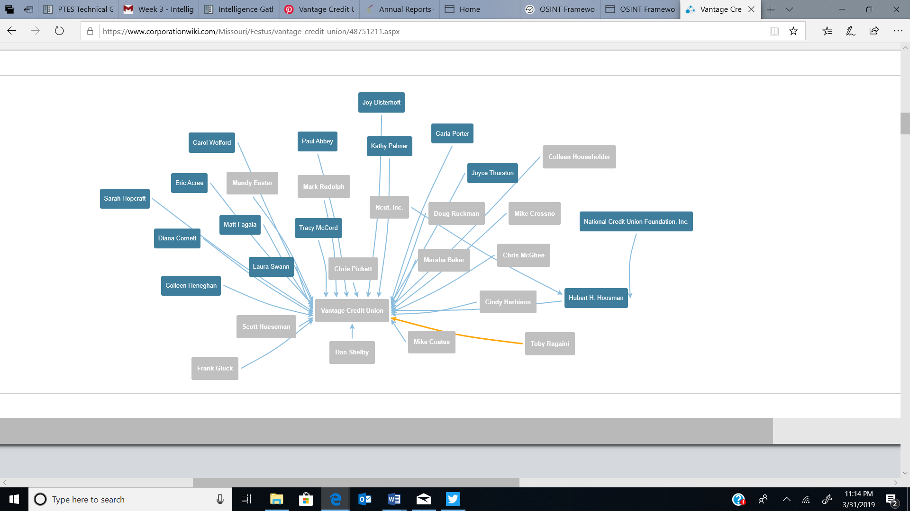
* Product line: Checking, Savings, E-Branch, Loans, Credit Cards, Home Buying Center Investments, Insurance.
* Meetings: Annual Meeting April 11, 2019
* Significant Company Dates: Closed on All National and Federal Holidays
* Job Opportunities:
  + Part-time teller,
  + Teller,
  + Financial Consult,
  + Software Support Analyst,
* Charity Affiliations:
  + Children Miracle
  + United Way
  + Special Olympics
* Electronic
* Infrastructure Assets
  + Network Blocks:
  + **WHOIS Lookups**[¶](https://pentest-standard.readthedocs.io/en/latest/intelligence_gathering.html#whois-lookups)
  + Domain Name: VCU.COM
  + Registry Domain ID: 2582620_DOMAIN_COM-VRSN
  + Registrar WHOIS Server: whois.networksolutions.com
  + Registrar URL: http://networksolutions.com
  + Updated Date: 2018-12-14T16:29:16Z
  + Creation Date: 1998-11-30T05:00:00Z
  + Registrar Registration Expiration Date: 2020-11-29T05:00:00Z
  + Registrar: NETWORK SOLUTIONS, LLC.
  + Registrar IANA ID: 2
  + Reseller:
  + Domain Status: clientTransferProhibited https://icann.org/epp#clientTransferProhibited
  + Registry Registrant ID:
  + Registrant Name: Vantage Credit Union
  + Registrant Organization: Vantage Credit Union
  + Registrant Street: 4020 FEE FEE RD
  + Registrant City: BRIDGETON
  + Registrant State/Province: MO
  + Registrant Postal Code: 63044-2708
  + Registrant Country: US
  + Registrant Phone: +1.3142645400
  + Registrant Phone Ext:
  + Registrant Fax: +1.231231234
  + Registrant Fax Ext:
  + Registrant Email: techops@vcu.com
  + Registry Admin ID:
  + Admin Name: Support, DCIT
  + Admin Organization: VCU
  + Admin Street: 4020 Fee Fee Rd
  + Admin City: Bridgeton
  + Admin State/Province: MO
  + Admin Postal Code: 63044-2708
  + Admin Country: US
  + Admin Phone: +1.3142645400
  + Admin Phone Ext:
  + Admin Fax:
  + Admin Fax Ext:
  + Admin Email: techops@vcu.com
  + Registry Tech ID:
  + Tech Name: Support, DCIT
  + Tech Organization: VCU
  + Tech Street: 4020 Fee Fee Rd
  + Tech City: Bridgeton
  + Tech State/Province: MO
  + Tech Postal Code: 63044-2708
  + Tech Country: US
  + Tech Phone: +1.3142645400
  + Tech Phone Ext:
  + Tech Fax:
  + Tech Fax Ext:
  + Tech Email: techops@vcu.com
  + Name Server: NS4.P23.DYNECT.NET
  + Name Server: NS3.P23.DYNECT.NET
  + Name Server: NS2.P23.DYNECT.NET
  + Name Server: NS1.P23.DYNECT.NET
  + DNSSEC: unsigned
  + Registrar Abuse Contact Email: abuse@web.com
  + Registrar Abuse Contact Phone: +1.8003337680
  + URL of the ICANN WHOIS Data Problem Reporting System: <http://wdprs.internic.n>
* Email

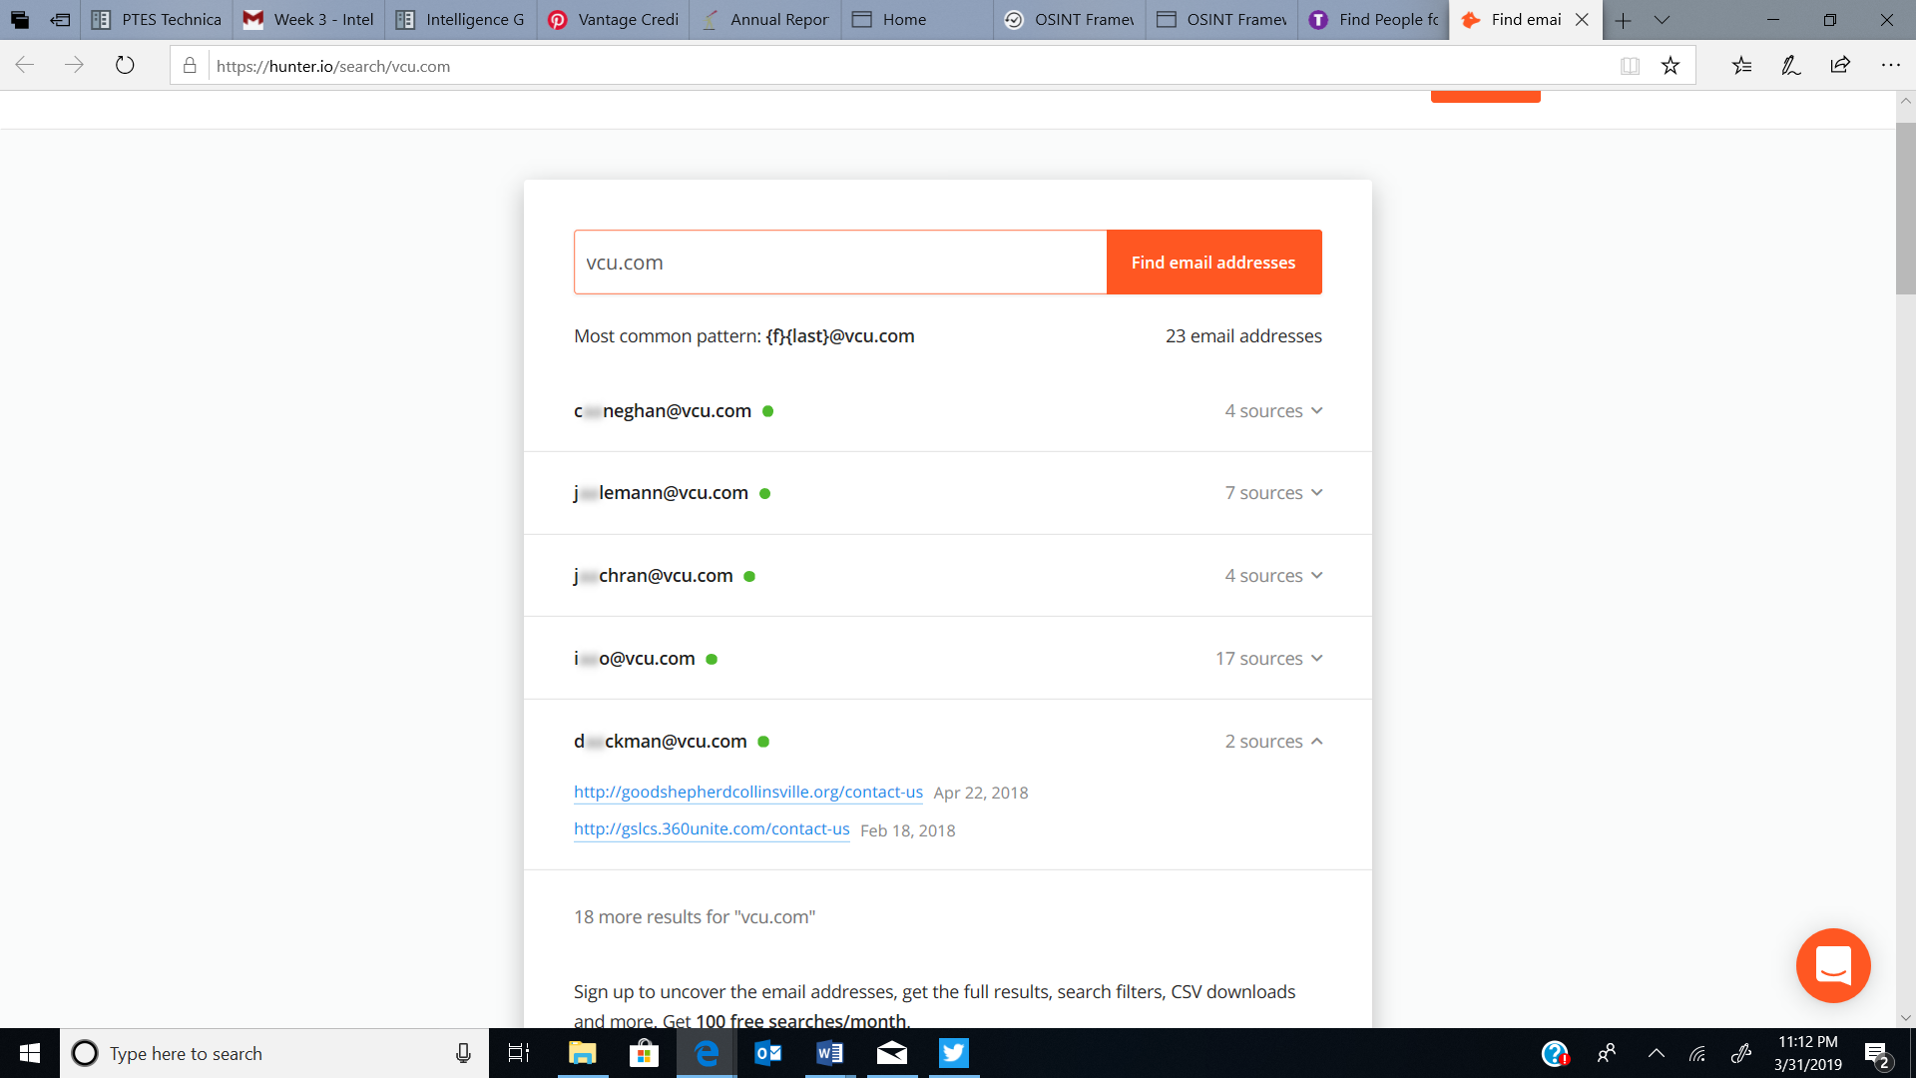

* Remote Access:
  + Paycom Payroll and HR
    - https://www.paycomonline.net/v4/ee/web.php/app/login
* Technologies/Applications used :
* Microsoft Office Suite
* Windows 7/10
* IIBM AIX Unix or Linux platforms required.
* Equipment :backup drives, hard disk drives, printers, and consoles.
* day-to-day maintenance of systems hardware, HDD drives, and related equipment.
* TLV System
* Unix system
* core software applications, including Episys, OpCon, Image Center, ARCU, Synergy, Synapsis, WYCOM and related systems.
* Financial

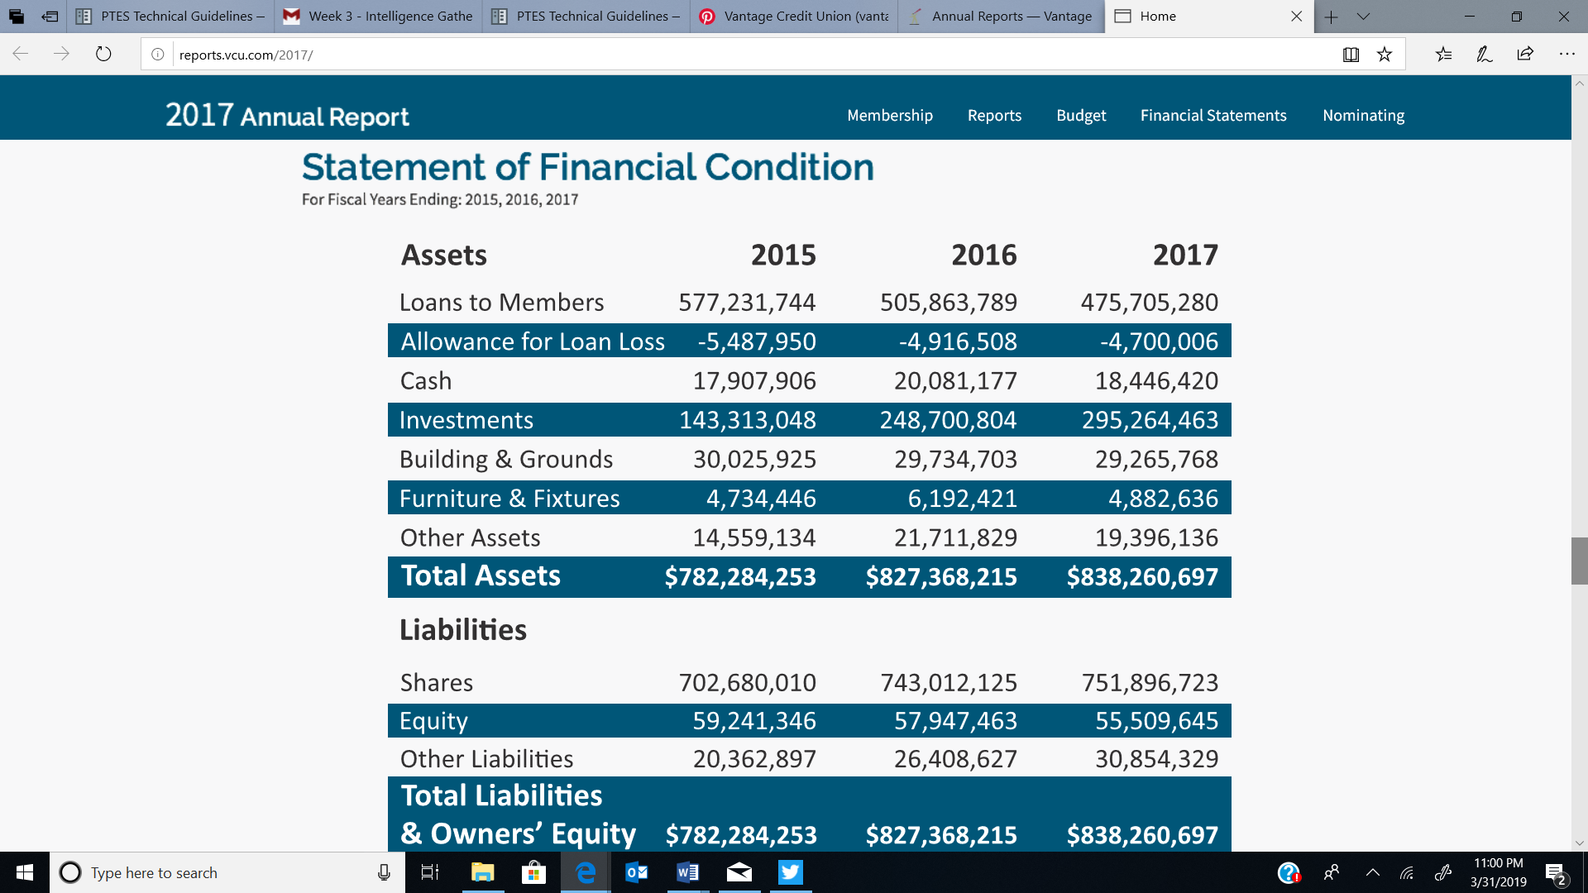

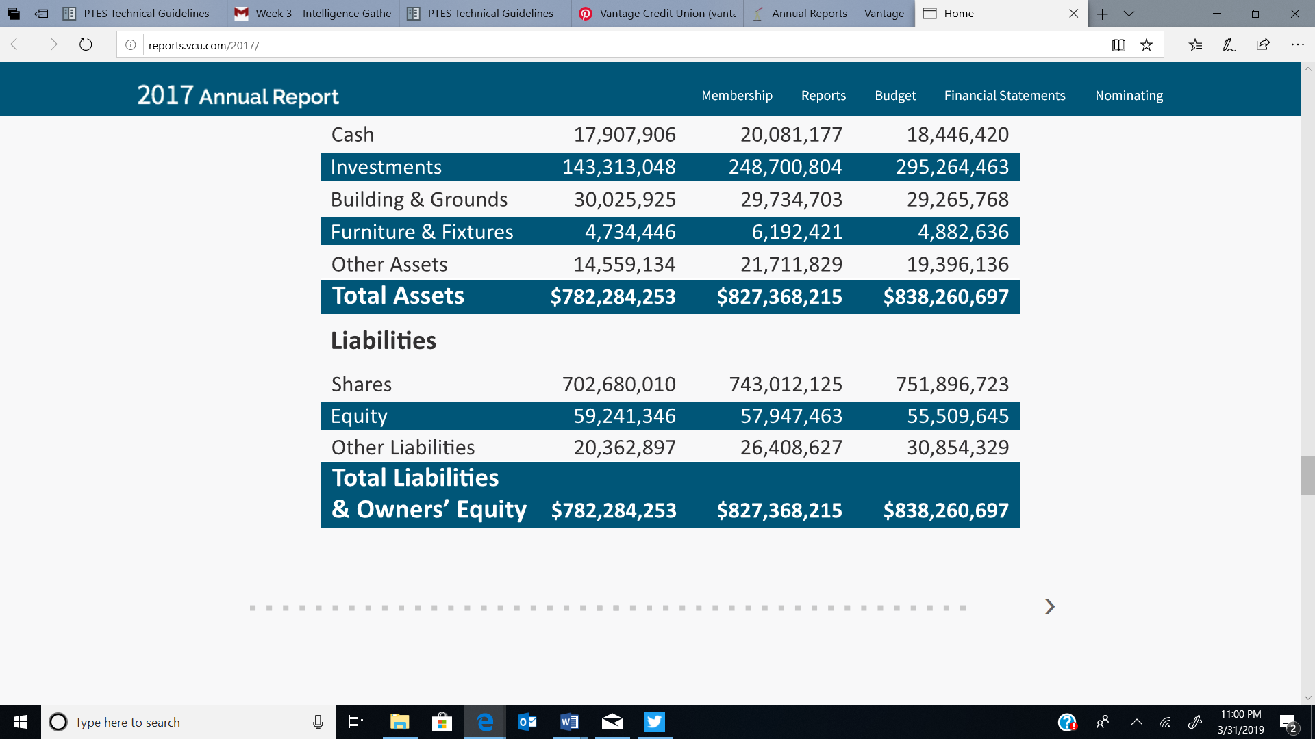

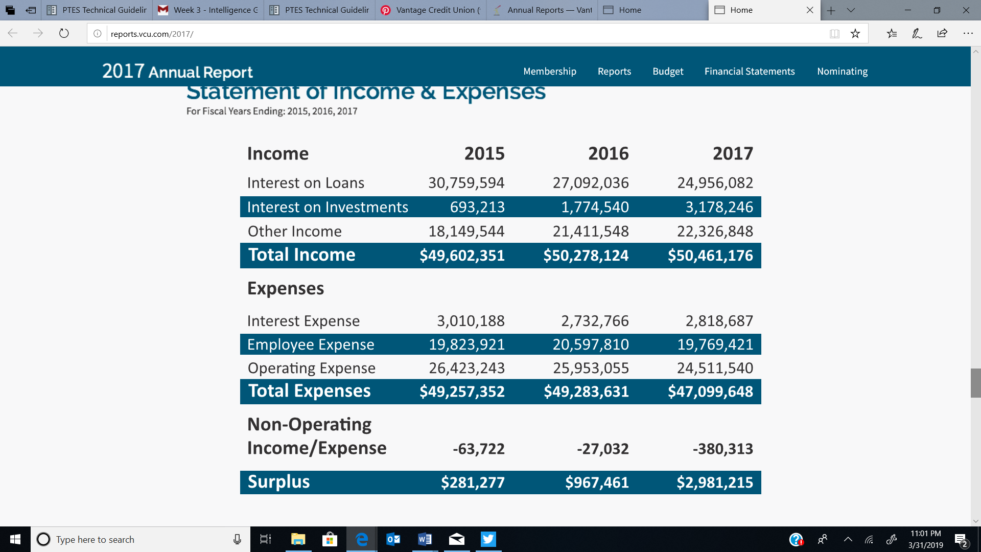

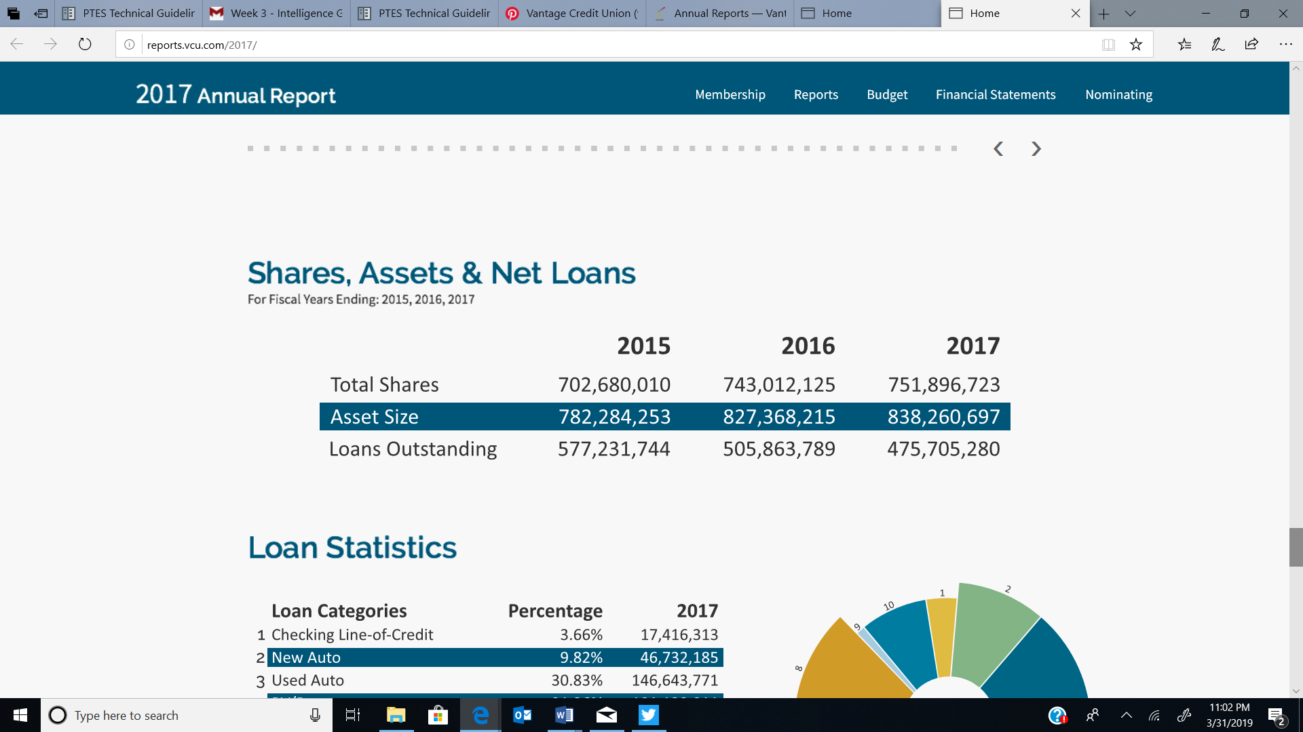

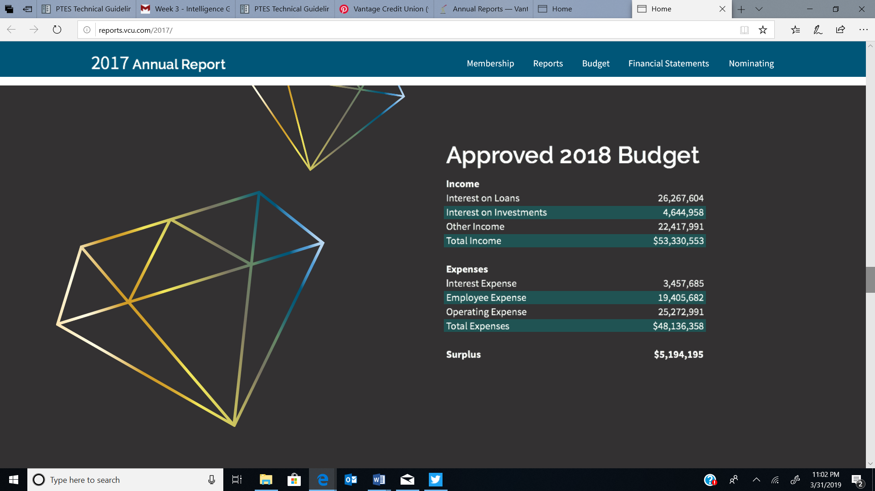

* Social Media
  + Social Media Presence (L1/L2/L3)
    - <https://www.pinterest.com/vantagecu/>
    - <https://www.youtube.com/user/VantageCreditUnion>
    - <https://www.instagram.com/vantagecu/>
    - <https://www.facebook.com/VantageCU>
    - Linkendin
* Passive Reconnaissance (subcategories as you see fit)
  + **WHOIS Lookups**[¶](https://pentest-standard.readthedocs.io/en/latest/intelligence_gathering.html#whois-lookups)
    - Domain Name: VCU.COM
    - Registry Domain ID: 2582620_DOMAIN_COM-VRSN
    - Registrar WHOIS Server: whois.networksolutions.com
    - Registrar URL: http://networksolutions.com
    - Updated Date: 2018-12-14T16:29:16Z
    - Creation Date: 1998-11-30T05:00:00Z
    - Registrar Registration Expiration Date: 2020-11-29T05:00:00Z
    - Registrar: NETWORK SOLUTIONS, LLC.
    - Registrar IANA ID: 2
    - Reseller:
    - Domain Status: clientTransferProhibited https://icann.org/epp#clientTransferProhibited
    - Registry Registrant ID:
    - Registrant Name: Vantage Credit Union
    - Registrant Organization: Vantage Credit Union
    - Registrant Street: 4020 FEE FEE RD
    - Registrant City: BRIDGETON
    - Registrant State/Province: MO
    - Registrant Postal Code: 63044-2708
    - Registrant Country: US
    - Registrant Phone: +1.3142645400
    - Registrant Phone Ext:
    - Registrant Fax: +1.231231234
    - Registrant Fax Ext:
    - Registrant Email: techops@vcu.com
    - Registry Admin ID:
    - Admin Name: Support, DCIT
    - Admin Organization: VCU
    - Admin Street: 4020 Fee Fee Rd
    - Admin City: Bridgeton
    - Admin State/Province: MO
    - Admin Postal Code: 63044-2708
    - Admin Country: US
    - Admin Phone: +1.3142645400
    - Admin Phone Ext:
    - Admin Fax:
    - Admin Fax Ext:
    - Admin Email: techops@vcu.com
    - Registry Tech ID:
    - Tech Name: Support, DCIT
    - Tech Organization: VCU
    - Tech Street: 4020 Fee Fee Rd
    - Tech City: Bridgeton
    - Tech State/Province: MO
    - Tech Postal Code: 63044-2708
    - Tech Country: US
    - Tech Phone: +1.3142645400
    - Tech Phone Ext:
    - Tech Fax:
    - Tech Fax Ext:
    - Tech Email: techops@vcu.com
    - Name Server: NS4.P23.DYNECT.NET
    - Name Server: NS3.P23.DYNECT.NET
    - Name Server: NS2.P23.DYNECT.NET
    - Name Server: NS1.P23.DYNECT.NET
    - DNSSEC: unsigned
    - Registrar Abuse Contact Email: abuse@web.com
    - Registrar Abuse Contact Phone: +1.8003337680
* Active Footprinting (subcategories as you see fit)
  + Ping IP address and Port Scanning
* 
 