Target: Vantage Credit Union

* Active
  + Port Based/Service/Banner Grabbing

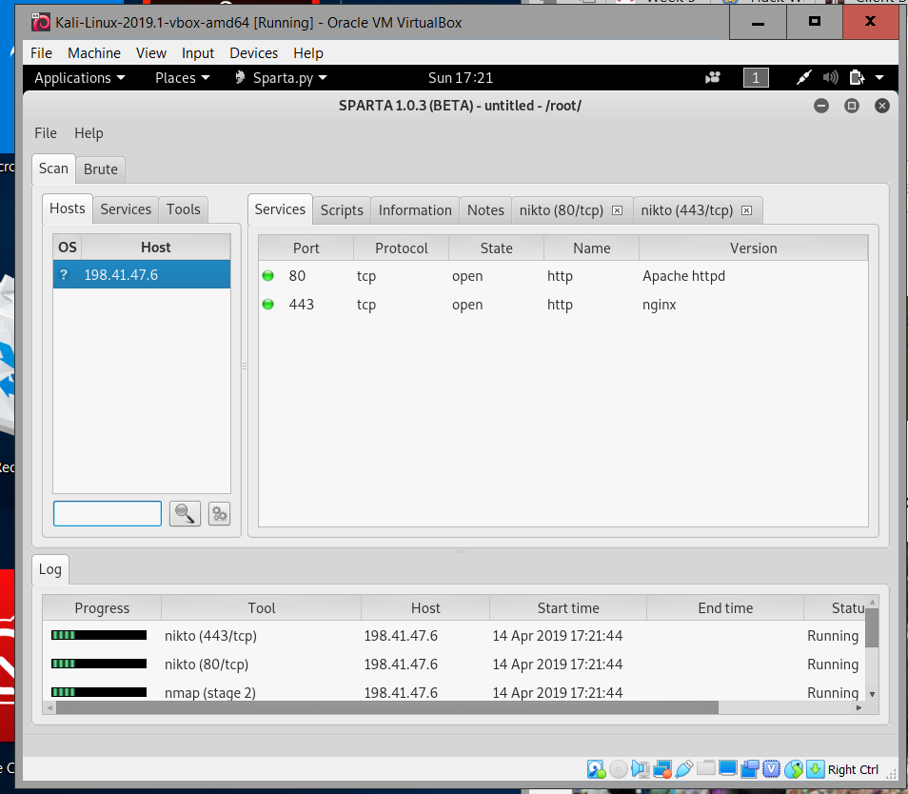

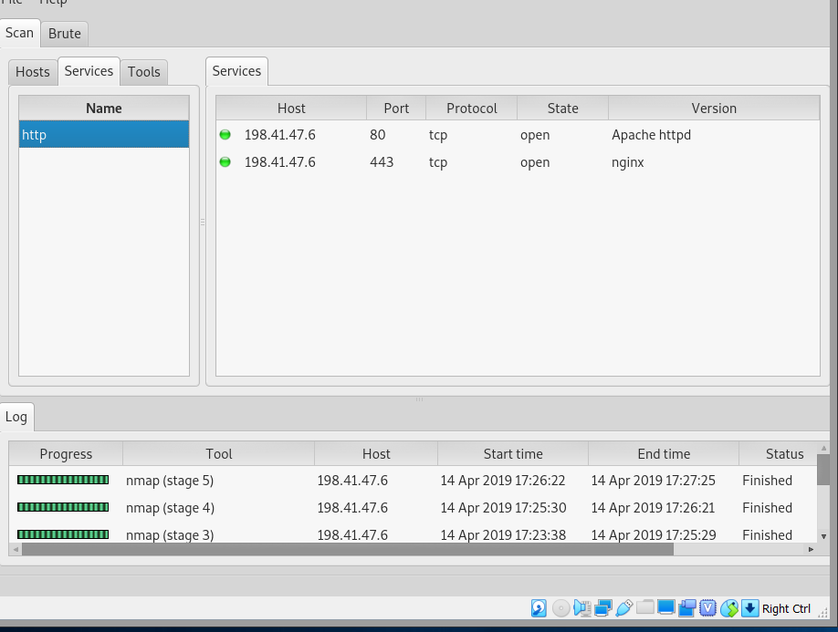

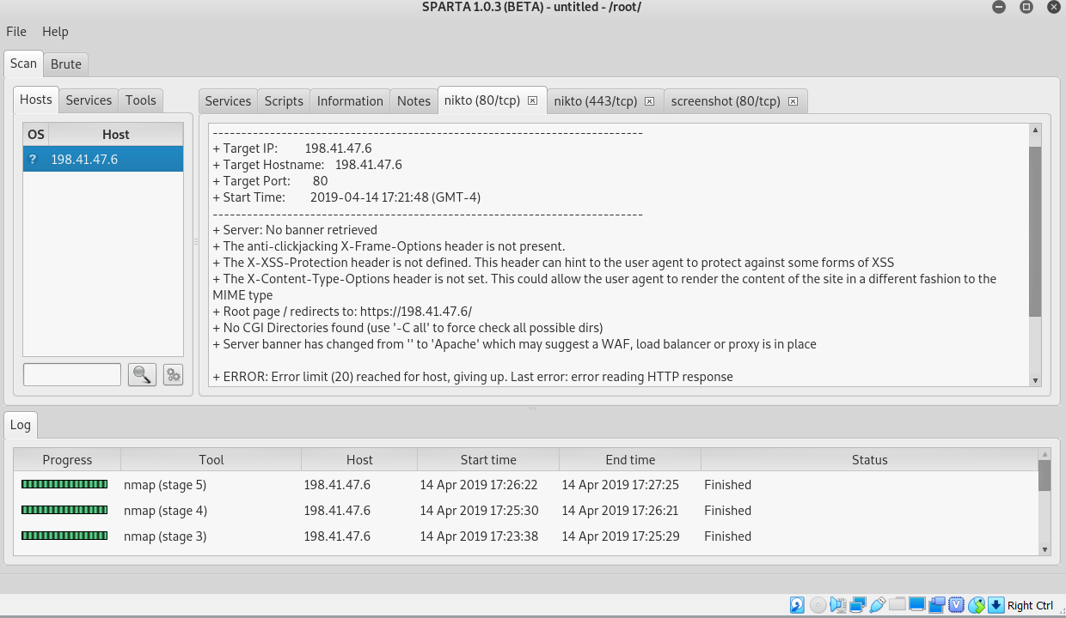

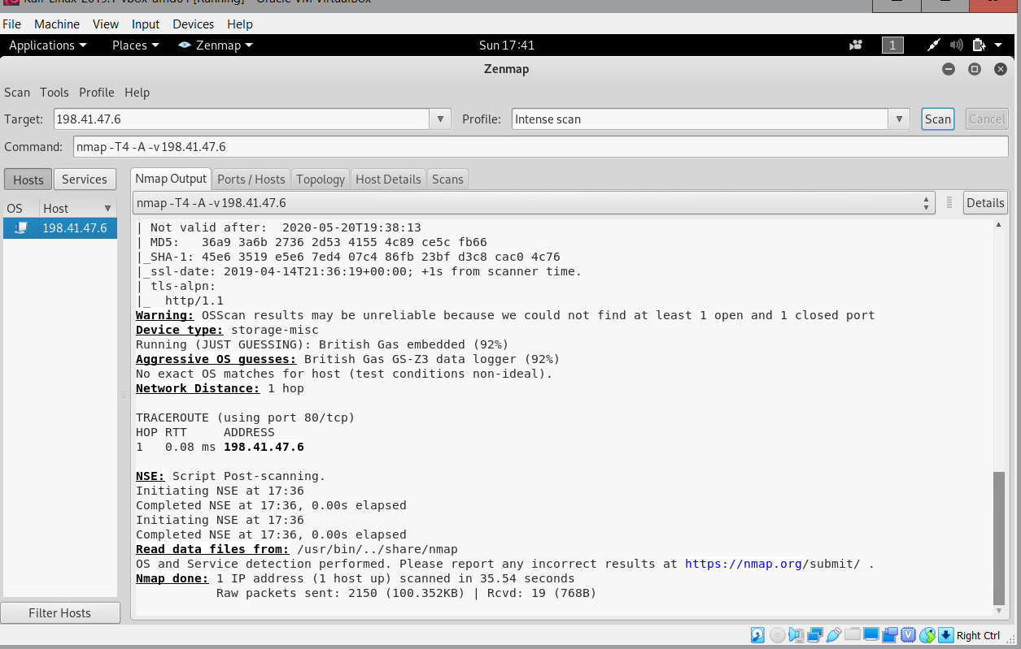

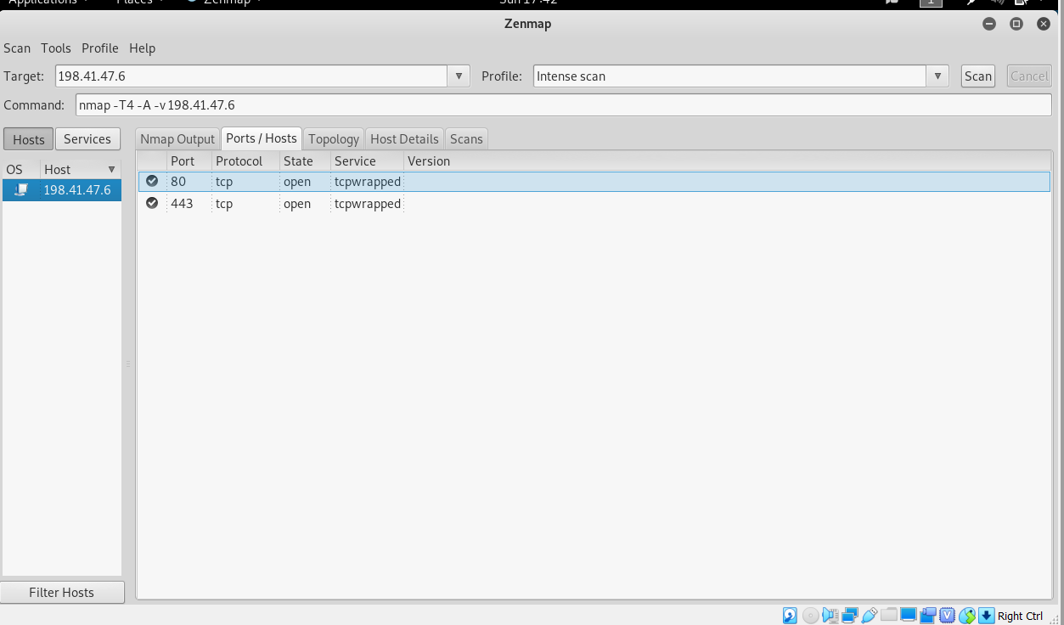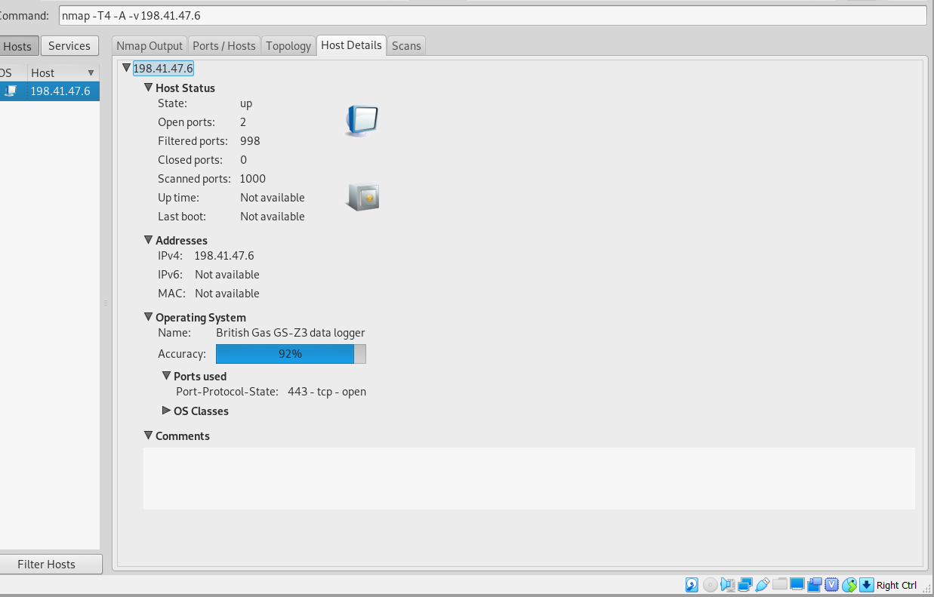

* Web Server Version

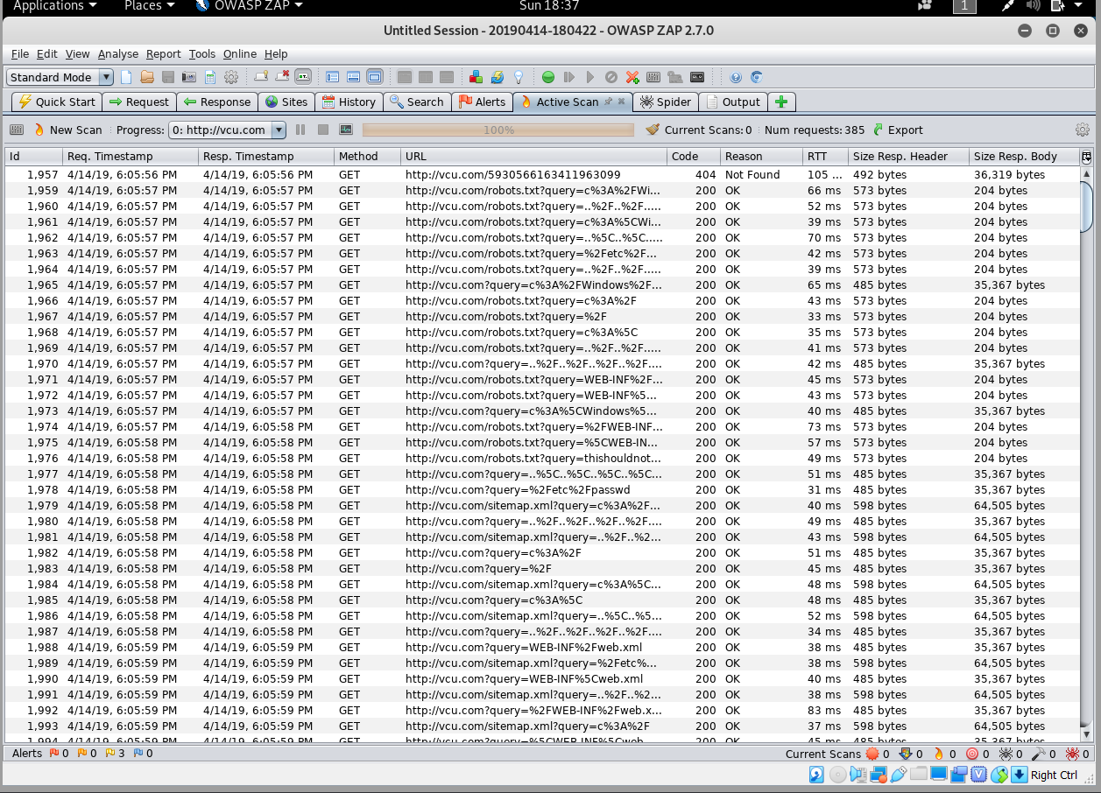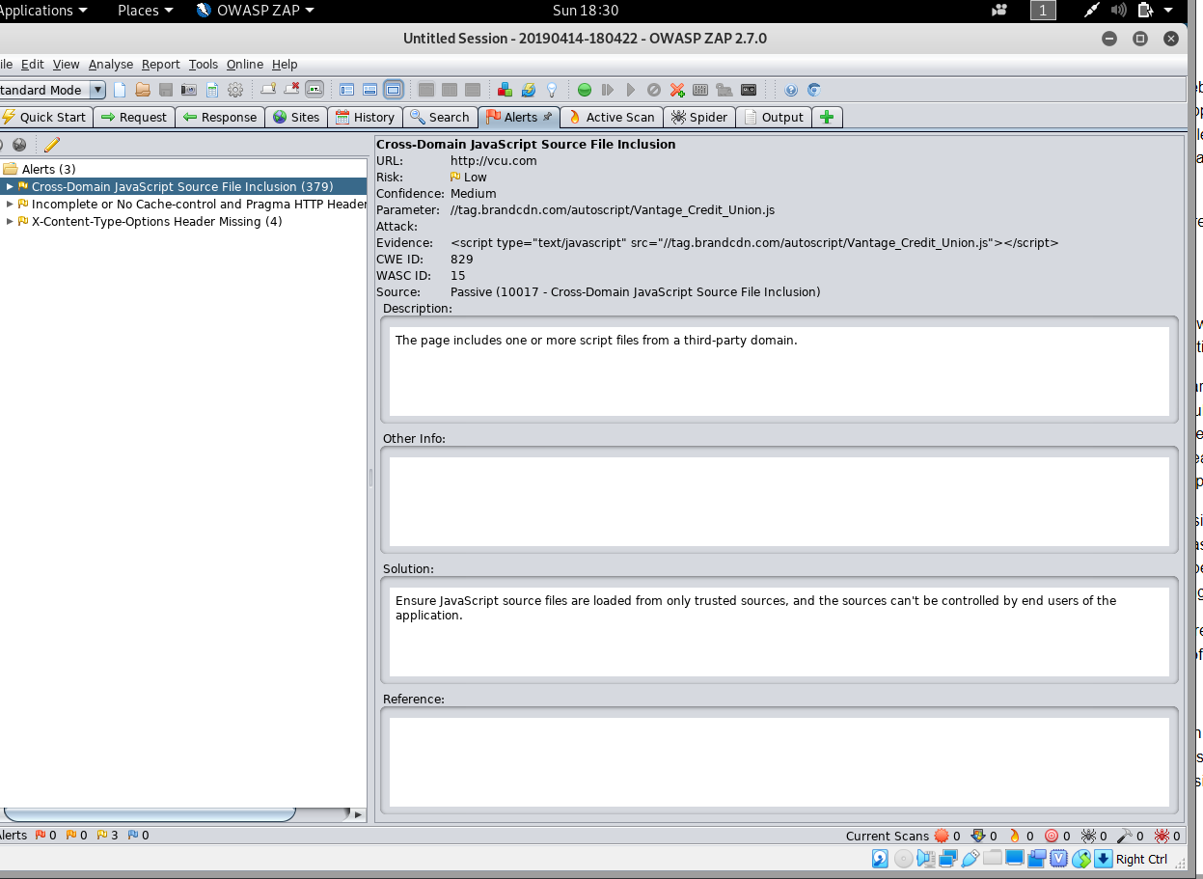

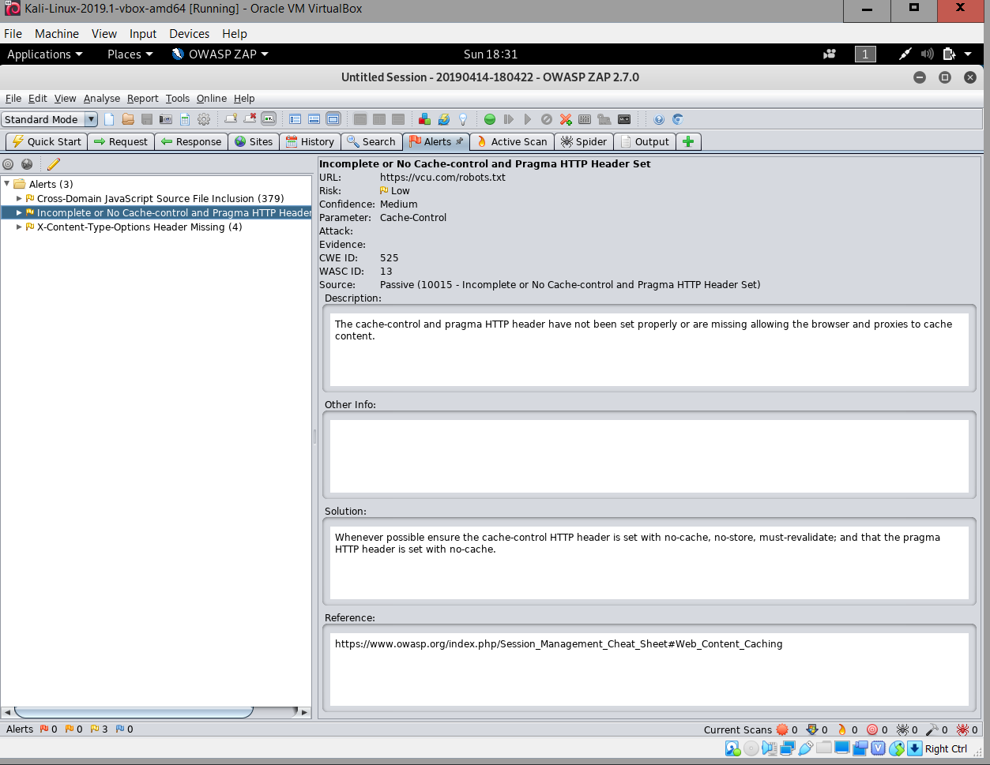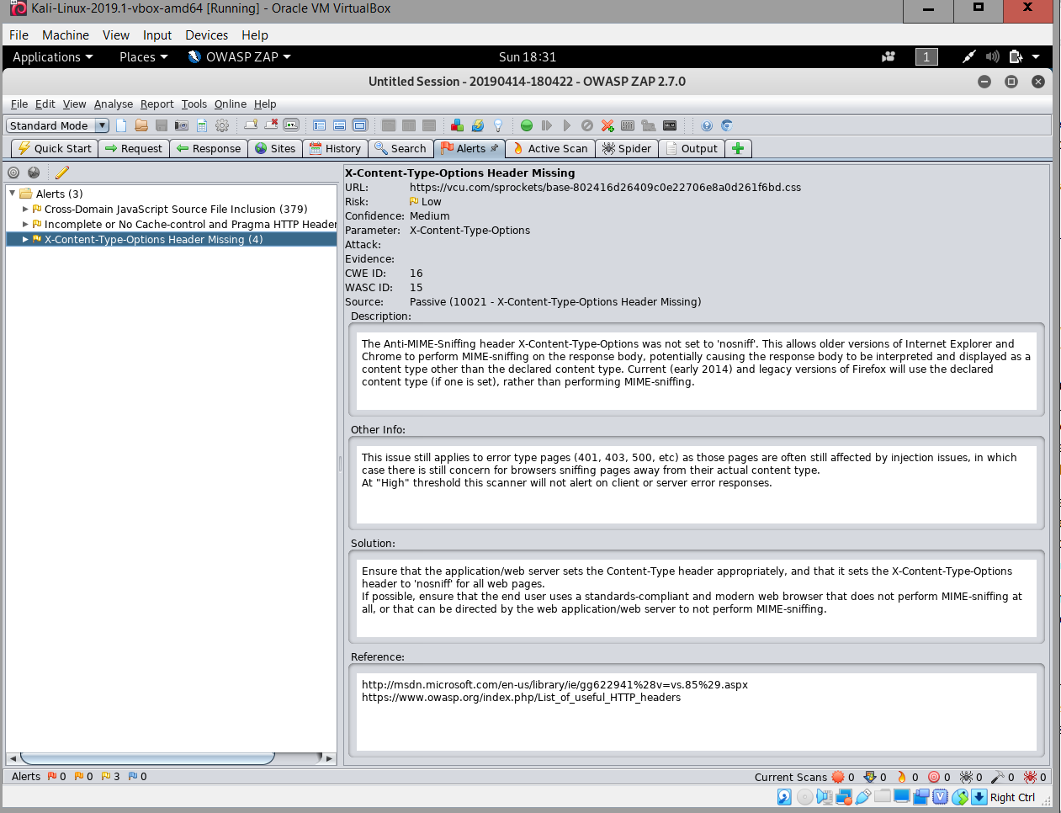

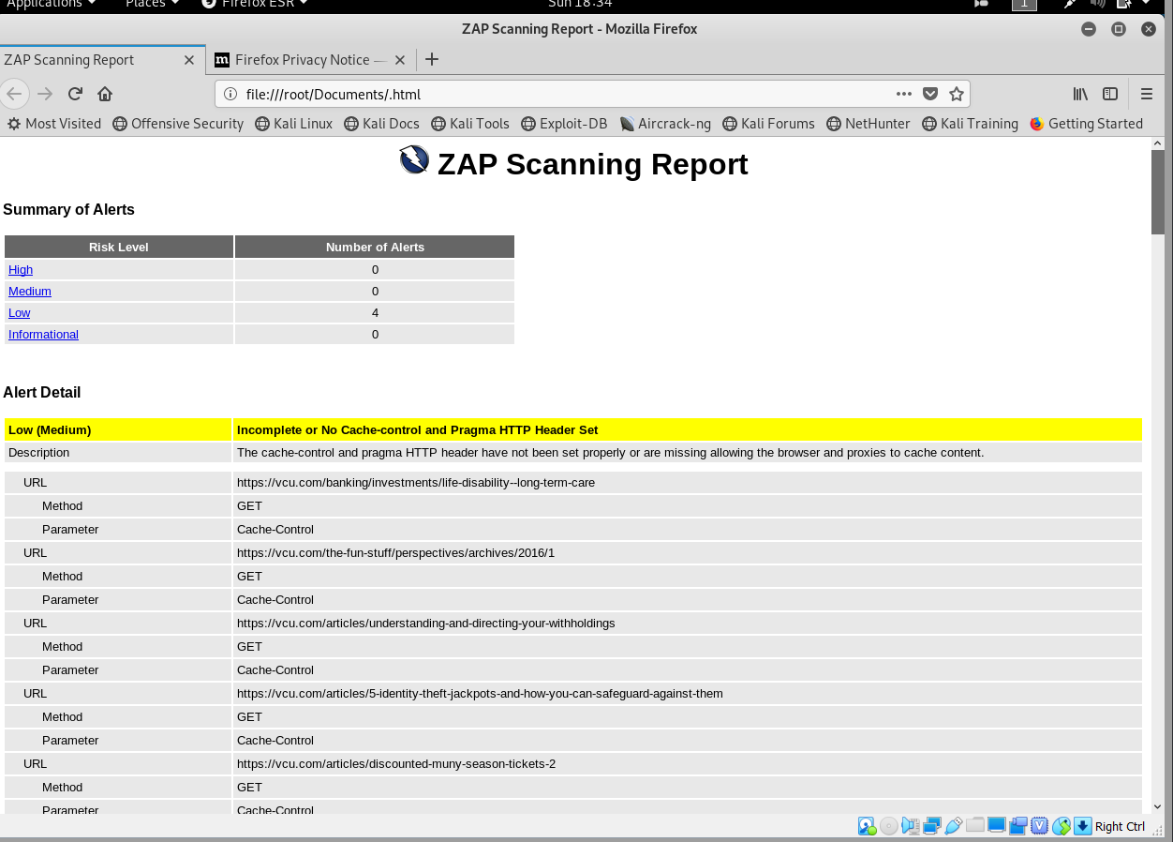

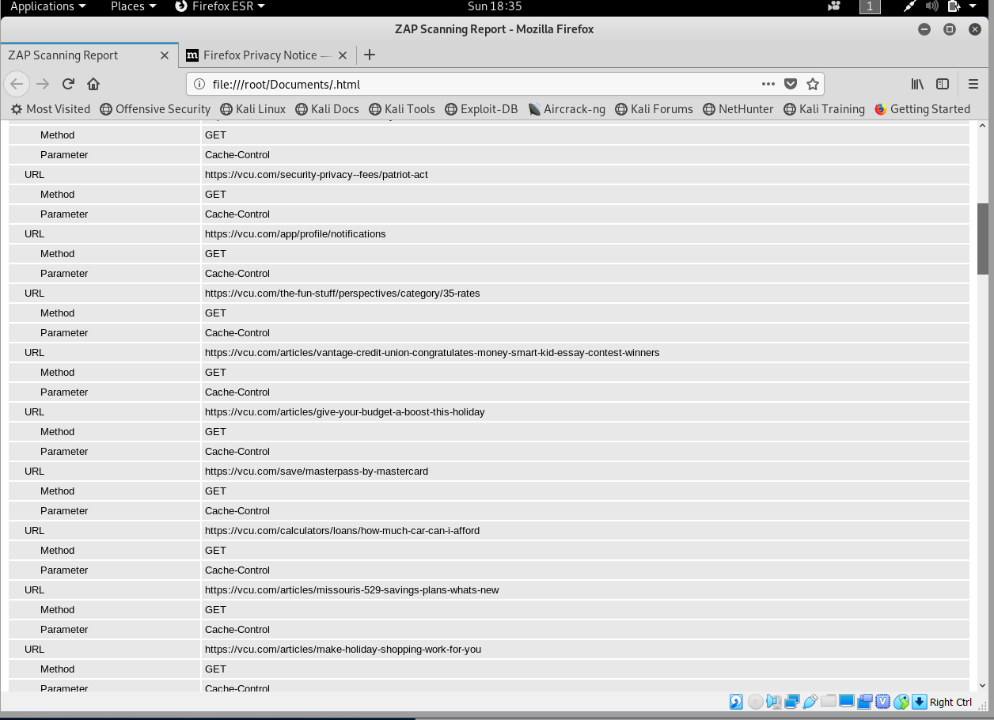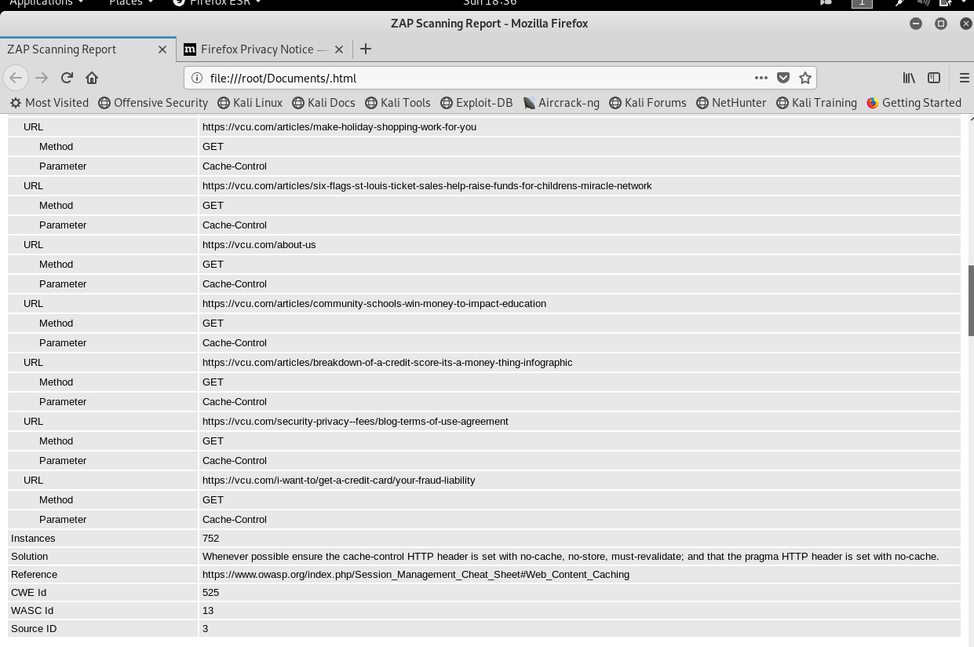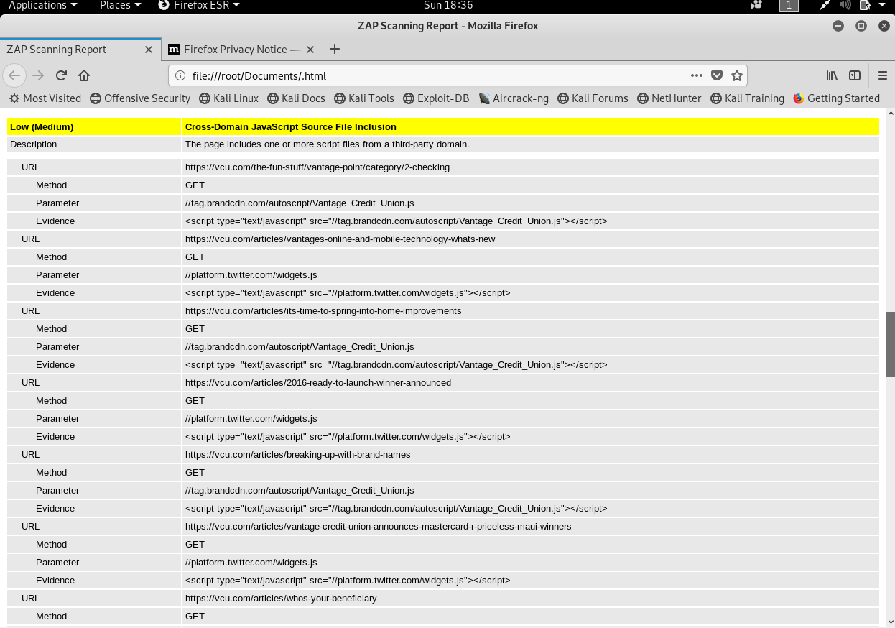

The target client is Vantage Credit Union.

For the active port scanning, vulnerability and banner grab tests, I used a variety of different programs. First, I used Sparta, and I scanned the IP address of vantage credit union. I’ve included the results in the document. The scanner scanned active ports and revealed any vulnerabilities on those ports. I also used zenmpap for a second scan and to get banner results. The same two ports 80 and 443 were showing the results.

Next, I ran a web scan on the URL using owa. This web scanner ran an in-depth analysis on all of the websites links sub links, and directories. The results alerted me to bumper abilities concerning different links. I also was able to save a report detailing the results of the scan.