Configuration procedure for MQTT and NodeRed
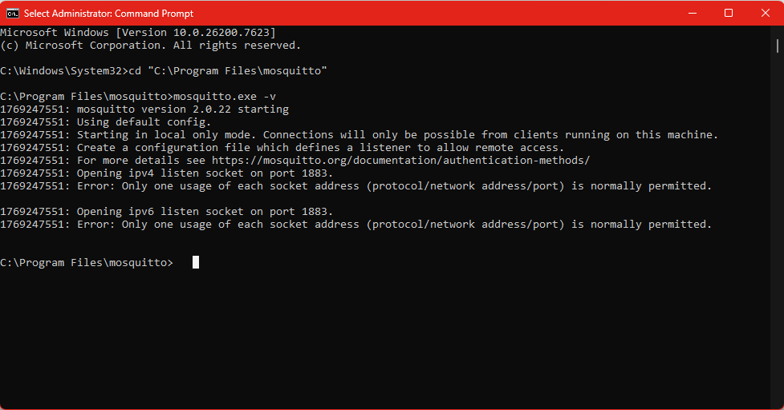
MQTT
Install Windows x64 version: Download | Eclipse Mosquitto
Open cmd.exe as Administrator
Task Manager -> Services -> mosquittoBroker -> Stop
C:\Program Files\mosquitto>netstat -ano | findstr :1883
C:\Program Files\mosquitto>mosquitto.exe -v -c mosquitto.conf
1769251385: mosquitto version 2.0.22 starting
1769251385: Config loaded from mosquitto.conf.
1769251385: Starting in local only mode. Connections will only be possible from clients running on this machine.
1769251385: Create a configuration file which defines a listener to allow remote access.
1769251385: For more details see https://mosquitto.org/documentation/authentication-methods/
1769251385: Opening ipv4 listen socket on port 1883.
1769251385: Opening ipv6 listen socket on port 1883.
1769251385: mosquitto version 2.0.22 running

C:\Program Files\mosquitto\mosquitto.conf:
Paste listener 1883
allow_anonymous true
The, in cmd:
cd "C:\Program Files\mosquitto"
mosquitto.exe -v -c mosquitto.conf

