**Project settings**

**\*Use this:** [**How to Install dlib Library for python in windows 10 - GeeksforGeeks**](https://www.geeksforgeeks.org/how-to-install-dlib-library-for-python-in-windows-10/)

**\*Or this bullshit I created here :**

***Install dlib (Python 3.10 only !!!)***

**Install cmake msi64:** [**Download CMake**](https://cmake.org/download/) **, restart**

**cmake –version**

**Install Visual Studio 2022 with C++ package, restart**



**pip install boost**



**pip install --upgrade pip setuptools wheel**

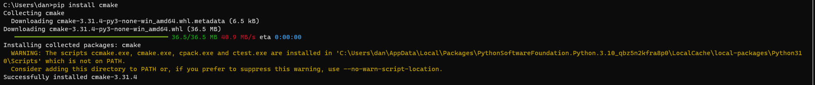

**pip install cmake in cmd prompt**

**pip install dlib**

**Take the path from here and then:**

**Select this, it opens to:**

**Click on “Enter Interpreter Path”**

**Put the path from above inside and press Enter, no more import errors.**